

TECHNICAL REPORT ON STUDENT INDUSTRIAL WORK EXPERIENCE SCHEME {SIWES}
HELD AT
SOLID MINERAL INDEX LTD

WRITTEN BY
Adebile Joshua Bukunmi
ND/23/MPE/FT/0021
DEPARTMENT: MINERAL AND PETOLEUM RESOURCES ENGINEERING TECHNOLOGY

SUBMITTED TO
THE DEPARTMENT OF MINERAL RESOURCES AND PETROLEUM ENGINEERING, INSTITUTE OF TECHNOLOGY, KWARA STATE POLYTECHNIC IN PARTIAL FULFILLMENT FOR THE AWARD OF NATIONAL DIPLOMA (ND) IN MINERAL RESOURCES AND PETROLEUM ENGINEERING

AUGUST –DECEMBER 2024

DEDICATION
I am delight to dedicate this report to Almighty Allah who gave me the grace and opportunity to complete this programme.

ACKNOWLEDGEMENT
My appreciation goes to the Industrial Training Fund (ITF) for their foresight in putting this program in place and also to the Kwara State Polytechnic, for providing a platform on which I was engaged on the training. I appreciate the siwes Coordinator, Many thanks to my supervisor for taking time to supervise me during my training. I also express my profound gratitude to all members and staff of SOLID MINERAL INDEX LTD who gave me training an exciting and blissful one. Also to my parents and siblings thank you all for your moral and financial support.
I am deeply indebted to God Almighty, the giver of all wisdom, knowledge and understanding without whom I would have achieved nothing at all.
Finally to my Industrial based supervisor his support and to my other friends and colleagues. Thank you all I am highly grateful.

ABSTRACT
This report covered the quarrying operation activities being carried out in the mine based company. different stages of production that involves good planning such as drilling, blasting, haulaging and crushing were looked into.
DEDICATION
I am delight to dedicate this report to almight God who gave me the grace and oppourtunity to complete this programme.
TABLE OF CONTENTS
TITLE PAGE. 1
ACKNOWLEDGEMENT II
DEDICATION III
TABLE OF CONTENTS IV
CHAPTER ONE
1.0 INTRODUCTION 1
1.1 BRIEF HISTORY OF SIWES 1
1.2 OBJECTIVES OF SIWES 1
1.3 BENEFITS SIWES 2
1.4 SAFETY MEASURES. 2
1.5 ORGANIZATION CHART 3
CHAPTER TWO
2.0 MAGAZINE 4
2.1 QUARRYLINK MAGAZINE 4
2.2 SAFETY INSTRUMENT/ MATERIAL USE IN MAGAZINE 4
2.3 BRIEF HISTORY OF EXPLOSIVE 5
2.4 DETONATOR 6

2.6 SAFETY FUSE 7
2.7 AMMONIUM NITRATE 8
CHAPTER THREE
3.0 SITE 9
3.1 OVERBURDEN 9
3.2 DRILLING 9
3.3 BLASTING 13
CHAPTER FOUR
4.0 CRUSHING IN MINING 15
4.1 INDUSTRIAL USE 15
4.2 JAW CRUSHER 17
4.3 MIILL (GRINDING) 17
4.4 GRINDING MACHINES 18
CHAPTER FIVE
5.0 CONCLUSION AND RECOMMENDATION 19
5.1 CONCLUSION 19
5.2 RECOMMENDATION 19
5.2.1 RECOMMENDATION TO THE POLYTECHNIC CONCERNING THE SIWES PROGRAMME 19
CHAPTER ONE
INTRODUCTION
- INTRODUCTION OF SIWES
Student industrial works experience scheme (SIWES) is a skill and acquisition of knowledge from the industrial sector. Quarry in a relation to the student is field of study, it’s also serve as a motive that compliments the learning which student have acquired theoretically.
  - BACKGROUND OF SIWES
Student industrial work experience scheme (SIWES) was established in the year 1973/1974 part of government policy to improve student’s ideas in knowledge about industrial sector, Quarry Site, Visitation Unit, or the practical aspect of their chosen career. Siwes was established by the federal government of Nigeria.
1.2 OBJECTIVE OF SIWES
- It provides an avenue for student in institution of higher learning to acquire industrial skills and experience in their approved course of study.
- It prepare students for the industrial works situation which they are likely to meet after graduation
- It exposes students to their working method and techniques in handling equipment and machinery in their institutions.
- Provide students with an opportunity to apply their knowledge in real work situation thereby bridging the gap between theory and practices
- It gives students the opportunity of putting some of the skills into practice.
- It make student familiar with kinds have deeper knowledge of their course
1.3 BENEFITS OF INDUSTRIAL TRAINING TO STUDENTS
The major benefits to students who participate conscientiously in the S1WES programme are the skills and competence they acquire. These relevant production skills remain a part of the student and long life assets which cannot be taken away from them.
- Several other benefits which the students who participate in the SIWES programme gain are listed below:
- The students will have the opportunity to blend theoretical knowledge acquired in the classroom with the practice knowledge gained in the industry.
- It exposes student to blend in the environment they will eventually work in the filter
- It minimizes the bewilderment experienced by students particularly those from a non-technological background.
- It prepares student on how to contribute to the productivity of their employers and national development.
- It enables students to appreciate the connection between their course of study and other related disciplines in the production of goods and services.
1.4 SAFETY MEASURES.
Safety is an important factor that should be put in place in the workshop to reduce accidents.
The workshop put a number of safety precautions in the workshop which all the students must dully obey and they are listed below:
- All the students must put on their workshop overall and safety boot whenever they are entering the workshop’s:
- There must be no un-necessary movement or running in the workshop
- Safety goggles must be worn when working on the winding machine Welding shield must be put on whitening welding operations.
- Fatal accidents should be reported to the workshop technician.
- No students should operate any machine without be given permission from the workshop technicians.
1.5 ORGANIZATION CHART
HOSTEL

MANAGER OFFICE
CRUSHING MACHINE

CRUSHING AND MILLING MACHINE

GATE

ACCOUNTANT OFFICE

DIRECTOR’S OFFICE

WORKER’S OFFICE

MOSQUE

CHAPTER TWO
- 2.0 MAGAZINE
Magazine can be define as a storage room used for storing explosives, cordtex, safety fuse, detonating cord and other blasting materials.
2.1Quarrylink Magazine
Quarrylink magazine contains 6 (six) storage rooms, and the distance between each of the magazine is 200mfrom each other. it was constructed in 1985, the structure was decked and there was enough ventilation in the magazine.
Furthermore, the sand must be at the roof level, it serves as the shock absorber to prevent explosive accident, and in addition magazine should not be in the community or close to the buildings.
Magazine must to be registered by federal ministries of solid minerals. Examples: Im1, Im2,Im3, Im4/1985. Each magazine must issue a certificate and it doesn’t exceed the maximum of 83,000kg
2.2 Safety Instrument / material use in Magazine
- Hand gloves
- Helmet
- Thermometer
- Read of instruction

2.3 BRIEF HISTORY OF EXPLOSIVE
EXPLOSIVE: It is define as a compound or mixture of compounds which when set off undergo a rapid, self-propagation.
It could be initiated be heat, shock or spark to produces gases.
TYPE OF EXPLOSIVE
High explosive: explosive of high energy contact which when properly primed and initiated produces high energy output
Low explosive: It burns rapidly, but do not detonate as compound of high explosive.
CHARACTERISTICS OF EXPLOSIVE
CHEMICAL STABILITY
DETONATION VELOCITY
CATEIDGE DENSITY
EXPLOSIVE POWER
WATER RESISTANCE
SIZE OF EXPLOSIVE
- 25mm
- 50mm
- 60mm
- 90mm
Uses of explosives based on hole
Wagon drill use 50mm
Jackhammer use 25mm
Stemming stock: It is a stock cover at the head of it with plastic for charging of holes or pushing.
2.4 DETONATOR
It is a device used to trigger an explosive device. Detonator can be chemically, mechanically or electrically initiated, the latter two being the most common, the commercial uses of explosive uses of explosive uses electrical detonators or the capped fuse which is a length of safety fuse to which an ordinary detonator has been crimped.
Types of Detonators
Ordinary detonator: usually takes the form of ignition based explosive. Theyare mainly used in commercial operation, ordinary detonators are still used in military operations. This form of detonator is commonly initiated using safety fuse, and used in non time-critical
Electrical Detonator
There are three categories of electrical detonators
Instantaneous electrical detonators (IED)
Short period delay detonators (SPD)
Long period delay detonators (LPD)
Non- Electric Detonator
Is a shock tube detonator designed to indicate explosive generally for the purpose of demolutive of building and for use in blasting of rocks in mines and quarries. Instead of electric wires, a hollow plastic tube delivers the firing impulse to the detonator
DETONATING CORD
Is a flexible plastic tube usually filled with pentaerythrutoltetranitrate (PETN) , (Pentrite). With the PETN exploding at the rate of approximately 6400m/s, any common length of detonating cord appear to explode instantaneously. It is a high-speed fuse which explodes, rather than burns, and is suitable for detonating high explosive.
2.5 CORDTEX
It is a type of detonating cord generally used in milling. It uses an explosive core of pentanerythrotoltetranitrate (PETN) inside its plastic coasting. It commonly has the thickness of electrical extension cord and has a velocity detonation of approximately 6000-7000 meters per seconds. It is used for “daily chain” a sequence of explosive together
2.6 SAFETY FUSE
Is a fuse that burn slowly for communicating fire to a detonator or blasting cap and that consist usually of a train of fone black powder surrounded a tight wrapping and contain gun powder
2.7 AMMONIUM NITRATE:
Ammonium nitrate chemically is a salty. It has a high bulk volume, and has high molecular formula of oxygen.
How to use Ammonium Nitrate
Mix it with hydrocarbon (diesel) and it will give high explosive, it increases the bulk volume of gas, it makes it very sensitive. The gas will try to escape and has to break or blast the rock.
NPK fertilizer can be used for blasting but it will take much diesel. Ammonium is very cheap i.e 25kg is #8000 while explosive is #40,000 per carton. (water gel is also made from ammonium nitrate and water)

CHAPTER THREE
- SITE
3.1 OVERBURDEN: These are material that overlays and which must be removed to get asset to the valuable minerals
MACHINES USED FOR the REMOVAL OF OVERBURDEN
- EXCAVATOR: This is the act of using machine to remove the overburden. The advantage of excavator is that it saves time and money compare to workmanship
- MANUAL (workmanship): This is the act of removing overburden by the use of human being
3.2 DRILLING
Rock drilling is the operation of placing a direct hole into the rock usually for the pry of development and exploration.
MECHANISM OR ROCK PENERATION
There are two basic ways in which rock could be drilled and these include
- Mechanical percussion
- Rotation
Although there are four classes of commercial drilling methods that utilizes these method or combination of both which are
- Rotary drilling
- Percussive drilling
- Percussive rotary drilling
- Rotary percussive drilling
Rotary drilling: this is the act whereby the rotation tools advancement toward the hole bottom and the cutting edge on the drill bit penetrate the rock, removing the cuttings with thickness ion equal to the drill steel diameter.
Percussive rotary: This is the act of using a chisel shape or bottom studded tools which impact the rock with a hammer like blow then rebound to strike the rock.
Percussive rotary: this is the combination of the rotary and percussive principle, blows been periodically struck against the rotating tools.
FUNDAMENTAL COMPONENT OF A DRILLING SYSTEM
The drill (Source of energy)
The rods (Transmitter)
The bit (Applicator)
SELECTION PROCEDURE FOR DRILLING METHOD
- Based on blasting requirement
- Select drilling system
- Estimate parameter performance
- Specific operation variable
- Determine the rock durability factor

FACTOR AFFECTING DRILLING PERFORMANCE
The drilling rod
The bit
Circulatory fluid
Hole dimensioned
Instrument used for drilling in quarrying site
Jackhammer
Wagon drilling machine
3.3 BLASTING
INTRODUCTION
Blasting is an essential part of the mining cycle. In virtually all forms of mining, rock is broken by drilling and blasting the rock. Blasting technology is the process of fracturing material by the use of a calculated amount of explosive so that a predetermined volume of material is broken. From the earliest days of blasting with black powder, there have been steady developments in explosive, detonating and delaying techniques and in the understanding of the mechanics of rock breakage by explosive.

CONTROLLED BLASTING
Controlled blasting is a technique of blasting for the purpose to reduce the amount of over break the ground vibrations. Following are the different types of controlled blasting techniques.
Pre-splitting: this is an old but highly recognized techniques with the purpose to form a fracture plane beyond which the radial cracks from blasting cannot travel. Other method include Trim(cushion) blasting, smooth blasting (contour or perimeter blasting) for underground mines and muffle blasting as a solution to prevent fly-rock from damaging human habitant and structures.
SECONDARY BLASTING
Irrespective of the method of primary blasting employed, it may be necessary to re-blast a proportion of the rock on the quarry floor so as to reduce it to a size suitable for handling by the excavators and crushers available.
Two methods of secondary blasting of rock are available, the first, called the plaster or mudcap method, is to fire a charge of explosive placed on the rock and covered with clay, the shock of the detonating explosive breaking the block. The second technique, known as pop-shooting, is to drill a hole into the block and fire a small charge in this hole, which is usually stemmed with “quarry fines”

NON-EXPLOSIVE ROCK BREAKING
Non-explosive are used in areas very closed to sensitive structure. These are mostly used in construction industry for breaking oversize rocks, concrete e.t.c. these are also hydraulic rock splitters that can be used where blasting is not permitted or where it is not suitable.
SOME BLAST DESIGN
Bench blasting is a common blast techniques most often used for open pit mines. By definition, bench blasting is blasting in a vertical or sub-vertical hole or a row of hole towards a free vertical surface. More than one row of holes can be blasted in the same round. A time delay in the detonation between the rows creates new free surfaces for each row.
One type of bench blast design is short- ole blasting which is usually limited to drilling rounds of 1.2m to 5.0m length and hole diameters up to 43mm. both ANFO and water gels can be used for this type of blasting. Holes are generally drilled in a square pattern.
Long hole drilled downward either parallel to eachother or in sight rings to cover the slope area. Initiation of the blast is with a booster down the hole.
Ring drilling and blasting is done from a series of sub level drill drift developed in the ore body. The drill pattern is designed to cover off the extent of the ore in the slope. This type of blasting will cause the ore to swell by 30%, and this must be allowed for when blasting otherwise the blast may freeze.
There are different types of blast design and this review does not attempt to cover them all. Along with the importance of selecting the proper blasting design other important factors that influence blast result are:
- Properties of explosives being used
- The initiation systems
- The distribution of the explosive in the blast
- Rock structure
- The overall geometry.
STEPS IN BLASTING
Drilling of holes
Charge with detonating cord and explosive
Stemming
Connecting
And then blast.

CHAPTER FOUR
4.0CRUSHING IN MINING
A crusher is a machine designed to reduce large rock into smaller rocks, gravel or rock dust. Crusher may be used to reduce the size, or change the form of waste material so they can be easily disposed or recycled, or to reduce the size of the solid mix of raw materials (as in rock ore), so that pieces of different composition can be differentiated.
Crushing is the process of transferring a force amplified by mechanical advantage through a material being crushed to. Crushing devices hold material between two parallel in tangent solid surfaces, and apply sufficient force to bring the material being crushed so that its molecules separate from (fracturing), or change alignment in relation to (deformation) each other.
4.1 INDUSTRIAL USE
Mining operations use crushers, commonly classified by the degree to which they fragment the starting material, with primary and secondary crusher handling coarse materials and tertiary and quaternary, crushes reducing ore particles to finer gradations. Each crusher is designed to work with a certain maximum size of raw materials and often delivers as output to a screening machine which sorts and directs the product for further processing. Typically, crushing stages are followed by milling stages if the materials need to be further reduced. Crushes are used to reduce particle size enough so that the material can be processed into finer particles in a grinder. A typical example is a pulverize which comprises of a feeder(jawcrusher),cups and chain, electric motor blower shifter), trammel screen jaw crusher.
2 JAW CRUSHER: a jaw crusher uses compressive force for breaking of particle. This mechanical pressure is achieved by the two jaws of the crusher of which one is fixed while the other jaw called a swing jaw, moves back and forth relative to it by a cam or pitman mechanism, acting like a class 11 lever or nut cracker.
4.3 MILL (GRINDING)
A mill is a device that breaks solid materials into smaller pieces by grinding, crushing or cutting. Combination is an important unit operation in many processes. There are many different types of mills and many types of material process in them. Historically mills and many types of material process in them. Historically mills were powered by hand, working animal (eg horse mill), and wind (wind mill) or water (water mill). Today they are usually powered by electricity. The grinding of solid matters occurs under exposure of mechanical forces that trench the structure by overcoming of the interior bonding forces. After the grinding the state of the solid is changed: the grain size disposition and the grain shape.
Milling also refers to the process of breaking down, separating, sizing, or classifying aggregate materials. For instance, rock crushing or grinding to produce uniform aggregate size for construction purposes of structural fill or land reclamation activities. Aggregate milling processes are also used to remove reclamation activities.
Aggregate milling processes are also used to remove or separate contamination or moisture from aggregate or soil and to produce dry fills prior to transport or structural filling.
Grinding may serve the following purposes in engineering
- Increase the surface area of a solid.
- Manufacturing of a solid with a desired grain size.
- Pubing of resources
4.4 GRINDING MACHINES: In materials processing, a grinder is a machine for producing fine particle size reduction through attrition and compressive forces at the grain size level. In general, grinding processes require a relatively large amount of energy, for this reason, an experimental method to measure the energy used locally during milling with different machines was recently proposed.
BALL MILL
ROD MILL
AUTOGENOUS MILL
SAG MILL
PEBBLE MILLHIGH PRESSURE GRINDING ROLLS.

CHAPTER FIVE
5.0 CONCLUSION
I was extremely impressed about how they practiced their daily activities. They are time conscious and greatly discipline about their work as well as generous.
5.1 PERSONAL IMPRESSION ABOUT THE ORGANIZTION
The organization is industrious their workers are obviously well skilled. They are highly accommodative and their environment also conducive. The organization is also perfectly lively to stay.
5.2.1 RECOMMENDATIONS TO THE POLYTECHNIC CONCERNING THE SIWES PROGRAMME.
I would recommend that the polytechnic should try to get a placement for the student by containing all engineering organization to admit any student for their SIWES programme.
I would recommend that the polytechnic should try to give adequate supervision to the student in their places of attachment for student assessment before the completion of the programme.
I would recommend that the polytechnic should encourage their student to spend their training period well and try their possible best to acquire the pratical knowledge on the field.
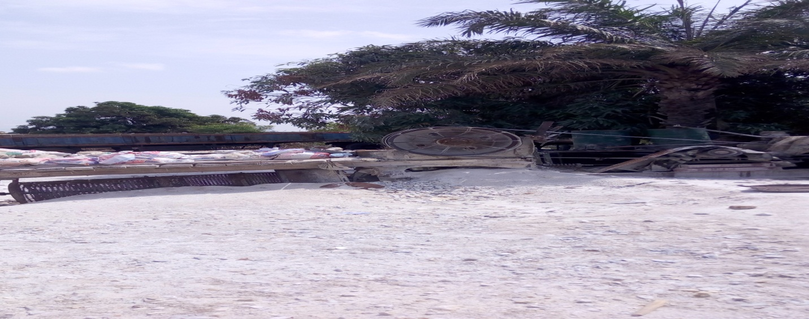
JAWCRUSHER

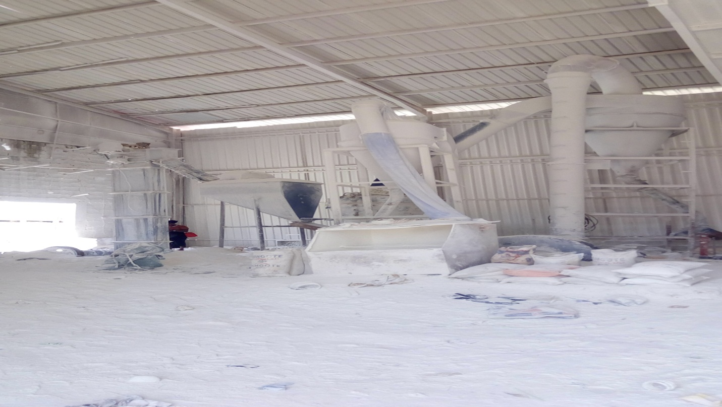
GRINDING MILL MACHINE
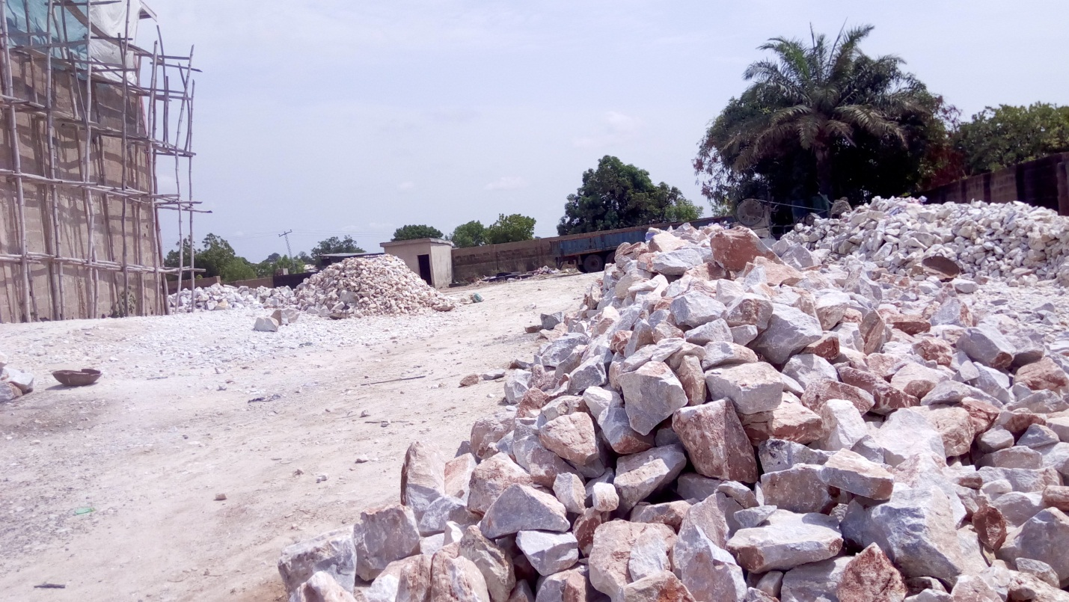
MARBLE (DOLOMITE) calcium magnesium carbonate

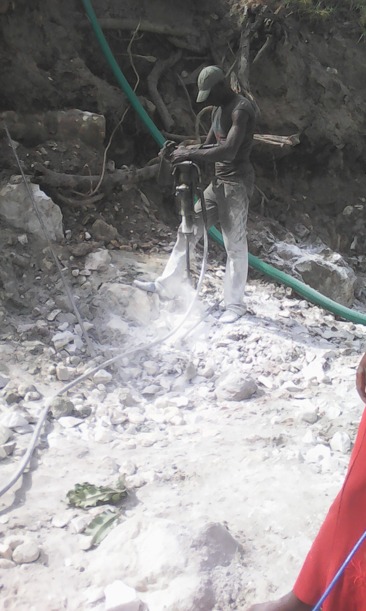
JACKHAMMER

