

A TECHNICAL REPORT ON
STUDENT INDUSTRIAL WORK EXPERIENCE SCHEME
(SIWES)

HELD AT:
SOFTROM ENGINEERING CONCEPT LTD
AIRPORT ROAD ILORIN KWARA STATE

WRITTEN BY
AMOO SOLA JACOB
ND/23/OTM/FT/0110

SUBMITTED TO
DEPARTMENT OF OFFICE TECHNOLOGY MANAGEMENT,
INSTITUTE OF FINANCE MANAGEMENT STUDIES (IFMS)
KWARA STATE POLYTECHNIC, ILORIN

IN PARTIAL FULFILLMENT OF THE REQUIREMENTS FOR THE
AWARD OF NATIONAL DIPLOMA (ND) IN OFFICE TECHNOLOGY MANAGEMENT

AUGUST –NOVEMBER, 2024

DEDICATION
This report is dedicated foremost to Almighty God for his favour may and grace upon my life especially during my 4 months Siwes programme.
I would also like to dedicate it to my lovely parent and siblings for their love and support and everyone else that contribute towards making my Siwes training fun and successful one

ACKNOWLEDGEMENT
My profound gratitude to God Almighty for keeping me alive, the giver and taker of lives and also extend my gratitude to my parent for their supports and prayers toward my every step in life. I pray my parent live long to eat the fruit of their labour
My sincere appreciation also goes to my parent Mr. and Mrs. Amoo for their spiritual, moral and financially support towards the success of my SIWES programme.
I sincerely appreciate the management and staff of the company, Ilorin for their support, guidance, and knowledge shared during my SIWES. I also extend my gratitude to my supervisors and lecturers for their continuous encouragement and constructive feedback throughout the program.

TABLE OF CONTENTS
Title Page i
Dedication ii
Acknowledgement iii
Table of Contents vi
CHAPTER ONE
1.1 Introduction to Training Programme 1
1.2 Objective of the programme to student 2

1.3 Description of the Organization
CHAPTER TWO

TRAINING EXPERIENCE

2.1 Work Description and Duties

2.2 Tools and Technologies Used
CHAPTER THREE
3.1 Introduction to Microsoft office
3.2 Key Microsoft Office Applications
3.3 Benefits of Microsoft Office Applications
3.4 How to Use Microsoft Word
CHAPTER FOUR

CHALLENGES AND SOLUTIONS

4.1 Challenges Faced

4.2 Solutions Implemented
CHAPTER FIVE
5.1 Conclusion 10

5.2 Recommendations 10

CHAPTER ONE

INTRODUCTION

1.1 Background of SIWES
The Student Industrial Work Experience Scheme (SIWES) is a program established by the Industrial Training Fund (ITF) to provide students of higher institutions with practical knowledge and experience in their respective fields of study. The program is designed to bridge the gap between theoretical knowledge acquired in the classroom and real-world industrial applications.

1.2 Objectives of SIWES
The main objectives of SIWES include:
- To expose students to the working environment and enable them to apply theoretical knowledge to practical work situations.
- To provide students with hands-on experience in the use of modern tools and technologies.
- To enhance students' employability and entrepreneurial skills.
- To familiarize students with organizational structures and work ethics.

1.3 Description of the Organization
Softrom Engineering Concept Ltd is a technology service provider specializing in IT solutions, including computer training, internet services, printing, scanning, and other digital services. The center offers various IT-related services such as graphic design, programming, and basic computer literacy training.

CHAPTER TWO

TRAINING EXPERIENCE

2.1 Work Description and Duties
During my Student Industrial Work Experience Scheme (SIWES) at Softrom Engineering Concept Ltd, I was actively involved in a variety of tasks that enhanced my technical and customer service skills. My responsibilities included the following:
- Customer Assistance and Internet Services:
  - Guided customers in browsing the internet efficiently for research, job applications, and online registrations.
  - Assisted in setting up and managing email accounts, including sending and receiving emails, attaching files, and troubleshooting common email-related issues.
- Basic Computer Training:
  - Provided hands-on training to customers on the use of Microsoft Office applications such as:
    - Microsoft Word – typing, formatting documents, and inserting tables/images.
    - Microsoft Excel – creating spreadsheets, using formulas, and generating simple charts.
    - Microsoft PowerPoint – designing presentations and adding multimedia elements.
  - Helped beginners understand basic computer operations, file management, and internet safety practices.
- Graphic Design and Digital Content Creation:
  - Learned and applied graphic design techniques using CorelDRAW and Adobe Photoshop.
  - Assisted in designing simple flyers, business cards, invitation cards, and banners for customers.
  - Edited and enhanced images for use in documents and social media platforms.
- Computer Troubleshooting and Maintenance:
  - Assisted in diagnosing and fixing minor computer issues, such as software errors, slow system performance, and network connection problems.
  - Helped with the installation and updating of basic software programs.
  - Learned about computer hardware components and performed routine maintenance tasks like dusting and checking connectivity.
- Document Handling and Office Equipment Operation:
  - Operated various office machines, including scanners, printers, photocopiers, and laminators, to provide essential document services.
  - Ensured proper handling and formatting of customer documents before printing or laminating.

2.2 Tools and Technologies Used
During my SIWES program at Softrom Engineering Concept Ltd, I worked with a variety of tools and technologies that enhanced my technical proficiency and problem-solving skills. These included:

1. Hardware:
I gained hands-on experience with various computer hardware and office equipment, including:
- Desktop Computers: Used for customer support, document processing, and software applications.
- Printers: Assisted in printing documents, images, and business materials such as flyers and reports.
- Scanners: Scanned hard copy documents for digital use, including editing and online submissions.
- Photocopiers: Operated photocopy machines for document duplication and bulk printing services.
- Laminators: Used for protecting and enhancing printed documents such as ID cards and certificates.

2. Software:
I worked with different software applications for office work, design, and internet-related tasks, including:
- Microsoft Office Suite:
  - Microsoft Word – Document creation, formatting, and editing.
  - Microsoft Excel – Spreadsheet management, data entry, and basic formula applications.
  - Microsoft PowerPoint – Designing presentations with animations and multimedia integration.
- CorelDRAW & Adobe Photoshop:
  - Assisted in graphic design for flyers, posters, business cards, and other promotional materials.
  - Edited and enhanced images for customers' digital and print needs.
- Internet Browsers:
  - Used Google Chrome, Mozilla Firefox, and Microsoft Edge for browsing, research, and online transactions.
  - Helped customers access web-based applications such as email services, job portals, and online banking.

CHAPTER THREE
3.1 Introduction to Microsoft office
Microsoft Office is a suite of productivity applications developed by Microsoft. It is widely used in businesses, educational institutions, and personal environments for document creation, data management, presentations, and communication. The suite includes various applications designed to meet different professional and personal needs.
3.2 Key Microsoft Office Applications
a. Microsoft Word Microsoft Word is a word-processing application used for creating, editing, formatting, and sharing text-based documents. It provides features such as spell check, grammar check, templates, and collaboration tools.
b. Microsoft Excel Excel is a spreadsheet application used for data analysis, calculations, and visualization. It includes formulas, pivot tables, charts, and automation through macros and VBA (Visual Basic for Applications).
c. Microsoft PowerPoint PowerPoint is a presentation software used for creating slideshows, business presentations, and educational materials. It offers various templates, animations, transitions, and multimedia support.
d. Microsoft Access Access is a database management system used for creating, managing, and analyzing databases. It allows users to store large amounts of data and create queries, forms, and reports.
e. Microsoft Publisher Publisher is a desktop publishing application used for designing brochures, flyers, newsletters, and other marketing materials. It provides templates and design tools for professional-looking documents.
3.3 Benefits of Microsoft Office Applications
- Productivity: Enhances efficiency through automation, templates, and collaboration features.
- Integration: Seamless integration between applications improves workflow.
- Accessibility: Available on various devices, including desktops, tablets, and smartphones.
- Security: Features like password protection and encryption ensure data security.
- Cloud Support: Microsoft 365 provides cloud storage and real-time collaboration through OneDrive and SharePoint.
3.4 How to Use Microsoft Word
Microsoft Word is a widely used word-processing application that allows users to create, edit, format, and share text-based documents. It is commonly used for writing reports, letters, resumes, and other professional or academic documents. This report provides a comprehensive guide on how to use Microsoft Word effectively.
2. Getting Started with Microsoft Word
- Open Microsoft Word from the Start menu or taskbar.
- Create a new document by selecting "Blank Document" or choosing a template.
- Familiarize yourself with the user interface, including the ribbon, toolbar, and workspace.
- Save the document by clicking "File" > "Save As" and selecting a location.
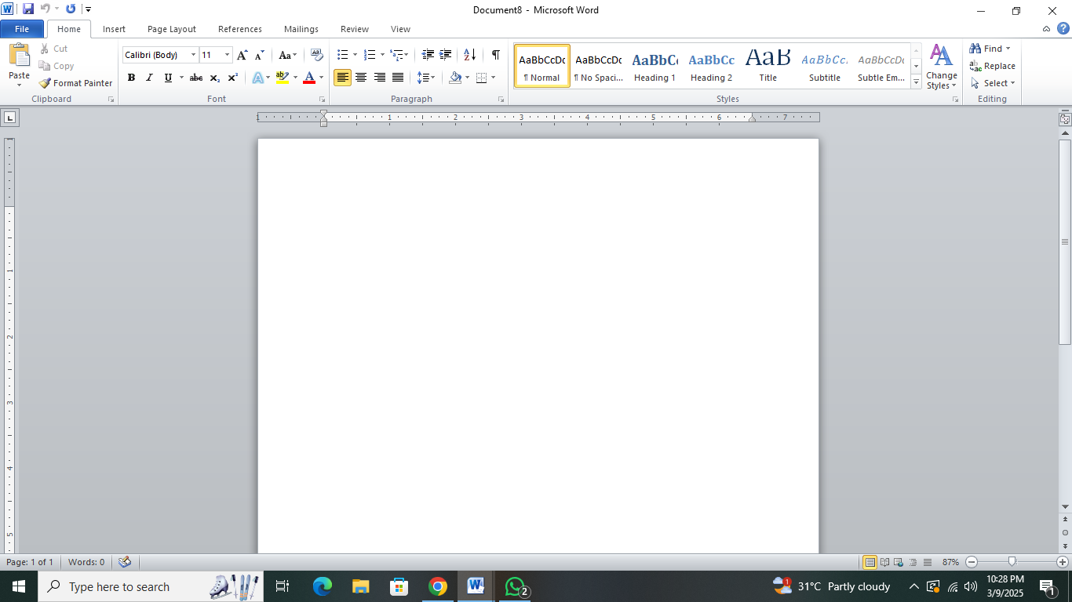
3. Basic Features of Microsoft Word
a. Text Formatting
- Enter text by typing in the document area.
- Change font type, size, and color using the "Home" tab.
- Apply bold, italics, underline, and strikethrough for emphasis.
- Adjust text alignment (left, center, right, justify).
- Use bullet points and numbering for lists.
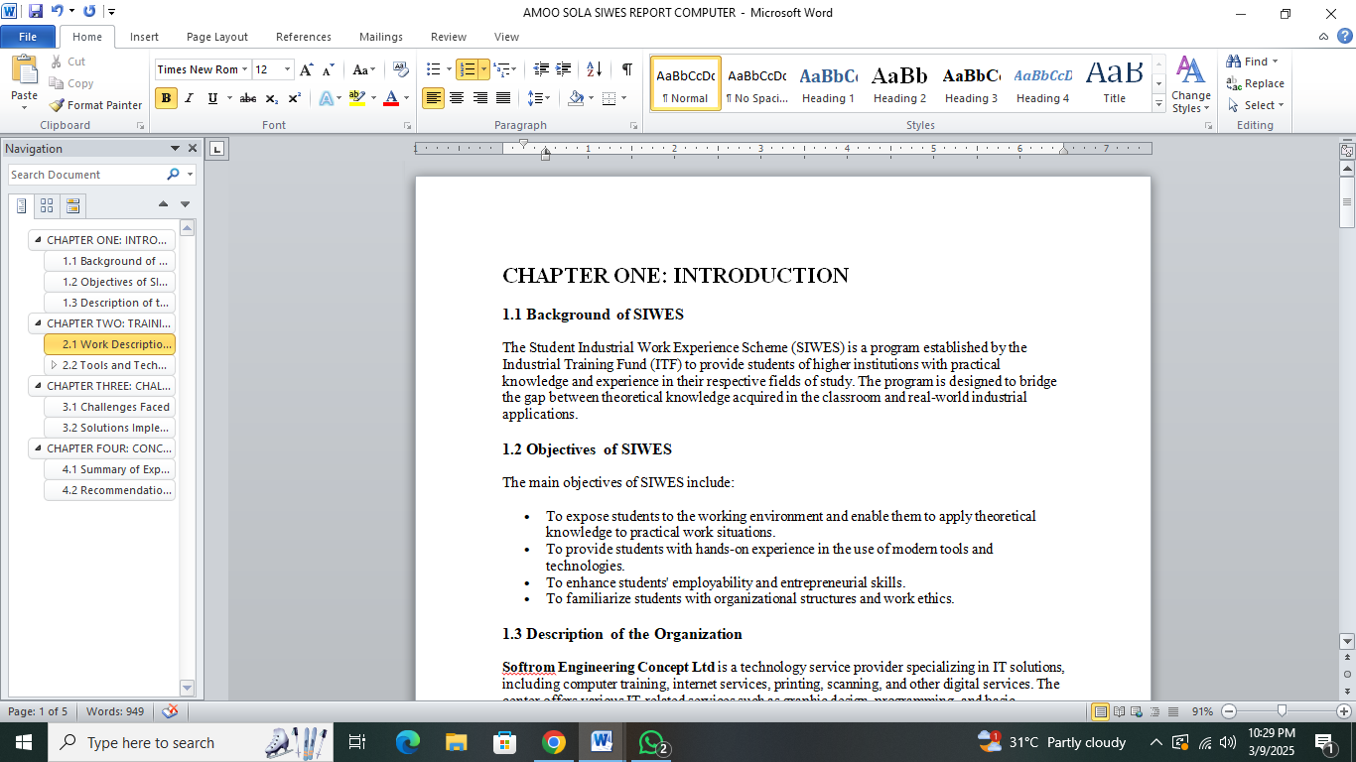
b. Page Layout and Design
- Set page margins, orientation (portrait/landscape), and paper size under the "Layout" tab.
- Insert headers and footers for consistent document formatting.
- Add page numbers, watermarks, and borders.
c. Working with Tables and Images
- Insert tables by clicking "Insert" > "Table" and selecting the desired size.
- Format tables by adjusting borders, colors, and text alignment.
- Add images using "Insert" > "Pictures" or online sources.
- Resize and position images within the document.
d. Using Styles and Templates
- Apply predefined styles for consistent formatting.
- Create and modify custom styles to maintain document uniformity.
- Use built-in templates for resumes, reports, and other professional documents.
e. Reviewing and Proofreading
- Use spell check and grammar check to detect errors.
- Track changes and add comments for collaborative editing.
- Compare different document versions to review modifications.
f. Advanced Features
- Insert hyperlinks to link text to websites or other documents.
- Add footnotes and endnotes for academic writing.
- Use mail merge for bulk document creation (letters, labels, envelopes).
- Insert equations and symbols for technical writing.
4. Saving and Exporting Documents
- Save files in various formats, including DOCX, PDF, and RTF.
- Use OneDrive for cloud storage and real-time collaboration.
- Print documents with customized settings for layout and page selection.
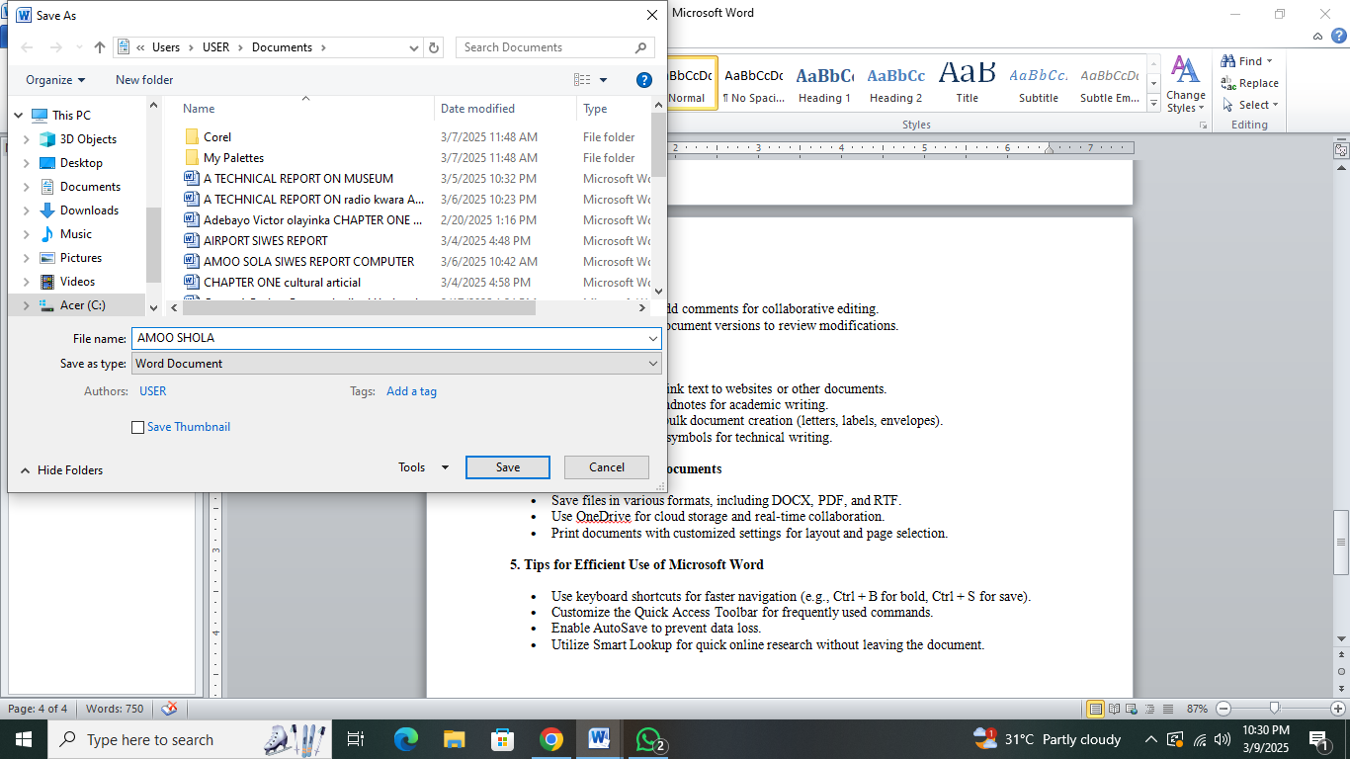
5. Tips for Efficient Use of Microsoft Word
- Use keyboard shortcuts for faster navigation (e.g., Ctrl + B for bold, Ctrl + S for save).
- Customize the Quick Access Toolbar for frequently used commands.
- Enable AutoSave to prevent data loss.
- Utilize Smart Lookup for quick online research without leaving the document.

CHAPTER FOUR

CHALLENGES AND SOLUTIONS

4.1 Challenges Faced
During the SIWES program, several challenges were encountered, including:
- Frequent power outages disrupting workflow.
- Slow internet connectivity affecting customer services.
- Difficulties in troubleshooting complex hardware issues.
- Managing customer expectations and complaints.

4.2 Solutions Implemented
- Usage of backup power supply (generator) to mitigate power failures.
- Alternative internet providers were considered to improve service reliability.
- Guidance from supervisors and online research helped in troubleshooting IT issues.
- Effective communication skills were developed to handle customer interactions professionally.

CHAPTER FIVE

CONCLUSION AND RECOMMENDATIONS

5.1 Summary of Experience
The SIWES program at Softrom Engineering Concept Ltd provided valuable practical experience in IT services, customer management, and digital skills. The internship improved my technical knowledge, problem-solving skills, and workplace professionalism.

5.2 Recommendations
- The center should invest in better internet infrastructure to enhance service delivery.
- More training sessions for interns on advanced IT skills should be introduced.
- Regular maintenance of hardware should be carried out to reduce breakdowns.
- Future interns should be given specific projects to work on to enhance their learning experience.

