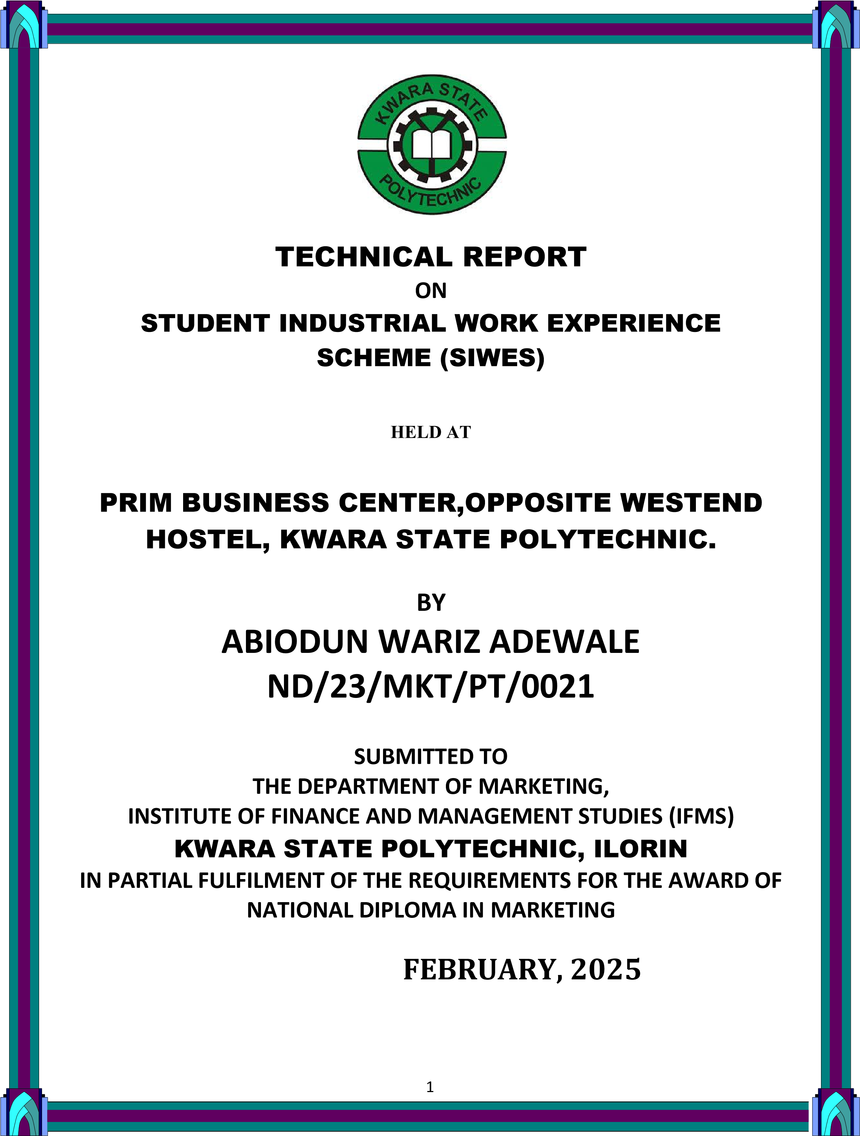
CERTIFICATION
This is to certify that the bearer has successfully completed the Student Industrial Work Experience (SIWES).

Department Cordinator Date

SIWES Director Date

DEDICATION
This report is dedicated to the almighty God, the giver and sustainer of life, for His unconditional love and mercy granted to me throughout the period of my Industrial Training.

ACKNOWLEDGEMENTS
I give thanks to Almighty God, who gave me the gift of life that made everything possible and kwara state polytechnic for the privilege of this siwes program

TABLE OF CONTENT
Title page
Dedication
Acknowledgement
Conclusion

FIRST WEEK
1.1 Introduction
1.2 Aims and objectives of SIWES (Definition of SIWES)

SECOND WEEK
2.1 Historical background of the organization
2.2 Organization chart

THIRED WEEK
3.1 Major activities of the organization
3.2 Specific function of various section/units of the organization

FOURTH WEEK
4.1 Student involvement at various section/ unit
4.2 Interpersonal relationship with the organization

FIFTH WEEK
5.1 communication in organization
5.2 Digital marketing consultancy

SIX WEEK
6.1 communication in organization with individual and online customer
6.2 Relevance experience gained to the student field study

SEVEN WEEK
7.1 Conclusion
7.2 Personal Impression about the organization

EIGHT WEEK
8.1 Recommendation

FIREST WEEK

1.1 INTRODUCTION
This program called (SIWES) student industrial work experience scheme is compulsory to all ND1 student who offer science course or any other practicable course. It enables student to have the experience of the aspect which have been taught in school. It is a program that takes up to four month in which student are expected to be able practices what they are taught.

1.2 AIMS AND OBJECTIVES OF SIWES
The student industrial work experience scheme (SIWES) can be define as a technical skills and acquisition of knowledge from the organization, industrial sector. It is also serving as the complement the learning which student have acquired in the classroom or theoretically.
The objective of the student industrial work experience scheme is as follow It enables the student to practically different test from what they learnt theoretically in the lecture room.
- It also enlighten student to various s division of industrial or organization of work in which the course of study can be radicalized.
- It relate the student to the labor market and how it being operated.
- To enable student to defend his or her self in anywhere he or she found itself.

SECOND WEEK

2.1 HISTORICAL BACKGROUND OF THE ORGANIZATION
The name of the organization is Prim business center it is located at opposite westend hostel Kwara state polytechnic Ilorin, Kwara State.
It was created in 2010 and was directed by MR. Hammed babatunde. The aims and objective of the organization is to train both SIWES and its student and also individual in digital marketing in order for them to know much or deep about and they have taught in their various institutions.

2.2 ORGANIZATION CHART

MANAGING DIRECTOR

B
U
S
I
N
E
S
S

C
E
N
T
E
R

OPERATOR

ATTENDANCE

ENGINEERING

TRAINEE STUDENTS

THIRED WEEK

3.1 MAJOR ACTIVITIES OF THE ORGANIZATION
The major activity of the organization is operating digital marketing The organization also accommodate SIWES student and individual.
Other activities performed by the organization are:
1. The organization based on digital marketing
2 . Data analysis interpretation digital marketing
3. Digital marketing marketing consultancy

3.2 INTRODUCTION DIGITAL MERKETING Digital marketing refers to the promotion of products, brands, or services using digital channels such as search engines, social media platforms, email, and websites. It involves using digital tools and techniques to reach and engage with target audiences, build brand awareness, drive website traffic, generate leads, and ultimately, drive sales and revenue.
Key Components of Digital Marketing
1. Search Engine Optimization (SEO)Optimizing website content to rank higher in search engine results pages (SERPs).
2. Pay-Per-Click (PPC) Advertising Creating and publishing online ads that are paid for each time a user clicks on them.
3. Social Media Marketing Using social media platforms to promote products, services, or brands.
4. Content Marketing Creating and distributing valuable, relevant, and consistent content to attract and retain a clearly defined audience.
5. Email Marketing Sending targeted and personalized messages to customers or prospects via email.
6. Influencer Marketing Partnering with influencers to promote products, services, or brands to their followers.
7. Affiliate Marketing Partnering with affiliates who promote products, services, or brands in exchange for commissions.
8. Mobile Marketing Using mobile devices to promote products, services, or brands.
9. Analytics and Reporting*: Measuring and analyzing the performance of digital marketing campaigns.

Benefits of Digital Marketing
1. Increased Reach Digital marketing allows businesses to reach a global audience.
2. Improved targeting digital marketing enables businesses to target specific audiences based on demographics, interests, and behaviors.
3. Measurable Results Digital marketing provides measurable results, allowing businesses to track the effectiveness of their campaigns.
4. Cost-Effective Digital marketing is often more cost-effective than traditional marketing methods.
5. Flexibility Digital marketing allows businesses to quickly adjust their campaigns in response to changes in the market or consumer behavior.
Career Opportunities in Digital Marketing
1. Digital Marketing Manager Oversees digital marketing campaigns and strategies.
2. SEO Specialist Optimizes website content for search engines.
3. Social Media Manager Manages social media presence and creates content.
4. Content Marketing Specialist Creates and distributes valuable content.
5. Email Marketing Specialist Creates and sends targeted email campaigns.
6. Paid Advertising Specialist Manages paid advertising campaigns.
7. Analytics Specialist Measures and analyzes digital marketing performance.

Tools and Software Used in Digital Marketing
1. Google Analytics Measures website traffic and behavior.
2. Google Ads Manages paid advertising campaigns.
3. Facebook Ads Manager Manages social media advertising campaigns.
4. HubSpot Manages inbound marketing and sales.
5. Mailchimp Manages email marketing campaigns.
6. SEMrush Analyzes website SEO and competitor analysis.
7. Hootsuite Manages social media presence and scheduling.
marketing is a rapidly evolving field, and staying up-to-date with the latest trends, tools, and best practices is essential for success.



FOURTH WEEK

4.1 DATA ANALYSIS INTERPRETATION IN DIGITAL MARKETING
Data analysis interpretation in digital marketing involves examining and understanding data from various digital marketing channels to extract meaningful insights, optimize marketing strategies, and improve return on investment (ROI).

Types of data analyzed in digital marketing:
1. Website analytics data Google Analytics, website traffic, engagement metrics
2. Social media data Engagement metrics, follower growth, sentiment analysis
3. Email marketing data Open r Data analysis interpretation in digital marketing involves examining and understanding data from various digital marketing channels to extract meaningful insights, optimize marketing strategies, and improve return on investment
4. Paid advertising data Cost-per-click (CPC), cost-per-conversion (CPA), return on ad spend (ROAS)
5. Customer relationship management (CRM) data Customer interactions, purchase history, demographic data

Performance indicators (KPIs) in digital marketing:
1. Conversion rate Percentage of visitors who complete a desired action
2. Return on investment (ROI) Revenue generated compared to marketing spend
3. Cost-per-acquisition (CPA) Cost of acquiring one customer
4. Customer lifetime value (CLV) Total value of a customer over their lifetime
5. Engagement metrics Likes, shares, comments, etc.

Data analysis techniques used in digital marketing:
1. Segmentation Dividing data into distinct groups based on demographics, behavior, or preferences
2. Regression analysis Analyzing relationships between variables to predict outcomes
3. Cluster analysis Grouping similar data points into clusters
4. Decision tree analysis Visualizing complex data to identify patterns and relationships
5. A/B testing Comparing two versions of a marketing element to determine which performs better

Tools used for data analysis in digital marketing:
1. Google Analytics Web analytics and reporting
2. Google Data Studio Data visualization and reporting
3. Adobe Analytics Web analytics and reporting
4. HubSpot In bound marketing and sales software
5. Tableau Data visualization and business intelligence

Benefits of data analysis interpretation in digital marketing:
1. Data-driven decision-making Using data to inform marketing strategies
2. Improved ROI Optimizing marketing spend for better returns
3. Enhanced customer understanding Gaining insights into customer behavior and preferences
4. Competitive advantage Staying ahead of competitors with data-driven insights
5. Personalization Tailoring marketing efforts to individual customers or segments

4.2 COMMUNICATION IN ORGANIZATION
Effective communication is crucial in an organization, especially in the field of digital marketing, where teamwork, collaboration, and stakeholder engagement are essential. Here are some key aspects of communication in an organization in the field study of digital marketing:

Types of Communication:
1. Internal Communication : Communication among team members, departments, and stakeholders within the organization.
2. External Communication : Communication with customers, clients, partners, and other external stakeholders.

Channels of Communication:
1. Email: Official communication, updates, and notifications.
2. Team Collaboration Tools: Slack, Trello, Asana, and other project management tools.
3. Meetings: Regular team meetings, brainstorming sessions, and progress updates.
4. Video Conferencing : Remote meetings, training sessions, and client calls.
5. Instant Messaging: Informal communication, quick updates, and feedback.

Key Communication Skills:
1. Clear and Concise Writing: Ability to write effective emails, reports, and proposals.
2. Effective Listening: Ability to listen attentively, understand, and respond appropriately.
3. Presentation Skills : Ability to deliver engaging, informative presentations.
4. Conflict Resolution: Ability to manage and resolve conflicts, disagreements, and misunderstandings.
5. Cultural Competence: Ability to communicate effectively with diverse teams, clients, and stakeholders.

Communication Challenges:

1. Information Overload : Managing the sheer volume of data, emails, and messages.
2. Miscommunication: Avoiding misunderstandings, misinterpretations, and miscommunications.
3. Language Barriers: Communicating effectively with team members, clients, or stakeholders who speak different languages.
4. Technical Issues : Overcoming technical challenges, such as email deliverability issues, software glitches, or connectivity problems.

Best Practices:
1. Establish Clear Communication Channels*: Define official communication channels, protocols, and expectations.
2. Set Clear Goals and Objectives : Align communication efforts with organizational goals, objectives, and key performance indicators (KPIs).
3. Foster Open Communication : Encourage transparency, feedback, and open communication among team members, departments, and stakeholders.
4. Use Collaboration Tools : Leverage team collaboration tools, project management software, and communication platforms to facilitate teamwork, productivity, and efficiency.
5. Provide Training and Development: Offer training, workshops, and coaching to enhance communication skills, conflict resolution, and cultural competence.

FIFTH WEEK

5.1 COMMUNICATION IN ORGANIZATION WITH INDVIDUAL AND ONLINE CUSTOMER
Effective communication is crucial in an organization, especially in the field of digital marketing, where interactions with individual customers and online communities are essential. Here are some key aspects of communication in an organization with individual and online customers in the field study of digital marketing:

Communication with Individual Customers:
1. Personalized Communication: Addressing customers by name, understanding their preferences, and tailoring communication to their needs.
2. Email Communication: Sending targeted, personalized emails to customers, including newsletters, promotional offers, and transactional emails.
3. Phone and Video Calls : Engaging with customers through phone and video calls to resolve issues, provide support, and build relationships.
4. Live Chat and Messaging: Using live chat and messaging platforms to provide instant support, answer questions, and engage with customers.

Communication with Online Communities:
1. Social Media: Engaging with online communities on social media platforms, including Facebook, Twitter, Instagram, and LinkedIn.
2. Forums and Discussion Boards: Participating in online forums and discussion boards related to the industry or niche.
3. Blog Comments: Responding to comments on the organization's blog and engaging with readers.
4. Online Reviews: Monitoring and responding to online reviews on platforms like Google My Business, Yelp, and TripAdvisor.

Key Communication Skills:
1. Empathy: Understanding and acknowledging customers' concerns, feelings, and needs.
2. Active Listening: Paying attention to customers' feedback, questions, and concerns.
3. Clear and Concise Writing: Communicating effectively through written channels, including email, social media, and live chat.
4. Conflict Resolution: Managing and resolving conflicts, complaints, and negative feedback.
5. Cultural Competence: Communicating effectively with customers from diverse cultural backgrounds.

Communication Channels:
1. Email Marketing Software: Using email marketing software like Mailchimp, Constant Contact, or HubSpot.
2. Social Media Management Tools: Utilizing social media management tools like Hootsuite, Sprout Social, or Buffer.
3. Live Chat and Messaging Platforms: Using live chat and messaging platforms like Intercom, Drift, or Many Chat.
4. Customer Relationship Management (CRM) Software: Leveraging CRM software like Sales for customer or Fresh sales .

Best Practices:
1. Respond Promptly: Responding quickly to customer inquiries, feedback, and concerns.
2. Be Personal: Personalizing communication to build relationships and trust with customers.
3. Use Multiple Channels: Using multiple communication channels to reach customers and provide support.
4. Monitor and Measure: Monitoring and measuring communication efforts to identify areas for improvement.
5. Provide Multilingual Support: Providing support in multiple languages to cater to diverse customer bases.

5.2 Digital marketing consultancy
Digital marketing consultancy is a service that provides expert advice and guidance to businesses and organizations on how to improve their online presence, reach their target audience, and achieve their digital marketing goals.

Services Offered:
1. Digital Marketing Strategy: Developing a comprehensive digital marketing strategy aligned with business objectives.
2. Website Optimization: Improving website design, user experience, and conversion rates.
3. Search Engine Optimization (SEO): Enhancing website visibility, ranking, and organic traffic.
4. Pay-Per-Click (PPC) Advertising: Managing and optimizing PPC campaigns for maximum ROI.
5. Social Media Marketing: Creating and implementing social media strategies to engage with target audiences.
6. Content Marketing: Developing and distributing valuable, relevant, and consistent content to attract and retain a clearly defined audience.
7. Email Marketing: Building and executing email marketing campaigns to nurture leads and drive conversions.
8. Analytics and Reporting: Providing regular analysis and reporting on digital marketing performance, including metrics such as website traffic, engagement, and conversion rates.

Benefits:
1. Improved Online Visibility : Increased website traffic, search engine rankings, and social media presence.
2. Enhanced Brand Awareness: Stronger brand reputation, recognition, and loyalty.
3. Increased Conversions: More leads, sales, and revenue generated from digital marketing efforts.
4. Data-Driven Decision Making Informed decisions based on accurate data analysis and insights.
5. Cost Savings: Optimized digital marketing budgets and reduced waste.

Types of Digital Marketing Consultancy:
1. Full-Service Digital Marketing Consultancy: Comprehensive services covering all aspects of digital marketing.
2. Specialized Digital Marketing Consultancy: Expertise in specific areas, such as SEO, PPC, or social media marketing.
3. Freelance Digital Marketing Consultancy: Independent consultants offering flexible, project-based services.

Qualities of a Good Digital Marketing Consultant:
1. Expertise: Proven experience and knowledge in digital marketing.
2. Strategic Thinking: Ability to develop and implement effective digital marketing strategies.
3. Analytical Skills: Strong data analysis and interpretation abilities.
4. Communication Skills: Clear, concise, and engaging communication style.
5. Adaptability: Ability to adapt to changing digital marketing trends and technologies.
Digital marketing consultancy is a service that provides expert advice and guidance to businesses and organizations on how to improve their online presence, reach their target audience, and achieve their digital marketing goals.

Key Services:
1. Digital Marketing Strategy: Developing a comprehensive digital marketing strategy.
2. Website Optimization: Improving website design, user experience, and conversion rates.
3. SEO: Enhancing website visibility and ranking.
4. PPC Advertising: Managing and optimizing PPC campaigns.
5. Social Media Marketing: Creating and implementing social media strategies.
6. Content Marketing: Developing and distributing valuable content.
7. Email Marketing: Building and executing email marketing campaigns.
8. Analytics and Reporting: Providing regular analysis and reporting.

Benefits:
1. Improved Online Visibility: Increased website traffic and search engine rankings.
2. Enhanced Brand Awareness: Stronger brand reputation and recognition.
3. Increased Conversions: More leads, sales, and revenue.
4. Data-Driven Decision Making: Informed decisions based on accurate data analysis.
5. Cost Savings: Optimized digital marketing budgets.

Types of Consultancy:
1. Full-Service Consultancy: Comprehensive services covering all aspects of digital marketing.
2. Specialized Consultancy: Expertise in specific areas, such as SEO or social media marketing.
3. Freelance Consultancy: Independent consultants offering flexible services.

Qualities of a Good Consultant:
1. Expertise: Proven experience and knowledge in digital marketing.
2. *Strategic Thinking*: Ability to develop effective digital marketing strategies.
3. Analytical Skills Strong data analysis and interpretation abilities.
4. Communication Skills Clear and concise communication style.
5. Adaptability Ability to adapt to changing digital marketing trends.

SIX WEEK

6.1 RELEVANCE EXPERINCE GAINED IN STUDYING FIELD IN DIGITAL MARKETING

Here's how the experience gained from studying digital marketing can be relevant to a student's field study:

Relevance to Research:
1. Research Design: Understanding of research methodologies, data collection, and analysis.
2. Data Analysis: Familiarity with data analysis tools, metrics, and methodologies.
3. Literature Review: Ability to conduct a comprehensive literature review on digital marketing topics.

Relevance to Practical Applications:
1. Digital Marketing Campaigns: Understanding of how to plan, execute, and measure digital marketing campaigns.
2. Social Media Management: Familiarity with social media platforms, content creation, and community engagement.
3. Content Creation: Ability to create high-quality, engaging content for various digital channels.

Relevance to Career Development:
1. Digital Marketing Career Paths: Understanding of various digital marketing career paths, including SEO, social media, email marketing, and content marketing.
2. Industry Trends: Familiarity with current digital marketing trends, challenges, and opportunities.
3. Professional Networking: Ability to connect with professionals in the digital marketing industry.

Relevance to Soft Skills:

1. Communication: Ability to communicate complex digital marketing concepts effectively.

2. Teamwork: Understanding of how to work collaboratively with cross-functional teams.

3. Time Management: Ability to manage multiple projects and deadlines in a fast-paced digital marketing environment.

Relevance to Real-World Scenarios:

1. Case Studies: Ability to analyze real-world digital marketing case studies and apply theoretical concepts.

2. Industry Examples: Familiarity with real-world digital marketing examples and campaigns.

3. Current Events: Understanding of how current events and trends impact digital marketing strategies.

By applying the knowledge and skills gained from studying digital marketing, students can develop a deeper understanding of the field and prepare themselves for successful careers in digital marketing.

6.2 In conclusion, student industrial work experience scheme program (SIWES) Student industrial work experience scheme program has given the opportunity to have at least some knowledge about my course of study and program has provided me an abridgement of gap.

SEVEN WEEK

7 PERSONAL IMPERSSION ABOUT THE ORGANIZATION
Though the organization is a growing firm, yet it is of standard. It is standard enough to impact great and immeasurable knowledge to students who have chosen computer science as a field of study.

EIGHT WEEK

8 RECOMMENDATION
I hereby recommend that the school management should promote proper orientation on the program for the student who lacks it for high rate of student un-involvement.
I will be glad if the programmer student industrial training experience scheme (SIWES) where student can do there siwes inside so that the student might have enough time to learn practical aspect of what have learnt in their various institutions.

