

A TECHNICAL REPORT
STUDENT INDUSTRIAL WORKING EXPERIENCE SCHEME
(SIWES)

HELD AT:
LAREDO CHOPS INTERNATIONAL VENTURES, 44 OMIDIDUN STREET LAGOS ISLAND LAGOS STATE

PREPARED BY:
ADEBAYO ROKIBAT ADURAMIPOSI
ND/23/BAM/PT/0181

SUBMITTED TO:

DEPARTMENT OF BUSINESS ADMINISTRATION MANAGEMENT
KWARA STATE POLYTECHNIC, ILORIN

IN PARTIAL FULFILLMENT OF THE REQUIREMENTS FOR THE AWARD OF NATIONAL DIPLOMA (ND) IN BUSINESS ADMINISTRATION MANAGEMENT

Sept., Nov., 2024
DEDICATION
I dedicate this technical report to the Almighty GOD, the giver of knowledge, wisdom and who is rich in mercy.

ACKNOWLEDGEMENT
I take this opportunity to express my profound gratitude and deep regards to the creator of heaven and earth, the one who knows the beginning and the end, the alpha and the omega. my sincere gratitude also goes to my guidance Mr. and Mrs. ADEBAYO for their financial support and word of encouragement during my SIWES Programme and also to those who stood by me during my SIWES programme, thank you all. I also take this opportunity to express a deep sense of gratitude to compliment my supervisor at the place of my attachment for taking her time for my practical knowledge and for her cordially support, valuable information and guidance which helped me in completing my SIWES through various stages may Almighty God bless you abundantly.
TABLE OF CONTENT
Dedication
Acknowledgement
CHAPTER ONE
  - Introduction to SIWES
  - History of SIWES
  - Objectives of the Programme
  - Objectives of Establishment
CHAPTER TWO
2.1 Activities of place of Attachment
2.2. Precaution Taken in the Place of Attachment
2.3 Uses of the Organization Equipment
CHAPTER THREE
Reporting on Work Carried Out
3.1 Reporting on Daily Work Carried Out
CHAPTER FOUR
Challenges and Gain Encounter In Place of Attachment
CHAPTER FIVE
Summary, Conclusion and Recommendations
5.1 Summary
5.2 Conclusion
5.3 Recommendations
CHAPTER ONE
1.1 INTRODUCTION TO SIWES
Students Industrial Work Experience Scheme (SIWES) is a Skills Training Program designed to prepare and expose Students of Universities, Polytechnics, Colleges of Technology, Colleges of Agriculture and Colleges of Education for the Industrial Work situation they are likely to meet after graduation. The Scheme affords Students the opportunity of familiarizing and exposing themselves handling equipment and machinery that are usually not available in their institutions.

1.2 HISTORY OF SIWES
The Students’ Industrial Work Experience Scheme (SIWES) was initiated in 1973 by the Federal Government of Nigeria under the Industrial Training Fund (ITF) to bridge the gap between theory and practice among products of our tertiary Institutions. It was designed to provide practical training that will expose and prepare students of Universities, Polytechnics, and Colleges of Education for work situation they are likely to meet after graduation.
Before the establishment of the scheme, there was a growing concern among the industrialists that graduates of institutions of higher learning lacked adequate practical background studies preparatory for employment in industries. Thus the employers were of the opinion that the theoretical education going on in higher institutions was not responsive to the needs of the employers of labour.
As a result of the increasing number of students’ enrolment in higher institutions of learning, the administration of this function of funding the scheme became enormous, hence ITF withdrew from the scheme in 1978 and was taken over by the Federal Government and handed to National Universities commission (NUC), National Board for Technical Education (NBTE) and National Commission for Colleges of Education (NCCE). In 1984, the Federal Government reverted back to ITF which took over the scheme officially in 1985 with funding provided by the Federal Government.
1.3 OBJECTIVES OF THE PROGRAMME
The specific objectives of SIWES are to:
- Provide placements in industries for students of higher institutions of learning approved by relevant regulatory authorities (NUC, NBTE, NCCE) to acquire work experience and skills relevant to their course of study
- Prepare students for real work situation they will meet after graduation.
- Expose students to work methods and techniques in the handling of equipment and machinery that may not be available in schools.
- Make transition from school to the labour market smooth and enhance students’ conduct for later job placement
- Provide students with the opportunity to apply their knowledge in real life work situation thereby bridging the gap between theory and practice
- Strengthen employer involvement in the entire educational process and prepare students for employment in industry
- Promote the desired technological knowhow required for the advancement of the nation.
1.4 OBJECTIVES OF ESTABLISHMENT
The specific objectives of establishment are to:
- To provide high-quality small chops (snacks) that meet customer expectations in taste, freshness, and presentation.
- To ensure customer satisfaction through excellent service and responsiveness to customer needs and feedback.
- To establish a strong presence in the local market and expand to new markets by increasing brand awareness and customer loyalty.
- To continually innovate and diversify the product offerings, introducing new flavors and styles to cater to different customer preferences.
- To adopt sustainable practices in sourcing ingredients and packaging, minimizing environmental impact.
- To achieve financial sustainability and profitability by managing costs effectively and optimizing pricing strategies.
- To engage with the local community, supporting local suppliers and contributing to community well-being through various initiatives.
- To create a positive work environment that fosters employee growth, satisfaction, and retention.
- To offer healthier small chop alternatives to meet the growing demand for nutritious snack options.
- To educate customers on the variety of small chops available and how they can be enjoyed in different settings (parties, events, etc.).

CHAPTER TWO
2.1 ACTIVITIES OF PLACE OF ATTACHMENT
The experience, knowledge, skills and exposure acquired during the period of attachment in the industrial exercise cannot be over emphasized. I was exposed to certain areas in my course of study, such as:
- Analyzing Customer Preference
- Customer Behavior
- Customer Relation
- Spring roll
- Samosa
- Mosa
- Chicken pie
- Doughnut
- Puff Puff
- Flour
- Glovers
- Frying Pan
- Container
- Packaging
- Restocked Packaging
- Sausage Roll
- Invoice
2.2. PRECAUTION TAKEN IN THE PLACE OF ATTACHMENT
- Promote the use of eco-friendly materials and processes.
- Strict adherence to hygiene practices for staff, including regular handwashing, wearing gloves, and using hairnets.
- Compliance with local food safety regulations and guidelines, including regular inspections and certifications.
- Sourcing ingredients from reputable suppliers to ensure freshness and quality, along with checking for food safety certifications.
- Proper storage of ingredients at appropriate temperatures to prevent spoilage and contamination. This includes using airtight containers and maintaining clean storage areas.
- Providing regular training for staff on food safety, handling procedures, and emergency protocols.
- Implementing practices to avoid cross-contamination, such as using separate utensils and cutting boards for raw and cooked foods.
- Establishing a quality control process to regularly check the quality and freshness of products before they are sold.
- Regularly cleaning and sanitizing all equipment, utensils, and work surfaces to minimize the risk of contamination.
- Using safe and appropriate packaging materials that preserve the quality and safety of the small chops during transport.
- Monitoring the health of employees to prevent illness from affecting food production, including protocols for reporting illness.
2.3 USES OF ORGANIZATIONAL EQUIPMENT
FOOD PROCESSORS
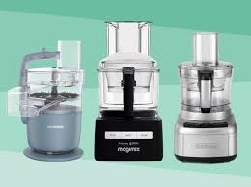

- Chopping, blending, and mixing ingredients quickly and efficiently.
- Preparing dough for pastries or snacks.

DEEP FRYERS

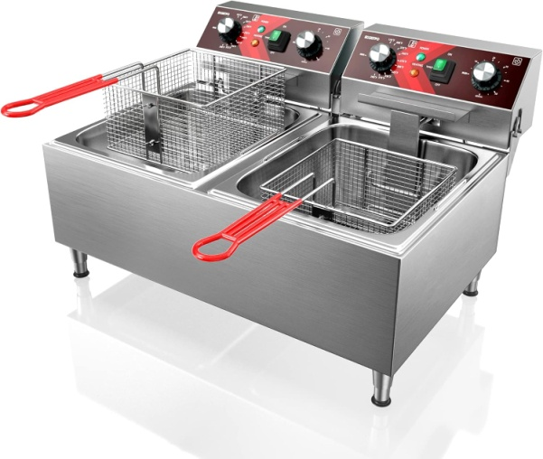

- Frying snacks like spring rolls, puff-puffs, and samosas to achieve a crispy texture.
- Controlling temperature for consistent cooking results.
BAKING OVENS
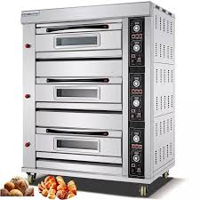

- Baking items like pastries, meat pies, and other baked small chops.
- Ensuring even cooking and browning of baked goods.

GRILLERS AND SMOKERS
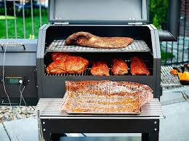

- Grilling items such as kebabs or grilled chicken for savory snacks.
- Adding a smoky flavor to products.
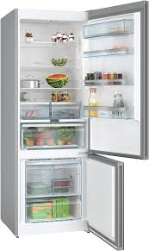
REFRIGERATORS AND FREEZERS

- Storing perishable ingredients to maintain freshness.
- Keeping finished products at safe temperatures before serving.
CUTTING BOARDS AND KNIVES



- Preparing and portioning ingredients safely and efficiently.
- Ensuring precise cutting for uniformity in product size.
MIXERS
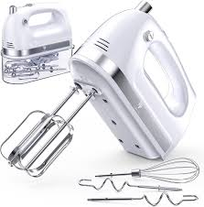

- Mixing batter for pastries or snacks to achieve the right consistency.
- Incorporating air into mixtures for light textures.

SERVING UTENSILS
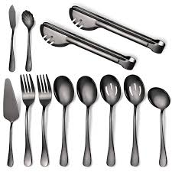

- Serving snacks in an appealing manner to customers.
- Ensuring hygiene during food handling.

ORGANIZATION STRUCTURE/ORGANOGRAM
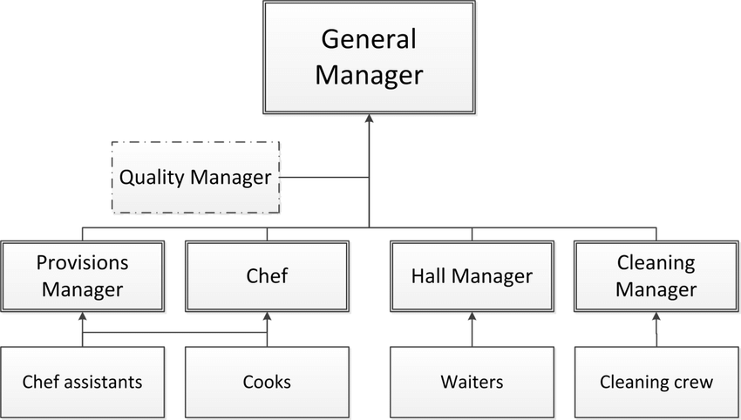
CHAPTER THREE
REPORTING ON WORK CARRIED OUT
3.1 Reporting on Daily Work Carried Out
WEEK 1: I was introduced to all members in the organization and I was given rules and regulation of the organization. Also, I learnt how to analyzed customer preference and customer behavior and their role of e-commerce in modern retail.
WEEK 2: I practicalized on how to stirred and prepared sponge cake to be used for a year old baby. I also learnt about restocked packaging materials and other materials such as glovers, frying pan, packaging box and so on
WEEK 3: I learnt about customer service skills related to product selection. I also conduct price check for customers. I learnt on how to deliver spring rol, samosa, mosa, chicken pie, doughnut to customer. I learnt on how to write bills of a customer demand
WEEK 4: I learnt on how to build rapport with customers and ensuring satisfaction. Also, I learnt on how to interact with customers to create a great experience from helping them check-in and creating personality on their interest.
WEEK 5: I practicalized on how to handle equipment for preparation of snacks
WEEK 6: I learnt on how to prepare the final report and how to review all experience
WEEK 7: I learnt about ordering supplies and weekly discussion
WEEK 8: I learnt about packaging doughnut and how to prepare chicken pie
CHAPTER FOUR
CHALLENGES AND GAIN ENCOUNTER IN PLACE OF ATTACHMENT

GAINS
Practical Experience
Hands-On Skills: I gain practical skills and knowledge about packaging product and assembly processes of organization activities
Real-World Application: I apply theoretical knowledge from their studies in a real-world setting, and enhancing their understanding.
Industry Exposure
Understanding the Market: I learn about market trends, consumer preferences, and competition in industry
Networking Opportunities: Working alongside professionals allows me to build valuable industry connections.
Technical Knowledge
Learning Technology: Exposure to modern technologies used in organization
Quality Control Practices: Understanding quality assurance processes and standards in manufacturing.
Problem-Solving Skills
Real-World Challenges: I encounter and solve practical problems, enhancing their critical thinking and adaptability.
Project Management: Involvement in projects fosters skills in planning, executing, and managing tasks.

CHALLENGES
Adjustment to Work Environment
Workplace Dynamics: Navigating different personalities and team dynamics as been a difficulty.
Learning Curve: I faced a steep learning curve when dealing with complex machinery and processes.
Understanding Technical Jargon: Familiarity with industry-specific terminology.

Time Management
Balancing Responsibilities: I manage their time effectively between work responsibilities and personal commitments.
Meeting Deadlines: The pressure to meet production deadlines can be stressful.
Limited Scope of Work
Repetitive Tasks: I assigned to repetitive tasks, which that has been less engaging.
Pressure to Perform
Expectations: I felt pressure to perform at a high level, which can lead to anxiety.
Feedback and Criticism: Receiving constructive criticism can be challenging, especially for those not accustomed to it.
Safety Concerns
Working with Machinery: I experience inherent risks associated with working in a industrial environment, necessitating careful attention to safety protocols.
CHAPTER FIVE
SUMMARY, CONCLUSION AND RECOMMENDATIONS
5.1 SUMMARY
Small chops activities involve the preparation, presentation, and serving of bite-sized snacks that are popular at social gatherings, events, and parties. These activities typically include a variety of delicious offerings such as spring rolls, puff-puffs, meat pies, and kebabs, which are designed to be easily consumed without utensils.
The process begins with selecting high-quality ingredients and preparing them through techniques like frying, baking, or grilling. Careful attention is given to flavor, texture, and presentation to ensure that the snacks are visually appealing and delicious.
Small chops activities also emphasize creativity, allowing for customization to cater to diverse dietary preferences and themes. These snacks play a significant role in enhancing the social experience, encouraging interaction among guests while providing a delightful culinary experience. Overall, small chops activities combine culinary skill with social engagement, making them a cherished aspect of celebrations and gatherings.
5.2 CONCLUSION
Small chops have become an integral part of culinary culture, especially at social events and gatherings. Their appeal lies in their variety, convenience, and ability to enhance social interactions among guests. The preparation of small chops not only showcases culinary skills but also allows for creativity and personalization to meet diverse tastes and dietary needs. As a result, small chops contribute to memorable experiences at celebrations, making them a popular choice for hosts and caterers alike.
5.3 RECOMMENDATIONS
- Siwes supervisors should make sure they visit the students in their place of attachment for proper monitoring, improvement and progress for the benefit of the societies as a whole.
- Employees should seek ongoing training and education to stay updated on industry trends and technological advancements.
- Always prioritize fresh, high-quality ingredients to ensure the best flavor and presentation.
- Implement eco-friendly practices, such as reducing water and energy usage, using biodegradable products, and promoting recycling programs to appeal to environmentally-conscious travelers.
- Expand the menu to include a range of options, including vegetarian, vegan, and gluten-free small chops, to cater to all guests.
- Experiment with new flavors and techniques to keep the menu exciting and appealing to repeat customers.
- Invest time in the presentation of small chops, using attractive platters and garnishes to enhance visual appeal.

