

KWARA STATE POLYTECHNIC
TECHNICAL REPORT
ON
STUDENT INDUSTRIAL WORK EXPERIENCE SCHEME
HELD AT:
NIGERIAN TELEVISION AUTORITY (N.T.A)
P.M.B 1478, FATE ROAD, ILORIN, KWARA STATE.

PREPARED BY:
SOLIU NIMOTA OPEYEMI
MATRICULATION NUMBER: 17/04/2003
SUBMITTED TO
THE DEPARTMENT OF MASS COMMUNICATION
SCHOOL OF

AUGUST - DECEMBER, 2024.

DEDICATION
This report is dedicated to Almighty God for his protection and mercy on me from the conception to completion of my SIWES and to my beloved and lovely parents, Mr. and Mrs. NJ their moral and financial support during my SIWES period.

ACKNOWLEDGEMENT
I thank God Almighty for His mercy ad grace that kept me all through my SIWES period.
I am greatly indebted to my parents, Mr. and Mrs Soliu for their financial and moral support during the course of the programme. May God strengthen u to reap the fruit of your labour on me (Amen).
Also thank my industrial training supervisor, Mrs. Bashirat Ayantola Bello for his motherly care and support during the training was a worthwhile and fulfilling one. May God continue to reign in your life sir. (Amen)
I appreciate my all my department lecturers for the knowledge they have impacted in me. Thanks and God bless you all (Amen)
I also want to thank everyone that contributed to my success; my colleagues, co-workers and all my relatives.
I am grateful to you all. May Almighty and merciful God bless you all. (Amen).

TABLES OF CONTENTS
Title page………………………………………………………………………………………….i
Dedication…………………………………………………………………………………………ii
Acknowledgements………………………………………………………………………………..iii
Table of contents…………………………………………………………………………………..iv
CHAPTER ONE:
1.1 BACKGROUND …………………………………………………………………………….. 1
1.3. Objectives of Siwes…………………………………………………………………………..2
CHAPTER TWO:
2.1. Location and brief history of establishment ……..…………………………………………3
2.2 Organogram of the Organisation…………………….……………………………………… 4
2.3 Various Department and their function …………………………………………………….. 4
CHAPTER THREE
3.1. Work done and experience gained during the training…………………………………..…5-8
CHAPTER FOUR
4.1. Equipment used in a Television Studio and their Functions…………………………..9-10
CHAPTER FIVE
5.1 Summary of attachment activities……………………………………………………….. 11
5.2 Problems encountered during the program …………………………………………….. 11
5.3 Suggestions for the improvement of the scheme ………………………………………. 11

CHAPTER ONE
- INTRODUCTION
1.1 BACKGROUND
The student industrial work experience scheme SIWES is a skills development training programme designed to expose and prepare students of Universities, Polytechnics/Colleges of technology/Colleges of Agriculture and colleges of education for the industrial work situation the federal government in its Gazette of April, 1978 as follows:
- To provide an avenue for student in institution of high learning to acquire industrial skill and experiences in their course of study.
- To provide students with an opportunity to apply their knowledge in real work and actual practice.
- To make the transition from school to the world of work easier and to enhance students contacts for later job placement.
The Student Industrial Work Experience Scheme (SIWES) is a planned and supervised training intervention best on a stated and specific learning and career objectives geared towards developing the occupational competencies of the participants. It is a programme required to be undertaken by all students of tertiary institutions in Nigeria pursuing courses in specialized engineering, technical, business, applied sciences and applied sciences and applied arts (ITF 2004). Therefore, SIWES is generic cutting across programmes in the Universities, Polytechnics and Colleges of education. SIWES was established by Industrial Training Fund (ITF) in the year 1973 to solve the problem of lack of adequate practical skills preparatory for employment in industries by Nigeria tertiary institutions graduates.
Partaking in SIWES has become a crucial pre-condition for the award of diploma and degree certificates in specific disciplines in most institution of higher learning in Nigeria in line with government education policies.
1.2. OBJECTIVES OF SIWES
- Provide avenues for students to acquire industrial skills for experience during their course of study.
- Expose student to work methods and techniques in handling equipment and machineries that may not be available in the university.
- Prepare students for industrial work situation they are likely to meet after graduation.
- Provide students with opportunities to apply their educational knowledge in real work situation thereby, bringing the gap between theories to practice.
- Strengthen employer’s involvement in the entire educational process prepare students for employment in industry and commerce.

CHAPTER TWO
2.0 LOCATION AND BRIEF HISTORY OF ESTABLISHMENT

2.1 Brief History of NTA, Fate, Ilorin
The Nigerian Television Authority (NTA) is the largest television network in Africa, established in 1977 by the Federal Government of Nigeria to provide quality television broadcasting across the nation. NTA aims to educate, entertain, and inform its audience through diverse programming that promotes national unity, cultural heritage, and development.
NTA Ilorin, located in the Fate area of Ilorin, Kwara State, is one of the numerous stations under the NTA network. The station was established to serve as a regional broadcasting hub, catering to the media needs of Kwara State and its surrounding communities.
The Fate area, where NTA Ilorin is situated, is a prominent location in Ilorin known for its accessibility and vibrant environment. The station was strategically established there to foster communication, enhance public engagement, and provide educational and entertainment content to the local audience.
2.1OBJECTIVE OF THE ORGANIZATION
- To educate the public.
- To inform the audience.
- To entertain viewers.
- To promote national unity.
- To preserve and promote Nigerian culture.

2.2. THE ORGANIZATIONAL CHART OF NTA

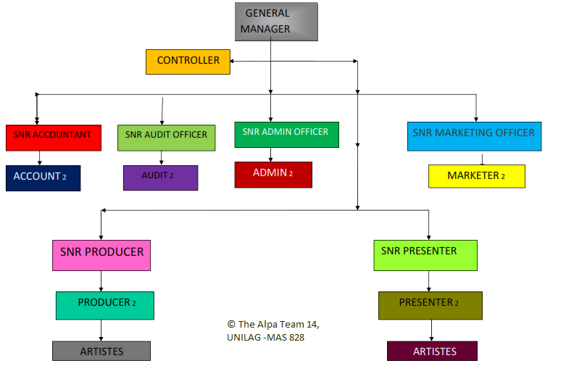

2.3 VARIOUS DEPARTMENTS AND THEIR FUNCTION
- Program Department: Produces and schedules content for broadcasting.
- News Department: Gathers, processes, and broadcasts news reports.
- Engineering Department: Maintains and operates broadcasting equipment.
- Marketing Department: Secures advertisements and sponsorships for programs.
- Administration Department: Manages the organization’s human and material resources.
- Finance Department: Oversees budgeting, accounting, and financial operations.
- Production Department: Handles the technical aspects of recording and editing programs.

CHAPTER THREE
3.1. WORK CARRIED OUT AND EXPERIENCE GAINED DURING SIWES AT NTA ILORIN (PROGRAM DEPARTMENT)
I resumed to NIGERIAN TELEVISION AUTHORITY on 5th August 2024 for my four month SIWES. I was posted to program department in N.T.A, Ilorin.
During my Student Industrial Work Experience Scheme (SIWES) at the Nigerian Television Authority (NTA) Ilorin, I was assigned to the Program Department. My primary responsibilities included learning and assisting in the production, management, and execution of television programs under the supervision of experienced professionals, including the producer. The activities I engaged in and the experiences gained are summarized below:

Work Carried Out
- Assistance in Program Scheduling and Planning
  - Participated in planning and organizing the station's program schedule to ensure seamless broadcasting.
  - Assisted in aligning program content with the station’s objectives and audience preferences.
- Involvement in Pre-Production Activities
  - Supported scriptwriting, program research, and logistics preparation.
  - Assisted in preparing scripts, camera setups, props, and reviewing content for quality assurance.
- Production Activities
  - Gained practical experience in the production process of television programs.
  - Operated and monitored cameras, microphones, and lighting equipment during live and recorded programs.
  - Assisted the production crew during live broadcasts, ensuring the smooth running of all technical aspects.
  - Worked on various productions, including talk shows, documentaries, news segments, and entertainment programs.
  - Supported the producer in coordinating the production crew, ensuring all elements of the show aligned with the creative vision.
- Role of the Producer and Responsibilities
  - Observed the producer’s critical role in overseeing the entire production process.
  - Learned how the producer:
    - Managed budgets, schedules, and resources for programs.
    - Coordinated with directors, presenters, and technical teams to ensure smooth program execution.
    - Ensured the content met broadcasting standards and resonated with the target audience.
    - Made creative decisions to enhance the quality and appeal of programs.
    - Supervised rehearsals, live shows, and recordings to maintain professional standards.
- Post-Production Activities
  - Edited recorded footage using video editing software, adding transitions, soundtracks, and visual effects.
  - Assisted in creating promotional clips and advertisements for station programs.
  - Ensured that final program outputs met broadcasting standards and guidelines.
- Interview Processes
  - Participated in organizing and conducting interviews with program guests, experts, and public figures.
  - Assisted in preparing questions and handling technical equipment during interviews.
  - Observed and practiced the art of engaging guests effectively to obtain insightful content for programs.
- Audience Engagement and Feedback Management
  - Observed and contributed to audience feedback sessions to evaluate the effectiveness of programs.

Experience Gained
- Technical Knowledge
  - Acquired practical skills in operating television equipment, including cameras, lighting systems, and audio equipment.
  - Learned the basics of directing and coordinating production crew activities.
  - Gained familiarity with video editing tools and techniques, including the use of transitions and effects.
- Production and Creative Skills
  - Developed an understanding of the complete production cycle, from pre-production planning to post-production editing.
  - Learned scriptwriting basics and how to create compelling program content.
  - Improved my ability to produce high-quality content, manage on-set tasks, and support the creative vision of a program.
- Producer's Perspective
  - Gained insight into the producer's role in managing all aspects of a production.
  - Observed the importance of multitasking, decision-making, and leadership in creating successful programs.
- Interviewing Skills
  - Learned how to prepare for and conduct interviews in a professional setting.
  - Improved confidence and adaptability in engaging with interviewees across diverse topics.
- Communication and Teamwork
  - Strengthened interpersonal skills by working closely with a diverse team of professionals.
  - Learned the importance of effective communication in a fast-paced production environment.
- Time Management
  - Gained insight into how to manage tight schedules and deadlines typical in the broadcasting industry.
- Professional Etiquette
  - Developed an appreciation for the discipline, punctuality, and professionalism required in a media organization.

CHAPTER FOUR

4.1 EQUIPMENT USED IN A TELEVISION STUDIO AND THEIR FUNCTIONS
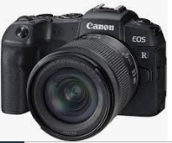
- Camera
Function: Captures video footage for broadcasting or recording. Studio cameras are designed for high-quality image capture and often include features like zoom lenses, autofocus, and advanced stabilization. They can be operated manually or remotely.
- Tripod
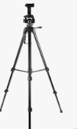
Function: Provides stable support for cameras, ensuring smooth and steady shots. Tripods are adjustable for height and angle, and they allow for panning and tilting to follow action during production.


- Microphone
Function: Captures sound for programs. Different types of microphones are used, such as:
    - Lapel microphones: Small and clip onto clothing for hands-free operation.
    - Boom microphones: Mounted on poles for capturing sound from a distance without being visible.
    - Handheld microphones: Commonly used during interviews or live reporting.


- Headphones
Function: Allows producers, directors, and crew members to monitor audio during recording or broadcasting. They ensure sound clarity and help detect any audio issues in real time.

- Studio Mixer (Audio Mixer)
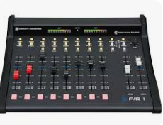
Function: Combines and balances multiple audio inputs, such as microphones, sound effects, and music, to produce a unified sound output. The mixer allows the adjustment of volume, equalization, and effects for each input channel.
- Visual Mixer (Video Switcher)
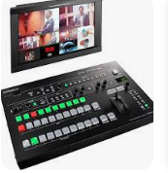
Function: Allows the operator to switch between multiple video sources (e.g., cameras, pre-recorded videos) during live or recorded productions. It’s essential for creating smooth transitions, adding effects, and managing overlays like captions.

CHAPTER FIVE
5.0 SUMMARY, CONCLUSION AND RECOMMENDATION

5.1 SUMMARY OF ATTACHMENT ACTIVITIES
During my SIWES attachment at NTA Ilorin, I was actively engaged in the following activities:
- Program Scheduling and Planning
- Pre-Production Tasks
- Production Activities
- Post-Production
- Interviews and Audience Engagement
- Technical Support
5.2 PROBLEM ENCOUNTERED DURING THE PROGRAM
During my training period I faced so many challenges.
• Transportation Challenges
• Time Management
• Technical Learning Curve
• High Demand for Equipment
• Adjusting to the Work Environment
5.3 SUGGESTIONS FOR THE IMPROVEMENT OF THE SCHEME
- Introduce structured training programs for interns.
- Provide dedicated equipment for interns' practical sessions.
- Improve coordination between departments for better workflow.

