


TECHNICAL REPORT
ON

STUDENT INDUSTRIAL WORK EXPERIENCE
SCHEME (SIWES)

DONE AT

AGS COMMUNICATIONS

BY:

ABDULFATAI FAWAS OLAMILEKAN

ND/23/PSM/FT/0110

SUMMITTED TO:
DEPARTMENT OF PROCUREMENT AND SUPPLY CHAIN MANAGEMENT INSTITUTE OF FINANCE AND MANAGEMENT STUDIES KWARA STATE POLYTECHNIC, ILORIN

IN PARTIAL FULFILLMENT OF THE AWARD OF THE REQUIREMENT OF THE AWARD OF NATIONAL DIPLOMA IN PROCUREMENT AND SUPPLY CHAIN MANAGEMENT

AUGUST-DECEMBER 2024
PREFACE
This is a report of four months industrial training which was done as part of the requirements needed for the award of National Diploma Certificate which was embarked upon by the technically student after their first year of stay in school.
It is also done to enable the student's to be exposed to the practical aspect of their course of study and write down what he/she has gained during the training. The program is aimed at correcting the incompetence in the school leaving the scientific and technical in the country.
DEDICATION
This report is dedicated to Almighty Allah, the most Beneficent, Merciful, the Cherisher of the universe, the Uncreated creator of all creatures and the most Knowledgeable who seeks knowledge just from himself for giving me the opportunity, privilege and understanding to participate in this Student Industrial Work Experience Scheme (SIWES)

ACKNOWLEDGEMENT
My gratitude first goes to Almighty God for is protection throughout my SIWES programme.
My special thanks go to my parent Mr. and Mrs. ABDULFATAI who has been very supportive to me with their unconditional love throughout my programme. May God grant them all their heart desire and let them reap the fruit of their labour in Jesus Name (Amen).
My appreciation goes to my siblings, friends and family for the moral support and contributions towards the success of this programme.
My profound gratitude goes to my industrial based supervisor the person of Miss Shuaib Babaata Aisha for his time that he devoted for me throughout my SIWES programme to make sure that I gain and have experience that benefitted me during the programme.
TABLE OF CONTENTS
Title i
Preface ii
Dedication iii
Acknowledgment iv
Table of Contents v

CHAPTER ONE
INTRODUCTION
1.2 BRIEF HISTORY OF SIWES
1.3 AIMS AND OBJECTIVES OF SIWES

CHAPTER TWO
2.1. LOCATION AND BRIEF HISTORY OF THE ESTABLISHMENT
2.2 ORGANIZATION CHART
2.3 SECTION OF THE ORGANIZATION AND SPECIFIC FUNCTION

CHAPTER THREE
3.1 STORE SYSTEM
3.2 FUNCTIONS OF “STORE SYSTEM”
3.3 CUSTOMER MANAGEMENT
3.4 SUPPLY CHAIN MANAGEMENT

CHAPTER FOUR
4.1 INVENTORY FORECASTING
4.2 SOME PRODUCTS OF AGS
4.1.1 PHONE
4.1.2 POWER BANK
4.1.3 PHONE BATTERY
4.1.4 MEMORY CARD
4.1.5 PHONE CHARGER
CHATPER FIVE
5.0 RECOMMENDATION AND CONCLUSION
5.1 CONCLUSION
5.2 RECOMMENDATION

CHAPTER ONE
INTRODUCTION
The student industrial work experience scheme (SIWES) is the acceptable sills training programme, which form part of the approved minimum academic standard in various degree programme from all Nigerian Tertiary Institution.
The organization responsible for student industrial work experience scheme (SIWES) is Industrial Training Fund (ITF) and was established on October 1971. The student industrial work experience scheme (SIWES) is the accepted skills training programe which form part of the approved minimum academic standards in the various programme.
The Student Industrial Work Experience scheme (SIWES) is a skilled acquisition programme designed to expose the “World of work of student to practice and utilize their knowledge.
The practical knowledge and skilled acquired Nigeria Tertiary Institution are no longer sufficient to provide adequate required skill in construction technology it is regarded as a part of the course requirement (Curriculum) for engineering and some other professional course offered in higher institution of leaning, it was established in 1973 by the Industrial Training Fund in collaboration with the National Board for Technical Education which has it headquarter at Kaduna to solve the problem or adequate practice skill required for employment in industries by Nigeria graduates of Tertiary Institution.
The main operations in the SIWES programme are the ITF and the Government agencies are NBTE. It is founded by the Federal Government of Nigeria and beneficiaries of the programme include Undergraduate Student of Agriculture Engineering, Environment Science Education, Medical science and pure and applied science.
1.2 BRIEF HISTORY OF SIWES
In recognition of the shortcomings and weakness in the formation of graduates, particularly with respect to acquisition of relevant production skills (RPSs), the Industrial Training Fund (which was itself established in 1971 by decree 47) initiated the Students’ Industrial Work-experience Scheme (SIWES) in 1973. The scheme was designed to expose students to the industrial environment and enable them develop occupational competencies so that they can readily contribute their quota to national economic and technological development after graduation. Consequently, SIWES is a planned and structured program based on stated and specific career objectives which are geared toward developing the occupational competencies of participants. Participation in SIWES has become a necessary condition for the award of degrees and diplomas

1.3 AIMS AND OBJECTIVES OF SIWES
- To expose the student to have practical knowledge of theories based on their field of study.
- To make student self – employed after schooling.
- To satisfy accreditation.
- To provide the students access to the equipment that are not available in the higher institution
- To brighten students chance of future employment.
- To make the students to be productive and acquire technical skills in developing the nation.
- To develop the student on their working problem solving ability.

CHAPTER TWO
2.1. LOCATION AND BRIEF HISTORY OF THE ESTABLISHMENT
AGS stands for Automatic Gain Control its a technology used in electronics, especially in audio and radio systems.
Essentially, it automatically adjusts the signal’s strength to maintain a consistent volume level/ it’s like having a built-in volume knob that constantly adjusts itself to compensate for changes in the signal strength.
AGS communications is established in established in 2012 by the managing director Mr. Sodiq Ranti Adenle.
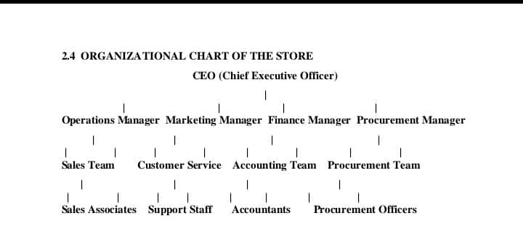
2.2 ORGANIZATION CHART
2.3 SECTION OF THE ORGANIZATION AND SPECIFIC FUNCTION
The Organization has probably a little amount of workers, whom are divide into section unit. The sectional unit can also be sub-divided into different section there are
- Operation Manager: An operations manager plans, directs, and coordinates multiple departments, operations, or locations of an organization to ensure efficiency and maximize profit, sometimes also known as operations general manager, store manager, or center manager.
Core Responsibilities:
  - Overseeing operations: Operations managers are responsible for the day-to-day activities of a business, including production, logistics, supply chain, and service delivery.
  - Improving efficiency: They focus on streamlining processes, reducing waste, and improving overall performance.
  - Managing resources: This includes personnel, equipment, and materials, ensuring they are utilized effectively.
  - Problem-solving: Operations managers identify and resolve issues that arise in the operational processes.
  - Strategic planning: They contribute to the development and implementation of operational strategies that align with the overall business goals.
  - Supply Chain Management: Operations managers often oversee the supply chain process, including procurement, inventory management, and logistics
Marketing Manager: A marketing manager leads the marketing efforts for a business, service, or product, developing and implementing strategies to drive customer interest and achieve marketing goals.
Core Responsibility
- Strategic Planning:
They develop and implement marketing strategies aligned with the company's overall goals, including identifying target audiences, setting marketing objectives, and determining how to reach those audiences.
- Campaign Management:
Marketing managers design, manage, and evaluate marketing campaigns to raise awareness and generate demand for products or services, often using various media channels.
- Team Leadership:
They lead and manage a marketing team, assigning tasks, providing guidance, and ensuring efficient execution of marketing plans.
- Market Research and Analysis:
They conduct market research to understand customer needs, identify trends, and assess the competitive landscape, helping to inform strategic decisions.
- Collaboration: Marketing managers often collaborate with other departments, such as sales, product development, and advertising, to ensure a cohesive approach to marketing efforts.
- Performance Tracking and Reporting:
They track the performance of marketing campaigns and initiatives, analyze data, and provide reports to stakeholders, demonstrating the effectiveness of their strategies.
Finance Manager: A finance manager is responsible for overseeing and managing the financial health of an organization, including tasks like budgeting, financial reporting, investment decisions, and ensuring the organization has the resources it needs to operate.
Responsibilities:
  - Financial Planning and Analysis: Developing and implementing financial strategies, creating budgets, and forecasting financial performance.
  - Financial Reporting: Preparing financial statements and reports for internal and external stakeholders.
  - Investment Decisions: Analyzing investment opportunities and making recommendations to maximize returns.
  - Cash Flow Management: Monitoring and managing cash flow to ensure the organization has sufficient funds.
  - Cost Control: Identifying and implementing cost-saving measures.
  - Compliance: Ensuring compliance with financial regulations and reporting requirements.
Procurement Manager: A procurement manager, also known as a purchasing manager, is responsible for sourcing, purchasing, and managing the supply of goods and services for an organization, ensuring quality, cost-effectiveness, and timely delivery.
Here's a more detailed breakdown of their role:
Key Responsibilities:
- Sourcing and Evaluating Suppliers:
Identifying potential suppliers, evaluating their capabilities, and negotiating contracts.
- Managing Supplier Relationships:
Building and maintaining strong relationships with suppliers to ensure consistent quality and timely delivery.
- Optimizing Procurement Processes:
Identifying and implementing cost-saving opportunities, streamlining workflows, and improving efficiency.
- Developing and Implementing Procurement Strategies:
Creating and implementing strategies to ensure the organization acquires the goods and services it needs in a cost-effective and efficient manner.
- Managing the Procure-to-Pay Process:
Overseeing the entire process from requisition to payment, ensuring smooth and efficient operations.

Sales Team: A sales team is a group of professionals within a company who are responsible for generating revenue by selling products or services, identifying potential customers, building relationships, and closing deals.
- Purpose:
The primary goal of a sales team is to drive revenue and achieve sales targets for the company.
- Key Functions:
  - Prospecting: Identifying and qualifying potential customers.
  - Lead Generation: Creating a pipeline of potential customers.
  - Relationship Building: Establishing and maintaining strong relationships with customers.
  - Needs Assessment: Understanding the needs and requirements of potential customers.
  - Sales Presentations: Presenting the company's products or services to potential customers.
  - Negotiation and Closing: Negotiating deals and securing sales.
  - Customer Retention: Retaining existing customers and building long-term relationships.
- Team Structure:
Sales teams often include various roles, such as:
  - Sales Representatives: Directly involved in selling products or services.
  - Sales Managers: Oversee and manage sales teams, setting goals and providing support.
  - Business Development Representatives: Focus on identifying and developing new business opportunities.
  - Sales Operations Managers: Focus on streamlining the sales process and improving efficiency.
  - Customer Service/Success Representatives: Focus on retaining customers and ensuring their satisfaction.

CHAPTER THREE
3.1 STORE SYSTEM
A "store system" or "store management system" is a software solution that helps businesses manage their retail operations, including inventory, point of sale (POS), and customer data, ultimately streamlining processes and improving efficiency.
A store system often refers to as retail management system, is a software application designed to help business manage their sales.
Here's a more detailed breakdown:
What it is:
A store system is a software platform designed to manage various aspects of a retail business, from managing inventory and processing sales to tracking customer data and analyzing sales trends.
3.2 FUNCTIONS OF “STORE SYSTEM”
  - Inventory Management: Tracks stock levels, orders, and deliveries, ensuring efficient stock control and minimizing waste.
  - Point of Sale (POS): Facilitates transactions, handles payments, and generates receipts.
  - Customer Relationship Management (CRM): Stores customer data, allowing for personalized interactions and targeted marketing efforts.
  - Order Management: Processes orders, tracks shipments, and manages returns.
  - Reporting and Analytics: Provides insights into sales performance, inventory trends, and customer behavior.
- Types of Store Systems:
  - Retail Management Systems (RMS): Comprehensive platforms that combine various tools for managing retail operations.
  - E-commerce Platforms: Enable businesses to create and manage online stores.
  - Specialized Software: Tools focused on specific areas, such as workforce management or inventory optimization.
- Benefits:
  - Increased Efficiency: Streamlines operations and reduces manual tasks.
  - Improved Inventory Control: Minimizes stockouts and reduces excess inventory.
  - Better Customer Service: Enables personalized interactions and efficient order processing.
  - Data-Driven Decision Making: Provides insights into sales trends and customer behavior
3.3 CUSTOMER MANAGEMENT
Customer management is a complex of processes, practices, systems, and applications a company uses to manage the relationships with its current customers and prospects.
A good customer management system is an essential competitive advantage for companies that want to prosper in the market. Below is what you should know about customer management and how to succeed in it.
Although some may use the terms interchangeably, customer management is not only about measurements, numbers, and sales predictions. To build an authentic relationship, not an occasional dialogue, the company has to:
- Create a brand identity and develop key messages: Yes, positioning is a duty of the marketing department, but it’s important to transform a brand book into a reference point for external communication for every single employee. Otherwise, there will be a strong disconnect between what the company claims and what it does when managing customers.
- Set an external communication policy: Before building any relationships, it’s vital to answer these questions: How should your sales reps or PR specialists speak to third parties? Who are authorized spokespersons to speak on behalf of your brand? What pieces of information are to be disclosed?
- Write briefs and create templates for the sales team: Although all departments may somehow interact with clients, customer management is mainly a sales reps’ task. Remember, your company’s reputation is not set in strategies. It’s shaped by day-to-day communication with your prospects.
- Invest in personnel: Since relationships exist between people, a human factor here is key. If truth be told, few people can and are willing to build social connections.
3.4 SUPPLY CHAIN MANAGEMENT
Supply Chain Management (SCM) involves coordinating and overseeing activities from sourcing raw materials to delivering finished goods to customers, aiming to optimize efficiency and reduce costs.
Here's a more detailed explanation:
- What it is:
SCM is the management of the flow of goods, data, and finances related to a product or service, from the procurement of raw materials to the delivery of the product at its final destination.
- Key Activities:
  - Sourcing and Procurement: Identifying and securing raw materials and components.
  - Production: Transforming raw materials into finished goods.
  - Logistics: Managing the movement and storage of goods.
  - Distribution: Delivering finished goods to customers.
- Importance:
  - Efficiency: Streamlining operations and reducing costs.
  - Inventory Management: Optimizing inventory levels to avoid shortages or overstocking.
  - Customer Satisfaction: Ensuring timely and reliable delivery.
  - Adaptability: Responding to changing market conditions and customer demands.
- Key Players:
Suppliers, manufacturers, wholesalers, transportation and logistics providers, and retailers.
- Examples of Supply Chain Models:
  - Continuous Flow Model: Suitable for companies producing the same products with little variation.
  - Fast Chain Model: Best for companies selling products based on the latest trends, requiring rapid movement from idea to production to consumer.
  - Flexible Model: Ideal for companies with seasonal or fluctuating demand, allowing for quick ramp-up and shutdown of production.

CHAPTER FOUR
4.1 INVENTORY FORECASTING
Inventory forecasting is the process of predicting future inventory needs by analyzing past sales data, market trends, and other relevant factors to optimize stock levels, minimize costs, and improve customer satisfaction.
Here's a more detailed explanation:
What it is:
- Predicting Demand:
Inventory forecasting, also known as demand planning, aims to estimate the amount of inventory a business will need to meet customer demand over a specific period.
- Optimizing Stock Levels:
By accurately predicting demand, businesses can avoid overstocking (which leads to wasted inventory and storage costs) and understocking (which can lead to lost sales and dissatisfied customers).
- Data-Driven Decisions:
Inventory forecasting relies on data analysis to identify patterns and trends in sales and demand, allowing businesses to make informed decisions about inventory management.
Why it's important:
- Cost Reduction:
Accurate forecasting helps minimize inventory carrying costs, storage costs, and the risk of obsolescence.
- Improved Customer Satisfaction:
Having the right products in stock at the right time ensures that customers' needs are met, leading to increased satisfaction and loyalty.
- Increased Efficiency:
By optimizing inventory levels, businesses can streamline their operations and improve overall supply chain efficiency.
- Better Profitability:
Accurate forecasting can lead to reduced waste, lower costs, and increased sales, ultimately improving profitability.
Factors to Consider:
- Historical Sales Data:
Analyze past sales patterns and trends to identify seasonal fluctuations, product popularity, and other factors that influence demand.
- Market Trends:
Stay informed about current market conditions, competitor activities, and emerging trends that could impact demand.
- Promotional Activities:
Factor in planned promotions, sales events, and marketing campaigns that could drive demand.

4.2 SOME PRODUCTS OF AGS
4.1.1 PHONE
A device that uses either a system of wires along which electrical signals are sent or a system of radio signals to make it possible for you to speak to someone in another place who has a similar device: Just then, his phone rang


4.1.2 POWER BANK
A power bank, also known as a portable charger, is a device that stores energy and allows you to recharge your electronic devices (like phones, tablets, etc.) on the go, without needing a wall outlet.



4.1.3 PHONE BATTERY
A phone battery is a rechargeable energy storage device, typically a lithium-ion battery, that powers a mobile phone, allowing it to operate for a period of time before needing to be recharged.
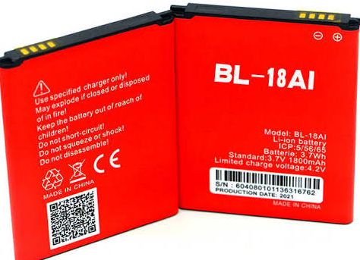
Phone batteries are essentially small, portable power sources that store electrical energy in the form of chemical reactions, which can then be released to power the phone.

4.1.4 MEMORY CARD
A memory card, also known as a flash memory card, is a portable, solid-state electronic data storage device that uses flash memory technology to store and transfer data like photos, videos, and documents.
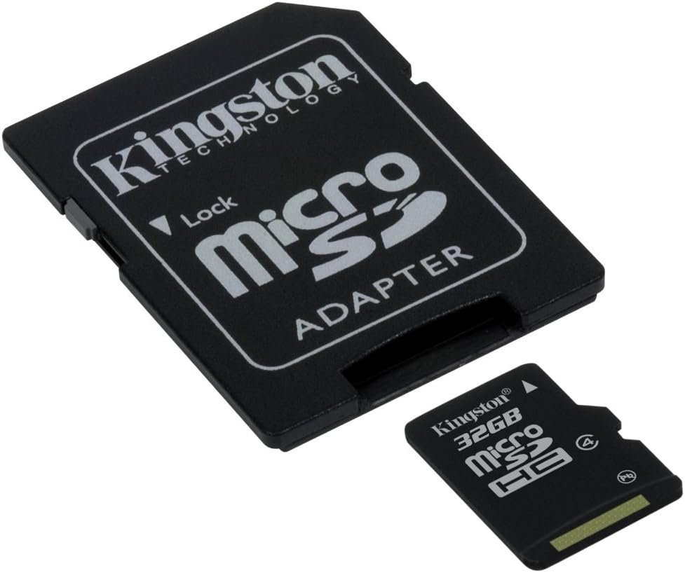

4.1.5 PHONE CHARGER
A charger is a device that you use to infuse energy into another object, typically a battery in devices like smartphones, laptops, tablets, and other electronic gadgets.



CHATPER FIVE
5.0 RECOMMENDATION AND CONCLUSION
5.1 CONCLUSION
The industrial attachment which lasted for three months has been able to help me to differentiate between theoretical work and practical. During this period I fully participated in poultry production, horticulture, cattle sheep and goat, feed mill, mechanization, fishery and piggery. Entrepreneurship in animal sciences were also carried out in poultry production this includes; transportation of old day chicks, installation of battery cages, house design
5.2 RECOMMENDATION
It is well known that the university system cannot provide all the technical knowledge and work experience needed by its students hence the opportunity provided through the SIWES. Nigeria students in higher institution should be encouraged to take the SIWES serious so as to enhance the opportunity of later job employment as well as self employment. Visitations should be made by supervisors from the institutions and representative from industrial training fund (ITF) in order to ensure students are getting the required and relevant training and exposure at their place of assignment.
I will also recommend prompt payment of Stipends by the establishments and payment of SIWES ALLOWANCE by the Industrial Training Fund (I. T. F.)during the period of attachment rather than after the program, so has to help the students solve minor needs such as feeding and transportation fare.

