

TECHNICAL REPORT ON
STUDENTS INDUSTRIAL WORKS EXPERIENCE SCHEMES (SIWES)

HELD AT

LAGOS ISLAND LOCAL GOVERNMENT COUNCIL
NO42, BROAD STREET AJELE LAGOS

PRESENTED BY:

KESHINRO RAHEEM KEHINDE
ND/23/PAD/PT/0095

SUBMITTED TO:

THE DEPARTMENT OF PUBLIC ADMINISTRATION , INSTITUTE OF FINANCE AND MANAGEMENT STUDY, KWARA STATE POLYTECHNIC, ILORIN.
IN PARTIAL FULFILMENT OF THE REQUIREMENT FOR THE
AWARD OF NATIONAL DIPLOMA (ND) PUBLIC ADMINISTRATION.

SEPTEMBER - NOVERMBER 2024

DEDICATION
I am delight to dedicate this report to Almighty God who gave me the grace and opportunity to complete this programme.

ACKNOWLEDGEMENT
I thank God Almighty for his mercy and grace that kept me all through my SIWES period.
I am greatly indebted to my parents, Mr. & Mrs. Keshinro for their morally, spiritually and financially, word of encouragement and prayer given to me, who make my SIWES programme successful and also my relatives and siblings.
I also want to thank my friend and everyone that contributed to the success of my SIWES program my Industrial supervisors, my colleagues and co-workers for the tremendous moral assistance throughout the period of my attachment.

REPORT OVERVIEW
The report comprises the background of SIWES, the description of the organization, its aims and objectives, the experiences gained as an industrial training student and the summary, conclusions and recommendations.
It has a total of 5 chapters with sub-chapters. It also has the preliminary pages, such as the title page, report overview and table of contents and recommendations on the improvement of scheme.

TABLE OF CONTENTS
1. CHAPTER ONE: INTRODUCTION
• 1.1 Background of SIWES
• 1.2 Objectives of SIWES
• 1.3 Importance of SIWES
2. CHAPTER TWO: DESCRIPTION OF ORGANIZATION
• 2.1 Overview of Lagos Island Local Government Council
• 2.2 Organizational Structure
• 2.3 Functions of the Local Government
3. CHAPTER THREE: TRAINING ACTIVITIES CARRIED OUT
• 3.1 Departments Worked In
• 3.2 Duties and Responsibilities Assigned
• 3.3 Skills Acquired

4. CHAPTER FOUR: CHALLENGES ENCOUNTERED AND SOLUTIONS
• 4.1 Challenges Faced
• 4.2 Solutions and How They Were Overcome
5. CHAPTER FIVE: CONCLUSION AND RECOMMENDATIONS
• 5.1 Summary of Experience
• 5.2 Recommendations for Improvement

CHAPTER ONE: INTRODUCTION
1.1 Background of SIWES
The Student Industrial Work Experience Scheme (SIWES) was established by the Federal Government of Nigeria through the Industrial Training Fund (ITF) in 1973 to expose students to practical aspects of their academic fields. The program bridges the gap between classroom knowledge and real-world work experience, allowing students to gain hands-on training relevant to their careers.
1.2 Objectives of SIWES
The objectives of SIWES include:
• Exposing students to the work environment related to their field of study.
• Enhancing students’ practical and technical skills.
• Helping students understand the functions and operations of organizations.
• Preparing students for future employment.

1.3 Importance of SIWES
SIWES plays a vital role in the educational system by:
• Providing students with real-world experience.
• Helping students develop professional work ethics.
• Improving students’ problem-solving and teamwork skills.
• Enhancing employability after graduation.

CHAPTER TWO: DESCRIPTION OF ORGANIZATION
2.1 Overview of Lagos Island Local Government Council
Lagos Island Local Government is one of the local government areas in Lagos State, Nigeria. It is located in the central part of Lagos and is one of the most commercially active areas in the state. The council is responsible for providing essential services, maintaining infrastructure, and implementing government policies within its jurisdiction.
2.2 Organizational Structure
The Lagos Island Local Government Council is structured as follows:
• Chairman: The head of the local government, responsible for policy implementation and governance.
• Vice Chairman: Assists the chairman in administrative functions.
• Secretary to the Local Government: Oversees council operations.
• Heads of Departments (HODs): Each department is managed by an HOD, including:
• Administration
• Finance and Accounts
• Works and Infrastructure
• Health and Environment
• Education and Social Welfare
• Agriculture and Rural Development
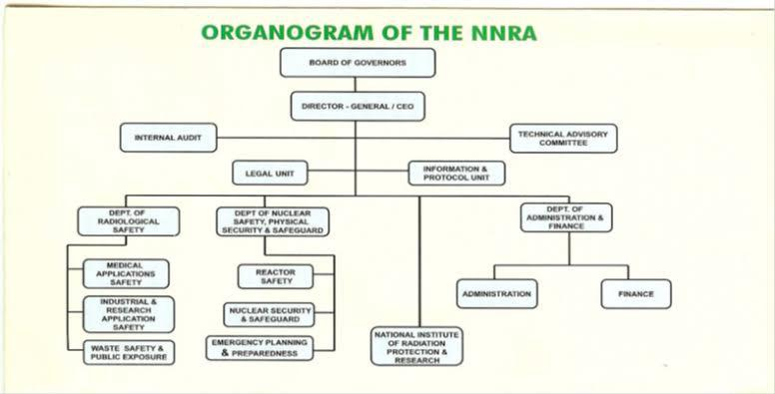
2.3 Functions of the Local Government
The Lagos Island Local Government performs several functions, including:
• Maintenance of roads, markets, and drainage systems.
• Collection of taxes and revenue.
• Issuance of birth and death certificates.
• Provision of primary healthcare services.
• Waste management and environmental sanitation.
• Regulation of business and trade activities.

\

CHAPTER THREE: TRAINING ACTIVITIES CARRIED OUT
3.1 Departments Worked In
During my SIWES, I was assigned to different departments, including:
• Administrative Department – Handling official correspondence and record-keeping.
• Finance and Accounts Department – Assisting in revenue collection and financial documentation.
• Works and Infrastructure Department – Observing road maintenance and infrastructure projects.
3.2 Duties and Responsibilities Assigned
Some of the tasks I performed during my training included:
• Assisting in the preparation of official documents and reports.
• Filing and organizing government records.
• Attending meetings and taking minutes.
• Assisting in tax collection and revenue documentation.
• Participating in community development projects.

3.3 Skills Acquired
During my SIWES training at Lagos Island Local Government, I developed the following skills:
• Office administration and documentation.
• Financial record-keeping and revenue management.
• Understanding of local government operations.
• Communication and teamwork skills.
• Problem-solving in a government setting.

CHAPTER FOUR: CHALLENGES ENCOUNTERED AND SOLUTIONS
4.1 Challenges Faced
Some of the challenges I encountered during my internship include:
• Limited access to office equipment and computers.
• Slow bureaucratic processes delaying project execution.
• Limited involvement in decision-making processes.
• Inadequate training sessions for interns.
4.2 Solutions and How They Were Overcome
• I adapted by using available office resources efficiently.
• I took the initiative to observe and learn from experienced staff.
• I actively participated in meetings to gain more knowledge.
• I sought guidance from my supervisors and senior staff.

CHAPTER FIVE: CONCLUSION AND RECOMMENDATION
5.1 Recommendations for Improvement
To improve the SIWES program at local government councils, I recommend the following:
• Provision of better resources: The government should provide adequate office equipment and materials for interns.
• Structured training programs: Local governments should organize workshops and training sessions for interns.
• Increased involvement: Interns should be given more practical responsibilities to enhance learning.
5.2 Conclution
My SIWES at Lagos Island Local Government Council provided me with a valuable understanding of government administration and public service delivery. I gained practical experience in office administration, financial management, and infrastructure development. The program helped me develop professional skills and improved my readiness for future employment

