

TECHNICAL REPORT ON
THE STUDENT INDUSTRIALWORKS EXPERIENCE SCHEME (SIWES)

HELD AT
(GERIN 95.5 F.M)
PRESENTED BY
ARANSIOLA ABIMBOLA AYOMIDE
ND/23/MAC/PT/0174

SUBMITTED TO:
DEPARTMENT OF MASS COMMUNICATION
INSTITUTE OF INFORMATION AND COMMUNICATION TECHNOLOGY [I.I.C.T.]
KWARA STATE POLYTECHNIC, ILORIN.

IN PARTIAL FULFILLMENT OF THE REQUIREMENT FOR AWARD OF NATIONAL DIPLOMA (ND) CERTIFICATE IN MASS COMMUNICATION

AUGUST To OCTOBER 2024

DEDICATION
This report is dedicated to God Almighty for His boundless grace, consistent love, immeasurable faithfulness, and for sparing my life throughout the duration of my SIWES program. It is also dedicated to my parents, Mr. and Mrs. ARANSIOLA , for their unwavering support and immeasurable assistance throughout the entire exercise, as well as to my beloved friends who always trigger me to be strong.

ACKNOWLEDGEMENT
I wish to register to my profound gratitude to god Almighty for the guidance and grace throughout my life.
I'm appreciative to (GERIN 95.5 F.M)complete crew for making my industrial training exciting, instructive, and beneficial.

PREFACE
The student industrial work Experience scheme (SIWES) helps in exposing students to the practical application of their course and to get used to equipment and machine that are utilize in the factory. The SIWES was established to promote student ability and skill in industrial Practice and pre-expose them to working experience in industrial settings.
The SIWES program covered a period of four month from August to October 2024 and it is a partial fulfillment of a two year academic program to obtain an OND certificate in Mass Communcation. The report explains the description of the work here.

TABLE OF CONTENT
TITLE PAGE i
DEDICATION ii
ACKNOWLEDGEMENT iii
PREFACE iv
TABLE OF CONTENT
CHAPTER ONE
  - INTRODUCTION 1
  - BACKGROUND 1
  - AIMS AND OBJECTIVE 1
  - IMPORTANCE OF SIWES 2
CHAPTER TWO
2.0 LOCATION AND BRIEF HISTORY OF THE ESTABLISHED 3
2.1 DEPARTMENT IN RADION STATION 5
CHAPTER THREE
3.1 PRODUCTION OF SCRIPT 6
3.11 PROGRAM PLAN 6
3.2 EQUIPEMENT’S USED AT KWARA STATE BROADCASTING COO-PERATIVE
(RADIO KWARA) 7
3.3 RADION MEDIA 9
3.4 PROGRAM FORMAT 8
CHAPTER FOUR
4.1 DIFFICULTIESE ENCOUNTERED DURING THE PROGRAM 9
4.2 SUMMARY ATTACHMENT ACTIVITIES 9
4.3.1 GENERAL APPRAISAL 9
4.4 SUGGESTION FORR IMPROVEMENT AND RECOMMENDATION OF THE
SCHEME WAYS OF IMPROVING THE PROGRAM 10
4.5 ADVICE FOR FUTURE PARTICIPATION 10
CHAPTER FIVE
5.0 CONCLUSION AND RECOMMENDATION 11
5.1 CONCLUSION 11
5.2 RECOMMENDATION 11

CHAPTER ONE

1.0 INTRODUCTION
What is SIWES? Siwes is an acronym for student industrial work scheme, which is organized by the federal government through the industrial training fund (I.T.F) it was established by decree 47 of 1971 and became active in 1973.
SIWES was made mandatory for all students and like in polytechnics, university, colleges of technology e.t.c during the long vacation of 2nd semester of 1st year. In order to improve the knowledge of practical in interest field and avoid re training of student after graduation. Any student who fail to undergo the programme is liable to fail the course itself because it is a of unit course.
1.1 BACKGROUND
The Student’s Industrial Work Experience Scheme (SIWES) was introduced in 1973 by the Industrial Training Fund (ITF), and the institution established federal government of Nigerian to carry training programmed for students in institution the country.
Student’s Industrial Work Experience Scheme (SIWES) is under the National Board for Technical Education (NBTE). It was established by ITF (Industrial Training Fund) to solve the problem of lack of adequate skills preparatory for employment in industries by Nigerian graduate of tertiary institution.
1.2 AIMS AND OBJECTIVES OF SIWES
- It is a means of improving the quantity of skilled manpower.
- It is setup as a practical supplement to the gap in skills acquisition
- It helps students to get exposed to needed experience in handling of machinery and equipment that are not available in educational institutions.
- It helps to gain practical experience.
- It also helps to strengthen employers involvement in the entire educational process to be able to employed students in their industry.
1.3 IMPORTANCE OF (SIWES)
- It is aimed at exposing student to machine and equipment of professional work method
- It is an opportunity to bridge the gap between theory and practical
- It makes the student to be more experience
- It prepares student for industrial work situation that they likely to meet after graduation
- It provide avenue for student to acquire skill.

CHAPTER 2
2.1 LOCATION AND BRIEF HISTORY OF ESTABLISHMENT
The (GERIN 95.5 F.M) Broadcasting Corporation is a prominent radio broadcasting station in Kwara State, Nigeria Founding and Establishment:
GERIN 95.5 F.M was established as part of the broader effort to promote mass communication and information dissemination in Kwara State. The station was founded with the aim of providing news, entertainment, education, and public information to the residents of Kwara State and surrounding areas.
Early Years:
GERIN 95.5 F.M likely began its operations in the early years following in 2020. Initially, the station might have started with limited resources and broadcasting capabilities, but it gradually expanded its reach and programming to become a prominent voice in the region.
Evolution and Growth:
Over the years, Radio Kwara evolved and grew, adapting to changes in technology, audience preferences, and societal needs. The station likely underwent upgrades in equipment, facilities, and programming to enhance its broadcast quality and audience engagement.
Role in Community Development:
GERIN 95.5 F.M plays a vital role in community development by providing information on government programs, civic engagement, healthcare, education, agriculture, and other developmental initiatives. The station serves as a platform for promoting local culture, traditions, and events, thereby fostering a sense of unity and identity among the people of GERIN 95.5 F.M
Modernization and Innovation:
In recent years, GERIN 95.5 F.M has likely embraced modernization and innovation in its operations, incorporating digital technology, online streaming, social media, and multimedia content to reach a wider audience and stay relevant in a rapidly changing media landscape.
Community Impact:
GERIN 95.5 F.M has undoubtedly made a significant impact on the lives of the people of Kwara State, providing them with timely information, entertainment, and public service announcements. The station's programming likely reflects the diverse interests and needs of its audience, covering topics ranging from politics and current affairs to sports, music, religion, and culture.

2.2 DEPARTMENTS IN RADIO STATION
- Administrative Department
- Programme Department
- Marketing Department
- Engineering Department
- Finance Department
- News and current affairs
- Audit Department
- Administrative Department: This department is in charge of all staffs matters, ranging from the code of conduct for all staffs, moral behavior, rules and regulation and scheme of services for all staffs. The department caters for personal matters training, training of staffs, and employment of new staffs, discipline and promotion. The department handles record keeping, takes care of matters relating to insurance of man and materials, survey of corporations land matters, dealing with contracts, provides clerical and secretariat duties for all department.
- Programme Department: This department handles the entire programs that are not part of news section details. There are expertise that anchoress programs for the organization. This department is responsible for the initiation of programs, and this idea must serve the purpose of informing, educating, persuading and entertaining. Programs that are being presented in GERIN 95.5 F.M
- Marketing Department: This is the department where the financial aspect of the organization is discussed and settled, not only that, this is the department that deal with any jingle or advert to go on air where program is going on.
- Engineering Department: This department is indebted with the task of supervising the equipment procurement, installation and maintenance of such equipment. He must be conversant with the broadcasting technology state.
- Finance Department: The finance department is a service department that deals with the inflow and the outflow of the organization finances. It is in charge of budget preparation and budget control. It offers advice on financial matters to the chief director at all times. This department discharge duties ranging from billings, debt collection and payment of all fees for all channel, account reconciliation.
- Graphic Department: This is the department of work of art, they are in charge of organization designs structure e.g. design of the station logo, captions, backdrops, and systematic arrangement of the studio.

CHAPTER THREE
WORK EXPERIENCE
3.1 Production of Scripts
The production and orientation are carried out in the programming unit during Mondays’ which include material which combine analog to digital. This production unit include all material use for recording and producing script needed in the mass media. The script include write-up that have being mechanized.
Type of Scripting
- Mechanized Scripting: This is written in the form of an essay which have introduction, body, conclusion, and signature. This include what to do, who should, how and when-link-dufftall-transaction-linking on insert to another place and emphasis on every program e.g. Supreme FM. 96.1 channel 1107, channel 492.1, etc.
Part of Mechanized Scripts
- Introduction
- Main body
- Conclusion
- Signature
3.1.1 Program Plan
I was told to attend the Jumu’at service and write a report to a news story.
3.2 Equipment’s used at Kwara State Broadcasting Co-operation (GERIN 95.5 F.M)
Equipment includes:
- Reel to reel audio tape recording:
Is a form of magnetic tape audio recording in which the recording medium is held on a reel, rather than being securely contained within a cassette. In use, the supply reel or feed reel containing the tape is mounted on a spindle; the end of the tape is manually pulled out of the reel, threaded through mechanical guides and a tape head assembly, and attached by friction to the hub of a second, initially empty take-up reel.
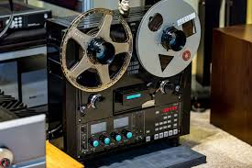

- Long grammar phone (Micro-Phone)
A microphone is a device that translates sound vibrations in the air into electronic signals or scribes them to a recording medium. Microphones enable many types of audio recording devices for purposes including communications of many kinds, as well as music and speech recording.


- Cassette (Tape)
The Compact Audio Cassette or Music-cassette, also commonly called the cassette tape or simply tape or cassette, is an analog magnetic tape-recording format for audio recording and playback
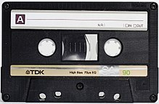

- CD
Compact disc (CD) is a digital optical disc data storage format that was co-developed by Philips and Sony and released in 1982. The format was originally developed to store and play only sound recordings (CD-DA) but was later adapted for storage of data (CD-ROM). Several other formats were further derived from these, including write-once audio and data storage (CD-R), rewritable media (CD-RW), Video Compact Disc (VCD), Super Video Compact Disc (SVCD), Photo CD, PictureCD, CD-i, and Enhanced Music CD.



- Deck to the Cassette
A cassette deck is a type of tape machine for playing and recording audio compact cassettes. Consumer electronics formerly used the term deck to distinguish them from a tape recorder, the "deck" being part of a stereo component system, while a "tape recorder" was more portable and usually had a self-contained power amplifier (and often speakers).

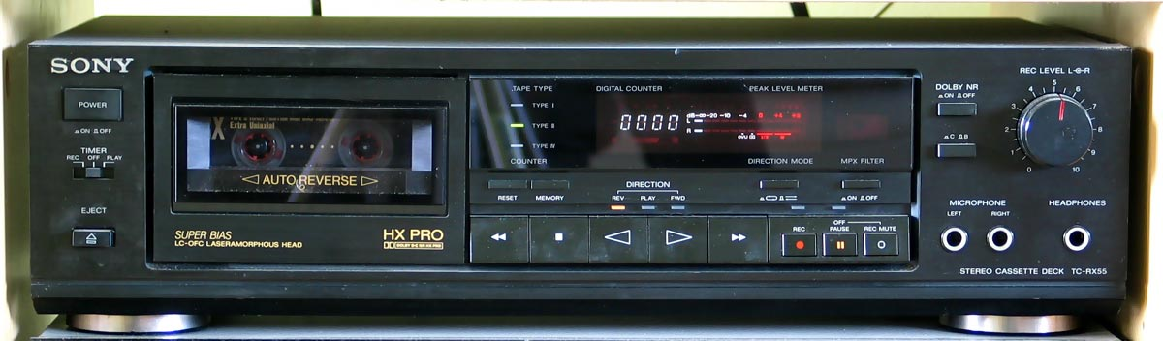

Other software’s include the audibling and Nero software
- Dubby Machine
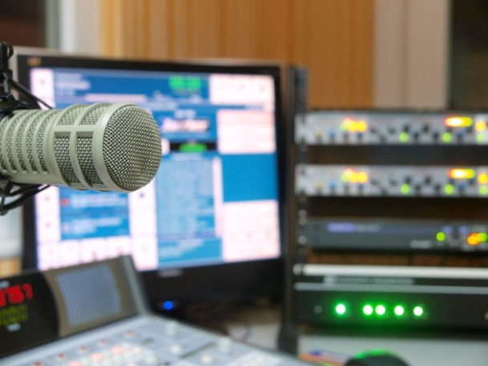
This is used in transforming radio cassette from one to another that is from one radio cassette other radio cassettes.

3.3 Radio Media
Radio is the technology of using radio waves to carry information, such as sound and images, by systematically modulating properties of electromagnetic energy waves transmitted through space, such as their amplitude, frequency, phase, or pulse width.

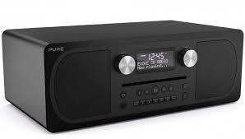

The Radio media is the largest in Africa but a kind of the oldest broadcasting network of Nigeria. It was gotten from radio-Nigeria operate as a network Kaduna State Media Cooperation (KSMC) news rooms give timely information of the program from the program unit which is the heart beat of the media.
Tips in making a good Radio Presentation
- Aim to create
- Understand how, when, why and what the listener is saying
- Know your listeners
- Make your listener care
3.4 Program Format
The type of the programs format is documentary, features, interview,
Discussion, ox pop, routine reporter, drama, testimonial, talk, chit-chat, montage, phone in programmes.

CHAPTER FOUR

4.1 Difficulties Encountered During the Programme
Life they say is not a bed of roses and whatsoever that has advantages also have its disadvantages. In as much as the SIWES Programme is a wonderful programme which has been designed to help the students have a practical knowledge of their various courses of study, it is note-worthy to also mention some of the problems encountered during the programme.
1. Problems of Securing a Place of Attachment
Securing a place of attachment for industrial training programme was a very big challenge to me. This is due to the fact that there are very limited establishment that accepts students undergoing industrial training. While I was searching for a place of attachments, I got to find out most of the establishments that accepts students had already taken the maximum number of students needed, while others would just reject the request giving one reason or the other.
2. Finance
Stipends given to me during my industrial training programme is nothing to write home about. The stipend was so little that it could not even cover up for my daily transportation fair not to even mention my feeding fee; therefore, making me spent more from my personal savings. Despite the fact that the stipend was little, it was delayed. Most students ended their programme without receiving their complete stipend due to late payment from firm and we are also asked to pay for the practical we are going to conduct which makes student loose interest in participating.
4.2 Summary of Attachment Activities
The gains of this exercise are immense; that it was worth the while is grossly an understatement. Being accorded another opportunity in life to be exposed to the rudiments of work places outside the class room teaching is an experience of a life time.
Furthermore, the exposure to practical tools, and working features had engendered better understanding of lessons thought in the class room and charted a course for career development in food science.
4.3.0 General Appraisal
4.3.1 Suggestion for Improvement & Recommendations of the Scheme ways of Improving the Programme
SIWES programme can be improved by the various actors in the programme which include the Federal Government of Nigeria (FGN), Industrial Training Fund (ITF), Supervisory Agencies (NUC, NCCE, and NBTE), the Institutions, and the Employers.
A. The Federal Government of Nigeria
The Federal Government should make it mandatory to all ministries, companies, and other organization to offer placement and as well as accept students for industrial attachment.
The Federal Government should increase the fund being provided for the SIWES programme and other educational programmes in general for effective and productive implementation of the scheme.
B. The Industrial Training Fund (ITF)
The Industrial Training Fund should provide a strong insurance policy covered for students on SIWES programme.
The ITF should provide logistic and material necessary for the effective administration of the scheme.
The ITF should formulate policies and guidelines for SIWES programme for enhancement to all SIWES participating bodies, institutions and companies involved in the scheme.
The ITF should provide information on companies for the attachment and help in the placement of students.
C. The Supervisory Agency
The supervisory agency should liaise with the Industrial Training Fund to ensure the implementation of all federal government policies on the scheme.
The supervisory agency should ensure adequate funding of the SIWES unit in all the institutions for effective administration of the scheme.
The supervisory agency should research into the development of the scheme in line with advances in technological development.
The supervisory agency should develop, monitor and review job specification in collaboration with the institution toward the maintenance of the National Minimum Academic Standard for the entire programme approved for SIWES.
D. The Institution
The Institution should help identify placement opportunities for student attachment with employers.
The Institution should ensure regular visitation of their students on industrial training to monitor their welfare and improvement status.
The Institution should have adequate information on some of the challenges facing the firm and the student; it should be noted and treated immediately.
The Institution should ensure payment of student’s allowances and other outstanding financial challenges.
E. The Employer
The Employers should accept students for industrial training attachment.
The Employer should allow the students to have access to some of their useful equipment and other useful facilities.
The Employer should provide welfare services like drugs and other medication and show good hospitality to students.
4.4 Advice for Future Participants
I strongly recommend that future participants should bear the following in mind;
- The student should be focused to avoid disputing the reputation of the institution in their place of industrial attachment and they should also bear in mind the objective of the scheme and show commitment, diligence and honesty.
- The student should obey and adhere strictly to all rules and regulations of the company; they should respect the industrial based supervisors as well as other staffs of the company because the moral standard of the student is also evaluated.
- The student should avoid change of placement without seeking permission from the institutional based supervisor, the employer and the industrial training fund.
- The student should handle the equipment if the firm with great care and they should take pride in protecting the interest of the company throughout the period of industrial attachment.
4.5 Advice for the SIWES managers
The SIWES managers should give attention to student welfare on industrial training and the students allowance should be increased as a result as high cost of living in our society.
Technologists from various departments or program should be involved in the drafting of time table for students on IT to ensure that students are always sent into areas where activities that will result in learning experience are taking place.

CHAPTER FIVE
RECOMMENDATION AND CONCLUSION
5.1 Recommendation
- Tertiary institutions need to comply with the standards set for proper implementations of SIWES to enable students derive the greatest benefits from participation in the scheme.
- Tertiary institutions need to provide adequate logistics (mobility, internet service etc.) and adequate funding to make their SIWES units functional.
- Students should be well prepared through meaningful orientation programmes by institutions before embarking on SIWES. A book, such as the “Guide to successful participation in SIWES” would be useful in achieving the purpose if read before, during and after SIWES by participants.
- Quality assurance of SIWES, through adequate supervision of participants by the relevant stakeholders (institutions, employers and ITF) would ensure that the scheme meets its objectives vis-à-vis the principles of cooperative education or work-integrated learning.
5.2 Conclusion
The Student Industrial Work Experience Scheme (SIWES) plays a significant role in human resource development, it helps students develop new skills and enlightens them of what the present society holds for them after graduation and helps them adapt accordingly. As a result of the programme, I am now more confident to build my future My four (4) months industrial attachment with Federal Radio Cooperation of Nigeria (FRCN) has been one of the most interesting, productive and instructive experience in my life. Through this training, I have gained new insight and more comprehensive understanding about the real industrial working condition and practice; it has also improved my soft and functional skills. All these valuable experience and knowledge that I have gained were not only acquired through the direct involvement in task but also through other aspect of training such as work observation, interaction with colleges, superior and other people related to the field.

