

A TECHNICAL REPORT
STUDENT INDUSTRIAL WORKING EXPERIENCE SCHEME
(SIWES)

Held at
UNIVERSITY OF ILORIN TEACHING HOSPITAL
Oke-ose, Ilorin Kwara State

Prepared by:
AJIBOYE IFEOLUWA ELIZABETH
ND/23/SLT/PT/0067

SUBMITTED TO

DEPARTMENT OF SCIENCE LABORATORY TECHNOLOGY
INSTITUTE OF APPLIED SCIENCE
KWARA STATE POLYTECHNIC, ILORIN

INPARTIAL FULFILLMENT OF THE REQUIREMENT FOR THE AWARD OF NATIONAL DIPLOMA IN SCIENCE LABORATORY TECHNOLOGY (SLT)

DEDICATION
I dedicate this technical report to the Almighty, the giver of knowledge, wisdom and who is rich in mercy.

ACKNOWLEDGEMENT
All adoration and glory are due to the Almighty for His Love, guidance and protection. I thank him for the perfect health, wisdom, knowledge, strength and opportunity to complete this stage of Academic in peace.
My Profound gratitude goes to my, Parents and every individual that supported me throughout the Student Industrial Work Experience. thanks so much for your support and care.

TABLE OF CONTENT
Title page i
Table of content ii
Dedication iii
Acknowledgements iv
TABLE OF CONTENTS
CHAPTER ONE
  - Background of SIWES 1
  - History of SIWES 1
  - Objectives of SIWES 2
  - Objectives of Establishment 3
CHAPTER TWO
2.1. Precaution taken in the laboratory 3
2.2. Equipment used in the laboratory 3
2.3 Sample Collection 5
CHAPTER THREE
3.1 Pregnancy Test 6
3.2 Malaria Test 6
3.3 Blood Pressure 7
3.4 Fasting Blood Sugar (FBS) Test Procedure 8
CHAPTER FOUR
4.1 Executive Summary 10
4.2 Challenges Encountered 10
CHAPTER FIVE
5.1 Conclusion 11
5.2 Recommendations 11

CHAPTER ONE
  - INTRODUCTION TO SIWES

The Students Industrial Work Experience Scheme (SIWES) is a training program aimed at equipping students from universities, polytechnics, colleges of technology, agriculture, and education with practical skills. It prepares them for the industrial work environment they are likely to encounter after graduation. The program allows students to gain hands-on experience with equipment and machinery that may not be accessible within their academic institutions.

1.2 HISTORY OF SIWES

The Students’ Industrial Work Experience Scheme (SIWES) was established in 1973 by the Federal Government of Nigeria through the Industrial Training Fund (ITF) to address the gap between theoretical knowledge and practical application in graduates of tertiary institutions. The program was developed to provide practical training that equips students from universities, polytechnics, and colleges of education with the skills needed for real-world work environments they are likely to encounter after graduation.

Prior to the scheme's creation, industrialists raised concerns that graduates lacked sufficient practical experience to meet the demands of the workforce. Employers believed that the theoretical focus of education in higher institutions did not align with the practical needs of industries.

With the increasing enrollment in higher education, managing and funding the scheme became challenging. As a result, ITF withdrew from the program in 1978, and its administration was transferred to the Federal Government, which delegated responsibilities to the National Universities Commission (NUC), the National Board for Technical Education (NBTE), and the National Commission for Colleges of Education (NCCE). In 1984, the Federal Government reassigned the program to ITF, which officially resumed control in 1985, with funding support provided by the Federal Government.

1.3 OBJECTIVES OF THE PROGRAMME
The primary objectives of the Students’ Industrial Work Experience Scheme (SIWES) are as follows:
- Facilitate industrial placements for students of tertiary institutions, approved by regulatory bodies such as the NUC, NBTE, and NCCE, to help them gain practical skills relevant to their academic disciplines.
- Equip students with the necessary preparation for the professional work environments they will encounter after graduation.
- Provide exposure to workplace methods, as well as the operation of equipment and machinery that may not be accessible within their academic institutions.
- Ensure a smooth transition from academic settings to the labor market and enhance students' employability.
- Offer students the opportunity to apply theoretical knowledge in real-world situations, bridging the gap between classroom learning and practical application.
- Foster employer engagement in the educational process and better prepare students for roles within various industries.
- Promote the development of technological expertise essential for national progress and industrial advancement.
1.4 OBJECTIVES OF ESTABLISHMENT
The objectives for which the Hospital was set up are:
i. To Train Medical and Paramedical Personnel
ii. To deliver Health Care Services
iii.To serve as referral Centre for other Hospitals around and
iv.To conduct researches

Vision: To transform University of llorin Teaching Hospital to be the hub of quality and standard healthcare service delivery in Africa by the year 2019, a player in the delivery of quality healthcarc service globally and expand the frontiers of the hospital in healthcare delivery by the year 2021.
Mission: This is to be attained through provision of quality and standard healthcare delivery that is second to none in Africa by the year 2019, and one of the global healthcare service institutions by the year 2021 regardless of clients statuses or creeds through quality researches, training (capacity building, manpower development and staff motivation) and services. Creation of industrial harmony in the hospital among health unions, stakeholders, as well as bolstering of staff dedication to duty; Providing high degrees of service satisfaction to our clients as well as job satisfaction to staff; Partnering locally, nationally and internationally with reputable organisations (through PPP); Attracting funds from entrepreneurs and stakeholders of high repute; Operation of clients-centred administration where the clients are KINGS; And the deployment of state-of-the art, hi-tech equipments for the management (diagnoses, treatments & follow-ups) of clients, to create a WORLD CLASS HEALTH INSTITUTION.

CHAPTER TWO
EXPERIENCE GAINED
2.1. PRECUATION TAKEN IN THE LABORATORY
- Wash hand thoroughly after each test
- Wear hand gloves before carrying out any test in the laboratory and discard after use.
- Do not touch exposed eyes, nose or skin gloved hands.
- Wash hand with water and soap or removal of gloves and after the day’s work.
- Always put on laboratory coat.
- Ensure that work surface are kept clean and disinfected before each work
- Do not store food, drink or beverages in the laboratory refrigerator.
- Unnecessary talks are disallowed during work.
- Eating, drinking or application of cosmetics is not allowed in the laboratory.
2.2. EQUIPMENT USED IN THE LABORATORY
There are various equipment used in the laboratory to carry out different tests, among which are briefly discussed below:
- Microscope: used for magnifying and focusing image that is not easily seen with the naked eyes.
- Bunsen burner: source of flame (red hot heat)
- Wire loop: used for inoculating
- Test tube: used to heat, centrifuge and hold sample during test.
- Slides: used for routine works such as microscopy and staining purpose in the laboratory.
- Micro capillary reader: used to measure the percentage of PCV
- Capillary tube: Used to spin blood during PCV determination
- Genotype machine: used for genotype determination
- Glucometer machine: used for blood glucose test.
- Laboratory refrigerator: used to keep sample for further use
- Centrifuge machine: used to centrifuge blood or urine.

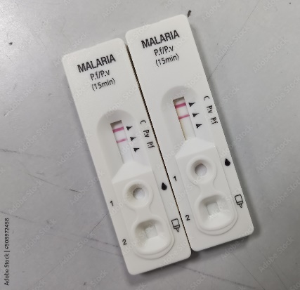
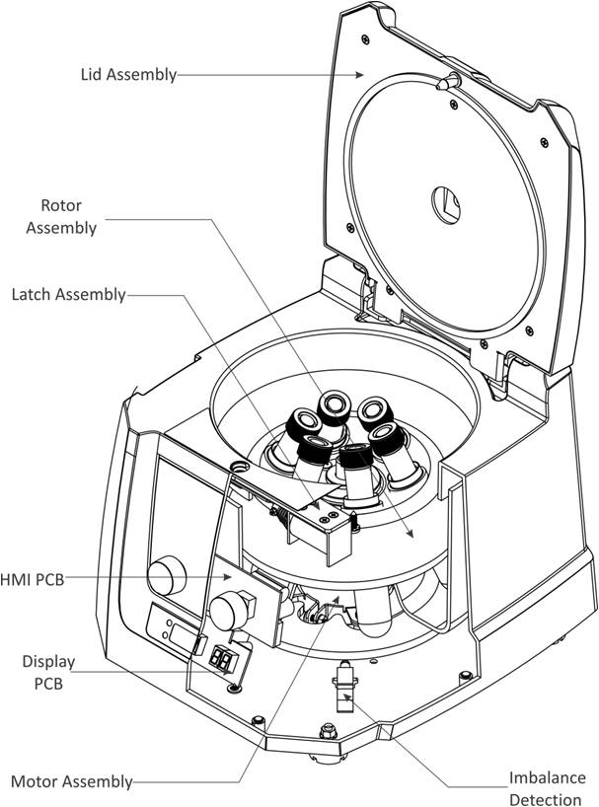
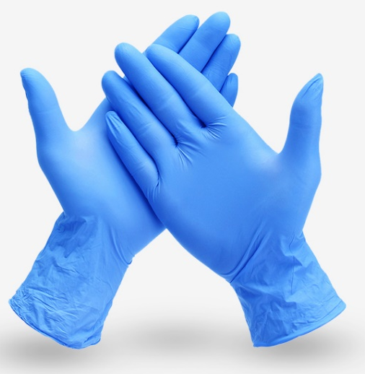

Malaria Parasite (MP) test Kit
Centrifuge Machine
Hand Glove

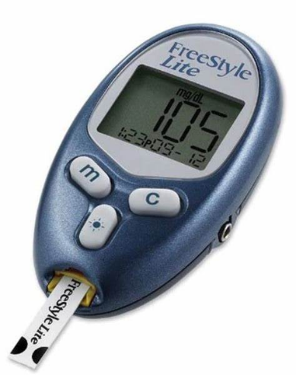
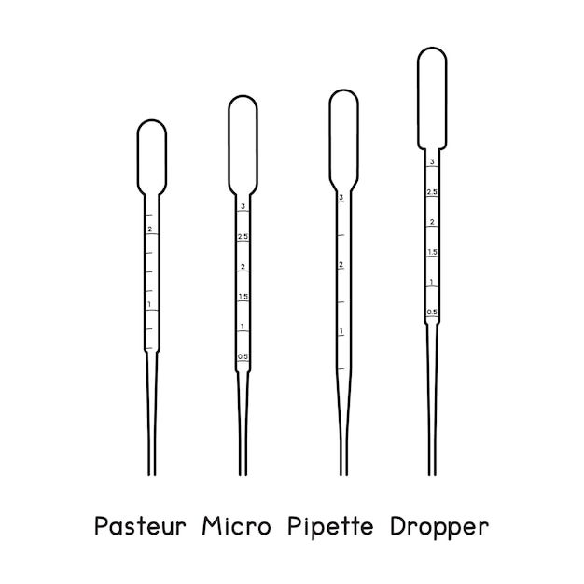
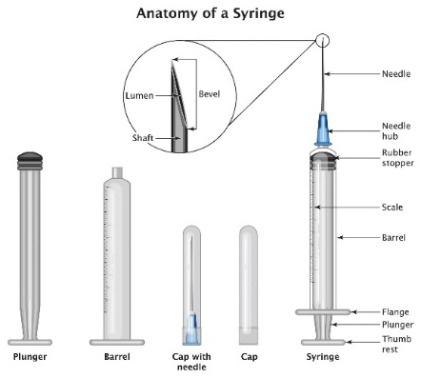

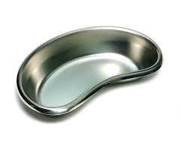
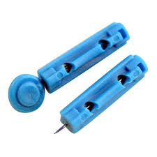
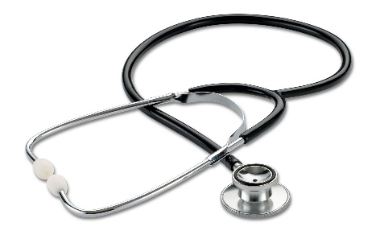
Glucometer
Micro pipette
Niddle and Syringe
Kidney dish
Lancet
Stethoscope
2.3 SAMPLE COLLECTION
The procedure used to collect blood through the vain
- Collect the necessary material such as syringe, cotton wool, spirit and tourniquet.
- Look for the vein and tie the tourniquet around the patient hand.
- Ask the patient to fold his or her hand in order to show clear appearance of the vein.
- Clean the particular place where you can see the vein clearly with spirit and cotton wool.
- Insert the syringe inside the vein, a little bit deep.
- Draw it little by little, in the case where you did not see blood at that particular place, gently remove the syringe and put it in another place.
- After you have get the blood, ensure that you remove the tourniquet before the syringe, then put the cotton wool on the place that you have remove syringe.
Another method used in the laboratory to collect sample is the use of fingertrip lancet.
- Clean the finger with spirit swap
- Use the lancet to prink the finger
- Collect the sample with EDTA capillary tube

CHAPTER THREE
3.1 PREGNANCY TEST
A pregnancy test using the PT (Pregnancy Test) strip is a quick and reliable method to detect the presence of the hormone human chorionic gonadotropin (hCG) in urine, which indicates pregnancy. Below is the process described step-by-step:

Procedure
- Preparation of Materials:
  - Obtain a PT strip, a clean urine collection container, and a timer.
  - Ensure a clean and dry workspace for the test.
- Sample Collection:
  - Collect a fresh urine sample in a clean container. Ideally, use the first morning urine for accurate results due to its higher hCG concentration.
- Application of Urine to the Test Strip:
  - Remove the PT strip from its packaging carefully.
  - Dip the absorbent end of the strip into the urine sample up to the marked line for a few seconds (typically 5–10 seconds) or as specified in the instructions.
  - Place the strip on a flat, dry surface with the result window facing up.
- Incubation:
  - Allow the test to process for the recommended time, usually 3–5 minutes.
- Observation of Results:
  - One line in the control region (C) indicates a negative result (not pregnant).
  - Two lines, one in the control region (C) and one in the test region (T), indicate a positive result (pregnant).
  - No line in the control region (C) means the test is invalid and should be repeated.
- Disposal of Materials:
  - Discard the used PT strip and urine sample appropriately.
  - Wash hands thoroughly and clean the workspace.
This simple procedure enables early detection of pregnancy, allowing individuals to seek timely medical advice and care.

3.2 MALARIA TEST
A malaria test is a diagnostic procedure used to detect the presence of Plasmodium parasites in the blood, which cause malaria. The test is essential for confirming malaria infection and determining the specific species responsible for the disease.
Types of Malaria Tests:
- Microscopic Examination (Blood Smear Test) – A blood sample is stained and examined under a microscope to identify Plasmodium parasites. It is the most accurate method but requires skilled personnel.
- Rapid Diagnostic Test (RDT) – A quick test that detects malaria antigens in the blood using a test strip (Malaria Parasite (MP) Kit). It provides results within minutes but may not identify the specific Plasmodium species.
- Polymerase Chain Reaction (PCR) Test – A highly sensitive test that detects malaria DNA in the blood. It is used for precise identification but is more expensive and requires specialized laboratory equipment.
Importance of Malaria Testing:
- Ensures proper diagnosis and treatment.
- Helps differentiate malaria from other fever-related illnesses.
- Prevents unnecessary use of antimalarial drugs.
- Monitors the effectiveness of malaria treatment.
3.3 BLOOD PRESSURE
Blood pressure is the force exerted by circulating blood against the walls of the arteries as the heart pumps it around the body. It is measured in millimeters of mercury (mmHg) and recorded as two values: systolic pressure (the pressure when the heart contracts) and diastolic pressure (the pressure when the heart relaxes). A normal blood pressure reading is typically around 120/80 mmHg. High blood pressure (hypertension) can increase the risk of heart disease and stroke, while low blood pressure (hypotension) may lead to dizziness and fainting. Blood pressure is commonly measured using a sphygmomanometer and a stethoscope or digital monitor. Maintaining a healthy lifestyle, including a balanced diet, regular exercise, and stress management, is essential for optimal blood pressure control.
Normal Blood Pressure by Age
Blood pressure varies with age, lifestyle, and overall health. Below is a general guide to normal blood pressure ranges by age:
Age Group | Normal Blood Pressure (mmHg)
Infants (0-1 year) | 70-90 / 50-70
Children (1-5 years) | 80-110 / 50-80
Children (6-13 years) | 90-120 / 60-80
Teenagers (14-19 years) | 105-135 / 60-85
Adults (20-39 years) | 110-130 / 70-85
Middle-aged Adults (40-59 years) | 115-140 / 75-90
Older Adults (60+ years) | 120-150 / 80-90

3.4 FASTING BLOOD SUGAR (FBS) TEST PROCEDURE
A Fasting Blood Sugar (FBS) test measures blood glucose levels after a period of fasting, usually for at least 8–12 hours. It helps diagnose diabetes, prediabetes, and monitor blood sugar control.
Procedure:
- Preparation:
  - The patient is instructed to fast (no food or drinks except water) for 8–12 hours before the test.
  - Avoid alcohol and excessive physical activity before the test.
- Sample Collection:
  - The healthcare provider cleans the puncture site (usually the fingertip or vein in the arm) with an alcohol swab.
  - If using a glucometer (capillary blood test), a lancet is used to prick the fingertip, and a drop of blood is placed on the test strip.
  - If using a laboratory test, blood is drawn from a vein using a syringe and collected in a tube for analysis.
- Testing and Analysis:
  - In a glucometer test, results appear within seconds.
  - In a lab test, the sample is analyzed for glucose concentration, and results are provided later.
- Post-Test Care:
  - If blood was drawn from a vein, slight pressure is applied to stop bleeding.
  - The patient can resume normal eating and drinking after the test.
- Interpretation of Results:
  - Normal: 70–99 mg/dL (3.9–5.5 mmol/L)
  - Prediabetes: 100–125 mg/dL (5.6–6.9 mmol/L)
  - Diabetes: 126 mg/dL (7.0 mmol/L) or higher (on two separate tests)

CHAPTER FOUR
4.1 EXECUTIVE SUMMARY
Executive Summary
This report provides a detailed account of the Students Industrial Work Experience Scheme (SIWES) undertaken at Oyinfolorunsho Hospital, focusing on key laboratory and clinical procedures. The training covered essential diagnostic and preventive healthcare practices, including malaria testing, which involved microscopic examination and rapid diagnostic tests to detect Plasmodium parasites; immunization, which entailed vaccine administration to prevent infectious diseases; blood pressure measurement, which assessed patients for hypertension and other cardiovascular risks; and fasting blood sugar (FBS) testing, a crucial procedure for diagnosing and monitoring diabetes. The hands-on experience gained during the program enhanced practical knowledge in patient care, diagnostic accuracy, and medical procedures, bridging the gap between theoretical learning and real-world healthcare applications.
4.2 CHALLENGES ENCOUNTERED
During the SIWES program at Oyinfolorunsho Hospital, several challenges were faced, which impacted the learning experience. Limited availability of modern laboratory equipment sometimes made testing procedures time-consuming and less efficient. Additionally, high patient turnout resulted in increased workload, making it difficult to focus on detailed procedural learning. There were occasional power outages, which disrupted laboratory tests and patient care, requiring reliance on alternative power sources. Another challenge was limited access to certain medical procedures, as some tests and treatments were restricted to qualified personnel, limiting hands-on participation. Lastly, the short duration of the training made it challenging to gain in-depth expertise in all covered areas. Despite these challenges, the experience was valuable in enhancing practical skills and understanding of clinical procedures.

CHAPTER FIVE
5.0 CONCLUSION AND RECOMMENDATIONS
5.1 CONCLUSION
The SIWES program at Oyinfolorunsho Hospital provided invaluable hands-on experience in essential healthcare practices, including malaria testing, immunization, blood pressure measurement, and fasting blood sugar (FBS) testing. The training bridged the gap between theoretical knowledge and practical application, enhancing skills in patient care and diagnostic procedures. Despite challenges such as limited equipment, high patient turnout, and occasional power outages, the experience significantly contributed to professional development and a better understanding of real-world medical practice. Overall, the program was a rewarding opportunity that reinforced the importance of laboratory and clinical procedures in disease diagnosis and prevention.
5.2 RECOMMENDATIONS
- Upgrade Laboratory Equipment – Providing modern and well-functioning diagnostic tools will enhance efficiency and accuracy in testing procedures.
- Improve Power Supply – Installing a reliable backup power source, such as an inverter or generator, will help prevent disruptions in laboratory and clinical activities.
- Increase Student Participation – Allowing students more hands-on involvement under supervision will improve their practical skills and confidence in medical procedures.
- Extend Training Duration – A longer SIWES period will enable students to gain more in-depth experience in various healthcare practices.
- Enhance Supervision and Guidance – Assigning dedicated mentors to students will ensure better learning, skill acquisition, and professional development.

