
TECHNICAL REPORT ON THE STUDENT INDUSTRIAL WORK EXPERIENCE
SCHEME (SIWES)

HELD AT
OGBOMOSO SOUTH LOCAL GOVERNMENT
AROWOMOLE, OGBOMOSO,OYO STATE, NIGERIA.
P.M.B 3601

BY
OGUNLEYE MATHEW GBENGA
ND/23/CEC/PT/0119

SUBMITTED TO:
THE DEPAERTMENT OF CIVIL ENGINEERING TECHNOLOGY,
KWARA STATE POLYTECHNIC, ILORIN.
INSTITUTION OF TECHNOLOGY (I.O.T).

AUGUST – NOVEMBER, 2024.
DEDICATION
I dedicated this report to my parent. Mr and Mrs. OGUNLEYE. Thank you for everything. God bless you.

ACKNOWLEDGMENT
I thank God Almighty for his mercy and grace that kept me all through my SIWES period. I am greatly indebted to my parents, Mr. & Mrs. Ogunleye for their morally, spiritually and financially, word of encouragement and prayer given to me, who make my SIWES programme successful and also my relatives and sibling.
I also want to thank my Siwes Supervisor in the name of Engr.Adeleke folorunsho Sunday and everyone that contributed to the success of my SIWES program my Industrial supervisors, my colleagues and co-workers for the tremendous moral assistance throughout the period of my attachment.

REPORT OVERVIEW
This is an industrial attachment report for the students industrial work experience (SIWES) programme carried out at Ogbomoso south local government Arowomole, ogbomoso. within the period of Four months from August - November, 2024.
The report comprises the background of SIWES, the description of the organization, its aims and objectives, the experience gained as an industrial training student and the summary, conclusion and recommendations.
It has a total of 5 chapters with sub-chapter. It also has the preliminary pages, such as the tile page, report overview and table of contents and recommendations on the improvement of scheme.

PREFACE
The student industrial work experience scheme (SIWES) helps in exposing students to the practical application of their course and to get used to equipments and machines used in the factory. The SIWES was established to promote student skill in industrial practice and pre-expose them to working experience in industrial setting.
It is a partial fulfillment of a two year academic programme to obtain an OND certificate in Civil Engineering Technology. The report explains the description of work done.

CHAPTER ONE

INTRODUCTION

1.1 Background of the Study
The Student Industrial Work Experience Scheme (SIWES) is a program established by the Federal Government of Nigeria to equip students with practical experience in their respective fields of study. This program aims to bridge the gap between theoretical knowledge acquired in the classroom and its practical application in the workplace.
Ogbomoso South Local Government, Arowomole, serves as an administrative hub, handling governmental and community-related responsibilities. The internship program at this location provided an opportunity to gain hands-on experience in administrative duties, community development, and public service operations. Ogbomoso South Local Government, Arowomole, serves as an administrative hub, handling governmental and community-related responsibilities. The internship program at this location provided an opportunity to gain hands-on experience in administrative duties, community development, and public service operations.

1.2 History of SIWES
SIWES was established in 1973 by the Industrial Training Fund (ITF) to address the lack of practical industrial experience among students in higher institutions. Initially, it was designed for students in engineering and technology-based programs but was later expanded to other fields of study. The scheme is a collaborative effort between the ITF, higher institutions, and various industries, ensuring that students gain the necessary exposure to real-world applications of their academic knowledge. Over the years, SIWES has contributed significantly to workforce development and has enhanced employability by bridging the gap between theory and practice.

1.3 Objectives of the SIWES Program
- To expose students to real-world applications of their academic knowledge.
- To enhance technical and managerial skills relevant to their fields.
- To foster teamwork and communication in a professional setting.
- To prepare students for the challenges of their future careers.

1.4 Significance of the Study
The importance of SIWES cannot be overemphasized as it provides students with firsthand experience in government administration, policy implementation, and public service management. It also prepares students for employment by equipping them with relevant workplace ethics and technical knowledge.

CHAPTER TWO

ORGANIZATIONAL STRUCTURE OF ESTABLISHMENT

ORGANIZATIONAL STRUCTURE

OGBOMOSO SOUTH LOCAL GOVERNMENT AROWOMOLE

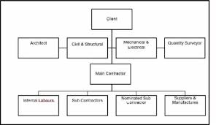

2.1 History and Establishment of Ogbomoso South Local Government
Ogbomoso South Local Government was created to enhance governance at the grassroots level. It is responsible for administrative functions such as tax collection, infrastructural development, education, and health services.

2.2 Organizational Structure
The local government is structured into various departments, including:
- Administrative Department – Handles staff affairs and record keeping.
- Finance Department – Manages financial transactions and budgeting.
- Works and Transport Department – Oversees road maintenance and transportation services.
- Health Department – Supervises healthcare facilities and programs.
- Environmental Department – Ensures sanitation and waste management.

2.3 Functions of the Local Government
- Revenue generation through taxes and levies.
- Provision and maintenance of public amenities.
- Implementation of government policies and programs.
- Ensuring law and order through local security agencies.

EQUIPMENT USED

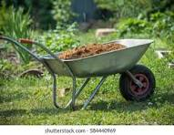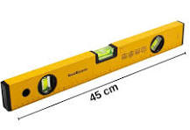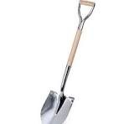
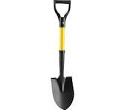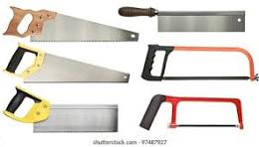
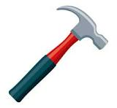

CHAPTER THREE

INDUSTRIAL TRAINING ACTIVITIES

3.1 Introduction to Assigned Tasks
During the SIWES program, I was assigned to different departments to understand their functions and gain practical experience.

3.2 Job Roles and Responsibilities
- Administrative Unit:
  - Document preparation and filing.
  - Assisting in staff coordination and meeting arrangements.
  - Plan reading or interpretation of plan.
  - Preparation for site cleaning for contruction.
- Finance Department:
  - Assisting in record-keeping of revenue and expenses.
  - Learning about the local government budgeting process.
- Works and Transport Department:
  - Site inspections of ongoing infrastructural projects.
  - Reporting maintenance needs of public utilities.
- Health and Environmental Unit:
  - Assisting in community sanitation programs.
  - Participating in public health awareness campaigns.

3.3 Challenges Faced
- Limited access to digital resources and modern office equipment.
- Bureaucratic processes that slowed decision-making.
- Shortage of manpower in some departments.

CHAPTER FOUR

EXPERIENCE AND LEARNING OUTCOMES

4.1 Skills Acquired
- Administrative Skills: Improved documentation and organizational skills.
- Financial Management Skills: Understanding of budgeting and financial reporting.
- Communication Skills: Enhanced ability to interact with government officials and the public.
- Technical Skills: Exposure to infrastructural project management.

4.2 Relationship Between Academic Knowledge and Practical Experience
The SIWES program provided a practical application of theoretical concepts learned in school, such as:
- The use of accounting principles in financial management.
- Application of public administration theories in governance.
- Implementation of health education strategies in community health programs.

4.3 Contributions to Personal and Professional Development
- Improved problem-solving abilities.
- Enhanced teamwork and leadership qualities.Increased awareness of government operations and policies.
. 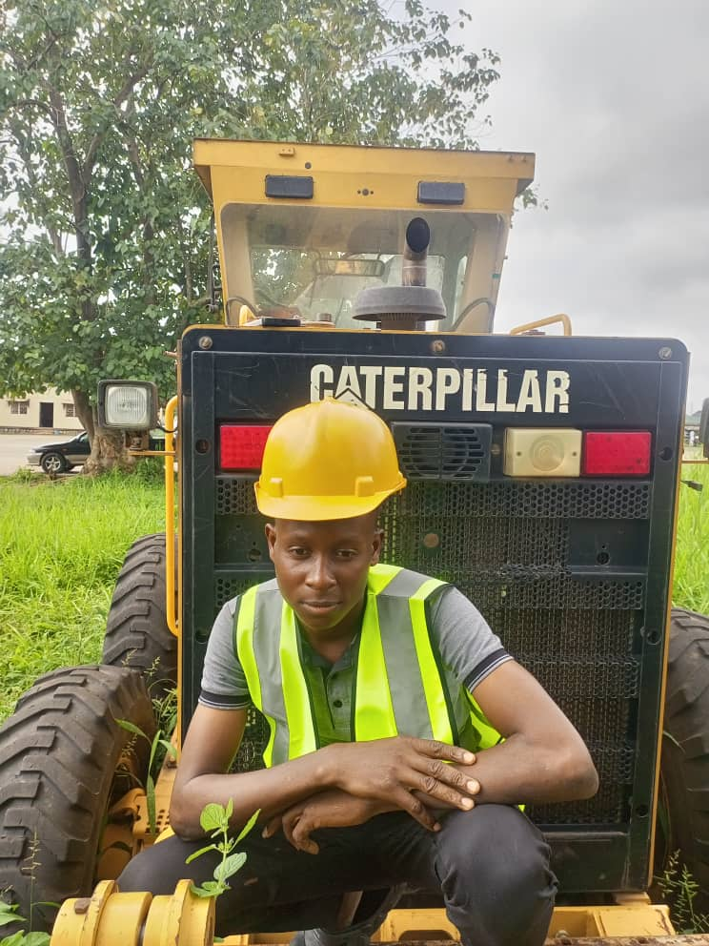

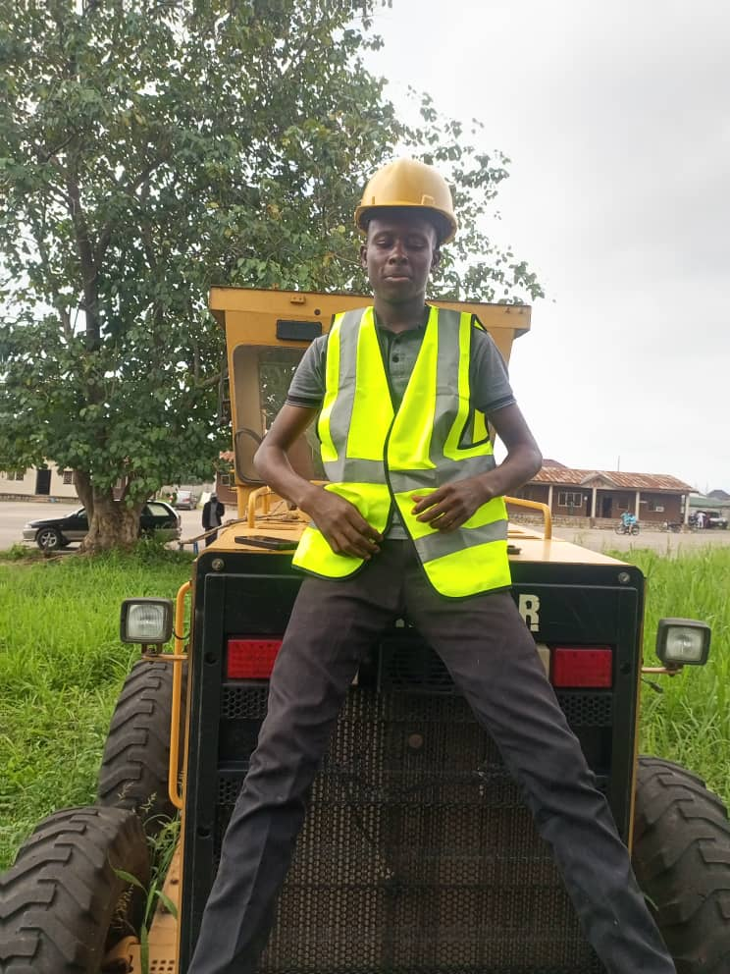
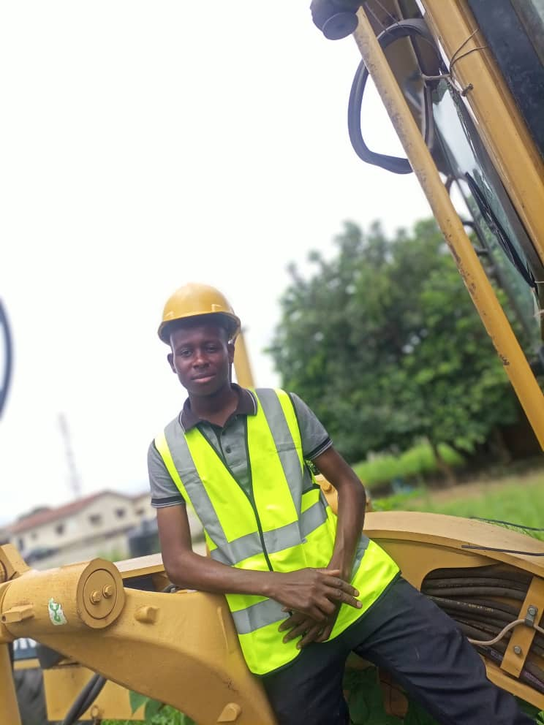

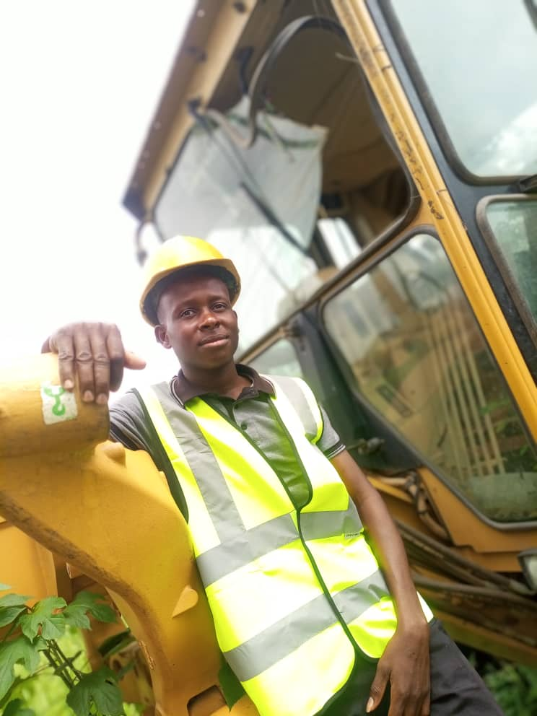

CHAPTER FIVE

CONCLUSION AND RECOMMENDATIONS

5.1 Summary of the Industrial Training
The SIWES program at Ogbomoso South Local Government, Arowomole, was an insightful experience that provided exposure to public service operations and administrative responsibilities. The training enhanced my knowledge in various aspects of governance, financial management, and community service.

5.2 Recommendations
- For the Local Government:
  - Improve digitalization of records for efficiency.
  - Increase internship opportunities for students.
  - Enhance collaboration with academic institutions for a structured training program.
- For Future Interns:
  - Be proactive in learning and taking on responsibilities.
  - Develop strong communication and problem-solving skills.
  - Engage with various departments to gain a well-rounded experience.

5.3 Conclusion
The SIWES program was a valuable learning experience that bridged the gap between classroom knowledge and real-world applications. It prepared me for future career endeavors by equipping me with essential skills and exposure to governmental functions. The experience gained will significantly contribute to my professional growth and career development.

