

A TECHNICAL REPORT ON
STUDENT INDUSTRIAL WORK EXPERIENCE SCHEME
(SIWES)

HELD AT:
BORIOWO BAKE HOUSE ENTERPRISE
KM 19 ILORIN AJASE-IPO ROAD KWARA STATE

WRITTEN BY
OGUNDIJI KEHINDE OLUWAGBEMILEKE
ND/23/BAM/PT/0820

SUBMITTED TO
DEPARTMENT OF BUSINESS ADMINISTRATION AND MANAGEMENT,
INSTITUTE OF FINANCE MANAGEMENT STUDIES (IFMS)
KWARA STATE POLYTECHNIC, ILORIN

IN PARTIAL FULFILLMENT OF THE REQUIREMENTS FOR THE
AWARD OF NATIONAL DIPLOMA (ND) IN BUSINESS ADMINISTRATION AND MANAGEMENT

AUGUST –NOVEMBER, 2024

DEDICATION
I dedicate this report, first and foremost, to Almighty God for His favor and grace upon my life, especially throughout my four-month SIWES program.
I also dedicate it to my loving parents and siblings for their unwavering love and support. Additionally, I extend my gratitude to everyone who contributed to making my SIWES training a rewarding and enjoyable experience.

ACKNOWLEDGEMENT
I express my deepest gratitude to Almighty God for the gift of life, the giver and taker of all things. I am also profoundly thankful to my parents for their unwavering support and prayers, which have guided me through every step of my journey. May they live long to reap the rewards of their hard work.
My heartfelt appreciation goes to my parents, Mr. and Mrs. OGUNDIJI, for their spiritual, moral, and financial support, which contributed immensely to the success of my SIWES program.
I am sincerely grateful to the management and staff of the company, especially my supervisor for their invaluable support, guidance, and knowledge shared during my training. I also extend my gratitude to my lecturers and supervisors for their continuous encouragement and constructive feedback throughout the program.

TABLE OF CONTENTS
Title Page i
Dedication ii
Acknowledgement iii
Table of Contents vi
CHAPTER ONE
1.0 Introduction to Training Programme 1
1.1 Objective of the programme to student 1
CHAPTER TWO

2.0 DESCRIPTION OF THE BAKERY 2

2.1 Overview of the Bakery 2

2.2 Organizational Structure 2

2.3 Products and Services 2
CHAPTER THREE

3.0 INDUSTRIAL TRAINING EXPERIENCE 3

3.1 Training Activities and Responsibilities 3

3.2 Skills Acquired 4

3.3 Challenges Encountered 4
CHAPTER FOUR
4.1 Introduction to Bakery Business setup 5
4.2 Market Analysis 5
4.3 Business Model and Structure 5
4.4 Operational Requirements 5
4.5 Financial Considerations 6
4.6 Marketing Strategies 6
4.7 Challenges and Risk Management 6
CHAPTER FIVE
5.1 Conclusion 9

5.2 Recommendations 9

CHAPTER ONE

INTRODUCTION

1.1 Background of SIWES
The Student Industrial Work Experience Scheme (SIWES) is a program designed to provide students with practical experience in their field of study. It serves as a bridge between theoretical knowledge and industrial application, allowing students to gain hands-on skills and industry exposure.
The students Industrial Work Experience Scheme (SIWES) was initiated in 1973 by the Industrial Training Fund (ITF). This was to update practical knowledge of students in the Universities, Polytechnics and College of Technology. It was aimed at bridging the gap between the theoretical knowledge acquired in classes and technical knowledge in the industries by providing students with opportunities to apply their educational knowledge in real work situations.
Over the years, SIWES has contributed immensely to building the common pool of technical and allied skills available to the Nigerian economy which are needed for the nation’s industrial development.
It provides students with hands-on experience in their field of study, preparing them for the professional workforce.

1.2 Objectives of SIWES
- To expose students to industrial environments related to their academic discipline.
- To develop students’ technical and managerial skills.
- To enable students to apply classroom knowledge to real-world scenarios.
- To improve students’ employability and readiness for the workforce.

CHAPTER TWO

2.0 DESCRIPTION OF THE BAKERY

2.1 Overview of the Bakery
Boriowo Bake House Enterprise is a well-established bakery specializing in the production of various baked goods such as bread, cakes, pastries, and cookies. The bakery is equipped with modern baking facilities and adheres to industry standards for quality and hygiene.

2.2 Organizational Structure
The bakery is structured as follows:
- General Manager
- Production Manager
- Quality Control Supervisor
- Sales and Marketing Team
- Bakers and Assistants
- Administrative Staff

2.3 Products and Services
The bakery produces:
- Bread (various types such as white, whole wheat, and fruit bread)
- Cakes (wedding cakes, birthday cakes, and cupcakes)
- Pastries (meat pies, sausage rolls, doughnuts)
- Cookies and biscuits
- Custom orders for special occasions

CHAPTER THREE

3.0 INDUSTRIAL TRAINING EXPERIENCE

3.1 Training Activities and Responsibilities
During my SIWES program, I was actively involved in the following activities:
- Mixing and Kneading: Learning how to prepare dough using precise measurements of ingredients.
- Baking Process: Understanding the use of industrial ovens, temperature control, and baking techniques.
- Quality Control: Ensuring baked goods met required standards in terms of taste, texture, and appearance.
- Packaging and Storage: Learning proper methods of packaging, labeling, and storing baked products.
- Sales and Customer Interaction: Assisting in customer service and understanding market demands.
- Hygiene and Safety Compliance: Following industry best practices for cleanliness and food safety.
Roles and Responsibilities During the training, I was assigned various tasks, including:
- Assisting in measuring and mixing ingredients.
- Observing the baking process and temperature control.
- Packaging and labeling finished products.
- Maintaining cleanliness and hygiene in the bakery.
- Handling customer orders and service.

3.2 Skills Acquired
- Knowledge of baking techniques and equipment usage.
- Time management in handling multiple baking processes.
- Teamwork and effective communication within a bakery setting.
- Quality assurance and hygiene standards in food production.

3.3 Challenges Encountered
- Adapting to the fast-paced bakery environment.
- Understanding the technical aspects of industrial baking equipment.
- Managing work shifts, especially during high-demand periods.

CHAPTER FOUR
4.1 Introduction to Bakery Business setup
The bakery industry is a thriving sector that caters to the increasing demand for baked goods, including bread, cakes, pastries, and cookies. This report examines the bakery business, covering its market potential, operational requirements, financial considerations, and success strategies.
4.2 Market Analysis
The bakery industry is driven by consumer demand for fresh and quality baked products. There is a growing preference for healthy, organic, and gluten-free bakery items. The target market includes households, restaurants, cafes, and retail stores. Seasonal and festive occasions also contribute significantly to sales.
4.3 Business Model and Structure
A bakery business can take different forms, including:
- Retail Bakeries: Sell directly to customers.
- Wholesale Bakeries: Supply baked goods to retailers and businesses.
- Home-Based Bakeries: Operate from home with online or local sales.
- Specialty Bakeries: Focus on specific products like wedding cakes or organic breads.
4.4 Operational Requirements
To run a successful bakery, the following are essential:
- Location: A strategic location with high foot traffic is ideal.
- Equipment: Ovens, mixers, proofing cabinets, baking trays, and storage facilities.
- Ingredients: Flour, sugar, yeast, dairy products, and flavoring agents.
- Staffing: Bakers, assistants, cashiers, and customer service personnel.
- Licensing and Permits: Compliance with food safety regulations and business registration.
4.5 Financial Considerations
Setting up a bakery requires an initial investment in equipment, rent, and raw materials. Revenue sources include direct sales, online orders, catering services, and wholesale distribution. Profitability depends on cost control, pricing strategy, and sales volume.
4.6 Marketing Strategies
To attract and retain customers, bakeries should employ:
- Social Media Marketing: Promote products on platforms like Instagram and Facebook.
- Loyalty Programs: Reward repeat customers.
- Local Partnerships: Collaborate with cafes, restaurants, and event planners.
- Online Ordering & Delivery: Expand reach through digital platforms.
4.7 Challenges and Risk Management
Common challenges include fluctuating ingredient costs, high competition, and maintaining product quality. Risk mitigation involves diversifying product offerings, maintaining supplier relationships, and adapting to market trends.
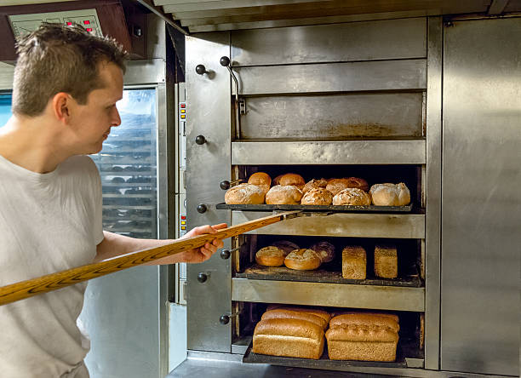
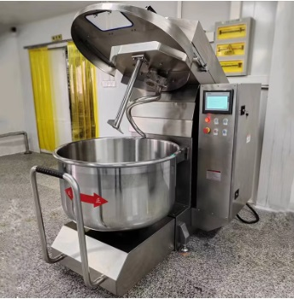

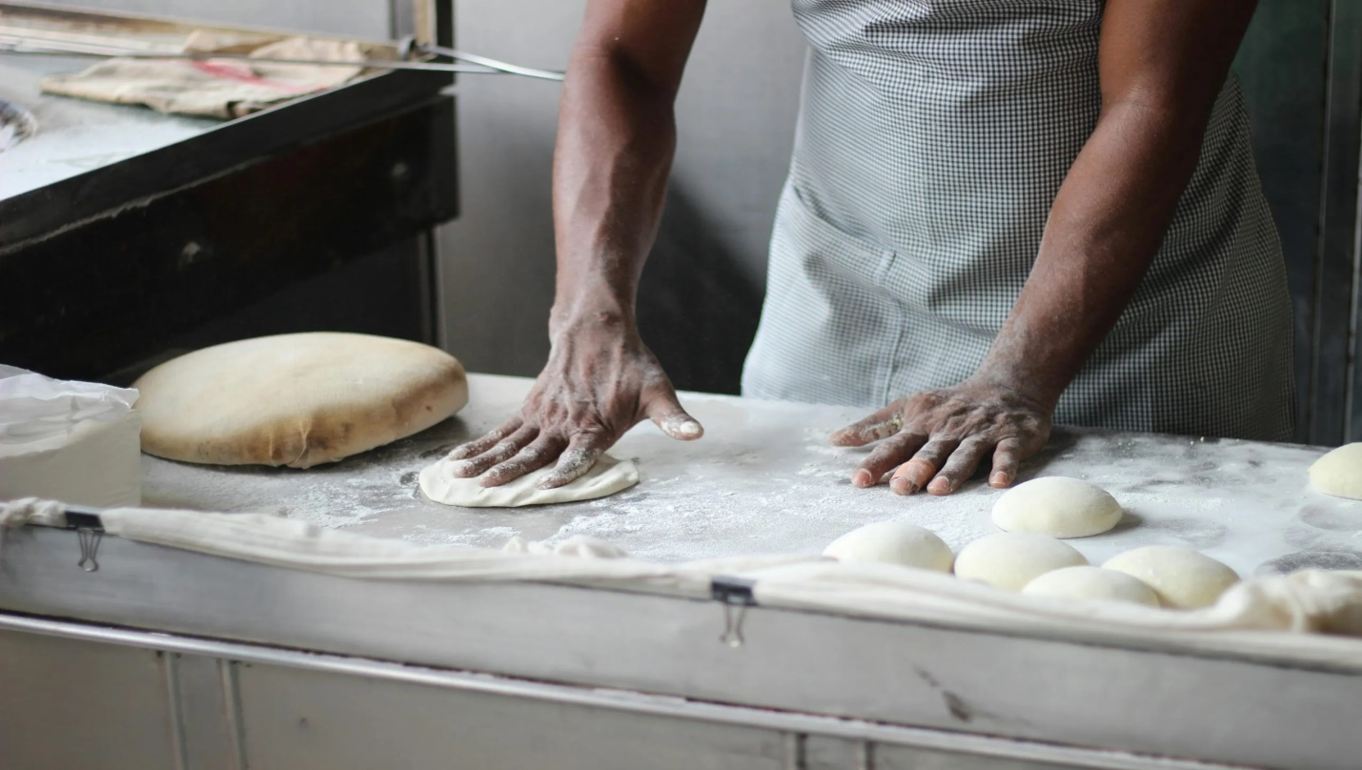
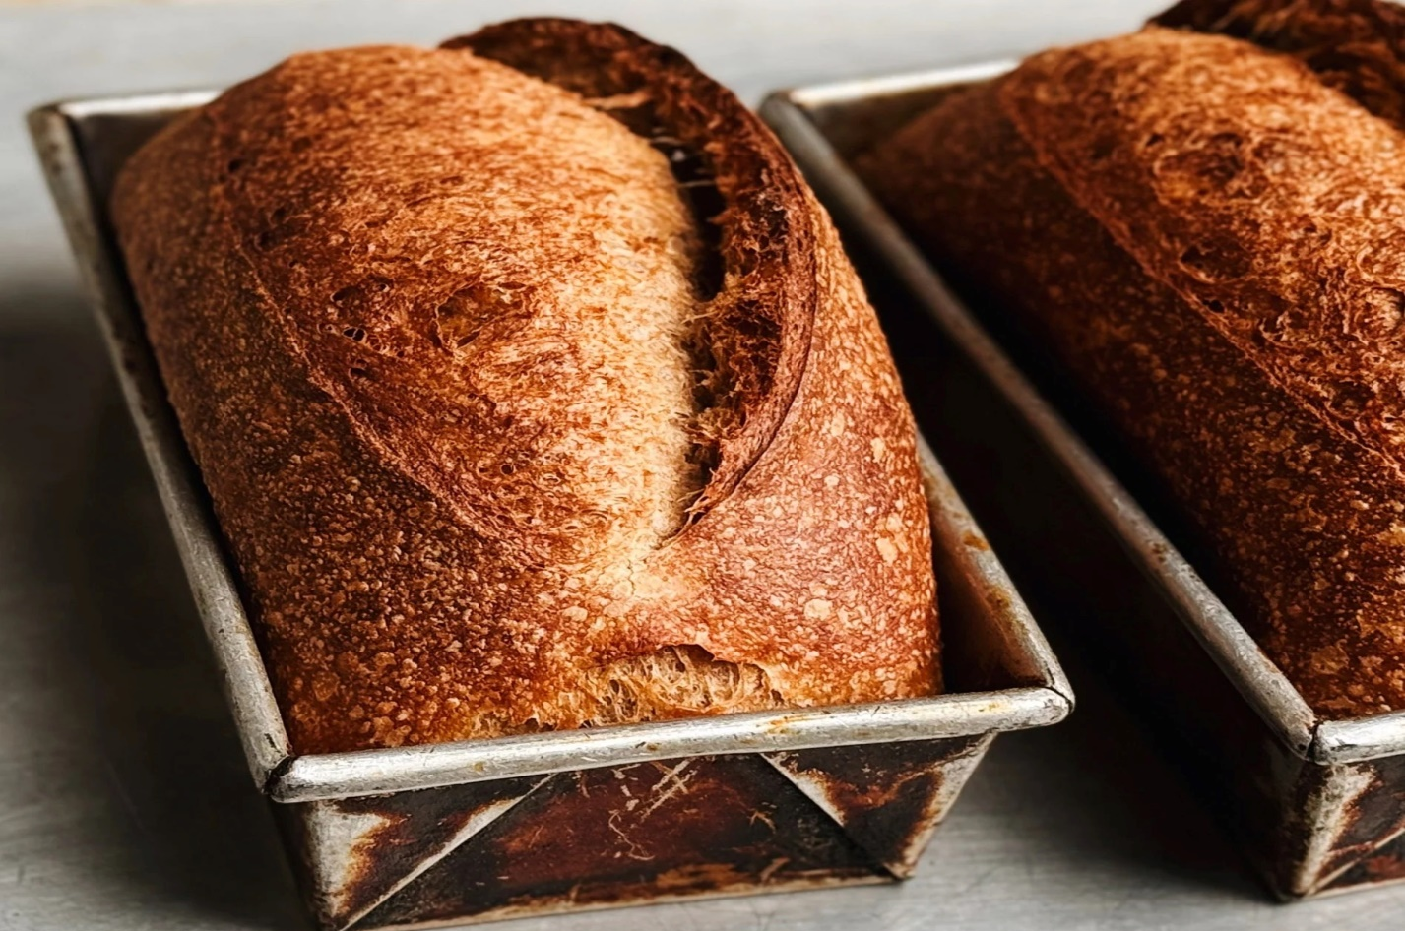

CHAPTER FIVE

5.0 CONCLUSION AND RECOMMENDATIONS

5.1 Conclusion
My SIWES experience at Boriowo Bake House Enterprise was highly beneficial, providing me with practical exposure to bakery operations. The hands-on experience enhanced my technical skills and understanding of the baking industry.
A bakery business presents significant opportunities for profitability and growth. Success requires careful planning, efficient operations, and effective marketing strategies. Entrepreneurs should stay updated with consumer preferences and industry trends to maintain competitiveness in the market.
The SIWES training at Boriowo Bake House Enterprise was a valuable learning experience that enhanced my technical and managerial skills in bakery operations. The knowledge gained will be beneficial for future career opportunities in the food industry.

5.2 Recommendations
- More theoretical training before placement in the bakery to ease adaptation.
- Introduction of more automation to improve efficiency in production.
- Regular training sessions for bakery staff to keep up with new trends and techniques.
- More training sessions should be provided on advanced baking techniques.
- Improved work scheduling to enhance efficiency.
- Adoption of modern technology for better production management.

