

A TECHNICAL REPORT ON
STUDENT INDUSTRIAL WORK EXPERIENCE SCHEME
(SIWES)

HELD AT:
ROTANA HOTEL
FATE ROAD ILORIN KWARA STATE

WRITTEN BY
SULYMAN MOTUNRAYO SIMBIAT
ND/23/TMT/FT/0051

SUBMITTED TO
DEPARTMENT OF HOSPITALITY MANAGEMENT,
INSTITUTE OF APPLIED SCIENCE (I.AS),
KWARA STATE POLYTECHNIC, ILORIN

IN PARTIAL FULFILLMENT OF THE REQUIREMENTS FOR THE
AWARD OF NATIONAL DIPLOMA (ND) IN HOSPITALITY MANAGEMENT.
AUGUST –NOVEMBER, 2023

DEDICATION
I dedicate this report to the Almighty Allah, the Incomparable king of kings, Omnipresent, Omnipotent, The Author and the finisher of the Universe, who is the pillar behind the success of this programme.
I also dedicate this to Amiable Mentor, Driver, Advocate, Motivator, and Incomparable loving and Darling Parent MR/MRS Sulyman for their Support and encouragement throughout the period.

ACKNOWLEDGEMENT
I give glory to Almighty Allah, the incomparable king of kings, the author and the finisher of all things. For the strength, grace and enablement given unto me to be partaker of this programme.
I also show my indebtedness to my able bloods for their irreplaceable and indefinable love, encouragement, advice, support, and financial back up during the course of this programme.
Finally, my profound gratitude goes to the officials and other staff of ROTANA HOTE for their help, advice, encouragement and other forms of support rendered during the period of the SIWES programme.
I thank you all and God bless you abundantly.

TABLE OF CONTENTS
Title Page i
Certification ii
Dedication iii
Acknowledgement iv
Table of Content v
CHAPTER ONE
1.0 Introduction to Siwes 1
1.1 Brief History of Siwes 1
1.2 Aims and Objectives of Siwes 2
1.3 Importance of Siwes 2
CHAPTER TWO
2.1 Organization Chart 3
2.2 Introduction of Department in the Restaurant 3
CHAPTER THREE
- Experience At The Pent House Inn Hotel 4
3.1 The Bar 4
3.2 The Food And Beverage Section 4
3.3 The Front Office 5
3.4 House keeping 6
CHAPTER FOUR
4.0 Introduction to Activities Acquired in the Restaurant 8
  - Section/Department I was privileged to work in The Restaurant 8
    - Front Office Department 8
    - Kitchen Department 9
    - Recipes and Method of Preparation of Semovita and Egusi soup 10
    - Recipes and Method of Preparation of Fried Rice 13
    - Restaurant Department 16
4.1.6 Housekeeping Department 18
4.2 Challenges Face in the Restuarant 19
CHAPTER FIVE
5.1 Problems Encountered During Siwes 20
5.2 Impact Created 20
5.3 Conclusion 10
5.4 Recommendation 21

CHAPTER ONE
- INTRODUCTION TO SIWES
The Student Industrial Work Experience Scheme (SIWES) is an academic support unit designed to provide avenue for student to acquire practical industrial exposure in their study. The SIWES serves as an accepted skill training programme which is part of the minimum academic standard in the various institutions.
Expert are of the opinion that, there is a yearning gap between the learning acquired by graduate of Nigerian institution and the skill application required in the work place. Clearly, academic learning and theoretical knowledge alone would not usually prepare an educated person for the world of work. Consequently, the capacity of Nigeria graduate in innovation and creativity determines the extent of their potential contribution to the growing economy and national development. However, the expected contribution cannot be made by graduates who are lacking in practical skills, hence; Student Industrial Work Experience Scheme (SIWES) was established. The technical report is based on the Student Industrial Work Experience Scheme (SIWES) which was commenced on 12th of December till 3th of March of the year 2022/2023.
The Student Industrial Work Experience Scheme (SIWES) is to let the student to have experience on works of their various field.
  - HISTORY OF SIWES
The Student Industrial Work Experience Scheme (SIWES) is a skill training programme designed to expose and prepare student of Universities, Polytechnic, Colleges of Technology, Colleges of agriculture and or meet after graduation. The scheme also afford students the opportunity of familiarizing and exposing themselves to the needed experience in handling equipment and machinery that are usually not available in their institutions.
Before the establishment of the scheme, there was a growing concern among industrialists that graduates of tertiary institutions lacked adequate practical background (studies) preparatory for employment in industry.
The ITF solely funded the scheme during its formative years. But as the financial involvement became unbearable to the fund, it withdrew from the scheme in 1978. The Federal Government handed over the scheme in 1979 to both the National Universities Commission (NUC) and the National Board for the Technical Education (NBTE), Later, the Federal Government in November 1978 reverted the management and implementation of the SIWES programme to ITF and it was effectively taken over by the Industrial Training Fund in July 1985 with the funding being solely borne by the Federal Government.
1.2 AIMS AND OBJECTIVES OF SIWES
Specifically, the objectives of the students work industrial scheme are to :
- Prepare students for the work situation they are likely to meet after graduation.
- Provide an avenue for student in the Nigerian polytechnics to acquire industrial skills and experience in their course of study
- Make the transition from the higher polytechnic to the world of work easier, and thus enhance student’s contacts for later job placement.
- Enlist and strengthen employer`s involvement in the entire educational process of preparing graduates for employment in the industry.
- Provide students with an opportunity to apply their theoretical knowledge in real work situation, thereby bridging the gap between polytechnic work and actual practice
- Exposed student to work methods and techniques in handling equipment and machinery that may not be available in the polytechnics.
- To provide student an opportunity to see the real world of their discipline and consequently bridge the gap between the classroom and real work situation
- To provide access to equipment and other facilities that would not normally be available in a Polytechnic Laboratory/Workshop.
- To enable student assess interest and suitability for their chosen profession.
1.3 IMPORTANT OF SIWES
The importance of SIWES is broad and complicated but the following are the extracted of some of its importance which are
- Practical soundness of student
- Self-reliance development
- Future employment
- Ability and capability of builder
- Economy growth and development

CHAPTER TWO
2.1 ORGANIZATION CHART
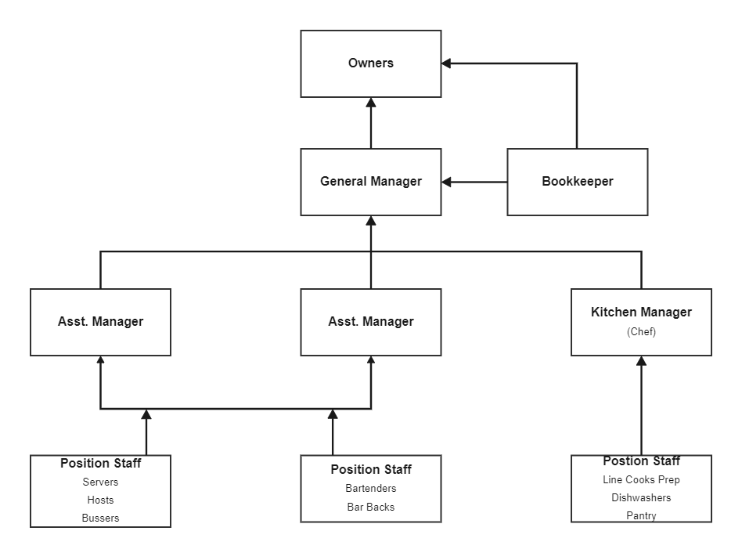
2.4 INTRODUCTION OF DEPARTMENT IN THE RESTUARANT
In order to run the Restaurant as a functional unit, there are several departments in a Restaurant which work and coordinate together and the major departments of the Restaurant are:
- Front Office Department
- Housekeeping Department
- Restaurant Department
- Kitchen Department
- Bar Operation
- Sale and Marketing Department
- Security Department
- Accounting Department
- Maintenance Department
- Purchasing Department
CHAPTER THREE
3.0 Experience at the Pent House Inn Hotel
The experience I had at the guest house would be summaried based on the section of the guest house I was posted to and I was only opportuned to work in four section in the Rotana Hotel.
3.1 THE BAR
- Checking of stock at resumption of duty.
- Stock confirmation and placing of order for item not available or those that are less.
- Welcoming of guest into the bar
- Taking order from guests and serving them.
- Cleaning of the bar after service
- Recording every sales made in relation to what is on the stock book.


3.2 THE FOOD AND BEVERAGE SECTION
This comprises of the restaurant and bar and I carried out the following task while serving there;

AT THE RESTAURANT
- Confirmation of menu each day from the chef
- Welcoming guest into the restaurant.
- Introduction of the menu to the guests and taking order the use of docket.
- Serving of guest accordingly
- Presentation of guests bills once they are done with their meals.
- Receive payment and record all payment made.
- Cleaning of the restaurant at the end of service each day
- Cleaning of tables after service
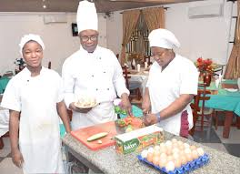

3.3 THE FRONT OFFICE
At the reception I carried out the following task.
- Welcoming of guests.
- Selling of accommodation
- Directing guest on how to fill their registration forms
- Checking in of guest
- Checking out of guests and dealing with settlement of bill.
- Handling enquiries and providing information when needed.
- Allocation of rooms.
- Preparation of guest lodger
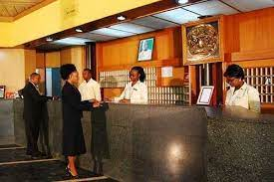
3.4 HOUSE KEEPING
At the house keeping section I carried out the following task;
- Receives key from the reception for rooms that the guests have checking.
- Dusts all items available in the rooms.
- Checking that all appliance are in good working condition and any fault notice is then reported to the reception.
- Change the bed layings and lay new beddings properly.
- Dusts, sweep and mop the rooms and toilet properly.
- Sweeping and cleaning of all passages.
- Checking for forgotten items and retuning such items to the receptions for identification and claims.
- Leaving cleaned rooms open for 15 minute for ventilation and for the rooms to dry properly.
- Handling over all used bed sheet and blanket to the laundry.
- Handling over keys of cleaned rooms over to the reception.
- Rooms still are cleaned only when permission is being granted by the guest occupying the rooms.

CHAPTER FOUR
4.0 INTRODUCTION OF ACTIVITIES ACQUIRED IN THE RESTUARANT
During the four (4) month period i used in my Student Industrial Work Experience Scheme (SIWES), they taught me on how to carry a large number of tasks in the restaurant and also satisfying customers is their major concern, some of their major concern include
  - Ensuring that the Restaurant environment is serene and of high hygienic standard to ensure customers comfort.
  - Ensuring customers safety and security during their stay in the Restaurant
  - The need and importance of good hygiene and how best to attend to customers.
  - The importance of serving meal corporately.
4.1 SECTION/DEPARTMENT I WAS PRIVILEGED TO WORK IN THE RESTUARANT
There are various departments in the Restaurant but I was privileged to work in the following departments which are
- Front Office Department
- Kitchen Section
- Restaurant Department
- House Keeping Department
4.1.1 FRONT OFFICE DEPARTMENT: -
The front office specifically refers to the area where customers first arrive at the Restaurant. The function of front office is to directly get in touch with customers, The front office can discover more information about the customer by asking them questions, also helping the customers out. This area is also called the reception area.
WORKS EXPERIENCE IN FRONT OFFICE DEPARTMENT
- I was taught how to welcome and attend to guest
- I was taught how to pick calls on the telecoms
- I learn how to relate with nagging guest as a front office staff
- I was taught how to check-in guest on the system and taking quest to rooms
- I was taught how to check-out guest
- Making sure guest is satisfied through the first impression
- I was taught how to do bookings/ reservation for guest
- I was taught how to activate different room keys to guest
- I was taught how to write receipt on the system and on receipt slip
- I was taught how to resolve issues with guest

INTER-COM P.O.S MACHINE
4.1.2 KITCHEN SECTION
kitchen is command central of any Restaurant, the place where food gets ordered, prepped, cooked, and plated before being served to customers. Whether it's spacious or tiny, if a Restaurant kitchen is carefully designed, its staff can consistently deliver hundreds of meals in an evening. Defining the different sections of the kitchen helps to increase the ease and productivity to the safety of the kitchen staff, when it pertains to food production.
- The Receiving section
- The Storage section
- The preparation and production section
- The service section
- The dishes and cleaning section
WORK EXPERIENCE IN KITCHEN SECTION
- I was introduce to different types of equipment used in the kitchen
- I was taught how to Keep proper record of all food items in stock both frozen and dry foods.
- I was taught how to make the whole kitchen environment clean and tidy
- I was shown how to take guest order and preparing of customer dish and deliver it to their various rooms
- I was taught different dishes like Amala, gbegiri and Ewedu, semovita with ogbono soup, omelete and arabiata, white rice, fried plantain e.tc.
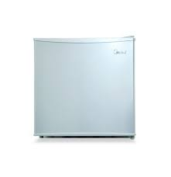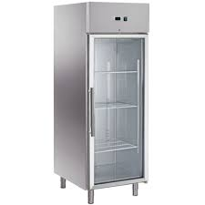
FRIDGE CHILLER

4.1.3 RECIPES AND METHOD OF PREPARATION OF FRIED RICE
RECIPES
- Rice
- Chicken stock and Chicken stock cube
- Onion
- Vegetable carrot
- Groundnut Oil
- Sweet corn and Sweet peas
- Beef Liver cubed
- Curry powder and Thyme
- Salt
- Scallions diced
- Cayenne pepper
- All Purpose Seasonings
- Water, As Needed

METHOD OF PREPARATION
1. Put some oil in a clean pot. Add the pepper, ginger, garlic and onions and allow to fry for about 3 minutes. Then, pour the stock water into the pot.
2. Add curry, thyme and stock cubes. Then add salt to taste.
3. Pour the parboiled rice into the mixture and mix. Add some warm water to just below the level of the rice.
4. Allow the rice to steam for 20-30 minutes on medium to low heat, checking on it at intervals.
5. When the rice is soft, add the chopped vegetables on top of the rice for them to steam.
6. When rice is done, turn off heat and stir. Allow to settle.
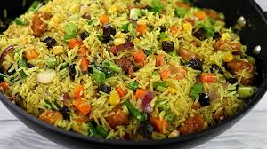
FRIED RICE

SPAGHETTI BOLOGNESE RECIPE
Spaghetti Bolognese is a classic Italian dish that has found a permanent place in kitchens worldwide. Its rich and hearty flavors, coupled with the simplicity of its preparation, make it a go-to choice for families, gatherings, or solo dining.It originates from the city of Bologna, Italy. The marriage of this rich meat sauce with pasta, specifically spaghetti is one worth trying in your household.

Ingredients for spaghetti bolognese recipe
To make a truly delicious Spaghetti Bolognese, you’ll need the following ingredients:
- Ground Meat: can be beef, pork or a mix of beef and pork, but you can use any ground protein of your choice
- Onions and garlic: For the aromatic base for the sauce.
- Canned Tomatoes: Choose high-quality canned tomatoes for a rich tomato flavor.
- Tomato Paste: For concentrated tomato flavor.
- Herbs and Spices: Typically, bay leaves, thyme, oregano for a depth of flavour
- Beef bullion: this adds more depth to the sauce.
- Sugar: a bit controversial, but it cuts the acidity of the tomatoes
- Salt and Pepper: To taste.
- Oil: For sautéing and flavor.

Preparing the sauce
The key to a great Spaghetti Bolognese is patience. Here’s a step-by-step guide to preparing the sauce:
- Heat olive oil in a large pot.
- Sauté the onions and garlic
- Add ground meat. Brown the meat while breaking it apart with a spoon.
- Stir in the tomato paste, canned tomatoes, herbs, and spices and let it gently simmer.
- Add al dente pasta and pasta water, toss, reduce the heat and let it
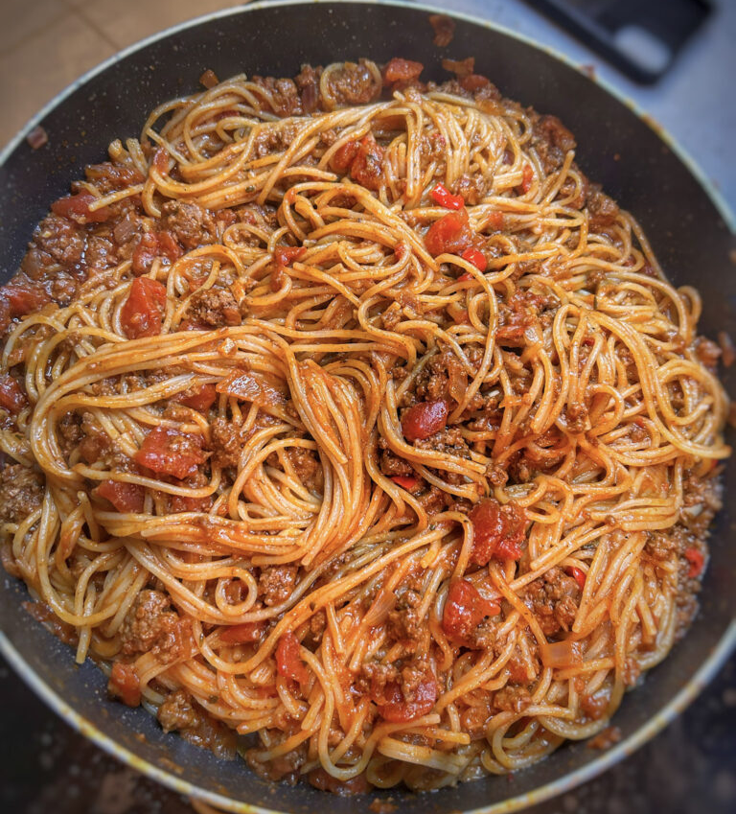

4.1.4 RECIPES AND METHOD OF PREPARATION OF MEAT PIE
i. Carrot,
ii. Irish Potatoes
iii. Minced meat
iv. corn flour
v. Ducros curry
vi. Onions
vii. cubes Seasoning
viii. Tyme
xi. Grounded galic (optional)
x. vegetable oil
xi. Dry Pepper
METHOD OF PREPARATION OF MEAT PIE SAUCE
Peel the Carrot and potatoes and cut into small sizes and set aside
Get a dry pot and put it on a low heat, then add little vetegable oil when it heat up
Add your chopped onions and stir to fry add your galic and minced beaf stir till brown color add water and your washed diced carrot and potatoes allow to cook for a few munite
Add dry pepper, salt, seasoning cube, curry and tyme cover the pot and allow it to cook.
Add your thickener (corn flour) to the sauce while you stir simultaneously to avoid the sauce having lumps mix it well and turn off the heat.
Turn it immediately in a tray and allow it to cool very well before using it for your pie.
PREPARATION OF THE DOUGH PIE
Ingredient
i. Flour
ii. Butter
iii. Eggs
vi. Salt
v. Sugar
vi. Baking Powder
vii. Water
In a large bowl mix flour, sugar, salt and baking powder
Add butter and rub it with the mixed flour until you get a crumbly texture, beat egg and water add it the flour mixture mix until dough it formed do not over mix.
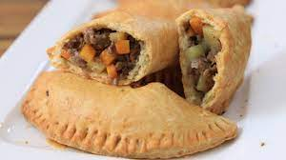
Ingredients
- 500g strong white bread flour
- 60g golden caster sugar
- 15g fresh yeast, crumbled
- 4 eggs
- ½ lemon, zested
- 2 tsp fine sea salt
- 125g softened unsalted butter
- about 2 litres sunflower oil, for deep-frying
- caster sugar, for tossing
- 300g jam for filling
Method
STEP 1
Put 150g water and all the dough ingredients, apart from the butter, into the bowl of a mixer with a beater paddle. Mix on a medium speed for 8 mins or until the dough starts coming away from the sides and forms a ball. Turn off the mixer and let the dough rest for 1 min.

STEP 2
Start the mixer up again on a medium speed and slowly add the butter to the dough – about 25g at a time. Once it's all incorporated, mix on high speed for 5 mins until the dough is glossy, smooth and very elastic when pulled.
STEP 3
Cover the bowl with cling film or a clean tea towel and leave to prove until it's doubled in size. Knock back the dough in the bowl briefly, then re-cover and put in the fridge to chill overnight.
STEP 4
The next day, take the dough out of the fridge and cut it into 50g pieces (you should get about 20).
STEP 5
Roll the dough pieces into smooth, tight buns and place them on a floured baking tray, leaving plenty of room between them, as you don’t want them to stick together while they prove.
STEP 6
Cover loosely with cling film and leave for 4 hrs or until doubled in size. Fill your deep-fat fryer or heavy-based saucepan halfway with oil. Heat the oil to 180C. Read our guide on how to deep-fry safely for more essential information.
STEP 7
When the oil is heated, carefully slide the doughnuts from the tray using a floured pastry scraper. Taking care not to deflate them, put them into the oil. Do 2-3 per batch, depending on the size of your fryer or pan.
STEP 8
Fry for 2 mins each side until golden brown – they puff up and float, so you may need to gently push them down after about 1 min to help them colour evenly.
STEP 9
Remove the doughnuts from the fryer and place them on kitchen paper.
STEP 10
Toss the doughnuts in a bowl of caster sugar while still warm. Repeat the steps until all the doughnuts are fried, but keep checking the oil temperature is correct – if it's too high, they will burn and be raw in the middle; if it's too low, the oil will be absorbed into the doughnuts and they will become greasy. Set aside to cool before filling.
STEP 11
To fill the doughnuts, make a hole with a small knife in the crease of each one, anywhere around the white line between the fried top and bottom.
STEP 12
Fill a piping bag with jam and pipe into the doughnut until nicely swollen – about 1 tbsp per doughnut. After filling, the doughnuts are best eaten straight away, but will keep in an airtight tin.

4.1.5 THE RESTAURANT DEPARTMENT
Restaurant operations, in the simplest terms, are various activities that are carried out in a restaurant to run the business. These include all activities involved in the preparation of food, customer service, cleaning, purchasing raw materials, accounting, reporting, etc.
PREPARATION OF SEMOVITA AND EGUSI

INGREDIENTS
- Golden Penny Semovita
- 2 Cups Melon
- 1 Cup Palm Oil or a little more or less depending on preference
- 4 Tbsp Crayfish
- 3 Tbsp locust beans
- Chopped spinach Ugu
- 1 Red Bell Pepper Tatashe
- 1 Habanero Pepper Ata Rodo
- 1 Fresno Pepper Shombo
- 2 Onions
- Stock Cube Optional
- 1 lb Beef Tripe Assorted meat, Dry Fish and Cow Leg
- Salt To Taste
- Instructions
- Blend the peppers and Onions together until smooth and set aside.
- Wash your stock fish and set aside.
- Boil your beef stock and set aside.
- Blend the Egusi melon, half of the second Onion, and Crayfish together. Set aside as well.
- Heat the Palm Oil in a pan and allow it to melt over medium heat but don't overheat the Oil. Add the remaining half onion (diced) and half of the Locust bean. Let it cook for about 3 minutes on medium heat.
- Add the blended pepper and cook till the water is reduced, this should take about 15 minutes on medium heat until the water is reduced stirring about every 5 minutes to prevent burning.
- Add the remaining locust bean, Beef stock, and salt to taste. Cover and leave to cook for another 5 minutes
- Gently introduce the blended Egusi inside the sauce but don't stir it at this point. Just cover it and leave it to cook for about 20 to 30 minutes Keep an eye on it so it doesn't burn but try not to stir it until the Egusi turns into a soft compact mass. Then, gently stir together and add more stock or water if necessary.
- Add the Fish and meat and leave to cook again for another 5 minutes.
- Stir in the Spinach and leave to simmer for about 5 minutes (stir constantly). Adjust the seasoning if necessary.
- Serve with Golden Penny Semovita.

WORKS EXPERIENCE IN RESTAURANT DEPARTMENT
- I was shown the morning routines which are, cleaning of tables, chairs, sweeping and mopping of the floor, washing and sterilizing of the cutleries, opening of windows to allow fresh airs
- I was taught the procedure of serving food, i.e. when serving rice, wrap knife, fork, and spoon with a serviette. For spaghetti/noodles, wrap knife with fork and pin it with a toothpick
- I was taught different types of dishes/meals with beverages and their price
- I learn how to account for the sales of the day
- Making sure the food environment is clean and germ free
- I was taught how to take guest order
- I was taught how to input food and beverages on the system
- I was taught the process of writing requisition/ impress which will be approved by the director and the purchasing officer will purchase the items needed
- I learn how to receive and cross-checking of goods and checking of expiring date
- I learn how to keep a proper record of daily sales by using control sheet

TABLE SETTING WISKY CUP

4.1.6 HOUSEKEEPING DEPARTMENT: -
Housekeeping is the department that essentially deals with cleanliness and the ancillary service. Housekeeping may be defined as “a provision of Clean, comfortable and safe environment”, and one who does so is commonly known as Housekeeper.

WORK EXPERIENCE IN HOUSEKEEPING DEPARTMENT
- I was introduce to different equipment used in housekeeping department
- I was taught how to keep the environment clean like sweeping, picking of bottles on the ground and dispose them to the appropriate place
- I was taught how to do room dusting and learn different types of dusting
- I was shown the procedures of cleaning room
- I learn how to clean the rest room perfectly and put the necessary things in the appropriate place

MOPPING STICK AND BUCKET

4.2 CHALENGES FACE IN THE RESTUARANT
- Change in marketing trends and dynamics.
- Operational issues.
- Housekeeping issues.
- Change in guest expectations.
- Irregular cash inflows.
- Data security challenges.

CHAPTER FIVE
5.1 PROBLEMS ENCOUNTERED DURING SIWES
There are numerous problems I encountered during my Industrial Training Programme Pent house Inn Hotel.
The Major Problems Are:
- Problem of Securing a Place of Attachment:- I had most of problem searching for a place of attachment for my Industrial Training because most of the companies rejected my request giving one reason or the other that they don’t want IT student.
- Problems of Light:- Light is the major thing an establishment needs for proper running, and also for comfort of the guest and functioning of the facilities and equipment in an establishment but the absent of light bring about discomfort of the guest and poor management of the establishment.
- Inadequate facilities:- the establishment didn’t provide any accommodation for the I.T student
5.2 IMPACT CREATED
1. Introduction of uniform to be warned by the staffs of the establishment.
2. Suggestion on proper stock taking and records to the establishment.
3. Suggestion on how to improve staff to staff as well as staffs to customer relationship
4. Suggestion on good maintenance procedure to be followed to avoid frequent breakdown of equipment which leads to a break in services.
5.3 CONCLUSION
In conclusion, I personally gained a lot of practical experience at ROTANA HOTEL, the industry has over the year brings a furtherance understanding and practical. The industrial training has a lot of advantages. It is therefore a must do for students because it has shown the difference between the theoretical knowledge and the practical aspect of analysis as a course, in which the government and the institution should emulate and maintain the continuity of this good act.
5.4 RECOMMENDATION
I hereby recommend that student on SIWES training programme should be much more focus throughout the SIWES training and they should pay more attention to the work that is been carried out, and student performance during the SIWES should be rewarded in order to motivate them to do more

