
TECHNICAL REPORT ON THE STUDENT INDUSTRIAL WORK EXPERIENCE
SCHEME (SIWES)

HELD AT
SOBI 101.9 FM
WALI SUM HOUSE SOBI HILL OFF SHAO ROAD ILORIN KWARA STATE.
BY
ABDULKAREEM NOFISAT ABISOLA
ND/23/MAC/PT/0393

SUBMITTED TO:
THE DEPAERTMENT OF MASS COMMUNICATION, KWARA STATE POLYTECHNIC, ILORIN. INSTITUTION OF INFORMATION AND COMMUNICATION TECHNOLOGY(I.I.C.T). KWARA STATE POLYTECHNIC, PMB 1375 ILORIN KWARA STATE.
IN PARTIAL FULFILMENT OF THE REQUIREMENT FOR THE AWARD OF NATIONAL DIPLOMA (ND) CERTIFICATE.

AUGUST – NOVEMBER, 2024.

DEDICATION
This report is dedicated to Almighty God for His guidance, wisdom, and strength throughout my industrial training. I also dedicate this work to my parents, lecturers, and mentors for their unwavering support and encouragement.

ACKNOWLEDGEMENT
I would like to express my sincere gratitude to the management and staff of Sobi FM 101.9 for giving me the opportunity to undergo my SIWES training at their esteemed organization. Special thanks to my supervisor in person of Mr. KUDIRAT .O. AYANWOLA and colleagues who provided valuable guidance and support during my training period.
I extend my appreciation to my lecturers and the Industrial Training Fund (ITF) for making this program possible. Lastly, I appreciate my family and friends for their encouragement throughout my learning journey.

PREFACE
This report documents my Student Industrial Work Experience Scheme (SIWES) training at Sobi FM 101.9, Ilorin, Kwara State. It provides insights into the various tasks and responsibilities assigned to me, the skills acquired, and the challenges encountered during my training.
The aim of this report is to give a comprehensive overview of my practical experience and to serve as a reference for future interns seeking knowledge about the broadcasting industry. The report is structured into five chapters covering different aspects of my training experience.

REPORT OVERVIEW
This SIWES report presents a detailed account of my industrial training experience at Sobi FM 101.9. The report is divided into six chapters:
- Chapter One: Introduction, including the background, objectives of SIWES, a brief history of Sobi FM, and the purpose of the report.
- Chapter Two: Organizational profile of Sobi FM 101.9, detailing its structure, services, and operations.
- Chapter Three: Industrial training activities, including the departments worked in, responsibilities undertaken, and challenges encountered. Skills acquired and lessons learned during the training period.
- Chapter Four:: Tools and equipment used in the broadcasting industry.
- Chapter Five Conclusion and recommendations for future interns and Sobi FM 101.9.

TABLE OF CONTENTS
Dedication
Acknowledgement
Preface
Report Overview
Chapter One: Introduction
1.1 Background of SIWES
1.2 Objectives of SIWES
1.3 Brief History of Sobi FM 101.9
1.4 Purpose of the Report
Chapter Two: Organization Profile
2.1 Introduction to Sobi FM 101.9
2.2 Organizational Structure
2.3 Services Offered
Chapter Three: Industrial Training Activities
3.1 Departments Worked In
3.2 Responsibilities and Tasks Undertaken
3.3 Challenges Encountered
Chapter Four: Skills Acquired and Lessons Learned
4.1 Technical Skills Acquired
4.2 Soft Skills Acquired
4.3 Lessons Learned
4.4Tools and Equipment Used
4.5 List of Tools and Equipment
4.6 Importance of the Tools and Equipment
Chapter Five: Conclusion and Recommendations
5.1 Summary of Experience
5.2 Recommendations for Future Interns
5.3 Recommendations for Sobi FM 101.9
5.4 Conclusion

CHAPTER ONE

INTRODUCTION

1.1 BACKGROUND OF SIWES
The Student Industrial Work Experience Scheme (SIWES) is a skill acquisition program designed to expose students to real-life work environments. It is a program mandated by the Industrial Training Fund (ITF) for students in technical, engineering, and media-related fields to bridge the gap between theoretical knowledge and practical application.
It is a programme required to be undertaken by all students of tertiary institutions in Nigeria pursuing courses in“specialized engineering, technical, business, applied sciences and applied arts and Mass Communication".
The Federal Government on 8th October 1971 established the industrial training (ITF) to acquaint the students on the industrial work method. The SIWES which is a subsidiary formed in 1973 was initiated to improve the students technical abilities to expose them to industrial culture thereby getting the acquainted with the role to play towards the technological advancement of the nation.
It creates an avenue on environment in which the students are exposed to areas of their various disciplines to enhance their mental and creative minds in the aspects of Practical.
It is therefore a practical aspect of the academic work; which students may not have opportunity to carry out throughout their stay in the higher institutions.

1.2 OBJECTIVES OF SIWES
The primary objectives of SIWES include:
- Providing students with practical exposure to their field of study.
- Enhancing student understanding of industrial operations and challenges.
- Developing technical and professional skills in a real work setting.
- Bridging the gap between academic knowledge and industry practices.

1.3 BRIFS HISTORY OF SOBI FM 101.9
Sobi FM 101.9 is a leading radio broadcasting station in Ilorin, Kwara State. It was established to provide top-quality news, entertainment, and educational programs to the community. The station is renowned for its unbiased news coverage, interactive programs, and engaging talk shows.
The station was founded to address the growing demand for an independent and people-oriented broadcasting platform in Kwara State and its environs. Since its inception, Sobi FM has grown to become one of the most influential radio stations in the region, known for its professionalism, high-quality programming, and commitment to community service.
With a strategic location at Wali Sum House, Sobi Hill, Off Shao Road, Ilorin, the station enjoys a wide signal reach, covering most parts of Kwara State and neighboring states. Sobi FM 101.9 is particularly known for its focus on local content, investigative journalism, and programs that engage the public on socio-political, economic, and entertainment issues. The station operates 24/7, delivering news updates, interviews, music, and various interactive programs to keep its audience informed and entertained.

1.4 PURPOSE OF THE REPORT
This report documents my experiences, tasks, and lessons learned during my SIWES at Sobi FM 101.9. It serves as a comprehensive account of my industrial exposure and provides recommendations for future participants.

CHAPTER TWO

ORGANIZATION PROFILE

2.1 INTRODUCTION TO SOBI FM 101.9
Sobi FM 101.9 is a privately-owned radio station situated at Wali Sum House, Sobi Hill, Off Shao Road, Ilorin, Kwara State. The station is known for its wide reach and diverse programming that caters to various demographics in the region.

2.2 ORGANIZATIONAL STRUCTURE
The organizational structure of Sobi FM 101.9 includes:
- General Manager
- Program Director
- News and Current Affairs Team
- Production Team
- Technical/Engineering Team
- Marketing and Advertising Department

2.3 SERVICES OFFERED
The services provided by Sobi FM include:
- News broadcasting
- Live talk shows and interviews
- Music and entertainment programs
- Advertisement and sponsorships
- Public enlightenment and educational programs

CHAPTER THREE

INDUSTRIAL TRAINING ACTIVITIES

3.1 DEPARTMENT WORKED IN
During my SIWES training, I was assigned to different departments within Sobi FM, including:
- News and Current Affairs
- Program Production
- Engineering and Technical Support

3.2 Responsibilities and Tasks Undertaken
Some of my key responsibilities during the training included:
- Assisting in news script writing and reporting.
- Participating in live radio productions and interviews.
- Handling basic sound editing and audio mixing.
- Learning and observing the use of broadcasting equipment.
- Supporting the technical team in setting up and maintaining studio equipment.
- Engaging with listeners through phone-in sessions and social media platforms.

3.3 Challenges Encountered
Some challenges faced during the training include:
- Adapting to the fast-paced work environment.
- Technical difficulties with broadcasting equipment.
- Handling real-time audience engagement.
- Limited resources for production.

3.4 LISTS OF TOOLS AND EQUIPMENTS

TOOLS AND EQUIPMENT USED

During my SIWES training at Sobi FM 101.9, I worked with various tools and equipment essential for radio broadcasting. These include:
- Microphones
Used for capturing high-quality audio during live broadcasts, interviews, and recordings.

Microphones
- Mixing Console
A crucial device for adjusting and balancing audio signals from multiple sources before broadcasting.

Mixing Console
- Computers and Editing Software
Used for recording, editing, and processing audio using software like Adobe Audition.
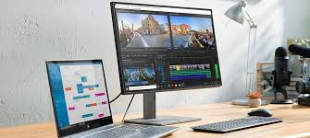
Computers and Editing Software
- Transmitters
Essential for sending out radio signals to reach the target audience.
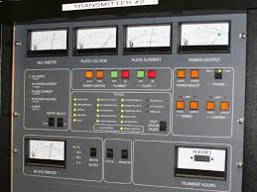
Transmitters
- Headphones
Used by presenters and engineers to monitor audio quality and communication during live broadcasts.

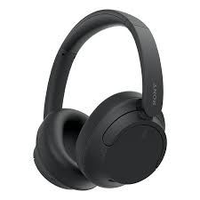Headphones

- Studio Monitors
High-quality speakers used in the production room for accurate audio playback.
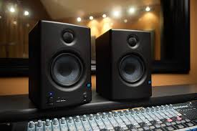
Studio Monitors
- Telephone Hybrid System
Allows phone calls to be integrated into live shows, enabling audience participation.
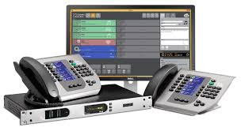 Telephone Hybrid System
- Audio Processors
Enhances sound quality before transmission to ensure clear and professional output.
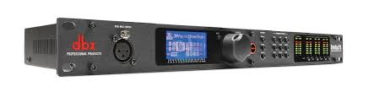
Audio Processors
- Radio Automation Software
Used to schedule and manage programs, advertisements, and music playlists.
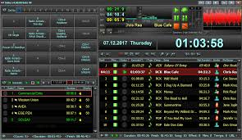
Radio Automation Software

- Recording Devices
Portable devices used for on-field interviews and audio capturing outside the studio.
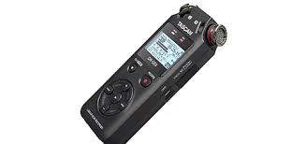Recording Devices

3.5 IMPORTANCES OF THE TOOLS AND EQUIPMENT
Each of these tools and equipment plays a vital role in ensuring seamless broadcasting operations at Sobi FM 101.9. The combination of hardware and software helps produce high-quality content, maintain clear audio signals, and enhance the listening experience for audiences.

CHAPTER FOUR

SKILLS ACQUIRED AND LESSONS LEARNED

4.1 Technical Skills Acquired
- News scriptwriting and editing.
- Audio recording and editing using industry-standard software.
- Operation and maintenance of studio equipment.
- Live broadcasting and radio presentation techniques.

4.2 Soft Skills Acquired
- Effective communication and teamwork.
- Time management and multitasking.
- Problem-solving in a professional setting.
- Adaptability and quick thinking in live broadcasting situations.

4.3 Lessons Learned
- The importance of accurate and objective journalism.
- The role of teamwork in media production.
- The impact of radio broadcasting on society.
- The significance of audience engagement in media.

CHAPTER FIVE

CONCLUSION AND RECOMMENDATIONS

5.1 Summary of Experience
The SIWES training at Sobi FM 101.9 provided invaluable hands-on experience in radio broadcasting. It bridged the gap between theoretical learning and industry practice, equipping me with both technical and interpersonal skills.
I was actively involved in assisting with live programs, scriptwriting, editing, and sound engineering, which deepened my understanding of broadcasting technology and programming. Additionally, I learned the importance of teamwork, effective communication, and meeting tight deadlines in a fast-paced media environment.
The challenges I encountered, such as handling technical issues, adapting to time constraints, and maintaining professionalism during broadcasts, helped strengthen my problem-solving skills and ability to work under pressure. My supervisors and colleagues provided continuous mentorship and support, ensuring that I gained practical knowledge beyond what is taught in the classroom.
Overall, my experience at Sobi FM 101.9 was transformative, equipping me with relevant skills in media production, communication, and teamwork. The knowledge gained during this training has enhanced my confidence and prepared me for future career opportunities in the broadcasting and media industry.

5.2 Recommendations for Future Interns
- Future interns should be proactive in learning and engaging in tasks.
- They should familiarize themselves with broadcasting software before commencing training.
- They should seek mentorship from experienced professionals in the industry.

5.3 Recommendations for Sobi FM 101.9
- Provide more structured training sessions for interns.
- Enhance technical equipment for better broadcasting quality.
- Increase interactive engagement opportunities for interns.

5.4 Conclusion
My time at Sobi FM 101.9 was both educational and fulfilling. The experience broadened my understanding of radio broadcasting and media operations. The skills and knowledge acquired will significantly contribute to my future career in the industry.

