

A TECHNICAL REPORT ON
STUDENT INDUSTRIAL WORKING EXPERIENCE SCHEME
(SIWES)

HELD AT
FEDERAL MORTGAGE BANK OF NIGERIA
ASA-DAM RD, OKO ERIN 240281, KWARA STATE
BY
ADEBAYO SALAMAT ENIOLA
ND/23/BFN/FT/0141

SUBMITTED TO

DEPARTMENT OF BANKING AND FINANCE
INSTITUTE OF FINANCIAL MANAGEMENT STUDIES
KWARA STATE POLYTECHNIC, ILORIN

INPARTIAL FULFILLMENT OF THE AWARD OF THE REQUIREMENT OF THE AWARD OF NATIONAL DIPLOMA IN BANKING AND FINANCE

AUGUST. – NOVEMBER. 2024
DEDICATION
I dedicate this technical report to the Almighty God, the giver of knowledge, wisdom and who is rich in mercy.

ACKNOWLEDGEMENT
I would like to begin by expressing my heartfelt gratitude to the Creator of heaven and earth, the One who knows the beginning and the end, the Alpha and the Omega, the Almighty Allah for His guidance and blessings throughout this journey.
I am deeply grateful to my beloved parents, Mr. and Mrs. Adebayo whose unwavering support and prayers have been my foundation. To my brothers and dear friends, your encouragement and companionship have meant the world to me.
I also extend my profound appreciation to everyone who supported me during my SIWES experience. May the Almighty God bless, protect, sustain, and guide you through all of life’s journeys.
Lastly, I wish to express my sincere regards to the school’s Board of Trustees and the entire staff of the banking and finance department for their dedication and support. Once again, a big thank you to everyone who contributed to making this experience a memorable and successful one.

TABLE OF CONTENT
Title page
Table of content
Dedication
Acknowledgements

TABLE OF CONTENTS
CHAPTER ONE
  - Background of SIWES
  - Objectives of SIWES
CHAPTER TWO
2.1. History of the organization
2.2. Structure of the Organization
2.3. Organogram of the Organization
CHAPTER THREE
3.0 Experience gained and lesson learned
CHAPTER FOUR
4.0 Challenges faced and assignment participation
CHAPTER FIVE
5.1 Summary
5.2 Recommendation
5.3 Conclusion

CHAPTER ONE
- INTRODUCTION
The students industrial work experience scheme (SIWES) is a skill training program that is designed by the federal government to expose and prepare students of university, polytechnic and colleges of education for industrial work situation that they might likely meet before or after graduation. Before the establishment of scheme was a growing concern among our industrialist that graduates of our institutions of higher learning lacked adequate practical background preparatory for employment in industries.
The main objective of the program is to bridge the gap between theories and practical by making it possible for students to get themselves exposed to real jobs and actual situation and environments. It is therefore an important and mandatory component of training in the accredited disciplines or courses like Banking and finance etc
1.1 INDUSTRIAL TRAINING FUND (ITF) AND SIWES
SIWES was founded by ITF in 1973 to address the issue of Nigerian tertiary school graduates lacking sufficient practical skills to prepare them for employment in industries. The program exposes students to industry-based skills that are essential for a seamless transition from the classroom to the workplace. It gives tertiary institution students the chance to become acquainted with and exposed to the necessary experience in operating machinery and equipment, which is typically not available in educational institutions.
Participation in industrial training is a well-known educational strategy. Classroom studies are integrated with learning through hands-on work experiences in a field related to the students’ academic major and career goals. Successful internships foster an experiential learning process that not only promotes career preparation, but provides opportunities for learning to develop skills necessary to become leaders in their chosen professions.
One of the primary goals of the SIWES is to help students integrate leadership development into the experiential learning process. Students are expected to learn and develop basic non-profit leadership skills through a mentoring relationship with innovative non-profit leaders. By integrating leadership development activities into the industrial training experience, we hope to encourage students to actively engage in non-profit managements as professional career objectives. However, the effectiveness of the SIWES experience will have varying outcomes based upon the individual student, the work assignment, and the supervisor/mentor requirements. It is vital that each internship position description includes specific, written learning objectivities to ensure leadership skill development is incorporated.
Participation in SIWES has become a necessary pre-condition for the award of diplona and degrees certificates in specific practical-oriented disciplines in most institutions of higher learning in the country, in accordance with the education
policy of government operators-the ITF, the coordinating agencies (NUC, NCCE and NBTE), employers of labor and the institutions.
1.2 Objectives of the Students Industrial Work Experience Scheme (SIWES)
1. To provide students the opportunity to test their interest in a particular career before permanent commitments are made.
2. To provide an avenue for students in institutions of higher learning, acquire industrial skills and experience in their course of study.
3. To provide and prepare students for the industrial work situation they are to meet after school.
4. To aid students in adjusting from college to full-time employments
5. To provide students the opportunity to develop attitudes conducive to effective interpersonal relationships.
6. To increase students’ sense of responsibility.
7. To make students acquire good work habits.
8. To provide students with an opportunity to apply their knowledge in real work situation thereby bridging the gap between theory and practice.

CHAPTER TWO
2.0 History of Federal Mortgage Bank, Ilorin Branch
The Federal Mortgage Bank of Nigeria (FMBN) established its Ilorin branch as part of its nationwide expansion to provide mortgage financing and support housing development in Kwara State. Over the years, the branch has played a key role in ensuring that residents, particularly civil servants and low to middle-income earners, have access to affordable housing through various financial interventions.
As part of its mandate, the Ilorin branch has facilitated access to the National Housing Fund (NHF), a scheme designed to provide long-term, low-interest mortgage loans to Nigerian workers. Through this initiative, many contributors in the state have been able to secure home loans for the acquisition, construction, and renovation of properties. The branch has also been instrumental in financing housing projects in collaboration with developers and cooperative societies, ensuring that more people can own homes through structured mortgage plans.
One of the significant milestones in the branch’s history was its involvement in large-scale housing projects across Kwara State. In recent years, the bank has financed numerous housing estates, including those developed through partnerships with housing cooperatives. These projects have provided hundreds of housing units for beneficiaries, further cementing the role of the Ilorin branch in addressing the state’s housing deficit.
Beyond financing new developments, the Ilorin branch has also focused on home renovation loans, allowing homeowners to improve their living conditions. By disbursing substantial funds to civil servants and other workers, the branch has contributed to housing upgrades, ensuring that people not only have access to homes but also live in decent environments.
Throughout its history, the Ilorin branch of FMBN has maintained a commitment to expanding mortgage access and reducing financial barriers to homeownership. Its operations continue to evolve, adapting to economic changes and housing demands, while remaining a crucial institution in the state's real estate and housing finance sector.
2.1 Organizational Background
The Federal Mortgage Bank of Nigeria (FMBN) was established to serve as the apex mortgage institution in Nigeria, with the primary goal of promoting accessible and affordable homeownership. Its origins trace back to 1956 when it was first created as the Nigerian Building Society (NBS). In 1977, the government transformed the NBS into the Federal Mortgage Bank of Nigeria (FMBN), expanding its role to regulate and provide funding for mortgage institutions across the country.
As a government-owned institution, the FMBN operates under the supervision of the Federal Ministry of Housing and Urban Development. Its core mandate is to facilitate the growth of Nigeria’s housing sector by providing long-term credit facilities to mortgage institutions and ensuring that Nigerians, especially low- and middle-income earners, have access to affordable housing finance.
One of its most significant initiatives is the National Housing Fund (NHF), which was established in 1992 to mobilize funds for mortgage lending. Through this scheme, Nigerian workers contribute a small percentage of their salaries, which is pooled to provide low-interest mortgage loans for housing development, purchase, and renovation.
FMBN also collaborates with Primary Mortgage Banks (PMBs), housing cooperatives, and real estate developers to implement housing projects nationwide. Over the years, the bank has expanded its loan offerings, including home renovation loans, cooperative housing development loans, and construction loans to support the real estate sector.
The organizational structure of FMBN includes a Board of Directors, led by a Managing Director and key executive members who oversee its various operational departments. The bank has branches across Nigeria, including in Ilorin, Kwara State, ensuring nationwide coverage and accessibility to its mortgage services.
FMBN continues to play a crucial role in bridging Nigeria’s housing deficit by providing sustainable mortgage financing, promoting homeownership, and driving policies that enhance housing sector development.

2.2 Organization structure of federal mortgage bank
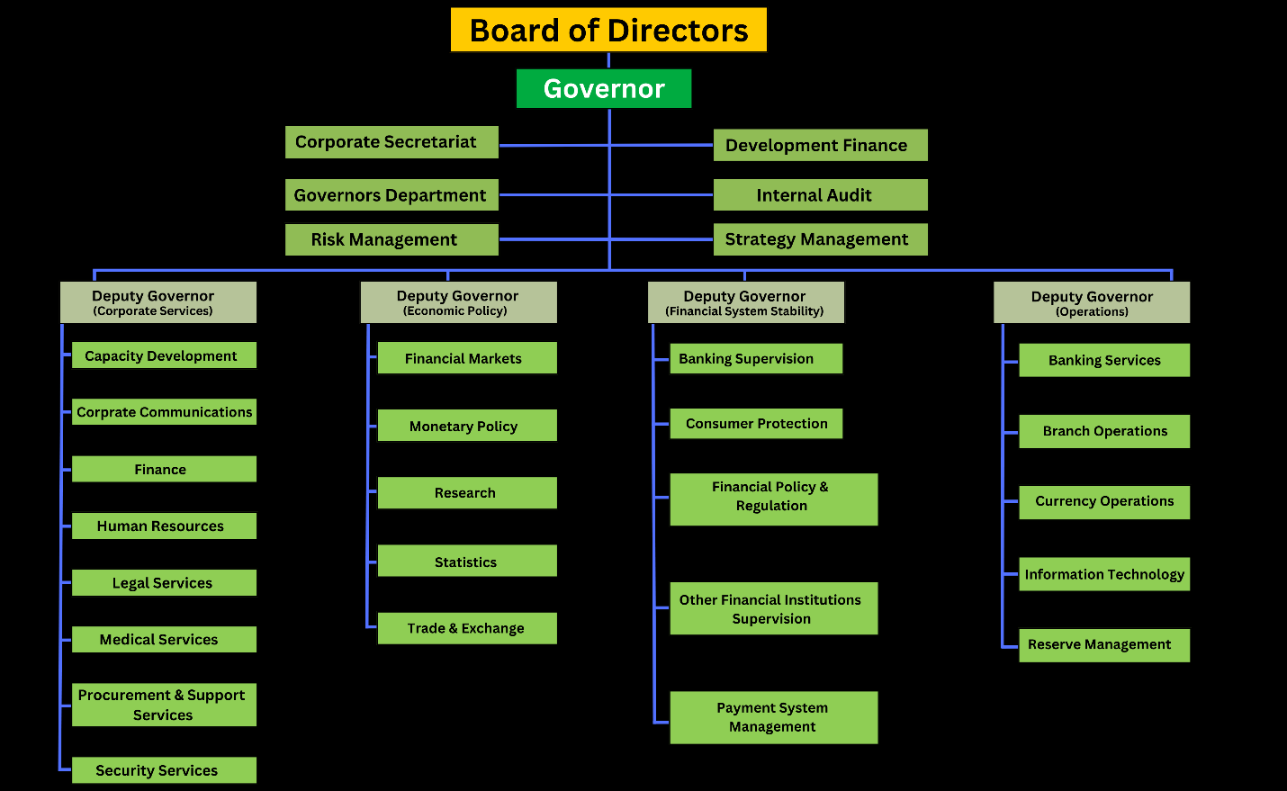

1. Board of Directors:
The Board is responsible for setting the overall direction and policy of the bank.
It comprises a Chairman appointed by the President, representatives from the Federal Ministry of Works and Housing, and the Central Bank of Nigeria.
2. Management Team:
Managing Director/Chief Executive:
Leads the bank's operations and is responsible for its overall performance.
Executive Directors:
Oversee key areas of the bank's operations, including:
Finance and Corporate Services: Responsible for the bank's financial management and corporate affairs.
Loans and Mortgage Services: Oversees the bank's lending activities and mortgage operations.
Business Development & Portfolio Management: Focuses on developing new business opportunities and managing the bank's portfolio.
3. Directorates/Departments:
Finance and Account Directorate: Manages the bank's financial resources and accounting functions.
Loans and Mortgage Services Directorate: Handles the processing and management of mortgage loans.
Business Development & Portfolio Management Directorate: Focuses on attracting new business and managing the bank's portfolio.
Management Service Directorate: Handles human resources and other administrative functions.
Research & Innovation Development Directorate: Conducts research and develops new products and services.
Project Implementation Directorate: Oversees the implementation of housing projects.
Estate Services Directorate: Manages the bank's real estate assets.

CHAPTER THREE
SIWES EXPERIENCED GAINED AND LESSON LEARNED
3.0 Introduction
The Student Industrial Work Experience Scheme (SIWES) is a crucial aspect of academic training that bridges the gap between classroom knowledge and practical application in the industry. As a Banking and Finance student, I had the opportunity to undergo my SIWES training at the Federal Mortgage Bank of Nigeria (FMBN), Ilorin Branch, where I gained valuable hands-on experience in banking operations, mortgage financing, and customer service.
3.1 Experience Gained
During my time at FMBN, I was exposed to various banking functions, particularly those related to mortgage banking. Some of the key experiences gained include:
1. Understanding Mortgage Financing:
- I learned about the National Housing Fund (NHF) and how it operates, including how customers contribute and qualify for mortgage loans.
- I gained insight into the process of loan disbursement, repayment structures, and risk assessment involved in mortgage financing.
2. Banking Operations and Documentation:
- I assisted in handling customer files, loan applications, and mortgage agreements while ensuring compliance with banking regulations.
- I became familiar with financial documentation such as credit appraisals, loan application forms, and mortgage account statements.
3. Customer Service and Relationship Management:
- I learned how to interact professionally with customers, respond to inquiries about mortgage financing, and guide them through the loan application process.
- I observed how bank officials handle customer complaints and queries efficiently to maintain good customer relations.
4. Use of Banking Software and Record-Keeping:
- I gained experience in data entry, loan processing, and account reconciliation using banking software and digital record-keeping systems.
- I assisted in preparing reports and maintaining proper documentation of loan transactions.
5. Loan Processing and Risk Assessment:
- I was introduced to the procedures for loan application assessment, risk evaluation, and approval processes within the mortgage banking system.
- I observed how bank officials analyze customers’ creditworthiness before granting loans.
3.2 Lessons Learned
Throughout my SIWES training at FMBN, I acquired several important lessons that have enhanced my understanding of banking and finance:
1. The Importance of Mortgage Banking in Economic Development:
- I learned that housing finance is a critical sector that helps improve the standard of living and contributes to national development.
- Affordable mortgage financing plays a key role in reducing Nigeria’s housing deficit.
2. Practical Application of Banking Theories:
- I saw how the theories of financial management, risk assessment, and credit analysis taught in class are applied in real-world banking operations.
3. Professionalism and Workplace Ethics:
- I understood the importance of teamwork, time management, confidentiality, and compliance with banking regulations in the financial sector.
4. Customer Relationship Management:
- Effective communication skills and the ability to handle customer complaints professionally are crucial in the banking industry.
5. Regulatory Compliance and Banking Policies:
- I became aware of how banks adhere to government policies, financial regulations, and the Central Bank of Nigeria (CBN) guidelines in their operations.

CHAPTER FOUR
CHALLENGES FACED AND ASSIGNMENT PARTICIPATION
4.1 CHALLENGES FACED
During my SIWES training at the Federal Mortgage Bank of Nigeria, Ilorin Branch, I faced several challenges that tested my adaptability and learning capacity. At the beginning, adjusting to the professional banking environment was quite overwhelming. Coming from an academic setting where theories were emphasized, stepping into a real-world financial institution required me to quickly grasp practical banking operations, especially those related to mortgage financing.
One of the biggest difficulties I encountered was understanding the complex processes involved in mortgage loan applications, disbursement, and repayment. Initially, the banking terminologies and documentation seemed technical, and I struggled to keep up with the workflow. I had to ask a lot of questions and dedicate extra time to studying various files and banking procedures to fully understand how things worked.
Another challenge I faced was dealing with customers. Many of them had inquiries about their loan applications or contributions to the National Housing Fund (NHF), and I sometimes found it difficult to provide immediate answers. Since I was still learning, I often had to refer customers to senior colleagues, which made me feel inadequate at times. However, with time and experience, I gained confidence in assisting customers and answering their questions more effectively.
The use of banking software was another hurdle. Although I had theoretical knowledge of financial management, working with real banking systems and digital records required practical skills that I initially lacked. I had to learn how to input data accurately, process loan applications, and generate reports while ensuring that all transactions were properly documented. Any mistake in data entry could cause errors in loan processing, so I had to be extremely careful and pay close attention to details.
Workplace expectations also posed a challenge. I had to adjust to strict professional ethics, such as maintaining confidentiality, adhering to banking regulations, and meeting deadlines. Unlike in school, where I had flexible schedules, working in a structured environment required discipline, punctuality, and a high level of responsibility. The pressure to deliver accurate results within set timeframes was sometimes stressful, but it helped me develop time management skills and a strong work ethic.
Despite these challenges, my SIWES experience at FMBN was incredibly rewarding. Each difficulty I encountered became an opportunity to learn and improve. Over time, I became more comfortable with banking operations, customer service, and financial documentation, making my training a valuable step toward my career in banking and finance.
4.2 Assignments Undertaken
One of my primary responsibilities was assisting in the processing of National Housing Fund (NHF) applications. This involved organizing customer files, verifying contributions, and ensuring all required documents were properly submitted for loan processing. I also participated in the loan documentation process, where I helped in sorting and filing mortgage agreements, credit appraisals, and customer records.
Another significant assignment was data entry and record-keeping, where I worked with banking software to update customer details, track loan applications, and generate reports. Accuracy was crucial in this task, as any errors could lead to discrepancies in loan processing.
I was also involved in customer service operations, assisting clients with inquiries related to their NHF contributions, mortgage loan applications, and repayment schedules. This role enhanced my communication skills and taught me how to handle customers professionally.
Additionally, I observed and assisted in the loan disbursement and repayment tracking process, gaining insight into how mortgage loans are approved, released, and monitored to ensure timely repayment.

CHAPTER FIVE
SUMMARY, RECOMMENDATION AND CONCLUSION
5.1 Summary
The industrial training provided an opportunity to gain practical knowledge of banking operations, particularly in mortgage financing and financial services. The experience enhanced my understanding of loan processing, customer service, documentation, and the use of banking software. Through hands-on assignments, I was able to apply theoretical knowledge in real-world scenarios, improving my problem-solving skills and professionalism. Although there were initial challenges, such as adapting to the banking environment and understanding complex financial processes, these obstacles helped strengthen my ability to learn and adjust to new situations.
5.2 Recommendation
To enhance the effectiveness of industrial training programs, organizations should provide structured orientation sessions to familiarize interns with workplace operations. Assigning mentors or supervisors to guide trainees would improve learning efficiency and ensure better engagement in tasks. Additionally, providing access to practical banking tools and encouraging more active participation in core financial activities would help interns gain deeper insights into industry operations.
5.3 Conclusion
The training experience contributed significantly to professional and personal growth by offering valuable exposure to financial and mortgage banking operations. It helped develop technical skills, teamwork, and a better understanding of workplace expectations. The knowledge and competencies acquired will be beneficial in future career pursuits, reinforcing the importance of practical training in bridging the gap between academic learning and industry practices.

