

A TECHNICAL REPORT ON
STUDENT INDUSTRIAL WORK EXPERIENCE SCHEME
(SIWES)

HELD AT:
GREATNESS DOOR INVESTMENT LIMITED
PLOT 5, PEACE ESTATE, LISA TOWN, SANGO OTTA IJOKO OGUN STATE

WRITTEN BY
ISIAKA AYOMIDE TEMILOLUWA
ND/23/PSM/PT/0028

SUBMITTED TO
DEPARTMENT OF PURCHASING AND SUPPLY CHAIN MANAGEMENT,
INSTITUTE OF FINANCE MANAGEMENT STUDIES (IFMS)
KWARA STATE POLYTECHNIC, ILORIN

IN PARTIAL FULFILLMENT OF THE REQUIREMENTS FOR THE
AWARD OF NATIONAL DIPLOMA (ND) IN PURCHASING AND SUPPLY CHAIN MANAGEMENT
AUGUST –NOVEMBER, 2024
DEDICATION
This report is dedicated foremost to Almighty Allah for his favour may and grace upon my life especially during my 4 months Siwes programme.
I would also like to dedicate it to my lovely parent and siblings for their love and support and everyone else that contribute towards making my Siwes training fun and successful one

ACKNOWLEDGEMENT
My profound gratitude to Almighty Allah for keeping me alive, the giver and taker of lives and also extend my gratitude to my parent for their supports and prayers toward my every step in life. I pray my parent live long to eat the fruit of their labour
My sincere appreciation also goes to my parent Mr. and Mrs. Isiaka for their spiritual, moral and financially support towards the success of my SIWES programme.
I sincerely appreciate the management and staff of the company, especially my supervisor Dr. Popoola for their support, guidance, and knowledge shared during my SIWES. I also extend my gratitude to my supervisors and lecturers for their continuous encouragement and constructive feedback throughout the program.

TABLE OF CONTENTS
Title Page i
Dedication ii
Acknowledgement iii
Table of Contents vi
CHAPTER ONE
1.0 Introduction to Training Programme 1
1.1 Objective of the programme to student 2
CHAPTER TWO

2.1 Historical Background of the Pure Water Industry 2
2.2 Organization Chart 3
CHAPTER THREE

3.0 INDUSTRIAL TRAINING ACTIVITIES 4

3.1 Department/Sections Worked 4

3.2 Description of Daily Activities 5
3.3. Sales Record Keeping 6
3.4. Importance of Record Keeping in Pure Water Business 6
CHAPTER FOUR

4.1 Knowledge and Skills Acquired 7

4.2 Challenges Encountered 9
CHAPTER FIVE
5.1 Conclusion 10

5.2 Recommendations 10

CHAPTER ONE

INTRODUCTION

1.1 Background of SIWES
The Student Industrial Work Experience Scheme (SIWES) is a program designed to provide students with practical experience in their field of study. It serves as a bridge between theoretical knowledge and industrial application, allowing students to gain hands-on skills and industry exposure.
The students Industrial Work Experience Scheme (SIWES) was initiated in 1973 by the Industrial Training Fund (ITF). This was to update practical knowledge of students in the Universities, Polytechnics and College of Technology. It was aimed at bridging the gap between the theoretical knowledge acquired in classes and technical knowledge in the industries by providing students with opportunities to apply their educational knowledge in real work situations.
Over the years, SIWES has contributed immensely to building the common pool of technical and allied skills available to the Nigerian economy which are needed for the nation’s industrial development.
Furthermore, the place and relevance of SIWES is underscored by the fact that the scheme contributes to improving the quality of technical skills generally available in the pool from which employers’ source technical manpower.

1.2 Objectives of SIWES
- To expose students to real industrial environments.
- To develop practical skills relevant to their field of study.
- To understand the operations and challenges in the pure water production industry.
- To improve technical competency and employability.

CHAPTER TWO

2.1 Historical Background of the Pure Water Industry
The packaged water industry has grown significantly over the years due to increasing demand for safe and hygienic drinking water. The concept of bottled and sachet water dates back to ancient times when people stored water in clay pots and animal skins for preservation. However, modern commercial water packaging began in the early 2018.
In Nigeria and many other developing countries, the demand for packaged water surged in the late 20th century due to urbanization, population growth, and concerns over the safety of public water supply. The introduction of sachet water, commonly known as “pure water,” revolutionized the industry, making clean drinking water more affordable and accessible. This innovation emerged in the late 2018 providing a cost-effective alternative to bottled water.
As regulatory bodies such as the National Agency for Food and Drug Administration and Control (NAFDAC) and the Standards Organisation of Nigeria (SON) established quality control measures, the industry saw improvements in production standards, hygiene, and packaging technology. Today, the pure water industry plays a crucial role in public health and economic development, with thousands of factories producing and distributing purified drinking water nationwide.

2.2 Organization Chart

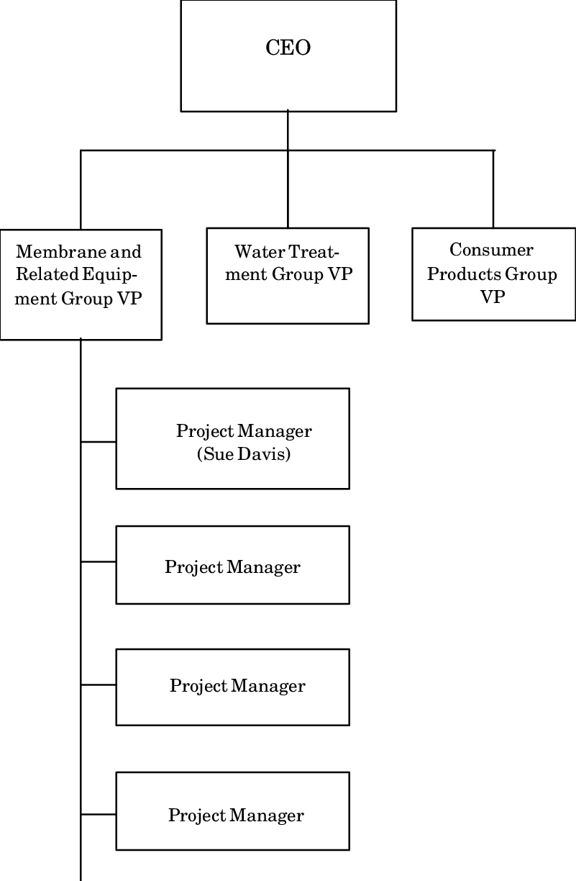

CHAPTER THREE

3.0 INDUSTRIAL TRAINING ACTIVITIES
1. Introduction Pure water production is a vital industry that provides safe and clean drinking water to the public. Effective record-keeping is crucial for managing production efficiency, ensuring quality control, and maintaining accurate sales records. This report outlines the processes involved in pure water production and the best practices for record-keeping in sales.
2. Pure Water Production Process The production of pure water involves several stages to ensure the removal of contaminants and impurities. The key steps include:
- Water Sourcing: Water is obtained from boreholes, municipal supply, or other sources.
- Filtration: The raw water passes through sand and carbon filters to remove physical and chemical impurities.
- Reverse Osmosis: This process removes dissolved solids and contaminants.
- UV Sterilization and Ozonation: These processes help eliminate bacteria, viruses, and other pathogens.
- Bottling and Packaging: The purified water is sealed in sachets, bottles, or dispensers under hygienic conditions.
- Storage and Distribution: The final products are stored properly before distribution to retailers and customers.

3.1 Department/Sections Worked
During my training at [Pure Water Factory Name], I worked in the following sections:
- Water Treatment Section – Understanding the processes involved in water purification, such as filtration, reverse osmosis, and disinfection.
- Packaging and Sealing Unit – Observing and assisting in the bottling and sealing of water sachets and bottles.
- Quality Control Department – Conducting tests to ensure water meets regulatory standards.
- Maintenance and Equipment Handling – Assisting in the maintenance of purification machines and packaging equipment.
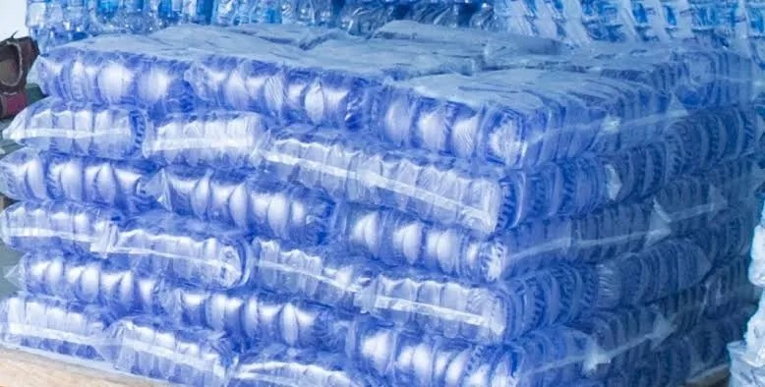

3.2 Description of Daily Activities
- Monitoring the filtration process and checking pH levels.
- Assisting in the operation of UV sterilization and ozone treatment.
- Observing and participating in the automatic sealing of sachet water.
- Engaging in routine cleaning and maintenance of production machines.
- Conducting quality control tests such as Total Dissolved Solids (TDS) and microbial testing.
- Recording daily production data and assisting in report preparation.
3.3. Sales Record Keeping
Maintaining proper sales records is essential for monitoring business performance, tracking inventory, and ensuring financial accountability. Effective sales record-keeping includes:
- Daily Sales Log: Documenting the quantity of water sold, unit prices, and total revenue.
- Customer Database: Keeping a record of wholesale and retail customers for follow-up and marketing.
- Invoice and Receipt Management: Issuing receipts for every transaction to track payments.
- Stock Inventory: Monitoring raw materials and finished products to prevent shortages.
- Cash Flow Management: Keeping track of income and expenses to ensure profitability.
3.4. Importance of Record Keeping in Pure Water Business
Proper record-keeping offers several benefits, including:
- Improved financial tracking and profitability analysis.
- Enhanced accountability and fraud prevention.
- Better customer relationship management.
- Compliance with regulatory standards.
- Informed decision-making for business growth.

CHAPTER FOUR

EXPERIENCE GAINED AND CHALLENGES FACED

4.1 Knowledge and Skills Acquired
- Understanding of different water treatment techniques.
Water treatment techniques involve a series of physical, chemical, and biological processes to remove contaminants from water, typically including steps like sedimentation, coagulation/flocculation, filtration, and disinfection, with the specific methods depending on the source water quality and desired outcome; common techniques include: filtration (sand, carbon), coagulation/flocculation, sedimentation, disinfection (chlorination, UV radiation), reverse osmosis, and ion exchange; each process plays a role in removing different types of particles, bacteria, and other contaminants from water to make it safe for consumption.
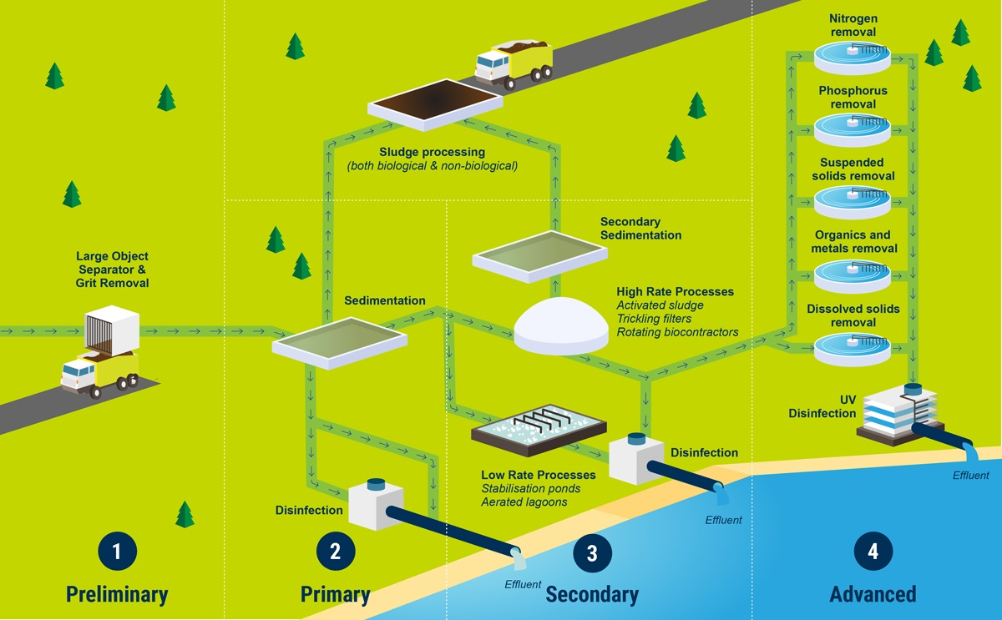
- Practical experience in operating purification equipment.
Practical experience in operating purification equipment" means having hands-on experience with running and maintaining machinery used to remove contaminants from a substance, such as water or air, including tasks like monitoring parameters, adjusting settings, troubleshooting malfunctions, and performing routine maintenance on filtration systems, reverse osmosis units, UV sterilizers, and other purification devices.
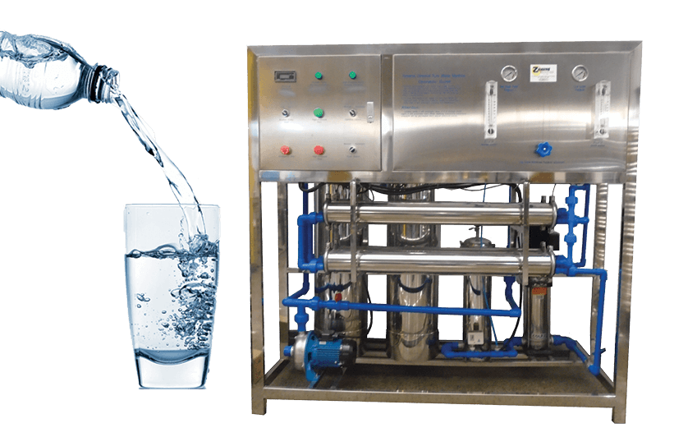
- Knowledge of quality control measures in water production.
- Exposure to industrial safety standards and hygiene protocols.
- Teamwork and communication skills in an industrial setting.
- Hands-on experience in maintaining purchase records and tracking inventory.

4.2 Challenges Encountered
- High operational costs and frequent machine breakdowns.
- Stringent regulatory compliance requirements.
- Physical demands of working in a factory environment.
- Learning curve in understanding technical aspects of water treatment.
- Managing stock records efficiently to avoid shortages or over-purchasing.

CHAPTER FIVE

CONCLUSION AND RECOMMENDATIONS

5.1 Conclusion
The SIWES program at Greatness Door Investment Limited was a valuable learning experience. It provided me with hands-on knowledge of water purification, packaging, and quality control. The training enhanced my understanding of industrial operations and their practical application in my field of study.

5.2 Recommendations
- The company should invest in advanced automation to reduce manual labor.
- Regular training sessions for employees on quality control and safety.
- Government and regulatory bodies should support small-scale water producers to improve compliance with standards.
- Future SIWES students should be given more opportunities for hands-on involvement in technical aspects.

