

A TECHNICAL REPORT
ON
STUDENT INDUSTRIAL WORK EXPERIENCE SCHEME
(SIWES)

HELD AT
KENKID LANDS AND CONTRACT
NO 107 BESIDE BEKIND FILLING STATION, UNIVERSITY ROAD, TANKE, ILORIN, KWARA STATE

BY
JIMOH MURITALA ABIODUN
ND/21/QTS/FT/0018

SUBMITTED TO:
DEPARTMENT OF QUANTITY SURVEY, INSTITUTE OF TECHNOLOGY (I.O.T), KWARA STATE POLYTECHNIC, ILORIN

IN PARTIAL FULFILLMENT OF REQUIREMENT FOR THE AWARD OF NATIONAL DIPLOMA (ND) IN QUANTITY SURVEY

SEPTEMBER - DECEMBER 2023

DEDICATION
This Siwes report is dedicated to Almighty God for his protection, kindness, strength over my life and also to my parents for their financial support and moral care towards me.

ACKNOWLEDGEMENT
I acknowledge with gratitude to Almighty GOD for the successful completion of this Siwes.
My Appreciation goes to all staffs and H.O.D of Quantity Survey Department who has contributed in one way or the other to the completion of this Siwes.
I also appreciate the effort of my parent in person of Mr. and Mrs. Jimoh for their morally, spiritually and financially support, i pray that almighty God should be with them.
Lastly i extend and express my appreciation to my friends for their moral support during the write up i say thank you to Kenkid Land and Contract and all my lecturers may God continue to bless you all abundantly.

PREFACE
The student industrial work experience scheme (SIWES) helps in exposing students to the practical application of their course and to get used to equipment and machines used in the factory. The SIWES was established to promote student skills in industrial practice and pre-expose them to working experience in industrial setting.
The SIWES program covered a period of four months from September to December 2023 and it is a partial fulfillment of a two years academic program to obtain an OND certification in Engineering. The report explains the description of the work done.

TABLE OF CONTENTS
Title Page
Dedication i
Acknowledgements ii
Preface iii
Table of contents iv

CHAPTER ONE: INTRODUCTION ON STUDENTS INDUSTRIAL WORK EXPERIENCE SCHEME (SIWES)
  - Background on SIWES
  - Aim and Objectives of SIWES

CHAPTER TWO: DESCRIPTION OF THE ESTABLISHMENT OF ATTACHMENT
2.1 Location and brief history of establishment
2.2 Objectives of establishment
2.3 Organization Structure/Organogram of The Establishment
2.4 Various Departments/Units and Their Function
2.5 Department Posted to and My Duties Over There

CHAPTER THREE: WORK DONE AND EXPERIENCE GAINED AT THE PLACE OF ATTACHMENT
3.1 Site Investigation
3.2 Method of Land Measurement
3.3 Type of Surveying Equipment and their uses

CHAPTER FOUR: SUMMARY, CONCLUSION AND RECOMMENDATION
4.1 Summary of attachment activities
4.2 Problems encountered during the program
4.3 Conclusion
4.4 Recommendation

CHAPTER 1
- INTRODUCTION
1.1 BACKGROUND OF SIWES
SIWES was established by industrial training fund (ITF) in 1973 to solve the problem of lack of adequate practical skills preparatory for employment in industries by Nigerian graduates of tertiary of institutions. That is, the needs to enable students match their theoretical school knowledge with the practical aspect of their training industry. The author stressed further that it was in realization of this that the ITF when it was established, set out to study the extent to which the theoretical knowledge that students in engineering technology and other allied fields In Nigerian Institutions offering technology-based courses related to the kind of work experience expected of them by employers. Also, it prepares student for employment and makes the transition from school to the world of work easier after graduation.
Over the years, SIWES has contributed immensely to building the common pool and allied skills available to the Nigerian economy which are needed for the nation’s industrial development.

1.2 AIMS AND OBJECTIVES OF SIWES
Industrial Training (IT) provides an avenue for students in an institution higher learning to acquire industries skills and experience in their course of study.

THE OBJECTIVES ARE AS FOLLOWS:
- It provides an avenue for students in institution of higher learning to acquire industrial skill and experience during their course of study
- The program teaches the students on how to interact effectively with other workers and supervisors under various conditions in organization
- It expose students to work methods and techniques in handling equipment and machine that may not be available in educational institution
- Introduce students to real work atmosphere so that they know what they would most likely meet once they graduate
- It makes the transition from school to the world of work easier and enhance students contact for later jobs placements and a chance to evaluate companies for which they might wish to work

AIMS OF SIWES
The SIWES is aimed at helping/training students in the Nigerian tertiary institution the practical aspect of their field of study by exposing students to machines and equipment, professional work.

CHAPTER 2
- DESCRIPTION OF THE ESTABLISHMENT OF ATTACHMENT
2.1 LOCATION AND BRIEF HISTORY OF THE ESTABLISHMENT
Kenkid Lands and Contract, Ilorin is a Non-Governmental Business. A sole Proprietorship Business been operated in Ilorin, Kwara State.
The Department is located at No 107 beside Bekind filling station, University road, Tanke, Ilorin, Kwara State.

2.2 OBJECTIVES OF ESTABLISHMENT
The objectives of Kenkid Lands and Contract includes provision of adequate amenities such as sales of lands and contract work (I.e building contract and lots more) within the state in other for the citizen to enjoy the betterment of the Non-Government operation.
2.3 ORGANIZATION STRUCTURE/ORGANOGRAM OF THE ESTABLISHMENT
Managing Director

Secretary

Labourer
Surveyor
Architect
Engineer
Builder

2.4 VARIOUS DEPARTMENTS/UNITS AND THEIR FUNCTION
There are two major departments in Kenkid lands and contract which includes;
- Land Surveyor: They oversee all administrative activities in support of land measurement and evaluation
2. Contract Department: This section deals with every contract work awarded to the organization or available from the Government that can be obtain.

2.5 DEPARTMENT POSTED TO AND MY DUTIES OVER THERE
I was posted to the field operation department throughout my programme in the company and my duties there is to observe how land survey is been carried out and measured, observing the materials used on site, the functions of the machine used on site, supervise machine operators and giving report to the site engineers, taking road measurement from one drainage to another, assisting the engineer to take records of daily activities of whatever happens on sites and observe the test result carried out e.g. slump test, tray test incite density test e.t.c

CHAPTER THREE
3.0 WORK DONE AND EXPERIENCE GAINED AT THE PLACE OF ATTACHMENT
3.1 Site Investigation
One of the experienced gained after been recognized and introduced to the workers on site was how to take a land measurement.
Land measurement is the process of finding the exact co-ordinate of a piece of land. It can be a unit of measurement such as hectares, acres, square feet, square meters (sqm).
3.2 Method of Land Measurement
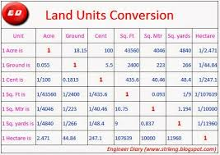
To measure land, surveyors typically use a method called land surveying, which involves physically measuring the boundaries and dimensions of a piece of land using tools like measuring tapes, theodolites, and GPS, then calculating the area using geometry and trigonometry, often converting the measurements to a standard unit like acres or hectares depending on the location; this process usually includes identifying reference points and marking boundaries on the land itself.

3.3 Type of Surveying Equipment and their uses;

A land surveyor uses instruments to make precise measurements of the earth’s surface. From determining property boundaries to preparing construction sites, surveyors rely on certain equipment to do their jobs properly.

Below is a summary of eight different types of surveying equipment and their uses:

1. Chains and Tapes

Taking accurate measurements is one of the most important tasks a land surveyor must complete. There is a variety of tools that can be used to take measurements including tapes, rulers, chains, and laser devices. Pocket tapes are ideal for small-scale measurements while measuring wheels, nylon coated steel tapes (Nyclad tapes), and fiberglass tape measures can be used for larger distances.

Nyclad Tape Measures – Ideal for jobs requiring accurate measurements in harsh climates or inclement weather, nylon-coated steel tapes offer a flexible and durable option with the added benefit of an expansion coefficient similar to that of a steel drag chain.

Fiberglass Tape Measures – Available in a variety of lengths, fiberglass tape measures are plastic-coated for durability but remain lightweight enough for easy portability and are less likely to kink the way a steel tape can.

Measuring Wheels – Also known as a surveyor’s wheel, measuring wheels feature a rotating wheel that measures the distance between two points while walking and is best suited for inspection or estimation work.

Laser Measuring Devices – For the ultimate in precise measurement, laser technology is capable of measuring inclination, slope distance, and azimuth, in addition to making both vertical and horizontal calculations.

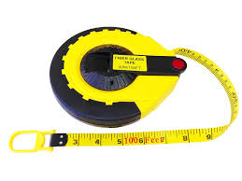
View Laser Technology, Inc. products for utilities inspection and forestry work.

2. Compasses and Clinometers

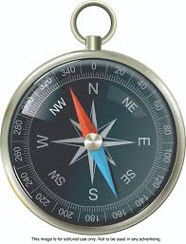
A compass is an essential piece of equipment when surveying in unfamiliar territory, backcountry, or just orienting your position on a map. Compasses can be used to measure distances between two points while clinometers are used to measure the angle or elevation of slopes.

3. Transits and Theodolites

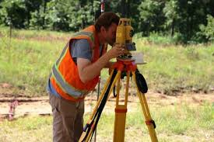
These tools are used to measure both horizontal and vertical angles. Both tools have a minimum accuracy of one minute of angle, though the theodolite is generally recognized as the more accurate of the two, measuring angles to an accuracy of one-tenth of a second angle.

4. Levels

A level can be used to read an elevation and determine differences in elevation between two points. These tools can be handheld, optical or digital, and are typically used in conjunction with level rods or tripods.

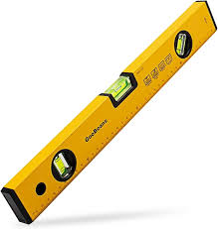

5. Safety Gear

Land surveyors work in all kinds of conditions and climates, but safety is always the primary concern. High-visibility gear and safety headwear are a must for all outdoor work crews.

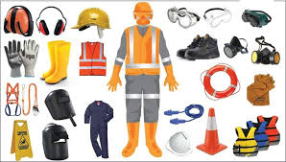

6. Prisms and Reflectors

Prism systems are used to secure control points at a comfortable and accessible height for pinpoint accuracy. These devices can be mounted on surveying poles and used in conjunction with electronic distance measuring (EDM) instruments for improved accuracy.

7. Magnetic Locators

When conducting a land survey, it is necessary to identify the location of certain features, such as manhole and utility covers, steel and iron pipes, underground tanks, and survey corner markers. Magnetic locators can be used to quickly and precisely locate ferrous materials like iron, steel, and rebar.

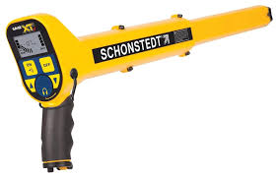

8. Poles, Tripods, and Mounts

Even the most precise of surveying instruments can be thrown off by an unstable mount. Poles, tripods, and other mounting accessories are essential for surveyors to ensure solid, stable readings. These mounts can be used for all kinds of surveying equipment, including prisms, lasers, and levels.
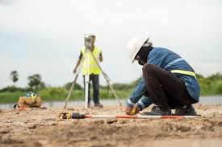

CHAPTER FOUR
SUMMARY, CONCLUSION AND RECOMMENDATION
4.1 Problems encountered during the program
The major problems encountered during my stay at the Kenkid Lands and Contracts are the longevity of working hours, working from 8am to 6pm with only an hour rest. Also, the lack of storage and processing facilities is a major setback on site.

4.2 Conclusion
Kenkid Lands and Contracts initiate Quantity Survey students into knowing the key importance in making Proper Land Measurement, construction of roads and building and more so how to set a foundation right in all construction.

4.3 Recommendation
Kenkid Lands and Contracts which happen to be a Non-Government firm should be encourage in all states and also the citizen should embrace them for better construction of roads and building.

