TECHNICAL REPORT ON STUDENT
INDUSTRIAL WORK EXPERIENCE SCHEME
(SIWES)

WITH

AMUWO ODOFIN MATERNAL AND CHILD
CENTER, FESTAC, LAGOS STATE.

BY

OJOLOWO-KORIBAT-OMOLAYO
ND/23/NAD/FT/0046
DEPARTMENT OF NUTRITION AND
DEITETICS

KWARA STATE POLYTECHNICS, ILORIN
AUGUST – DECEMBER 2024

`
CHAPTER ONE
1.1. About SIWES
1.2. Brief History of SIWES
1.3. Objectives and scope of SIWES
1.4. History and location of establishment of attachment
1.5. Vision and mission of establishment
1.6. Organization structure (Organogram)
1.7. The various department in the organization and their functions

CHAPTER TWO
2.1. Health talks to lactating mothers
2.2. Health talks to pregnant woman
2.3. Food Demonstration practical

CHAPTER THREE
3.1. Dietary counseling on diabetic, hypertension, and GDM patient
3.2. General Ward rounds at MMC
3.3. General counseling

CHAPTER FOUR
4.1. Description of kitchen
4.2. Areas of kitchen

CHAPTER FIVE
5.1. Summary
5.2. Conclusion
5.3. Recommendation
5.4. Problems encountered during the program

ACKNOWLEDGEMENT

I would like to take this opportunity to acknowledge God for his guidance throughout my journey. I am also deeply grateful to the staff of AOMCC for their support.
my special appreciation goes to my HOD, the nutritional officer of nutrition and dietetic department, Mr Aderounmu A.O and registered dietitian Ogundipe Gbemisola for their invaluable assistance during my SIWES program. Your encouragement and mentorship have been instrumental in my development. And I also give thanks to my parent for putting in so much effort to ensure I was attached to recognized establishment of my field (Nutrition and Dietetics) where I gained needed experienced to begin my career as a dietitian later in the future.

DEDICATION

This report is dedicated to God, whose guidance has been my strength.

CHAPTER ONE

ABOUT SIWES
SIWES stand for student industrial work experience scheme. It is a program designed to provide students, particularly in technical and vocational fields, with practical experience in their chosen industries.
The Scheme aims to bridge the gap between the orifical knowledge acquired in academic institution and practical skills needed in the work place. They work under the supervision of experienced professionals, which helps them develop essential skills, understand workplace dynamics, and gain insights into their chosen industries.
It also helps students understand industry standards tools and technology relevant to their studies
Moreover, completing SIWES often contributes to a student academic requirement and can enhance their employ ability. Because employers tend to favor candidates who have practical experience, as it indicates that they can adapt to the work environment and apply to their knowledge effectively.

HISTORY OF SIWES
The student industrial work experience scheme (SIWES) was established in Nigeria to enhance the educational experience of student in tertiary institutions by providing them with practical exposure to their fields to study. The scheme was initiated in the late 1970s and early 1980s as a response to the need for a more hands on approach to education, particularly in science and technology related disciplines. Over the years, the program has evolved to include various industries ensuring that student from different disciplines can benefit from practical training.
SIWES has become a vital part of the academic curriculum in many Nigeria universities and polytechnics, helping to prepare students for the workforce and contributing to the overall development of the country’s human resources. As industries continue to evolves, SIWES adapts to meet the changing needs of both students and employers, making it an essential component of higher education in Nigeria.
In 1980s, it became more structured, with guidelines established to standardize the experience across different institutions and industries it was crucial for ensuring that students received quality training and exposure to relevant technologies and practices.
As the Nigeria economy evolved, SIWES expanded to include a wider range of sectors beyond traditional engineering fields, embracing areas such as information technology, health science, and business management. This diversification allowed students from various academic backgrounds to gain practical experience, making them more competitive in the job market.
Today, SIWES is not just a requirement for graduation, it is also viewed as an essential stepping stone for students to launch their careers. Many organizations now actively participate in the program, recognizing the value of mentoring the next generation of professionals while also benefiting from the fresh perspectives and skills that students bring to their leams.

OBJECTIVES AND SCOPES OF SIWES.
OBJECTIVES
1. Practical work experience: Provide students with hand on industry experience.
2. Skills Department: Enhance student’s technical, entrepreneurial and soft skills.
3. Industry- Academic collaboration: Foster partnership between educational institutions and industries.
4. Employability Enhancement: Improve graduates job prospects.
5. Exposure to workplace culture: Familiarize student with industry operation and professional ethics.
6. Research and Development: Encourage student is contribute to industry innovation.
7. National Development: Develop skilled manpower for Nigeria’s economic growth.

SCOPES
1. Eligible Discipline: Engineering, Technology, Agriculture, health service, Education, social science and other approved field.
2. Participant institution: Accredited Nigeria tertiary institutions (Polytechnics, Universities and College of Education)
3. Student Eligibility: student enrolled in SIWES approved programs.
4. Industry participation: private and public sectors organization, including manicuring construction, agriculture, health and finance.
5. Duration: Typically, 4 – 6months for polytechnics students and 3 – 6months for universities students.
6. Geographical Coverage: Nationwide implementation across Nigeria.
7. Supervision and evaluation: I T F monitor student performance and industry feedback.

HISTORY AND LOCATION OF ESTABLISHMENTS
Amuwo Odofin material and child Centre (AOMCC) was commissioned on January 21/2014 with the core value of “respects for human lives” to provide quality health are service to residents of Amuwo Odofin.
AOMCC aims to reduce material and child mortality rates in line with sustainable Development goals 5b. To achieve this, the Centre offers integrated health care service for woman of child bearing age and children, equipment with modern equipment and furniture.
AOMCC also provide so many services which include prenatal, delivery and post-natal care, pediatric services, immunization and emergency care, and training and education for staff and the community on material and child health.

LOCATION OF ESTABLISHMENT
Amuwo Odofin material and child Centre (AOMCC) is located in Lagos, Nigeria at First Gate 1st Avenue

VISION AND MISSION OF ESTABLISHMENT
Vision is a statement that describes an organization hopes to achieve optimal health through innovative diet solution and technology.
Mission is a statement that define the organization purpose, what it does who it serves and how it serves them.
MISSION
Provide personalized dietary guidance and support while leveraging technology to enhance the accessibility and effectiveness of nutrition services.

ORGANOGRAM OF ESTABLISHMENT
ORGANIZATION STRUCTURE (INCLUDING ORGANOGRAM AMUWO ODOFIN MATERNAL AND CHILD CENTER, FESTAC, MANAGEMENT STRUCTURE
(ORGANOGRAM)
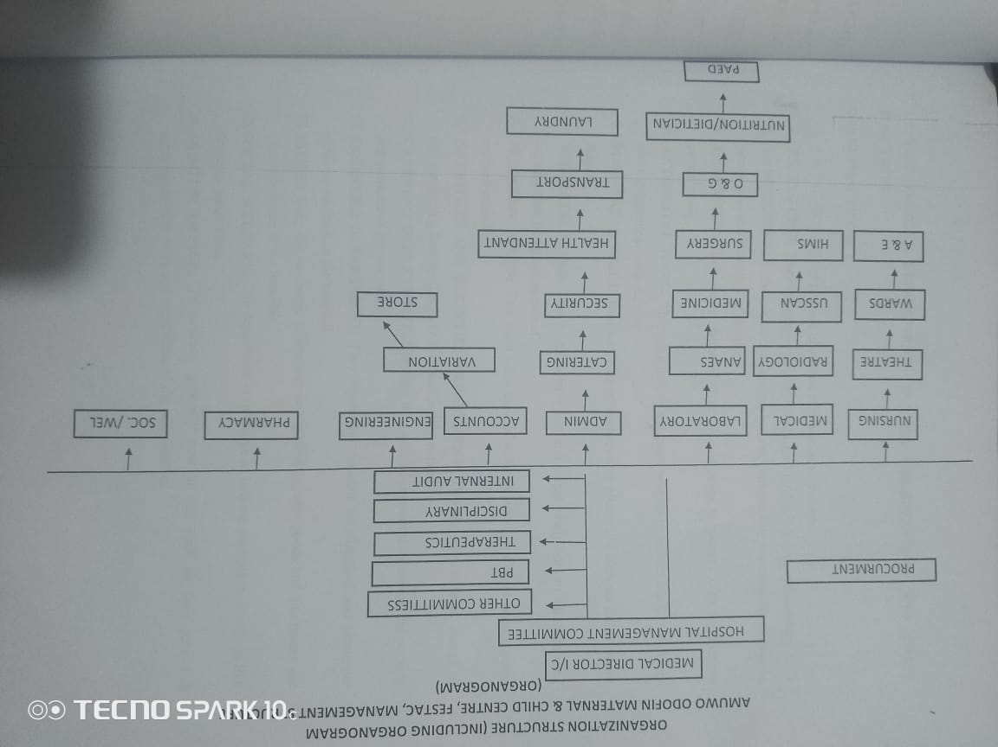

THE VARIOUS DEPARTMENT IN THE ORGANISM AND THEIR FUNCTIONS
1. Material care department: focuses on providing prenatal and post-natal care to ensure the health and well-being of mother during and after pregnancy.
2. Pediatric department: Offers health services for infants and children including regular check – up vaccinations and treatment of common childhood illnesses
3. Family planning Dept.: provides counselling and services related to families make informed choices about reproductive health.
4. Nutrition Department: works with dietitian to offer nutritional guidance and supports for mothers and children, promoting healthy eating habits.
5. Health Education Dept.: Aims to educate mother on various health topics, preventive health measure
6. Immunization Department: Responsible for administering vaccines to children, ensuring they are protected against preventable diseases.
7. Gynecology Department: Focuses on women’s reproductive health, offering services related to menstrual health, contraception and gynecological conditions.
8. Laboratory Services: provide diagnostic testing to support the health care services offered, including blood tests and other necessary examinations.
9. Emergency services: Offers immediate care for urgent health issues, ensuring that mothers and children receive timely medical attention when needed.
10. Mental Health Service: provide support and counselling for mental health issues particularly for new mother’s facing post – partum challenges.

CHAPTER TWO

HEALTH TALK TO LACTATING MOTHER’S

WHAT IS LACTATION
Lactation is the process by which a woman’s body produces milk to feed her baby after childbirth.

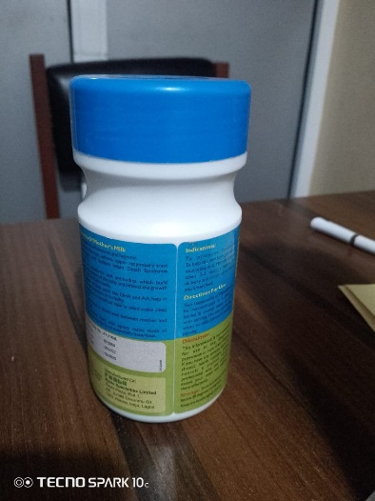
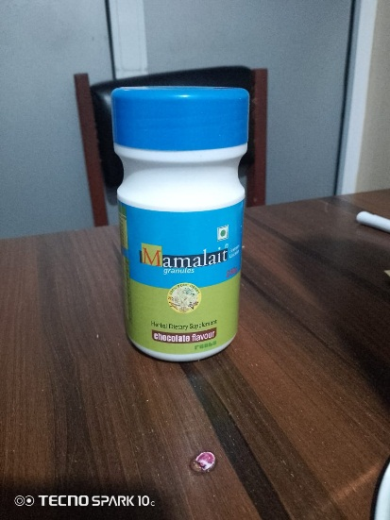

Mamalait: A supplement that aids breast milk to flow very well.

HEALTH TALKS
1. Nutrition: emphasize the importance of an adequate diet rich in fruits, vegetable, whole grains, lean protein, and healthy fats. Staying hydrated is also crucial, so encourage drinking plenty water.
2. Breastfeeding techniques: ensure proper breastfeeding position to ensure comfort for both mother and baby. Encourage mothers to seek help if they experience pain or difficulties.
3. Frequency of feeding: breastfeeding should be on demand, meaning mothers should feed their babies whenever they show signs of hunger. This helps establish a good milk supply.
4. Rest when possible: sleep and rest are crucial for recovery and maintaining energy levels while breastfeeding.
5. Limit Caffeine & Avoid Alcohol: Try to minimize caffeine intake and avoid alcohol for the health safety of the infant.
6. Practice Good Hygiene: wash your hands regularly and keep breastfeeding equipment clean to prevent infections.
7. Increase Calorie Intake: Aim for an addition 300 – 500 calories per day to support breastfeeding.
8. Get Enough Iron: incorporate iron – rich foods such as lean meat, beans, and fortified cereals to prevent anemia.
9. Include lactogenic foods: food like oats, leafy, greens, and nuts can help to support milk production.
10. Avoid or limit foods high in added sugars, saturation fats, and sodium.

HEALTH TALK TO PREGNANT MOTHERS
1. Prenatal Vitamin: Take prenatal vitamin that include folic acid, iron, and calcium to support your baby development.
2. Adequate Diet: Eat a variety of foods, including fruits, vegetables, whole grains, lean protein and healthy fat to ensure you get all the essential nutrient.
3. Stay Hydrated: Drink plenty of water to stay hydrated, which is important for both you and your baby.
4. Regular Check - ups: Attend all pre – natal appointment to monitor your health and baby development.
5. Exercise Safety: Engage in moderate exercise like walking or swimming, unless advised other by your health provider.
6. Avoid Harmful Substance: Stay away from alcohol tobacco and recreational drugs, as they can harm your baby.
7. Limit Caffeine: Reduce caffeine intake, a high amount can be linked to complication in pregnancy.
8. Manage Stress: Practice relaxation techniques such as deep breathing yoga, or meditation to help manage stress.
9. Get Enough Sleep: Prioritize rest and sleep to support your baby’s needs during pregnancy.
10. Educate Yourself: Read books or take classes about pregnancy and childbirth to prepare for labour and parenting.

FOOD DEMONSTRATION PRACTICAL
Food demonstration was prepared in child welfare clinic for children of age of 6 month and above.

FOOD PREPARED: RICE PUDDING
Ingredient used:
Rice
Carrot
Banana
Child formula (milk) frisco gold milk

Direction:
1. Cook the rice:
The rice was rinsed with cold water until the water runs clear. This helps remove excess starch.
The raw rice was put in a pot with accurate water that will make it boil
Once it boiled the heat was reduce to low and the pot remain covered to let it simmer for about 15 – 20 minutes until the water is absorbed.
2. Prepared the carrots:
While the rice is cooking, the carrot was peeled and after peeling the carrot was steam for some minutes to soften it, making it easier to blend.
3. Prepared the banana:
- The banana was peeled also and cut into smaller sizes
4. Blend the ingredient together:
- the boiled rice, steamed carrot and the peeled banana was blended together to make it easier for the child to digest.
5. Serve:
- we served it by putting it in a disposable cup and adding the child formular to it for each baby’s.
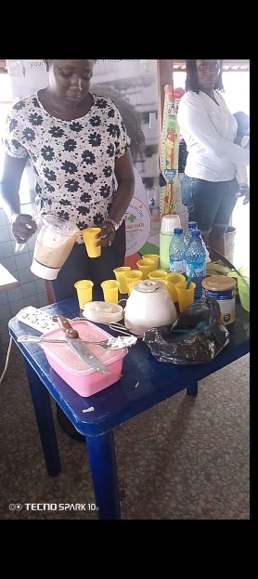
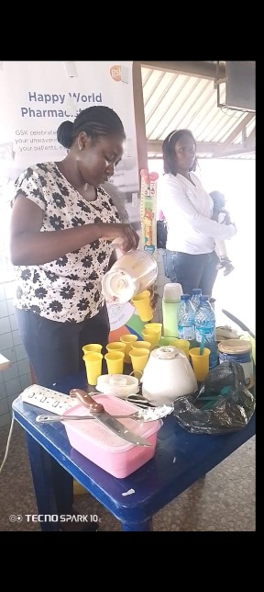
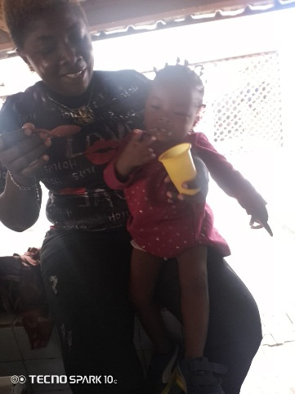


NB: This rice pudding is suitable for children of ages six months and above

CHAPTER THREE

DIETARY COUNSELLING ON DIABETIC, HYPERTENSION AND GDM PATIENT.

WHAT IS DIABETES
Diabetes is a chronic medical condition that occurs when the body is unable to properly regulate blood sugar (glucose) level. There are different types of diabetes which are listed below:

TYPES OF DIABETES
1. Type 1 Diabetes: Autoimmune disease where the pancreas doesn’t produce insulin.
2. Type 2 Diabetes: Body becomes resistant to insulin, leading to high blood sugar.
3. Gestational Diabetes: Develops during pregnancy due to hormonal changes.
4. LADA (latent autoimmune diabetes in adults) Type 1 diabetes symptoms appear in adulthood.
5. MODY (maturity – Onset diabetes of the young) rare genetic form typically appearing before Age 25.
6. Secondary Diabetes: cause by other medical condition or medication

CAUSES AND RISK FACTORS
1. Genetics
2. Obesity
3. Physical Inactivity
4. Unhealthy Diet
5. Age (45+)
6. Family History
7. Previous history of gestational diabetes or delivering a baby over 4KG
8. Polycystic ovary syndrome (PCOS) e.t.c

SYMPTOMS
1. Increase thirst and urination.
2. Fatigue.
3. Blurred vision.
4. Slow healing of cuts and words.
5. Tingling or numbness in hand and feet.
6. Recurring skin, gum, or bladder and infection.
7. Unexplained weight loss.

DIETARY COUNSELLING ON DIABETES PATIENTS
For diabetes patients is crucial for managing blood sugar level and overall health here are some key points:
1. Carbohydrate management: Patients should learn to monitor their carbohydrates intake carb have the most signification impact on blood sugar level using tools like carbohydrate counting method or the glycemic index can help.
2. Adequate Diet: A well adequate diet that include a variety of food is essential this should consist whole grain lean proteins healthy fat fruit and a lot of vegetables.
3. Portion Control: Educating patient on portion size can help manage calorie intake and prevent over reading which is especially important for those with type 2 diabetes
4. Regular meal timing: Encouraging regular meal time can help maintain stable blood sugar levels skipping meal can blood to spikes and drops in blood sugar
5. Limit sugary food and drink: Patient should be refined carbs as these can cause rapid increases in blood sugar
Food allowed freely
1. Lean beef
2. Tea bags
3. Spinach
4. Ginger and Garlic
5. Cucumber e.t.c

FOOD ALLOWED IN LIMITED AMOUNTS
1. Milk
2. Butter/Margarine
3. Baked beans
4. Cash nut
5. Fried foods

SOME FOOD TO AVOID
1. Beverages Milo, Bournvita, Pronto, Ovaltine, Harlicks.
2. Sugar, Glucose, Honey.
3. Chocolate, Sweets, Biscuit, Cakes, Chewing gum
4. Pastries: Chinchin, Puff-Puff, Buns, Sharwama, Gala, Meat /Fish/Chicken pie.
5. All soft drink cake, fanta, pepsi , maltina , and 7up teem, schweeps, bigi products e.t.c

Note:
It is advisable for them to pair each meal with vegetable because it contain fiber content which slow down the digesting and absorption of carbohydrates. This help prevent rapid increase in blood sugar after meals.
And also vegetable are generally low in calories and carbohydrate, which help in managing blood sugar level. They provide essential nutrients without causing significant spikes in glucose.

WHAT IS HYPERTENSION
Hypertension also known as high blood pressure is a medical condition where the force of the blood against the walls of the arteries is consistently too high blood pressure is measure in millimeters of mercury (mmHg) and is expressed with two numbers: systolic (the pressure during heartbeats) over diastolic (the pressure between heartbeat) A normal blood pressure reading is usually are and 120/8ommHg

SOME TYPES OF HYPERTENSION
1. Primary [Essential] Hypertension: this is the most common types, accounting for about 90-95% of cases. It develop gradually over many years and has no identifiable cause, though factors like genetics, diet, and lifestyle can contribute.
2. Secondary Hypertension: this type is cause by an underlying condition, such as kidney disease, hormonal disorder, or certain medication, it tends to appear suddenly and can be more severe the primary hypertension.
3. Isolated systolic Hypertension: this occur when only the systolic blood pressure {the top number} is elevated, while diastolic pressure remains normal it is more common in order adults and can lead to cardiovascular issues

CLASSIFICATION OF BLOOD PRESSURE
1. Normal blood pressure: less than 120/80mmHg
2. Elevated blood pressure: 120-129/80mmHg
3. Stage 1 hypertension: 130-139/80-891mmHg
4. Stage 2 hypertension: 140 or higher 190 or higher

CAUSES AND RISK FACTORS
1. Genetics
2. Age
3. Obesity
4. Physical in activity
5. Smoking
6. High sodium intake
7. Low potassium intake

SYMPTOMS
1. Headache
2. Dizziness
3. Nosebleeds
4. Fatigue
5. Confusion
6. Vision problems
7. Chest pan {in severe cases}

DIETARY COUNSELLING ON HYPERTENTION PATIENT
Hypertensive patient focuses on making life style change that can help low or blood pressure and improve overall health. Here are some keys recommendations.
1. Reduce sodium intake: limiting salt intake is crucial aim for less than 2,300mg of sodium per day as even lower {1,500mg} if possible. This can help reduce blood pressure.
2. Eat balanced diet: emphasizes fruits, vegetable, whole grow, lean proteins and healthy fats. The dash {dietary approaches to stop hypertension} diet is often recommended, which highlights these food groups.
3. Increase potassium intake: food rich in potassium such as banana, oranges, spinach, and potatoes, can help balance sodium levels and lower blood pressure.
4. Limit alcohol consumption: if you drink alcohol, do so in moderation. This usually means up to one drink per day for women and two drinks per day for men.
5. Limit processed foods: many processed foods high in a sodium, and unhealthy fat focus on whole unprocessed foods whenever possible.

WHAT IS GDM
GDM stands for gestational diabetes mellitus it is a condition that occurs during pregnancy when the body cannot produce enough insulin to regulate blood sugar level effectively. This can lead to higher-than-normal blood sugar levels, which can affect both the mother and the developing baby.
Gestational diabetes mellitus typically develops around the 24th to 28th week of pregnancy and usually resolve after the body in born however, it can increase the risk of developing type 2 diabetes later in life for the mother and the child.

FACTORS OF GDM
1. Obesity
2. Age
3. Family history
4. Ethnicity
5. Previous GDM
6. Multiple pregnancies
7. Polycystic Ovary Syndrome {PCOS}
8. Unhealthy Fat

DIETARY COUNSELLING ON GDM PATIENTS
Encourage the consumption of healthy fats like those found in avocadoes nuts and olive oil while limiting saturated and Tran’s fats
Also advice drinking plenty of water and limiting sugary beverages. Teach patient how to monitor their blood sugars levels regularly and adjust their and based on their reding and recommend working with a registered dietitian who specialize in diabetes management to create a personalize meal plan.

GENERAL WARD ROUND AT MMC EMERGENCY WARD
Is where they provide immediate and comprehensive care to mothers and their infants. This specialized ward is designed to address the unique health needs of pregnant women new mother and their newborn ensuring they receive the best possible care during critical times.
The ward also plays a significant role in neonatal may face various challenges such as respiration distress jaundice or law birth weight which require immediate attention.

PEDIATRIC WARD
The pediatric ward also known as a children ward or pediatric medicals care and treatment infants meet the unique need of young patients from birth to adolescence.

SERVICES PROVIDED IN PERDIATRIC WARD:
1. Medical care
2. Surgical care
3. Emergency care
4. Chronic diseases management
5. Palliative care

PRENATAL WARD
Is a specialized are in the hospital that focuses on the care of pregnant women before child birth ward is essential for monitoring the health of both the mother and developing fetus. It provides a safe environment for expectant mother to receive routine checkup, ultra sound and screening that assess the progress of the pregnancy.

POST NATAL WARD
Is a specialized area that is designed for the care of mother in the days following delivery providing essential medical care support and education this the stage where mother are advised to exclusive breast feeding for their new born babies for the first six mother of age.

WHATS EXCLUSIVE BREASTFEEDING
Exclusive breastfeeding refer to the practice of feeding an infant only breast for first six month of life, without ducing any other foods or liquids including water

ADVANTAGE OF EXCLUSIVE BREASTFEEDING
1. Nutrition benefit
2. Immune support
3. Bonding
4. Digestive health
5. Cost – health
6. Weight management
7. Convenience

GENERAL COUNSELLING FOR INFANTS ON NUTRITION AND
FEEDING
It is advisable for mother to do exclusive breastfeeding for their babies for the first six month
And also introduction of solid foods should start around that six months and above, while breastfeeding continue until three years (3yrs) but minimum of 2yrs.
And hygiene also matters, by sterilizing you’re feeding like feeders, flasks and so on by handling them carefully.
And also introduce. One food at a time before introducing another one may be after one or two weeks.

SAMPLE MENU
Beans plantain / yam pottage
Peeled beans plantain / yam / sweet potato
Palm oil blended crayfish blended tomatoes
/ onion / blended fish. (Titus fish)

EGG CUSTARD
Egg / child’s milk.

NB: Also all fruit are allowed except oranges that start from 1 year and above.

CHAPTER FOUR

DESCRIPTION OF KITCHEN
1. I was posted to the kitchen department for two weeks. This where normal and therapeutic diet is been prepared. Therapeutic diet is a diet meal plan that controls the intake of certain foods or nutrient. It is a part of treatment of a medical condition and are normally prescribed by a physician and planned by a dietitian.

TYPES OF THERAPEUTIC DIET
1. Clear liquid diet
2. Low Sodium (LS) diet
3. No added salt diet
4. Diabetic or caloric controlled diet (NON)
5. Full liquid diet

REASON FOR THERAPEUTIC DIET
- To maintain nutritional status
- To provide extra calories for weight gain
- To correct nutritional states e.t.c

WHAT IS KITCHEN
A Kitchen is a room or area in a home or building where food is been prepared, cooked, and stored. It is typically enquired with various appliances, tools, and surface to facilitate food prepared and cooking

AREAS AVAILABLE IN KITCHEN
1. Washing area
2. Cooking area
3. Grinding area
4. Canteen area
5. Dishing area
6. Staff office
7. Where they used to keep utensils

Washing Area: This is where dishes, utensils, and cooking equipment are cleaned it include sinks, dishwashers and drying racks to ensure hygiene and cleanliness.
Cooking Area: This is where food is actually prepared and cooked.
Grinding Area: This space is used for grinding spices, grains, and other ingredient it often include equipment like grinding machine and mortals essential for prepare fresh ingredient for cooking .
Canteen Area: The canteen is a dining area where staff and sometimes guests can eat.
Dishing Area: This space is dedicated to plating and serving food. It often includes counters for arranging dishes and serving utensils.
Staff Office: This area is designated for kitchen staff to manage schedules, plan menus and handle administrative task.
Utensils storage: This is where utensils pots, pons, and other cooking tools are stored

CHAPTER FIVE

SUMMARY
Department I worked during my SIWES program at Amumo Odofin maternal and child center in Lagos at 1st avenue
- The kitchen
- The nutrition and dietetics office
- The child welfare clinic
- The pediatric clinic
- The antenatal clinic

THE KITCHEN
I was posted to the kitchen for two weeks, during my stay in the kitchen, I learnt how to prepare different kinds of meal for patient depends on their medical condition.

THE NUTRITION AND DIETETICS OFFICE
During my period of SIWES program, every Monday, Wednesday and Thursday, I followed the dieticians to child welfare, ante-natal clinic to give an health and also I followed the dietitian to the words for nutritional counseling to the patient who are in need of nutrition attention and I also assisted the dietitian in recording the patients information into the departments record book. During my stay in nutrition office, learn how to give nutritional health talks to pregnant woman and children. And sometimes on Friday I and the dietitian go to pediatric clinic to give health talks to mothers of sick babies.

THE CHILD WELFARE CLINIC
I always follow the dietitian to the child welfare clinic to give a health talks to infant mothers e.g: exclusive breastfeeding, complementary feeding and so on.

THE PEDIATRIC CLINIC:
I always follow the dietitian to the pediatric clinic where sick infant are to give a nutritional health talks on how to feed their children, so as to control their childhood sickness.

THE ANTE-NATAL CLINIC:
I always followed the dietitian to the ante-natal clinic to give a nutritional counseling to the pregnant mother’s on food to avoid limit and eat freely during their pregnancy period.

CONCLUSION:
My SIWES program has been an invaluable experience that has significantly contributed to my personal and professional development.
Throughout the duration of the program, I had the opportunity to apply theoretical knowledge in a practical setting, which enhanced my understanding of the industry. I developed essential skills in giving nutritional health talks to mothers and infant babies, and I gained hands on experience that will be important for my future career.

RECOMMENDATION
I would like to recommend that the nutrition and dietetics should get bigger office space, student, patient and the dietitians can work comfortably, and provide additional resources to enhance the functionally of the nutrition and dietetics office.

PROBLEM ENCOUNTERED DURING THE PROGRAMME
One of the major challenges I faced during my SIWES program was the financial burden of transportation costs plus the daily expenses added up, making it difficult to manage my budget effectively.
Additionally, the times of resumption at the SIWES placement was quite early, which affect my daily routine and made it challenging for me to arrive on time.
lastly, was the small size of the office is another issue, which affected my ability to work efficiently especially when the dietitian had patient we have to go out for each other, so as to accommodate the patients.

