

TECHNICAL REPORT ON

THE STUDENT INDUSTRIAL WORKS EXPERIENCE SCHEME (SIWES)

HELD AT

MINISTRY OF WORKS AND TRANSPORT

PRESENTED BY

YUNUS ABDULRAHMAN

ND/23/CEC/PT/0070

SUBMITTED TO:

DEPARTMENT OF CIVIL ENGINEERING,
INSTITUTE OF TECHNOLOGY [I.O.T.] KWARA STATE POLYTECHNIC, ILORIN. P.M.B.1375 ILORIN, KWARA STATE.

IN PARTIAL FULFILLMENT OF THE REQUIREMENT FOR AWARD OF NATIONAL DIPLOMA (ND) CERTIFICATE IN CIVIL ENGINEERING

AUGUST – NOVEMBER 2024.

DEDICATION

I gratefully dedicate this SIWES report to Almighty Allah, and the most awesome and merciful who gave me the uncountable opportunity to participate in the program. I also dedicate it to my parents.

ACKNOWLEDGEMENT
Special appreciation goes to my parent Mr& Mrs Yunus for their love and care. applaud them for making me fall in love with education.
My gratitude is incomplete without acknowledging my maternal family for their support and contribution to my onward progress in life.
I also commend my supervisor, Mr. Aremu Ridwan M. for his intellectual contribution and support during my SIWES
A big thanks to my colleagues from different institution that formed the group members during my training.

TABLE OF CONTENTS

TITLE PAGE…………………………………………………………………………..i
Dedication……………….………………………………………………………………ii
Acknowledgement………………………………………………………………………iii
Table of Contents…………………………..…………………………………………iv-v
CHAPTER ONE
- Introduction………………………………………………………………………….1
  - Goals and Objectives of Siwes ….……………………………………………...…..1
CHAPTER TWO
2.0 Brief history of Organization ……..…..…………………………………………..3
2.1 Major activities of the organization…………………………………………..…..3

CHAPTER THREE
3.0 Theoretical Framework ……..…..……………………………………………….4
3.1 Transportation Engineering System…………………………………………..…..4
3.2 Origin of Highway………………………………………………………………..5
3.3 Significance of Highway…………………………………………………………5
3.4 Road and Water…………………………………………………………………...8

CHAPTER FOUR
4.0 Asphalt Plant…………..……..…..……………………………………………….14
4.1 Drainage System……………...........…………………………………………...15
4.2 Side Drains……………………………………………………………………….16

CHAPTER FIVE
5.0 Conclusion…………..……..…..……………………………………………….17
5.1 Suggestion and Recommendation………………………………………………17

CHAPTER ONE
1.0 INTRODUCTION
Student Industrial Work Experience Scheme (SIWES) programmed, was establish in year 1973 by federal Government of Nigeria through the industrial Training Fund (ITF) under the NBTE (National Board for Technical Examination). It has it’s headquarter in jos, plateau state. The major reason behind the establishment of siwes programmed and the importance of the student to display their talents and also learn the practical aspects of their fields of study. After their graduation, they will have something valuable to contribute to the society. They will also be able to face future challenges in their respective field of study.
In accomplishment of my compulsory four months training program, I did my SIWES at Kwara State Ministry of Work and Transportation.
I was involved in several operation on site and experience in relation to my career of study (civil engineering).
  - GOALS AND OBJECTIVES OF SIWES
- To enhance the knowledge of students (theory) of what they have been
taught in school by backing it with enough practical.
- To provide students the opportunity to apply their theoretical knowledge
in real work situation, bridging the gap between university work and actual site work.
- To provide an avenue for students to acquire industrial skill and
experience in their course study.
- To enable students to develop more affection for their chosen profession.
- To expose students to working method and technique in handling equipment and machineries that may not be available to them in school.

CHAPTER TWO
2.0 BRIEF HISTORY OF THE ORGANIZATION
Kwara state ministry of works and transport sited along Ahmadu bello way, it was set up by the state government to control some specific activities in rural and urban center development in term of routes and other external works in the state. The organization was first known as public work co- operation since creation of kwara state in 1967 until some years back when it was changed to kwara state ministry of works and transports with its headquarter at Ilorin the state capital.
Kwara state ministry of works and transport was meant for developments of new route, construction of road network and countdown of bridges for public utility project in the state. The organization has done many construction works and has been the clients of majority constructions work done in kwara state. Eg construction of township roads in kaima, erin-ile, offa, shonga and rehabilitation of rods along sabo-oke, GRA, ipata, sango etc. construction of post office flyover in Ilorin and so many construction works that could not be mentioned. They are ensuring the easy conveyance of goods services from one area to the other through construction and rehabilitation of roads, highways, bridges, flyover.
2.1 MAJOR ACTIVITIES OF THE ORGNIZATION
Civil engineering department of the ministry of works and transport represent government in any ongoing project i.e engineering project (i.e civil, electrical and mechanical) to ensure that the said project is done to specification. Also, job of the ministry of the ministry of works and transport are to monitor the activities on road, development of new routes and maintenance of road and advised the state government on what to do to make such road effective.

CHAPTER THREE

3.0 THEORETICAL FRAMEWORK

CIVIL ENGINEERING
Civil engineering is a professional engineering discipline that deals with the design, construction, and maintenance of the physical and naturally built environment, including works like roads, bridges, canals, dams, and buildings. Civil engineering is the second-oldest engineering discipline after military engineering, and it is defined to distinguish non-military engineering from military engineering. It is traditionally broken into several sub-disciplines including architectural engineering, environmental engineering, engineering, control, structural engineering, earthquake engineering, transportation engineering, construction surveying, and construction engineering etc. Civil engineering takes place in the public sector from municipal through to national governments, and in the private sector from individual homeowners through to international companies.

3.1 TRANSPORTATION ENGINEERING SYSTEM
Highway engineering is one of the most important branches of transportation system. (Gupta 2009), in his opinion defines Highway Engineering as the art of planning, design, construction and maintenance of road system. While Rogers (2003) defines Highway Engineering as the application of scientific principle to the planning, design, maintenance of a highway project or system of projects. We conclude that Highway Engineering is the science and technology dealing with road engineering. However, the term road or road ways was called Highway, which refers to a road way constructed on small embankments a little above the general ground level to avoid drainage and maintenance problems.
Its scope includes development, planning, alignment, geometric design and location, highway material, pavement design, maintenance and construction, traffic operation and its control, economic consideration, finance and administration, road architecture, arboriculture and landscaping.
On the other hand, Transportation Engineering involves planning, design and supervision of construction, maintenance and operational stages of the country’s infrastructure which is related to the movement of goods and people from their origin to destination (Hill, 2001).

3.2 ORIGIN OF HIGHWAY
The oldest mode of transportation was obviously on foot path. In those days, man travelled by watching stars or own shadows, or noting the direction of wind, soals of elled Trees were used to cross narrow streams an drivers were crossed by swimming or by rafts, and animals were used to transport men and materials.
However, man felt the necessity of easy transport, later wheel was invented and simple animal drawn wheeled vehicles were a common and popular mode of transportation for a long time. This gave birth to the necessity of a hard surface for easy movement of men and goods.
The first recorded road was the Assyrian Empire about 1900B.C, other developments include;
      - ROMANS ROAD (312 B.C) 600 KM of road was constructed of stone blocks of considerable thickness.
      - TREASAGUET CONSTRUCTION (1716-1796): a French man developed and improved road in 1764, he suggested that Thickness of road above 30CM does not contribute to the stability of the road. Considerations are given to the sub-grade moisture condition and compaction.
      - METACALF (1717-1810) CONSTRUCTED 290KM of road in northern region of England, but he was blind much of his works were not recorded.
      - MACADAM (1756-1836): he was Surveyor General of roads in England. His concepts are based on scientific basic and hence became very popular far and wide.

3.3 SIGNIFICANCE OF HIGHWAY
Highways are vitally important to a country’s economic development. The construction of a high quality road network directly increases a nation’s economic output by reducing journey time and cost, making a region more attractive economically. The actual construction process will have the added effect of stimulating the construction market.
A road is a thoroughfare, route, or way on land between two places that has been paved or otherwise improved to allow travel by foot or some form of conveyance, including a motor vehicle, cart, bicycle, or horse. Road network system in Nigeria has been classified into four categories these are:
- Trunk A Roads: - This form the major network around which other categories of roads are built. They run through the length and breadth of the country. They connect ports, capitals of various states and also provide international links with neighboring countries.
- Trunk B Roads: - These are the highway within the states, as they connect important towns and cities of the states. They also connect the cities of the states to federal highways end serve as the main arteries of traffic to and fro meet district roads.
- Trunk C Roads: - These are also called local government roads. They are constructed with nearly the same specifications as those of the state highways. They are intended to connect areas of production and market with state highways and railways.
- DFRRI Roads: - These are the least in Nigerian classifying system and they are connected to major district roads and railways. They are intended to serve the interior rural population of the district.

COMPONENTS OF ROAD STRUCTURE
Road Structure Cross Section is composed of the following components:
- Crown
- Camber
- Surface/Wearing Course
- Kerbs
- Shoulder
- Drainage
- Base Course
- Sub-base
- Formation level
- Sub Grade

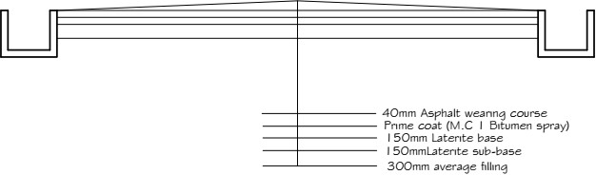

Plate1.0:Road cross section

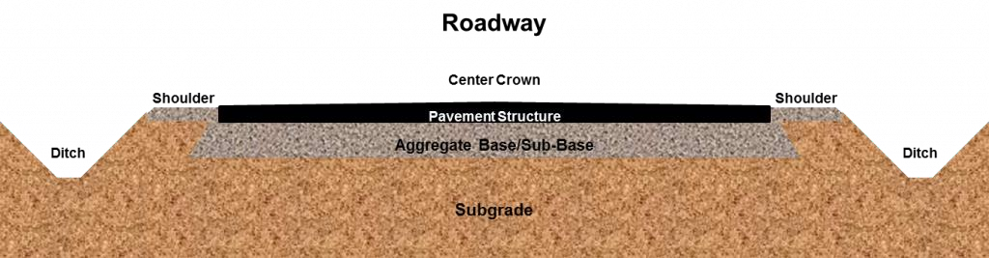
Plate2.1: Road cross section

3.4 ROAD AND WATER
The greatest threat to an asphalt road is water when a road is laid down, it flexes and moves slightly to accommodate changes in temperature and load. All this flexing eventually leads to cracking. Water penetrates those cracks and through processes like freezing, causes damage to the roadway. Crack sealing cleans debris from these cracks then fills them with an asphalt based polymer that adheres to the sides and bottom of the cracks, preventing the water from getting in.
Depending on the climate, the materials used, the pavement conditions and the technique used, crack sealing will last three to eight years.
Crack sealing has two primary purposes:
      - To prevent the intrusion of water through the crack into the underlying pavement structure.
      - To prevent extraneous materials from entering the crack and causing further deterioration as the pavement expands and contracts with temperature changes.

ROADWAY EXCAVATION
The work consist of all the required excavation within the limits of the right of way unlesscoveredbyotherSectionsoftheseSpecifications.Thisshallincludeexcavationofside ditches, where required, the removal, hauling and proper utilisation or disposal of all excavated materials and shaping of excavation and preparation of exposed surfaces of excavationontheentirelengthoftheroadway,inaccordancewiththeseSpecificationsandto the lines, levels, grades, dimensions and cross sections shown on the Drawings or as required by the Engineer. The works specified shall also include operations in part widths and small areas of roadway where directed by the Engineer without any extra cost to the Employer.
Road way excavation shall include the following:
- AllexcavationindicatedontheDrawingswithinthelimitsofthecrosssectionsand excavation of all materials for side roads and intersections.
- The removal of existing pavement, sidewalks, kerbs and gutters within the limits of construction.
- Excavation for stream and channel changes where not covered under Section 2.4, Channel Excavation.
- Excavation required in cuts under embankments below the lowest normal limit of excavation indicated on the Drawings or below ground line and for the removal of unsuitable material. Materials from roadway excavations shall be classified as suitable or unsuitable as fill material, or as road pavement material, by the Engineer. To be suitable as fill material, soil must not contain roots, sods or other deleterious materials.

FILLING AND GRADING
Laterite is filled into the cut portion of the road and compacted using sheep foot roller and smooth wheel roller. Laterite is a deep brown soil of cellular structure, easy to excavate, but gets hardened on exposure to air owing to the formation of hydrated iron oxides. The CBR (California Bearing ration) ratio of the laterite on our site is 85%.The laterite is brought form the borrow pit, the borrow pit is a hole dug to a certain depth where laterite of good CBR ratio can be obtained.

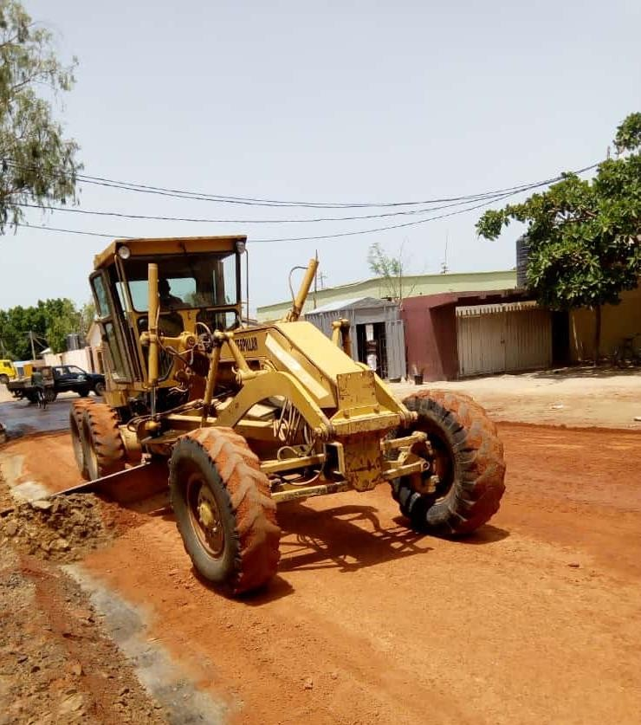
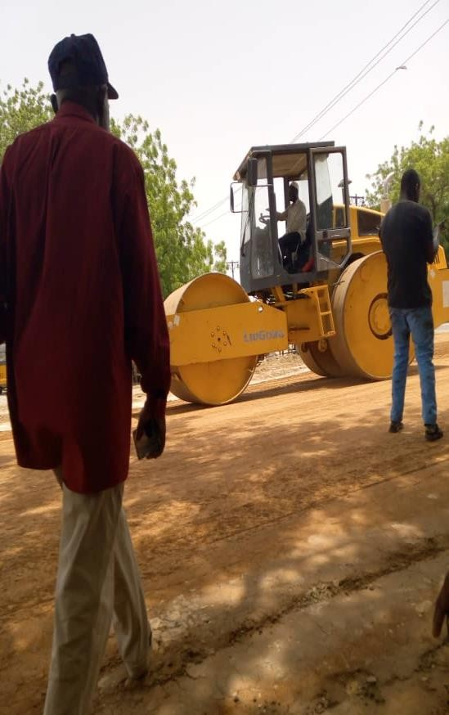
Plate2.3:Road grading Plate2.4:laterite compaction

SPRAYING OF WATER
Water is sprayed on the laterite to give it the required moisture just enough to allow maximum compaction. Also water is sprayed after compaction of laterite when there will be another layer of laterite to be laid on the current layer to create bond between the two layers. This was done the water bauxer.

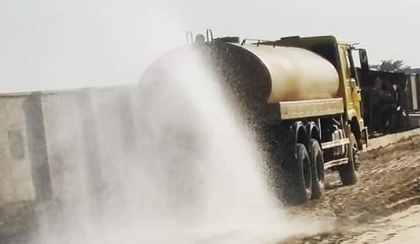
Plate2.5: spraying of water by the water bauxer

FIELD COMPACTION
Most of the compaction in the field is done with the aid of compaction equipment such as rollers. The four most common types of rollers are:
      - Smooth-wheel rollers: they are suitable for proof rolling sub-grades and for finishing operation of fills with sandy and clayey soils. These rollers provide 100% courage under the wheels, with the ground contact pressure as high as 310 to 380 KN/m².They are not suitable for producing high nit weights of compaction when used on the thicker layer.
      - Pneumatic rubber tyre rollers: they are heavily loaded with several rows of tyres. The contact pressure under the tyre ranges from 600 to 700 KN/m², and they produce up to 70 to 80% courage. Pneumatic rollers can be used for sandy and clayey soil compaction.
      - Sheep foot rollers: these are drums with large number of projections. The area of each projection ranges from 25 to 85 cm². These rollers are most effective in compacting clayey soils. The contact pressure under the projection ranges from 1400 to 7000 KN/m². These projections help in creating bond between the current layer of soil and the next layer of soil to be laid.
      - Vibratory Rollers: they are extremely efficient in compacting granular soils. Vibrator con be attached to smooth-wheel, pneumatic robber type, or sheep foot rollers to provide vibratory effects to the soil.
Factors affecting field compaction
- Soil type and moisture content
- Thickness of the layer of the soil
- The intensity of pressure applied by the compacting equipment
- The area over which the pressure is applied

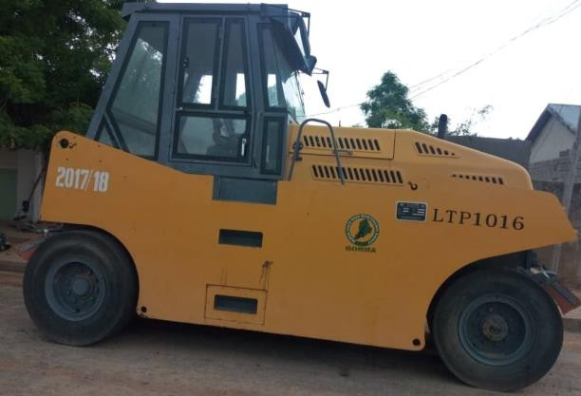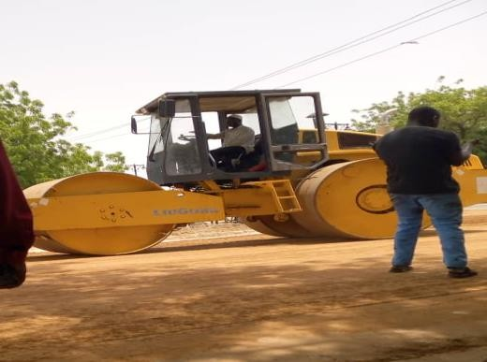
Plate2.6:Pneumatic rubber tyre roller Plate2.7:Drumwheel roller

BLINDING
After application of MC1 (prime coat) to the base and the asphalt is not readily available from the Marini, blinding is done. This is the application of river sand OR Quarry dust after priming to;
      - Remove the air voids in the MC1,
      - To allow vehicles to use the roads immediately after priming and blinding,
      - To prevent the MC1 from sticking to the tyres of vehicles thereby cleaning it away from the applied surface.
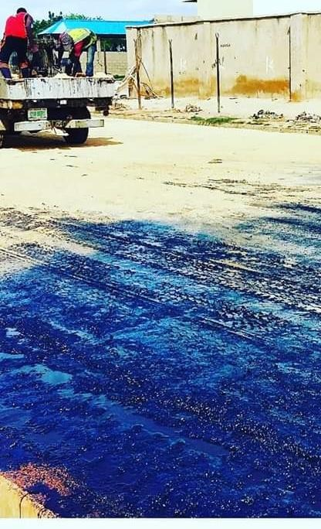
Plate2.9: blinding of the primed surface using quarry dust

ASPHALT OVERLAYING
An asphalt overlaying is simply the process of installing a new layer of hot mix asphalt directly over the existing asphalt on roads. The main aim of overlay is to add structural support to the existing pavement. Overlaying existing asphalt is a good solution when the existing road is still in decent shape and the existing elevations will allow proper drainage without milling of the entire surface. To maximize the overlays useful life, failed sections of the existing pavement were cut, excavated and replaced. If the percentage of bitumen in the asphalt mix is high, it will result in folding of the road surface and if the percentage of the aggregates is higher in the mix, it will result in excessive cracking of the road. This not only results in poor surface, but it result in a surface that retains water, thereby reducing the life span of the road by accelerating the ravelling process.
Hot mixed asphalt is manufactured at temperatures between 270ºF and 325ºF, depending on the environmental conditions and the distance from the hot mix plant to the site, hot mixed asphalt can lose between 5ºF and 25ºF.After overlaying the hot asphalt, it is left for the temperature to cool to a temperature below 80ºc before compaction is started. The measurement of temperature at our site is done by the use of thermometer. If the compaction process is started at a temperature above 80ºc, it leads to development hairy crack which enlarges as time passes.
In the overlay process, if the hot mix asphalt pavement cools too quickly, the entire surface will ravel living a rough, rocky surface in a short period of time.
For the compaction of the newly over-laid asphalt, smooth wheel and pneumatic rubber tyre rollers are used. The smooth wheel roller compacts it first, water is sprayed to the wheel so that the asphalt does not stick to the wheel during the compaction process.
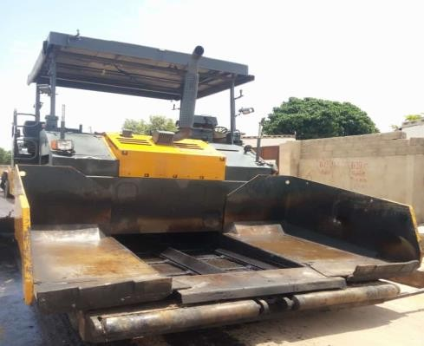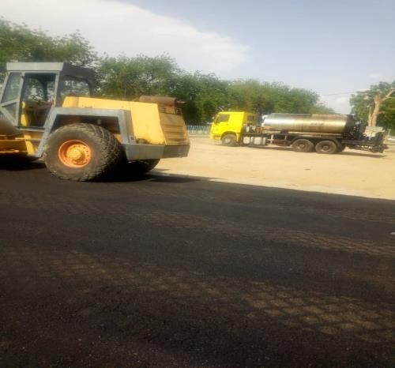
Plate2.9.1:pneumatic finisher ready for use Plate2.9.2: compaction of laid asphalt

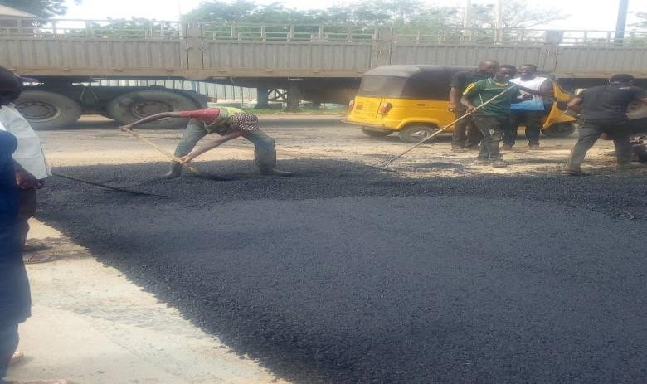
Plate2.9.3: workers spreading asphalt

CHAPTER FOUR

4.0 ASPHALT PLANT
This chapter discussed our visit to the drum mixing asphalt plant located along Gubio road. The main purpose of the asphalt plant is to produce Asphalt. We were shown the machines involved in the production of asphalt and the procedure involved was thoroughly explained to us. Some of the equipment used was:
    - Hopper: there are about four hoppers at the Marini namely: hopper 1, hopper 2, hopper 3 and hopper 4. The hopper has a conveyor belt used for transporting the aggregates to another section of the production process. The aggregates fall onto the conveyor by gravity.
    - Dryer: used to dry moist aggregate that enters it. Its temperature ranges between 150⁰c and 170⁰c.
    - Bunnerfan/Air Blower: this helps in pumping air into the dryer. It also sprays diesel to the dryer and flames it to create fire.
    - Hot Elevator: this collects the hot aggregates and passes it to the mixer.
    - Mixers: this is used to mixes the aggregates with bitumen by the use of Paddles. The mixture is then dumped into a bucket.
    - Bitumen Storage Tank: this is used for heating the bitumen.
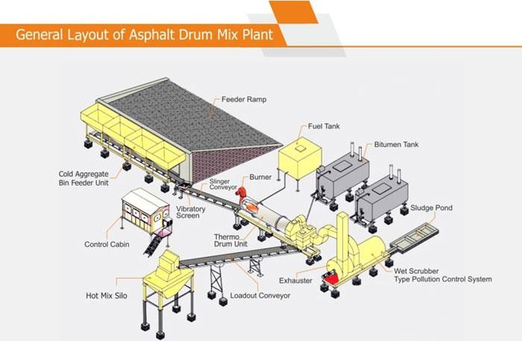
Plate3.0: General layout of Asphalt drum mix plant

MATERIALS
    - Aggregates: the main aggregates used in mixing asphalt the Mariniare1⁄2inch,
3⁄8inch,3⁄4inch,Quarry dust, rivers and andBitumen.
    - Bitumen: Production of Bitumen:
Bitumen is the residue or by-product when the crude petroleum is refined. A wide variety of refinery processes, such as the straight distillation process, solvent extraction process etc. may be used to produce bitumen of different consistency and other desirable properties. Depending on the sources and characteristics of the crude oils and on the properties of bitumen required, more than one processing method may be employed.

4.1 DRAINAGE SYSTEM
One of the most important aspects of the design of a road is the provision made for protecting the road from surface water or ground water. If water is allowed to enter the structure of the road, the pavement will be weakened and it will be much more susceptible to damage by traffic. Water can enter the road as a result of rain penetrating the surface or as a result of the infiltration of ground water.
The road surface must be constructed with a sufficient camber or cross fall to shed rainwater quickly and the formation of the road must be raised above the level of the local water table to prevent it being affected by ground water.
Water can also have a harmful effect on shoulders, slopes, ditches and other features. High water velocities can cause erosion which, when severe, can lead to the road being cut. Alternatively, low velocities in drainage facilities can lead to silt being deposited which, in turn, can lead to a blockage. Blockages often result in further erosion.
A good road drainage system, which is properly maintained, is vital to the successful operation of a road. It has four main functions:
    - To convey rainwater from the surface of the carriage way to outfalls
    - To control the level of the water table in the sub grade beneath the carriage way
    - To intercept ground and surface water flowing to wards the road
    - To convey water across the line of the road in a controlled fashion.
The first three functions are performed by side drains and the fourth by culverts, drifts and bridges.

4.2 SIDE DRAINS
The cost of side drains will normally be calculated as part of the cost of earthworks Side drains should be flat-bottomed if they are to be maintained by hand or 'v'-shaped if they are to be maintained by machine. Wide flat drains, known as 'meadow drains', can be used with advantage if there is room. The longitudinal gradient of side drains should always exceed 0.5 per cent to reduce the possibility of silting up. In hilly terrain, providing side drains with the same gradient as the road may result in water velocities that are too high. It may therefore be necessary to reduce the maximum gradient to an acceptable level by the provision of shallow dams or scour checks. These are often constructed of masonry, but can also be constructed in concrete or even timber. Wide drains are preferred to reduce the velocity and so minimise erosion. The provision of turnout or cut-off drains should also be considered to reduce or control the amount of water in the side drains. Costing may need to take account of these and the need to line drains with masonry or concrete in highly erodible soils.
Various stages of side drain construction can be see in the figures below;

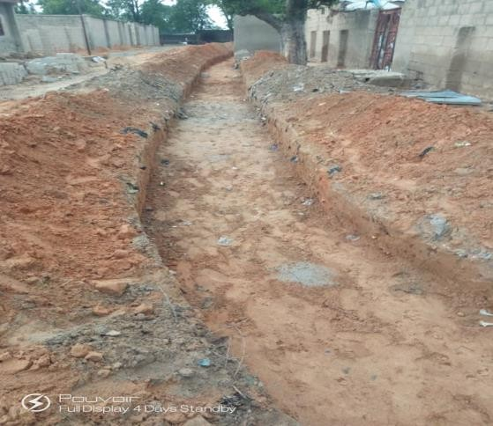
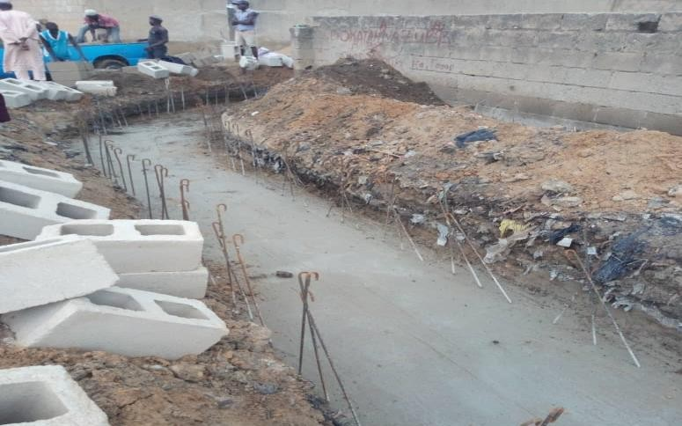

Plate4.0:Excavated Drainage trench Plate4.1:Blinding and concrete base

CHAPTER FIVE
5.0 CONCLUSION
I was highly impressed on the ways the company carried out their activities.
They work with me time to time and skill acquisition is of great import. I learnt a lot from the company.
5.1 SUGGESTION AND RECOMMEDATION TO THE ORGANIZATION AND POLYTECHNIC CONCERNING THE SIWES PROGRAM
SIWES coordinator and the polytechnic authority should try to stop the habit of rejecting student for SIWES program by the industry. The institution supervisor should make it a priority to visit their designated student in the various organizations to update the student’s log book.
Finally, they should resist the habit of staying in school and wait for their wards to finish the SIWES program only for them to sign their training log book and award them grade of the choices without checking the performance of the student in the field.

