

A TECHNICAL REPORT
STUDENT INDUSTRIAL WORKING EXPERIENCE SCHEME
(SIWES)

HELD AT:
FIV’S MART COMPANY ILORIN KWARA STATE, NO 23 ADEWUYI STREET ASA-DAM ILORIN KWARA STATE

PREPARED BY:
ABDULWAHAB FAISAT OMODASOLA
ND/23/BAM/PT/0391

SUBMITTED TO:

DEPARTMENT OF BUNIESS ADMINISTRATION AND MANAGEMENT
KWARA STATE POLYTECHNIC, ILORIN

IN PARTIAL FULFILLMENT OF THE REQUIREMENTS FOR THE AWARD OF NATIONAL DIPLOMA (ND) IN BUSINESS ADMINISTRATION AND MANAGEMENT

Sept., Nov., 2024
DEDICATION
I dedicate this technical report to the Almighty GOD, the giver of knowledge, wisdom and who is rich in mercy.

ACKNOWLEDGEMENT
I take this opportunity to express my profound gratitude and deep regards to the creator of heaven and earth, the one who knows the beginning and the end, the alpha and the omega. my sincere gratitude also goes to my guidance Mr. and Mrs. Abdulwahab for their financial support and word of encouragement during my SIWES Programme and also to those who stood by me during my SIWES programme, thank you all. I also take this opportunity to express a deep sense of gratitude to compliment my supervisor at the place of my attachment for taking his time for my practical knowledge and for his cordially support, valuable information and guidance which helped me in completing my SIWES through various stages may Almighty God bless you abundantly.
TABLE OF CONTENT
Dedication
Acknowledgement
CHAPTER ONE
  - Introduction to SIWES
  - History of SIWES
  - Objectives of the Programme
  - Objectives of Establishment
CHAPTER TWO
2.1 Activities of place of Attachment
2.2. Precaution Taken in the Place of Attachment
2.3 Various Department in Local Government
CHAPTER THREE
Reporting on Work Carried Out
3.1 Reporting on Daily Work Carried Out
CHAPTER FOUR
Challenges and Gain Encounter In Place of Attachment
CHAPTER FIVE
Summary, Conclusion and Recommendations
5.1 Summary
5.2 Conclusion
5.3 Recommendations
CHAPTER ONE
1.1 INTRODUCTION TO SIWES
Students Industrial Work Experience Scheme (SIWES) is a Skills Training Program designed to prepare and expose Students of Universities, Polytechnics, Colleges of Technology, Colleges of Agriculture and Colleges of Education for the Industrial Work situation they are likely to meet after graduation. The Scheme affords Students the opportunity of familiarizing and exposing themselves handling equipment and machinery that are usually not available in their institutions.

1.2 HISTORY OF SIWES
The Students’ Industrial Work Experience Scheme (SIWES) was initiated in 1973 by the Federal Government of Nigeria under the Industrial Training Fund (ITF) to bridge the gap between theory and practice among products of our tertiary Institutions. It was designed to provide practical training that will expose and prepare students of Universities, Polytechnics, and Colleges of Education for work situation they are likely to meet after graduation.
Before the establishment of the scheme, there was a growing concern among the industrialists that graduates of institutions of higher learning lacked adequate practical background studies preparatory for employment in industries. Thus the employers were of the opinion that the theoretical education going on in higher institutions was not responsive to the needs of the employers of labour.
As a result of the increasing number of students’ enrolment in higher institutions of learning, the administration of this function of funding the scheme became enormous, hence ITF withdrew from the scheme in 1978 and was taken over by the Federal Government and handed to National Universities commission (NUC), National Board for Technical Education (NBTE) and National Commission for Colleges of Education (NCCE). In 1984, the Federal Government reverted back to ITF which took over the scheme officially in 1985 with funding provided by the Federal Government.
1.3 OBJECTIVES OF THE PROGRAMME
The specific objectives of SIWES are to:
- Provide placements in industries for students of higher institutions of learning approved by relevant regulatory authorities (NUC, NBTE, NCCE) to acquire work experience and skills relevant to their course of study
- Prepare students for real work situation they will meet after graduation.
- Expose students to work methods and techniques in the handling of equipment and machinery that may not be available in schools.
- Make transition from school to the labour market smooth and enhance students’ conduct for later job placement
- Provide students with the opportunity to apply their knowledge in real life work situation thereby bridging the gap between theory and practice
- Strengthen employer involvement in the entire educational process and prepare students for employment in industry
- Promote the desired technological knowhow required for the advancement of the nation.
1.4 OBJECTIVES OF ESTABLISHMENT
The specific objectives of establishment are to:
- Provide a wide range of products to meet customer needs and preferences.
- Achieve financial success through sales and cost management.
- Increase presence in the market by attracting more customers and expanding operations.
- Offer diverse products, including groceries, household items, and personal care products, to cater to different customer segments.
- Create a shopping environment that is accessible and easy to navigate, enhancing the overall shopping experience.
- Ensure high quality of products to build trust and retain customers.
- Implement eco-friendly practices to reduce environmental impact and appeal to conscientious consumers.
- Foster a positive work environment and provide training and development opportunities for staff.
- Support local communities through initiatives, partnerships, and contributions.
- Stay updated with market trends and technology to improve operations and customer engagement.
CHAPTER TWO
2.1 ACTIVITIES OF PLACE OF ATTACHMENT
The experience, knowledge, skills and exposure acquired during the period of attachment in the industrial exercise cannot be over emphasized. I was exposed to certain areas in my course of study, such as:
- Inventory Management: Monitoring stock levels, managing orders, and ensuring product availability.
- Purchasing: Sourcing products from suppliers and negotiating prices to maintain profitability.
- Sales Promotions: Running marketing campaigns, discounts, and loyalty programs to attract and retain customers.
- Customer Service: Assisting customers with inquiries, handling complaints, and providing a pleasant shopping experience.
- Store Layout and Merchandising: Designing the store layout to maximize product visibility and accessibility, including effective product placement.
- Checkout Services: Managing cashier operations and ensuring efficient payment processing.
- Hygiene and Safety Compliance: Ensuring that the store adheres to health and safety regulations, including cleanliness and food safety standards.
- Staff Training and Management: Recruiting, training, and managing employees to ensure high levels of service and operational efficiency.
- Market Research: Analyzing customer preferences and market trends to inform product offerings and marketing strategies.
- Community Engagement: Participating in local events and supporting community initiatives to build relationships with customers.
2.2. PRECAUTION TAKEN IN THE PLACE OF ATTACHMENT
- Health and Safety Standards: Adhering to local health regulations to ensure food safety and cleanliness.
- Regular Cleaning: Frequent cleaning of surfaces, shopping carts, and high-touch areas to minimize the spread of germs.
- Social Distancing Measures: Implementing spacing guidelines in checkout lines and store aisles to promote social distancing.
- Personal Protective Equipment (PPE): Providing masks and gloves for staff, especially in food handling areas.
- Sanitizing Stations: Installing hand sanitizer dispensers at entrances and throughout the store for customer use.
- Employee Training: Training staff on health protocols, customer service, and emergency procedures.
- Emergency Preparedness: Developing plans for emergencies, including fire drills and evacuation procedures.
- Surveillance Systems: Using security cameras to monitor the store for theft and ensure customer safety.
- Product Recalls: Having a system in place to quickly respond to product recalls and inform customers.
- Customer Awareness: Communicating safety measures to customers through signage and announcements.
  - VARIOUS DEPARTMENT IN FIV’S MART SUPERMARKET
Grocery Department:
- Function: Stocks a wide range of packaged and canned goods, dry foods, and household items.
Produce Department:
- Function: Offers fresh fruits and vegetables, focusing on quality, freshness, and seasonal availability.
Meat and Poultry Department:
- Function: Provides fresh and packaged meats, poultry, and seafood, including butchering and preparation services.
Dairy Department:
- Function: Stocks milk, cheese, yogurt, and other dairy products, ensuring proper refrigeration and freshness.
Bakery Department:
- Function: Produces and sells fresh bread, pastries, cakes, and other baked goods, often on-site.
Frozen Foods Department:
- Function: Offers frozen meals, vegetables, desserts, and snacks, maintaining appropriate freezing temperatures.
Health and Beauty Department:
- Function: Sells personal care products, cosmetics, and health-related items, including over-the-counter medications.
Household Goods Department:
- Function: Provides cleaning supplies, paper products, and other household essentials.
Customer Service Department:
- Function: Assists customers with inquiries, processes returns, and manages loyalty programs.
Cashier Department:
- Function: Handles transactions, processes payments, and ensures efficient checkout experiences for customers.

ORGANIZATION STRUCTURE/ORGANOGRAM
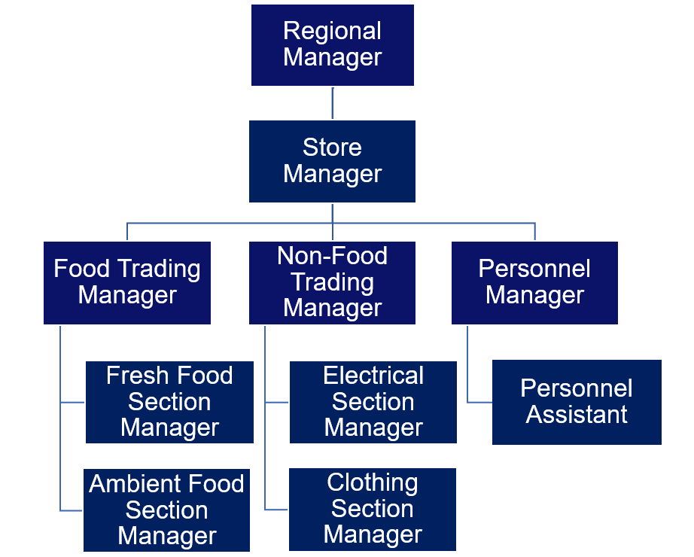

CHAPTER THREE
REPORTING ON WORK CARRIED OUT
3.1 Reporting on Daily Work Carried Out
WEEK 1: I was introduced to all members in the organization and I was given rules and regulation of the organization and I learnt about different department.
WEEK 2: I was taught on how to take a proper record of the account and also I had a practical class about business
WEEK 3: I practicalized on how to deliver a goods for a client
WEEK 4: I practicalized on how to work on a laptop and I was ask to deliver a goods out of the company for a customer
WEEK 5: Ensure of files arrangement in a chronological and alphabetically and receiving of mails
WEEK 6: I was taught on how to take proper record of a goods and how to handle company account
WEEK 7: I was given a task to execute in a company
WEEK 8: I was given a task to work on the company’s laptop and also I learnt on how to manage our own business

CHAPTER FOUR
CHALLENGES AND GAIN ENCOUNTER IN PLACE OF ATTACHMENT

GAINS
Practical Experience
Hands-On Skills: I gain practical skills and knowledge about the inventory audit management and assembly processes of organization activities
Real-World Application: I apply theoretical knowledge from their studies in a real-world setting, and enhancing their understanding.
Industry Exposure
Understanding the Market: I learn about market trends, consumer preferences, and competition in industry
Networking Opportunities: Working alongside professionals allows me to build valuable industry connections.
Technical Knowledge
Learning Technology: Exposure to modern technologies used in organization
Quality Control Practices: Understanding quality assurance processes and standards in manufacturing.
Problem-Solving Skills
Real-World Challenges: I encounter and solve practical problems, enhancing their critical thinking and adaptability.
Project Management: Involvement in projects fosters skills in planning, executing, and managing tasks.

CHALLENGES
Adjustment to Work Environment
Workplace Dynamics: Navigating different personalities and team dynamics as been a difficulty.
Learning Curve: I faced a steep learning curve when dealing with complex machinery and processes.
Understanding Technical Jargon: Familiarity with industry-specific terminology.

Time Management
Balancing Responsibilities: I manage their time effectively between work responsibilities and personal commitments.
Meeting Deadlines: The pressure to meet production deadlines can be stressful.
Limited Scope of Work
Repetitive Tasks: I assigned to repetitive tasks, which that has been less engaging.
Pressure to Perform
Expectations: I felt pressure to perform at a high level, which can lead to anxiety.
Feedback and Criticism: Receiving constructive criticism can be challenging, especially for those not accustomed to it.
Safety Concerns
Working with Machinery: I experience inherent risks associated with working in a industrial environment, necessitating careful attention to safety protocols.
CHAPTER FIVE
SUMMARY, CONCLUSION AND RECOMMENDATIONS
5.1 SUMMARY
Supermarkets are essential components of modern retail, serving as one-stop shopping destinations for a diverse range of consumer needs. The activities carried out in supermarkets are pivotal for ensuring efficient operations, customer satisfaction, and profitability. These activities encompass everything from inventory management and product procurement to customer service and marketing strategies.
Supermarkets aim to provide a wide selection of goods, including groceries, household items, and personal care products, all under one roof. To achieve this, they engage in a variety of operational activities that facilitate smooth day-to-day functioning. These activities are designed not only to maintain product availability but also to enhance the shopping experience for customers.
In today's competitive market, supermarkets must continually adapt their activities to meet evolving consumer preferences and technological advancements. This dynamic environment requires effective management of resources, skilled staff, and innovative marketing approaches to attract and retain customers.
5.2 CONCLUSION
Supermarkets play a vital role in the retail landscape by providing a diverse range of products and services that cater to the everyday needs of consumers. The various activities within supermarkets, from inventory management to customer service, are essential for ensuring operational efficiency and customer satisfaction. As consumer preferences evolve and market dynamics change, supermarkets must remain agile and responsive to maintain their competitive edge.5.3 RECOMMENDATIONS
- Siwes supervisors should make sure they visit the students in their place of attachment for proper monitoring, improvement and progress for the benefit of the societies as a whole.
- Employees should seek ongoing training and education to stay updated on industry trends and technological advancements.
- Implement regular public forums and online platforms to gather citizen feedback and involve residents in decision-making processes.
- Invest in staff training to improve customer service and create a welcoming shopping environment. Consider implementing loyalty programs to reward frequent shoppers.
- Utilize technology for inventory management, online shopping, and customer engagement. Implement self-checkout options to reduce wait times and improve efficiency.

