A TECHNICAL REPORT

ON
STUDENT INDUSTRIAL WORK EXPERIMENCE SCHEME [SIWES]

HELD AT
EXPRESS DELIGHT IDEAL SOURCE
NO. 17, CRESCENT D GODS TIME ESTATE, IGBE LAARA, IKORODU, LAGOS STATE

WRITTEN BY:
ODUTOLA SAMUEL JOHNSON
ND/23/BAM/PT/0128

SUBMITTED TO THE
DEPARTMENT OF BUSINESS ADMINISTRATION
INSTITUTE OF FINANCE AND MANAGEMENT STUDIES
KWARA STATE POLYTECHNIC, ILORIN

IN PARTIAL FULFILLMENT OF THE REQUIREMENTS FOR THE AWARD OF NATIONAL DIPLOMA (ND) IN BUSINESS ADMINISTRATION,

KWARA STATE POLYTECHNIC, ILORIN.

SEPTEMBER-DECEMBER 2024

DEDICATION
This Technical report is dedicated to Almighty God for sparing my lives throughout this programme. Also to my Parents Mr. & Mrs. ODUTOLA.

ACKNOWLEDGEMENT
I give thanks to Almighty God for given me the grace and opportunity to participate in this SIWES programme. May his name be praise forever
I want to specially appreciate the effort of my parent Mr. & Mrs. ODUTOLA for their financial support and their moral support, they will live to eat the fruit of their labour.
I also acknowledge my amiable and capable SIWES coordinator, I will be an ingrate if I fail to mention my SIWES Supervisor and my Lecturer in Business AdministrationDepartment for their tremendous effort in my life and the knowledge they have impacted to me
My gratitude goes to Industrial base supervisor for the impartation of knowledge given to me.
My profound gratitude goes to my brother and sister for their support during this program.
May Almighty God bless every one of you (AMEN)

TABLE OF CONTENTS
Front Page
Dedication
Acknowledgement
Table of Content
CHAPTER ONE
  - Introduction to Siwes
1.2 Definition of Siwes
1.3 Historical Background of Siwes
1.4 Aims and Objectives of Siwes
1.5 Reasons for Training
1.6 The Major Document of ITF
CHAPTER TWO
2.1 A Brief History of the Company
2.2 Organogram of the Company
CHAPTER THREE
3.1 Introduction
3.2 Types of Business Enterprises
3.3 Functions of a Business Enterprise

CHAPTER ONE
  - INTRODUCTION TO SIWES
In the early stages of Business Administration, Nigerian Student were graduating from their respective Institutions without any technical knowledge or working experience. According to Akereloja (2008), acquisition of practical skills is an antidote of meaningful development in any society. In accordance with Akereloja's view, Odiagha (1995) also posits that practical knowledge is learning without which mastery of an area of knowledge may be too difficult to achieve and that practical knowledge involves developing skills through the use of tools or equipment to perform tasks that are related to a field of study.
As a result, the Federal Government of Nigeria introduced the Student Industrial Work Experience Scheme (SIWES) programme in Tertiary Institutions in 1975 to ensure acquisition of field practical knowledge and skills by Students before graduation, and to further expose Students to Industry based skills that are necessary for smooth transition from classroom to the labour world, providing the students with the basic prospects to be part of real work situations outside the lecture room. Thus, it became obligatory for Students in Tertiary Institutions, mostly those studying Business Administration related courses to embark on SIWES programme in order to acquire practical knowledge and working skills prior to graduating from their various institutions of learning.To this end, the Business Administration professionlike other course professions require practical skills. Hence it became imperative for Students of Urban and Regional Planning to embark on theSIWES programme so as to acquire the necessary practical skills required for the profession before graduation
1.2 DEFINITION OF SIWES
The student industrial working experience scheme is a Program that constitutes immensely to building of technical skills available to the Nigeria economy, which are needed for the national industrial development.
1.3 HISTORICAL BACKGROUND OF SIWES
The Student Industrial Work Experience Scheme (SIWES) was established in 1973 by the Industrial Training Fund (ITF). Prior to the establishment of the Scheme, there was a growing concern among our Industrialists that graduants of our institutions of higher learning lacked adequate practical background studies preparatory for employment in industries. It is against this rationale for initiating and designing the scheme was hinged.
Consequently the scheme affords students the opportunity of familiarizing and exposing themselves to the needed experience in handling equipments and machinery that are usually not available in their institutions so as to smoothen their entry into industrial practices on completion of their studies and also reduces period spent in training fresh graduates as new employees.
1.4 AIMS AND OBJECTIVES OF SIWES
SIWES is strategized for skills acquisition, therefore, the key aim is to bridge the gap between theory and practice by exposing students to the industrial environment and enable them to develop occupational competences so that they can readily contribute their quota to national economic development and technological advancement after graduation.
The Specific Objectives of the Scheme as outlined in the Industrial Training Funds Policy document no.1 of 1993 are as follows:
- To provide placements in industries for students of higher institutions of learning approved by relevant authorities (NUC, NBTE, NCCE) to acquire experience and skills relevant to their course of study.
- Prepare Students for the real work situations they will meet after graduation.
Expose Students to work methods and techniques in handling of equipment and machinery that may not be available in school. Makes transition from School to the labour World smooth and enhance Student contact for later job placement.
- Provides Students with the opportunity to apply their knowledge in real life work situation thereby bridging the gap between theory and practice.
1.5 REASONS FOR TRAINING
Reason for the industrial training are as follows:
1. The knowledge acquired in the classrooms are not enough due to lack of practical
2. The program has also helped to distinguish between class and practical work
3. Class room theories cannot be compare with the practical work done on the field.
4. The Siwes program has proved a means of opportunity for students to handle some sophisticated equipment not found in the school
1.6 THE MAJOR DOCUMENT OF ITF
1. PLACEMENT LETTER: This is the formal letter of the placement to be submitted to any employer by each students
2. THE JOB REPORTING FORM: This form is to be completed by students before he/she settle down with the employer. The information on the form will assist the central and department during supervision visits. Failure to return this form is taken as non participant in the program.
3. THE TRAINING LOG BOOK: This has to be completely filled daily and signed weekly by industrial based supervisor, and this logbook carried detailed information about work carried out daily, the logbook must be with you daily.

CHAPTER TWO
2.1 A BRIEF HISTORY OF THE COMPANY
Express delight ideal source was established in the year 2009. it is a well-recognized company that deals with training it's subjects in computer software, selling of gas cylinders, spanners, POS terminal, gas pump, screw drivers etc. The hardware engineering part involves the repairing of any faulty computer system as well as any computing electronic devices that got spoilt or damaged.
The Institution offers training to students from the environment or students from universities and polytechnic as well as colleges that are willing to acquire knowledge in learning computer and sales of other equipments, repairing of faulty computer system, assembling of computer system components, and other aspects of computer software and hardware engineering.
2.2 ORGANIZATION CHART
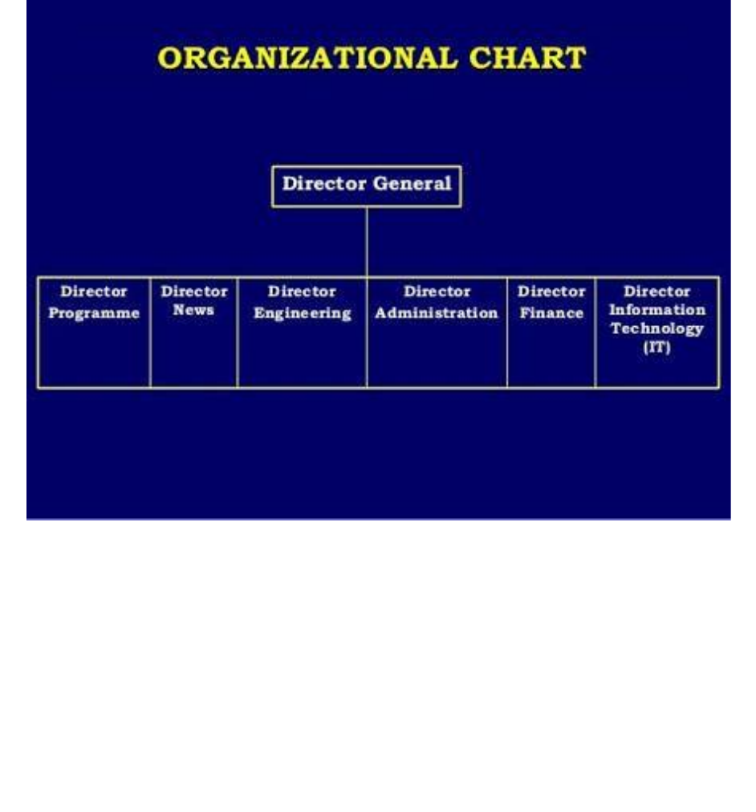

2.3 WORKDONE AND EXPERIENCE GAINED
During the industrial training I was exposed to some areas of computer hardware engineering which I found very interesting. Firstly, I was introduced to various computer hardware components like the system board (Motherboard), disk drives (hard disk drives,



CHAPTER THREE

Computer Monitor
A computer monitor is an output device that displays information in pictorial or textual form. A discrete monitor comprises a visual display, support electronics; power supply, housing, electrical connectors, and external user controls.
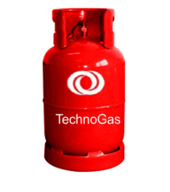
Gas Cylinder
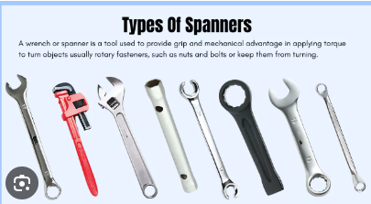

Spanners

POS Terminal
2.3 ADMINISTRATIVE AND OPERATIONAL STRUCTURE
Marketing Department: provides a formidable, robust and resort oriented media campaign on various products and services in the marketing department into a advertising branding and promotional activities for any commercial items to boost acceptance and patronage in the market. Other supportive department includes:
2.3 DEPARTMENTS OF THE ORGANIZATION
Financial Department: ensure prudent management of available resources, the audit moderate financial regulation based on the principle of transparency and accountability
Marketing Department: this department mainly meant to advertising and promotion of goods and services through the use of news, it also means awareness for the target audience of the product.
Administrative Department: This is also important in media organization; they manage office, supply stocks and place orders, also prepare regular reports on expenses and office budget and also organize a filling system for important and confidential company documents.

CHAPTER THREE
3.1 TECHNICAL TRANING EXPERIENCE
Week 1: I was taught on how to attend to customers and keep the entire environment clean.
Week 2: assisting in preparing and submitting sales report and also taught on how to communicate with customers and customers are always right.
Week 3: I assisted my colleagues in dispensing gas and making everywhere neat. The supervisor tells me to continue my punctuality and seriousness.
Week 4: I was made not to make mistakes and avoid any habits of smoking or drinking for the safety of myself and the company.
Week 5: I was taught how to operate POS terminal machine and how to make withdrawal and deposits.
Week 6: I make sure I keep the environment clean all the time
Week 7: I participated in daily and weekly meetings to discuss operations and safety.
Week 8: I also develop time management skills by balancing multiple and different task given to me such as making the environment clean and follow instructions for safety such as no smoking, no calls etc.

CHAPTER FOUR
4.1 CONCLUSION
Siwes was established to provide opportunities for students to be involved in the practical aspect of their respective discipline in the industrial working environment. During the 2 months industrial training, I gained a wide range of experience from the various assignments undertake such as news writing and reporting, news alignment, news commentary and editing process, all the experience gained help me to fulfill the objectives of Siwes.
4.2 RECOMMENDATIONS
Going through some of the experience gained during the programme, I will recommend that there is need for some activities both in the organization where I served and the school.
The time duration for the programme should be extended for more than four months. The organization should create practical knowledge for the students for them to acquire more knowledge from their versatile staffs.

