
A TECHNICAL REPORT

STUDENT INDUSTRIAL WORK EXPERIENCE SCHEME (SIWES)
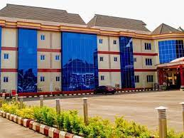
HELD AT

J&B SUITS
House 5, Chief Samuel Alabi Baale Street off Winner Road Egiri Area Osi Ekiti LGA, Kwara State

PRESENTED BY

TITUS TEMILOLUWA RACHEAL
MATRIC NO: ND/23/HMT/PT/0011

SUBMITTED TO THE

DEPARTMENT OF HOSPITALITY MANAGEMENT TECHNOLOGY
INSTITUTE OF APPLIED SCIENCES (IAS),
KWARA STATE POLYTECHNIC, ILORIN

IN PARTIAL FULFILLMENT OF THE REQUIREMENT OF AWARD OF NATIONAL DIPLOMA (ND) IN
HOSPITALITY MANAGEMENT TECHNOLOGY

AUGUST – NOVEMBER, 2024
DEDICATION
This report is dedicated to Almighty God, the embodiment of knowledge, wisdom and understanding.

ACKNOWLEDGEMENTS
Foremost, I am grateful to the most high for seeing me through this level of my SIWES report. I dedicate this work to Almighty God. He has been the wind beneath my wings. His grace, strength and mercy has brought me thus far and I am grateful.
My deepest appreciation and thanks go to my supervisor for his guidance and tutelage and more importantly constructive criticisms that helped me to stay focused from the beginning of this work to the end.
I am equally grateful to all lecturers in the Department of Hospitality Management for their role in instilling in me the virtue of hard work.
I would remain externally indebted to my parent, benefactor, advisers friends and siblings for their love, concern and support.

TABLE OF CONTENTS
TITLE PAGE
DEDICATION
ACKNOWLEDGEMENTS
TABLE OF CONTENTS
CHAPTER ONE
1.1 Background of SIWES
1.2 Objective SIWES Programme
1.3 Philosophy of job specification for SIWES
CHAPTER TWO
2.1 Historical Background of the Company Organization of Attachment
2.2 Major Activities of the Organization Department
2.3 Section unit of the Organization and their specific function
CHAPTER THREE
3.1 Student Specific Involvement of the Various Section units
3.2 Relevance of Experience Gained by Students in the front office
CHAPTER FOUR
4.1 My Involvement at the Restaurant
4.2 My involvement at the Kitchen
CHAPTER FIVE
5.1 Conclusion
5.2 My Advice
5.3 To the Polytechnic
5.4 Recommendation

CHAPTER ONE
1.1 BACKGROUND OF SIWES
SIWES was established by industrial training fund (ITF) in 1973 to solve the problem of lack of adequate practical skills in preparatory for employment in industries by Nigeria graduates of tertiary institutions.
The scheme exposes student to industry-based skill necessary for a smooth transition from the classroom to the world of work. It affords student of tertiary institutions the opportunity of being familiarized an exposed to the needed experience in handling machinery and equipment which are usually not available in the educational institutions.
Participation in SIWES has become a necessary precondition for the award of diploma and degree certificates in specific disciplines in most institutions of higher learning in the country in accordance with the educational policy of government.
OPERATORS: the ITF, the coordinating agencies (NUC, NCCE, NBTE) employers of labour and the institution funding. The federal government of Nigeria.
BENEFICIARIES: undergraduate students of the following: agriculture engineering technology, environmental science education, medical science and pure and applied science.
DURATION: four months for polytechnics and colleges of education, six months for the universities.
Highlight number of participating institutions
Universities = 59
Polytechnics = 85
Colleges of education = 62
Total = 206

1.2 OBJECTIVE OF SIWES PROGRAMME
The aims of this four month’s industrial training program undertaken in different places are states below:
- To exposed student into work methods and techniques in handling equipment and machinery that may not be available in the polytechnic.
- To develop in the student more skill in their various discipline as they actively participate in the activities on the site of their attachment.
- Prepare students for work situation they are likely to meet after graduation.
- To provide an avenue for student in Nigeria polytechnic to acquire industrial skills and experience in their course of study.
- To provide student the opportunity to apply their theoretical knowledge in real practical situation therefore bringing the existing gap.
1.3 PHILOSOPHY OF JOB SPECIFICATION FOR SIWES
It is essential to ensure the proper training of the polytechnics student in preparing them for the world so work, so as to facilitates the full realization of the objective of (SIWES) one important instrument for maintain uniformly high and consistent standards is the provision of polytechnics wide job specification for each programme.
Job specification is therefore, the breakdown of or packaging of a discipline into various tract elements, which would serve as a major guide not only for the student on industrial attachment but also for the industrialist.
The job specification involves the itemization of the tasks the polytechnics students are expected to perform while on industrial attachment the lines of the theoretical knowledge imparted in the classroom.

CHAPTER TWO
2.1 HISTORICAL BACKGROUND OF THE COMPANY ORGANIZATION OF ATTACHMENT
J&B Suit was incorporated in house 5 chief Samuel Alabi Baale Street off Winner Road Egiri Area Osi Ekiti LGA Kwara State, Nigeria with Registration Number 2307148. It was registered on 30 Jun 2014.
The J&B Suit sited on a serene environment covering about 2 hectares of land has functional facilities for recreation, events centre, rental services, restaurant, bar and accommodation.
2.2 MAJOR ACTIVITIES OF THE ORGANIZATION DEPARTMENT
- Front Office: - the front office department deals with welcoming the guest and they also sell out the hotel accommodation.
- Food and Beverages Services: - The food and beverage section deal with production of food and services and provision of drinks and beverages to the guest.
- House Keeping Department: - The house keeping department deal with provision of accommodation, cleaning of room premises sweeping of the line clean and neat.
- Maintenance Department: - The department repair any faulty equipment and electronic in the hotel example is the engineer.
- Account Department: - This is in charge of the guest house incomes goals and take care proper record of the daily money or sales of the hotel.
- Administration Section: - The Administration sections take proper care of the staff welfare and employ new staff when needed.

2.3 SECTION UNIT OF THE ORGANIZATION AND THEIR SPECIFIC FUNCTION
- House Keeping Department: - The house keeping department is responsible for the management at guest rooms and the cleanliness of hotel premises. A close liaison between housekeeping and front office is essential so that the information about the rooms is kept accurately up to date.
- Account Department: - This is in charge of all the income and keeping financial record of the hotel. The account department prepares internet report, audits and financial statement.
- Maintenance Department: - They repairs any damaged or faulty equipment or facilities in the hotel including air condition, carpentry, plumbing and other works.
- Front Office Department: - They deal with welcoming of incoming guest and the outgoing guest they also sell accommodation.
- Security Department: -The security department is responsible for the safety and security of hotel guest and employees.
- Marketing and Sales Department: - The sales and marketing department is responsible for generating new business for the hotel. This could be sales of rooms, sales of the garden bar and restaurant. They also deal with the advertising of hotel as well as sales promotions and punchiest and often taken on the role of public relation.
- Food and Beverages Department: - They deal with production of food and services and the provision of drinks to the guest.
CHAPTER THRE
3.1 STUDENT SPECIFIC INVOLVEMENT OF THE VARIOUS SECTION UNITS
The Department:
- Front office
- House keeper
- Kitchen
As a Hospitality Management Student, I was posted to various units, in the guest house like the house keeping department, front office and food and beverages department.
I worked in the House Keeping and was taught the procedures for cleaning rooms how to lay beds and sweeping of the hotel premises.
I also worked in the food and beverages department, I worked at the bar where I was taught how to attend to different guest, served food and I also worked at the restaurant where I learnt how to use various equipment in the kitchen like the microwave machine, gas cooker, electrical stove, kerosene stove; I clean the kitchen and its surroundings.
I also worked with the laundry department where I washed the duve and bed sheet, pillow case, curtains with the washing machine and also drain it with the machine and then ironed it when due for ironing.
3.2 RELEVANCE OF EXPERIENCE GAINED BY STUDENTS IN THE FRONT OFFICE
3.2.1 The Front Office Department
This is the unit department in the hotel that is concern with welcoming and receiving guest, they receive and welcome the guest checking and checking out, they also sell hotel rooms to the guest.
The sections which consists the front office department are the reception, they also deal with advance reservation or booking of rooms and the conference hall and garden bar, they handle enquires or complain and provide information and so on. These are done by the receptionist.
Therefore, reception section is considered as a centre of activities in the hotel, the efficiency and personality displayed by the receptionist is of permanent importance to the hotel because is the first person that will attend to the guest and the last person that will check the guest out. The reception have a direct contact with guest and also have any information concern about the hostel services.

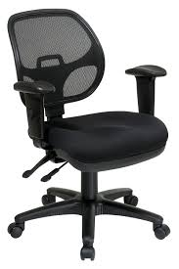
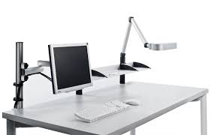
Equipments in Front Office



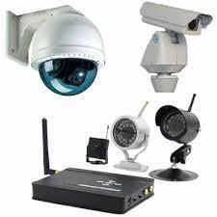
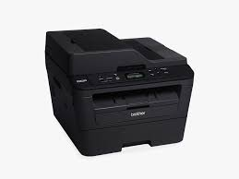

3.2.2 Quality of a Good Receptionist
1. Good Listening Skills: - Good receptionists listen closely as clients are talking so they can be efficient in solving their problems or answering their questions, the receptionist must be able to give the guest a good first impression.
2. Patience: - A good receptionist must be patience in carrying out his/her duty.
3. Tactfulness: - He/she must be able to get along with difficult guest, must be tolerant, diplomatic in handling guest etc.
4. Telephone Conversation: - A good receptionist must be able to handle telephone calls politely and must be able to operate the system due to the technology.
5. Manner: - A good receptionist must have to maintain personal hygiene, he/she must dress properly, neatness, the uniform must be well ironed in order to give the guest a good first impression.

3.2.3 Document Used in the Receptionist
1. Guest registration form
2. Tariff book
3. Daily chart
4. Bill form
5. Reservation book
6. Daily guest register
7. Monthly and daily file
8. Booking chart
9. Notice board
10. Cupboard/drawer
3.2.4 Method of Selling Accommodation
  - By Personal Contract or Personal Selling: - is an act and a good selling technique which can be improved and develop so that with quite confidence knowledge and enthusing for the product the receptions can highlight the special features of the establishment.
  - By Telephone: - A guest may phone to confirm from the establishment or the receptionist booking certain data and certain time either for accommodation, booking of the conference hall or the garden bar. The receptionist will then give the potential guest about the request.
  - By Letter: - This would be done inform of written words, to the hotel through the help of receptionist giving a prompt reply to all enquires and enclosing the hold brochure and tariff and any other relevance confirmation that may exist.

CHAPTER FOUR
4.1 MY INVOLVEMENT AT THE RESTAURANT
4.1.1 Restaurant
Restaurant is a business which prepares and serves food and drinks to customers in exchange for money meals are generally served and eaten on the premises, but many restaurants also offer take-out or take-away and food delivery services and some offer only take-away and delivery when food is been order from the room is the waiter or waitress that will go and serve it, and they will be the one to collect the money from the guest.
The restaurant serves all the major meals such as, breakfast, lunch and dinner, when the waiter or waitress want to attend to the customer, he/she must go with the docket, where the items is been put down and they must know the price off hand.
- Serving high quality food and tasty will earn a restaurant a good reputation, causing customers to make return visits.
- It is very good to prepare meals using the best, high quality ingredients to ensure consistency, so that the customer can come back some other time
And the waiter/waitress must be responsible, honest, smart, well behave, record keeper, passionate, profitable thinking, systemized thinking.
You serve drinks by the right because wine glass cup is placed at the right-hand side on the table, you are also to serve the kids first and Host at the end which is the father. But in case of serving wine instead of water, it is necessary for the host to first of all have the taste of what you want to serve. i.e. when you bring the order (wine) show it to the guest to confirm whether that is what he ordered for, put it down on a table and open, remove the cook I mean the wine cover and place it on the side plate, put a little wine inside the wine glass cup and let the host have a taste, just to zeap after that you can serve the table round, but the host is to be serve at the end.
4.2 MY INVOLVEMENT AT THE KITCHEN DEPARTMENT
Kitchen is a room area or part of a room used for cooking and food preparation in a dwelling or in a commercial establishment when the food is been order from the restaurant, it will be prepare in the kitchen and when they are done with it, they with call to come and serve it to the customer.
And portion control is very important because it allows us to know and have a tight handle on how many calories you are presumably taking in. all the raw food and vegetable has its own measurement, before it been served to or cooked to the customer. It is there right to cook anything that is been order from the restaurant.
4.2.1 The Equipment in Kitchen
Cutting board, cast iron pan, stainless steel pots and pans, blender dutch oven, immersion blender, food processor, pressure cooker, microplane wooden spoon, rubber spatula, vegetable peeler, utensils and small wares.
More so, they posses good grooming and hygiene because grooming is one of the most important qualities of a kitchen department.
When working in the kitchen, one must cover his/her head must not put on jewelries, must not put on a high heel shoe and must be hygiene.
EQUIPMENT IN THE RESTAURANT
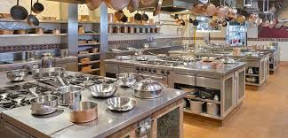
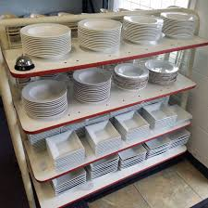

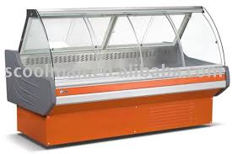
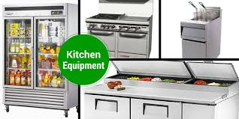

CHAPTER FIVE
5.1 CONCLUSION
My impressions about the J&B Suit Ltd have the necessary equipments which can aid easy learning and boost knowledge. The management is friendly; accommodative they give students the freedom to learn freely.
5.2 MY ADVICE
To the organization: - The hotel should please try to accept student who apply for SIWES programme.
5.3 TO THE POLYTECHNIC
The polytechnic should also guide student in choosing a standard hotel for their SIWES.
5.4 RECOMMENDATIONS
I hereby recommend student of Hospitality Management to carry out their Industrial Training Programme in J&B Suit Ltd as they stand the chance to learning. The hotel helps them in achieve their aim with a good practical method rather than sitting in the class room always.

