

SIWES REPORT
BY

SHEHU FATHIAT AJOKE
ND/23/MKT/PT/0200

AT

ABBEY SHITTU (ABS) WATER

NO 10 ORI-OKE OLD JEBBA ROAD ILORIN KWARA STATE

CERTIFICATION

This is to certify that SHEHU FATHIAT AJOKE ND/23/MKT/PT/0200 whose matric number is ND/23/MKT/FT/0200 has complete his 4 months Industrial attachment at ABBEY SHITTU (ABS) WATER.
The work contained here is original and entirely executed by the above named student.

___________________ _______________
Shehu Fathiat Ajoke Date
(Student)

___________________ _______________
Mr. Yusuff Abiodun Date
( Marketing SIWES Coordinator)

DEDICATION

This work is dedicated to the Almighty God, also to Jesus the divine mercy, for their love, mercies, guidance and protection during and even after this work.

This work is also dedicated to my lovely and caring parents and wonderful brothers and sisters for their love, support and encouragement.

ACKNOWLEDGEMENT

I wish to acknowledge and thank everyone who contributed one way or the other towards the success of my SIWES.

My special thanks goes to the management of ABBEY SHITU (ABS) WATER my supervisor for their numerous contribution and effort to make this SIWES a success.

I want to say a big thanks to my siblings and my friends for their support and love also my friends for their encouragement and advice.

ABSTRACT
The Student Industrial Work Experience Scheme (SIWES) Relevance to the Department of Marketing was researched upon. The instruments used was practicalised and this practical were used to answer the research questions. The results were collected and analyzed in the chapters that make up this study report and SIWES works.
Based on the analysis, Major findings emerged revealing that students did receive practical work on the job training. The SIWES scheme further exposes students to proper methods of using and handling information technology (IT) equipment and development.
However, the study concluded that if students are adequately exposed to research materials and facilities, if students are provided with thorough and proper supervision by supervisors, if orientation towards equipment and machinery handling was well fashioned out, there will necessarily be an upsurge in performance rates Therefore, the researcher recommends the following
That employers ought to accept students supervisors need to be attached to individual’s students. Students should be allowed to express and get themselves exposed to information technology (IT) practices in order to acquire a deeper orientation before the commencement of the programme if adequate performance is to be guaranteed.

TABLE OF CONTENT
Title Page Certification Dedication Acknowledgement Abstract
Table of Content

Chapter One
- Introduction of SIWES
- The role of SIWES fund
- The Scope and importance of SIWES
- The Role of the student and the institution
Chapter Two
- General Overview of the organization of attachment
- Organizational Chart
- Various Departments and Functions
Chapter Three
- Activities during SIWES (IT) programme.
- Discuss all tool you work with.
Chapter Four
- Challenges of ICT for SIWES
- Ways of improving the programme

Chapter Five
- Conclusion
- Recommendation

CHAPTER ONE
- Student Industrial Work Experience Scheme
The Students Industrial Work Experience Scheme (SIWES), is a skills Development programme initiated by the SIWES Fund (ITF), in 1973 to bridge the gap between theory and practice among students of Polytechnic and technology in Institutions of Higher Learning in Nigeria. It provides for on-the-job practical experience for students as they are exposed to work methods and techniques in handling equipment and machinery that may not be available in their Institutions.
SIWES was established by ITF in 1973 to solve the problem of lack of adequate practical skills preparatory for employment in industries by Nigerian graduates of tertiary institutions.
The Scheme exposes students to industry based skills necessary for a smooth transition from the classroom to the world of work. It affords students of tertiary institutions the opportunity of being familiarized and exposed to the needed experience which are usually not available in the educational institutions.
Participation in SIWES has become a necessary pre-condition for the award of Diploma and Degree certificates in specific disciplines in most institutions of higher learning in the country, in accordance with the education policy of government.
Duration – 4 months for the Polytechnics.
Aim of the Study
The aim of the study was to evaluate the impact of SIWES on Technical Skills Development in the Nigerian economy. This is to enable Institutions of Higher Learning and other Stakeholders assess the performance of their roles in the Scheme.

- THE ROLE OF THE SIWES FUND
The SIWES Fund (ITF) was established by the decree 47 of 1971 constitution and charged with the responsibility of promoting and encouraging the acquisition of industrial skills, with the view of generating a collection of indigenous trained manpower, sufficient enough to enhance and meet the needs of the economy so as to promote development. Supervision of students, organizing orientation programs, and disbursing allowances to students are some of the roles played by the SIWES fund in the implementation of SIWES.

- THE SCOPE AND IMPORTANCE OF SIWES
The scheme covers all science and technological based students in monotechnics, polytechnics and universities in Nigeria, resulting in a high population of students which is easily managed because of the public and private industries that partake in the scheme. SIWES enables students acquire industrial know-how in their field of study particularly in technological based courses. It also enables students experience the application of theoretical knowledge in solving real life problems.

- THE ROLE OF THE STUDENT AND THE INSTITUTION
The role of the student is to partake in the program in such a way that he/she will achieve maximum benefit from the program. The student is advised to ask questions, be submissive, and adhere to all the rules and regulations of the organization where he is attached. Identification of placement opportunities, funding of SIWES supervisors and assessment of the student are some of the roles played by the institutions to ensure smooth running of the program.

CHAPTER TWO
I had the opportunity to carry out my SIWES at No 10 ori-oke old jebba road ilorin kwara state, I was able to undergo training on water production, treatments, production equipments, equipment utilization, sales, sales management, and lot more.
Abbey Shittu (A.B.S) Water is a private organization that is into the production of sachet water. It was established in the year 2013 by Mr. Abbey Shittu, Their principal goals are to provide clean, adequate, hygiene, and affordable water to the table of every home at affordable price.

- ORGANIZATIONAL STRUCTURE OF ABBEY SHITTU (A.B.S) WATER

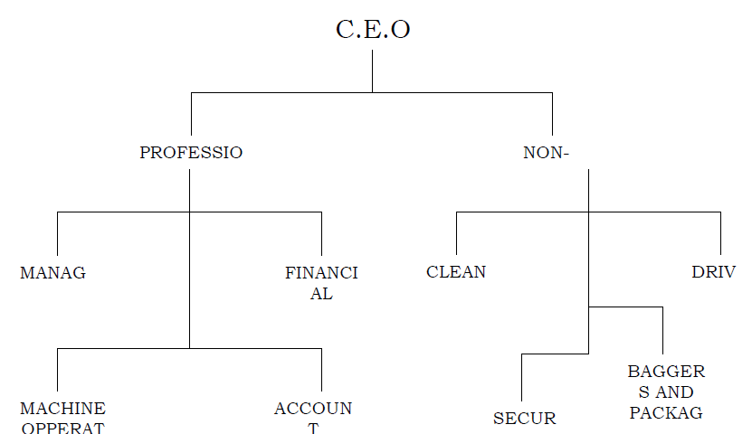
Fig. 1.0: ORGANIZATIONAL STRUCTURE OF ABBEY SHITTU (A.B.S) WATER

CHAPTER THREE

- DAILY ROUTINE

The daily routine in the ABS table and sachet water limited includes the following: sweeping of each unit, mopping of the floors, cleaning of the machines and water tanks, checking temperatures of the sterilizers frequently and more.
- WATER TREATMENT

Water treatment is a process designed to remove colors, odors, turbidity as well as bacteria and other contaminants.
By nature, water is known to be pure as it is composed of strongly bonded atoms of hydrogen and oxygen. However the water supply across the globe has to share space with other things such as organic materials, minerals, chemicals and manmade pollution. This brings about undrinkable solution, since it can contain deadly bacteria and viruses among other disease causing agents.
The process of treating water may have slight difference at various locations based on the plant’s technology as well as the type of water that needs to be treated. The following section talks about standard process of water treatments;

- COAGULATION/FLOCCULATION

Coagulation is the addition of liquid aluminum sulfate or alum and polymer to raw or untreated water. The resulting mixture causes the dirt particles in the water to stick together. Then, the group of dirt particles attached together forming larger particles named floc that can easily be removed via filtration or setting.
- SEDIMENTATION

When water and floc undergo the treatment process, they go into sedimentation basins. There, water moves slowly, making the heavy flocs particles settle to the bottom. Floc, that accumulates on the bottom is known as “sludge”. This is carried on to the drying lagoons. Direct filtration does not include the sedimentation step and the floc is just removed by filtration.
- FILTRATION

In filtration, water passes through a filter, which is made to take away particles from the water. Such filters are composed of gravel and sand or sometimes called anthracite. This process gathers together impurities that float on water and boosts the effectiveness of disinfection. This process is regularly cleared by means of backwashing.

- DISINFECTION

Before water goes into the distribution system, it is disinfected to get rid of disease causing bacteria, parasites and viruses. Chlorine is also applied since it is very effective.
- WATER TREATMENT PLANT

- DESCRIPTION OF SYSTEM

The water treatment plant is made up of three integrated treatment system

- Raw water pretreatment

- Make up water treatment
- Waste water treatment These systems are designed to meet
- Boiler feed water(make up water)

- Steam purity

- ALZD requirements

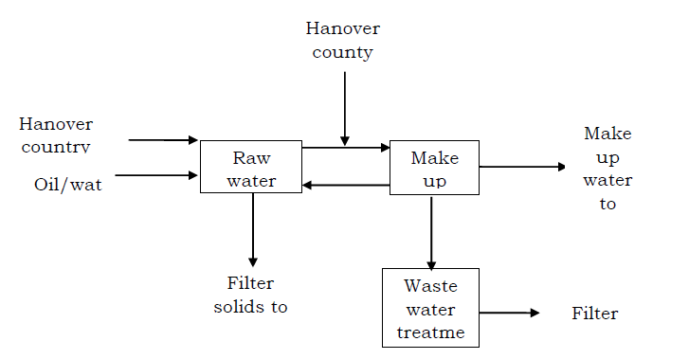
Fig. 2 WATER TREATMENT PLANT

The plant takes water from both the waste water and portable water facilities at Hanover County and discharge solids in form of filter cakes from both the pretreatment and waste water treatment plants.
- RAW WATER PRE-TREATMENT

The raw water pretreatment plant is designed majorly for solids removals from the incoming Hanover County sewage effluent, backwash water and waste water from the oily water collection system. Raw water enters a coagulation chamber followed by a clarifier and dual media depth filters.
- MAKE UP WATER TREATMENT

Treated raw water is mixed with portable water and pumped to the boiler feed water treatment system. This system is designed to remove 99% of the dissolved minerals and provide high purity water to the boiler. The mixed water flows through a reversed osmosis plant operating at a recovery of 80% and an average salt rejection of 95%. This process is used to remove carbon dioxide and a mixed bed demineralizer.
- HOW CHLORINE IS USED TO TREAT WATER

Chlorination is the process of adding chlorine to drinking water to disinfect it and kill germs. different processes can be used to achieve safe levels of chorine in drinking water. It is achievable as compressed elemental gas, sodium hypochlorite solution (NaOCl). The chemical could be harmful in high doese when they are added to water. Chlorination is the best way to provide safe water to the end users. Chlorine kills pathogens such as bacterial and viruses by breaking the chemical bonds in their molecules. Disinfectants that are used for this purpose consists of chlorine compounds which can exchange atoms with other compounds such as enzymes in the bacteria and other cells. When enzymes come in contact with chlorine, one or more of the hydrogen atoms in the molecule are replaced by chlorine. When chlorine is added to water, it forms ;
CL2 + H2O --> HOCL + H^+ + CL^-

- TYPES OF CHLORINE USED IN WATER TREATMENT
- Chlorine gas

- It is greenish yellow in color and heavier than air
- It's high toxicity makes it an excellent substance for drinking
- it is a respiratory irritant

- When used to treat water, it becomes harmless
- it is the least expensive form of chlorine
- Chlorine Hypochlorite

- It is a white solid with a bad odor
- It must not be stored near wood, cloth or petroleum products

- It increases the ph of the water being treated.
- Sodium Hypochlorite

- It is recognized as household bleach
- It is light yellow liquid that has a short shell life
- It requires a lower concentration to treat water

Addition of chlorine during water treatment is summarized into 4 parts which are as follows:

- Pre-chlorination of raw water

- Addition of various points in the treatment process

- Addition during distribution, and

- Miscellaneous use during maintenance activities

- USES AND BENEFITS OF CHLORINE CHEMISTRY
- Chlorine chemistry helps keep drinking water and swimming pools safe

- Chlorine chemistry is used to manufacture household bleaches/disinfectants

- Chlorine chemistry helps provide safe and abundant food by protecting crops from pests

- Chlorine chemistry plays an important role in energy and environment

- It is used in advanced technologies

- Building and constructions

- Defense and law enforcement i.e. in building bullet resistance vests

- Transportations i.e. trains and automobiles

- PRODUCTION ROOM PRECAUTIONS

There are basic rules and regulations that must be followed while working in the production room to avoid dangers or any accidents. And these are grouped into different categories which includes: Hand washing techniques, personal protective and machinery safety.
- HAND WASHING TECHNIQUE
- Wet hands and apply liquid hand washer

- Clean fingers, fingernails and thumbs

- Rinse with clean water

- PERSONAL PROTECTIVE ACTIONS
- Laboratory/production hat must be worn whenever we are in the production room

- Reagents label must be read properly before using it
- Never eat or drink or smoke in the production room
- Covered footwear (white preferably) must be worn at all times

CHAPTER FOUR

3.0 DEFINITION OF TERMS

- PRODUCTION EQUIPMENTS AND THEIR USES
- ROW:- This is a material in form of foils put into the machine to package the sachet water

- DINGLI MACHINE: This is the machine used in the production of only sachet water

- RESERVOIR: This is where water are being kept until production is needed. And it must be kept neat at all times. It is called PVC water tanks (Black color preferably)
- SUBMERSIVE WATER PUMPING MACHINE: This is usually installed deep down in the ground. It is used for pumping water from the underground
- SURFACE PUMPING MACHINE: This is usually not inside the ground but on the surface. It is also used for pumping water from the underground
- AERATION FAUCETS:

- PVC PIPES AND PUMBING FITTINGS: This is used for transmission of water from one facet to another
- SHORT STOOLS OR CHAIRS: This are used for sitting. It could either be plastic or steel.

Note:- Understand the operating procedures of a machine before using it or have a guide.

CHAPTER FIVE

- SUMMARY, CONCLUSION AND RECOMMENDATION

- SUMMARY

During this period, I was well trained on how I can manage a pure water factory to an extent, how to operate some of the machines, the depth of a borehole for water, how production management, different chemicals used in water production, and lot more
- RECOMMENDATION

Based on my experience during the industrial training I hereby recommend the following:

- The institution should assist in securing placement for students by liaising with established organization.
- The institution should improve coordination during the SIWES program to help assess the quality of training under gone by the students.
- This kind of program should be conducted often to expose students to the working experience or condition of the broadcast industry.
- The student’s supervisor from the institution should try to visit the student regularly during the industrial training
- The student should endeavor to stop truancy towards work and improve their relationship with the employees and their co-workers to make out the best during the training program.

- Lastly I will also like recommend that this program should continue and future participants should develop more attitudes towards the programme because it helps one develop more interest in his or her discipline.
- CONCLUSION

In conclusion, there were many things that I have experience and learnt during this period. The whole training period was very interesting, instructive and challenging. Through this training, I was able to gain new insights and more comprehensive understanding about the real industry working condition and practice. It has also provided me the opportunities to develop and improve myself in this field. All of this valuable experience and knowledge that I have gained were not only acquired through the direct involvement in task given but also through other aspect of the training such as work observation, interaction with colleagues, superior, and other people related to the field. From what I have undergone, I am very sure that the industrial training program has achieved its entire primary objectives. It’s also the best way to prepare students to face the real life task that will surely surface after academic activities. As a result of the program now I am more confident to build my future career which I have already started.

