
A
TECHNICAL REPORT
ON
STUDENT INDUSTRIAL WORK EXPERIENCED SCHEME
(SIWES)

HELD AT
BROADCAST JOURNALIST OFFICE (BJO)
KM 3 ogo oluwa gbonga road Ibadan express way, Osogbo, Osun State

PRESENTED BY
KOSAMOTU MSARIAM OPEYEMI
ND/23/MAC/PT/0395

SUBMITED TO:
THE DEPARTMENT OF MASS COMMUNICATION
INSTITUTE OF INFORMATION AND COMMUNICATION TECHNOLOGY
KWARA STATE POLYTECHNIC, ILORIN.
IN PARTIAL FULFILMENT OF AWARD ON NATIONAL DIPLOMA.

2023/2024 SESSION

DEDICATION
This technical report is dedicated to the Almighty Allah who gave me the life, strength, ability to acquire the knowledge and practical experience for the period of my attachment of my SIWES on my field of study.

ACKNOWLEGEMENT
I’m indebted to several people who at various stages contributed towards making this industrial training programme a success. My special thanks first and foremost goes to Almighty God for the grace and enablement He gave to me during the period of my attachment and during the period of writing this technical report.
I also wish to appreciate my parent in persons of Mr. and Mrs. KOSAMOTU who has helped me in all aspect of my life. You will reap the fruit of your labour. Thank you

PREFACE
This student industrial work experience scheme (SIWES) is purposely design to enhance student in Educational development and also in subject in gaining more experience in filled of study throughout development and industrial training for the four month attachment programme.

TABLE OF CONTENTS
Title Page
Dedication
Acknowledgement
CHAPTER ONE
1.0 Introduction
1.1 Nature and Scope of Siwes
1.2 Goals and objectives of Siwes
CHAPTER TWO
2.0 History of OSBC
2.1 Organogram of OSBC
2.2 Function of each unit
CHAPTER THREE
3.1 Equipment found in the studio
3.2Functions
CHAPTER FOUR
4.0 Jobs Done
4.1 Safety Rules and Regulations
4.2 Introduction to Broadcasting
4.3 The Emergence of Broadcast communication
CHAPTER FIVE
5.0 Experience Gained
5.1 Conclusion
5.2 Recommendation

CHAPTER ONE
INTRODUCTION OF STUDENT INDUSTRIAL WORK EXPERIENCE SCHEME (SIWES)
The student work experience scheme programme prepares students for the labour market. It has been established to widen up the student’s mind on the practical aspects of his career. It has become an innovative programme in human resources development and training in Nigeria.
The contemporary environment indication expressed the need to educate and train students as suitable professional to acquire adequate skills and training in the appropriate.
NATURE AND SCOPE OF SIWES
Practical knowledge is putting into action of knowledge derived from learning. It is referred to as doing according to learning. It involves the use of equipments needed to perform a task that is related to a field study. For instance, journalist needs equipment like pen, jotter, midget camera e.t.c to perform his duty.
Progress cannot be attained in a country if the youths are not encouraged to acquire necessary practical skill which will assist in the development of industrialization to meet the need of the society. With this knowledge, SIWES was introduced in Nigeria tertiary institution.
SIWES is a skill development programme designed to prepared students for universities polytechnic, monotechnics and college of education for transition from the school environment to the practical work. This work experience programme gives the student the opportunity to relate with professional in the field.
It is a course mandatory for students studying pure sciences, engineering, vocational technologies and related courses.
SIWES forms part of the approved minimum academic standards in the institutions. It is a core academic requirement carrying four (4) credit unit.

GOALS AND OBJECTIVE OF SIWES
Specially, the major objective of SIWES is to provide an avenue for students in the institutions acquire industrial skills and experience in their course of study.
However, its aims are highlighted below
- To prepare student for the industrial work situations they are likely to face after graduation.
- It affords students the opportunity of a familiarizing and exposing themselves to the needed experience in handling equipment and machines that are usually not available in the institution.
- To provide students with the chance if applying their knowledge in a real work situation thereby birding the gap between theory and practical.
- To enlist educational process and prepared student for employment opportunities in the organization.
- To make transition from the school to the world of world easier and enhance student contact for later job placement.

CHAPTER TWO
2.0 HISTORY OF OSUN STATE BROADCASTING CORPORATION
The journey of what is today called Voice of the South West, with four stations (two radio stations and two television stations), began from the snippets. It began on Monday, August 27 1991 when the then Military President of Nigeria, General Ibrahim Badamosi Babangida (retired) announced the creation of Osun State. To indigenes of the new State who were serving at the Broadcasting Corporation of Oyo State (BCOS), 27th of August 1991 was the outcome of what everyone had expected. However, it became inexcusable that they had to move to Osun State to establish the State’s owned media outfits. The officers who came to Osun were made of experienced journalists, professional broadcasters, seasoned administrators and tested engineers who could make much out of nothing.
Osun State Broadcasting Corporation (OSBC) was established on 27th August, 1991 after the creation of Osun State from former Oyo State.
The Radio Channel 89.5 FM, situated in Ile-Ife, came on air on 25th November, 1991. On 27th August 1992, the Television arm of OSBC, Channel 22 uhf, situated in Ibokun came on air. The two Broadcast outfits
were created through the initiatives of the first Military Administrator of the State, Major-Gen Leo Segun Ajiborisha(Rtd).Mr. John Fademi was the first General Manager. The station started with an administration structure of five departments:
Personnel/Finance and Supplies,
Commercial, Engineering, Programmes, News & Current
Affairs
a General Manager.
Mission Statement
OSBC has been envisioned to be the Regional Voice of the South West Zone of Nigeria to the delight of the populace by creating, developing and transmitting unparalleled quality, informative, educative and entertaining value-added programmes profitably.
Objectives
- To inform, educate and entertain the public;
- To produce and broadcast entertainment, education and public
- enlightenment programmes;
- To disseminate information and analyse issues and events of local, national and international importance;
- To generate revenue through the sale of air-time and to promote other commercial activities like product exhibitions, film show and joint promotion of products and social activities;
- To instal and maintain equipments for gathering, processing and transmission of information on Radio and Television; and
- To facilitate the achievement of these objectives through relevant support services.
TECHNICAL INFORMATION ON FACILITIES
S/N Channel Frequency Power Output Tx make Mast Studio Location Tx Location Co-ordinate Location
1. Radio 1 Ile-Ife Radio Osun 89.5mhz 5kw Harris FM 5K 150’ Ile Awiye Oke Itase Ile-Ife
7028’N/4033’E
2. Radio 2 Living Spring FM 104.5mhz 30Kw x 2 Harris HT 30 1000’ Ile-Awiye Osogbo Ile-Awiye Osogbo
7045’N/4035’É
3. TV – 1 Ch.22 UHF Ibokun 479.25 14kw Thompson csf 750’ Ibokun Ibokun
7047N/4043’E
4. TV – 2 Ch.32 UHF Osogbo 552 - 25 30 kw Harris 1000’ Osogbo Osogbo
7045’N/4035E.

FUNCTIONS OF EACH UNIT

i. ADMINISTRATION DEPARTMENT
This department sees to the affairs of the organization and its staff. It also deals with the keeping of records. It is also a department that deals with the recruitment new staff.
ii. NEWS AND CURRENT AFFAIRS DEPARTMENT
This department gives adequate information activities. It also informs ad enlighten public on current issues. It also generates revenue for the organization.
iii. ENGINEERING DEPARTMENT
This department is in charge of all equipment in corporate and ensures proper maintenance of them.
iv. MARKETING / COMMERCIAL DEPARTMENT
This department s responsible for getting revenue and securing adverts for the corporation.
v. FINANCIAL DEPARTMENT
This department is responsible for all the financial activities of the corporation.
vi. PROGRAMMES DEPARTMENT
This department is in charge of reading programme and also plan predication for corporation. The department gets sponsorship in conjunction with the marketing department.
- Speaker: this change electronic voice to physical voice for the people to hear clearly.

CHAPTER THREE

EQUIPMENT THAT WAS FOUND IN THE STUDIO
Audio Console
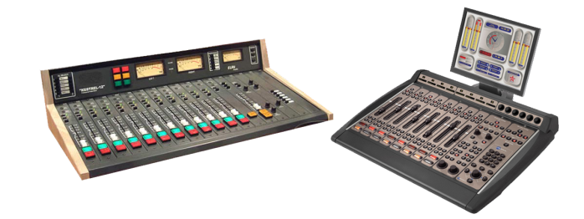
At the heart of any studio is the audio console (sometimes called a radio panel, sound panel, or sound desk). This is the interface the radio announcer (or panel operator) uses to control what’s heard on air. Every channel represents one “input”. The fader (slider) attenuates or amplifies the incoming signal.
Radio Audio Consoles are very different from a regular PA or Live Sound audio console, and are often more expensive than PA audio consoles as they are purpose-built for on-air talent ease of use. When you turn a microphone on or off, a radio console will mute any speakers and illuminate an “on air” light. When you turn a CD Player, Phone or Computer channel on, often it will “trigger” that input so it starts playing immediately.

Microphone

A microphone captures sounds from the studio and turn it into electrical impulses. Broadcast microphones are designed a little differently to PA microphones, as issues such as feedback (the squealing sound that can come through speakers) isn’t an issue in a studio.
Experienced audio announcers will often have a favourite microphone. Common microphones include ElectroVoie RE20, Sennheiser MD421, and Rode Broadcaster.
Microphone Arm
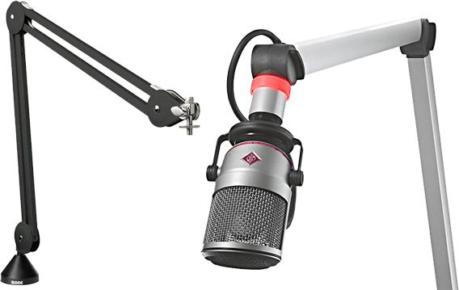
Studio microphones are often mounted on a special arm that keeps the microphone at the correct height. These arms often extend over the audio console, computer monitors, and other equipment – leaving plenty of table space free for equipment and paper.
Playout & Automation Software
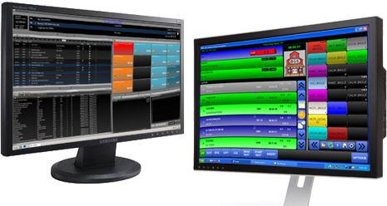
The computer system that plays back music, spots (ads, promos, etc.) and sweepers (the little voice-overs played between songs) is called a Playout System or Automation Software. These are specially designed computer programs that allow for continuous playback of audio, with a lot of granular control for Announcers and Programme Directors.
At the heart of any Automation System is the “log”. This is a sequential list of all audio files and commands that need to be played at certain times. All music played on a commercial radio station will be pre-programmed by the Music Director and loaded into the log. A separate person will often load all advertisements into the same log.
Most automation systems also contain a music database, hot keys (to play ad-hoc audio), an audio editor, segue editor (to change the mix between different elements), interfaces for website and RDS data, and a lot more.
Level Meters
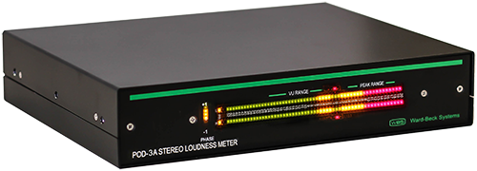
To ensure output of a station is somewhat consistent, radio studios contain different Level Meters. These allow the announcer or panel operator to see if their audio is too loud or too quiet at any given time. Often, you’ll have multiple meters showing the levels at different points in the signal chain.
Some radio stations also provide phase meters along side level meters. This helps you detect mono content, and spot any problems in source material that are likely to cause issues with the stereo image.
Studio Monitor Speakers
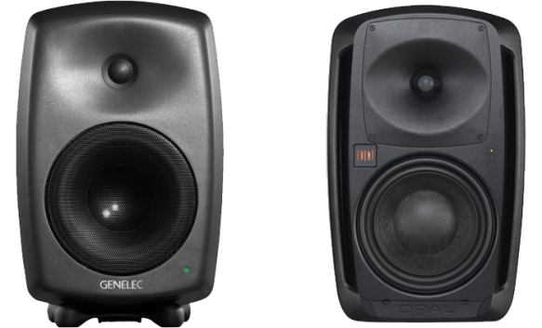
Studio Monitor Speakers provide an easy way to hear what’s going to air without headphones. Often, these are very high quality speakers so any abnormalities in sound quality can be detected.
Cue/Preview Speaker
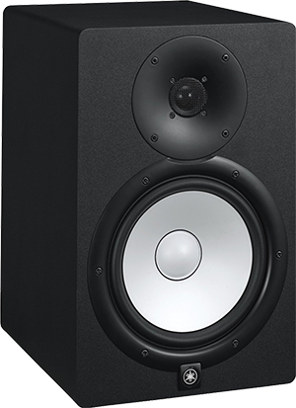
A separate speaker is often provided for the announcer hear all audio that isn’t going to air, such as the preview output from your audio console or the feed from your audio editor. By having a separate speaker for this, announcers can be sure their “preview” audio isn’t going to air.
Headphones
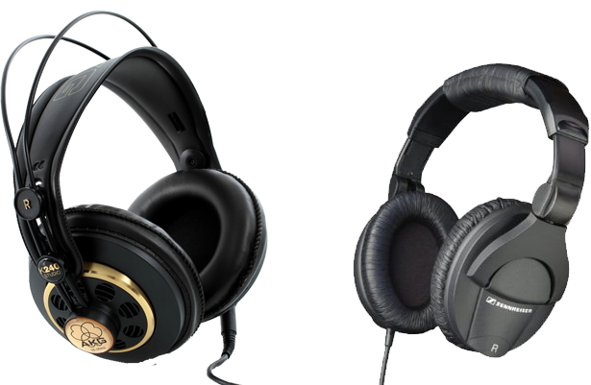
Studio Monitor Speakers are automatically muted whenever a microphone is turned on. As a result, anyone in a studio needs headphones to hear what is going to air. Headphone selection is often a very personal decision based on your preferences in comfort and frequency response.

FUNCTION
- Micro phone: it is use in changing physical/natural voice to electronic voice.
- Console mixer: basic units of all equipment to control the each programme.
- Computer system: to keep a file, songs and typing news.
- Aquatic wall: to present sound and hear.
- Que light: it enable the people to known whether there is a live programme going on or not.
- Disk: it is use to record some programme.
- U.p.s: it enable the programme to be continue when the light is off.
- Phone: the serve as a means of which audience get through to the presenter.
- Log book: the is where title of programme is been written and other necessary document to be put down.
- Air condition: it make all the equipment in the studio to be cool.
- Dictionary: it help the newscaster to be able to pronounce words correctly.

CHAPTER FOUR
4.1 JOBS DONE
On my first day at the radio station, I was given an opportunity to introduce myself to other members and also given a rundown of the studio safety rules and regulations. I took time to peruse through, and understand, this safety rules. I was also introduced to the management and various departments in the company, after which I was shown some transmission and broadcasting machines.
I learn how to copy stories from camera to the system.
And as well I was taught how to make a news worthy and how it can be gathered from the source. I learnt quality of news such as proximity, time etc.
4.2 SAFETY RULES AND REGULATIONS
General Safety Rules When using the studios for broadcast or production.
Health & Safety
• REPORT ANY INJURIES TO THE TEACHER IMMEDIATELY!
• Learn the location of the nearest fire extinguisher
• NEVER MOVE ANYTHING HEAVY BY YOURSELF. Some of the equipment in the station is very large and heavy. Avoid back strain or other bodily harm by working with a partner.
• NEVER MOVE ANYTHING IF YOU HAVE PREVIOUS INJURIES. If you have preexisting back injuries, other physical injuries, or health issues that may be aggravated by moving an object, notify the Radio Operations Manager and/or your teacher, and do not move anything.
• Keep all food and drink out of all studios and the radio office area.
• Keep all exits free of obstruction and keep belongings in designated areas.
• Turn off (or airplane mode) all cell phones and other electronic communication devices before entering any radio broadcast or production studio.
• Never enter a studio above which the “onair” light is illuminated.
This studio is meant to accommodate 3 talent onmic.
The studio doors must always be closed when broadcasting.
4.3 DEFINITION OF NEWS
News is an accurate account and timely delivery of recent events. This is a generally accepted definition.
Sources of News
Press release can be defined statement purposely compose to send a message on a particular subject situation and event. It is also aim at creating public reaction for such a specific course. It contains information idea.
BEAT: Assign place of work for practicing newsmen or journalist. News could be specific aims in generating useful idea.
MONITORING:- A situation by which you monitor information from another station or accessing information fro the interest, monitor other media to get information.
Press conference:- It falls within coverage of event.
Mails:- You receives mail electronically you can receive information through email message. It can be receive in hard copy.
INTERNET:- Through the internet we receive information form the source of national and international information the major sources of new are .
NATURAL OCCURRENCE:- natural disaster like earthquake snow and outbreak.
ORGANIZE EVENT:- Accident, bomb blast Instinct and perspective to issue around you to create or elicit public reaction.
4.4 QUALITIES OF GOOD NEWS
The major qualities of news are
OBJECTIVITY:- It means being factual, it being bias. It also determines the transparency in news reporting. It stresses accountability in news writing. It must be reported as it happened.
SIMPLICITY:- Using word that an average listener or reader can understand. News must be simple in terms of language, expression, arrangement of ideas e.t.c
CLARITY:- Encodes the decoders on news it deals with breaking of ideas in to the simplest form of communication. It also encourages effective clarification. It entrendes expanded explanation in the news.
TIMELINESS:- It deals with processing (writing and delivery (reports) of reports that are current. Timeliness is the al mark in news writing and reporting.
BRIEFING:- The news must be brief avoid length sentences or compound sentences. Arrange ideas in the simplest from of writing.
4.5 COMPONENT OF GOODS NEWS
CAPTION:- Is a catchword that summary what the story is all about. It is usually at the left hand side of the paper.
Date:- This is the date in which the news was written
Lead:- Should contain all element of a headline lead. Contain the critical, valuable useful, beneficial idea contained in the news. It contain the essential part of SW’s and it confirms and establishes has the beauty of new writing.
Attribution tells who said a thing, it also accommodates other aspect of SW’s and H. attribution could be promote or delayed.
AFFIRMATION:- It is the combination of the lead and attribution. It affirms the statement contain in the lead.
RE-AFFIRMATION:- It untwines the listeners, raising anther super.
ADDITIONAL INFORMATION:- These are other information related to the story.
IDENTIFICATION OF THE SOURCE:- After writing the news the reporter must state the source of his news; for example if the story was from a mail, he write “mail” at the left hand side of the paper.
NAME OF THE WRITE:- The reported must state his name or initial before ending the story.
DETERMINANT OF GOOD NEWS
Prominence:- It deals with the critical value of the personality place and issue involved in the story. It deal with how important, relevant and current the personality. Place or issue is.
Proximity:- Nearness or closeness of the information to the people.
TYPES OF PROXIMITY
- Physical proximity
- Strategic proximity
- Psychological proximity
Public Interest:- It deals with the interest of the public on issues like, polities, agenda setting, new policy e.t.c
Human interest:- from other stories that might interest surprises and unexpected happening.
Nation Interest:- From other stories that might interest surprises and unexpected happening.
Conflict or controversy story:- Funny stories, love, hatred e.t.c
Impact and significance to the life of the people
Relevance of the story
Oddity / absorbing: when some thing strange happens e.g man bites dogs.
Breaking news
Timeliness
Attribution of good news attribution tells who gives the information. It established the source of information. It identify who which where and how the information was given.
Attribution may be a person groups of people research conducted, observation of the information. Attribution is necessary for the credibility of the news. It makes the news sound authoritative and real. Attribution may be promoted or delayed.
Attribution of personality title
Post + name e.g Nigeria president, Dr. Goodluck Jonathan.
Do not use initials, give name in details
Attribution authenticate the story, it uses title, name and pronoun e.g the state governor said,
They should presented in present forms of verbs e.g indicate, suggest, highlight. Recommends, stimulate e.t.c
When there is more than one speaker in a story, treat each speaker separately.
4.6 QUALITIES OF A GOOD ANNOUNCER/PRESENTER/NEWS ERA/ PUBLIC COMMUNICATOR.

- Good reading skills:
- Obeying the rule of punctuation
- Effective words pronunciation
- Effective word articulation
- Affordance of intrusive.

CHAPTER FIVE
EXPERIENCE GAINED
- In my four months of the SIWES training my first and most challenging experience, is how to be a good presenter.
- I attended departmental meeting and was latter given orientation about the studio and its equipment
- I leant how to transfer stories from camera to the system
- learnt about the organization ways writing news, how to record news.
- I went to the editing studio for recording and editing video for news production.
- And as well I was taught how to make a news worthy and how it can be gathered from the source. I learnt quality of news such as proximity, time etc.
SUGGESTION
I will like to suggest that the student industrial work experience programme should not stop in other to help student to have good knowledge of the profession.

RECOMMENDATION
My recommendation is that student should endeavour to partake in the SIWES programme and make sure they keep every record of whatever they have learnt from their area of attachment because it will be relevant in the nearest future.
The school management should also support the students by producing constant supervisors to monitor the student at their area of attachment. The school should
also support the student with a little payment amount, at least every month to sustain students throughout the programme.
CONCLUSION
It is necessary to understand at this point in time that success is not measured by the height in which one finds himself, but can greatly be measured by what you can achieve through your own initiative.
With the experience gained, my advice to the school management is to add some months to the SIWES programme so as to build professional in their field of study.
Finally, I would like to state that the siwes programme is a very relevance and necessary programme for all student, for their benefit in order to be self reliance.

