`
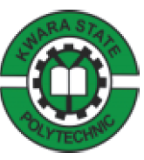

STUDENT INDUSTRIAL WORKING EXPERIENCE SCHEME TECHNICAL REPORT

HELD AT

MAGFIK LIVESTOCK FARM

PRESENTED BY:

ISIAQ SIKIRULLAHI AKANDE
ND/23/PAD/PT/0263

SUBMITTED TO DEPARTMENT OF PUBLIC ADMINISTRATION

INSTITUTE OF FINANCE AND MANAGEMENT STUDIES
IN PARTIAL FULFILMENT OF THE REQUIREMENT FOR THE AWARD OF NATIONAL DIPLOMA IN PUBLIC ADMINISTRATION.
PREFACE
I am so happy for the blessings the Student Industrial Working Experience Scheme [SIWES] has turned out to be for the students of Public Administration and other departments.
The SIWES has really exposed and increase the knowledge of students who really had passion for Administration.

DEDICATION
I dedicate this report to God Almighty for his unlimited grace, consistent love and for sparing my life throughout the period of my SIWES programme and also to my darling parent Mr & Mrs Isiaq for their support throughout the whole exercise and also to my beloved friends for their support and encouragement.

ACKNOWLEDGEMENT
My deepest acknowledgement goes to God Almighty for His Grace, Mercy, Wisdom, Knowledge, Understanding and loving kindness bestowed upon me.
I greatly express my gratitude to the lecturers in the department of Public Administration, Kwara State Polytechnic and our H.O.D for their challenging and kindly advise.
My special thanks to my parents, siblings, family, and friends for their support.
I wish to express my gratitude to the director and entire staff of Magfik Livestock Farm for the love showed towards me during my SIWES
Finally,a very big thanks to those who contributed one way or the other in making my Industrial Working Experience scheme a success, I pray that Almighty God will continually abound for you

TABLE OF CONTENTS
Tittle page
Preface
Dedication
Acknowledgement
Table of content
CHAPTER ONE
- Introduction
1.1Aims and Objectives of SIWES
CHAPTER TWO
- Historical background
  - Department in the establishment
CHAPTER THREE
  - Siwes Experience
  - Conclusion
  - Recommendation

CHAPTER ONE
1.0 INTRODUCTION AND DEFINITION OF SIWES
Student Industrial Work Experience Scheme (SIWES) is a tripartite programme involving (employers of labour).The programme is founded by the federal government of Nigeria and Jointly coordinated by the industrial training Fund(ITF)and the National Board for Technical Education (NBTE)
The students industrial work experience scheme (SIWES)is a skill training programme designed to prepare and expose student of tertiary institution to the industrial work situation they are likely to meet after graduation the scheme afford students the opportunity to Familarizing and exposing themselves to handling equipment and machiney that are usually not available in institutions.
The industrial training fund(ITF)initiated designed and introduced SIWES in 1973 to acquire student with the skills of handling industrial equipment and machinery.

1.1 AIMS AND OBJECTIVES OF `SIWES
The student Industrial Working Experience Scheme is to:
- Provide avenue for student in institutions of higher learning to acquire industrial skills and to experience relevant to their course of study.
- Expose students to work methods and techniques in handling equipment and machinery that may not be available in their institutions.
- Make the transition from school to the world of work easier, and enhance students contact for later job placement.
- Provide student with the opportunity to apply their knowledge in real work situation thereby bringing the gap between theory and practice.
- To enlist and strengthen employer`s involvement in the entry process of preparing university and polytechnic graduate for employment in industries.

CHAPTER TWO
2.0 HISTORICAL BACKGROUND
Magfik Livestock Farm is a fast growing poultry farm dedicated to customer’s satisfaction through supply of poultry products like chicken; live and processed. We also render poultry consultant service in the aspect of poultry establishment, poultry health management and personnel training program.
Located at Phase 3, Sobi Fm, Ilorin, Kwara State. being established on December 12th, 2017 under the Chairmanship of Shuaib Bolaji after his poultry training seminar.
The farm started as a backyard poultry farming project with 50 broiler capacity farm which eventually developed gradually to about 200 broiler capacity farm as at April 2019. Due to our online appearance and social media connects; Facebook, Twitter and Instagram, numerous customers have been trying to do business with us. This is prompting us to increase our farm capacity of ten to thousands broiler capacity.
Other than broiler farming, we have knowledge of egg production and our farm is looking forward to venture into egg production (Layer Farming) in commercial quantity to develop our backyard layer farming at any given opportunity.
2.1 DEPARTMENT IN THE ESTABLISHMENT
Breeding Department: Breeding and hatching chicks, managing breeding stock, egg production, and hatching.
Brooding Department: Caring for young chicks from hatching to 4-6 weeks old, providing heat, light, feed, and water.
Grow-out Department: Raising chickens from 4-6 weeks old to market age, managing feed, water, health, and welfare.
Health Department: Monitoring and maintaining bird health, implementing vaccination programs, disease surveillance, and biosecurity measures.
Layer Department: Managing laying hens for egg production, optimizing feed, water, health, and welfare.
Nutrition Department: Formulating and managing feed for all stages of bird growth, ensuring optimal nutrition.
Research and Development Department: Conducting research and development to improve farm operations, bird health, and product quality.

SOME OF THE EQUIPMENT USED IN THE DEPARTMENT
Feeding Equipment:
Feeders: Hoppers, troughs, or tubes that dispense feed to birds.
Feed carts: Mobile carts that carry feed to different areas of the farm.
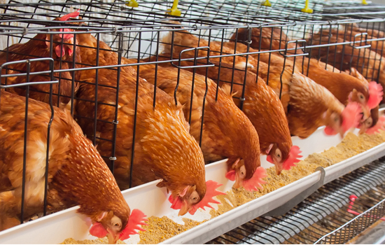

Watering Equipment:
Watering: Nipples, cups, or bell drinkers that provide water to birds.
Watering systems: Piped systems that distribute water throughout the farm.
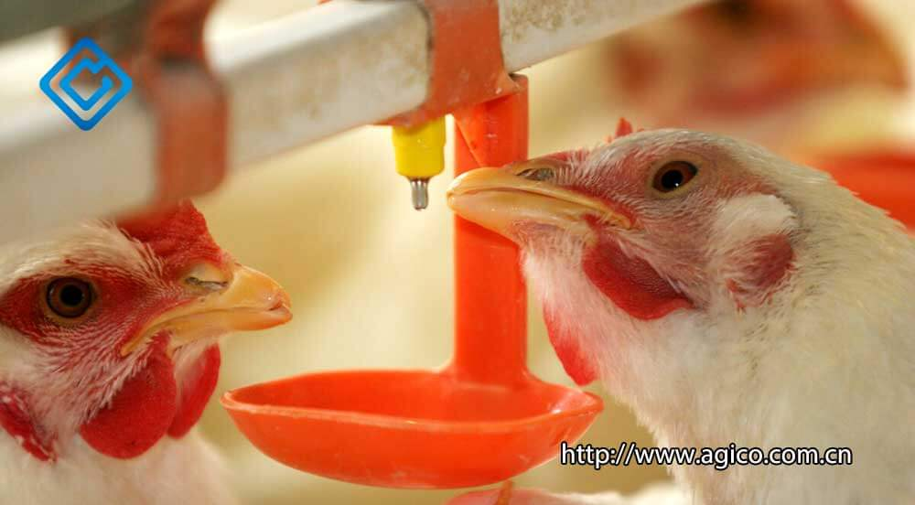
Egg Collection and Handling Equipment:
Egg collectors: Conveyors, elevators, or collection systems that gather eggs.
Egg graders: Machines that sort and grade eggs by size, weight, or quality.
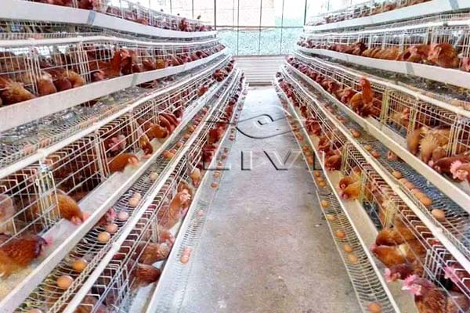

CHAPTER THREE
3.1 SIWES EXPERIENCE
My Job Schedule.
During my SIWES program at Magfik Livestock Farm, I was attached to the Layers department. My training experience was focused on the technical aspects of Managing laying hens for egg production, optimizing feed, water, health, and welfare, which included the maintenance and monitor of equipment, as well as the production of livestock’s.
I was able to gain practical experience in the following areas:
- Feeding of Hens
- Egg Production
- Health and Welfare of the livestock
I also assist the receptionist in keeping records of some documents, making
3.2 CONCLUSION
Student Industrial Working Experience Scheme (SIWES) was established to provide opportunities for students to be involved in the practical aspect of their respective discipline in the industrial working environment .During the 2months industrial training, I gained a wide range of experience from the various assignments, interview, promo and programme schedule. The experience gained helps to fulfil the objective of the SIWES.
3.3 RECOMMENDATION
Going through some of the experience gained during the programme, I will recommend that there is need for improvement on some activities, both in the farming production where it is served and the school.
The time duration for the programme should be extended for more than two month farming Organisation should create more practical knowledge for the students.

