

A TECHNICAL REPORT
STUDENT INDUSTRIAL WORKING EXPERIENCE SCHEME
(SIWES)

Held at

AIMS ACCESSORIES
DELE MARIAM PLAZA SANGO ILORIN, KWARA STATE
Prepared by:
TAJUDEEN YUSHROT BOLANLE
ND/23/BAM/PT/0813

SUBMITTED TO

DEPARTMENT OF BUSINESS ADMINISTRATION
INSTITUTE OF FINANCE AND MANAGEMENT STUDIES
KWARA STATE POLYTECHNIC, ILORIN

INPARTIAL FULFILLMENT OF THE AWARD OF THE REQUIREMENT OF THE AWARD OF NATIONAL DIPLOMA IN BUSINESS ADMINISTRATION AND MANAGEMENT STUDIES

DEDICATION
I dedicate this technical report to the Almighty GOD, the giver of knowledge, wisdom and who is rich in mercy.

ACKNOWLEDGEMENT
I take this opportunity to express my profound gratitude and deep regards to the creator of heaven and earth, the one who knows the beginning and the end, the alpha and the omega, the Almighty Allah and also to my guides (MR & MRS TAJUDEEN, and to all those who has helped me during my SIWES programme. The blessings, help and guidance given by them, time to time has carry me so this far and shall carry on the journey of life on which I am about to embark. I also take this opportunity to express a deep sense of gratitude to compliment my mentor for his cordial support valuable information and guidance which helped me in completing my SIWES through various stages.

TABLE OF CONTENT
Title page i
Table of content ii
Dedication iii
Acknowledgements iv
CHAPTER ONE
  - Background of SIWES 1
  - History of SIWES 1
  - Objectives of SIWES 2
  - Objectives of Establishment 3
CHAPTER TWO
2.1. INTRODUCTION TO THE COMPANY 4-6
2.2 JEWELLERY
2.3 HOW TO MEASURE JEWELRY
CHAPTER THREE
3.1 HOW TO OPERATE POS
3.2 PICTURES OF SOME JEWELRY 6-10
CHAPTER FOUR
4.1 CONCLUSION AND RECOMMENDATIONS 11
4.2 RECOMMENDATIONS

CHAPTER ONE
  - INTRODUCTION TO SIWES
Students Industrial Work Experience Scheme (SIWES) is a Skills Training Program designed to prepare and expose Students of Universities, Polytechnics, Colleges of Technology, Colleges of Agriculture and Colleges of Education for the Industrial Work situation they are likely to meet after graduation. The Scheme affords Students the opportunity of familiarizing and exposing themselves handling equipment and machinery that are usually not available in their institutions.

1.2 HISTORY OF SIWES
The Students’ Industrial Work Experience Scheme (SIWES) was initiated in 1973 by the Federal Government of Nigeria under the Industrial Training Fund (ITF) to bridge the gap between theory and practice among products of our tertiary Institutions. It was designed to provide practical training that will expose and prepare students of Universities, Polytechnics, and Colleges of Education for work situation they are likely to meet after graduation.
Before the establishment of the scheme, there was a growing concern among the industrialists that graduates of institutions of higher learning lacked adequate practical background studies preparatory for employment in industries. Thus the employers were of the opinion that the theoretical education going on in higher institutions was not responsive to the needs of the employers of labour.
As a result of the increasing number of students’ enrolment in higher institutions of learning, the administration of this function of funding the scheme became enormous, hence ITF withdrew from the scheme in 1978 and was taken over by the Federal Government and handed to National Universities commission (NUC), National Board for Technical Education (NBTE) and National Commission for Colleges of Education (NCCE). In 1984, the Federal Government reverted back to ITF which took over the scheme officially in 1985 with funding provided by the Federal Government.

1.3 OBJECTIVES OF THE PROGRAMME
The specific objectives of SIWES are to:
- Provide placements in industries for students of higher institutions of learning approved by relevant regulatory authorities (NUC, NBTE, NCCE) to acquire work experience and skills relevant to their course of study
- Prepare students for real work situation they will meet after graduation.
- Expose students to work methods and techniques in the handling of equipment and machinery that may not be available in schools.
- Make transition from school to the labour market smooth and enhance students’ conduct for later job placement
- Provide students with the opportunity to apply their knowledge in real life work situation thereby bridging the gap between theory and practice
- Strengthen employer involvement in the entire educational process and prepare students for employment in industry
Promote the desired technological knowhow required for the advancement of the nation.
1.4 OBJECTIVES OF ESTABLISHMENT
To provide innovative and effective solutions
➢ To deliver exceptional customer service
➢ To drive business growth and expansion
➢ To build a strong brand reputation
➢ To develop and maintain a skilled workforce
➢ To promote a culture of innovation and continuous improvement
➢ To maintain high-quality standards and best practices
➢ To foster strategic partnerships and collaborations

CHAPTER TWO
2.1. INTRODUCTION TO THE COMPANY
- I was introduce to the administrative department and some other departments
- I was introduced to organization structure, office and their functions
An organizational structure is a system that defines how a company operates, including how employees are grouped, their roles, and how they communicate. It also outlines how tasks are delegated to achieve the company's goals.
ORGANIZATION STRUCTURE
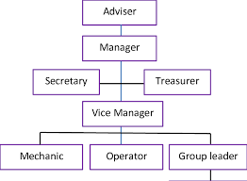

2.2 JEWELLERY
Jewellery (or jewelry in American English) consists of decorative items worn for personal adornment such as brooches, rings, necklaces, earrings, pendants, bracelets, and cufflinks. Jewellery may be attached to the body or the clothes. From a western perspective, the term is restricted to durable ornaments, excluding flowers for example. For many centuries metal such as gold often combined with gemstones, has been the normal material for jewellery, but other materials such as glass, shells and other plant materials may be used
2.3 HOW TO MEASURE JEWELRY
To measure jewelry, use a flexible measuring tape for bracelets and necklaces, a ring sizer or string for rings, and a ruler for earrings and other items, ensuring measurements are taken accurately in millimeters or inches, depending on the desired precision.
Here's a more detailed guide:
1. Necklaces and Chains:
- Measure the length: Lay the necklace flat and measure from one end of the clasp to the other.
- Consider the clasp: The clasp is included in the measurement, so ensure you measure the entire length of the necklace.
- Common lengths: Necklaces are typically 16, 18, or 20 inches, but can vary depending on style.
2. Bracelets:
- Measure the circumference: Use a flexible tape measure to measure around your wrist at the narrowest point.
- Account for the gap: For open bracelets, the length of the gap is already accounted for in the given size.
- Common lengths: Common bracelet lengths are 7, 7.5, or 8 inches.
- Bangles: Measure the inside diameter of the bangle.
3. Rings:
- Use a ring sizer: Ring sizers are the most accurate way to measure ring size.
- Use a string or paper: If you don't have a ring sizer, wrap a thin string or paper strip around your finger, mark where it overlaps, and measure the length.
- Refer to a ring size chart: Compare your measurement to a ring size chart to determine your ring size.
4. Earrings:
- Stud earrings: Measure the length and width of the earring design.
- Dangle earrings: Measure from the top of the earring to the bottom, including the clasp, and at the widest point.
- Hoop earrings: Measure the inside diameter of the hoop.
- Dimensions are given in millimeters: Dimensions for earrings are typically given in millimeters.
5. Other Jewelry:
- Use a ruler or caliper:
For measuring the dimensions of beads, gemstones, or other small jewelry components, use a ruler or caliper to measure length, width, and diameter.
- Millimeter gauge:
A millimeter gauge can be used to measure the width of beads and other small jewelry components.
- Consider tolerances:
Be aware that there may be slight variations in measurements, especially for handmade jewelry.

CHAPTER THREE
3.1 HOW TO OPERATE POS
To operate a point of sale (POS) machine, you can:
- Enter the purchase amount
- Ask the customer to pay
- Process the payment
- Print receipts
Accepting payment
- Card payment: Swipe, insert, or hover the card over the machine
- Cash payment: Enter the amount, then give the customer the correct change
Processing payment
- The POS machine sends the card information to the bank
- The bank confirms if the customer has enough funds
- If the payment is approved, the transaction is complete
Printing receipts
- If the POS machine can print receipts, it will print one for the customer and one for the merchant
- If the machine can't print receipts, you can send a receipt to the customer's phone or email
Additional functions Scanning barcodes or logging products into the till, Connecting customers to sales, Calculating how much change is due, and Putting cash into the cash drawer.

3.2 PICTURES OF SOME JEWELRIES:
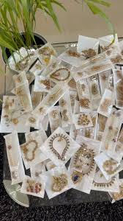
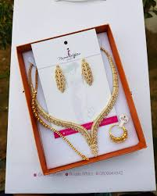
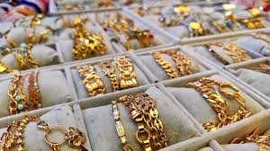
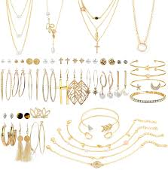

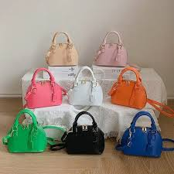
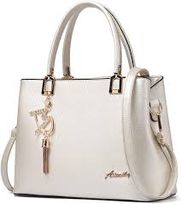
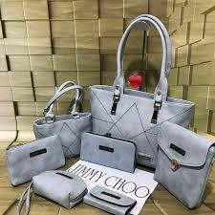

CHAPTER FOUR
4.1 CONCLUSION
The Student Industrial Work Experience Scheme (SIWES) plays a significant role in human resource development, it helps students develop new skills and enlightens them of what the present society holds for them after graduation and helps them adapt accordingly. As a result of the programme, I am now more confident to build my future, My four (4) months industrial attachment with Radio Kwara has been one of the most interesting, productive and instructive experience in my life. Through this training, I have gained new insight and more comprehensive understanding.

4.2 RECOMMENDATION
The following are the suggested recommendation for the program
i. The company should remain friendly and accommodating to future IT student.
ii. The SIWES coordinator and school should where organized enlightenment program for IT student in order to know the important of SIWES.
iii. The school (Polytechnics) should consider the four months mandatory SIWES while drafting the calendar for a successive session in a way that will affect the returning IT Student.

