

KWARA STATE POLYTECHNIC, ILORIN
INSTITUTE OF FINANCE AND MANAGEMENT STUDIES
DEPARTMENT OF BUSINESS STUDIES

A TECHNICAL REPORT OF THE STUDENTS INDUSTRIAL WORK EXPERIENCE SCHEME (SIWES)

GARUBA RISKAT
ND/23/BAM/PT/0190

UNDERTAKEN AT:
SELECT BUSINESS ENTERPRISE
NO 4, ASA-DAM ROAD ILORIN KWARA STATE.

PERIOD OF ATTACHMENT:
SEPTEMBER 2024 – NOVEMBER 2024
CERTIFICATION
This is to certify that this report is compiled by the author, GARUBA RISKAT with Matric No ND/23/BAM/PT/0190 of the Department of Business Administration, Institute of Finance and Management Studies, Kwara State Polytechnic, Ilorin upon completion of Student Industrial Work Experience Scheme (SIWES).

SIWES SUPERVISOR _________________________
Sign/Date

HEAD OF DEPARTMENT _________________________
Sign/Date

DEDICATION
This report is dedicated to Almighty Allah for the opportunity granted to acquire this industrial experience. Also to my parent, to the place of my attachment and to the Institution I belonged to Kwara State Polytechnic, Ilorin.

ACKNOWLEDGEMENT
Alhamdulillah, all praise and thanks are due to Allah (SWT), the Most Gracious, the Most Merciful, for His infinite blessings and guidance throughout my Students' Industrial Work Experience Scheme (SIWES). I acknowledge that without His divine will, this experience would not have been possible.
I extend my heartfelt gratitude to Select Business Enterprise for providing me with the valuable opportunity to gain practical experience in Business Operating and Management with ICT. I am particularly thankful to Abdulrasaq Anofi Alabere for his patient guidance, insightful mentorship, and unwavering support throughout my time here. His expertise and encouragement have been instrumental in my professional development.
I also express my sincere appreciation to Mr. Hezekiah Kehinde and the entire Staffs of Select Business Enterprise for their assistance and cooperation. Their willingness to share their knowledge and expertise has enriched my learning experience.
Furthermore, I am grateful to my SIWES Supervisor (Garba S Folashade), Kwara State Polytechnic, family and friends for their unwavering advice, encouragement, impacted knowledge, prayers and encouragement. May Allah (SWT) reward them abundantly.
Finally, I pray that the knowledge and skills I have acquired during this SIWES program will be beneficial to myself, my community, and the Ummah at large. Jazakum Allahu Khairan.

TABLE OF CONTENT
Title page i
Certification ii
Dedication iii
Acknowledgement iv
Table of contents v
CHAPTER 1: INTRODUCTION
SIWES Background 1
1.1 Objectives of SIWES 2
1.2 Bodies involved in the management of SIWES 3
1.3 Background of Establishment. 4

CHAPTER 2:
Work experience during attachment 7
2.1 Daily Operations 8
2.2 Staff Scheduling and Team Collaboration 11
2.3 Introduction to Cyber Café Operations 12
Microsoft Word 13
Microsoft Excel 15
Photocopy 16
Internet 17
CHAPTER 3
3.0 Problems encountered during period of attachment 19
CHAPTER 4
4.0 Conclusion 20
4.1 Recommendation 21

CHAPTER ONE

INTRODUCTION

STUDENT INDUSTRIAL WORK EXPERIENCE SCHEME (SIWES) BACKGROUND
In the earlier stage of science and technology education in Nigeria, students were graduating from their respective institutions without any technical knowledge or working experience. It was in this view that students undergoing science and technology related courses were mandated for students in different institution in view of widening their horizons so as to enable them have technical knowledge or working experience before graduating from their various institutions.
The Student Industrial Work Experience Scheme (SIWES) was established by the Industrial Training Fund (ITF) in 1973 to enable students of tertiary institution have technical knowledge of industrial work base on their course of study before the completion of their program in their respective institutions. The scheme was designed to expose students to industrial environment and enable them develop occupational competencies so that they can readily contribute their quota to national economic and technological development after graduation. The major background behind the embarkment of students in SIWES was to expose them to the industrial environment and enable them develop occupational competencies so that they can readily contribute their quota to national economic and technological development after graduation. The major benefit accruing to students who participate conscientiously in Students Industrial Work Experience Scheme (SIWES) are the skills and competencies they acquire. The relevant production skills remain a part of the recipients of industrial training as life-long assets which cannot be taken away from them. This is because the knowledge and skills acquired through training are internalized and become relevant when required to perform jobs or functions.

1.1 OBJECTIVES
The Industrial Training Funds policy Document No. 1 of 1973 which established SIWES outlined the objectives of the scheme. The objectives are to:
- Provide an avenue for students in higher institutions of learning to acquire industrial skills and experiences during their course of study.
- Prepare students for industrial work situations that they are likely to meet after graduation.
- Expose students to work methods and techniques in handling equipment and machinery that may not be available in their institutions.
- Make the transition from school to the world of work easier and enhance students’ contacts for later job placements.
- Provide students with the opportunities to apply their educational knowledge in real work situations, thereby bridging the gap between theory and practice.
- Enlist and strengthen employers’ involvement in the entire educational process and prepare students for employment in Industry and Commerce (Information and Guideline for SIWES, 2002).
1.2 BODIES INVOLVED IN THE MANAGEMENT OF SIWES
The bodies involved are:
- The Federal Government.
- Industrial Training Fund (ITF).
Other supervising agents are:
- National University Commission (NUC)
- National Board for Technical Education (NBTE)
- National Council for Colleges of Education (NCE)
The functions of these Agencies above include;
- Establish SIWES and accredit SIWES unit in the approved institutions.
- Formulate policies and guideline for participating bodies and institutions as well as appointing SIWES coordinators and supporting staff.
- Supervise students at their places of attachment and sign their lob-book and IT forms.
- Ensure payment of allowances for the students and supervisors.
- Ensure adequate funding of the scheme.
1.3 BACKGROUND OF ESTABLISHMENT
SELECT BUSINESS ENTERPRISE, a pioneering computer business center and internet service provider, offers a comprehensive suite of technology and business solutions to individuals, businesses, and organizations in Ilorin, Kwara State.

Our mission is to provide a one-stop-shop for all technology, internet, and business needs, fostering convenience, productivity, and growth.

Key Services:

- Computer and Internet Services: High-performance computers, laptops, and tablets with secure, high-speed internet connectivity for any kind of online registration. Other services includes Typesetting, colored printing, scanning, photocopy ,e.t.c

- TV Subscription Services: Subscription management for leading TV providers, like Dstv, Gotv, Startimes, offering a range of channels and packages.

- Online School Fees Payment: Convenient and secure online payment platform for students and other based professional bodies.

- POS Services: Point-of-sale solutions for would be customers for the services flexibility.

- Passport Photography Services: Professional passport photography services, ensuring compliance with international standards.

- NIMC Registration Centre: Authorized registration center for the National Identity Management Commission (NIMC), providing secure and efficient registration services.

- Computer training centre
Objectives

- Provide a comprehensive technology and business hub for the local community.
- Offer convenient and secure online payment solutions for school fees and other services.
- Foster a productive and collaborative environment for businesses and entrepreneurs.
- Establish strategic partnerships with local organizations, businesses, and institutions.
- Projected to achieving customer service oriented through efficient operations and strong customer retention.
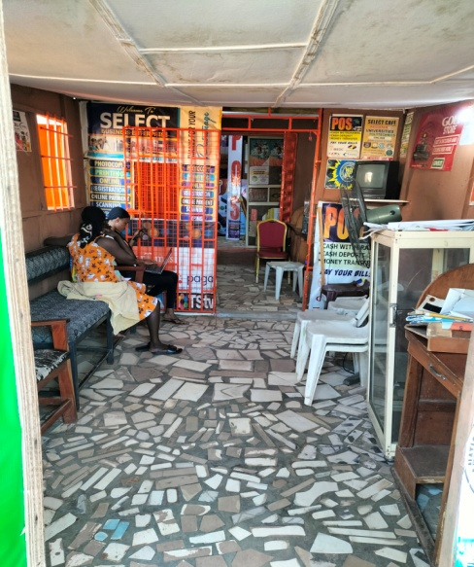
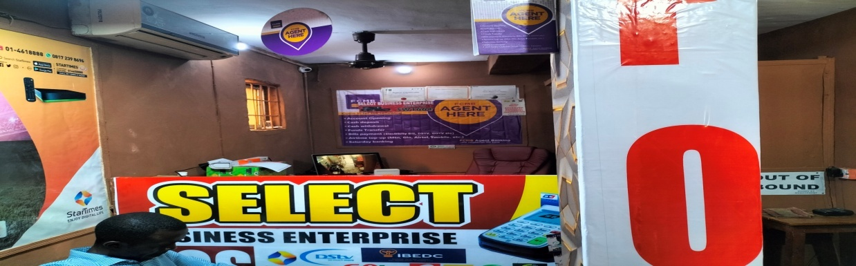

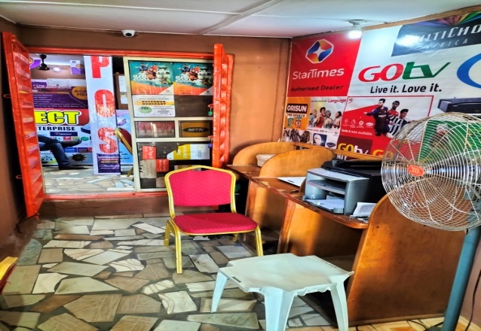
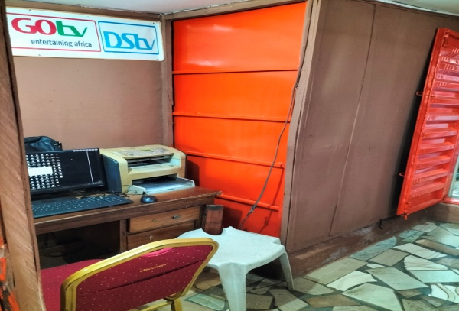

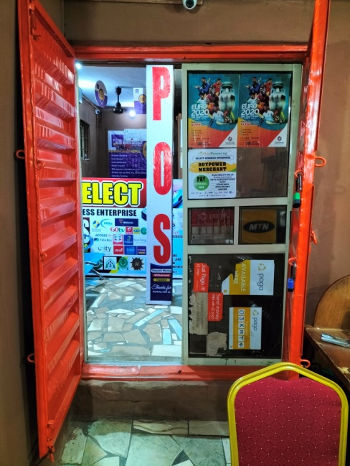

CHAPTER TWO
2.0 WORK EXPERIENCED DURING ATTACHMENT
During my SIWES placement at the cyber café, I gained practical experience in network setup, internet connectivity troubleshooting, and hardware maintenance. My customer service skills improved through assisting customers with technical issues, online services, typing, photocopy and printing/scanning tasks. I developed my communication and problem-solving abilities by handling customer inquiries and complaints, and I learned to manage customer accounts while ensuring data privacy. I became proficient in using time management and billing systems to track customer usage and process payments, and I observed and assisted with the management of printing, scanning, and other digital services, improving my organizational skills. I learned how to manage customer flow during peak usage times. I gained insights into the cyber café's revenue streams and cost structure by tracking internet usage, printing/scanning costs, and other expenses. I learned about online payment processing and financial transactions, and I observed the creation of sales reports. Overall, this SIWES placement provided me with a comprehensive understanding of how business administration principles are applied in a cyber café setting, and I developed practical skills in technology management, customer service, and financial operations.

2.1 DAILY OPERATIONS
Opening Procedures:
Observed the detailed opening procedures, including PC set up, setting up the display cases, and preparing the POS system. Noted the importance of a standardized checklist to ensure consistency and efficiency. The POS system was then logged into and tested.
Point-of-Sale (POS) System Usage:
Gained hands-on experience with the café's POS system, including order entry, payment processing, and generating sales reports. Observed how the system was used to track customer orders, manage inventory, and calculate daily sales totals. Observed the systems ability to generate reports on most popular items.
Billing Systems:
Documented the billing methods used by the cyber café, including hourly rates, package deals, and printing/scanning charges. Observed the process of generating and processing customer invoices. Analyzed the system's ability to calculate accurate charges based on usage and services. Noted the use of a point of sale system, for billing.
Observed how the billing system handled discounts, promotions, and refunds. Analyzed the system's integration with other operational systems, such as time tracking and inventory management. Noted the generation of sales reports."
Analyzed the methods of payment, and the security of the payment processing systems.
Printing and Scanning:
Observed the workflow for printing and scanning services, including customer requests, document processing, and payment. Documented the procedures for handling different types of print jobs, such as black and white, color, and high-resolution printing. Analyzed the efficiency of the printing and scanning equipment. Noted the use of print queues.
Observed how the staff handled document scanning, including file format conversions and image quality control. Analyzed the process of providing digital copies to customers. Noted the use of document feeders on scanners.
Observed the process of maintaining the printers and scanners, including the changing of toner and paper.
Other Services:
Documented any other services offered by the cyber café, such as software installations, data backups, or technical support. Observed the procedures for providing these services and the efficiency of their delivery. Analyzed the impact of these services on customer satisfaction and revenue. Noted the process of burning data to optical media, or transferring data to USB drives.
Observed the process of assisting customers with online tasks, such as email setup, document preparation, or online form completion. Analyzed the staff's ability to provide technical assistance. Noted the use of remote desktop software, to assist customers.
Evaluation of the Overall Efficiency of the Cyber Café's Operations:
Analyzed the overall efficiency of the cyber café's operations, considering factors such as customer wait times, equipment uptime, and staff productivity. Evaluated the impact of operational efficiency on customer satisfaction and profitability. Noted the flow of customers, and the peak usage times.
Identified potential areas for improvement, such as streamlining workflows, optimizing equipment usage, or implementing automation tools. Assessed the effectiveness of the cyber café's operational management practices. Noted the impact of the cyber cafe's layout, on customer flow.
Observed the staff's ability to multitask, and handle multiple customer requests at the same time. Noted the staff's ability to handle stressful situations.
Closing Procedures:
Observed the closing procedures, including cleaning and sanitizing equipment, restocking supplies, and reconciling cash drawers. Noted the importance of thorough cleaning to maintain hygiene standards. The POS system was used to generate end of day sales reports, and cash drawers were counted and reconciled.

2.2 STAFF SCHEDULING AND TEAM COLLABORATION
Recorded the process of creating staff schedules, taking into account peak hours and employee availability. Noted the importance of clear communication and flexibility in managing staff schedules. Recorded the use of digital scheduling tools.
Analyzed the dynamics of team collaboration, noting the importance of effective communication and teamwork in providing efficient customer service. Recorded how staff members communicated during peak hours, and how they supported each other. Noted the importance of clear roles and responsibilities.
Recorded how staff members handled stressful situations and resolved conflicts. Noted the impact of positive team morale on customer service and overall efficiency.
Handling Customer Inquiries and Complaints:
Documented the handling of various customer inquiries, ranging from menu questions to requests for special orders. Noted the importance of providing accurate and timely information. Recorded how staff members responded to customer inquiries both in person and over the phone.
Recorded and documented the process of handling customer complaints, focusing on the effectiveness of communication and problem-solving. Noted the importance of remaining calm and empathetic when addressing customer concerns. Recorded the use of apologies and solutions to resolve complaints. Documented the use of a system to record customer complaints, in order to track and analyze them.
Emphasized the need for clear and concise communication in resolving customer issues. Noted the importance of active listening and understanding the customer's perspective. Recorded the importance of empowering staff to resolve customer complaints effectively.
2.3 INTRODUCTION TO CYBER CAFÉ OPERATIONS
Below are the services delivered by Select Business Enterprise:
- Computer and Internet Services: High-performance computers, laptops, and tablets with secure, high-speed internet connectivity for any kind of online registration. Other services includes Typesetting, colored printing, scanning, photocopy ,e.t.c

- TV Subscription Services: Subscription management for leading TV providers, like Dstv, Gotv, Startimes, offering a range of channels and packages.

- Online School Fees Payment: Convenient and secure online payment platform for students and other based professional bodies.

- POS Services: Point-of-sale solutions for would be customers for the services flexibility.

- Passport Photography Services: Professional passport photography services, ensuring compliance with international standards.

- NIMC Registration Centre: Authorized registration center for the National Identity Management Commission (NIMC), providing secure and efficient registration services.
- Computer training centre

MICROSOFT WORD (APPLICATION PACKAGE)
This software is specifically designed for editing text, formatting text, inserting pictures, typing documents like memos, thesis, letter, seminar, etc. Application packages is the collection of software programs that have been licensed for the purpose of typesetting of documents which support images with it features.
Microsoft word has the following features:
- The Menu bar
- Office button
- The title bar
- Formatting tool bar
- The task pane
- Minimize button
- Drawing bar
- Scroll bar
- Maximize bar
- Close button
Microsoft word has some basic function which it performs:
- Editing of document
- Save and save as
- Previewing of document before printing
- Spellchecking of spelt words
- Page setting
- Typing of professional texts
- Inserting of word Art, page Number
- Inserting of tables, smart Art
- Inserting of header and footer, shapes, charts.
- Creating of link to a web page
- Inserting water marks page borders
- Creating of newspaper columns
- Inserting of symbols

MICROSOFT EXCEL (APPLICATION PACKAGE)
Microsoft Excel is a spreadsheet program that was created by Microsoft and can be used on computers, tablets and cell phones. It allows people to conveniently share their work with others and organize data. In the modern era, many businesses and firms collect data from multiple sources, which include in-store transactions, online sales and social media. This means that they need a quick and efficient way to gather the data together and analyze it. Excel is most often used for financial information and the data that is relevant to financial information; however, it can also be used for other processes, such as human resources list data.
Excel allows users to build a variety of great charts including pie charts, clustered column charts and graphs. This helps users visualize their data. Excel also allows conditional formatting, which means that users can use different colors as well as bolding, shades and italics to help differentiate between their data. Trend lines are able to extend beyond each graph's lines and help to offer predictions and forecasts. Data can be imported and exported from a variety of files.
This is an electronic spreadsheet package designed specifically for the purpose of processing data in a tabular form. It is specially designed for analyst, accountants, administrators, statisticians etc.
Schools make use of excel for computation of students’ semester results and grade point determination using the school grading system.
The following are the features of excel
Title bar
Formatting tool bar
Formula bar
Standard tool bar
Excel performs the following functions:
Protection of documents
Previewing of document before printing
Formatting of text
Perform some computation like; average, percentage, sum, subtraction etc.
Picture formatting
Cell formatting
PHOTOCOPYING
This is the process whereby printed or written document are directly copied by photographic techniques with a copier. The machine that carried out these task is known as the photocopying machine.
LIQUID TONER MACHINE: this machine produces copies using toner which is mixed with kerosene.eg virtual and cannon machine
DRY POWER MACHINE: this machines perform the job using ordinary power tuner .eg sharp machines SF8200
Materials used for photocopying
Toner
Heating box to avoid dampness
Paper size like A4, Card, Envelope#10 etc.
INTERNET
The internet is the global system of interconnected computer networks that uses the internet protocol suite to link device worldwide. It is a network of networks that consist of private ,public, academic, government and business network of local to global scope linked by a brand array of electronic, wireless, and fiber optical networking technologies.
The internet carries and extensive range of information resource and services, such as the inter-linked hypertext documents and application of worldwide web, electronic mail. Telephony and peer-peer network for sharing files.
The origin of the internet date back to research commission by the united state federal government to build robust, fault-tolerant communication via computer network.
The primary precursor network the ARPANET, initially served as a backbone
For internet connectivity
USES OF INTERNET
Individual use
Business uses the internet to retain customers
Internet is a powerful tool for advertising
Research project
Internet is used as educational tool
Sending and receiving mails
Online marketing
Online transaction
INTERNET MODERM
Internet modem is a device that is used in converting analog signals to digital signals and vice- versa .it provides internet services to computers and enables them to browse the internet.

CHAPTER THREE
3.0 PROBLEMS ENCOUNTERED DURING ATTACHMENT
- Intermittent internet outages disrupting customer access and services.
- Slow network speeds hindering customer productivity and satisfaction.
- Wi-Fi connectivity problems causing frustration for customers using wireless devices.
- Printer/scanner malfunctions delaying customer tasks and affecting service quality.
- Hardware incompatibility issues preventing the use of certain software or devices.
- Virus or malware infections compromising system security and data integrity.
- Accidental deletion of customer data causing data loss and customer dissatisfaction.
- Point of sale system crashing disrupting transactions and causing financial losses.
- Payment processing errors causing customer dissatisfaction and financial discrepancies.
- Incorrect sales recording leading to financial inaccuracies.
- Shortages of printing supplies or other materials affecting service availability.
- Lack of staff training leading to poor performance and customer dissatisfaction.
- Power outages causing loss of work and potential equipment damage.

CHAPTER FOUR
4.0 CONCLUSION
This report is the summarizing of the experienced of works and activities carried out during my SIWES placement at Select Business Enterprise located at No 4, Asa-Dam Road Ilorin, Kwara State, I gained practical experience in network setup, internet connectivity troubleshooting, and hardware maintenance. My customer service skills improved through assisting customers with technical issues, online services, typing, photocopy and printing/scanning tasks. I developed my communication and problem-solving abilities by handling customer inquiries and complaints, and I learned to manage customer accounts while ensuring data privacy. I became proficient in using time management and billing systems to track customer usage and process payments, and I observed and assisted with the management of printing, scanning, and other digital services, improving my organizational skills. I learned how to manage customer flow during peak usage times. I gained insights into the cyber café's revenue streams and cost structure by tracking internet usage, printing/scanning costs, and other expenses. I learned about online payment processing and financial transactions, and I observed the creation of sales reports. Overall, this SIWES placement provided me with a comprehensive understanding of how business administration principles are applied in a cyber café setting, and I developed practical skills in technology management, customer service, and financial operations.

4.1 RECOMMENDATION
The following Recommendation are required and thus goes mostly to place where I took my SIWES, in order to improve and enhance the expected results of SIWES:
- To improve customer satisfaction, I recommend implementing a more robust network monitoring system to proactively address connectivity issues.
- To enhance operational efficiency, I suggest standardizing software update procedures and creating a detailed troubleshooting guide for common technical problems.
- To boost revenue, I recommend developing targeted marketing campaigns that highlight the cyber café's specialized services, such as high-quality printing or specialized software access.
- To strengthen security protocols, I suggest conducting regular cybersecurity training for staff and implementing a more rigorous data backup system.
- To improve customer relations, I recommend establishing a clear and concise system for handling customer complaints and providing timely resolutions.
- To improve inventory management, I recommend the adoption of a digital inventory system to accurately track supplies and reduce waste.

