

TECHNICAL REPORT ON
STUDENTS INDUSTRIAL WORKS EXPERIENCE SCHEMES (SIWES)

HELD AT

T NOBLE BLOCK INDUSTRY
BEHINDE KWRAPOLY QUARTERS ILORIN KWARA STATE

PRESENTED BY:

ADEPOJU SEYI STEPHEN
ND/23/BAM/FT/0103
SUBMITTED TO:

THE DEPARTMENT OF BUSINESS ADMINISTRATION, INSTITUTE OF FINANCE AND MANAGEMENT STUDIES, KWARA STATE POLYTECHNIC, ILORIN.
IN PARTIAL FULFILMENT OF THE REQUIREMENT FOR THE
AWARD OF NATIONAL DIPLOMA (ND) IN BUSINESS ADMINISTRATION.

AUGUST - NOVERMBER 2024

DEDICATION
I am delight to dedicate this report to Almighty God who gave me the grace and opportunity to complete this programme.

ACKNOWLEDGEMENT
I thank God Almighty for his mercy and grace that kept me all through my SIWES period.
I am greatly indebted to my parents, Mr. & Mrs. ADEPOJU for their morally, spiritually and financially, word of encouragement and prayer given to me, who make my SIWES programme successful and also my relatives and siblings.
I also want to thank my friend and everyone that contributed to the success of my SIWES program my Industrial supervisors, my colleagues and co-workers for the tremendous moral assistance throughout the period of my attachment.

REPORT OVERVIEW
The report comprises the background of SIWES, the description of the organization, its aims and objectives, the experiences gained as an industrial training student and the summary, conclusions and recommendations.
It has a total of 5 chapters with sub-chapters. It also has the preliminary pages, such as the title page, report overview and table of contents and recommendations on the improvement of scheme.

TABLE OF CONTENT
Title Page
Dedication
Acknowledgement
Report Overview
Table of Contents
CHAPTER ONE
- Background of SIWES
1.1 Defination of SIWES
1.2 Purpose of the Training
1.3 Scope of the Training
CHAPTER TWO
- History and background of organization
2.1 Organizational Structure
2.2 Equipment and Materials Used
CHAPTER THREE
3.0 Mixing of Materials
3.1 Block Molding Process
3.2 Curing Process
3.3 Quality Control Measures
3.4 Safety Practices in Block Manufacturing
CHAPTER FOUR
4.0 CHALLENGES FACED DURING THE TRAINING

CHAPTER FIVE
5.0 Conclusion
5.1 Recommendation

CHAPTER ONE
INTRODUCTION

1.0 Background of SIWES
SIWES program was established in year 1973 by the federal Government of Nigeria through the industrial Training Fund (ITF) under the National Board of Technical Education (N.B.T.E) and it has its head quarters in Jos, plateau state.
There are other reasons behind the establishment of SIWES program, but the major reason is to learn the practical aspect of their field of study while still in course of study, which will help to face the future challenges in their respective field of study.

1.1 Defination of SIWES
Student Industrial Work Experience Scheme (SIWES) can simply be defined as a course by which student are exposed to practical training in their respective field of study. Its aim is to expose students to work practically in their respective disciplines. However, the scheme therefore was introduce to enable students match theoretical classroom knowledge with related practical knowledge in the industrial environment.
1.2 Purpose of the Training
The primary objectives of this SIWES program in a block industry include:
• Gaining practical experience in the production of concrete blocks.
• Understanding the various processes involved in block making.
• Learning about the materials, equipment, and machines used in block production.
• Enhancing technical skills relevant to civil engineering and construction.
• Understanding quality control measures in block manufacturing.

1.3 Scope of the Training
The training covered the following areas:
• Mixing of raw materials such as cement, sand, and gravel.
• Operation and maintenance of block molding machines.
• Curing and storing of manufactured blocks.
• Quality control and testing of block strength.
• Safety procedures in block manufacturing.

CHAPTER TWO
DESCRIPTION OF THE BLOCK INDUSTRY

2.0 History of the Block Industry
T NOBLE BLOCK INDUSTRY was established in 2010 and has been in operation for several years. The industry specializes in the production of different types of blocks, including hollow and solid blocks, used for construction purposes.

2.1 Organizational Structure
The block industry consists of various departments, including:
• Production Unit: Responsible for mixing, molding, and curing of blocks.
• Quality Control Unit: Ensures that blocks meet required standards.
• Maintenance Unit: Handles repairs and maintenance of machines.
• Sales and Marketing Unit: Manages customer relations and sales.

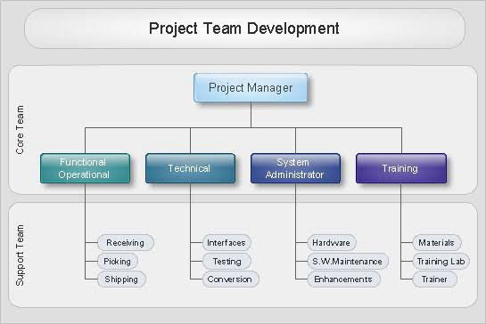

2.2 Equipment and Materials Used
The major equipment and materials used in block production include:
• Cement – A binding agent in concrete block production.
• Sharp Sand – Used to provide texture and strength.
• Gravel – Enhances the durability of blocks.
• Water – Essential for mixing cement and achieving the right consistency.
• Block Molding Machine – Used for molding blocks into desired shapes and sizes.
• Wheelbarrows and Shovels – For transportation and mixing of materials.


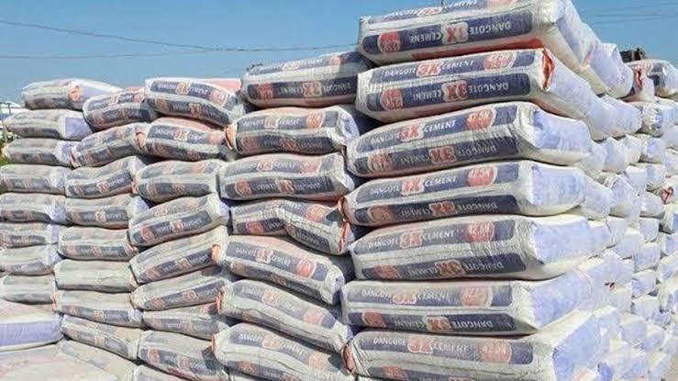

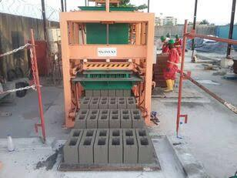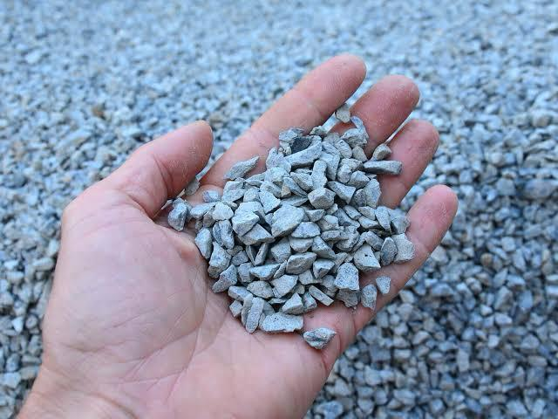

CHAPTER THREE
EXPERIENCE GAINED DURING THE TRAINING

During my SIWES training at T NOBLE BLOCK INDUSTRY, I was actively involved in the following activities:

3.0 Mixing of Materials
I learned the proper ratio of cement, sand, and gravel to achieve a strong concrete mix. The mixture is usually in a ratio of 1:6 (cement to sand) for standard blocks.

3.1 Block Molding Process
I was trained on the operation of both manual and automated block molding machines. The process involved:
• Pouring the mixed concrete into the mold.
• Compressing the mixture using the molding machine.
• Removing the molded block for curing.

3.2 Curing Process
Curing is essential to strengthen the blocks. I assisted in the proper curing method by:
• Sprinkling water on the blocks regularly for at least 7–14 days.
• Covering the blocks with a wet sack to retain moisture.

3.3 Quality Control Measures

I learned how to test the strength and durability of blocks using methods such as:
• Drop Test – Dropping a block from a certain height to check for cracks.
• Compression Test – Using a compression machine to determine block strength.

3.4 Safety Practices in Block Manufacturing
I was trained on safety measures, including:
• Wearing personal protective equipment (PPE) such as gloves, boots, and helmets.
• Proper handling of cement to avoid skin irritation.
• Keeping work areas clean to prevent accidents.

CHAPTER FOUR
CHALLENGES FACED DURING THE TRAINING
Some of the challenges encountered during the training included:
• Weather Conditions: Heavy rainfall disrupted outdoor block production.
• Machine Breakdowns: The molding machines occasionally developed faults, causing delays.
• Manual Labor Intensity: Some tasks, like mixing concrete manually, were physically demanding.
• Dust and Cement Exposure: Prolonged exposure to cement dust caused discomfort.

CHAPTER FIVE
RECOMMENDATION AND CONCLUTION

5.1 Conclusion
My SIWES training at T NOBLE BLOCK INDUSTRY was an insightful experience that improved my practical knowledge of block manufacturing. I gained hands-on skills in material mixing, molding, curing, and quality control. The training also helped me understand workplace ethics and safety measures in the construction industry.

5.2 Recommendations
To improve the SIWES experience in the block industry, I recommend:
• Providing more automated machines to reduce manual labor.
• Implementing proper safety measures and PPE for workers.
• Conducting routine maintenance of machines to prevent breakdowns.
• Organizing workshops for students to enhance their technical skills before industrial training.

