REPORTS ON
STUDENTS’ INDUSTRIAL WORK EXPERIENCE
SCHEME (SIWES)
PRIME SURVEY LTD
06A, Ebunoluwa Complex, Off Offa Road, Lajonrin Street, Sabo-Oke, Ilorin, Kwara State
BY
BETIKU FUNMILOLA OYINKANSOLA
ND/23/SGI/PT/0005

SUBMITTED TO
THE DEPARTMENT OF SURVEYING AND GEO-INFORMATICS, INSTITUTE OF ENVIRONMENT STUDIES, KWARA STATE POLYTECHNIC ILORIN, KWARA STATE
IN PARTIAL FULFILMENT OF THE REQUIREMENT
FOR THE AWARD OF NATIONAL DIPLOMA (ND) IN
SURVEYING AND GEO-INFORMATICS
NOVEMBER, 2024.

DEDICATION
I dedicate this report to God Almighty for His Unlimited Grace, Consistent Love, Immeasurable Faithfulness, and for sparing my life throughout the period of my SIWES programme.
Secondly, I dedicate it to my parents for their undiminished support and unquantifiable assistance throughout the whole exercise and beyond.

ACKNOWLEDGEMENTS
First and foremost, my deepest acknowledgement goes to God Almighty for His overwhelming love upon my life throughout the Scheme.
I appreciate my parents and friends for their constant help and support.
My special thanks go to my lecturer, Miss Disu Sherifat Omowunmi for inspiring me to be a good broadcaster.
Furthermore, I express my appreciation to Mr Bello Felix Diran, General Manager of Prime Survey Ltd, 06A, Ebunoluwa Complex, Off Offa Road, Lajonrin Street, Sabo-Oke, Ilorin, Kwara State.
I also appreciate all staff members of Prime Survey Ltd, especially Bro Ayanfe who gave out of his tight schedules to attend to me.
TABLE OF CONTENTS
Title Page
Certification Page
Dedication
Acknowledgements
CHAPTER ONE
1.0 Introduction
1.1 History Background of Students’ Industrial Work Experience Scheme (SIWES)
1.2 Objectives of SIWES
CHAPTER TWO
2.0 History of Prime Survey Limited
2.1 Organizational Chart (Organogram)
2.2 In Conclusions
CHAPTER THREE
3.0 My Experience at Prime Survey Limited
CHAPTER FOUR
Conclusion
Recommendations

ABSTRACTS
The Students’ Industrial Work Experience Scheme (SIWES) is an accepted skills acquisition programme which forms part of the approved academic standard in the degree programme for Nigeria University.
In 1973, the federal government of Nigeria introduced the national policy on industrial training, called the Students Industrial Work Experience Scheme (SIWES).
This programmes is under the umbrella of the ministry of education through the industrial training fund (ITF), was designed to help students acquire the necessary practical education/experience in their field of study and other related professions.
This is an effort which was created on order to bridge the existing gap between the theory taught in the classroom and practice of science, agriculture, medicine, engineering, technology and other professional programmes in the Nigeria tertiary institution.
The programme was established basically to impact elaborate practical understanding to students with respect to their various disciplines.
This report is a summary of the experience I acquired during my Students' Industrial Work Experience Scheme (SIWES) in Prime Survey Ltd, 06A, Ebunoluwa Complex, Off Offa Road, Lajonrin Street, Sabo-Oke, Ilorin, Kwara State.
I served as a surveyor Department of the organization.

CHAPTER ONE
1.0 INTRODUCTION
The origin of industrial training could be traced to the advent of industrial revolution which ushered in steam engines, power-driven machines and a new system of production in Europe.
To function satisfactorily then, workers needed to depart from their craft capabilities and embrace knowledge and understanding which the new technologies offered in work-settings via practical training. Therefore, the need prompted higher citadels of learning to commence application of practical and technical affairs.
The concept thrived between 1824 and 1830 extensively to warrant the creation of technical and engineering courses. These courses were established first at the Rensselaer Polytechnic Institute, USA, and secondly at Colombia University based on the new scientific curriculum that necessitated the Greek or Latin, language inclusion. The effect of this concept has been argued and it led to the spread or escalation of science, engineering and technical education in several tertiary institutions in America and Europe, towards the end of 19th century.
The products of these institutions were trained through systematic instruction with a body of knowledge in engineering and science which was theoretical and universal. Hence, they had broad ideas on fundamental knowledge to the workability of various engineering systems but lacked an in-depth foundation on practical knowledge needed for effective production in certain jobs.
The gap between theoretical knowledge and practical training was therefore noticed for bridging and it necessitated science and engineering students complementing their theoretical knowledge with practical training in industries so as to become productive in their career after graduation. This prompted the innovation that later took place in the 20th century with the introduction of cooperative education through Herman Schneider, the Dean, College of Engineering, University of Cincinnati. Therefore, engineering students started attending classes to acquire theoretical knowledge and also engaged in trainings with the same duration in companies for practical experiences.
Although studies have shown some variations in cooperative education in work-settings across the globe till date, but it is still a striking fact that Schneider’s innovation of 1906 serves as the foundation for all training in science, engineering and technology in developed nations such as North America and Western Europe, with little impacts in some developing countries.
1.1 HISTORY BACKGROUND OF STUDENTS’ INDUSTRIAL WORK EXPERIENCE SCHEME (SIWES)
Students’ Industrial Work Experience Scheme (SIWES) is a programme designed to expose and prepare students of Universities, Polytechnics, Colleges of Technology, Colleges of Agriculture and Education for Industrial Work situation which they are likely to meet after graduation. It is a skills training programme which affords students the opportunity of familiarizing, acquiring and exposing themselves with the needed experience in handling industrial equipment and machinery that are not usually available in their institutions.
Students’ Industrial Work Experience Scheme (SIWES) is a human capital formation programme through industrial attachment for which students are expected to have a practical experience on the basis of theories and principles acquired in the teaching-learning process. However, the prevalence of the inability of participants of SIWES to secure employment after the programme casts doubt on the continuing relevance of SIWES to the contemporary industrial development drive in Nigeria.
Human resource development constitutes the most critical factor in the development process and the quality must therefore be inherent in the productive capacity of people. Human societies in the quest for development have identified and developed institutional as well as structured training and educational programmes as major avenues for processing human beings to acquire the necessary skills and technical competence for their roles in the development of the society.
In this context, it is observed that, it is not only in advanced nations that science and technology are spreading, but that, they are increasingly valued whenever people value their nation’s independence, prosperity, power and prestige, and also, where nations seek a high standard of living, improved health or better education. In most discussions on human resource management, training and development represents the most significant.
SIWES was established by ITF (industrial training fund) in the year 1973 to solve the problem of lack of adequate proper skills for employment of tertiary institution graduates by Nigeria (SIWES) was founded to be a skill training programme to help expose and prepare students of University, polytechnic and college of education for the industrial work situation to be met after graduation, this scheme serve as a smooth transition from the class room to the world of work and further help in the application of knowledge the scheme provide students with the opportunity of acquiring and exposing themselves to the experience required in handling and managing of equipment and machinery that are usually not made available in their institution.
In Nigeria, SIWES was introduced in 1973 to enable undergraduate students in Science and engineering acquire practical skills needed to function satisfactorily in work-settings. Industrial training commenced in the country due to the reliance of companies or industries on technical proficiencies, for production process and preservation of company resources.
In practice, it is said to originated from the then Yaba Technical Institute, now Yaba College of Technology. At that point, students were being sponsored by various government owned institutions and other private firms. The practice permitted students to return to work with their employers during long vacations. Through this, students were having work-related experience and the training available in companies then must have been responsible for the quality of graduates in organizations in those early days.
However, it could be observed that the quality of the Nigerian graduates began to diminish afterwards due to the dearth of faculties to impart quality education on students in tertiary institutions. As military imperialists began to unleash terror on social critics, most of which were faculty members, they decided to find greener pastures abroad. To fill the vacuum, unqualified faculty members’ were recruited into the academics. To worsen the situation, most of the expatriates left Nigeria for their countries of origin; the vacuum created could not be filled satisfactorily with the skills of fresh graduates from the nation’s educational systems.
Given this, multinational companies in Nigeria such as Flour Mill Nigeria Plc, Bagco Plc, Nigerite, Nigerian Breweries Plc, Unilever Nigeria Plc, Texaco Overseas (TO), Chevron Nigeria Limited (CNL) established training schools: Also, Shell Petroleum Intensive Training Programme was established in 1998 for technical skill acquisition through hands-on experience.
Since independence, the issue that has attracted the interest of succeeding Governments in Nigeria has been that of human resource development. From the beginning of Nigeria’s nationhood, it was imminent that the pace of national development through technological advancement devolved not so much on the availability of means or resources, rather, on the articulation and effective utilization of the vast human and material resources. It is on this basis that investment on training of the human factor becomes a serious challenge as science and technology related courses are requisite for national development.
Therefore, it is observed that, initial efforts aimed at achieving rapid national development were concentrated on the expansion of formal educational institutions, though these considerably increased in number, yet did not and were not expected to have acquired the skilled, knowledge and varied technological expertise required to meet the needs of special and vital sectors of the economy. However, the fundamental role of education in human resource development is a matter of priority for any developing country to evolve a functional education policy. This is necessary because, only through such priority can a country lay a solid foundation for a future, stable and result-oriented human resource development. Thus, growth and development, which will result from effective organizational change, depend on a well educated and adequately skilled human capital that is capable of applying vision, knowledge and creativity to their economic activities. Thus, industrial education which can be achieved through the formal or/and informal educational approach (es) attracted the attention of Government and individuals, in contemporary development environment.

1.2 OBJECTIVES OF STUDENT INDUSTRIAL WORK EXPERIENCE SCHEME
The core objectives of the Scheme are as follow:
- To expose the students to work method and techniques.
- To provide an avenue for students to acquire industrial skills.
- Enhancing student contact with potential employers while on training.
- To help students appreciate the role their professional play in the society.

CHAPTER TWO
2.0 HISTORY OF PRIME SURVEY LTD, 06A, EBUNOLUWA COMPLEX, OFF OFFA ROAD, LAJONRIN STREET, SABO-OKE, ILORIN, KWARA STATE.
Prime Survey Ltd is located at 06A, Ebunoluwa Complex, Off Offa Road, Lajonrin Street, Sabo-Oke, Ilorin, Kwara State. The industry is primarily known for survey work.
Prime Survey Limited is a professional surveying and geospatial solutions company located at Ebunoluwa Complex, Sabo Oke, Ilorin, Kwara State. The company was established to provide high-quality land surveying, mapping, and geospatial data services to individuals, private organizations, and government agencies.
Since its inception, Prime Survey Limited has been committed to excellence in the field of surveying, utilizing modern technology and industry best practices to deliver accurate and reliable results. Over the years, the company has built a reputation for providing professional services in land surveying, engineering surveys, cadastral surveys, GIS mapping, topographical surveys, hydrographic surveys, and property documentation.
With a team of experienced and licensed surveyors, Prime Survey Limited has contributed significantly to infrastructural development projects in Kwara State and beyond, assisting in land acquisition, property development, and environmental planning.
The company's mission is to enhance land management and spatial data accuracy through cutting-edge technology and efficient service delivery. By integrating modern tools such as GPS technology, drones, and GIS software, Prime Survey Limited ensures precision in all its projects, meeting clients' needs with professionalism and integrity.
As part of its corporate social responsibility, the company also plays a role in training and mentoring students undergoing SIWES (Student Industrial Work Experience Scheme), providing hands-on experience in field surveying, data analysis, and geospatial applications.
Through continuous innovation and expertise, Prime Survey Limited remains a leading surveying company in Kwara State, contributing to sustainable land development and infrastructural growth in Nigeria.
2.1 ORGANIZATIONAL CHART (ORGANOGRAM)
Hon. Commissioner
Perm. Secretary
Dir. Town Planning

Dir. Lands

Surveyor General

DAS

DFA

DPRS

Asst. Dir. planning

Asst. Dir. Lands

Admin Officer

Store

Asst. Surveyor General

Account

Main Cashier

2.2 OBJECTIVES OF THE SURVEY
The basic functions of the ministry are as follow;
- Surveying
- Advising government on land policy
- Provision of residential, commercial, industrial and other relevant layout.
- Preparation of physical development plan
- Processing of land permission and titles which extend to subsequent transactions that may arises.
2.3 VARIOUS DEPARTMENTS IN THE ESTABLISHMENT AND THEIR FUNCTIONS
Town planning: -Is an intention or proposal in building a larger settlement. The town planning department is with the following activities.
- Designing of layout for various uses.
- Inspects all physical planning activities.
- Handle all physical planning activities.
- Coordinates layout plans for government and private individual.
- Production of site analysis and environmental impact analysis report.
Lands Department:-Lands department is the mother of the ministry because you take care of every activities that is going on the department which they are as follows:-
- Settlement of land disputes.
- Allocation of land to prospective applicant by land use and allocation committee.
- Acquisition of land for government project and scheme.
- Opening of new files applicants and keeping of land record.
- Preparation of ground rent and others fees chargeable by the ministry.
- Granting and convergence of tittles.
Survey Department:-The work of the survey are as follows:-
- Undertake cadastral survey to produce title deeds plans of individuals a lot, government items and other layouts for processing certificate of occupancy.
- Provision and updating of township maps.
- Maintenance of cadastral records.
- Demarcation of administration maps and survey plans.
Department of Administrative and Supplies (DAS):- This department serves as the link and bridge between the management and staff and also handle all financial transaction of the ministry and it also handle welfare aspects of the staff. e.g. promotion discipline and transfer.
Department of Finance and Account (DFA):- This department is saddle with the following:
- Keeping of all financial record.
- Preparation of subject.
- Rendering of financial report.
- Formulation of financial policies.
- Also responsible for all collections and disbursement of funds on behalf of the ministry.

CHAPTER THREE
3.0 MY EXPERIENCE AT PRIME SURVEY LIMITED
I carried out my four (4) month Industrial training program at Prime Survey Ltd, 06A, Ebunoluwa Complex, Off Offa Road, Lajorin Street, Sabo-Oke, Ilorin, Kwara State. During my training, I was able to acquire the following experience;
  - Administrative Orientation
  - Little briefing about Survey and some Survey Instruments.
  - Site inspection analysis
  - Drawing of sketch plan of inspected sites.
  - Layout design
  - Solving land disputes
  - Record keeping
  - Assessment of township road.
  - Process of obtaining statutory.

3.1 ADMINISTRATIVE ORIENTATION
This involves how the different sections of the ministry perform their duties. Among the orientation given to me, I was told that the section under which I have done my training provide field data to the other sections for further analysis.
3.2 SURVEY AND SURVEYING INSTRUMENTS
What is Survey?
Survey is a technique, profession and science of accurately determining the terrestrial or three dimensional position of points and the distance and angles between them commonly practiced by surveyors and members of various engineering profession.
SURVEYING INSTRUMENTS
Ranging Pole: It is a 5m straight piece of wood or steel colored red and white used for alignment during survey.
Compass: Is used for measuring bearings from 0º to 360º in clockwise direction.
Leveling Staff: Also called leveling rod used with a leveling instrument to determine the difference in height between points above a datum surface.
Gunter Chain: A formal measuring instrument of 66 ft (20.1m) long, subdivided into 100 links, each of which is a short section of wire connected to the next link by a loop.
Measuring Tape: A flexible ruler t0hat is used to measure distance. It consists of a ribbon of cloth, plastic, fibre glass, or metals strip with linear measurement markings.
G.P.S (Global Positioning System): A framework for gathering, managing, and analyzing data.
Field Notebook: A roundup note that entails all necessary information jotted from the field.
3.3 SITE INSPECTION ANALYSIS.
Site: - is the position or location of a town, building, plot, etc especially as to its environment. It can be described in terms of physical characteristics of the site.
Site inspection and analysis: - is the act or process of looking at something closely in order to learn more about it, to find problems, and give details account of the site in terms of physical features.
PROCESSES INVOLVED IN SITE INSPECTION ANALYSIS.
Location of site: the planner locates the site which is to be inspected using topographical map of the area.
Identification: the planner identifies the plot boundary.
Measurement: the length and breadth of the plot is measured using either tape or chain and the measurements are being recorded.
Sketch: - draw the rough sketch of the area.
Calculation: - the dimension of the plot is calculated and recorded.
Drawing: - the planner draws the site inspection plan in the studio.
Report: - write down the report of the site inspection analysis.
Documentation: - the site inspection plan and report is documented in technical file.
Forwarding: - the technical file is forwarded to the Director Town Planning for further analysis.
PRACTICAL EXPERIENCE OF SITE INSPECTION AT THE PRIME SURVEY LTD, 06A, EBUNOLUWA COMPLEX, OFF OFFA ROAD, LAJONRIN STREET, SABO-OKE, ILORIN, KWARA STATE
I learned about sites inspection of various places within the Ilorin metropolis and its environs.
Some of the various places/areas we went for site inspections are listed below:-
- A site for capping at Bolohunduro Area, of upper Gaa akanbiwith surcon number SCKWH.8421-H842AX
- Site for capping at Gaa Akanbi Area behind correct filling station with surcon number SCKWI.9604AX to SCKWI.9607AX
- A site for re connection of survey under title at Budo omo Alao village along Afon Aboto road with Tersus Oscar Dual frequency GPS, SCKWH4016AX to SCKWH4022AX.
- A site for a layout survey at eyenkorin area off airport road, Ilorin, the layout plan attached. .
- A site at Jimba Oja to give set out alignment of University of Ilorin sugar research faculty fence of 2.5km
As it is stated earlier the function of the ministry specifically the planning section/units in the surveying deals with the inspection, and writing commendations regarding the inspections carried out to draw updated firsthand information on the inspected property and for proper referencing.

3.4 DRAWING SKETCH PLAN OF INSPECTED SITES
In drawing the sketch plan of inspected sites, suitable scale has to be chosen. The chosen scale depends on the type of paper the sketch is to be done, for example larger scale (1:1000) will be suitable for A4 paper type, because the larger the scale the smaller the sketch appears on the paper and the smaller the scale the larger the sketch appears on the paper. Some instruments such as; pencil, eraser, set square, scale rule, black and red pen are used in the process of drawing a sketch plan of inspected sites.
Below are some sketches of inspected sites carried out in the ministry;
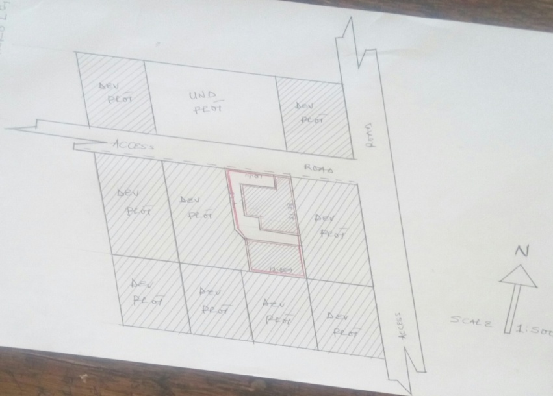
NOTE: The red lines on the sketch shows the boundaries of the main area of observation and the hatched areas signifies build-up plots as of the time of the inspection.
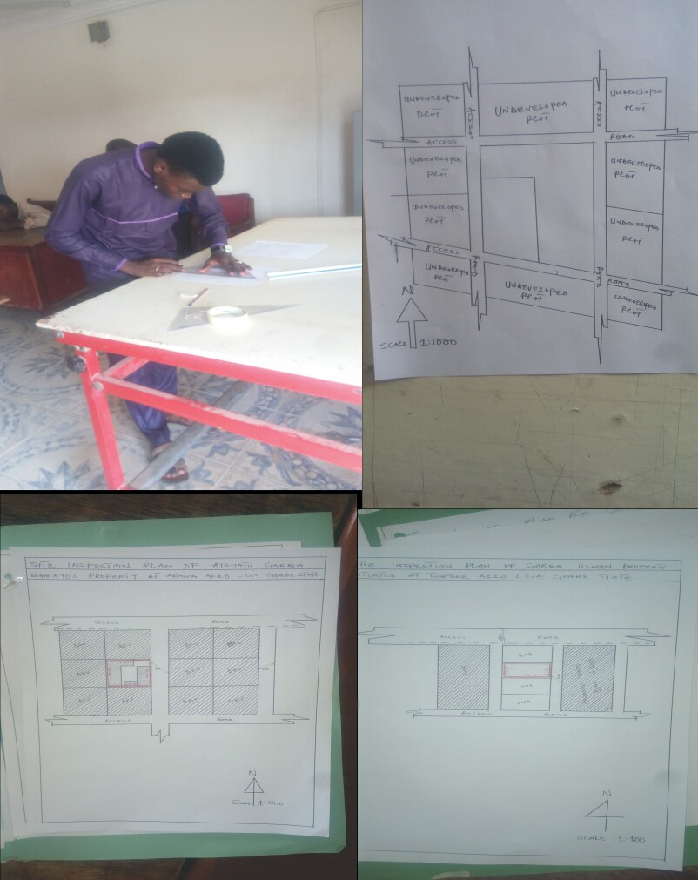
3.5LAYOUT DESIGN
Layout: A structured arrangement of items within certain limits or a map or a drawing of a construction site showing the position of roads, buildings, or other construction.
Layout Design: This can be said as the process of designing a suitable plan containing so many plots for several functions, such as; residential, commercial, educational etc.
FEATURES OF A GOOD LAYOUT
- Good road network
- Accessibility to market
- Accessibility to religious center
- Provision of health care sector
- Security offices
- Availability of job opportunities
- Adequate electricity
- Good spacing
- Accessibility to educational sectors
3.6 DISPUTE RESOLUTION
Dispute: it can be said as a state of argument, disagreement, or failure to agree between two or more parties.
Dispute resolution: This has to do with finding a solution or bringing an end to a disagreement or argument between two or more parties.
For a dispute to take place, it must have two or more parties disagreeing with each other’s decision as stated above. The Ministry of Lands and Survey plays a vital role in solving such kind of issues, which may arise between two parties.
3.7 ASSESSMENT OF TOWNSHIP ROAD
What is assessment? There is various definition of the word assessment, in education it is simply the ways which a teacher will follow to check, mark, reward, and placed confidence on his or her students knowing the exact capacity, ability, and well-being of the performance of the students, that calls for the student award of certificate at the end of the program attained.
PROCESSES OF MAKING ASSESSMENTS
There are different processes that are involved in making an assessment exercise, and they are listed below:-
- Reaching the property owners.
- Making of appropriate survey by the surveyor using its instrument.
- Marking the affected areas i.e. signs of corridors.
- Placement of road construction sings e.g. pegs, number marks, benchmarks, (km, m, cm) etc.

MATERIALS USED IN THE ASSESSMENT EXERCISE.
- Measuring tapes (10m, 30m, 50m, 100m, 150m, 200m, 300m,) and etc.
- Pegs wooden arrows,(alignment).
- Markings e.g.BM, Marks, Arrows.
- Record books.
- Cameras if necessary.
- Pens (biros, pencils, plain sheets, rulers).etc.
PROCESSION OF ASSESSMENT MAKING:-
The assessment work is done with a cover letters from the ministry to the areas affected through their heads, e.g. Either the Hakim’s, Dagacis, Mai-anguwas and other concerned heads, of which the letters are written in the letter heads of the ministry of land and survey with the signs of the Honorable commissioner, permanent secretary of the ministry portraying the authority of the executive governor of the states.
FACTORS /REASONS FOR ASSESSMENT
- Provision of dual roads within the town to alleviate the general public to meet up with their goods and services around the metropolitan city.
- To help control the erosion effect in some areas this is already eating up the lives and property of the public.
- Ensuring the placement of the original plans of some areas already design by the ministry.
- For proper evaluation and compensation.
- To provide avenue for town planning and maintenance.
STEPS INVOLVE IN THE ASSESSMENT WORK.
- Reaching the owner of the property to be assessed.
- Explain the purpose of the work you are to do there.
- Expressing the organization involve in the work, and the authority empowering the work.
- Taking the measurement and the description of the affected property.
- Stating the nature of the property.
- Measuring the size of the property by the length, breath, or even taking of the gross measurement of the property. (In some cases is allowed).
- Recording of the data collected.
VALID PROPERTIES TO BE ASSESSED:-
  - Houses made up of cement/blocks, and mud houses.
  - Structures owned by government and private owners, religious societies, and company owns.
  - Boreholes, wells, reservoirs, (both underground and surface ones).
  - Block and cement overhead tank/iron constructed overhead tank.
  - Soakaways (waste bins).
  - Veranda, car porch, walls.
  - Incinerators. (Be it community, organizational ones e.g. GOSEPA).
  - Transformer standout.
CHAPTER FOUR
This chapter contains the summary of my four (4) month siwes experience, the problems I encountered during the process, recommendations and lastly, my conclusion.
4.1 SUMMARY
During my industrial training at prime survey limited at plot 06 ebunoluwa complex off offa road lajorin street,sabo oke,Ilorin,Kwara state ,I have acquired a lot of knowledge and skills concerning the activities of the ministry which include: allocation of lands to members of the public, layout design, assessment of township road, settlement of dispute among two parties, site inspection and analysis, drawing of sketch plans of inspected sites, process of obtaining statutory.
In respect to the higher ranking of the establishment, the ministry of lands and survey is headed by the commissioner and assisted by the permanent secretary and surveyor general of the state. While director’s takes charge of the various departments of the ministry and staff officer (SO) take charge of the affairs of all administration works in the ministry.
In planning departments, I learned about developmental plan, how to design a plan, processes in applying for conversion of plots of land from customary to stationary plots of land, processes in acquisition of certificate of ownership (C of O), the importance of layout designs, importance of site inspection and many others functions of the departments.

4.2 PROBLEMS ENCOUNTERED
During my industrial training attachment in the Prime Survey Ltd, 06A, Ebunoluwa Complex, Off Offa Road, Lajorin Street, Sabo-Oke, Ilorin, Kwara State, I encountered some problems which include;
- Insufficient site vehicles.
- Insufficient staffs within the planning department.
- Inadequate design materials/instruments.

4.3 RECOMMENDATIONS
- The government of Kwara state should try to provide more vehicles to the ministry, so that the staffs and the I.T student would have more access to site work.
- The government of Kwara state should also try to employ more experienced workers to the ministry (graduates in geography, urban and regional planning).
- Provision of more design materials/instrument should be made by the government to the ministry.
4.4 CONCLUSION
In conclusion, The Industrial training program was a wonderful experience that provided me with the opportunity to know what it feels like to be in the working environment and how to meet and cope with office works and challenges and how to tackle matters arising from place of work, it also advance my thought about planning and survey profession in general and the type of challenge encounter when I was in such field as officer.

REFERENCES
Alan and Arthur Strahler (2000), Physical Geography, Science and Systems of the
Human Environment, Second Edition, Pg 7 and 46-48.
American Planning Association 2011 article
Anderson, J & Mikhail, E (1998), surveying: theory and Practice, Seventh Edition, McGraw-Hill, Pg 1011.
BaklitMukang (2012), Department of Geography and planning, University of Jos, Plateau State, Nigeria.
Canadian Institute of Planners 2011 article Copyright @2013 Dictionary.com LLC.
Dahlman, Renwick & Bergman (2003), Introduction to Geography, People, Places and Environment, Fifth Edition, Pg 392. Fcda.gov.ng/index.php%3Foption%3Dco...
Getis, Bjelland & Fellmann (2011), Introduction to Geography, Thirteenth Edition, McGraw-Hill, pg 363.
Michael Pacione (2005), Urban Geography, Second Edition, Pg 670,674.
O.A. Iwena, (2007), Essential Geography for senior secondary schools. Pg 138-139.
Personal Observations Made while on the Field.
Prof. Naomi N. James-Rugu, SIWES KEY POINTS 1st Edition 2012, published by EUK and Associates limited, 26, Shendam Street, Jos, Plateau State, Nigeria.
Walters, D, (2007), Designing community, charettes, master plans and Form-based codes, Oxford, UK.
William P. & Mary Ann Cunningham (2006), Principles of Environmental `
Science, Inquiry & Application, Third Edition, Pg 347-349.

