

TECHNICAL REPORT

ON

STUDENT INDUSTRIAL WORK EXPERIENCE
SCHEME (SIWES)

HELD AT

DEAN GRAFIX PRINT ARENA,
OYO TOWN, OYO STATE

BY

LAWAL MISRAFA OYINDAMOLA
ND/23/BAM/PT/0561

SUBMITTED TO

SUBMITTED TO

THE DEPARTMENT OF BUSINESS ADMINISTRATION
INSTITUTE OF FINANCE AND MANAGEMENT STUDIES (IFMS)
KWARA STATE POLYTECHNIC, ILORIN
IN PARTIAL FULFILMENT OF THE REQUIREMENTS FOR THE AWARD OF NATIONAL DIPLOMA IN BUSINESS ADMINISTRATION

JANUARY, 2025
CERTIFICATION
This is to certify that the bearer has successfully completed the Student Industrial Work Experience (SIWES).

_________________________ ___________
Department Cordinator Date

________________________ ____________
SIWES Director Date

DEDICATION
This report is dedicated to the almighty God, the giver and sustainer of life, for His unconditional love and mercy granted to me throughout the period of my Industrial Training.
ACKNOWLEDGMENT
I am deeply grateful to Almighty God for granting me the strength and wisdom throughout my SIWES program. My profound appreciation goes to Kwara State Polytechnic , my Department, and the Industrial Training Fund (ITF) for providing the opportunity to undergo this experience. I also extend my gratitude to the management and staff of DEAN GRAFIX PRINT ARENA, OYO TOWN, OYO STATE especially my industry-based supervisor, for their guidance and mentorship. Lastly, I thank my family and friends for their unwavering support.

TABLE OF CONTENTS
Title Page
Certification
Dedication
Acknowledgment
Chapter One: Introduction
Background of SIWES
Objectives of SIWES
Significance of the Training
Chapter Two: Overview of Dean Grafix Print Arena
Company Profile
Organizational Structure
Services Rendered
Chapter Three: Training Activities and Experience
Introduction to Printing and Graphics Design
Printing of ID Cards
Design and Printing of Banners, Flyers, and Stickers
Use of Graphic Design Software (CorelDRAW, Photoshop)
Laminating and Binding Techniques
Customer Service and Order Processing
Chapter Four: Challenges and Solutions
Challenges Faced
How the Challenges Were Overcome
Chapter Five: Conclusion and Recommendations
Summary of Experience
Recommendations for Future Interns
Conclusion

CHAPTER ONE

INTRODUCTION

Background of SIWES
The Student Industrial Work Experience Scheme (SIWES) was established to bridge the gap between theoretical learning and practical application in industrial settings. The program is a requirement for students in technical and vocational disciplines to gain hands-on experience in their fields of study.

Objectives of SIWES
The objectives of the SIWES program include:
- Exposing students to the practical aspects of their academic discipline.
- Helping students acquire industrial skills and work ethics.
- Enhancing employability through real-world experience.
- Strengthening the link between institutions and industries.

Significance of the Training
Industrial training is significant in preparing students for future career opportunities. It helps develop problem-solving skills, improves creativity, and allows students to work with advanced technology in their field.

CHAPTER TWO

OVERVIEW OF DEAN GRAFIX PRINT ARENA

Company Profile
Dean Grafix Print Arena is a professional printing and graphic design company located in Oyo Town, Oyo State. The company specializes in high-quality printing services, including ID cards, banners, flyers, and other promotional materials.

Organizational Structure
The company operates with a well-structured team, including:
- Managing Director
- Graphic Designers
- Print Technicians
- Customer Service Representatives

ORGANIZATION CHART
C E O
MANAGEING DIRECTOR
IT SUPPORT STAFF
Print Technicians

Graphic Designers

CUSTOMER SERVICE REPRESENTATIVES

Services Rendered
Dean Grafix Print Arena offers services such as:
- ID Card Printing
- Banner and Flyer Design
- Business Card Printing
- Sticker and Label Printing
- Digital Printing and Branding
- Internet browsing
- Photocopying, scanning, and printing
- Computer repairs and maintenance
- Digital marketing support

CHAPTER THREE:

TRAINING ACTIVITIES AND EXPERIENCE

Introduction to Printing and Graphics Design
During my training, I was introduced to the basics of graphic design and printing processes. I learned how to use different printing machines and software to create professional designs.

Printing of ID Cards
I was actively involved in designing and printing ID cards for individuals and organizations. This process involved data entry, image processing, and printing using special ID card printers.

Design and Printing of Banners, Flyers, and Stickers
I assisted in designing and printing banners, flyers, and stickers using software like CorelDRAW and Photoshop. I also learned the importance of color management and layout design.

Use of Graphic Design Software
I gained hands-on experience in using CorelDRAW, Photoshop, and other graphic design software to create high-quality designs for printing.

Laminating and Binding Techniques
I was trained on how to laminate printed materials for durability and bind documents professionally.

Customer Service and Order Processing
I learned how to interact with customers, take orders, and ensure timely delivery of printing projects.

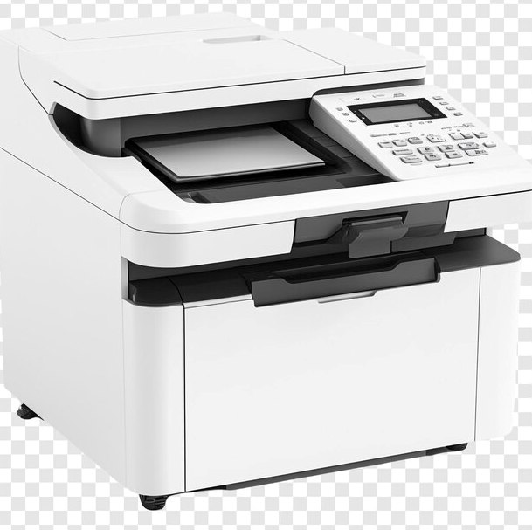
PHOTOCOPIER MACHINE
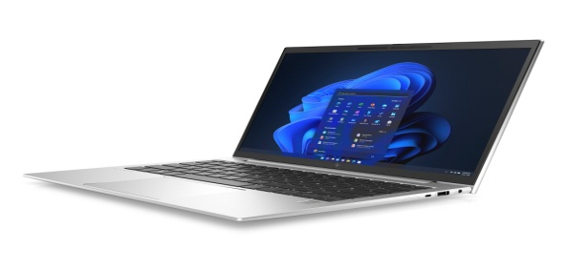
LAPTOP COMPUTER SYSTEM
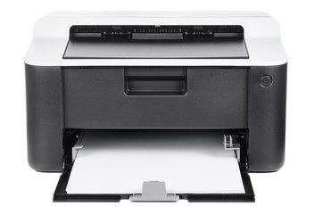
PRINTER

CHAPTER FOUR

CHALLENGES AND SOLUTIONS

Challenges Faced
Some of the challenges encountered during my training included:
- Technical issues with printing machines.
- Understanding complex design tools.
- Managing customer expectations.

How the Challenges Were Overcome
- I received guidance from experienced staff on troubleshooting printer issues.
- I practiced regularly to improve my graphic design skills.
- I learned effective communication to handle customer demands.

CHAPTER FIVE

CONCLUSION AND RECOMMENDATIONS

Summary of Experience
The training at Dean Grafix Print Arena was an eye-opening experience. I gained practical skills in graphic design, printing, and customer service. The hands-on experience helped bridge the gap between academic knowledge and industry application.

Recommendations for Future Interns
- Future interns should be proactive in learning and practicing design software.
- They should develop strong customer service skills.
- They should be open to learning new printing techniques and machine operations.
Conclusion
Industrial training at Dean Grafix Print Arena was highly beneficial. The experience gained will contribute greatly to my career growth in the printing and graphics industry.

