
TECHNICAL REPORT
ON
STUDENT INDUSTRIAL WORK EXPERIENCE SCHEME
(SIWES)

HELD AT

GLOBAL LINK MANAGEMENT
5, AJIA STREET, KOSUBOSU, KWARA STATE

BY

AKINWUNMI AL-AMEEN ABEFE
ND/23/BLD/FT/0050

SUBMITTED TO
THE DEPARTMENT OF BUILDING TECHNOLOGY
INSTITUTE OF ENVIRONMENTAL STUDIES (IES)
KWARA STATE POLYTECHNIC, ILORIN
IN PARTIAL FULFILMENT OF THE REQUIREMENTS FOR THE AWARD OF NATIONAL DIPLOMA (ND) IN
BUILDING TECHNOLOGY

AUGUST-DECEMBER, 2024
CERTIFICATION
This is to certify that the bearer has successfully completed the Student Industrial Work Experience (SIWES).

Department Coordinator Date

SIWES Director Date

DEDICATION
This report is dedicated to the Almighty God, the giver and sustainer of life, for His unconditional love and mercy granted to me throughout the period of my Industrial Training.

ACKNOWLEDGEMENTS
My acknowledgement goes to God Almighty, the most gracious, the most merciful and also to my Parents, Mr. and Mrs. Akinwunmi, for their parental care over me.
TABLE OF CONTENTS
Cover Page
Certification
Dedication iii
Acknowledgement iv
Table of contents v
Chapter One
1.1 Introduction
1.2 History of Siwes
1.3 Objectives of the Programme
1.4 Objectives of Establishment
Chapter Two
2.1 Brief History of the Organization
2.2 Organizational Chart of the Organization
2.3 Methods of Shipping Charcoal
2.4 Types of feeds
2.5 Order Placement Process
2.6 Feed Production Process
Chapter Three
3.1 Experience Gained
3.2 Skills Acquired
Chapter Four
4.1 Challenges Faced
Chapter Five
5.1 Conclusion
5.1 Recommendation

CHAPTER ONE
  - INTRODUCTION TO SIWES
Students Industrial Work Experience Scheme (SIWES) is a Skills Training Program designed to prepare and expose Students of Universities, Polytechnics, Colleges of Technology, Colleges of Agriculture and Colleges of Education for the Industrial Work situation they are likely to meet after graduation. The Scheme affords Students the opportunity of familiarizing and exposing themselves handling equipment and machinery that are usually not available in their institutions.

1.2 HISTORY OF SIWES
The Students’ Industrial Work Experience Scheme (SIWES) was initiated in 1973 by the Federal Government of Nigeria under the Industrial Training Fund (ITF) to bridge the gap between theory and practice among products of our tertiary Institutions. It was designed to provide practical training that will expose and prepare students of Universities, Polytechnics, and Colleges of Education for work situation they are likely to meet after graduation.
Before the establishment of the scheme, there was a growing concern among the industrialists that graduates of institutions of higher learning lacked adequate practical background studies preparatory for employment in industries. Thus the employers were of the opinion that the theoretical education going on in higher institutions was not responsive to the needs of the employers of labour.
As a result of the increasing number of students’ enrolment in higher institutions of learning, the administration of this function of funding the scheme became enormous, hence ITF withdrew from the scheme in 1978 and was taken over by the Federal Government and handed to National Universities commission (NUC), National Board for Technical Education (NBTE) and National Commission for Colleges of Education (NCCE). In 1984, the Federal Government reverted back to ITF which took over the scheme officially in 1985 with funding provided by the Federal Government.

1.3 OBJECTIVES OF THE PROGRAMME
The specific objectives of SIWES are to:
- Provide placements in industries for students of higher institutions of learning approved by relevant regulatory authorities (NUC, NBTE, NCCE) to acquire work experience and skills relevant to their course of study
- Prepare students for real work situation they will meet after graduation.
- Expose students to work methods and techniques in the handling of equipment and machinery that may not be available in schools.
- Make transition from school to the labour market smooth and enhance students’ conduct for later job placement
- Provide students with the opportunity to apply their knowledge in real life work situation thereby bridging the gap between theory and practice
- Strengthen employer involvement in the entire educational process and prepare students for employment in industry
Promote the desired technological knowhow required for the advancement of the nation.
CHAPTER TWO
OVERVIEW OF THE ORGANIZATION
GLOBAL LINK MANAGEMENT is a leading building construction company specializing in residential, commercial, and industrial projects. Established in 2016, the company has built a reputation for delivering high-quality projects within stipulated time frames. Its mission is to provide innovative and sustainable building solutions that meet client needs while adhering to industry standards.
The company’s operations are supported by a team of skilled architects, engineers, project managers, and laborers who work collaboratively to achieve project goals. It is equipped with modern construction tools and machinery, including concrete mixers, bulldozers, and scaffolding systems, which enhance efficiency and precision on-site.
In addition to its focus on safety and quality, GLOBAL LINK MANAGEMENT emphasizes employee development through regular training programs. The organization’s project portfolio includes residential estates, office complexes, shopping malls, and industrial facilities, reflecting its versatility and expertise in the construction sector.
2.2 ORGANIZATION STRUCTURE
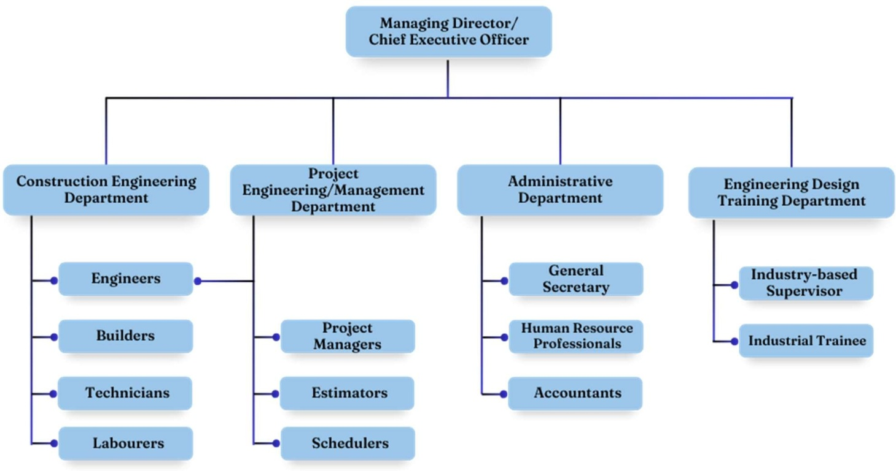

CHAPTER THREE
ACTIVITIES AND EXPERIENCES
I attended an orientation program introducing the company’s policies, safety standards, and organizational structure. This period also involved familiarization with construction tools and equipment, as well as observing ongoing projects and their stages of development.
I participated in site preparation and foundation work. My responsibilities included assisting in site clearance and excavation, laying foundations, and ensuring alignment according to design specifications. I also learned about soil testing and its importance in determining foundation type.
I gained hands-on experience in structural works. This involved reinforcement and formwork design, observing and assisting in concrete mixing and pouring, and monitoring curing processes to ensure quality control measures were adhered to.
I was actively involved in masonry and finishing tasks. I worked on bricklaying, plastering, and flooring activities, as well as assisting in tiling, painting, and the installation of fixtures. Additionally, I gained insights into materials selection and cost estimation processes.
We were dedicated to electrical and plumbing installations. I observed the installation of electrical wiring and fixtures, assisted in plumbing works including pipe installations and fittings, and learned how these systems are integrated into the overall building design.
I focused on supervision and project management. I monitored daily site activities to ensure adherence to safety regulations, assisted in scheduling tasks and resource allocation, and prepared progress reports and documentation for the project.

SKILLS ACQUIRED
- Importance of teamwork and communication in construction projects.
- Application of building codes and standards in real-life scenarios.
- Effective time management and multitasking in a dynamic work environment.
- Significance of safety measures in preventing site accidents.

CHAPTER FOUR
CHALLENGES AND SOLUTION PROFFERED

4.1 Challenges Encountered in Course of Work

The following challenges were encountered in the course of my industrial training at GLOBAL LINK MANAGEMENT, either in the engineering design studio or on the site:

In the Engineering Design Studio:

    - Insufficient Information on the Architectural Plan: Before going into designing, modelling and analyzing a particular project, there is an architectural plan of that project that is needed to be checked to know the right dimensions used and to find a strategic point to place the columns in that project. Some of the architectural plans we received does not have dimensions, or the dimensions are not clearly seen and the related elements of the plans cannot be find. This made works very difficult and delay the submission of the structural working design, as it takes more time in the conceptualization process.
    - Cost of Printing: The economic in stability of the nation has really affected the cost of printing working drawings. Likewise, the location of our company acts as a factor affecting the cost. With that, there is higher financial need in getting a full structural working drawing of residential development project printed.

On-Site:

- Tight Scheduling: There was this particular project, the construction of drainage pa that BHL Limited, along Lagos-Ogun State Expressway, that came in around December 12, 2023 and we were expected to finish up by January 6, 2024. Due to the some challenges found in the site ground, most especially the partially flood area caused by the heavy downpour and the leak age in the pipe used to transfer water for the construction of other projects along the area and alongside with the number of labours available, it seemed difficult to achieve our goal within the stipulated schedule.
- Unavailability of Materials: Using the construction of drainage path at BHN Limited, along Gure-Kosubusu Expressway as case study, the transportation of the materials needed, such as the concrete mixture and reinforcement bars, for the construction were being scheduled and synchronize. We even need to wait until it gets to our turn to have the materials, as a lot of construction and engineering activities were going on and as such, had an impact to the construction schedule.
- Conflicts among the Labourers: While on work, some labourers were found fighting over in activeness, lack of productivity, and poor attribute towards work. This caused a little delay in the project.
- Communication Barrier: Still using the construction of drainage pa that GLOBAL LINK Limited, along Gure-Kosubusu Expressway as a case study-This project was assigned to our company as sub-contractor. While we visited the site for inspection, we got to notice that the main contractor for the project is a Lebanese and other key professional working on other construction activities are from Lebanon; it was not easy for us to comprehend with the way they were delivering with English language using their native intonation.

Solutions Proffered to the Challenges

The solutions proffered to the challenges I encountered during my industrial training at Global Link Management are:

In Engineering Design Studio:

    - In order to the insufficient information on the architectural plan, we established a clear communication channel with the architects responsible for providing the architectural plans. We requested comprehensive dimensions and ensured that all relevant elements are clearly visible on the plans.
    - Given the economic instability and the impact of location on printing costs, we explored alternative printing options – by transporting to nearby printing press firm that offers competitive and affordable prices. Afterwards, we fixed our company’s printer in order to be able to print by ourselves with little or no cost.

On-Site:

- When we were faced with a tight schedule, we identified potential challenges and develop contingency plans. We also assessed the site conditions, including potential flooding areas, on the first day of visit in order to know whether the construction methodologies already used can be adjusted and also, to secure additional resources.
- To mitigate the impact of material availability on construction schedules, we established strong relationships with suppliers within the site and engaged in proactive planning. We maintained regular communication with suppliers to monitor material.
There was a proactive intervention, which prevented a potential escalation of the conflicts into something more serious. Then, there was a meeting between us and the labourers in which we address the causes of the conflicts among labourers, created a positive work environment and encouraged open communication channels.

Overcoming communication barriers with individuals from different linguistic backgrounds requires a proactive approach. The only issue we had is that the spoken English language was not fluent enough. In order to bridge the communication gap and facilitate effective collaboration, we decided to listen carefully and pay attention to details to every statement made.

CHAPTER FIVE

CONCLUSION AND RECOMMENDATION

Conclusion

The Students’ Industrial Work Experience Scheme (SIWES) has helped in shedding more light on the theoretical aspect of some of the courses previously taken in school classes. It gave me more experience into the codes and ethics governing civil engineering practices and civil construction works. Through this industrial training, I have gained new insight and more understanding about the real industrial working conditions and practices and have improved my soft and functional technical skills.
The eighteen-week duration of the programme at GLOBAL LINK MANAGEMENT has provided me with valuable hands-on experience and knowledge on structural design and analysis, structural calculation, contract negotiation, cost estimation, project evaluation and management, site coordination, preparation of Gantt charts and bar bending schedule, project presentation and execution, building interpersonal relationships on-site and dealing with clients. These experience gained were not only acquired through the direct involvement in task, but also through other aspects of the training, such as observation and interaction with colleagues and other people related to the field. Because of this programme, my mind has been prepared for who I will become, my importance, and my roles in the society, and I am now confident to build my future career.

After the eighteen-week duration of the programme at GLOBAL LINK MANAGEMENT, I would like to make the following recommendations, which must be done to improve the industrial training and to make it more efficient and challenging in future:
    - Proper Planning: It is crucial that the SIWES programme be well planned by the university and properly fixed into the academic calendar properly so that the required period of the training will not be compromised, and so that the quantity and quality of the experience gained are augmented.
    - Adequate Monitoring: The school officials should monitor the activities of IT students and make more regular visits to ensure that the objectives of the scheme are achieved.
    - Financial Assistance: To ease the financial burden on students especially on transport, ITF should endeavor to pay the allowances stipulated to the students. In addition, the company should encourage students by providing financial support to aid them during their industrial training programme.
    - Accessibility: Establishments should provide the necessary growth tools related to the field and grant access to students to make use of them in order to have a practical understanding on how to use them and to make the programme enjoyable.
    - Foundational Learning: Students should have learnt the basics of some Civil Engineering related software like AutoCAD, Orion 18, and Prota Structure before the industrial training, so that they will be more easy for the Industry-based supervisor to provide further assistance without going back to the basics again.

