

A TECHNICAL REPORT
STUDENT INDUSTRIAL WORKING EXPERIENCE SCHEME
(SIWES)

Held at

TASKA ENERGY RESOURCES LTD
OLOMI ACADEMY IBADAN, OYO STATE
Prepared by:
ALIMI ROKIBAT JUMOKE
ND/23/ACC/PT/0197

SUBMITTED TO

DEPARTMENT OF ACCOUNTANCY
INSTITUTE OF FINANCE AND MANAGEMENT STUDIES
KWARA STATE POLYTECHNIC, ILORIN

INPARTIAL FULFILLMENT OF THE AWARD OF THE REQUIREMENT OF THE AWARD OF NATIONAL DIPLOMA IN ACCOUNTANCY

DEDICATION
I dedicate this technical report to the Almighty GOD, the giver of knowledge, wisdom and who is rich in mercy.

ACKNOWLEDGEMENT
I take this opportunity to express my profound gratitude and deep regards to the creator of heaven and earth, the one who knows the beginning and the end, the alpha and the omega, the Almighty Allah and also to my guides (MR & MRS ALIMI, and to all those who has helped me during my SIWES programme. The blessings, help and guidance given by them, time to time has carry me so this far and shall carry on the journey of life on which I am about to embark. I also take this opportunity to express a deep sense of gratitude to compliment my mentor for his cordial support valuable information and guidance which helped me in completing my SIWES through various stages.

TABLE OF CONTENT
Title page i
Table of content ii
Dedication iii
Acknowledgements iv
CHAPTER ONE
  - Background of SIWES 1
  - History of SIWES 1
  - Objectives of SIWES 2
  - Objectives of Establishment 3
CHAPTER TWO
2.1. Introduction to The Company 4
2.2 Functions of An Organizational Structure 4
2.3 Types Of Organizational Structures
CHAPTER THREE
3.1 Some equipment and there uses in office 6
3.2 Record of Service 6
CHAPTER FOUR
4.0 Conclusion and Recommendation 12
4.1 conclusion 12
4.2 Recommendation 13

13

CHAPTER ONE
  - INTRODUCTION TO SIWES
Students Industrial Work Experience Scheme (SIWES) is a Skills Training Program designed to prepare and expose Students of Universities, Polytechnics, Colleges of Technology, Colleges of Agriculture and Colleges of Education for the Industrial Work situation they are likely to meet after graduation. The Scheme affords Students the opportunity of familiarizing and exposing themselves handling equipment and machinery that are usually not available in their institutions.

1.2 HISTORY OF SIWES
The Students’ Industrial Work Experience Scheme (SIWES) was initiated in 1973 by the Federal Government of Nigeria under the Industrial Training Fund (ITF) to bridge the gap between theory and practice among products of our tertiary Institutions. It was designed to provide practical training that will expose and prepare students of Universities, Polytechnics, and Colleges of Education for work situation they are likely to meet after graduation.
Before the establishment of the scheme, there was a growing concern among the industrialists that graduates of institutions of higher learning lacked adequate practical background studies preparatory for employment in industries. Thus the employers were of the opinion that the theoretical education going on in higher institutions was not responsive to the needs of the employers of labour.
As a result of the increasing number of students’ enrolment in higher institutions of learning, the administration of this function of funding the scheme became enormous, hence ITF withdrew from the scheme in 1978 and was taken over by the Federal Government and handed to National Universities commission (NUC), National Board for Technical Education (NBTE) and National Commission for Colleges of Education (NCCE). In 1984, the Federal Government reverted back to ITF which took over the scheme officially in 1985 with funding provided by the Federal Government.

1.3 OBJECTIVES OF THE PROGRAMME
The specific objectives of SIWES are to:
- Provide placements in industries for students of higher institutions of learning approved by relevant regulatory authorities (NUC, NBTE, NCCE) to acquire work experience and skills relevant to their course of study
- Prepare students for real work situation they will meet after graduation.
- Expose students to work methods and techniques in the handling of equipment and machinery that may not be available in schools.
- Make transition from school to the labour market smooth and enhance students’ conduct for later job placement
- Provide students with the opportunity to apply their knowledge in real life work situation thereby bridging the gap between theory and practice
- Strengthen employer involvement in the entire educational process and prepare students for employment in industry
Promote the desired technological knowhow required for the advancement of the nation.
1.4 OBJECTIVES OF ESTABLISHMENT
To provide innovative and effective solutions
➢ To deliver exceptional customer service
➢ To drive business growth and expansion
➢ To build a strong brand reputation
➢ To develop and maintain a skilled workforce
➢ To promote a culture of innovation and continuous improvement
➢ To maintain high-quality standards and best practices
➢ To foster strategic partnerships and collaborations

CHAPTER TWO
2.1. INTRODUCTION TO THE COMPANY
- I was introduce to the administrative department and some other departments
- I was introduced to organization structure, office and their functions
An organizational structure is a system that defines how a company operates, including how employees are grouped, their roles, and how they communicate. It also outlines how tasks are delegated to achieve the company's goals.
Organization Structure
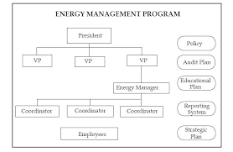

2.2 FUNCTIONS OF AN ORGANIZATIONAL STRUCTURE
- Defines roles and responsibilities: Clarifies what each employee does and how it fits into the company's overall goals
- Streamlines communication: Shows how employees report to each other and who makes decisions
- Helps with decision-making: Provides a framework for how decisions are made and resources are allocated
- Helps with resource allocation: Helps the company operate efficiently and achieve its goals
2.3 INVENTORY MANAGEMENT
Inventory management is the process of overseeing a company's inventory, including ordering, storing, and selling products, aiming to meet customer demand while minimizing costs and avoiding overstocking or stockouts.
Here's a more detailed breakdown:
- What it involves:
  - Demand Forecasting: Predicting future demand for inventory items.
  - Inventory Tracking: Monitoring inventory levels and movement.
  - Reordering and Replenishment: Determining when and how much to reorder inventory.
  - Inventory Optimization: Finding the right balance of stock levels to meet demand without excessive holding costs.
- Key Objectives:
  - Meeting customer demand.
  - Minimizing inventory holding costs.
  - Avoiding stockouts and overstocking.
- Methods and Techniques:
  - Just-in-Time (JIT): Receiving goods from suppliers only as they are needed.
  - ABC Analysis: Classifying inventory items based on their importance to the business.
  - Materials Requirement Planning (MRP): Planning and controlling the production of materials.
  - Economic Order Quantity (EOQ): Determining the optimal order quantity to minimize costs.
- Benefits:
  - Reduced costs.
  - Improved customer satisfaction.
  - Increased efficiency.
  - Better cash flow.

THE ESSENTIAL GUIDE TO MONTH END CLOSE PROCESS

The month end close process is a complete review of financial activity and performance for an entire month and the preparation of monthly financial statements.

DAILY SUMMAR RETURNS
With the use of daily S&P 500 index and simulated returns, the empirical results are achieved, which reveal that the SV-EVT-based models can outperform
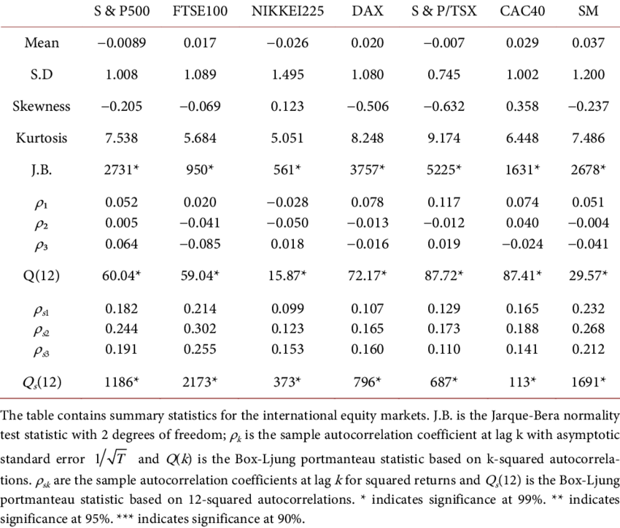
A cash book is an accounting record of all cash transactions for a business, including deposits and withdrawals. It's a primary book of accounts that's updated in real time.
Purpose
- Helps maintain accurate records of a business's cash position
- Tracks finances in an organized way
- Helps make decisions about the future of the business
- Can be used to create financial statements
How it works
- Transactions are recorded in chronological order
- The balance is calculated, verified, and carried forward on a daily basis
- The difference between the total of the debit and credit sides gives the cash in hand or bank account balance

TYPES OF CASH BOOKS

- Cash receipts journal: Records all the money received by the business
- Cash disbursement journal: Accounts for payments made
- Triple column cash book: Similar to the double column cash book, but with an additional column for bank transactions

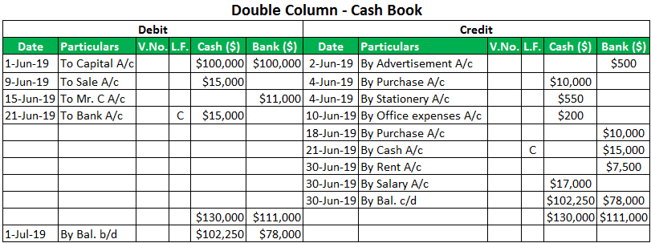

The Revenue Based Finance Coalition (RBFC) is a group of companies that work to support small and medium-sized businesses. The RBFC advocates for policies that expand the revenue-based financing (RBF) industry.
What does the RBFC do?
- Educate policymakers on issues related to the non-bank commercial finance industry
- Promote policies that expand access to RBF
- Collaborate with policymakers to build a sustainable financial ecosystem
- Provide clear and accurate cost of capital information to business owners
- Promote policies that are favorable to the industry
- Oppose policies that threaten industry interests

CHAPTER THREE
3.1 SOME EQUIPMENT AND THEIR USES
- Computers: Used to input, process, store, and output information

- Printers: Used to print documents


- Scanners: Used to scan documents for filing

- Photocopiers: Used to print copies of documents in black and
- white or color, at the same size, reduced, or enlarged
- Fax machines: Used to send and receive documents electronically
- Shredders: Used to destroy documents
- Postage meters: Used to pay postage

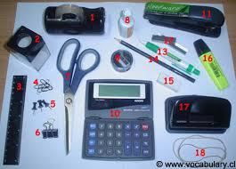
- Telephones: Used for communication

- Software: Used for word processing, spreadsheets, databases, and email
- Furniture: Includes desks, chairs, tables, and file cabinet

- Collaboration tools: Used for collaboration
- Kitchen supplies: Such as a coffee machine

3.2 RECORD OF SERVICE
A record of service is a collection of documents that record a person's activities and accomplishments while working for an organization. It can be electronic or printed.
EXAMPLES OF SERVICE RECORDS:
- Vocational rehabilitation records: Records that contain information about an individual's participation in a vocational rehabilitation program
- Employment records: Records that contain information about an individual's employment history, including length of service, age, and work status
- Military service records: Records that contain information about an individual's military service
- Client records: Records that contain information about services provided to a client
Uses of service record
Service records can be used for a variety of purposes, including: Documenting a person's activities and accomplishments, Recording an individual's employment history, Recording an individual's participation in a vocational rehabilitation program, Recording services provided to a client, and Researching war service.
DISPATCHING OF LETTER
Dispatching a letter" means to send a letter off promptly or quickly, essentially just mailing it or sending it out with haste; it implies a deliberate action to get the letter to its destination without delay.

CHAPTER FOUR
4.0 CONCLUSION AND RECOMMENDATIONS
4.1 CONCLUSION
Having passed through the SIWES training, have been able to discover and explore different things about the microbial world; therefore, its usefulness cannot be over – emphasized. The interesting part of this is that the field of microbiology has gotten answer to most of the infection and disease affecting the world. For the few infections that has not been diagnosed, precautionary measures that can be taken against it has been discovered. The only section left is for people should come out of their ignorance and go for medical check – up instead of relying on self – medication and visiting unqualified practitioners, if people could visit hospitals or health – centers frequently and follow the treatments given to them, mortality rate will drastically be reduced and the health status of the nation will be promoted.
More importantly I have been able to see the various prospects available in the field and also the various challenges that call for quick attention. Indeed, the industrial training program has been impactful; it was never a waste of time and energy.
4.2 RECOMMENDATIONS
The effort of the industrial training fund (ITF) was recommended for bringing up this programme known as student industrial work scheme (SIWES). This has paved way for self practice of the theoretical works that have been taught during lectures.

