

Technical Report
On
STUDENT INDUSTRIAL WORK EXPERIENCE SCHEME (SIWES)

HELD AT
GOLAD TELECOMS LIMITED (MTN)
130, University Road (Unilorin) Tanke, Ilorin Kwara State
Presented by:
ABDULAZEEZ MISTURAH BUKOLA
ND/23/ACC/PT/0270

Submitted to:
DEPARTMENT OF ACCOUNTANCY, INSTITUTE OF FINANCE AND MANAGEMENT STUDIES
KWARA STATE POLYTECHNIC
P.M.B. 1375, ILORIN

IN PARTIAL FULFILLMENT OF THE REQUIREMENT FOR THE AWARD OF NATIONAL DIPLOMA (ND) IN
ACCOUNTANCY, KWARA STATE
POLYTECHNICS, ILORIN

September – December, 2024
PREFACE
This technical report is written to situate the standard of experience gain by student in the industrial as awareness of continuity at the tertiary level of learning. The technical indulgence of training has been expressed formally in these report required by the constitution of the industrial training office of polytechnic.
This report is divided into five different parts which each part explains the meaning of siwes, major organization, work actually carried out and experienced gain. Even challenged faced, conclusion and recommendation are also involved.

DEDICATION
I dedicate this report to the Almighty God, for granting me the privilege to commence this course. Also to my reliable and respectful loving parents, Mr. & Mrs. Abdulazeez for being there for me. I pray may the Almighty Allah reward you abundantly, Amen.

ACKNOWLEDGEMENT
I wish to express my sincere gratitude to Almighty God for spearing my life throughout my first year in Kwara State Polytechnic, Ilorin and for making my vision to come to reality. I also thank him for his goodness, mercy and joy throughout my life.
My greatest debt is to my indispensible parent Mr. and Mrs. Abdulazeez for their moral and financial support throughout the duration of my training may Almighty God reward you abundantly.
My special thanks go to the head department and the entire staff of Accountancy department, Kwara State Polytechnic.
My appreciation also goes to the entire staffs of MTN, GOLAD TELECOMS LIMITED
I also acknowledge the effort of my friends and siblings for their financial, moral and spiritual support throughout my academic pursuit. Also to my SIWES supervisor for his great work.

TABLE OF CONTENT
Title Page
Preface
Dedication
Acknowledgement
Table of content
CHAPTER ONE
1.1 Meaning of SIWES
1.2 Brief history of SIWES
1.3 Aims and Objectives of SIWES
CHAPTER TWO
2.1 History of the Organisation
2.2 The organizational Structure
2.3 Department in the organization
2.4 Interpersonal Relation with the organization
CHAPTER THREE
3.1 Work Actually Carried Out
CHAPTER FOUR
4.1 Experienced Gained
4.2 Challenges Faced
CHAPTER FIVE
5.1 Conclusion
5.2 Recommendation

CHAPTER ONE
1.1 MEANING OF SIWES
SIWES is skill development program designed to prepare students of all institutions for transition from the collage environment to work. Also to promote and encourage the acquisition of skills in industry and commerce with a view of generating a poll of indigenous trained manpower sufficient to meet the needs of the Nigeria economy
It is also described as work experience in a education program in while attending school, while the work experience gives student opportunity to be part of an actual work situation outside the classroom.
1.2 BRIEF HISTORY OF SIWES
The government decrees no 47 of 8th October, 1971 as amended in 1990 highlighted the capacity building resource in industry commerce and government through training and re-training of workers in order to effecting provide the much needed high quality goods and services in a dynamic economy as ours (Jemerigbo 2003) the decree led the establishment of Industrial Training Fund (ITF) in 1973/1974.
The growing concern among our industrialist that graduates of our institution lack adequate practical background studies preparatory for employment in industries, led to the information of student industrial work experience scheme (SIWES) by ITF 1993/1994
The student industrial work experience scheme (SIWES) is a skill training program designed to expose and prepare student of agriculture, technology, environmental science, medical science and applied science for the industrial work situation which they are likely to meet after graduating.

1.3 AIMS AND OBJECTIVES OF SIWES
1. The main aim is the exposing of students to work method and technologies in handing equipment and machinery that may not be available in educational institutions.
2. SIWES provide an avenue for students in institutions of higher learning to acquire industrial skills and experience in their course of study especially in engineering.
3. To strengthen employers involvement in the educational process of preparing students for past graduation work situation.
4. To make transition from school to the world of Work easier and to enhance student contact for later job placement.
5. To provide student an opportunity to apply their knowledge in actual practice
6. Provide opportunity for students to apply their knowledge in real work situation thereby bringing the gain between theory and practical.

CHAPTER TWO
ABOUT ALERT MICRO-FINANCE BANK
Golad Telecoms Limited is a well-established telecommunications company that provides various communication services including mobile voice services, internet broadband, data packages, and more.
We are a dynamic and world-class telecommunications brand and outfit registered with the Corporate Affairs Commission in Nigeria as Golad International Services Nigeria Ltd. As is well known amongst our customers, integrity is our watchword and the quality of our services and products can be relied upon. Our head office is situated in Ilorin and we have branch offices and outlets at various points and locations across Nigeria.
VISION AND MISSION
Mission
To provide reliable, innovative, and affordable telecommunications services that empower individuals, businesses, and communities, fostering connectivity, communication, and digital transformation in every corner of the market
Vision
To be the leading provider of cutting-edge telecommunications solutions, recognized for our commitment to exceptional customer service, sustainable growth, and the advancement of technology, bridging the digital divide across the globe.

THE ORGANIZATION STRUCTURE AND CHART
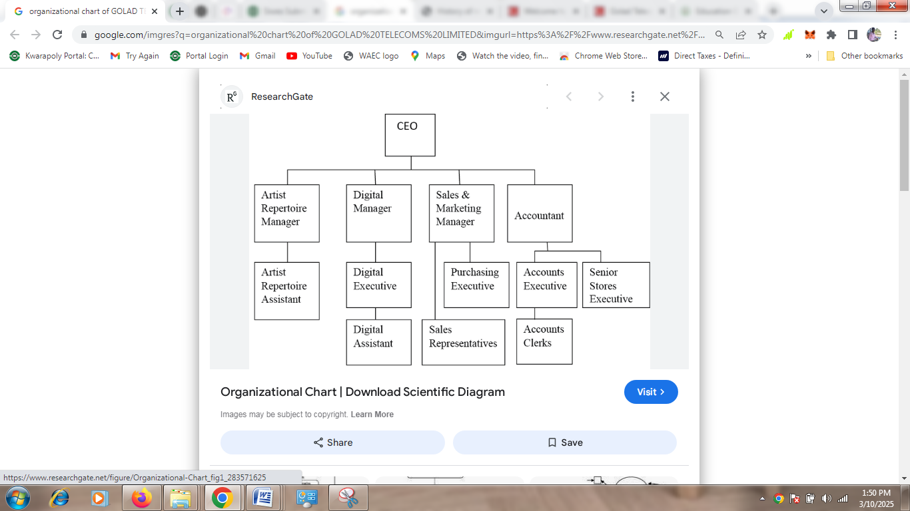
  - DIFFERENT DEPARTMENT IN THE ORGANIZATION
- Finance and Accounting Department
- Marketing and Sales Department
- Customer Service Department
- Information Technology (IT) Department
- Human Resources (HR) Department
- Operations Department
- Legal and Compliance Department
- Procurement and Supply Chain Department
- Business Development Department
- Corporate Communications and Public Relations (PR) Department
- Technical Support Department
2.4 INTERPERSONAL RELATION WITH THE ORGANIZATION
There was mutual understanding and love among the staff and the student that did their SIWES programme there because they took all the student like their own children, advising and guiding them to do the right thing at the right time.
High level of discipline was displayed among the student, even though the staffs a make sure that every problem encountered by the student are been tackled and solved out by both the student and staff all in the aspect of bringing about unity and peace.

CHAPTER THREE
3.1 WORK ACTUALLY CARRIED OUT
During my time at MTN, Golad Telecoms Limited, I was involved in several accounting and finance-related activities, which included the following:
Financial Reporting and Analysis
I assisted in the preparation of monthly financial statements, including the balance sheet, profit and loss statement, and cash flow statement. This involved gathering data from various departments, reviewing accounts, and ensuring the accuracy of financial information.
Reconciliation of Accounts
I was involved in reconciling bank statements with internal accounting records to ensure that all transactions were properly documented. I also helped reconcile supplier accounts, ensuring that payments and invoices matched and were recorded correctly.
Budget Preparation and Monitoring
I helped the finance team in preparing departmental budgets. This involved reviewing expenditure patterns, forecasting costs, and ensuring that budgets were aligned with the company's financial goals. I also helped monitor actual expenses against the budget to identify any discrepancies.

Tax Compliance
I assisted in preparing tax returns and ensuring that MTN adhered to local tax regulations. This included reviewing VAT filings and ensuring that tax payments were timely and accurately documented.
Account Audits
I participated in internal audits to ensure that financial transactions were in compliance with both internal policies and external regulations. This also involved checking for any discrepancies or areas for improvement in financial procedures.
Use of Accounting Software
I was trained to use accounting software such as SAP, which is used for recording and tracking financial transactions. This experience allowed me to become proficient in handling large amounts of financial data and performing routine accounting tasks.
.

CHAPTER FOUR
4.1 EXPERIENCED GAINED
I can actually say I gained a lot from my SIWES Programme by having the opportunity to know my capability on the work I have been taught in school.
During my internship at MTN Golad Telecoms Limited, I developed several key skills that will be beneficial in my future career as an accountant, including:
- Technical Skills: I gained proficiency in using accounting software (SAP) and other tools used in financial analysis and reporting.
- Analytical Skills: I improved my ability to analyze financial data, identify discrepancies, and make recommendations for improvements.
- Attention to Detail: I developed a keen eye for detail, especially when reconciling accounts and preparing financial reports.
- Communication Skills: I enhanced my ability to communicate effectively with both colleagues and supervisors, ensuring that financial information was clearly understood.
- Teamwork: I collaborated with various departments, gaining insight into how different teams contribute to the financial health of the company.
4.2 CHALLENGES FACED
During my time, I faced several challenges, including:
- Adapting to a Large Corporate Environment: Initially, it was challenging to adjust to the fast-paced environment of a large corporation like MTN, where multiple teams work together to meet deadlines.
- Understanding Complex Financial Software: Learning to navigate the various accounting systems was initially overwhelming, but with guidance from the team, I was able to overcome this challenge.
- Managing Time and Multiple Tasks: Balancing multiple tasks with tight deadlines required effective time management skills.

CHAPTER FIVE
CONCLUSION AND RECOMMENDATION

5.1 CONCLUSION
Student Industrial Work Experience Scheme (SIWES) is a good programme for higher institution in the sense that it adds to one’s practical knowledge based on your course of study. As for me SIWES as a course has truly exposed me to face in a growing information world that depend on Business Administration and Management.
5.2 RECOMMENDATION
As a bonafide student of the department of Accountancy of Kwara State Polytechnic and who has undergo industrial training. I hereby make the recommendation that the government should continue funding this programme (SIWES) and pay directly to student after the completion of the programme due to the stress inclined to the programme, in order to serve as encouragement to student that want to increase their practical and technical knowledge.

