

A TECHNICAL REPORT
ON
STUDENT INDUSTRIAL WORK EXPERIENCE SCHEME (SIWES)
HELD AT
HARMONY FM 103.5 FM AJASEPO ROAD IDOFIAN KWARA STATE

PREPARED BY:
JIMOH RUKAYAT ADENIKE
ND/22/MAC/PT/1002

[
SUBMITTED TO:
THE DEPARTMENT OF MASS COMMUNICATION, INSTITUTE OF INFORMATION AND COMMUNICATION TECHNOLOGY (I.I.C.T), KWARA STATE POLYTECHNIC, ILORIN.
IN PARTIAL FULFILLMENT OF THE REQUIREMENT FOR THE AWARD OF THE NATIONAL DIPLOMA (ND) MASS COMMUNICATION

AUGUST-NOVEMBER, 2024
DEDICATION
This Siwes Report is dedicate to the Almighty Allah who sustain over life till this moment and serves as a source of my inspiration through my programmed, I pray for more blessing and protection from Allah (Ameen).

ACKNOWLEDGEMENT
I give all thanks to Almighty Allah for his grace upon me right from my infancy to this time, and granted me the grace, strength, wisdom, knowledge to complete this programme successful.
I express my heartfelt gratitude to my admirable and beloving parents Mr. and Mrs. OLAIYA for their great love prayer before and during the study of this course, may God in his infinity mercy grant them long life to eat the fruit of their labour (Ameen)
I also appreciate my brothers and sisters for their caring and support who always, ask about my Academic Study may Almighty Allah continue to lift them up Insha Allah (Ameen) they are most cherished.
I salute the effort of all my lecturers in the department for nurturing and preparing me for great task ahead of me.
I also appreciate the grace given to me become one of the successful completion of my programme.
My special greeting goes to my course mate; friends and my colleague at tranquility villa.
TABLE OF CONTENT
THE TOPIC

SIWES REPORT

MODE OF OPERATION

CHAPTER ONE:

Contain the Background of Federal Radio Corporation of Nigeria

CHAPTER TWO:

News format; Date, Catch Word, Body Text, Correspondent, Cue in: Cue out; The Source/Editor/Typist Name

CHAPTER THREE:

Description of work done, Reporting, Vox pop or Interview, Typing and Editing of News Story

CHAPTER FOUR:

News bulleting, Headlines, News story,
CHAPTER ONE
1.1 INTRODUCTION
Student industrial work experience scheme as a programme was established by ITF in 1973 in order to seek a lasting solution to the problem of inefficiency and lack of practicable skill and the technical know-how required of graduates after graduation.

The scheme exposes students to industry based skills necessary for a smooth transition from the classroom to the world of work. It affords student of tertiary institution the opportunity of being familiarized and exposed to the needed experience in handling machinery and equipment which are usually not available in the education institution and also serve as a preparatory employment training and enhancement of the theoretical lectures they have being taught in the confines of the classroom walls.

The scheme is commission by the Federal Government and funded through the Industrial Trust Fund (ITF) and the duration of the programmed spans for months.

Training is a key factor in enhancing efficiency and expertise of the workforce. The SIWES program therefore prepares students for the world of work. The scheme is therefore a skill training oriented program so as to expose the student on work they would meet after graduation.

1.2 DEFINITION OF SIWES
SIWES is an acronym of the Student Industrial Work Experience Scheme. It is a practical skill program development and design to prepare student to gain more practical experience and for transition and enhancement of the theoretical lecturing in the classroom experience to practical experience.

1.3 AIM OF SIWES
The purpose of SIWES is to promote industrialization in Nigeria, and an advance between the world of teaching, learning industrial experience and work with reference to a field of study.
OBJECTIVES OF SIWES
The specific objectives of SIWES as summarized by the Federal Government Gazette of April 1978 are listed below:

To provide an avenue for the student in institution of the higher learning to acquire industrial skill and experience in their course of study.
To make the transaction from school to the world of work easier.
To enhance student contact for later job replacement. And actual practice.
To provide student with an opportunity to supply their knowledge in real work actual practice.

CHAPTER TWO

2.1 HISTORICL BACKGROUND OF ORGANIZATION

The ha state broadcasting corporation, Ilorin, with broadcasting identification, ât harmony fm kwaraâ€ started broadcasting service in Idofia in 1956 as a relay station. It was than known as provincial broadcasting house.
The one fourth kilo watt {kW} medium wave transmitter which was then used covered only eight kilometer radius of Idofia.

Hormony, fm idofia Broadcasting Corporation as constitution today finally come into being with enactment of the kwara edict no 3 of 1979, but with retrospective effect from April 10th, 1978, this was not of the beneficiary by product of the first state creation in Nigeria.
On the creation of the state in 1967, a master plan was drawn up and approved for the country base on the number and capacity of transmitter and mode of transmission to be sited in each creation owning to the topography of kwara state, it was decided that it should covered with both medium and shirt wave transmitter.

In 1974, instruction work started in the modern studio/broadcasting house the 10kw short wave and 20kw medium wave transmitting station sites these facilities wave put in use is from 19th December, 1976however, following the directive of the federal government the short wave transmitter was closed down in 1976. On 1st April, 1978, in camphene with federal government is directive which transfers all radio Nigeria station on the state to their respective host states. The formal handing over of the station by the NBA to the kwara state government was reframed by Mr. Horation Agedoti of radio corporation, Lagos in 5th September,1978, all the existing staff the wave given the option of either staying with corporation or going to Federal Radio Corporation. Those who opted to stay were retained.

At the time of takeout by the state government, the state had broadcasting house situated at the present premises and transmitting station. The two inherited ten kW transmitters were very old in fact only one of them was working satisfactorily at the time of over in 1978.
In 1984, the federal government booted the transmitting capacity of radio kwara through the directive that transferred the federal radio station in Ilorin to the kwara state government. The station then had two {2} 50kw medium wave transmitted at budo eko. With this development, the state government approved the recommendation at the corporation to install the four imported 10kw medium wave transmitter in the fringe area of the then kwara state for effective coverage. Two of them were installed Egba. One at okike near okene {both now in kogi state} and the forth at koro in new bussa {now in Nigeria skew}. All the three booked station were completed and commissioned.

CHAPTER THREE
3.0 PLACE OF ASSIGNED
I was assigned to the Programming department in harmony fm Network Centre. There I was able to learn a lot about musical, business publishing, editing and setup of studio.
CONTROL ROOM
- Scrolls: It was our duty to type scrolls into the system, call for a senior officer to read before it goes on air. Then when they were done reading, I was to send it on air or keep it on standby for the Transmission Director.
- Visuals Management: This is part of the production process and this NTA is sending the visuals that are meant to be used for the bulletin to the server so that they can be ready in time for the news bulletin. This also involves sending your program to the transmission system so that it can go on air when required. Also I check the server system to make sure that all the visuals for the bulletin are available and are playing perfectly.
- Audio Management: Here I manage the sound during the news hour. This involves muting and un-muting of audio channels. The two channels I am managing are the casters audio and the VTR or servers audio. I also managed the audio level to make sure the output is not more than the expected quota.
3.1 EXPERIENCE GAINED PER DEPARTMENT
NEWS ROOM
- I learnt about scripting. Most especially the news script, the first thing I had to learn about scripting was the house style and format of writing a script having learnt that I now began to go on assignments and when I came back I wrote my own script. After which the reporter I went out with will assess it and after that, I pass it on to the producer for final screening. The producer usually tutors me to correct the mistakes I made. After having learnt how to do this I wrote some scripts that were approved.
- I learnt how to produce news and programs. This came by continuous work with the Production Editor, the person that works with the producer directly to know what it NTA and to this effect I had the opportunity to work as the production Editor in different occasions. Where I managed the script, got visual and did whatever the producer wanted for the production to be successful. And this earned me a lot of end credits at the end of the news. Also I aided the production of Frontiers. That was like the program I was assigned to. Helping the producer directly with his work in scripting and production at all stages.
THE STUDIO
- I adapted to the job of the Teleprompter. This is a device that helps the caster or presenter look like he or she is reading extempore. The person handling the Teleprompter types the script into the system using Q-start then when you are done you roll it for him to read. I was the regular Teleprompter for daily programs.
- I learnt how to use the camera basically. Positioning and angling your shot. As a director I learnt the best shots from different angles.
- I also learnt stage management keeping the stage in for each shoot. Also learnt about Chroma key and how it works.

CONTROL ROOM
- I learnt how to direct news and programs. I learnt how to direct using a video switcher and the Tricaster. Using these devices, I directed 7pm, 1am and 4am news bulletins severally. Also I directed programs like Diplomatic ties and Frontiers.
- I learnt how to use CG Playout. The software is used to input graphics on air like the logo and the scrolls. So I got acquainted with the software. Inputting scrolls, meddling with the graphics of the scrolls and the logo by changing position et al. I was one of the people mandated to correct the scrolls during news production without errors.
- I learnt the job of the VTR and the audio engineer and played the roles when necessary. The VTR is responsible for arranging the stories on the server and playing them on air. The audio personnel manage the sound during the production.

3.2 RELEVANCE OF TRAINING
The relevance of this training cannot be over emphasized, it aided the sharpening of inherent skills and the acquiring of new ones. Also it helped to place high level of relevance on what I have been taught in school. The relevance of this training to me can be divided into two broad groups; the relevance to my academics and the relevance to the labour market.

- Element of Journalistic Style:
- We were taught about style i.e organizational style & house style. There was a house style in Radio Kwara for script writing. There was a laid down format for writing script and doing a lot of other thing and I appreciated and respected that because of the knowledge I had.
- We were also taught the inverted pyramid style of writing which involved the 5w’s and 1h. I put this into major consideration when writing my intro, knowing full well what an intro is and how to write it.

- SCREEN PRODUCTION AND DIRECTING:
- This course enlightened the trainee to the duties of the director and the producer, and during the training he was exposed to the practical job of a director as he became a director par excellence. Also working with producers over time made me understand who they were really.
- The trainee saw the different production crew member and their functions as he even played most them. Duties like the production Editor, the film Editor, the typist, engineers, etc.
- The different kind of shots I learnt about helped me to know the right shots to use even as a director and as film Editor.
- INTERNATIONAL COMMUNICATIONS
- Intercultural communication is about interrelating with cultures, harmony fm Idofia practices intercultural communication because they broadcast home based content to the world and it international because Radio Kwara is a satellite stations that shows on DStv and Sky.
- Based on my observation and the operations of Radio Kwara they represent and support the reformist school of thought, Radio Kwara is trying to balance the concept of cultural imperialism, media imperialism and a free and balanced flow of news and information.
- Although not taught in class every news bulletin must have a taint of foreign information. When writing your script you write with the mindset that you are writing for an international audience, in that light you are conscious of things like time.
- Mass media dependency: harmony fm was depending on foreign media and other Nigerian media.
3.4 IDENTIFICATION OF EQUIPMENT IN STUDIO
There are basic equipment found in the studio which are used for production, they include:
- Studio light
- Computer system
- Sound mixer
- Camera
- Monitor (Television)
- Cromer machine
- Camera control unit (CCU)
- Back drop (Cromer cloth)
- Air condition (AC)
- Studio chairs and table

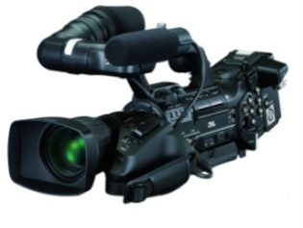
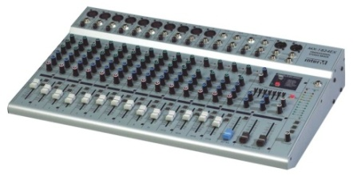

AUDIO MIXER MACHINE STUDIO CAMERA
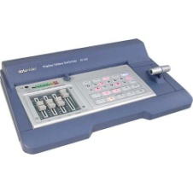
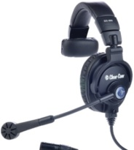
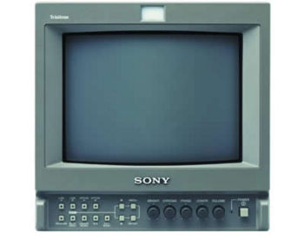

MONITOR
MONITOR HEADSET CAMERA SWITCHER
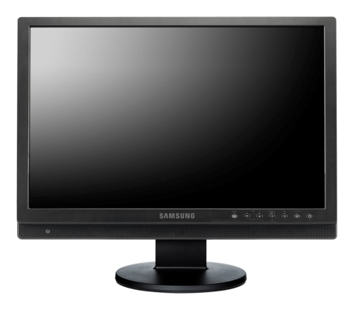

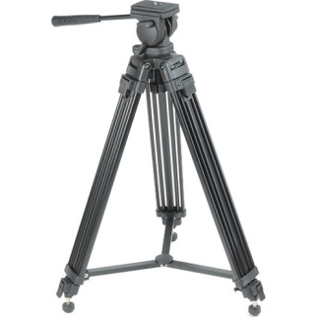

CAMERA TRIPOD MONITOR
CHAPTER FOUR
4.0 PROBLEM ENCOUNTERED
The success of my training is undisputed, but it was not devoid of rough edges. I experienced some challenges, among these are:
- The issue of expensive transportation: I have to pay an average of 350 naira every day for transport without remuneration.
- Discrimination of my colleagues with school which shortage the learning and experience of SIWES students.
4.1 RECOMMENDATIONS
- I strongly recommend that students undertaking internship should understand the importance of the training and not joke about it. They should use the opportunity to be hard working and enterprising.
- I strongly recommend that the supervisors that come to invigilate the students should be familiar with the student and be at least in the social management sciences. This is because e is a lecturer from the faculty of IICT.
- Also the number of visits during the training period should be increased.
4.2 CONCLUSION
My working experience with the Nigerian harmony fm International has brushed me up and unveiled the inner me turning me into a breaded reporter. I want to thank the management of harmony fm idofia for the opportunity to serve diligently. This has placed relevance on who I am.
To the few interns that worked hand in hand with me like Auta Mercy, et al I want to appreciate your humility. Then to the members of staff that contributed immensely to my training I salute you. And may all the seeds I sowed in Radio Kwara not die.

3.3 WORK DONE
- I learn how to change a stage background to set up a studio for recording a television program named (Business matters).
- I was at studio working with the floor manager and the camera-man, I get to handle equipment and frame the shoot before the programme.
- I get to know that audio visual materials are classified using the same classified location and booking material.
- I was assigned to cover a movie premiere on “MY WIFE AND I” at IMAX CINEMA Lekki, I and my colleagues were the presenter for the red carpet.
- I went for an interview at Eko Hotel and Suite on summer Vibe Concert. It is a musical performance by Nigeria Music artists.
- I worked as the production assistant for morning rode.
- I learnt how to balance audio when editing video on Adobe Premiere.
- I was rehearsing for a drama filler on attitude to work with my colleagues
- I learnt how to voice over in the voicing booth.
- I was in studio B for Football Fans Forum (FFF), also learning how to grab a program out of a cinema for editing.
- Learn how to edit a 25 minute program documentary
- Act as O.D about the programme that occurs in the station.
- I was the floor manager for the programme that occurs every Saturday morning (Morning Rides).
- Working on particular filler giving together in a group called “Child Artist”.
- I was in the library previewing programmes. However, I went for a vox pop at T.B.S on the danger of cigarette to health.
- I learnt how to write a script for filler, it was difficult because it is form of a news script.
- I assisted in the production of a recordable programme (Nigeria Movies Today).

CHAPTER FIVE
5.1 CONCLUSION
To conclude my report I have seen the essence of going through the student industrial work experience scheme (SIWES) the impact of the training on me cannot be over emphasized in the sense that I have been able to understand practically the importance aspect of the course of my study which might not have possible without this program.

5.2 PERSONAL IMPRESSION ABOUT THE ORGANIZATION
One of the reason why I was personally impress about the organization
I was attached to this because the firms that undertake service that is relevant to my field of study.

Another reason why I was impressed about the organization was because my principal is ready to train me and I go out with him for an inspection and supervisor of the organization properties undergoing repair so he had the time to train me. Also I was in a position to stay in the office to do office work. I use to draw on Auto cad which has increase my knowledge concerning the field of architecture. Again I was given guideline by the staff of the organization in any work given to me and how to do it well. I was impressed because of the interaction I had with all other members of the organization during the four months training so with all that has been said above I can say that I was personally impressed about the organization that I was attached during my four months industrial training.

5.3 SUGGESTIONS/RECOMMENDATION
I hereby suggest to the organization to expand more time and energy to. I.T student, so as for them to take more serious their SIWES programme. To this end, as practicing and prospective practicing surveyors, my admonition “do not sacrifice honesty, integrity and devotion” to the Polytechnic, I suggest institution and the industrial training fund office to find a suitable solution to the problem that the student are facing during industrial attachment programme the Federal Government should urge the prospective corporation and company were student normal undertakes SIWES programme to pay more attention to them and also assist them wherever their assistant id required, the industrial training fund office and institution should ensure that the delay in given student their entitlement, so that the oncoming student will be able to appreciate more the essence of going for industrial training scheme (I.T.S)

