

STUDENTS’ INDUSTRIAL WORK EXPERIENCE SCHEME (SIWES)

HELD AT

THE ESSENCE CORPORATE AND BUSINESS HUB
SHOP 24, WESTEND MARKET, KWARA STATE POLYTECHNIC, ILORIN

BY

IPADEOLA TAIWO SARAH
ND/23/OTM/FT/0047

SUBMITTED TO THE DEPARTMENT OF OFFICE TECHNOLOGY MANAGEMENT,
INSTITUTE OF INFORMATION AND COMMUNICATION TECHNOLOGY,
KWARA STATE POLYTECHNIC, ILORIN

2024/2025 Academic Session

Dedication
This SIWES report is dedicated to Almighty God for its successful completion

Acknowledgements
Foremost, my appreciation goes to Almighty God for the successful completion of this SIWES report.
My sincere appreciation goes to Industrial Training and Management of Kwara State polytechnic for the opportunities given in having practical idea of what’s learnt in the four wall of a class room.
Lastly, my appreciation goes to all those who were supportive in one way or the other in the success of this work.
Thanks to you all.

TABLE OF CONTENTS
Title Page i
Dedication ii
Acknowledgements iii
Table of Contents iv
CHAPTER ONE: INTRODUCTION
1.1 Background of SIWES 1
1.2 Objectives of SIWES 2
CHAPTER TWO: ORGANIZATION PROFILE
2.1 History and Background of The Essence Corporate and Business Hub 3
2.2 Services Rendered by the Organization 4
2.3 Organogram 6
CHAPTER THREE
3.1 Description of Work Done 7
3.2 Lessons Learned 9
CHAPTER FOUR: CONCLUSION AND RECOMMENDATIONS
4.1 Conclusion 11
4.2 Recommendations 12

CHAPTER ONE
INTRODUCTION
1.1 Background of SIWES
The Student Industrial Work Experience Scheme (SIWES) was introduced as a response to the growing need for practical experience in the Nigerian educational system. Many students graduate with strong theoretical knowledge but lack hands-on skills, making it difficult for them to adapt to real work environments. SIWES was created to bridge this gap by exposing students to industry practices, workplace ethics, and professional skills before they complete their academic programs.
Initially established in 1973 by the Industrial Training Fund (ITF), SIWES was designed to cater to students in technical and vocational fields such as engineering, science, and technology. Over time, it has expanded to include other disciplines, including management and social sciences. This expansion recognizes the importance of practical exposure for all students, regardless of their field of study. Today, the program is a key part of the curriculum in many Nigerian tertiary institutions.
One of the major objectives of SIWES is to familiarize students with the work environment and industry expectations. It helps students understand how organizations operate, how teams collaborate, and how tasks are executed in real-time. Through this experience, students develop problem-solving skills, critical thinking, and adaptability—qualities that are essential for career success. It also provides an opportunity to learn directly from professionals in their chosen fields.
Another significant aspect of SIWES is the enhancement of technical and digital skills. In today’s fast-changing world, industries rely heavily on technology, and students must be equipped with relevant skills to remain competitive. Whether it’s learning office software, handling machinery, or understanding customer relations, SIWES allows students to practice what they have been taught in class and improve their proficiency through real-world applications.
Beyond technical skills, SIWES also fosters personal and professional development. Students gain firsthand experience in workplace culture, including punctuality, discipline, communication, and teamwork. Many students find that their confidence grows as they interact with colleagues, handle responsibilities, and make decisions in a professional setting. This exposure prepares them for the transition from school to work life, making them more employable and career-ready.
Ultimately, SIWES plays a crucial role in shaping students into well-rounded professionals. It bridges the gap between theory and practice, preparing students to meet industry demands and contribute meaningfully to society. For many students, the experience gained during SIWES serves as a foundation for future job opportunities, entrepreneurial ventures, or further studies. It is a stepping stone that helps them align their academic knowledge with real-world expectations, making them more competent and confident in their chosen careers.
1.2 Objectives of SIWES
- To expose students to real-world office operations and technology management.
- To develop technical and practical skills relevant to the profession.
- To understand and apply office management software tools.
- To enhance problem-solving skills in an organizational setting.

CHAPTER TWO
ORGANIZATION PROFILE
2.1 History and Background of The Essence Corporate and Business Hub
The Essence Corporate and Business Hub was established in May 2018 as a small café within Kwara State Polytechnic, Ilorin, Kwara State. It was created to meet the growing demand for professional business services among students, lecturers, and business owners in the area. Initially, the organization focused on providing basic document processing, printing, and photocopying services. Over time, it expanded its operations to include graphic design, data entry, and office-related solutions to cater to a wider range of clients.
The founders of The Essence Corporate and Business Hub recognized a significant gap in the availability of quality corporate and administrative services within the polytechnic environment. Many students and staff needed a reliable place to process documents, create presentations, and handle business-related tasks efficiently. By setting up the business within the school premises, the organization positioned itself as a convenient and accessible solution provider for both academic and business purposes.
As the demand for digital and corporate services grew, the organization continuously adapted to meet the changing needs of its customers. The business introduced new services such as CorelDRAW for graphic design, Microsoft Excel for data management, and PowerPoint for professional presentations. These additions allowed the company to serve not only students working on assignments and projects but also small business owners who required branding and administrative support.
Over the years, The Essence Corporate and Business Hub has built a reputation for providing quality and timely services. Many students rely on the business center for their printing, pagination, and documentation needs, while local entrepreneurs and professionals benefit from its expertise in corporate branding and business documentation. The organization’s commitment to efficiency and professionalism has contributed to its steady growth and strong customer loyalty.
The success of the business can also be attributed to its customer-focused approach. The team ensures that clients receive personalized services tailored to their specific requirements. Whether it is assisting a student in formatting a report or helping a business owner design an official letterhead, The Essence Corporate and Business Hub strives to deliver excellence. The business has also embraced technological advancements to improve service delivery and maintain a competitive edge in the market.
Today, The Essence Corporate and Business Hub continues to play a vital role in supporting the academic and business community in Kwara State Polytechnic. With a solid foundation built on professionalism and quality service delivery, the organization remains a go-to destination for individuals and businesses seeking efficient corporate solutions. As it looks to the future, the company aims to further expand its service offerings and maintain its reputation as a reliable corporate service provider within the region.
2.2 Services Rendered by the Organization
The Essence Corporate and Business Hub offers a wide range of services tailored to meet the academic and business needs of students, lecturers, and professionals within Kwara State Polytechnic, Ilorin. One of its core services is document processing, which includes typing, formatting, and printing academic and business documents. Many students rely on the business hub for the preparation of assignments, reports, and projects, while business owners use the service for proposals, invoices, and official letters.
Another essential service provided by the organization is printing and photocopying. The business hub is equipped with modern printers and photocopiers to handle bulk and urgent printing requests. Whether customers need black-and-white or colored prints, single or multiple copies, The Essence Corporate and Business Hub ensures high-quality output. Additionally, scanning services are available for clients who need to digitize important documents for storage or electronic sharing.
The organization also specializes in graphic design and branding services, using software such as CorelDRAW to create professional designs. Customers can request logo designs, business cards, flyers, banners, letterheads, and other promotional materials. This service is particularly beneficial to small businesses and startups within the polytechnic who require professional branding solutions to enhance their visibility and credibility.
For students and professionals working on data-related tasks, the business hub provides Microsoft Excel and PowerPoint services. Clients can request assistance in data entry, calculations, and spreadsheet formatting in Excel, as well as the design of visually appealing PowerPoint presentations for academic or corporate purposes. These services help clients save time while ensuring accuracy and professionalism in their work.
Additionally, The Essence Corporate and Business Hub offers mail dispatch services, helping customers send and receive documents efficiently. Whether it’s forwarding letters, submitting official documents, or handling correspondences, the business hub ensures that mail is processed in a timely and organized manner. This service is particularly useful for students and lecturers who need to submit forms and official documents to institutions or organizations.
Beyond these core services, the organization also provides general business support, such as pagination, document binding, lamination, and consultancy on office-related tasks. By offering these diverse services, The Essence Corporate and Business Hub has established itself as a one-stop shop for academic and business solutions within Kwara State Polytechnic. The company’s commitment to quality service delivery continues to attract a loyal customer base and enhance its reputation as a reliable corporate service provider in the region.
2.3 Organogram
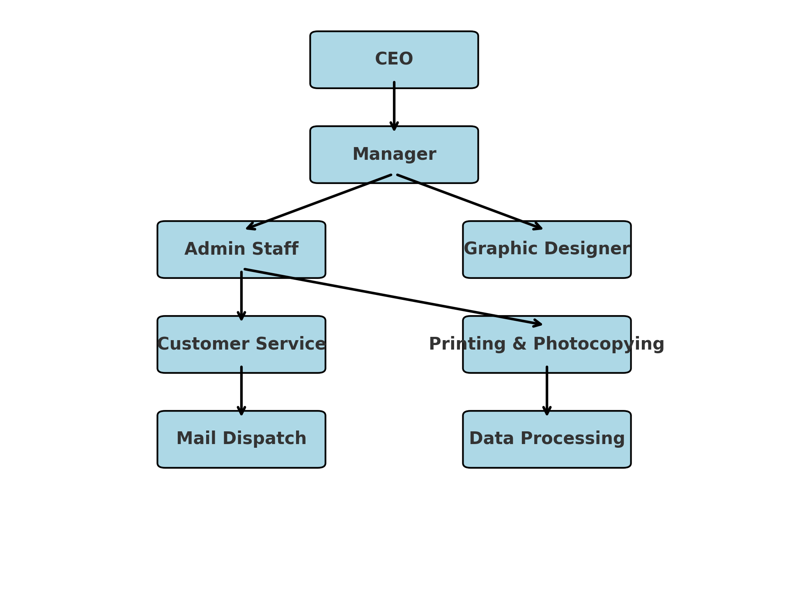

CHAPTER THREE
3.1 Description of Work Done
During my Student Industrial Work Experience Scheme (SIWES) at The Essence Corporate and Business Hub, I was actively involved in various office and business-related tasks that enhanced my technical skills and practical knowledge. The experience provided me with hands-on training in document processing, printing, pagination, and other office technology functions. I was able to apply my academic knowledge in a real business environment, which helped me understand the importance of efficiency, accuracy, and customer service in a professional setting.
One of the key tasks I was taught during my SIWES training was how to print a letter on a letterheaded paper. I learned the proper way to format official letters, insert company logos and details, and adjust document settings for professional printing. This skill is essential for business communication, as properly formatted letters enhance the credibility of an organization and ensure clarity in correspondence.
I also had the opportunity to work with CorelDRAW, a graphic design software used for creating professional designs such as business cards, flyers, and letterheads. Under supervision, I practiced designing simple layouts and learned how to manipulate text, images, and colors to produce visually appealing documents. This experience introduced me to the fundamentals of graphic design and its importance in branding and business communication.
Another important aspect of my training was pagination, which involves structuring documents correctly for printing and presentation. I learned how to number pages, create sections, and format documents to improve readability and professionalism. This was particularly useful when working on large documents such as reports and project work submitted by students and business clients.
Additionally, I was taught how to dispatch mail and organize documents for clients. This task involved sorting and arranging documents for proper delivery, labeling files, and ensuring that outgoing mail reached the intended recipients on time. Through this, I developed organizational and time management skills, which are crucial for office administration.
Moreover, I received training on the use of Microsoft Excel and PowerPoint, which are essential tools in office technology. I learned how to enter and manage data in Excel, use formulas for calculations, and create charts for data analysis. I also gained experience in designing PowerPoint slides for presentations, learning how to arrange content effectively, add visual elements, and ensure smooth slide transitions. These skills are highly valuable in both academic and corporate environments.
Overall, my SIWES experience at The Essence Corporate and Business Hub was highly beneficial in preparing me for the professional world. The training helped me develop technical, administrative, and communication skills that will be useful in my future career. The practical knowledge I gained has strengthened my understanding of office technology management and improved my confidence in handling business-related tasks efficiently.
3.2 Lessons Learned
My Student Industrial Work Experience Scheme (SIWES) at The Essence Corporate and Business Hub was a valuable learning experience that exposed me to real-world office operations and business practices. Throughout my training, I gained practical knowledge, improved my technical skills, and developed a better understanding of workplace expectations. The experience enhanced my confidence and prepared me for future career opportunities in office technology management.
One of the most important lessons I learned was the importance of accuracy and professionalism in document processing. Whether printing a letter on a letterheaded paper or formatting a document, I realized that attention to detail is crucial. A single mistake in an official document can lead to miscommunication or loss of credibility for an organization. This taught me to double-check my work, proofread documents, and ensure they meet professional standards before printing or dispatching.
I also learned the significance of time management and efficiency in handling multiple tasks. Working in a busy environment required me to complete assignments quickly while maintaining accuracy. I developed the ability to prioritize tasks, organize documents systematically, and work under pressure. This experience helped me understand the need to balance speed with quality in an office setting.
Another key lesson was the value of technology in modern office management. Learning to use CorelDRAW for graphic design, Microsoft Excel for data entry, and PowerPoint for presentations showed me how digital tools enhance workplace productivity. These skills are essential in today’s business world, and I realized that continuous learning and adaptability to new technologies are necessary for career growth.
Furthermore, I understood the importance of effective communication and teamwork in a business environment. Interacting with colleagues and clients helped me improve my verbal and written communication skills. I learned how to listen attentively, follow instructions, and respond professionally to customers’ requests. Teamwork was also emphasized, as completing tasks efficiently often required collaboration and cooperation with others.
Lastly, I learned how to provide quality customer service and maintain a positive work ethic. Dealing with clients daily made me understand the need for patience, politeness, and responsiveness in business interactions. A satisfied customer is more likely to return and refer others, which helps a business grow. I also learned that discipline, punctuality, and dedication are essential qualities that contribute to professional success.
Overall, my SIWES experience at The Essence Corporate and Business Hub was a transformative journey that equipped me with practical skills and workplace knowledge. The lessons I learned will be useful in my academic journey and future career, as they have prepared me to handle office tasks efficiently, embrace technology, and adapt to professional work environments.

CHAPTER FOUR
CONCLUSION AND RECOMMENDATIONS
4.1 Conclusion
My Student Industrial Work Experience Scheme (SIWES) at The Essence Corporate and Business Hub was an insightful and enriching experience that provided me with practical exposure to office technology management. Through hands-on training, I developed essential skills in document processing, printing, pagination, graphic design, data management, and customer service. The experience also helped me understand the importance of accuracy, time management, teamwork, and professionalism in a business environment. Overall, SIWES has significantly contributed to my personal and professional growth, equipping me with the knowledge and confidence needed to excel in my future career.
4.2 Recommendations
At the end of the program, the below recommendations are made:
- More hands-on tasks should be given to SIWES students.
- The organization should upgrade printers and computers for efficiency.
- More software applications should be introduced to trainees.
- Students should be taught how to manage tasks effectively.
- Supervisors should closely guide trainees for better learning outcomes.
- Staff should be trained to handle clients professionally.

