+

TECHNICAL REPORT ON THE STUDENT INDUSTRIAL WORK EXPERIENCE SCHEME (SIWES)

HELD AT
BABARINDE ELECTRICAL CONTRACTOR
DEVELOPMENT AREA OGBOORO BLOCK 3 NO 19 OJA OBA OYO STATE NIGERIA

BY

OLADOKUN FELIX OLAWALE
ND/23/EEE/PT/0215

SUBMITTED TO:
DEPARTMENT OF ELECTRONICAL AND ELECTRONIC
KWARA STATE POLYTECHNIC,
INSTITUTE OF ELECTRONICAL AND ELECTRONIC TECHNOLOGY (I.E.E.T)
P.M.B 1375, ILORIN KWARA STATE

SEPTEMBER – DECEMBER, 2024

DEDICATION
I dedicated this report of my SIWES program to Almighty God that made it a successful one for me.
Also to my lovely parents in person of MR. & MRS. OLADOKUN for their support both morally and financially they gave me, may Almighty GOD reward them abundantly with long life and good health.
Also to my SIWES coordinator who didn’t make the Twelve weeks program went in vain and also to the school authority who accepted me in school for the program.

ACKNOWLEDGEMENT
I wish to express my profound gratitude and sincere appreciation to my lovely and caring parents in persons of MR and MRS OLADOKUN may GOD bless you. I also appreciate the effort of my Brother and Sister may God help you all.
Also to my amiable SIWES coordinator and to all my lecturers at Kwara State Polytechnic, Institute of Information and Communication Technology (I.E.E.T).

ii
REPORT OVERVIEW
This is an industrial attachment report for the students industrial work experience (SIWES) programme carried out at Babarinde Electrical Contractor Development Area Ogbooro Block 3 No 19 Oja Oba Oyo State Nigeria within the period of four months from August – December, 2024.
The report comprises the background of SIWES, the description of the organization, its aims and objectives, the experience gained as an industrial training student and the summary, conclusion and recommendations.
It has a total of 5 chapters with sub-chapter. It also has the preliminary pages, such as the tile page, report overview and table of contents and recommendations on the improvement of scheme.

iii
TABLE OF CONTENT
Title page i
Dedication ii
Acknowledgment iii
Table of content iv
CHAPTER ONE
1.0 Introduction 1
1.1 Definition of SIWES 1
1.2 Aims and Objectives of SIWES 1
CHAPTER TWO
2.0 Historical Background of the Organization Attachment 2
2.1 Organization Chart of the Organization 2
CHAPTER THREE
3.0 What is a Utility Pole 3
3.1 Pole Material 3
3.2 Concrete Utility Poles 4
3.3 Steel Utility Poles 5
3.4 The Utility Poles Used to Support These Are Transmission Pole 6
Distribution Poles and Light Pole
CHAPTER FOUR
4.0 Aluminium Binding Wire 8
4.1 Installation Method 9
4.2 Shackle Insulator 10
4.3 How Does a Stay Insulator Work 11
CHAPTER FIVE
5.0 Summary and Conclusion 12
5.1 Sumary and Attachment 12
5.2 Problem of Encountered 12
5.3 Conclusion 13

CHAPTER ONE
- INTRODUCTION
The student industrial works experience scheme (SIWES) was established by the industrial training fund (I.T.F) in 1973 and control by the national board for technical education (NBTE). The aims and objectives is to develop student skill and to expose students in the school of engineering, technology, environment, science and agriculture and medical science to the working experience in which they will found themselves in future.
It is integral part of degree and National Diploma programme institute of higher learning in Nigeria. This privilege programme would definitely broaden student chance of learning and would empower his/her academic efficiency.
During my four months Industrial Working Experience Scheme (SIWES) at Federal Ministry of Agricultural and Rural Development, the usefulness of maintenance in Tractor was proved and lot of experience was gained.
1.1 DEFINITION OF SIWES
Student industrial Working Experience (SIWES) is a skill acquisition training programme set up by the Federal and State government across the Nation in collaboration with the body known as Industrial Training Fund (I.T.F) for student to have a working experience and a feel of what it takes to be genius in one discipline before challenges ahead.
1.2 AIMS AND OBJECTIVES OF SIWES
1. It exposes the prepare students of higher institution for the industrial working situation they can likely to meet in the future.
2. It enables student to apply what they have learn theoretically in class into practice in the real world.
3. It makes student to understand the technical implication of their profession.
4. It helps student to express their initiatives, competence and standard in task they have chosen.
5. It enable student to be technically and morally oriented
6. It helps to make transition from school to the working environment easier and to enhance students contact for later job placement

CHAPTER TWO
2.0 HISTORICAL BACKROUND OF THE ORGANIZATION ATTACHMENT
Babarinde Electrical Contractor Development Area Ogbooro Block 3 No 19 Oja Oba Oyo State Nigeria
The company also engages in other activities which differ from its academics activities, this includes:
- Construction and Fabrication
- Construction of Wooden Utility Pole
- Construction of Concrete Utility Pole
- Construction of Steel Utility Pole

2.1 ORGANIZATION CHART OF THE ORGANIZATION

BABARINDE ELECTRICAL CONTRACTOR
Manager
Assistant
Manager
Apprentice

Finishing Section
Engineers
Engineering Workshop

CHAPTER THREE

3.0 WHAT IS A UTILITY POLE
A utility pole is an upright column used to provide support to public utility and services apparatus such as power lines, cables, and wires. They are also sometimes used to accommodate other relevant equipment such as road appliances (e.g. traffic lights), as well as decorations for events and public holidays.
Utility poles are an efficient way of keeping awkward or hazardous equipment where it has the least chance of being disturbed. The overhead suspension also helps to provide a more reliable means of signal transmission for computers, phones, and other telecommunication devices.
A single utility pole may be used for multiple purposes. Depending on requirements and the available resources utility poles vary in both size and the material used to make them. An average pole is around 12 metres (40ft) in height, and (depending on the terrain) spaced anywhere between 38 – 91 metres (125-300ft) apart.

3.1 POLE MATERIAL
The most common three materials used to make utility poles are wood, concrete, and steel. In selecting the best material a range of factors need to be considered, including the location, voltage load, and installation and maintenance costs.

WOODEN UTILITY POLES
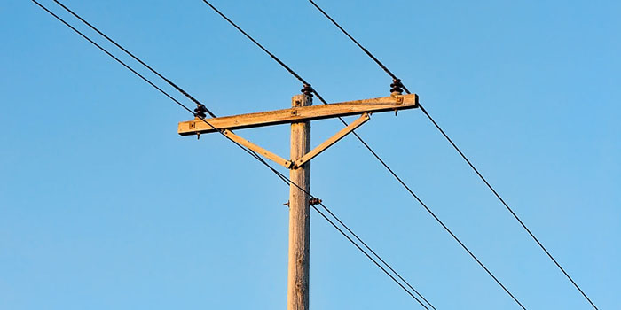

Cheap and widely available, wood has historically been a popular choice for line poles, with pine, cedar, and fir varieties especially favoured due to their height and durability. Wooden poles must be ‘seasoned’ (dried out) before use to enable them to tolerate more moisture absorption in wet weather conditions.
Wooden poles also need to be treated with a preservative to minimise the risk of fungi, rot, and the damage caused by wildlife. In modern times there has been a shift away from creosote towards the use of more environmentally-friendly preservatives, such as Pentachlorophenol and Copper Zinc Arsenate.
Poles crafted from wood have a limited voltage capacity and run a fire risk if exposed to extreme heat. In addition, they require regular maintenance to ensure that they are not rotting or otherwise deteriorating (e.g. due to woodpecker damage).
Seasoned wooden utility poles have an average lifespan of 25-50 years. Their eventual deterioration usually results from rot below ground level.

3.2 2. CONCRETE UTILITY POLES
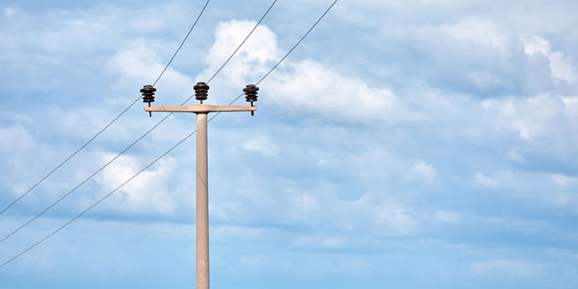

Concrete utility poles possess the highest load capacity out of the three. Like steel, they are extremely resistant to rot and wildlife damage, require minimal maintenance, and weather well in harsh climatic conditions. The insulating properties of concrete are also similar to those of wooden poles.
The two main types of concrete poles used to accommodate overhead lines are reinforced concrete (useful for weight and stability), and prestressed concrete (useful for strength and lateral capacity).
The main disadvantages of concrete poles are that if not made on-site, the cost of transporting them is considerable. In addition, concrete poles also cannot be easily modified, are heavy and awkward, and can pose a safety risk if they weaken.
Spun-cast concrete poles have a lifespan of 50 years or more. Their heaviness and relative impenetrability make them the ideal choice for use in coastal areas, where they can weather sea air, harsh winds, and boggy ground well.

3.3 3. STEEL UTILITY POLES
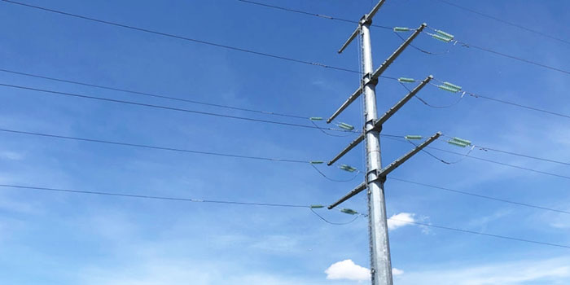

As a more durable, environmentally-friendly option with a higher loading capacity, steel is often used as an alternative to wood. Because it can be melted down and reformed, steel also offers flexibility with pole length – enabling taller poles suited to higher voltage loads to be made.
Poles crafted from steel are also relatively reliable and easy to install – making them the ideal choice in densely populated towns and cities.
Steel utility poles are of two main types:
- Stepped poles (ISTPs): Poles made with built-in maintenance steps (useful for road signs); and
- Swaged poles (ISWPs): Poles specially shaped for extra strength (useful for street lighting).
For the heavier duty projects covering a wider area, large steel towers are used in place of poles. Steel electricity towers can transport anywhere up to 300,000 volts.
However, steel poles are more expensive to manufacture and can be prone to rust. As there is also a risk of electrocution if a live wire comes into contact with the pole, more robust safety features are necessary for their use.
Correctly installed and maintained, steel line poles last an average of 60 years. Galvanization helps to maximise their life expectancy.

3.4 THE UTILITY POLES USED TO SUPPORT THESE ARE TRANSMISSION POLES, DISTRIBUTION POLES, AND LIGHT POLES:
- Transmission Poles transport primary, high voltage power (230KV or more for towers) between power stations. Transmission poles and towers are often made of metal, and anchored to the ground with concrete;
- Distribution Poles transmit secondary, lower voltage power (5-33KV) directly to businesses and homes. The power carried by these lines has already been processed and converted to an appropriate level (known as a ‘service drop’) for ordinary, everyday usage; and
- Light Poles are used to transmit varied levels of power to the range of fixtures used in public services, such as traffic equipment, CCTV, and street lighting. These kinds of utility poles are normally self-supporting.
Distribution poles can be tangent, guyed, or self-supporting. Tangent poles are basic purpose poles arranged in a straight line. Guyed distribution poles are those which have an in-built guy wire as an additional means of support, and self-supporting poles are those which are unable to depend on any additional support (e.g. those which house an awkward space).
Sub-transmission and distribution lines are often carried by different sets of utility poles. However, it can be cost and space-effective to accommodate both on the same poles. This is achieved via an ‘under build’, whereby distribution lines are incorporated onto transmission line poles.

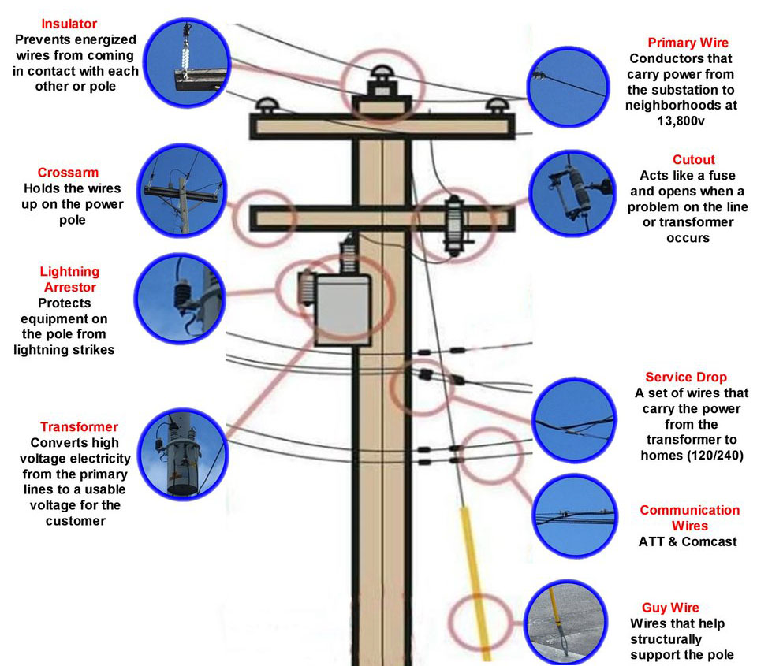

CHAPTER FOUR

4.0 ALUMINIUM BINDING WIRE
Aluminum Binding Wire, also known simply as aluminum wire, is a versatile material widely used in various applications due to its outstanding properties. Known for its strength, durability, and corrosion resistance, aluminum binding wire is suitable for both indoor and outdoor uses. Its lightweight nature combined with its robust strength makes it an ideal choice for environments that require a reliable and durable binding solution.
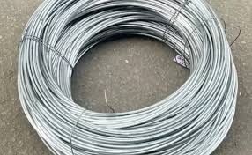

- Aluminum Binding Wire, Bare (BS 2627):
  - Diameter: 3.65mm (SWG 9)
  - Plain aluminum for AAC (All-Aluminum Conductor) & ACSR (Aluminum Conductor Steel Reinforced)
- Aluminum Binding Wire, PVC Covered (BS 6746):
  - Same specifications with an additional PVC coating for enhanced protection and insulation.
Structural Features:
- High-Strength Material:
  - Made from high-quality aluminum, providing excellent strength and durability.
- Corrosion Resistance:
  - Naturally resistant to corrosion, making it suitable for various environmental conditions.
- Lightweight Yet Strong:
  - The wire is lightweight, making it easy to handle and install, yet strong enough to ensure reliable performance.
- Optional PVC Coating:
  - The PVC covered variant adds an extra layer of protection and insulation, making it suitable for specific applications that require additional safety and durability.
4.1 Installation Method:
- Preparation:
  - Ensure all necessary tools and materials are available before starting the installation process. Verify the specifications of the aluminum binding wire to ensure it meets the requirements of the application.
- Cutting the Wire:
  - Cut the aluminum binding wire to the required length using appropriate cutting tools.
- Positioning:
  - Position the wire around the components or structures that need to be bound or secured.
- Securing the Wire:
  - Twist or tie the wire securely around the components, ensuring a tight and stable connection. For PVC covered wire, ensure that the coating remains intact to maintain its protective properties.
- Inspection:
  - Inspect the installation to ensure the wire is securely fastened and properly aligned. Check for any signs of wear or damage.
Applicable Environmental Conditions:
- Temperature Range:
  - Suitable for operation in temperatures ranging from -50°C to +85°C, ensuring performance in extreme weather conditions.
- Humidity:
  - Effective in environments with high humidity, providing reliability in moist conditions.
- Weather Resistance:
  - Designed to withstand harsh weather conditions, including high winds, heavy rain, snow, and UV exposure.
- Corrosive Environments:
  - The aluminum material provides excellent resistance to corrosion, making it suitable for environments exposed to salt, chemicals, or industrial pollutants.

4.2 SHACKLE INSULATOR
The shackle insulator (also known as a spool insulator) is usually used in low voltage distribution network. It can be used in both the horizontal or vertical positions. The use of such insulator has decreased recently after increasing the using of underground cable for distribution purpose.
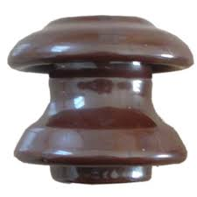
The tapered hole of the spool insulator distributes the load more evenly and minimizes the possibility of breakage when heavily loaded. The conductor in the groove of shackle insulator is fixed with the help of soft binding wire.

SHACKLE INSULATOR

4.3 WHAT IS A STAY INSULATOR?
Stay insulators are a form of insulators that are utilized on the stay path. They are modeled to supply insulation in case the wire cuts and falls on the ground. The stay insulator will guarantee that the wires don’t contact the ground.

Knowing the performance of a stay insulator is important. There are some holes in the body of the stay insulator. The two pieces guy grips go through from the body in the opposite path. The guy grip will wrap the main wire to create the connection. The connection path isn’t confirmed. For different types, there are various ways to connect, and any manufacturer can make the insulator fittings according to the customers’ requirements and application.

The importance of the stay insulator is commonly witnessed once the poles fall on the ground or when the main wires accidentally cut because of the excess mechanical load. It is among the most suitable insulators for overhead transmission lines that you should install. The stay type insulator is normally installed in the middle of the stay path. In the case the pole fails, the insulator will ensure that the lower part of the system will have no voltage.

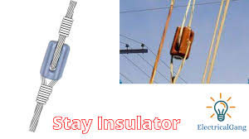

4.4 HOW DOES A STAY INSULATOR WORK?
A usual stay insulator has two holes that are placed on opposite sides of each other. Pieces of stay wires enter within one hole and exit through the other. Guy wires are employed to support the grip and ensure that there is a complete connection between the stay insulator and stay wire.
So, what happens when the wires find themselves on the ground? Let’s say the tower or pole fails and everything breaks. The wires will be completely insulated and No voltage will go to the earth.

CHAPTER FIVE
5.0 INTERPERSONAL RELATIONSHIP WITHIN THE ORGANIZATION
My four months SIWES program has equipped me the knowledge of electronical engineering design in terms of generator and services.
During the course of staying with the coordinators in the various sections has turn a new moment in my course of study in engineering and automobile respectively.
5.1 SUGGESTION FOR IMPROVEMENT OF THE PROGRAMME
The industrial training fund should have up and hold committee on inspecting the student in their various organizations that they are attached to as this will improve the level of seriousness of the student to the program. Also, the federal government in collaboration with the industrial training fund (ITF) to increase the student allowance for the program as this will encourage them in active participation.

5.2 CONCLUSION
My four months industrial attachment with Babarinde Electrical Contractor has been one of the most interesting, productive and instruction experience in my life. Through this training I have gained new insight and more comprehensive understanding about the real industrial working condition and practice, it has improved my soft and functional skills. All these valuable experience and knowledge that I have gained were not only acquired through the direct involvement in the task but also through other aspects of the training such as: work observation, interaction with colleagues, supervisor and other people related to the field. It also exposes me on some certain things about marine environment. And from what I have undergone, I achieved and am sure that the industrial training programme has achieved its primary objectives. As a result of the programme I am now more confident to build my future career which I have already started with Babarinde Electrical Contractor

