

A REPORT ON THE STUDENTS INDUSTRIAL WORK EXPERIENCE SCHEME (SIWES)

DONE AT

LOWER NIGER RIVER BASIN DEVELOPMENT AUTHORITY, ILORIN

BY

SOLIU KAFILAT MOTUNRAYO
ND/23/AGT/PT/0017

DEPARTMENT OF AGRICULTURAL TECHNOLOGY

KWARA STATE POLYTECHNIC ILORIN, KWARA STATE
DEDICATION
This report is dedicated to God for seeing me through. I also dedicate it to Mr. And Mrs. SOLIU for their love and support for making it successful for me.

ACKNOWLEDGEMENT
Special appreciation goes to my parent Mr. And Mrs. SOLIU for their love and care. I applaud them for making me fall in love with education and for always keeping me in check with my fashion design skills.
My gratitude is incomplete without acknowledging my maternal family for their support and contribution to my onward progress in life.
A big thank you to my colleagues from different institutions that formed the group members during my training, and all staff of Lower Niger River Basin Development Authority, Ilorin.

TABLE OF CONTENTS
Title Page
Declaration
Acknowledgement
Table of Contents
CHAPTER ONE
1 INTRODUCTION
1.1 Background Information on SIWES
1.1.1 Objectives of SIWES
CHAPTER TWO
2 LOWER NIGER RIVER BASIN DEVELOPMENT AUTHORITY, ILORIN
2.1 Brief history of LNRBDA, Ilorin
2.1.1 Objectives of LNRBDA, Ilorin
.1.2 Organizational/Promotional Structure of LNRBDA, Ilorin
CHAPTER THREE
3 DUTIES PERFORMED
3.1 Activities carried out
CHAPTER FOUR
4 EQUIPMENT USED
4.1 Description of the equipment used
CHAPTER FIVE
5 PROBLEMS ENCOUNTERED AND RECCOMENDATIONS
5.1 Experienced gained
5.1.1 Problems Encountered
5.1.2 Recommendations
References
ANNEX A
Completed Form 8

CHAPTER ONE

INTRODUCTION

1.1Background Information on SIWES
The Students’ Industrial Work Experience Scheme (SIWES) is a skill development program initiated by the Industrial Training Fund (ITF), in 1973 to bridge the gap between theory and practice among students of engineering and technology in institutions of higher learning in Nigeria. It provides for on-the-job practical experience for students as they are exposed to work methods and techniques in handling equipments and machineries that may not be available in their institutions. Started in 1974, with 748 students from 11 institutions of higher learning participating, by1978, the scope of participation in the scheme had increased to about 5000 students from 32 institutions. The Industrial Training Fund however withdrew from the management of the scheme in 1979 owing to problems of organizational logistics and the increased financial burden associated with the rapid expansion of SIWES (ITF, 2003). Consequently, the Federal Government funded the scheme through the National Universities Commission (NUC) and the National Board for Technical Education (NBTE) who managed SIWES for five years (1979-1984).The supervising agencies (NUC and NBTE) operated the scheme in conjunction with their respective institutions during this period.
The scheme was subsequently reviewed by the Federal Government resulting in a Decree No 16 of August, 1985 which required that “all students enrolled in specialized engineering, technical, business, applied sciences, and applied arts should have supervised industrial attachment as part of their studies”. In the same vein, the ITF was directed by the Federal Government to take charge and resume responsibility for the management of SIWES in collaboration with the supervising agencies i.e. National Universities Commission (NUC),the National Board for Technical Education (NBTE) and the National Commission for Colleges of Education (NCCE).
Following the resumption of management of SIWES by the ITF IN 1984, the scheme has witnessed rapid expansion. Between 1895 and 1995, the number of institutions and students participating in SIWES rose to 141 and 57,433 respectively. Between 1995 and 2003, a total of 176 institutions and 535,210 students participated in the scheme. In 2008 alone, the number of institutions which participated in SIWES rose to 204 while the number of students from these institutions who participated in the scheme was 210,390.
Presently, participation in the scheme is limited to science, engineering and technology program in Universities and Polytechnics while in Colleges of Education NCE programs in Technical Education, Agriculture, Business, Creative Arts and Design, Computer Studies and Home Economics are eligible.
The scheme was designed to expose students to the industrial environment and enable them develop occupational competencies so that they can contribute their quota to national economic and technological development after graduation.

1.1.1. Objectives of SIWES
- Provide an avenue for students in institutions of higher learning to acquire industrial skills and experience during their courses of study.
- Prepare students for industrial work situations that they are likely to meet after graduation.
- Expose students to work methods and techniques in handling equipment and machinery that may not be available in their institutions.
- Opportunity for students to blend theoretical knowledge acquired in the class room with practical hands-on application of knowledge required to perform work in industry.
- Exposure of students to the environment in which they will eventually work, thereby enabling them to see how their future professions are organized in practice.
- Enabling SET students appreciate work methods and gain experience
- Enhancing students’ contacts with potential employers while on training.
- It exposes students to work methods and how to handle machines

CHAPTER TWO

LOWER NIGER RIVER BASIN DEVELOPMENT AUTHORITY, ILORIN

2.1Brief history of LNRBDA, Ilorin.
The Lower Niger River Basin Development Authority is one of the twelve River Basin Development Authorities in Nigeria. The Authority was re-established in 1994, having been severally merger and demerger since it was originally established in 1976 by Decree No. 25 of June under the name Niger River Basin Development Authority with its headquarters in Ilorin. In 1984, the Authority Â was split into two, namely, the Upper Niger River Basin and Rural Development Authority and Rural Development Authority, with the headquarters in Minna, Niger State and Ilorin, Kwara State respectively.
In 1987, the two autonomous establishments were merged again into one Authority with the Headquarters in Minna, Niger State.
However, in 1994,the Authority was split again and Lower Niger River Basin Development Authority was re-established with it's Headquarters back in Ilorin, Kwara State. The area of operations of the Authority now cover the entire geographical boundary of Kwara state and part of Kogi State, West of the River Niger. The Authority, an agency of the Federal Government of Nigeria under supervision of the Federal Ministry of Water Resources, has a board of Directors comprising a Chairman, five other members and the managing Director of the Authority.
2.1.1OBJECTIVES OF LNRBDA, Ilorin
- To undertake comprehensive development of both surface and underground water resources for multi-purpose use with particular emphasis on the provision of irrigation infrastructure and the control of floods and erosion and for water shed management.
- To construct, operate and maintain dams, dykes, polders, wells, boreholes, irrigation and drainage systems, and other works necessary for the achievement of the Authority's functions and hand over all lands to be cultivated under the irrigation schemes to the farmers.
- To supply water from the Authority's completed storage schemes to all users for a fee to be determined by the Authority concerned with the approval of the Minister.
- To construct, operate and maintain infrastructural services such as roads and bridges at projects sites, provided that such infrastructural services are included and form an integral part of the list of approved projects.
- To develop and keep up-to-date comprehensive water resources master plan, identifying all water resources requirements in the Authority's area of operation, through adequate collection and collation of water resources, water use, socio-economic and environmental data of the River Basin.

CHAPTER THREE

WORKDONE

3.1: WORK-DONE
The work done includes the following:

3.1.1 Introduction to Horticulture
This is the branch of agriculture that deals with the art, science, technology and business of vegetable garden plant growing. It includes the cultivation of medicinal plants, nuts, fruits, vegetables, seeds, sprouts, herbs, flowers, etc.
Horticulture is of various types, which include: - Pomology (production of fruit trees), Olericulture (production of vegetables), and Floriculture (production of flowering and ornamental plants).

3.1.2. Propagation of Crops
This can be defined as the multiplication of individual into new plants. Propagation is of two types, that is, sexual and asexual propagation.
- Sexual Propagation involves reproduction by seed, which can either be planted directly or sowed in the nursery and later transplanted to the field.
- Asexual Propagation involves the growing of new plants from vegetative organs (vegetative parts of the parent plants) e.g. root, stem and leave cutting, and thus also known as Vegetative Propagation.
Plants that can be propagated by vegetative means are:
i) Plants that do not produce seeds.
ii) Plants that is easier to propagate by vegetative means, instead of using seeds which may take longer period viable for planting.
iii) Plants that produce seeds, but whose seeds are not.

Types or Asexual Propagation Carried out include:
- Cuttings: Involves cutting parts of a plant into portions called cuttings. Cuttings may come from stems or leaves, depending on the type of plant being propagated, the part cut from the parent plant are taken to the nursery for propagation. Plants whose stems produce roots fairly readily are propagated by stem cuttings. Plants propagated by stem cuttings include: ornamental plants, e.g. Euphorbiamilli, Ixorasp.,Crotonspp., Queen of Philippine, Thujaoccidentalis, etc. An example of plants propagated by leave cuttings is sweet potato.

- Budding: This is a skilled technique used when plants do not grow easily from cuttings.

Procedure:
A bud is cut from a defoliated matured branch(parent plant), usually two years old. Attached to the bud is a flat shield-shaped piece of stem. The stem piece and bud is called the scion. An inverted T-shaped cut is made on the bark of another plant of desirable characteristics (must be at least of pencil-size), called the rootstock. The edges of the cut are turned back to expose the cambium. The scion is inserted into the root stock and the two are bound into position and the joint made waterproof by polythene tape (usually called buddingtape), leaving the actual bud from the scion exposed. This prevents the bud from being scalded by the sun and also prevents bacteria and water from entering the wood before it heals. If the bud unites successfully with the root stock, it begins to develop into a new shoot after about two weeks. The bud eventually produces a shoot system and when well developed, the portion of stock above the bud is removed with a pair of secateurs. All branches below the scion should be carefully removed. When fully developed, the budded plant is carefully transplanted to its permanent site/sold. Crops usually propagated by budding include: citrus especially, rubber and cocoa. Advantage include the induction of fruits and flowers.
- Grafting: This is closely related to budding and is a method of vegetative propagation which involves the application of a whole shoot or stem (the scion) into another parent plant (root stock).

Procedures
The graft-wood is gotten from the parent plant which must have been defoliated two weeks before grafting. The graft-wood is cut using a pair of secateurs. Making sure that the root stock is of at least pencil-size, scrape its epidermis (without removing completely), and the graft-wood of the same size as the root stock, the epidermis of graft-wood is scraped off using a sharp knife. The graft-wood is tied to the root stock using a graft tape, to prevent water and a bacterium from entering into the scraped wood before it heals. Crops usually propagated by grafting include: Mango. The advantage include increasing early fruiting of plant.
- Pest Control: This is done to prevent pests from destroying crops in the field.

Pest control methods used include:
- Physical control of pest by fencing round the farm with wire nets and wire mesh.
- Chemical control of pest through the use of pesticides and insecticides. Chemical preparations used to control insect pests are known as insecticides, while pesticides are chemicals used to control pests.
- Weed Control: Weeding is the removal of unwanted or undesirable plants especially one that grow where it is not wanted and often grows fast or takes the place of desired plant. This is done regularly in order to prevent competition with plants for space, sunlight, nutrients, soil moisture, soil oxygen, etc.

Methods of weed control carried out include:
- Mechanical / Physical Control: These include
- Hand picking: This involves uprooting weeds from the soil by hand.
- Hoeing: This involves uprooting weeds with hoes before or after planting.
- Slashing: This involves the use of a slasher mounted on tractor. Aerial parts of weeds can also be removed with cutlasses, leaving behind the roots in the soil.
- Chemical Control: This involves the use of chemical solutions called herbicides to control the growth of weeds.

Types of Herbicides
There are two types of herbicides: Pre-emergence and Post-emergence.
- Post-emergence Herbicides: These are used after the appearance of weeds and are mostly selective, that is, they kill specific types of weeds. This comprise of the systemic and contact herbicides.
- Contact Herbicides: The effect is noticed within 3-4 hours of application, but if it rains within 2-3 hours of spraying, it becomes ineffective. Examples include: Paraforce, Gramazone, Dragon, Weed crusher, etc.
- Systemic Herbicides: This becomes effective after 3-4 days of application. It is more effective if the soil has moisture and is still very much effective after 2-3 months of application. The active ingredient in systemic herbicide is Glyphosate. Examples include: Sunphosate, Bush fire, bush clear, random, etc.
- Pre-emergence Herbicide: These are used before the appearance of weeds and most effective when the soil is moisturized, when its rain is still very effective. Example includeTravest used for cassava, maize, sugarcane, yam, sorghum. It prevent the weed from germinating because once the weed absorb moisture it will be poisonous to it and the weed dies.
Note: There is a mixing ratio for chemicals. Measure the herbicide with a measuring cup and put some water in the sprayer before and after pouring the chemical, for perfect mixing.

SPRAYERS
These are used for the application of chemicals, including herbicides.
Types of Sprayers used are: Knapsack sprayer (hand-operated), Handgun, Boom sprayer (tractor-mounted), Motorised sprayer.
- Improvisation of Polythene Pot, Filling with Top Soil and Arranging in the Garden
- Improvisation of Polythene Pot: This is done by cutting a pure water nylon (usually at the horizontal end) using a sharp razor blade or scissors. Then, make a hole or two on the opposite end of the cut horizontal end; this is for easy escape of excess water.
- Filling of Polythene Pot with Top Soil and Arrangement: Polythene pots are filled with top soil (mixture of manure and loamy soil) and arranged in the nursery, using a measurement of 10 by 10, that is, 10 in each row and column (making a total of 100 in each bed). Ridges are made round the arranged polythene pots, so as to prevent them from being washed away by water.
- Application of Manure: This involves the application of manure, e.g., farm-yard manure, green manure and compost manure to the soil in order to improve its fertility.
- Irrigation: This is the artificial application of water to soil or land for farming purposes, to supplement insufficient rainfall.

Types of irrigation carried out include: Manualirrigation and Overheadirrigation. Overhead irrigation is of two forms, namely: sprinkler and drip irrigation
- Manual irrigation is carried out using a watering can.
- Overhead irrigation system involves the supply of water to farmland above the surface of the soil. The form of overhead irrigation carried out is the sprinkler irrigation, which involves the use of a device called the sprinkler. In sprinkler irrigation system, water is sprayed from the air and allowed to fall on the ground surface somehow as rainfall through nozzles under high pressure. Pumping machine which operates under high pressure is needed to pump water into irrigation pipes which are spaced to ensure even distribution of water.

Parts of Irrigation System
The irrigation machine comprises of the engine and pump.
- End cap: stops water flow from pipes
- Gate valve: It allows water to move from foot valve to other parts.
- Seal rubber: Usually around the end of pipes.
- Ground packing: found inside the machine. It usually contains water. It’ll burn if there’s no water in it.
- Primer: It is essential to make use of this for a new irrigation system. It pumps water into pipes that do not contain water.
- Sprinkler: It sprinkles water
- Reducer: A large pipe which reduces to a smaller one. This reduces the flow of water.
- T-joint: this is where two pipes meet.
- Elbow pipes: here, the female pipe receives the male pipe.
- Foot valve: this is usually inside the stream (it draws water from the stream). The radiator must be filled with water to avoid overheating, after starting the engine the endcap is used to stop water flow in other to increase the pressure of sprinkler.
- Transplanting: This is the transfer of seedlings from beds to their permanent positions in the field. This is mostly done in cool weather, in the morning or evening times. Also, it is usually done at the early stages of development of the crop plant, long before maturity. Plants are removed with balls of soil around the roots; soils around roots at permanent site are firmed to eliminate air pockets, for good root establishment. Watering is done in the morning and equipment used for transplanting are hand trowel, digger, hoe or cutlass. Plants transplanted include: - Mango (Mangiferaindica); Pawpaw (Caricapapaya).
- Land Preparation: This is done by clearing the land with cutlass or slasher; making ridges or heaps manually with hoe, or mechanically by ploughing, ridging and harrowing. This is done in preparation for other planting activities.
- Pruning: Pruning involves trimming ( a tree, shrub etc) by cutting away dead or overgrown branches or stem especially to encourage growth. Pruning is done using pruning shear careful is taken so as not to destroy the plant.
Advantages include;
- Accessibility of plant
- To improve fruit production of the plant
- It helps to control shape and size of plant
- It helps to control the spread of disease by removing the dead part

INTRODUCTION TO SCREEN HOUSE FARMING
- Screen houses: Screen houses are structures which are covered in insect screening material instead of plastic or glass. They provide environmental modification and protection from severe weather conditions as well as exclusion of pests. They are often used to get some of the benefits of greenhouses in hot or tropical climates.
They can be opened or closed easily without any jerk and inconvenience to plants and their growth but the outside weather conditions matters. Screen houses are easy to carry and construct at any size with all facilities according to any climate that plants prefer. Screen houses are preferable for other research applications that demand strict insect control and an ambient temperature.
The advantages of using screen houses:
- Humidity control
- Luminosity control
- Temperature control
- Heating fuel savings.
- More control and less expense in watering
Majorly, Screen houses prove more helpful for green vegetables as insects easily catch them and destroy their growth but Screen house confidently prevent the entrance of insects. Rarely found fruits and vegetable, flowers and plants are grown in Screen houses due to its protective environment.
Many commercial glass greenhouses or hothouses are high tech production facilities for vegetables or flowers. The glass greenhouses are filled with equipment including screening installations, heating, cooling, lighting, and may be controlled by a computer to optimize conditions for plant growth. Different techniques are then used to evaluate optimality-degrees and comfort ratio of greenhouse micro-climate (i.e., air temperature, relative humidity and vapor pressure deficit) in order to reduce production risk prior to cultivation of a specific crop.
USES OF SCREEN HOUSE
- Screen houses allow for greater control over the growing environment of plants.
- Screen house allows for control of temperature, levels of light and shade, irrigation, fertilizer application, and atmospheric humidity.
- Screen houses may be used to overcome shortcomings in the growing qualities *piece of land, such as a short growing season or poor light levels, and they can thereby improve food production in marginal environments.
- Screen houses in hot, dry climates used specifically to provide shade are sometimes called "shade houses".
As they may enable certain crops to be grown throughout the year, Screen houses are increasingly important in the food supply of high-latitude countries. Screen houses are often used for growing flowers, vegetables, fruits etc.

THEORY OF OPERATION
The warmer temperature in a greenhouse occurs because incident solar radiation passes through the transparent roof and walls and is absorbed by the floor, earth, and contents, which become warmer. As the structure is not open to the atmosphere, the warmed air cannot escape via convection, so the temperature inside the greenhouse rises. This differs from the earth-oriented theory known as the "greenhouse effect".
3.1.2 PLANTING OF (CORCHORUS OLITORIUS SEED) ON A CLEARED LAND
Corchorus Olitorius is a species of shrub in the family malvaceae together with C (capsularis) it is the primary source of jute fiber .the leaves and young fruits are used as a vegetable,the dried leaves are used for tea and as a soup thickner and the seeds are edible. Common name: Jute mallow or corchorus olitorius
African name : Ewedu
- Operation required in raising Corchorus olitorius(Ewedu) or Jute mallow.
- Clearing of land – A cleared land must be prepared in order before cultivation can take place.
- Making of bed: the bed is raised to 80-90cm width and 15cm above the ground level. The soil that is between the rows is lifted on top of the bed using a digger or shovel.
- Soil analysis: It is important to do soil analysis before farming start, the procedure involves collection of slightly moist soil at various points within the environment .The sample is then taken to the accredited laboratories for the pathological and nutritional analysis.
- Planting process: The seeds of ewedu is directly sowed on the bed provided on the cleared land 60cm spacing to between each other.
- Weeding: Hand weeding was carried out on the ewedus (Corchorus olitorius )seedlings has there was removal of unwanted plants growing around the planted ewedus(jute mallow)
NOTE: The ewedu germinated precisely after two three weeks of planting. It can only be raised using Rebroadcasting or by seed drilling methods

CHAPTER FOUR

EQUIPMENT USED

Description of the equipment used
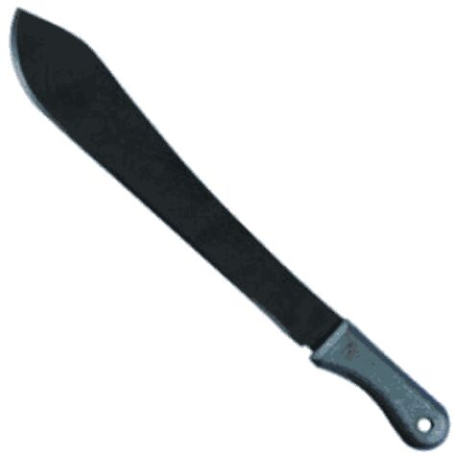
- CUTLASS: The cutlass is one of the commonest used farm tools in Nigeria. They come in various shapes and sizes. It is a flat long metal blade with a short wooden or plastic handle with one edge sharp while the other is blunt. They perform many functions. It is used for the clearing of bushes around your homes, for the felling of big trees. It is used in harvesting crops like sugar cane, maize, cassava, yam and palm nut fruits. It is also used in the planting of melon during the planting season, cutlass can also be used for the transplanting of seedlings, weeding of crops, both in the digging of shallow holes and used in the trimming and pruning of flowers.

Plate 4.1: Cutlass
- HOE: It comes in different types, which are used in Nigeria today. There is the West African hoe and the Indian hoe. They both have metal blades with wooden or metal blades. Hoes are used in tilling the soil, harvesting of crops like cassava, sweet potato and cocoyam, weeding between the rows of crops, digging of drains, making trenches and foundation of farmhouses, and the making of ridges and mounds. The hoes all over the world perform the same function but we are going to differentiate them the West African hoe is made of short curve handle while the Indian hoe has a long handle. The West African hoe has a round metal blade while the Indian hoe has a rectangular metal blade. The blade (metal) is attached to the handle with a prong while that of the Indian hoe is attached to the handle with a hoop.
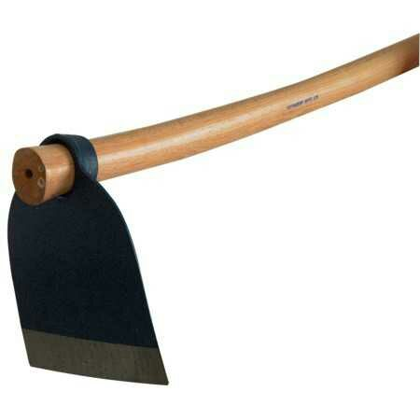

Plate 4.2: Hoe
- GRAFTING KNIFE: The blades are made from stainless steel with durable nylon handles and brass linings and will provide years of good service, Standard budding and grafting knife. Budding and Grafting knife widely used for grafting grapevines and for roses. Has a straight blade with slightly sharpened bark lifter on the top edge

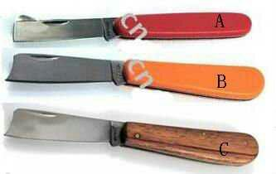

Plate 4.3: Grafting Knife
- HAND TROWEL: It is boat shaped or it is either curved sloop metal blade that is attached to a short wooden or metal handle. When using it, you hold it with one hand. It helps in the transplanting of seedlings, for the application of fertilizer and also for the application of manure to the soil, it helps in loosening vegetable beds, it can also be used for , sampling or mixing up of soil and digging holes for the planting seeds.
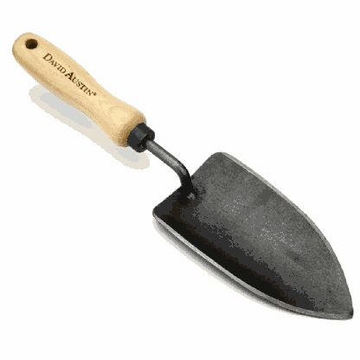

Plate 4.5: Hand Trowel
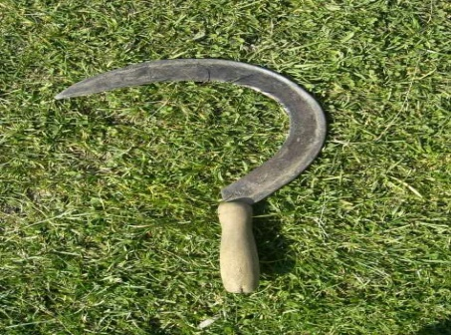
- SICKLE: The sickle has a curved metal blade that is fitted into a short wooden handle. The inner part of the curved metal blade is very sharp while the other part, has a blunt edge. To recognize a sickle when been viewed, it has a structure like that of a question mark (?). It used in the plucking of fruits. This can only be possible, when it is tied to a long handle, it can also be used to harvest cereals like rice, wheat barley because they possess thin stems. It can also be used in the harvest of grasses.

Plate 4.6 : Sickle
- SHEARS: It is seen as a pair of an enlarged pair of scissors with two long blades, connected at a point by a bolt and a nut of which the blades are sharpened at one edge not the two sides in other not to injure someone. The handle of the shears may be made of wood, metal, plastic or rubber. It is usually handled with both hands. Shears are used to prune down trees or branches of shrubs, trimming of hedges and trimming of Ornamental plants used in house decoration.

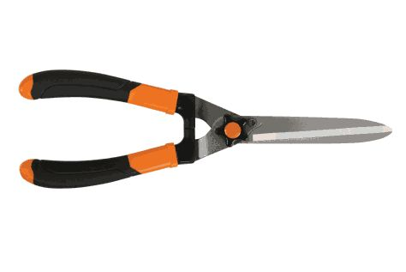

Plate 4.7 : Shears
- WATERING CAN: It is made up of galvanized iron which prevents it from rusting. Some are also made of very synthetic rubber. The water watering can is made up of a tank, a handle and a spout .This spout is long with a perforated metal sheet over its mouth which is referred to as the ROSE, but in case of the rubber made watering can the mouth is covered by a rubber. It is used to apply water to crops like seedlings in a nursery and vegetables. Sometimes it is used in applying liquid fertilizers to crops as well as the watering of cement blocks used for the constructions of structures and buildings.
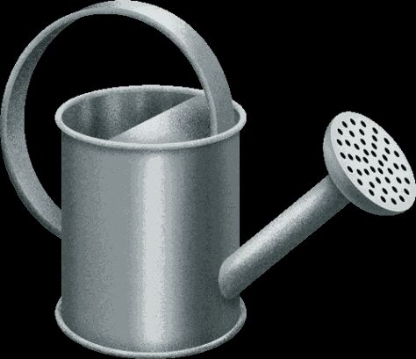

Plate 4.8: Watering Can
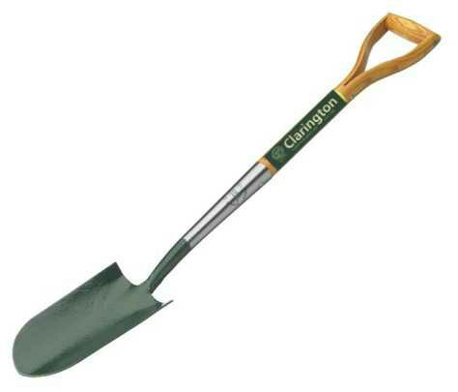
- SPADE: The spade is made up of a long rectangular flat blade which is attached to a fairly long cylindrical handle that widens at the posterior end to form a triangular block with a D-shaped whole for hand when used. Spade is used for different proposes. It can be used for levelling the ground, for making seedbeds, ridges, mounds and heaps, transplanting of seedlings like palm oil seedlings, turning the soil and the mixing of manures, light weeding in the farm .

Plate 4.9 : Spade
- PRUNING SHEARS: It also called hand pruners (in American English), or secateurs, are a type of scissors for use on plants. They are strong enough to prune hard branches of trees and shrubs, sometimes up to two centimeters thick. They are used in gardening, arboriculture, farming, flower arranging, and nature conservation, where fine-scale habitat management is required.

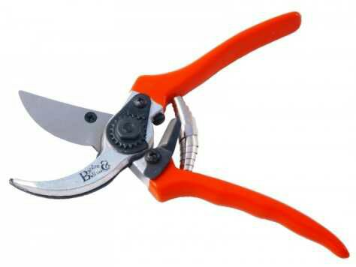

Plate 4.1.0: Pruning Shears
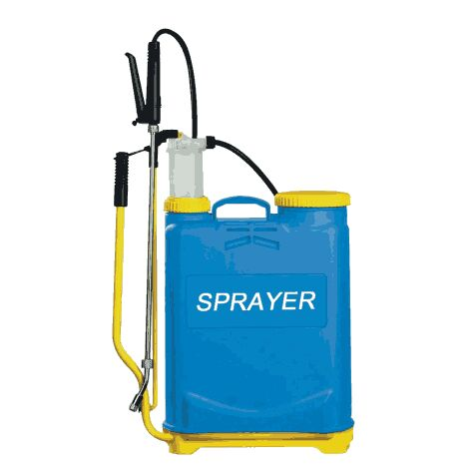
- KNAPSACK SPRAYER: It is a spraying apparatus consisting of a knapsack tank together with pressurizing device, line, and sprayer nozzle, used chiefly in fire control and in spraying fungicides or insecticides Variants knapsack sprayer or knapsack pump

Plate 4.1.1: Knapsack Sprayer
- WHEELBARROW: It is a small, hand-propelled cart designed to carry moderately sized loads. Its structure distributes the weight of comparatively heavy loads, allowing an operator to move loads that would be impossible to lift or maneuver without some type of assistive device. Wheelbarrows can be seen on construction sites and in gardens, among many other places, and most hardware suppliers stock them in a variety of shapes and sizes
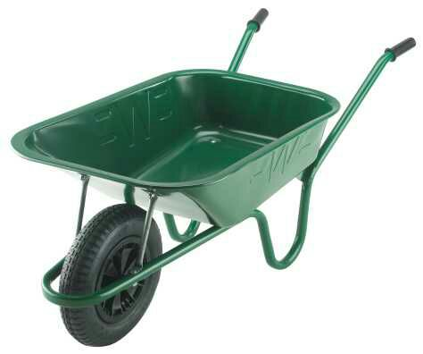

Plate 4.1.2: Wheelbarrow
- POLYTHENE POT: This is also known as poly pot, plastic pot, plant bags. They are extremely popular, as they are cheap alternative to standard plant pots. They are made from 200 gauge recycled polythene. They are supplied flat making them very easy to store and once filled with compost they are sturdy, free-standing pots. They are ideal for propagating or for nurturing young plants in the green house or potting shed.
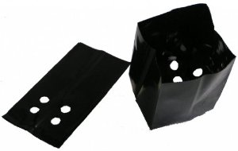

Plate 4.1.3 : Polythene Pot

CHAPTER FIVE

PROBLEMS ENCOUNTERED AND RECCOMENDATIONS

5.1 Experienced gained
- I was exposed to various kinds of horticultural activities
- I learnt on how to operate a green house
- I was opportune to know how various kinds of plants are been propagated both sexually and asexually.

5.1.1 Problems Encountered

- The six month assigned for Student Industrial Work experience Scheme is too short to amass all the horticultural experience in the garden.
- Limited number of equipment which rendered us to work in turns. This made works slow, tiring and waste time.
- Lack of stipends from both government and the establishment to boost the morale of the students during the industrial training.
- Poor marketing system in the organization

5.1.2Recommendations
- Over working of students on industrial training should be discouraged and totally abolished.
- The Lower Niger River Basin Development Authority should endeavor to provide fund to the ecological garden to increase the number of their very few equipment to make work interesting, fast and less time consuming.
- The organization and the federal government should provide a good means of transportation and accommodation to the students to make work easier.
- Seminar relevant to the work of the establishment and course of students on industrial training should be once in a while organized.

REFERENCES
Aloko F.T(2021) Conversation with I.T students at LNRBDA
Abubakar M (2021) Conversation with I.T students at LNRBDA

