A TECHNICAL REPORT

ON

STUDENTS INDUSTRIAL WORK EXPERIENCE SCHEME
(SIWES)

UNDERTAKEN
AT

M.K LAUNDRY SERVICES

BY
ADEBAYO MARIAM BISOLA
MATRIC NO: ND/23/BAM/PT/0129

SUBMITTED TO

THE DEPARTMENT OF BUSINESS ADMINISTRATION
INSTITUTE OF FINANCE AND MANAGEMENT STUDIES

KWARA STATE POLYTECHNIC, ILORIN

IN PARTIAL FULFILMENT OF THE REQUIREMENTS FOR THE AWARD OF NATIONAL DIPLOMA IN BUSINESS ADMINISTRATION

AUGUST TO DECEMBER, 2024
DEDICATION
I dedicate this report write up to Almighty Allah who gives me strength and inspiration in the course of this work. Special dedication also goes to my ever supportive parents Mr. and Mrs. ADEBAYO, and other family members for their relentless, financial and moral support towards the success of my four (4) months SIWES programme.

ACKNOWLEDGEMENT
I have taken effort in this Siwes. However, it would not have been possible without the kind support and help of some individuals and this organization. I would like to extend my earnest thanks to all of them.
I would and in Respect like explicitly express my gratitude to the Managing Director of M.K LAUNDRY SERVICES, in person of Taiwo Ayobamidele S., and the staff in person of Mr. Abdulrahman, Mr. Ali, for their kind co-operation and their professional guidance and instruction during my Siwes which assisted me in completion of this Siwes.
I would like to express my special gratitude and thanks to industry persons for giving me such attention and time.
My thanks and appreciations also go to my colleagues in developing the Siwes Report and people who have willingly helped me out with their abilities. I am highly indebted to you all.

TABLE OF CONTENTS
TITLE PAGE
Dedication 1
Acknowledgement 2
Table Of Contents 3
CHAPTER ONE: INTRODUCTION 5 - 10
1.1 History Of Siwes
1.2 Objectives Of Siwes
CHAPTER TWO: DESCRIPTION OF THE ESTABLISHMENT OF ATTACHMENT 11-17
2.1 Location And Brief History Of Establishment
2.2 Objectives Of Establishment
2.3 Organization Structure
2.4 The Various Departments/Unit In The Establishment
CHAPTER THREE 18
3.0 Reporting On Work Actually Carried Out And Gained
CHAPTER FOUR: SUMMARY, CONCLUSTION AND RECOMMENDATION 19
4.0 Summary Of Attachment Activities
4.1 Problems Encountered During The Program
4.2 Suggestions For The Improvement Of The Scheme

CHAPTER ONE
INTRODUCTION
1.1 HISTORY OF SIWES
SIWES (Student Industrial Working Experience Scheme) was established by ITF in 1973 to solve the problem of lack of adequate practical skills preparatory for employment in industries by Nigerian graduates of tertiary institutions.
The Scheme exposes students to industry based skills necessary for a smooth transition from the classroom to the world of work. It affords students of tertiary institutions the opportunity of being familiarized and exposed to the needed experience in handling machinery and equipment which are usually not available in the educational institutions. Participation in Industrial Training is a well-known educational strategy. Classroom studies are integrated with learning through hands-on work experiences in a field related to the student’s academic major and career goals. It also expose the student to the practical aspect of some course being offer in the school.
Successful internships foster an experiential learning process that not only promotes career preparation but provides opportunities for learners to develop skills necessary to become leaders in their chosen professions.
One of the primary goals of the SIWES is to help students integrate leadership development into the experiential learning process. Students are expected to learn and develop basic non-profit leadership skills through a mentoring relationship with innovative non-profit leaders.
By integrating leadership development activities into the Industrial Training experience, we hope to encourage students to actively engage in non-profit management as a professional career objective. However, the effectiveness of the SIWES experience will have varying outcomes based upon the individual student, the work assignment, and the supervisor/mentor requirements.
It is vital that each internship position description includes specific written, learning objectives to ensure leadership skill development is incorporation.
Participation in SIWES has become a necessary pre-condition for the award of Diploma, Degree and NCE certificates in specific disciplines in most institutions of higher learning in the country, in accordance with the education policy of government.
1.2 OPERATORS OF SIWES
Operators - The ITF, the coordinating agencies (NUC, NCCE, NBTE), employers of labor and the institutions.
Funding - The Federal Government of Nigeria
Beneficiaries - Undergraduate students of the following: Agriculture, Engineering, Technology, Environmental, Science, Education, Medical Science and Pure and Applied Sciences.
Duration - Four months for Colleges of Education and Polytechnics, and Six months for the Universities.
1.3 OBJECTIVES OF SIWES
1. SIWES will provide students the opportunity to test their interest in a particular career before permanent commitments are made.
2. SIWES students will develop skills in the application of theory to practical work situations.
3. SIWES will provide students the opportunity to test their aptitude for a particular career before permanent commitments are made.
4. SIWES students will develop skills and techniques directly applicable to their careers.
5. SIWES will aid students in adjusting from college to full-time employment.
6. SIWES will provide students the opportunity to develop attitudes conducive to effective interpersonal relationships.
7. SIWES will increase a student's sense of responsibility.
8. SIWES students will be prepared to enter into full-time employment in their area of specialization upon graduation.
9. SIWES students will acquire good work habits.
10. SIWES students will develop employment records/references that will enhance employment opportunities.
11. SIWES will provide students the opportunity to understand informal organizational interrelationships.
12. SIWES will reduce student dropouts.
The four (4) months Students Industrial Work Experience Scheme (SIWES) which is a requirement for the completion of my course of study, was undertaken at M.K LAUNDRY AND DRYCLEANING SERVICES
The Industrial Training was based on working with Personal Computers, laptops, installation and maintenance, spreadsheet and word processing.

CHAPTER TWO
DESCRIPTION OF THE ESTABLISHMENT OF ATTACHMEMT
2.1 Location and brief history of M.K LAUNDRY AND DRYCLEANING SERVICES
M.K LAUNDRY AND DRYCLEANING SERVICES is a brain child of Taiwo Ayobami S., a non-governmental organization (NGO) which was established 5years ago to assists in tackling basic societal problems, promotes education for indigent children and empowering youths through the provisions of various opportunities to be self-reliant.
This Institute is a skill acquisition centre which was established to compliments the state governments’ efforts at finding lasting and sustainable solution to the menace of unemployment through the provision of an enabling environment for youths to function effectively in the society.
The centre is also designed to eradicate unemployment in the society and to ensure that graduates of the institute could be gainfully employed in the state, nationally and internationally through the provision of a recognized qualification.
The venture is also giving efficient services to individual in the following areas as well:-
- Sales supply, washing, dry cleaning, starching etc.
2.2 Objectives of Establishment
The company’s core value offers include:-
- As part of its cooperate social responsibility, the company offers the most affordable prices on its service rendered
- It also provides unmatched after sales service to its numerous customers.
- The brand named M.K LAUNDRY AND DRYCLEANING SERVICES. is known for providing quality services, prompt service and excellent customer relations.
- Building strong reputation in the community through trust, honesty and transparency
- Continuously improving processes and services to meet evolving customer needs.
2.3 Organization Structures/Departments
M.K LAUNDRY AND DRYCLEANING SERVICES is divided into the following departments:-
- Washing department
- Dry department
- Ironing department and
- Customer service department
2.4 The various departments in the establishment and their functions
M.K LAUNDRY AND DRYCLEANING SERVICES
The service rendered by M.K LAUNDRY AND DRYCLEANING SERVICES are washing, starching, ironing etc. These departments also educate clients on the type of soap to wash their cloth that will be suitable for their daily activities.

CHAPTER THREE
SKILLS AND KNOWLEDGE ACQUIRED
2.0 INTRODUCTION OF DRY CLEANING
Dry cleaning describes a professional cleaning process that involves the use of minimal water and special solvents to ensure a deep clean on all clothes and garments. Rather than washing with water in a washing machine, dry cleaning uses methods that maintain the quality of your fabrics, extend the lifespan, and remove stubborn stains.
Instead of using water, a dry cleaner utilizes organic solvents to clean clothes more gently and effectively. Unlike regular washing machines, special solvents and expert techniques can be a safer solution for even the most delicate of fabrics. So, how exactly does the dry cleaning process work?

The Dry Cleaning Process Explained
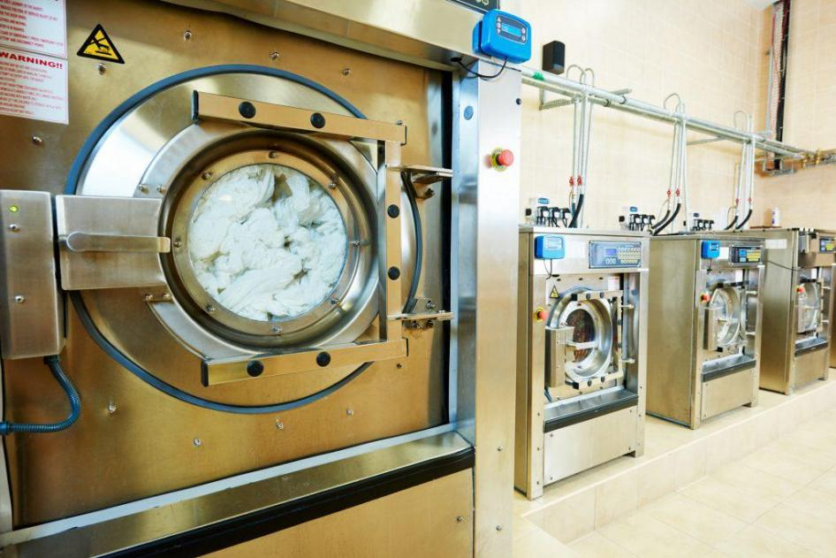

Step by Step Overview
There are three stages to the dry-cleaning process. Let’s take a look at each of these three stages and their role in maintaining the quality and appearance of all clothes and fabrics.

Stage 1: Dry Scouring and Pre-Treatment
The initial stage of dry cleaning is the dry scouring and pre-treatment phase. Dry scouring is a technique used to remove stubborn stains without the use of water. Instead of tossing garments into a washing machine, a dry cleaner will use a variety of solvents to remove dirt and treat stains without causing any shrinkage or damage to the clothes. With the pre-treatment stage, dry cleaning services can ensure each garment is returned to its owner in its top condition.

Stage 2: The Cleaning Cycle
The second stage is the cleaning cycle in a dry-cleaning machine. It is important to note that dry cleaning machines differ from the typical washing machines you find in homes and laundromats. In these machines, organic solvents are used instead of water. These solvents dissolve oil-based stains and grime while being gentle on fabrics. This cleaning cycle also does not submerge the garments, minimizing wear and tear, making it ideal for delicate fabrics.

Stage 3: Drying and Inspections
The final stage comes once the cleaning cycle has concluded. Once clean, garments enter the drying phase which uses warm air to remove excess solvents. During the drying stage, professional dry cleaners will also complete a thorough inspection of each textile, ensuring they are stain-free and ready to be returned to the client. In some cases, pressing or ironing may be used to finish off the dry-cleaning process.

Different Solvents in Dry Cleaning
At the most basic level, dry cleaning is a method of “washing” clothes where the water usually used in the cleaning process is replaced with a solvent. Water is removed from the process to allow for the cleaning of garments that might be damaged, distorted, or otherwise harmed if they come into contact with water. While there are several different solvent options that can be used during dry cleaning, the most widely used is perchloroethylene (perc), but liquid carbon dioxide and synthetic petroleum hydrocarbon solvent are commonly used.

Liquid carbon dioxide is also an inexpensive, yet highly effective solvent. Hydrocarbon solvent—used by about 20% of cleaners—is an effective dry-cleaning solvent that cleans similarly to perc but is engineered to mitigate some of the risks associated with perc.

Why Dry Cleaning is Beneficial for Your Clothes
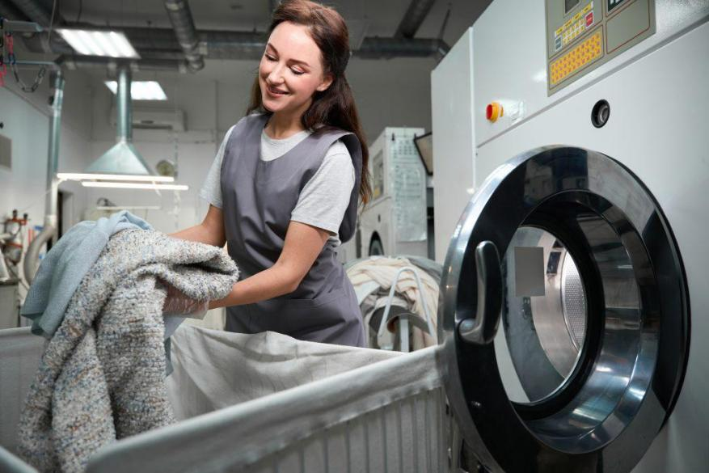

So, we know how dry cleaning works but what are the actual benefits of a traditional washing opportunity? Here are a few key benefits of dry cleaning your clothes:

Longevity and Fabric Protection

Many individuals prefer dry cleaning over the use of a washing machine because of its ability to lengthen the life expectancy of their favorite garments. Dry cleaning is especially effective at preserving delicate fabrics and natural fibers, which are more vulnerable to damage during traditional washing. For example, clothing items made from natural or fragile fibers, such as silk, wool, and lace, require gentle care. Unlike standard washing machines, which can lead to issues like shrinkage, fading, and fabric weakening, the dry-cleaning process helps protect these items and keeps them looking new longer.

Effective for Delicate and Specialty Fabrics
Many garments cannot just simply be thrown into the washing machine. If you take a look at some of your most delicate fabrics, you may notice that the care label advises handwashing or dry cleaning. This is because, as we mentioned, a standard washing machine is not gentle enough to prevent damage from occurring. Instead, a dry cleaner can use their expertise and gentle solutions to effectively clean, dry, and press all delicate and specialty fabrics.

Stain Removal Expertise
Many people bring their clothes to dry cleaners because dry cleaning is a highly effective way to remove even the most stubborn stains. Not only do these cleaners use specialized chemicals to remove these stains, but they also take great precautions to ensure there is no harm to the fabric. This means that even with the toughest stains, a dry-cleaning experience can provide a reliable and safe way to clean your clothes.

Environmental and Health Aspects of Dry Cleaning
Nowadays a lot of cleaning businesses are shifting towards environmentally friendly options by steering clear of harsh chemicals and opting for greener solutions instead. The eco-friendly techniques employ cleaning products that effectively remove stains while being safer, for both your wellbeing and the ecosystem.

Specialized Care for Whites and Bright Colors
Another benefit of dry cleaning is its impact on maintaining the overall vibrancy of colors and brightness of white garments. Overtime, yellowing and fading can occur which is why regular dry cleaning is important. With consistent trips to the dry cleaners, you can prevent fading and yellow stains from occurring. The act of regular dry cleaner also keeps garments and fabrics in pristine condition by reducing staining and grime build-up.

Value of Regular Dry Cleaning
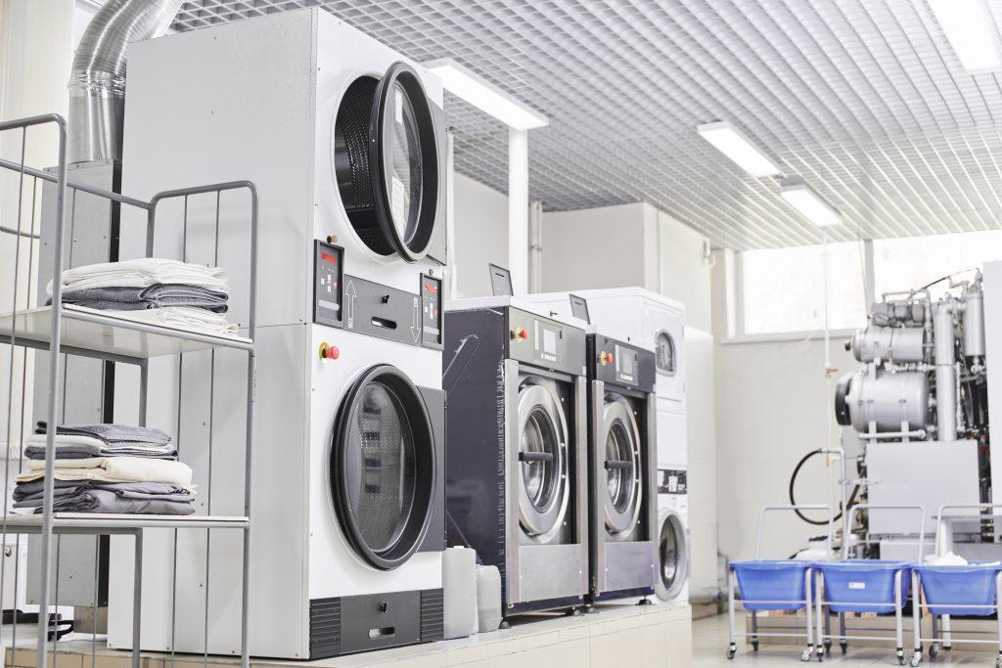

A regular dry-cleaning routine is particularly helpful for garments that require consistent upkeep, such as business attire or special occasion clothing. By having your clothes cleaned professionally, you ensure they stay free from buildup, maintain their shape, and look fresh longer. Routine dry cleaning also helps fabrics maintain their softness and luster, giving you confidence in your clothes’ longevity and quality.

Regular dry cleaning can greatly protect the integrity of your wardrobe. However, to ensure you maintain the quality in between cleanings, follow these additional steps:

- Step one for caring for your clothes between dry cleanings, is to hang your garments on padded or wooden hangers. Unlike folding, using hangers can maintain shape and prevent wrinkles.
- Next, limit the number of wears before dry cleaning for more delicate fabrics. Overwearing without cleaning can lead to odor and stain buildup, making it harder to restore the original quality.
- When storing your clothes, be sure not to store them in direct sunlight. This is because the sun’s UV light can fade clothing over time, lessen the vibrancy, and create duller garments.
- Finally, when spills and accidents occur, never allow the stain to set. Instead, take care of it by gently blotting the area with a soft cloth. Do NOT scrub. Scrubbing can work the dirt and grime deeper into the fibers, making it harder to remove.
By following these proactive steps, you can keep your clothing in tip-top shape, even in between dry-cleaning sessions. These tips not only ensure your clothes are safe from wrinkles, stains, and damage, but they also ensure longevity, allowing you to keep your favorite items for longer.

Choosing a Dry Cleaning Service for Quality Garment Care
The truth is that not every dry-cleaning service is created equally. To ensure your clothes are receiving the very best care, consider the following when choosing your dry-cleaning professional:

Quality of Customer Service
When deciding which dry cleaner to take your clothes to, it is important to consider the quality of the customer service. A professional dry cleaner will offer supreme garment care as well as responsive customer service. Your chosen cleaner should be able to answer all your questions, provide accurate time quotes, and ensure a positive dry-cleaning experience. These factors play a tremendous role in overall customer satisfaction, which can be a deciding factor for many to go back or find a new cleaner.

The Expertise of the Team and the Equipment Used
The decision of which dry cleaner is best for your clothes will also be determined by how reliable their equipment and treatments are. A good dry cleaning facility will have a well-maintain dry cleaning machine that works gently and consistently to cleanse clothes. By choosing a dry cleaning establishment that complies with all industry standards and stay up-to-date with innovative treats, you can rest assured your clothes are in the hands of a trusted professional.

CHAPTER FOUR
SUMMARY, CONCLUSION AND RECOMMENDATION
5.1 SUMMARY OF ATTACHMENT ACTIVITIES
This report contained and gives the details explanation of all activities carried out at M.K LAUNDRY AND DRYCLEANING SERVICES, Old Jebba Road, Elekoyangan Area, Ilorin, Kwara State, Nigeria.
The report explains briefly the details of all the activities with each Siwes been involved in outlined under each chapter. Chapter 1 started with the general introduction knowledge and objectives of the SIWES programme, Chapter 2 gives detailed of the skills and knowledge acquired during the programme, contained the activities at Laundry department and gives detailed of the skills and knowledge acquired during the programme, Chapter 3 explained the problems encountered during SIWES programme and Recommendations, Chapter 4 contained the summary of the whole report and the conclusion.

5.2 PROBLEMS ENCOUTERED DURING THE PROGRAM
There are numerous problems I encountered during my SIWES program at M.K LAUNDRY AND DRYCLEANING SERVICES.
Some of the major problems are as follow:-
- Problem of searching a place of attachment:- I had so many problems when searching for a place of attachment for my SIWES because most organization rejected my request giving one reason or the other that they do not want SIWES student.
- Cost of transport:- Also encountered challenges in the aspect of transport fair during the course of my training due to the distance of my place of attachment.
- Finance: - The organization do not make any provision to pay SIWES student nor do they draft any allowance package for s so as to less the expenses during the course of the program.
5.3 SUGGESTIONS FOR THE IMPROVEMENT OF THE SCHEME
- The establishment should provide the adequate facilities to make the programme enjoyable for the students.
- Government should motivate partners from the private sector through granting tax relief for companies that accept Students on SIWES.
- The company should be willing to accept and encourage students that are seeking for SIWES placement in their company without requesting for any money.
- Institutions should be encouraged to create financial autonomy for Institution based SIWES Units/Directorates.

- The establishment should provide the adequate facilities to make the programme enjoyable for the SIWES Students.
- SIWES should be properly presented to potential sponsors, such as Banks, multinational companies and other corporate institutions for Support in creating placement opportunities, training, equipment, Facilities, as well as direct funding of SIWES.

