A TECHNICAL REPORT

ON

STUDENTS INDUSTRIAL WORK EXPERIENCE SCHEME
(SIWES)

UNDERTAKEN
AT

SLOTDEM GLOBAL TECH
BY
OLABODE AISHAT MOTUNRAYO
MATRIC NO: ND/23/BAM/PT/0093

SUBMITTED TO

DEPARTMENT OF BUSINESS ADMINISTRATION
INSTITUTE OF FINANCE AND MANAGEMENT STUDIES (IFMS)

KWARA STATE POLYTECHNIC, ILORIN

IN PARTIAL FULFILMENT OF THE REQUIREMENTS FOR THE AWARD OF NATIONAL DIPLOMA IN BUSINESS ADMINISTRATION

AUGUST TO DECEMBER, 2024
DEDICATION
I dedicate this report write up to Almighty Allah who gives me strength and inspiration in the course of this work. Special dedication also goes to my ever supportive parents Mr. and Mrs. OLABODE, and other family members for their relentless, financial and moral support towards the success of my four (4) months SIWES programme.

ACKNOWLEDGEMENT
I have taken effort in this Siwes. However, it would not have been possible without the kind support and help of some individuals and this organization. I would like to extend my earnest thanks to all of them.
I would and in Respect like explicitly express my gratitude to the Managing Director of SLOTDEM GLOBAL TECH, in person of Mr Omoniyi, and the staffs for their kind co-operation and their professional guidance and instruction during my Siwes which assisted me in completion of this Siwes.
I would like to express my special gratitude and thanks to industry persons for giving me such attention and time.
My thanks and appreciations also go to my colleagues in developing the Siwes Report and people who have willingly helped me out with their abilities. I am highly indebted to you all.

TABLE OF CONTENTS
TITLE PAGE
DEDICATION 1
ACKNOWLEDGEMENT 2
TABLE OF CONTENTS 3
CHAPTER ONE: INTRODUCTION 5 - 10
  - HISTORY OF SIWES
  - OBJECTIVES OF SIWES
CHAPTER TWO: DESCRIPTION OF THE ESTABLISHMENT OF ATTACHMENT 11-17
2.0 LOCATION AND BRIEF HISTORY OF ESTABLISHMENT
2.1 OBJECTIVES OF ESTABLISHMENT
2.2 ORGANIZATION STRUCTURE
2.3 THE VARIOUS DEPARTMENTS/UNIT IN THE ESTABLISHMENT
CHAPTER THREE 18
3.0 REPORTING ON WORK ACTUALLY CARRIED OUT AND GAINED
CHAPTER FOUR: SUMMARY, CONCLUSTION AND RECOMMENDATION 19
5.0 Summary of attachment activities
5.1 Problems encountered during the program
5.2 Suggestions for the improvement of the scheme

CHAPTER ONE
INTRODUCTION
1.1 HISTORY OF SIWES
SIWES (Student Industrial Working Experience Scheme) was established by ITF in 1973 to solve the problem of lack of adequate practical skills preparatory for employment in industries by Nigerian graduates of tertiary institutions.
The Scheme exposes students to industry based skills necessary for a smooth transition from the classroom to the world of work. It affords students of tertiary institutions the opportunity of being familiarized and exposed to the needed experience in handling machinery and equipment which are usually not available in the educational institutions. Participation in Industrial Training is a well-known educational strategy. Classroom studies are integrated with learning through hands-on work experiences in a field related to the student’s academic major and career goals. It also expose the student to the practical aspect of some course being offer in the school.
Successful internships foster an experiential learning process that not only promotes career preparation but provides opportunities for learners to develop skills necessary to become leaders in their chosen professions.
One of the primary goals of the SIWES is to help students integrate leadership development into the experiential learning process. Students are expected to learn and develop basic non-profit leadership skills through a mentoring relationship with innovative non-profit leaders.
By integrating leadership development activities into the Industrial Training experience, we hope to encourage students to actively engage in non-profit management as a professional career objective. However, the effectiveness of the SIWES experience will have varying outcomes based upon the individual student, the work assignment, and the supervisor/mentor requirements.
It is vital that each internship position description includes specific written, learning objectives to ensure leadership skill development is incorporation.
Participation in SIWES has become a necessary pre-condition for the award of Diploma, Degree and NCE certificates in specific disciplines in most institutions of higher learning in the country, in accordance with the education policy of government.
1.2 OPERATORS OF SIWES
Operators - The ITF, the coordinating agencies (NUC, NCCE, NBTE), employers of labor and the institutions.
Funding - The Federal Government of Nigeria
Beneficiaries - Undergraduate students of the following: Agriculture, Engineering, Technology, Environmental, Science, Education, Medical Science and Pure and Applied Sciences.
Duration - Four months for Colleges of Education and Polytechnics, and Six months for the Universities.
1.3 OBJECTIVES OF SIWES
1. SIWES will provide students the opportunity to test their interest in a particular career before permanent commitments are made.
2. SIWES students will develop skills in the application of theory to practical work situations.
3. SIWES will provide students the opportunity to test their aptitude for a particular career before permanent commitments are made.
4. SIWES students will develop skills and techniques directly applicable to their careers.
5. SIWES will aid students in adjusting from college to full-time employment.
6. SIWES will provide students the opportunity to develop attitudes conducive to effective interpersonal relationships.
7. SIWES will increase a student's sense of responsibility.
8. SIWES students will be prepared to enter into full-time employment in their area of specialization upon graduation.
9. SIWES students will acquire good work habits.
10. SIWES students will develop employment records/references that will enhance employment opportunities.
11. SIWES will provide students the opportunity to understand informal organizational interrelationships.
12. SIWES will reduce student dropouts.
The four (4) months Students Industrial Work Experience Scheme (SIWES) which is a requirement for the completion of my course of study, was undertaken at SLOTDEM GLOBAL TECH
The Industrial Training was based on working with Personal Computers, laptops, installation and maintenance, spreadsheet and word processing.

CHAPTER TWO
DESCRIPTION OF THE ESTABLISHMENT OF ATTACHMEMT
2.1 Location and brief history of SLOTDEM GLOBAL TECH
SLOTDEM GLOBAL TECH is a brain child of Mr. Omoniyi, a non-governmental organization (NGO) which was established 5years ago to assists in tackling basic societal problems, promotes education for indigent children and empowering youths through the provisions of various opportunities to be self-reliant.
This Institute is a skill acquisition centre which was established to compliments the state governments’ efforts at finding lasting and sustainable solution to the menace of unemployment through the provision of an enabling environment for youths to function effectively in the society.
The centre is also designed to eradicate unemployment in the society and to ensure that graduates of the institute could be gainfully employed in the state, nationally and internationally through the provision of a recognized qualification.
The venture is also giving efficient services to individual in the following areas as well:-
- Sales supply, installation and maintenance of computer systems; and computer accessories.
- Information Technology (IT) consulting.
- Information Technology training.

2.2 Objectives of Establishment
The company’s core value offers include:-
- As part of its cooperate social responsibility, the company offers the most affordable prices on its service rendered
- It also provides unmatched after sales service to its numerous customers.
- The brand named SLOTDEM GLOBAL TECH. is known for providing quality services, prompt service and excellent customer relations.
- Building strong reputation in the community through trust, honesty and transparency
- Continuously improving processes and services to meet evolving customer needs.
2.3 Organization Structures/Departments
SLOTDEM GLOBAL TECH is divided into the following departments:-
- COMPUTER TRANING CENTER
- COMUNICATION ENTERPRISE
2.4 The various departments in the establishment and their functions
SLOTDEM GLOBAL TECH
The service rendered by SLOTDEM GLOBAL TECH are Computer Training Service, Type Setting, printing and Spiral Binding etc. These departments also educate clients on the type of computer that will be suitable for their daily activities. Also supports are giving in this department on issues related to online registration as well as recommendation.

CHAPTER THREE
SKILLS AND KNOWLEDGE ACQUIRED
2.0 INTRODUCTION OF COMPUTER
Computer is a device or machine that is used to store and process (work on) a piece of information. It receives data and instructions (command) from the user, works on them and generates the result (output) know as information. In common use, the Computer is a machine that is used to produce letters (Word Processor), analyze data (Spreadsheet), store data (Database Application - RDBMS), create drawing drawing (Graphics, CAD), create reports (Seagate Crystal Report), and so on. Meanwhile, the computer does much more than that. There is no field of study where the Computer is not applied in this present age of civilisation. Just name it - is it in Medicing, Engineering, Architecture, Astonomy, etc? In these areas, it is connected to other devices (hardware) which directly interact with the system to be studied, and from it the system is monitored.
PART OF COMPUTER
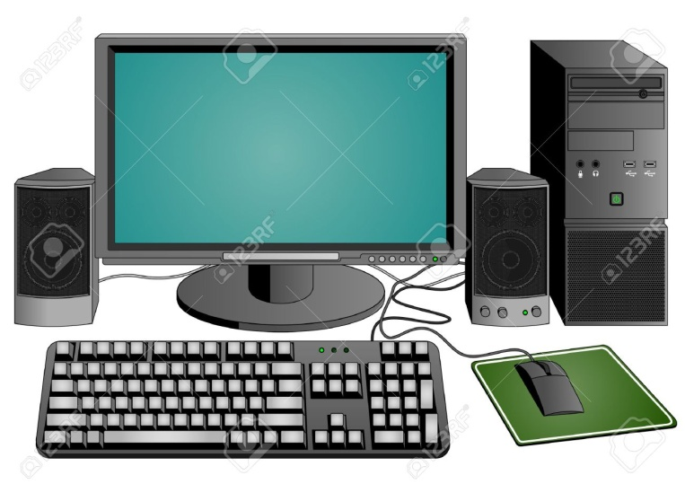

INPUT
An input Device is a part of the computer that is used to key in data. It receives instructions from the user through these parts called Input Devices. The major input devices are the Mouse and Keyboard. Anything that is used to feed in data into the computer is an Input Device. Examples are the Scanner, Web Cam, Microphone, Trackball, Graphic Tablet, Touch Screen, Joystick, Light Pen, Sensors, etc.
KEYBOARD
This is the most frequently used device of the computer system. Even, most data entry operators and some other users make little use of the mouse. This is because of the Keyboard can carry out virtually almost all the functions of a mouse. To be a good user of the computer, you should master the use of the Keyboard. I advise you to learn how to type, by using a typing tutor. Ask a Computer Engineer for assistance. Let's see some of the special keys of the keyboard:
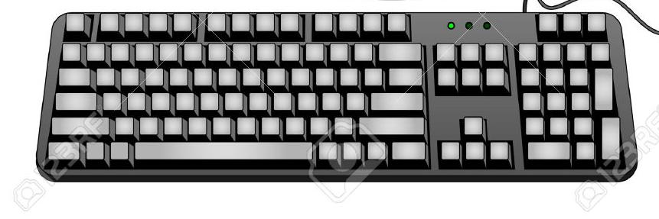

MOUSE
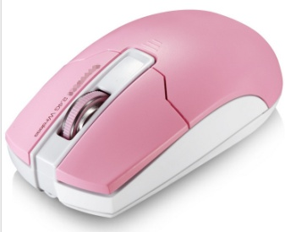
The mouse is a pointing device which has two or more buttons. It is operated by clicking on the left button with your first finger. To select an object, move the mouse to its position and left-click on it (with your first finger). There are cases where you may want to choose from a quick menu. This is called a Context menu. You do this by right-clicking on the empty space on the program or right-clicking on the object concerned.

THE SCANNER
The Scanner is a machine that is used to convert the image of picture, document, and any other object into computer readable format. There are hand-held scanners which may be passed over a picture and also flat-bed scanners which remain still while the picture is scanned. Apart from digitizing pictures, scanners may be used for capturing text from document OCR (Optical Character Reader). OCR is used for reading characters from paper, using scanners, and inputting them into a computer
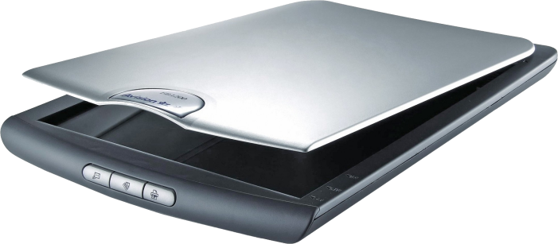
THE OUTPUT
An output device is that part of the computer system that is used to show the result of what the Computer has done, whenever it is requested. It is useless to design your document and you cannot produce the result of your labour by having a hard copy, i.e., sending it to printer
The printer is the reverse of the scanner in the sense converts hard copy to softcopy, the printer convert hard copy to softcopy, the printer convert softcopy to hardcopy. Other examples of output devices are the Monitor, Printer, Speakers, Plotters, Siwesors, etc.
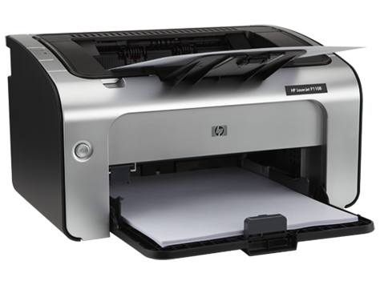
UNDERSTANDING MICROSOFT WORD
Microsoft word is the most commonly used in Ms office suite. Microsoft office is a collection of Ms word, Excel, Power point and so on. depending on the version. Hence, it will be wrong to mention any of these programs again, after mentioning "Ms Office" because Office comprises all of them.


How To Start A New Document
To start Ms word, go through the following:
Start ==> All program ==> Microsoft Word
Save the document by going to file ==> save as (or save). Whenever you are saving a file for the first time, the program will prompt (ask) you for the location of the document. it will normally take you to My document folder.
How To Save A Document
You need to organize your work. Don't just save files inside My Documents folder. Each time you save a job, save it in an existing folders that you have created for that group of documents, e.g in the office, you may have folders like Siwes, Personnel, Account and Administration.. you may also create personal folders at home like finance (income, Expenditure),
Summary
This is the beginning of your contact with the computer in the area of Ms Word. You should be conversant with the use of the keyboard. for example, the Delete Key deletes selected, it erases to the right of the cursor. Backspace (erases an item to the left of the cursor), Enter use to start a new line. Control used in conjunction with other keys as short cut keys, Tab moves the cursor through a longer distance than the spacebar, Shift for Capital letters and also, for keys that have two characters. Also remember the Home and End keys, for moving the cursors to the beginning and end of the line in your document respectively.
The arrow keys are other powerful keys for navigating your document. There are also the Page up and Page down keys used for moving up or down your document through a longer distance.
As you type, when you see minor errors, don't correct them. They will slow you down. Correct all errors after you must have finished typing.
Once you have finished typing your document, the next step is to format a document is to make it more presentable by changing the Font Size, Font style (bold, underline, etc),Font Colour, adding bullets and numbering (if you need one), and other Properties that will enable you to manipulate the document to your taste. Meanwhile, you should observe standard formatting style in preparing your documents.

PRINTING IN WORD
Printing is very important in the use of the computer, irrespective of the program you are using. This is because no matter how beautiful your job is, if you cannot produce a hard (printed) copy of it, you've not yet done the job! Your boss in the Office or Colleague or co-worker or even the Board Members of your organization will not come to your computer screen to view your finished work. You need print it out.
In order to print your job, make sure the printer is powered on properly connected to your computer. If you have problems, call a Computer Engineer.

MICROSOFT EXCEL
Microsoft Excel is a data processing Package. It is used for data analysis, mainly in the area of Statistics. Once you are conversant with Ms Word. you have little problem using Ms Excel, since the user interface (what you see is similar to that of Ms Word.
Meanwhile, we shall break it down up to the level where you can understand the basics and be able to use it for minor and complex calculations that would have caused you some headaches while using the calculator.
In our treatment of how to use Ms Excel, it is assumed that you can make use of Ms word and if you are still new to common commands like formatting of text in Ms Word, I advise you go over them first, in the Ms Word part of this book.

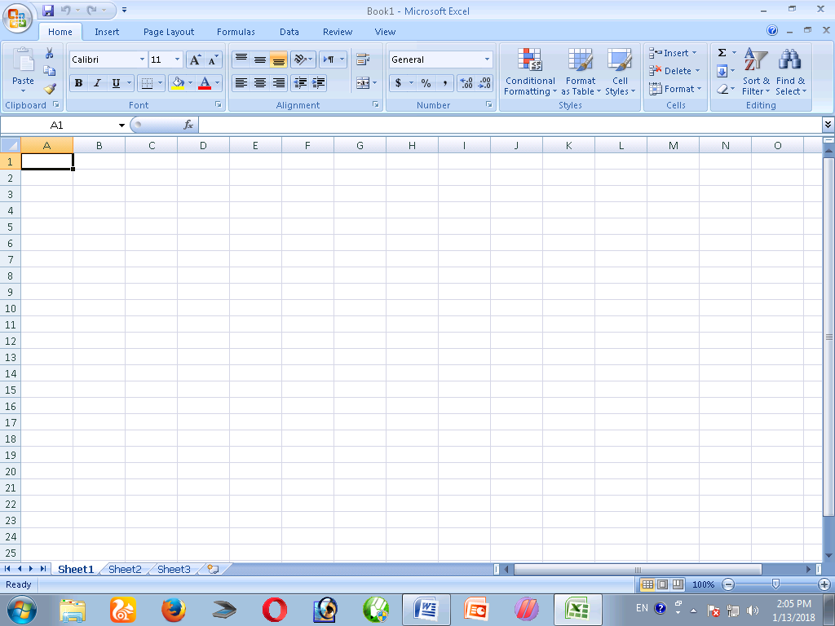

In this chapter, we learnt how to type (enter), copy and move data from one cell to another. These operations are virtually the same with those of Ms Word. In Excel, once you select a cell, all the values are selected at once. To select individual characters in the cell, double-click on it.
You can use your mouse cursor to adjust cell width/height on the column heading and row heading respectively.

POWERPOINT
PowerPoint is a computer software packages that is used for presentations. A presentation is the process of addressing a group of persons at a time, either formally or informally in order to pass across information to them. A presentation could be inform of a seminar. lecture, book launch, Annual General Meeting, Siwes defense (both in schools and in the work place), Siwes proposal, etc. MS Power Point is a powerful tool for training, selling your ideas, products, knowledge and so on.
Normally, you would need Audio Visual Aids, like a Siwesor, Which is connected to a laptop and the laptop display Siwesed to a screen. The Siwesor can also be attached to a desktop computer. You can use a presentation mouse or a remote control with the laptop. The sole work of the Siwesor is to enlarge the image coming from your computer.
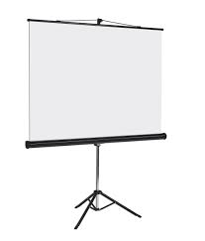
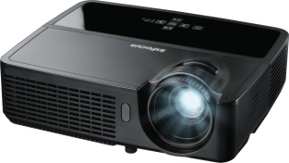

Screen
Projector


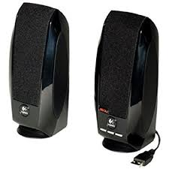

Microphone

Speaker

CHAPTER FOUR
SUMMARY, CONCLUSION AND RECOMMENDATION
5.1 SUMMARY OF ATTACHMENT ACTIVITIES
This report contained and gives the details explanation of all activities carried out at SLOTDEM GLOBAL TECH, 27 Agbabiaka Area, Ilorin, Kwara State, Nigeria.
The report explains briefly the details of all the activities with each Siwes been involved in outlined under each chapter. Chapter 1 started with the general introduction knowledge and objectives of the SIWES programme, Chapter 2 gives detailed of the skills and knowledge acquired during the programme, contained the activities at Laundry department and gives detailed of the skills and knowledge acquired during the programme, Chapter 3 explained the problems encountered during SIWES programme and Recommendations, Chapter 4 contained the summary of the whole report and the conclusion.

5.2 PROBLEMS ENCOUTERED DURING THE PROGRAM
There are numerous problems I encountered during my SIWES program at SLOTDEM GLOBAL TECH.
Some of the major problems are as follow:-
- Problem of searching a place of attachment:- I had so many problems when searching for a place of attachment for my SIWES because most organization rejected my request giving one reason or the other that they do not want SIWES student.
- Cost of transport:- Also encountered challenges in the aspect of transport fair during the course of my training due to the distance of my place of attachment.
- Finance: - The organization do not make any provision to pay SIWES student nor do they draft any allowance package for s so as to less the expenses during the course of the program.
5.3 SUGGESTIONS FOR THE IMPROVEMENT OF THE SCHEME
- The establishment should provide the adequate facilities to make the programme enjoyable for the students.
- Government should motivate partners from the private sector through granting tax relief for companies that accept Students on SIWES.
- The company should be willing to accept and encourage students that are seeking for SIWES placement in their company without requesting for any money.
- Institutions should be encouraged to create financial autonomy for Institution based SIWES Units/Directorates.
- The establishment should provide the adequate facilities to make the programme enjoyable for the SIWES Students.
- SIWES should be properly presented to potential sponsors, such as Banks, multinational companies and other corporate institutions for Support in creating placement opportunities, training, equipment, Facilities, as well as direct funding of SIWES.

