

A SIWES TECHNICAL REPORT
STUDENT INDUSTRIAL WORK EXPERIENCE SCHEME (S.I.W.E.S)
BY:
FATAI WASIU OLUWATOBILOBA
ND/23/ABE/PT/0050

KWARA STATE POLYTECHNIC ILORIN, NIGERIA
DEPARTMENT OF AGRICULTURAL AND BIO-ENVIRONMENTAL ENGINEERING TECHNOLOGY

INSTITUTE OF TECHNOLOGY

PERIOD OF ATTACHMENT: AUGUST 5, 2024 – DECEMBER 5, 2024

FOOD SOLUTION LIVESTOCK LIMITED
MAYIN VILLAGE VIA OGBOMOSHO OKO, OSOGBO ROAD, SURULERE LGA, OGBOMOSHO OYO STATE

IN PARTIAL FULFILLMENT OF THE REQUIREMENT FOR THE AWARD OF NATIONAL DIPLOMA (ND) IN AGRICULTURAL AND BIO-ENVIRONMENTAL ENGINEERING TECHNOLOGY
KWARA STATE POLYTECHNIC ILORIN, NIGERIA

TABLE OF CONTENTS
Introduction
1.1 Background of SIWES
1.2 Objectives of SIWES
1.3 Brief History of FOOD SOLUTION LIVESTOCK LIMITED
1.4 Organizational Structure of FOOD SOLUTION LIVESTOCK LIMITED

Description of Work Done
2.1 Poultry Management (Broilers)
2.2 Poultry Management (Layers)
2.3 Turkey Management
2.4 Goat Rearing
2.5 Cattle Rearing
2.6 Feed Mill Operations
2.7 Abattoir Operations
2.8 Fish Farming
2.9 Crop Farming (Maize and Cassava)
2.10 Machinery Operation and Maintenance
2.11 Logistics and Supply Chain

Skills Acquired and Experience Gained
3.1 Animal Husbandry Technical Skills
3.2 Other Experiences

Challenges Encountered

Conclusion

Recommendations

Appendix

1. INTRODUCTION
1.1 Background of SIWES
The Students Industrial Work Experience Scheme (SIWES) is a skills development program designed to prepare students of tertiary institutions for the transition from the academic environment to the workplace. It is a tripartite program involving the students, the institutions, and employers. SIWES forms part of the approved academic curriculum for students in various disciplines. It is aimed at bridging the gap between theoretical knowledge acquired in the classroom and the practical skills required in the industry. It exposes students to real-life work situations and allows them to apply their knowledge in solving practical problems.

1.2 Objectives of SIWES
The main objectives of SIWES are to:
- Provide students with the opportunity to gain practical experience in their field of study.
- Expose students to work methods and techniques not typically taught in the classroom.
- Enable students to develop essential skills such as problem-solving, teamwork, and communication.
- Facilitate the transition of students from school to the world of work.
- Enhance the contact between employers and students, providing potential recruitment opportunities.
- Bridge the gap between theory and practice.

1.3 Brief History of FOOD SOLUTION LIVESTOCK LIMITED
FOOD SOLUTION LIVESTOCK LIMITED is a large-scale, integrated agricultural enterprise established in 2016. It began as a small family poultry farm and has grown to encompass a diverse range of agricultural activities including poultry (broilers, layers, and turkeys), goat rearing, cattle rearing, fish farming, maize and cassava farming, feed production, and a standard abattoir operation. The farm is committed to sustainable agricultural practices and providing high-quality products to the market. The farm's focus on integrated production allows for efficient resource utilization and waste management. The firm prides itself on its modern facilities, including a state-of-the-art abattoir and feed mill. The farm's integrated approach allows for efficient use of resources, with crop residues used in animal feed and animal waste used as fertilizer for the crops.

1.4 Organizational Structure of Food Solution Livestock Limited
The organizational structure of Food Solution Livestock Limited is hierarchical, designed to ensure efficient management and operation of the various farm units. The structure is as follows:
- Managing Director: Oversees all farm operations and makes strategic decisions.
- Farm Manager: Responsible for the day-to-day running of the farm and implementing the Managing Director's directives.
- Unit Heads: Each unit (Poultry, Ruminants, Fish Farming, Abattoir, Crop Production, Feed Mill, Logistics, and Maintenance) has a head responsible for managing their respective section.
Poultry Unit Head: Oversees broiler, layer, and turkey production.
Ruminant Unit Head: Manages goat and cattle rearing.
Fish Farming Unit Head: Supervises fish pond operations.
Abattoir Unit Head: Manages the slaughtering and processing of poultry.
Crop Production Unit Head: Oversees maize and cassava farming.
Feed Mill Unit Head: Manages feed production.
Logistics and Transportation Unit Head: Manages the movement of products and materials.
Maintenance unit head: manages the maintenance of the machines.
- Junior Staff: Farm workers who carry out daily tasks under the supervision of the Unit Heads.
This structure allows for clear lines of communication and accountability, ensuring smooth operation of the farm.
2. DESCRIPTION OF WORK DONE
2.1 Poultry Management (Broilers)
- Housing: The broiler section consists of ten pens, each with a capacity of 15,000 birds, totaling 200 meters in length. The pens are designed for optimal ventilation and temperature control, utilizing a tunnel ventilation system with fans and cooling pads. The flooring is concrete with deep litter bedding made of wood shavings.
- Feeding: Broilers are fed a formulated diet mixed in the farm's feed mill. The feed is delivered to the pens via automatic pan feeders. I participated in distributing feed, ensuring consistent access to feed for all birds, and monitoring feed consumption rates. The feeding stages include: Starter feed (0-2 weeks), Grower feed (3-4 weeks), and Finisher feed (5 weeks to slaughter).
- Watering: A constant supply of clean water is provided through nipple drinkers. I learned how to check water lines for leaks and ensure proper water pressure.

- Medication and Vaccination: I assisted in administering medications and vaccinations according to the farm's meticulously planned health program, which was developed in consultation with a veterinarian. This program is preventative and addresses common poultry diseases in the region. Here's a generalized example of the type of program I observed:
Day 1: A multivitamin solution was added to the drinking water to help the chicks overcome the stress of transportation and placement. I learned how to calculate the correct dosage based on the volume of water and the manufacturer's instructions.
Day 5-7: A coccidiostat was administered in the feed to prevent coccidiosis, a common parasitic disease. I learned the importance of accurately mixing the medication into the feed to ensure uniform distribution.
Day 10-14: A vaccine against Newcastle Disease (ND) and Infectious Bronchitis (IB) was administered. This was done via eye drop application. I learned the proper technique for handling and administering live vaccines, including the importance of using cool, distilled water and protecting the vaccine from direct sunlight.
Day 18-21: A booster vaccination for ND and IB was given, often using a different strain or type of vaccine to provide broader immunity. This might be administered in the drinking water. I learned how to monitor the birds' water intake to ensure they received the full dose.
Throughout the growing period: Antibiotics were only used therapeutically, meaning they were administered only when there was a confirmed bacterial infection, and under the direction of a veterinarian. I learned about the importance of responsible antibiotic use to prevent antibiotic resistance. If an antibiotic was needed, it would be administered via the drinking water or, in severe cases, by injection. I learned how to calculate dosages based on body weight and the specific antibiotic's instructions. I also learned to observe withdrawal periods.
Injection Training: I received specific training on intramuscular injections, focusing on the correct injection site (breast muscle), needle size (appropriate for bird size), and technique to minimize tissue damage and stress to the birds. I practiced using sterile needles and syringes, and proper disposal of sharps. The ratio of the medication was taught to me based on the prescription from Vet. Doctor.

- Monitoring: I was involved in daily monitoring of the birds for signs of illness, injury, or stress. This included observing their behavior, feed and water intake, and checking for any abnormal droppings.

- Biosecurity: Strict biosecurity protocols were rigorously followed to maintain a clean and safe environment, and to prevent the introduction and spread of diseases. These protocols included:
Restricted Access: Only authorized personnel were allowed to enter the poultry houses.
Footbaths: Disinfectant footbaths were used at the entrance of each pen.
Protective Clothing: I was required to wear clean overalls and boots dedicated to the poultry section.
Equipment Disinfection: All equipment used in the pens was regularly cleaned and disinfected.
Rodent and Pest Control: A comprehensive program was in place to control rodents and other pests that could carry diseases.

2.2 Poultry Management (Layers)
Housing: The layer section comprises twelve pens, each housing 15,000 birds. The housing system is a battery cage system. The layout is designed to facilitate egg collection and manure removal.
Feeding: Layers receive a specialized diet formulated for egg production, also produced in the farm's feed mill.
Watering: Similar to the broilers, water is provided through nipple drinkers. I learned the importance of maintaining consistent water quality for optimal egg production.
Egg Collection: I participated in egg collection, which occurred twice daily.
Medication and Vaccination: The layer vaccination program is even more extensive than the broiler program, as layers have a much longer lifespan. A generalized example is provided below:
Early Chickhood (similar to broilers): Vaccinations against ND, IB, and coccidiostats are administered in the first few weeks.
Growing Period (Pullet Stage): Additional vaccinations are given to protect against diseases like Infectious Bursal Disease (IBD/Gumboro), Fowl Pox, and Avian Encephalomyelitis (AE). These are often administered via various routes, including wing- web stab, intramuscular injection, or drinking water. I learned the importance of following a specific schedule to ensure proper immunity development before the onset of lay.
During Lay: Periodic booster vaccinations are given to maintain immunity throughout the laying period. These may be administered in the drinking water or by individual injection. I learned about the importance of monitoring antibody titers (through blood samples) to assess the effectiveness of the vaccination program.
Deworming: Regular deworming is carried out to control internal parasites. I learned how to administer deworming medication via the feed or water, and the importance of rotating different types of dewormers to prevent resistance.
Antibiotic Use: Similar to broilers, antibiotics were used only under veterinary supervision and for confirmed bacterial infections. I learned about the importance of considering egg withdrawal periods when using antibiotics in laying hens.
Lighting: I learned about the importance of controlled lighting programs in layer management to stimulate and maintain egg production. The farm uses artificial lighting with timers to provide a consistent day length of 16 hours, gradually increasing from a shorter day length during the pullet rearing phase.

2.3 Turkey Management
Housing: The turkey section has a separated pen with an iron net demarcation.
Feeding: Turkeys receive a diet tailored to their specific nutritional needs. I learned about the different feed formulations used for turkeys at various stages of growth, which were in different ratios to the broiler's.
Watering, Medication, and Monitoring: Watering system is Nipple drinker. I learnt the medication and vaccination for Turkey, and it differences from broiler's and layer's, example of the vaccines are: Fowl Pox, Newcastle, cholera and Hemorrhagic Enteritis vaccines. Antibiotics are administered as prescribed by Vet. Doctor. I learnt the biosecurity protocols for Turkey.

2.4 Goat Rearing
Housing: Goats are housed in a dedicated goat rearing house, designed for good ventilation and protection from the elements. The housing is divided into sections for does, kids, and bucks.
Feeding: I learned about the nutritional requirements of goats, including the importance of roughage (hay sourced from the local market) and concentrates (from the farm's feed mill). I participated in feeding the goats and learned how to monitor their body condition score.
Breeding: I was exposed to the basics of goat breeding, including heat detection and kidding management. The farm primarily uses natural mating, with selected bucks for breeding.
Health Management: I assisted in routine health checks, including deworming (administered orally) and hoof trimming. I learned to identify signs of common goat diseases and the importance of isolating sick animals.

2.5 Cattle Rearing
Housing: Cattle are reared in a pasture-based system with a dedicated cow rearing garden. A stable provides shelter during inclement weather and at night.
Feeding: The cattle feeding program involves grazing on pasture supplemented with hay (sourced externally) and concentrates (produced in the farm's feed mill). I learned about the importance of providing a balanced diet for optimal growth and milk production (for the few dairy cows present).
Health Management: I assisted in routine health checks and learned about common cattle diseases and their prevention. I participated in administering vaccinations against common local diseases, under the supervision of the farm manager.

2.6 Feed Mill Operations
Ingredient Sourcing: The farm utilizes maize and cassava from its own farms, supplemented with purchased ingredients like soybean meal, groundnut cake, bone meal, fish meal, lysine, methionine, premix, salt, and limestone.
Grinding and Mixing: I learned how to operate the grinding and mixing machinery. This involved understanding the correct sequence of adding ingredients, the importance of particle size (achieved through proper grinding), and the use of the horizontal mixer to ensure a homogenous blend. I was taught the different feed formulas for different animals and growth stages (e.g., broiler starter, broiler finisher, layer mash, grower mash, turkey starter, turkey grower, ruminant concentrate).
Quality Control: I learned about the importance of quality control in feed production, including checking the raw materials for quality (visual inspection, checking for mold or pests) and the finished feed for consistency.
Storage: I was taught how to package the feed in labeled bags and how to store to prevent spoilage from moisture and pests. The feed mill has a designated storage area.

2.7 Abattoir Operations
Slaughtering Process: I observed and participated in the humane slaughter of chickens in the abattoir. The process follows strict hygienic standards, adhering to best practices for animal welfare and food safety. The steps include:
Stunning: Electrical stunning was used to render the birds unconscious before slaughter.
Bleeding: Proper bleeding is ensured by cutting the jugular veins and carotid arteries.
Scalding: Birds are scalded in hot water (sourced from the borehole and heated in a large tank) to facilitate feather removal.
Defeathering: A defeathering machine removes the feathers.
Evisceration: I learned how to remove the internal organs carefully and hygienically, separating edible and inedible offal.
Washing: Carcasses are thoroughly washed with clean water.
Chilling: Carcasses are chilled in one of the two blast freezers to reduce temperature rapidly (below 4°C) to prevent bacterial growth.
Packaging: I learned how to package the chilled carcasses in labeled bags for storage and distribution.
Hygiene and Sanitation: The abattoir maintains very high standards of hygiene. I learned about the importance of regular cleaning and disinfection of equipment and surfaces (using appropriate detergents and disinfectants) to prevent contamination. The use of potable water from the borehole is crucial.
Waste Management: I learned how the abattoir manages waste products, such as feathers and offal. Feathers are collected and dried for potential sale, while inedible offal is disposed of responsibly in a designated pit.

2.8 Fish Farming
Pond Management: The farm has 24 fish ponds, each stocked primarily with catfish. I learned about pond preparation, including liming (to adjust pH and control parasites) and fertilization (to promote plankton growth).
Water Quality Management: The large water pumping machine and reservoir ensure a constant supply of fresh water to the ponds. I learned about monitoring water quality parameters, such as dissolved oxygen (using a simple visual check for fish surfacing) and observing the water color for signs of algal blooms.
Feeding: Fish are fed a formulated diet, sourced from a commercial supplier. I participated in feeding the fish and learned about the importance of feeding rates and frequency, adjusting the amount based on observed feeding activity.
Harvesting: I observed the process of harvesting fish using seine nets. I learned how to assist in pulling the nets and carefully handling the harvested fish to minimize stress and damage.
Pond maintenance: I was taught how the draining and refilling of the pond is carryout, with regular liming.

2.9 Crop Farming (Maize and Cassava)
- Land Preparation: I participated in land preparation activities, including ploughing and harrowing using a tractor-drawn implement. Ridges were created for the cassava, while the maize was planted on flat ground.
- Planting: I learned about the proper planting techniques for maize (spacing of 75cm between rows and 25cm within rows, using seeds sourced from a reputable supplier) and cassava (spacing of 1m x 1m, using stem cuttings from the farm's previous harvest).
- Weed Control: I participated in weeding activities, primarily using manual weeding with hoes.
- Fertilizer Application: I learned about the use of fertilizers to improve crop yields. For maize, NPK fertilizer was applied at planting, followed by Urea topdressing later in the growing season. Cassava received NPK fertilizer at planting. I learned how to apply fertilizer correctly to avoid damaging the plants.
- Harvesting: I participated in harvesting the maize (by hand, picking the cobs) and cassava (by carefully digging up the tubers). I learned how to identify mature crops ready for harvest.

2.10 Machinery Operation and Maintenance
- Generators: The farm has a large generator house to provide backup power. I learned how to start and stop the generators and perform basic maintenance checks, such as checking oil and fuel levels, and cleaning the air filters.
- Pumping Machine: I learned how to operate the water pumping machine used for the fish ponds and general farm use, including priming the pump and checking for leaks.
- Feed Mill Machinery: I learned how to operate the grinding and mixing equipment in the feed mill, under the supervision of the mill operator.
- Tractors and Other Farm Equipment: I received basic instruction on operating a tractor (though I did not operate it independently) and observed the use of other implements like ploughs and harrows.
- Maintenance Schedule: I participated in carrying out the maintenance schedule of the machines, which include: Regular cleaning, checking of nuts and bolts, changing of oil and filters.

2.11 Logistics and Supply Chain
I learned how to record the quantity of products (eggs, live birds, processed chicken, fish, maize, cassava) and materials (feed ingredients, medications, packaging materials) coming in and going out of the farm.
I participated in loading and offloading products onto and from the farm's delivery trucks.
I was taught the documentation processes, including waybills and invoices, used to track the movement of goods. I learned the importance of accurate record-keeping for inventory management and sales tracking.

3. SKILLS ACQUIRED AND EXPERIENCE GAINED
3.1 Animal Husbandry Technical Skills
Poultry Management (Broilers, Layers, and Turkeys): I gained hands- on experience in all aspects of broiler and layer management, including feeding, watering, medication, vaccination, and egg collection. I developed skills in monitoring bird health and identifying signs of disease. I learned the biosecurity protocols and vaccination programs for broilers, layers, and turkeys. I was able to differentiate the ratio of feed production and vaccines, and the route of administration.
Goat and Cattle Rearing: I acquired basic knowledge and practical skills in managing these livestock species, including feeding, health monitoring, and basic husbandry practices.
Feed Formulation and Production: I learned how to formulate and produce animal feeds using various ingredients and machinery, understanding the nutritional requirements of different species and growth stages.
Abattoir Operations: I gained experience in the humane slaughter of poultry and the processing of carcasses, adhering to strict hygiene standards and food safety protocols.
Fish Farming: I learned the basics of fish pond management, including water quality monitoring, feeding, and harvesting.
Crop Production: I gained practical experience in various stages of maize and cassava production, from land preparation to harvesting.
Machinery Operation: I learned how to operate and perform basic maintenance on various farm machinery, including generators, pumps, and feed mill equipment.

3.2 Other Experiences
- Teamwork: I learned the importance of teamwork and collaboration in a large-scale agricultural setting, working alongside other farm workers and supervisors.
- Problem-Solving: I developed problem-solving skills by addressing practical challenges encountered in various farm operations, such as identifying sick animals or troubleshooting minor equipment issues.
- Time Management: I learned to manage my time effectively to complete assigned tasks within deadlines, often working within a structured daily schedule.
- Communication: I improved my communication skills by interacting with farm workers and supervisors, learning to ask questions and clearly convey information.
- Record Keeping: I learned the importance of accurate record-keeping in various aspects of farm management, including animal health, feed production, and inventory.
- Adaptability: I learned to adapt to different work situations and environments, working both indoors (in the poultry houses, feed mill, and abattoir) and outdoors (in the fields and fish ponds).
- Work Ethics: I was exposed to a professional work environment and learned about work ethics, punctuality, and responsibility.
- Sustainability: I gained an understanding of sustainable agricultural practices, including integrated farming (utilizing crop residues for animal feed and animal waste for crop fertilization) and resource management.

4. CHALLENGES ENCOUNTERED
- Initial Adjustment: Adapting to the physical demands of farm work, particularly the early morning routines and long hours, was initially challenging.
- Technical Complexity: Understanding the intricacies of feed formulation and the operation of some machinery (e.g., the feed mill) required focused learning and practice.
- Harsh Weather Conditions: Working outdoors, particularly during the rainy season, presented challenges due to heat, humidity, and muddy conditions.
- Communication: Though not a major barrier, there were occasional minor communication challenges due to regional dialects, which I overcame by asking for clarification and being patient.

5. CONCLUSION
My SIWES experience at FOOD SOLUTION LIVESTOCK LIMITED was extremely valuable and provided me with a comprehensive practical understanding of integrated agricultural operations. I gained hands-on skills in poultry management (broilers, layers, and turkeys), goat and cattle rearing, fish farming, crop production, feed milling, and abattoir operations. The experience significantly enhanced my theoretical knowledge and exposed me to the realities of working in the agricultural sector. I am confident that the skills, knowledge, and work ethic I developed during my SIWES will be highly beneficial in my future career in Livestock Farming. The training broadened my knowledge in animal husbandry, and improved my practical skills.

6. RECOMMENDATIONS
To the Institution: KWARA STATE POLYTECHNIC ILORIN, NIGERIA
Provide more pre-SIWES workshops focused on practical skills relevant to specific agricultural disciplines, perhaps including basic animal handling techniques and machinery operation.
Strengthen the link between the institution and agricultural organizations to ensure more relevant and well-structured SIWES placements, with clear learning objectives.
Arrange more frequent visits by SIWES supervisors to monitor student progress and provide guidance, perhaps incorporating a mid-placement evaluation.
TO FOOD SOLUTION LIVESTOCK LIMITED
Consider developing a more structured training program for SIWES students, with a designated mentor to provide guidance and support.
Provide students with a written manual or guide outlining farm procedures and protocols, particularly for complex tasks like feed formulation and medication administration.
Offer opportunities for students to rotate through different units of the farm more systematically, ensuring exposure to all aspects of the operation.

7. APPENDIX
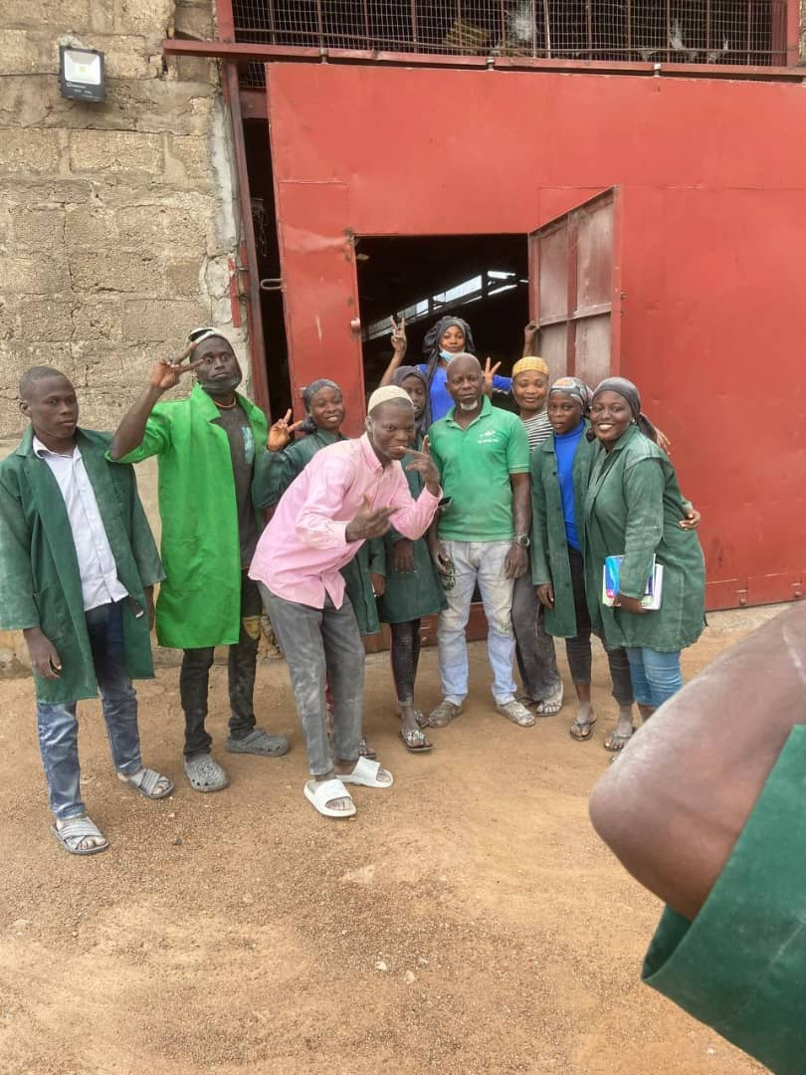

TAKING OF SHOT WITH MY AMIABLE SUPERVISOR AND MY COLLEAGUES
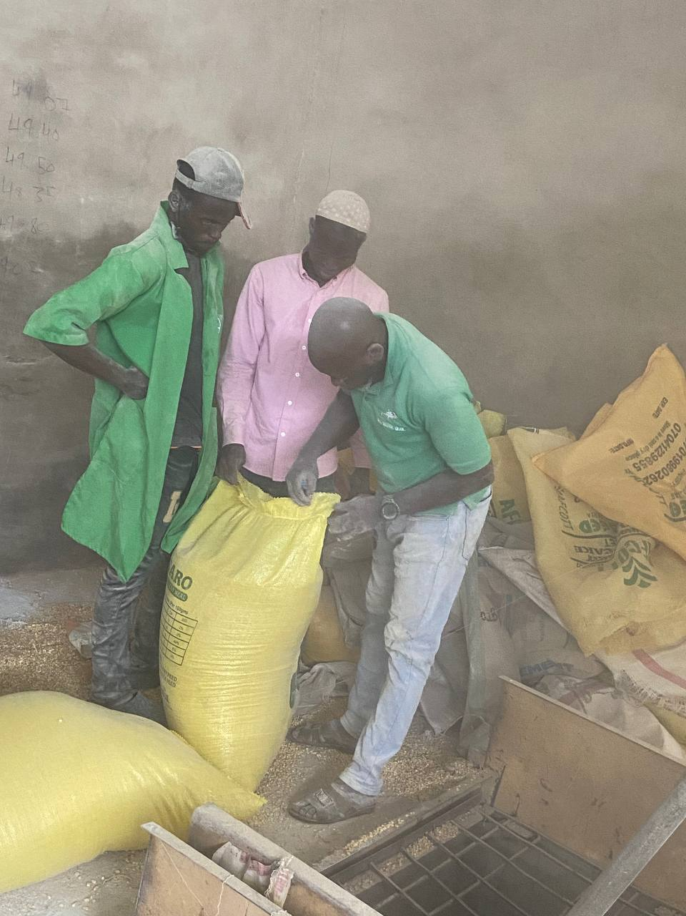

MIXING OF SUYA BEANS FOR PROTEIN SOURCE FOR THE BIRDS

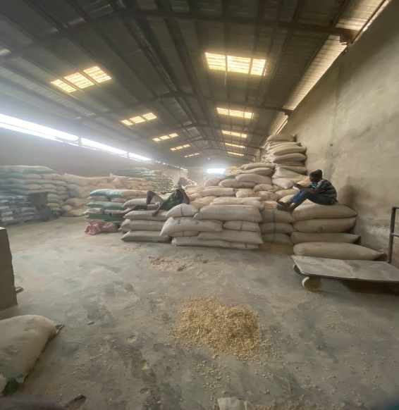
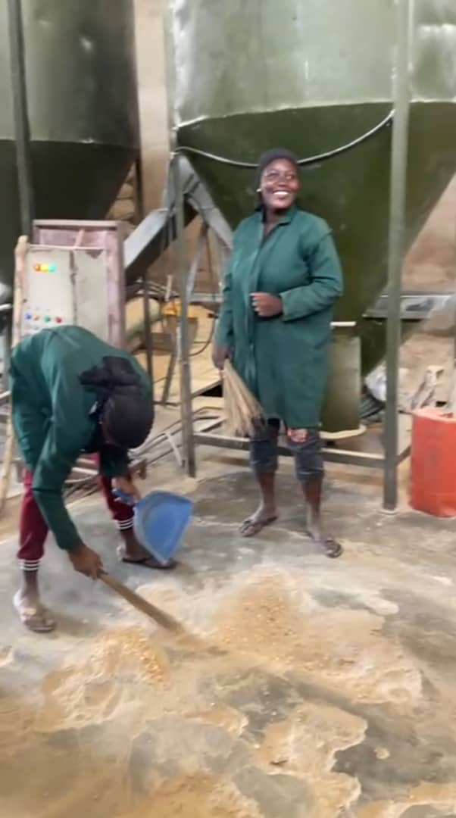
SWEEPING THE FEED MILL FEEDING MILL INTERIOR

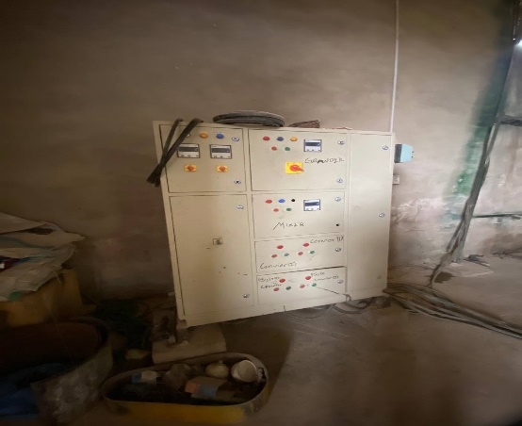
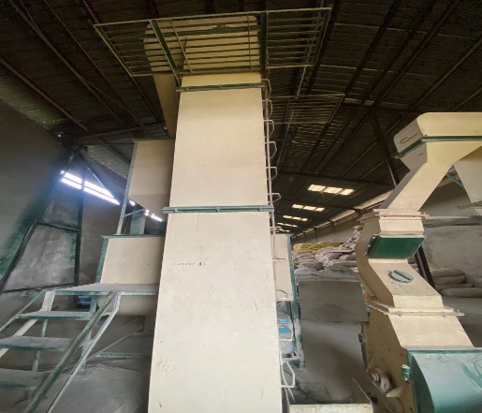
THE CONVEYOR II THE FEED MILL GENERAL POWER SWITCH

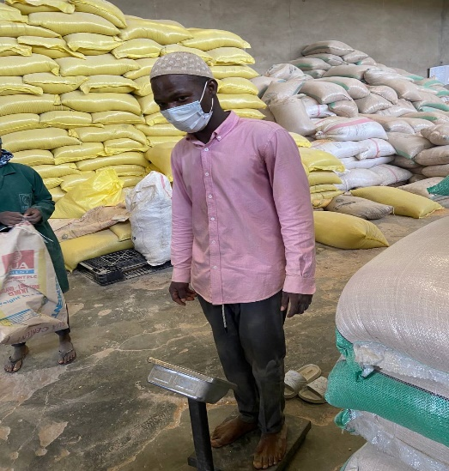
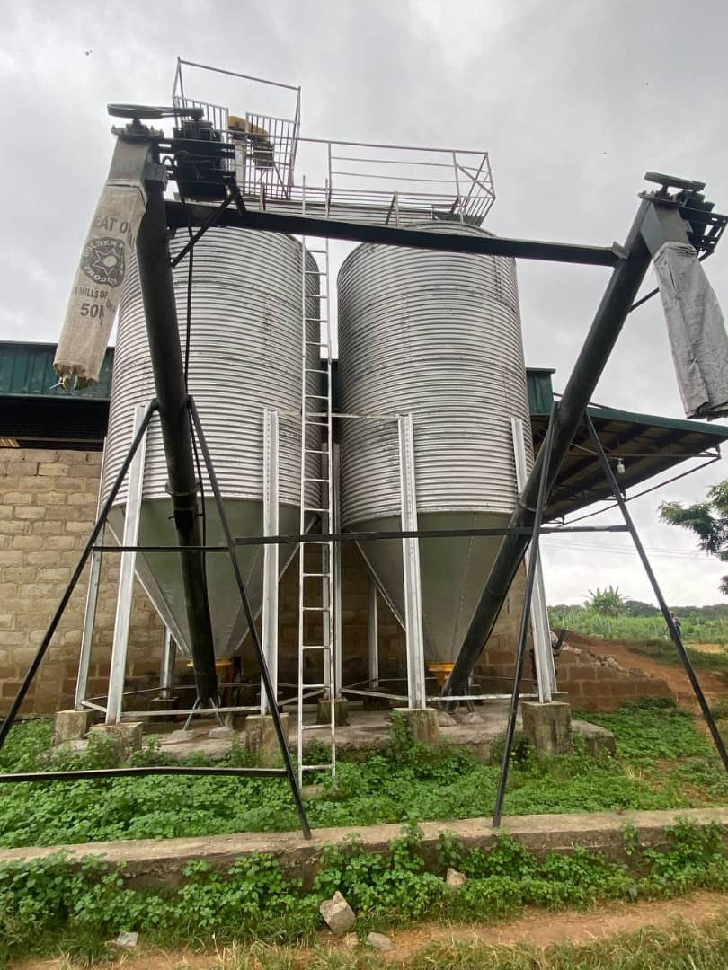
THE SILOS I ON THE MINI DIGITAL SCALLING MACHINE

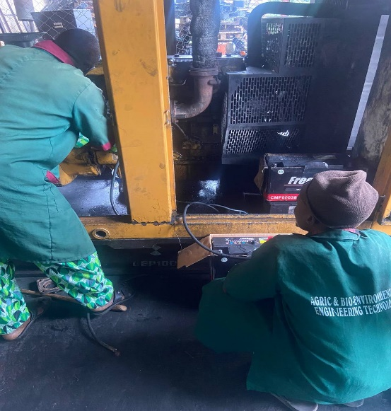
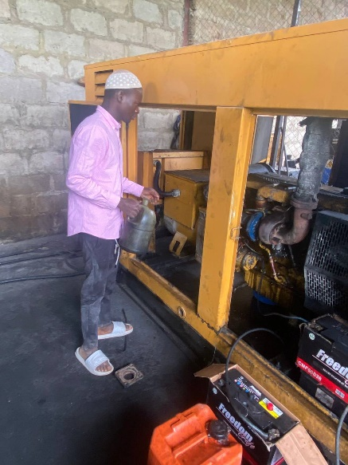
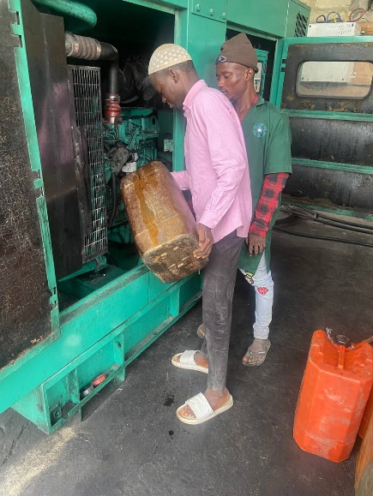
REFILLING THE GENERATOR TANK REFILLING THE GENERATOR RADIATOR

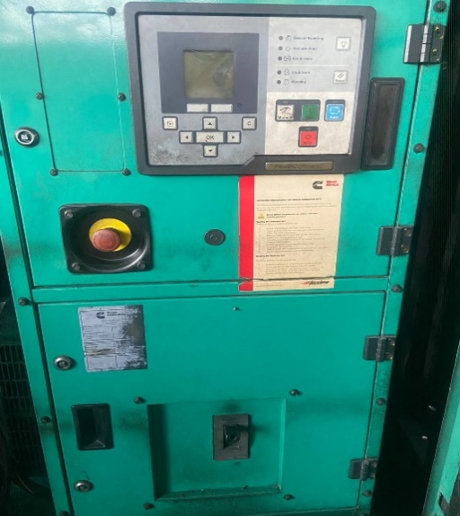

SERVICING THE GENERATOR THE GENERATOR CONTROL PANEL

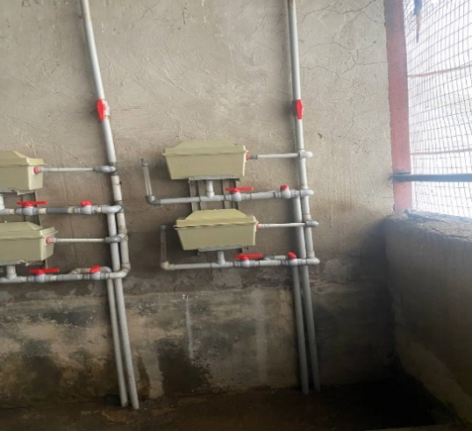
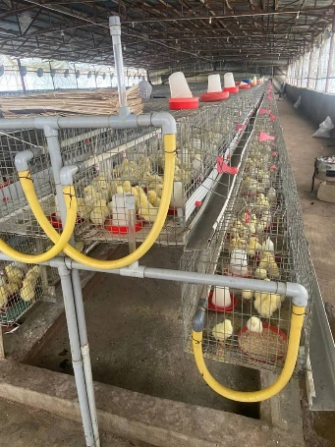

PIPING AND VALVES DAY OLD CHICKS

