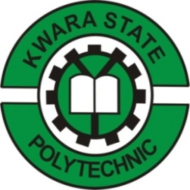

TECHNICAL REPORT ON STUDENT INDUSTRIAL WORK EXPERIENCE SCHEME (SIWES)

HELD AT:

TRANSMISSION COMPANY OF NIGERIA
Ganmo Sub–Station, Ganmo, Afon Road, Ilorin, Kwara State.

WRITTEN AND SUBMITTED BY:

ADELOWO AZEEZ OLAIDE
MATRIC NO: ND/23/EEE/PT/0099

SUBMITTED TO:

DEPARTMENT OF ELECTRICAL/ELECTRONIC ENGINEERING
INSTITUTE OF TECHNOLOGY (I.O.T)
KWARA STATE POLYTECHNIC,ILORIN
P.M.B. 1375 ILORIN, KWARA STATE

IN PARTIAL FULFILLMENT OF THE REQUIREMENT FOR THE AWARD OF NATIONAL DIPLOMA (ND) CERTIFICATE IN ELECTRICAL AND ELECTRONIC ENGINEERING

FROM AUGUST-DECEMBER, 2025
DEDICATION
This report work is dedicated to the Almighty Allah, the Alpha and Omega. The one who make me whom I am today, also dedicated to my mother Mrs. ADELOWO. And to all the staffs of Transmission Company of Nigeria.

ACKNOWLEDGMENT
What I am now is by the grace of the almighty God who is able to do all things and make me to excel abundantly above in all I ask and think, according to the power that works in me unto him the glory and domination and also to my Parents ADELOWO for her words of encouragement.
The success of this report however would not have been possible without the invaluable support, assistance and encouragement of a large number of people who are too numerous to mention.
And to those whose names did not appear who at one point or the other contributed to the success of this write-up.
I say thank you and GOD BLESS YOU

PREFACE
Student industrial work experience scheme is geared towards educating and giving the participant i.e. the student to the practical aspect of the academic discipline and course he or she is pursuing.
This technical report is based on all the training acquired by me during the course of my industrial attachment the attachment lasted for four months.
This program is organized for all engineering and technological students of higher institution of leaning, is a sure way of achieving the guest for technological and self reliance in a country like ours where the need for technological advancement cannot be over emphasized.
My acquired experience on this industrial work which I did at Transmission Company of Nigeria has given me insight into the course of my study. It has exposed me and given me the knowledge about the various types of electrical and inverter installation and some work techniques, whose operational techniques work only, but theoretically explained in our lectures in class. I want to appreciate the national board of technical education for the introduction of the student industrial work experience scheme programme to the higher institution to prepare us for a better future.

TABLE OF CONTENTS
Title i
Dedication ii
Acknowledgment iii
Preface iv
Table of contents v
CHAPTER ONE
1.0 Introduction 1
1.1 Historical Background of SIWES 1
1.2 Aims and Objectives of SIWES 2
CHAPTER TWO
2.0 Organization Description 3
2.1 Brief History of establishment 3
2.2 Location and Brief history of establishment 4
2.3 Duties of establishment 4
CHAPTER THREE
3.0 Transmission and Distribution 5
3.1 Electrical transmission by overhead wire 6
3.2 Electrical Transmission by Underground Cables 6
3.3 Step-up and Step-Down of voltages 7
3.4 Over power 7
3.5 Classification of Operating voltages 8
3.6 Load Analysis 9
3.7 Cables 9
3.7.1 Types of Cables 10
3.7.2 Cables Selection 12
3.8 Distribution Board 12
3.9 Types of Breakers based on Number of Pole 13

CHAPTER FOUR
4.0 Relevance of the Experience Gained at Students field of study 16
CHAPTER FIVE
5.0 Conclusion 17
5.1 Recommendation 17

CHAPTER ONE
1.0 INTRODUCTION
The Industrial Training program or Student Industrial Work Experience Scheme (SIWES) is appreciable skills programmed designed to equip students to the real life working experience. This scheme is a program involving universities, polytechnics and technical colleges and students of various institutions in the country. The students Industrial Work Experience Scheme (SIWES) is funded jointly by Industrial Training Fund (ITF). The training lasts for three months. The theory and practical aspect is being joined together in the programme in order to find out how things are being done. In theory, we are to read novels, books, but in practical we have to know how to do things by ourselves practically.
1.1 HISTORICAL BACKGROUND OF SIWES
The Students Industrial Work Experience Scheme (SIWES) initiated in 1973 by the Industrial Training Fund (ITF). This was in response to the mandate given to the ITF through Decree 47 of 1971, charging it with the responsibility of promoting and encouraging the acquisition of skills in Industry and commerce with the view to generate a pool of trained indigenous manpower sufficient to meet the needs of the economy.
SIWES has come to be recognized as the major avenue of bridging the gaps between the theory acquired by students of tertiary institutions and the industrial practice of the various profession and disciplines essential to the technological and economic development of Nigeria. Since its introduction by the ITF in1973, the scheme has gone through series of reforms and restructuring. For instance, its management has changed hands from the ITF to the various regulatory agencies, National Universities Commission (NUC), National Board for Technical Education (NBTE) and National Commission for Colleges of Education (NCCE) and back to the ITF. Similarly, the structure and operational framework have been reviewed, streamlined and made more functional at the various levels of its operations.
Over the years, SIWES has contributed immensely to building the common pool of technical and allied skills available to the Nigerian economy which are needed for the nation’s industrial development. These contributions and achievements have been possible because of regular innovations and improvements in the modalities employed for the management of the Scheme.
The management of a scheme as strategic as SIWES requires dissemination of reliable information in order to ensure that all stakeholders direct their energies and activities toward achieving the objectives and goals of the scheme information is, therefore, indispensable in enabling students to derive the greatest benefits possible from participating in the Scheme. The need for students to possess adequate information on SIWES is further underlined by the fact that SIWES is a course study that attracts two, four and six credit units in colleges of education, polytechnics and universities respectively. The availability of required information, therefore, enhances the capacity of students to work for and earn the credit units allotted for SIWES.
1.2 AIMS AND OBJECTIVES OF SIWES
- Provides an avenue for students in institution of higher learning to acquire industrial skills and experience during their course of study.
- Prepare students for industrial work situation that they are likely to meet after graduation.
- Expose students to work methods and techniques in handling equipment and machinery that may not be available in their institutions.
- Make the transition from school to the world of work carrier and enhances students contacts for later job placements.
Provide students with the opportunity to apply their educational knowledge in real work situations, thereby bridging the gap between theory and practical.

CHAPTER TWO
2.0 TRANSMISSION COMPANY OF NIGERIA
Transmission Company of Nigeria (TCN) was incorporated in November 2005. TCN emerged from the defunct National Electric Power Authority (NEPA) as a product of the merger of the Transmission and Operations sectors on April 1, 2004. Being one of the Eighteen(18) unbundled Business Units under the Power Holding Company of Nigeria (PHCN), the company was issued a License transmission to generate power of 330/132kV on 1st July, 2006. Transmission Company of Nigeria licensed activities include: Electricity Transmission, System Operation and Electricity Trading which is ring fenced.
TCN operations cover the whole country and administratively it is divided into Eight(8) Transmission Regions: Bauchi, Benin, Enugu, Port-Harcourt, Kaduna, Shiroro, Osogbo and Lagos that contain various Work Centers amongst which are as follows:
- Jebba Work Center
- Ganmo Work Center
- Shiroro Work Center
- Akangba Work Center
- Ikeja West Work Center
- Papalanta Work Center
- Egbim Work Center
2.1 BRIEF HISTORY OF TRANSMISSION COMPANY OF NIGERIA, GANMO
Transmission Company of Nigeria, Ganmo 330kV substation was energized in November 2008 and was commissioned by late President Umar Musa Yar’adua GCFR under the administration of Dr. BukolaSaraki, Kwara State Governor in 2009. It was one of the NIPP project under the then Administration, and was designed and constructed by a Lebanese construction company named Matelec Engineering and Construction Company. The Ganmo Works Centre was commissioned with an installed capacity of 2/150 MVA Transformer with the maximum load of 240MW. The Transmission Company of Nigeria Ganmo is a substation operating at 330/132/33kV, its received High Voltage Alternating Current (HVAC) of 330kV from Jebba generating station and Oshogbo National Grid station. The Ganmo Works Centre is the Area Control Centre (ACC) and has two sub-transmission stations under its supervision, 132kV are sent to the substations under TCN Ganmo which are Transmission Company of Nigeria sawmill, Ilorin operating at 132/33kV and Transmission Company of Nigeria, Omu-Aran operating at 132/33kV. In each of the stations, the 33kV is now feeds to the districts or Distribution Companies as well as the special industries. The commissioned was based on the insufficient power supply in the vicinity of the Kwara State and its laboring states.
Transmission Company of Nigeria, Ganmo comprises of the switch yard see Fig 2.1 (a), control room see Fig 2.1(b) and a block for offices.
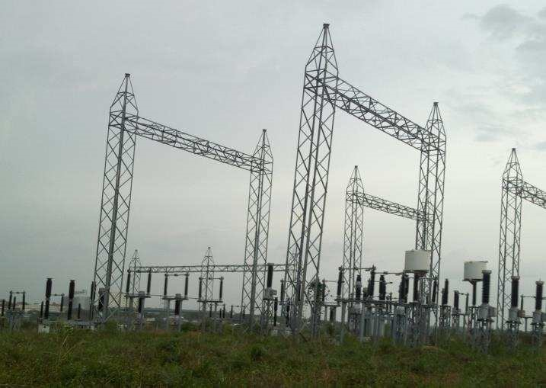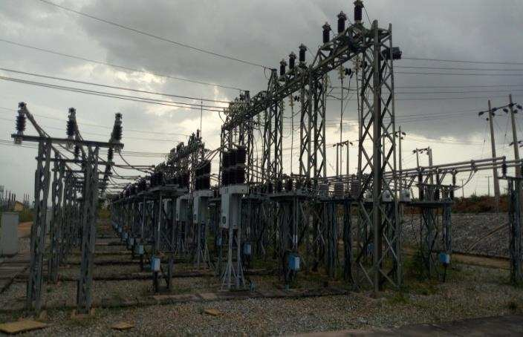

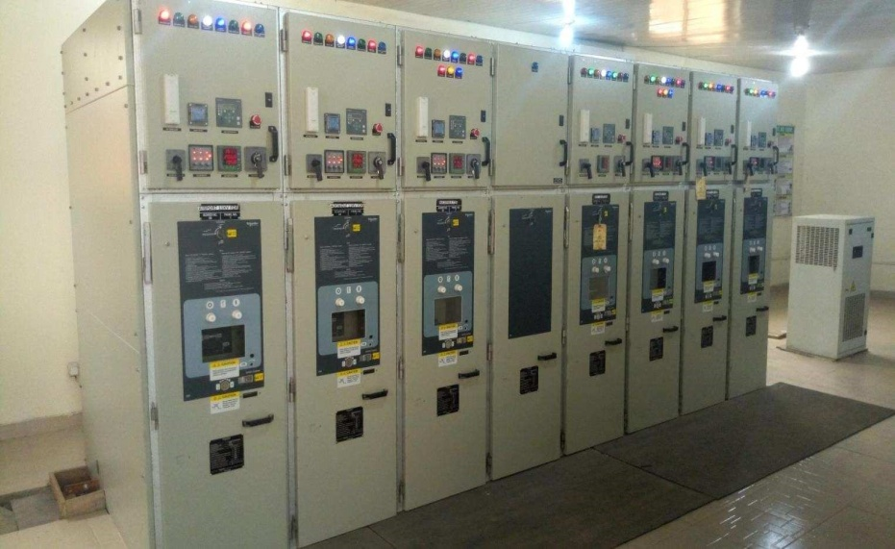

ORGANIZATION STRUCTURE OF TCN GANMO
SENIOR MANAGER
MANAGER
ASSISTANCE MANAGER
OFFICER IV
OFFICER I
OFFICER II
OFFICER III
PRINCIPAL MANAGER
HUMAN
RESOURCE
DEPARTMENT
PROTECTION
CONTROL
AND METERING
ELECTRICAL
MAINTENANCE
DEPARTMENT
SYSTEM
OPERATIONS
DEPARTMENT

LINES
DEPARTMENT
SECRETARY

CLERK

2.3 TCN GANMO DEPARTMENTS AND THEIR FUNCTIONS
The main departments in TCN Ganmoare as follows:
- Administrative Department
- Protection Control and Metering Department
- Electrical Maintenance Department
- System Lines Department
- Communication Department
2.3.1 THE FUNCTIONS OF THE VARIOUS DEPARTMENTS
ADMINISTRATIVE DEPARTMENT
Thisprovides essential administrative support to thestaffs of the Organization, with their system operation, communication and data entry skills, administrative assistants are able to assist with both complex and general administrative duties, allowing their supervisors more time to carry out their managerial tasks. The department is responsible for data processing, file maintenance, communication and clerical of the Transmission Company of Nigeria Ganmo.
PROTECTION, CONTROL AND METERING DEPARTMENT
This is a technical department saddled with the responsibility of ensuring correct and efficient protection of the various component and devices in the transmission station. The department actualizes this by carrying out correct circuit connection, clearing of faults, installation programming and wiring of protection and metering devices like Circuit Breaker, Current Transformers, Relay and so on, complete installation of other protective equipment, which is why the department always work with their Circuit Diagram designed by the manufacturer of the device. The department also conducts various scheduled maintenance and tests on power equipment.
ELECTRICAL MAINTENANCE DEPARTMENT
The Electrical Maintenance Department as a maintenance department is concern with Installation, Repair and Maintenance of the various electrical devices like Transformer, circuit breaker, isolator, etc. The department is responsible for the maintenance of all the electrical equipment in the station.
LINES DEPARTMENT
This department is concerned with monitoring and maintaining the transmission lines from the station to the designated substation. Patrol carries out their duties in a way of avoiding earth tripping from the feeder’s relay, maintaining the transmission lines poles, cutting the elongated trees that is disturbing the spaces between the transmission lines wire that cause the feeder to trip on earth fault. The department carries out its duty by conducting scheduled inspection and also responsible for the tightening the lines conductors on the switch yards and repairing the hotspots identified by the operators on duties.
SYSTEM OPERATION DEPARTMENT
The main responsibility of the System Operator includes load shedding, granting of outage permit for the maintenance crew, taking load and energy readings. Its also operate the transmission system by monitoring and operating switching devices like breaker, isolators, e.t.c in a safe and reliable manner.

COMMUNICATION DEPARTMENT
This department is responsible for communication of sending and receiving information necessary for the operation of the station, monitor activities going on within the station and other activities outside the station that influencing it between transmission stations and National Control Center (NCC), maintenance of the 48V battery bank used for communication, Power Line Carrier Communication (PLCC), inspection for fault in the control room and filling of trouble report.

CHAPTER THREE
3.0 WORK DONE AND THE EXPERIENCE GAINED DURING THE SIWES PROGRAM
According to the Transmission Company of Nigeria Ganmo policy, SIWES students are usually posted to all the aforementioned departments in order to gain the maximum experience possible and to understand the duties of the various departments and the Station as a whole, so by implication I was posted to all the departments The scope of work done and experience gained shall be analyze below according on each of the department visited.
3.1 LINES DEPARTMENT
This department is concerned with monitoring and maintaining the transmission lines from the station to the designated substation.
The transformer and conductors at Ganmo station was inspected in order to detect hot spots that needs to be attended to in other to avoid any pending danger that might occur as a result of the abnormal temperature. Then, 330kV J1H Jebba – Osogbo line trace maintenance patrol of Tower T28 – T1 – T5 Tee off to Ganmo substation. Cutting of trees that can pose threat to the line, cutting of climbers of the towers. Also, clearing of Hotspot on Otte Ogbomosho 33kV line down dropper, burnt bolt and nut were replace. The male and female contacts were thoroughly washed with electro-clean to remove the carbon deposited.
A conductor on the wave trap at the 132kV side of Ilorin Transmission Station switch-yard got burnt and detached from fault returning from the secondary side, the associated clamp was also burnt and welded. The line was discharged and earthed before the burnt clamp was removed, the plate cleaned and led before replacing it with a new one. The detached cable was also connected back to the clamp. 3.1.1 MATERIAL AND TOOLS USED
The following are some of the materials and tools used in the department:
- Lines Tools Box: This is a storage to hold and keep tools
- Safety Wears: This are the boots, over all, head hat, hand gloves and belts.
- Chain Saw: This is a portable power saw that has teeth linked together to form an endless chain. It is used to cut big trees.
- Tyfor: This is used to draw and to control any tree touching the conductor with the aid of wire swing to direct the tree to the opposite direction of the line.
- Ground Leads with stick: This used to de-energise (removing the residual charges) to the ground before working on the lines.
- Clamps: This can be either Straight or T Clamps. They are a fastening device used to hold or secure objects tightly together to prevent movement or separation through the application of inward pressure.
- Pulley: is a wheel on an axle or shaft that is designed to support movement and change of direction of a taut cable or belt. It is used to guide the cable or exert a force.
3.1.2 EXPERIENCED GAINED
The training I passed through during my duration at the Line department has really been so helpful to me, as I have being able to know the usefulness of Grounding leads with stick that is use to deenergise to the ground before working on the lines. The reason for this, is to remove the residual charge to the ground because the conductors are capacitive in nature. I also learnt about the things and causes of faults/tripping on Transmission Lines. Some of the reasons are listed below
- If trees are allowed to grow beyond the normal height than the conductor, faults occur
- We should not allow the Transmission span to be bushy
- Tripping do occur at times due to ageing of the conductors.
Also, I knew about the usefulness of a Distance Operation Relay which is to show the exact area where the fault is/has occur with a tolerance of + - 1 and also the kind of fault happening there.
3.2 COMMUNICATION DEPARTMENT
This department is responsible for communication of sendingand receiving information necessary for the operation of the station, monitor activities going on within the station and other activities outside the station that influencing it between transmission stations and National Control Center (NCC), maintenance of the 48V battery bank used for communication, Power Line Carrier Communication (PLCC), inspection for fault in the control room and filling of trouble report.
Wave Traps are used at sub-stations using Power Line Carrier Communication (PLCC). PLCC is used to transmit communication and control information at a high frequency over the power lines.
This reduces need for a separate infra for communication between sub-stations
3.2.1 EXPERIENCED GAINED
Communication department was my second posting department where I was able to learn and know more about communication can be made locally and internationally. I gained the knowledge of knowing how Wave Traps are used at substations using Power Line Carrier Communication (PLCC). PLCC is used to transmit communication and control information at a high frequency over the power lines. This reduces need for a separate infra for communication between sub-stations.
3.3 ELECTRICAL MAINTENANCE DEPARTMENT
Electrical Maintenance Department which was actually my third posting department in the station, the activities of the department comprises installation, maintenance and repair of electrical devices within the area control.
Installation is a process whereby a system with parts and accessories are assembled (connected) to make the system ready for operation, such installation includes installation of miniature circuit breaker, battery banks
Maintenance is a process carried out on the equipment to ensure proper functioningand to avoid breakdown or shut down of the system. Some of the equipments that require maintenance are as follows changing of oil in a circuit breaker, changing of silica gel, Transformer oil filtration, filling of gas, electrolyte topping in lead acid batteries.
Repairs are type of maintenance that is carried out to correct a problem or something.Such includes bleeding of the transformer, clearing of hotspot, changing of leaking gasket, changing of lightning bulbs, changing of circuit breakers.
3.3.1 MATERIALS AND TOOLS USED
i. Tools Box: This is a box that contains the tools used in carrying out the job to be done, such tools includes Allen keys, File, Grounding Switch, spanners, screw drivers, hack saw, punch, chisels and so on.
ii. Gas kit: This contains the gas pipes and nozzles, for the purpose of gas filling like the SF6 gas type Circuit Breaker.
iii. Insulation resistance tester: a testing tool/meter for detecting the states and conditions of equipment and bushings.
iv. Distilled Water: used during maintenance of batteries.
v. Oil dielectric strength tester: as the name suggests, it is used to test the dielectric strength of transformer oil.
vi. Funnel and Bucket: this is used during jobs that involve oil.
3.3.2 EXPERIENCE GAINED
Electrical maintenance department was actually an interesting department, because a lot of things were been gained in this particular section. I have been able to understand some fundamental concept about how to properly handle tools when a work is to be done. The following are some of the highlights of the work done and the experience gained.
- Changing oil of the Oil Circuit Breaker (OCB): when the oil inside the 15MVA PrimaryOil Circuit Breaker was observed to be carbonized at Ilorin Transmission Station (Ilorin TS).The process of the work done is as follow;
  - The carbonized oil was drained out of the OCB through oil drainage tap.
  - The oil tank or oil sump was loosen and suspended using pull jack.
  - The fixed and moving contact surfaces were filed to remove the built up carbon on it.
  - iv. The oil sump was cleaned by rinsing it with new oil.
  - New transformer oil was filled into the oil sump/tank of the OCB to it normal indicated level.
  - The suspended oil sump was raised to it normal position and tightened with its nuts.
  - The OCB was restored back to services.
- The broken Isolators: The T1-60MVA 132/32kV secondary isolators of blue and yellowphases stack isolator were observed broken at Omu-Aran TS. The broken stack isolators were replaced with new ones. The bolts and nuts of red phase was also replaced.
- The Circuit Breaker Repairing: The 33kV Egbe line Circuit Breaker at Omu-Aran TShad mechanism problem, the moving mechanism was stiffed. Troubleshooting was carried out on it. The stiffness was caused by the motor that is driving the mechanism part of the CB. The motor was replaced with new one and test was carried out on it, it was restored back to services.
- Fixing of a Surge Arrester: New surge arrester was installed at the Ilorin Transmission Station. Surge Arrester is a device designed to protect electrical equipment from transient over voltages, to limit the duration and amplitude of the follow current. It is normally connected between line and earth and close to the equipment, so as to protect
(usually transformers). The surge arrester is expected to have the following qualities
  - It should behave as a perfect insulator for the highest system voltage to ground.
  - It should discharge any over-voltage into the ground safely.
  - It should restore itself as an insulator after discharging the excess voltage.
The new Surge Arrester's resistance was tested with the High Voltage Insulation Tester (Mega) in order to ascertain the capability of the equipment to serve its purpose, after which its base was on the supporting base structure. The Surge Counter was installed in series between the Surge Arrester and earth, lines connection was made ensuring continuity in the wires, the Arrester and Surge Counter was properly earthed.

CHAPTER FOUR

4.0 THE EQUIPMENT
This chapter entails the equipment used, the functions of the equipment used and the descriptions of their usage during the cause of this attachment at Transmission Company of Nigeria, Ganmo.
The equipment used is as follow;
- Circuit Breaker
- Wave Trap
- Secondary Injector
- Leakage Current Tester (Clamp on)
- Auto-Transformer
- Instrument Transformers
- Relays
- Grounding/Earthing Transformer
- Lightning Arrester
- Isolators
4.1 THE EQUIPMENT USED AND THEIR FUNCTIONS

4.1.1 CIRCUIT BREAKER
A Circuit Breaker is an automatically operated electrical switching device which is designed to protect an electrical circuits from damage caused by excess current from an over load or short circuit.
Its basic function is to interrupt current flow after a fault is detected.
There are basically four type of circuit breaker namely;

- Vacuum Circuit Breaker
- Oil Circuit Breaker
- Air Break Circuit Breaker
- SF6 Circuit Breaker
v. Air Blast Circuit Breaker.
But the most used types in Transmission Company of Nigeria Ganmo are Oil Circuit Breaker (OCB) and SF6 Circuit Breaker.

USAGES OF CIRCUIT BREAKER
This is used to make or break a circuit, for the purpose of preventing Electrical Energy from getting to certain segments of the transmission station. The circuit breaker can operate under normal (when it is operated deliberately) and abnormal conditions (when its contacts open on discovery of a fault within its jurisdiction). Its contacts are embedded in a medium which function as insulation and arc quenching during operation. Its contacts are not visible to the human eyes; however it could have an indicator telling whether the circuit breaker is open or closed. The medium could be air, oil, gas (Sulphur hexafluoride SF6 gas is widely used), vacuum (absence of oxygen eliminates combustion).
In addition, the mode of operation of a circuit breaker could be hydraulic or by spring action (mostly used).

FUNCTIONS OF CIRCUIT BREAKER
The main functions of circuit breakers are;
- It has the ability to break and make in normal conditions
- Sense the current flowing in the circuit
- Measure the current flowing in the circuit
- Compare the measured current level to its pre-set trip point
- It pick up actions within a predetermined period by breaking the circuit quickly so as to limit the rate of energy that is allowed to flow after the trip point has been reached.
4.1.2LEAKAGE CURRENT TESTER (CLAMP ON)

FUNCTIONS OF CLAMP ON
Some electrical circuit, some current will flow through the protective ground conductor to ground. This is usually called leakage current. Leakage current most commonly flows in the insulation surrounding conductors and in the filters protecting electronic equipment around the home or office. So what's the problem? On circuits protected by GFCIs (Ground Fault Current
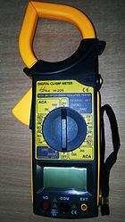
Interrupters) e.g. Circuit Breaker, leakage current can cause unnecessary and intermittent tripping.
In extreme cases, it can cause a rise in voltage on accessible conductive parts.

Clamp On

USAGE OF LEAKAGE CURRENT TESTER
The Clamp-on is use in TCN to detect leakage current in secondary terminal of a CT while performing maintenance and detecting the start of the windings and insulation of the CT. The Clamp-on is clamp on the shorted secondary terminals of the CT while a known current has been injected to the primary side of the CT to test.

4.1.3 AUTO-TRANSFORMER
A transformer is a static device that transfers electric energy from one circuit to another withoutchanging frequency. Auto-transformer is a single-winding transformer with taps. With primary voltage applied to the primary terminals, the required secondary voltage from zero volts to the rated primary volts can be availed from the secondary by varying the taps.

4.1.4 GROUNDING TRANSFORMER
A grounding or earthing transformer is a type of auxiliary transformer used in three-phase electric distribution systems to provide a neutral point where the main power source is unavailable. The earthing transformers may in addition supply a local auxiliary load. It is sometimes classified as standard reactors.
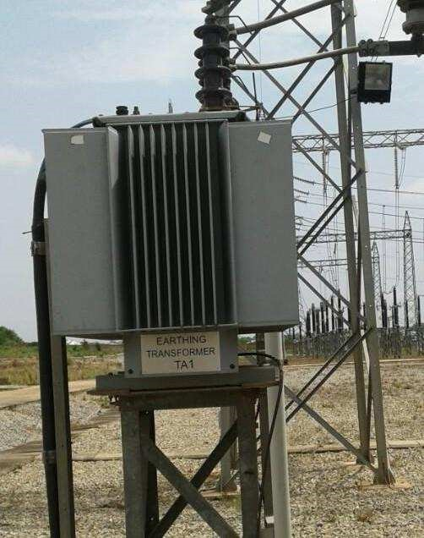

FUNCTIONS AND USAGE OF A GROUNDING TRANSFORMER
- Grounding transformers let three-wire (delta) system supplies accommodate phase-toneutral loads by providing a return path for current to a neutral.
- Grounding transformers are very common on generators in power plants and wind farms.iii. The grounding point of the transformer may be connected through a resistor to limit the fault current on the system in the event of a line-to-ground fault.
iv.This is used as earthing for the auto transformer and likewise as auxiliary supply for station. The earthing transformer serves as the neutral for the secondary of the transformer as step down of the 33KV at the tertiary to 415V, which is used for station auxiliary supply.
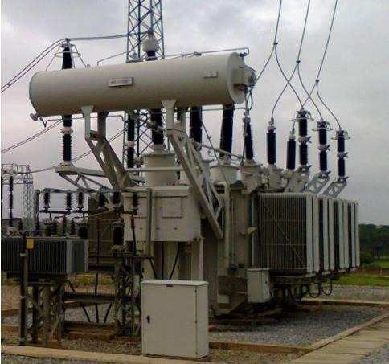
150MVA 330/132/33kV Auto-transformer

CHAPTER FIVE
5.0 CONCLUSIONS
The SIWES program had contributed positively to my exposure and training in the field of electrical and electronics engineering. It has also helped me to put practice their knowledge gained in classroom with actual industrial experience. Also to develop a critical and realistic approach with their solution in electrical field.
5.1 RECOMMENDATION
The polytechnics should make it compulsory for all students, since the program goes way in improving students practical and theoretical experience.
I recommend that the SIWES letter should be given to students early so as to avoid attachment in irrelevant places
I also that substantial percent of the National budget should go into the development, improvement and sustenance of the power sector. Doing this would help improve electricity production and in turn improve development and industrialization, so that students can have a good place of attachment.

