

A TECHNICAL REPORT AND PRESENTATION
ON
STUDENT INDUSTRIAL WORK EXPERIENCE SCHEME (SIWES)
HELD AT
SOUTH LOCAL GOVERNMENT
SUSUN POLICE STATION AROWOMOLE AREA OGBOMOSHO, OYO STATE.
SUMMITTED BY
NAME: ALADE MOSES OLAMIDE
MATRIC NUMBER: ND/23/COM/PT/0232
DEPARTMENT OF COMPUTER SCIENCE
INSTITUTE OF INFORMATION COMMUNICATION TECHNOLOGY
KWARA STATE POLYTECHNIC, ILORIN.

FEBUARY 2025

DEDICATION
This report is dedicated to Almighty God, the supreme Being and also to my loving parents, Mr. & Mrs. ALADE.

ACKNOWLEDGEMENT
Firstly, with every sense of humility, I give my sincere appreciation to Almighty God from whom all knowledge, wisdom and intelligence are given to humanity for making it possible for me to accomplish my SIWES programme.
Education is an instrument of change, for human emancipation from ignorance, superstition and enslavement. My parents made sure they planted this in me. I am grateful to my parents, Mr. and Mrs. ALADE for their love, care, encouragement and financial support. I pray that Almighty God will grant them long life and hearty health to reap the fruit of their labour.
Words alone cannot express my enthusiasm to my SIWES supervisor and departmental lecturers for their parental advice and tutelage. May God almighty continue to bless you all?

FOREWORD
This report contains all the work done and the experience gained during my four months of industrial programme which I had at SOUTH LOCAL GOVERNMENT in ogbomosho, oyo State and it is written in chapters according to how the training goes.
The five chapters report is arranged as follow. Chapter one unveils a brief background of the advent of SIWES industrial programme into Nigeria tertiary institution academic calendar. Chapter two reveals the major sections and units in the host organization and student’s specific involvement in the organization during training. Chapter four elucidates on work done by the intern in the organization, the relevance of the experience gained as it is in-line with the kernel of Computer Science.
The last chapter of the report elucidates on conclusion, recommendation and suggestion for institution and organization.

TABLE OF CONTENT
Title Pages
Title page
Dedication
Acknowledgement
Foreword
Table of content
CHAPTER ONE
1.0 Introduction
1.1 About SIWES
1.2 Brief history of SIWES
1.3 Aim and objectives of SIWES
1.4 Role of student during SIWES
1.5 Objectives of the report
1.6 The logbook
CHAPTER TWO
2.0 Organization Chart
2.1 Brief history of the establishment
CHAPTER THREE
3.0 Introduction to COMPUTER NETWORKING
CHAPTER FOUR
4.0 Knowledge gained during the SIWES exercise
CHAPTER FIVE
5.0 Conclusion
5.1 Recommendation
CHAPTER ONE

1.0 INTRODUCTION
This chapter gives a brief history of SIWES, its aims and objectives, as well as a short narrative on my application and posting. It also introduces intelligent solution providers (ISP) of Computer, where I had my SIWES training.
1.1 ABOUT STUDENTS INDUSTRIAL WORK EXPERIENCE SCHEME
The student work experience scheme (SIWES) is a worldwide program practiced in countries like Japan, Australia, USA, Europe, and in African countries too. It is popularly known as co-operative education and referred to as sandwich in Europe. It is a six (6) months students industrial work experience scheme (SIWES) taken in the third year of the degree program, where the students go to various establishments related to their course of study.
The program was initially introduced in Nigeria by the Industrial Training Fund (I.T.F.) which was established under Decree 47 of 1972 by the Supreme Military Council, headed by General Yakubu Gowon. The Decree was billed to take effect from 31st March, 1974 and had as its core objective, the gradual reduction of the percentage of foreign participation in most of Nigeria’s economic activities, accompanied by a systematic cooperation of locally oriented skilled manpower into the vast economic sector.
One of the key functions of the ITF is to work as cooperative body with industry and commerce where students in institutions of higher learning can undertake mid-career work experience attachment in industries which are compatible with student’s area of study. The students Industrial Work Experience Scheme (SIWES) is a skill Training program designed to expose and prepare students for the Industrial work situation which they are likely to meet after graduation. Participation in SIWES has become a necessary pre-condition for the award of diploma and degree certificate in specific disciplines in most institutions of higher learning in the country in accordance with the education policy of government.

1.2 BRIEF HISTORY OF SIWES
The word SIWES (Student Industrial Work Experience Scheme) was introduce by the federal government in the year 1973 to develop the technological, physical and social skill of our nation, through this, adequate and intelligent student are provide the department involved the actual challenge various discipline before they can be awarded as am National Diploma (ND) graduate.
1.3 AIMS AND OBJECTIVES OF SIWES
- Provide an avenue for students in institutions of higher learning to acquire industrial skills and experience in their approved course of study and also by interacting with people with more experience in the field under consideration.
- Prepare students for the industrial work situation which they are likely to meet after graduation.
- Expose students to work methods and techniques in handling equipment and machinery that are mostly not available in their various institutions.
- Provide students with an opportunity to apply their knowledge in real world situation thereby reducing the gap between theoretical knowledge and practical work.
- Enlist and strengthen employers’ involvement in the entire educational process and prepare students for employment in Industry and Commerce.
1.4 ROLES OF STUDENT
- Attend SIWES orientation programme before going on attachment.
- Comply with the establishment’s rule and regulation.
- Arrange living accommodation during the period of attachment.
- Record all training activity done and other assignment in the log book.
- Complete SPEI from ITF, FORM 8 and get it endorsed by the employer for submission to the ITF.
1.5 OBJECTIVES OF THE REPORT
The objectives of the SIWES report are;
- To make through explanation of the work done during my four month industrial training.
- To fulfill the requirement for national diploma in computer science.
- To contribute to the body of knowledge and to enhance the understanding of the writer about a similar or same job.
1.6 THE LOGBOOK
The logbook issued to student on attachment by the institution was used to record all daily activities that took place during the period of attachment, and it was checked and endorse by the industry based/institution based supervisors and ITF during supervision.

CHAPTER TWO

2.0 ORGANIZATIONS CHART OF SOUTH COMPUTER TECHNOLOGY
MANAGING DIRECTOR

ADMINISTRATIVE MANAGER
ACCOUNTANT

ENGINEERS
SECRETARY

SYSTEM ANALYST
INSTRUCTORS

IT/SIWES

2.1 BRIEF HISTORY OF SOUTH COMPUTER TECHNOLOGY
South local government and IT Solutions, was private organization. It owned and managed by Mr. BASHIR.
It is a non-governmental organization in Oyo state. They operate ICT situated behind SUSUN POLICE STATION AROWOMOLE AREA OGBOMOSHO, OYO STATE. Science academic for training and skill acquisitions in nearly every aspect of IT of some of which include: web design, graphics design, computer networking, computer programming and robotic, and computer graphic e.t.c.
This company is head by the director and administrative manager next to him followed by the engineers, system analyst and the instructors.
South local government was founded in [2005] with a vision to revolutionize the computer technology landscape. From its inception, the company focused on pushing the boundaries of innovation and providing state-of-the-art solutions to its clients.
In its early years, South local government quickly gained recognition for its expertise in hardware development, particularly in designing and manufacturing high-performance computer components. This laid the foundation for the company's reputation for quality and reliability.
As the technology landscape evolved, South local government expanded its offerings to include software solutions and IT consulting services. By leveraging its technical expertise and industry insights, the company began providing comprehensive IT solutions tailored to the unique needs of its clients.
Over the years, South local government has consistently stayed ahead of the curve by embracing emerging technologies and trends. Whether it's adopting cloud computing, developing innovative software applications, or implementing robust cybersecurity measures, the company has always been at the forefront of technological advancements.
Moreover, South local government maintains strong partnerships with leading technology providers, ensuring access to the latest tools and resources.
CHAPTER THREE
3.0 INTRODUCTION TO GRAPHICS DESIGN AND DEVELOPMENT
Graphic design is the art and practice of visual communication that combines imagery, typography, and other elements to convey messages or information to an audience. It is a creative process that involves the arrangement and manipulation of visual elements to communicate ideas, concepts, or emotions effectively.
At its core, graphic design aims to solve problems and fulfill objectives through visual means. Whether it's creating a logo, designing a website, crafting a poster, or developing an advertising campaign, graphic designers use their skills to visually engage and inform viewers.
Key elements of graphic design include:
- Typography: The art of arranging typefaces to make written language legible, readable, and appealing. Typography plays a crucial role in conveying tone, mood, and emphasis in graphic design.
- Imagery: The use of photographs, illustrations, icons, and other visual elements to complement and enhance the message being communicated. Imagery can evoke emotions, create visual interest, and help convey complex ideas.
- Layout: The arrangement of visual elements on a page or screen to create a cohesive and aesthetically pleasing composition. Layout design involves considerations such as hierarchy, balance, and visual flow to guide the viewer's attention and convey information effectively.
- Color: The selection and application of colors to evoke specific emotions, create visual contrast, and reinforce branding or identity. Color theory plays a significant role in graphic design, influencing the overall look and feel of a design.
- Composition: The organization and structure of visual elements within a design to create harmony, unity, and visual interest. Composition principles such as balance, symmetry, and proportion help designers create visually appealing layouts.

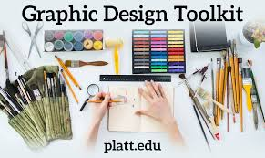
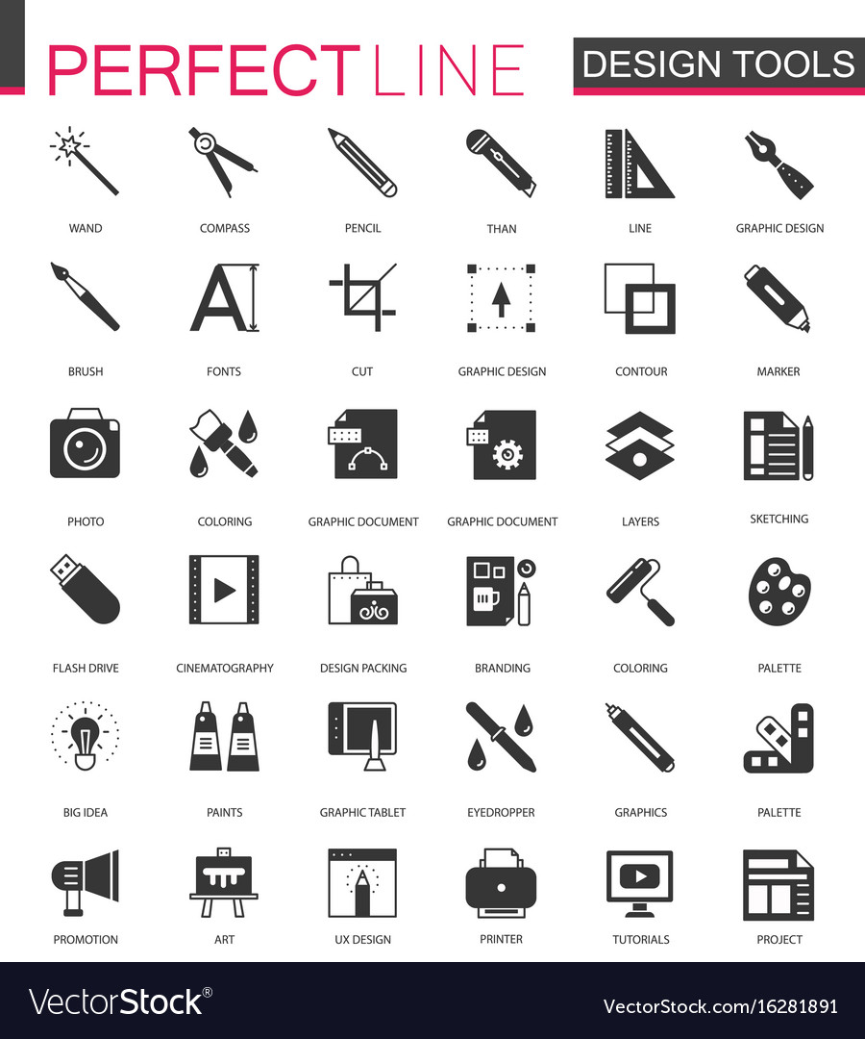
TYPES OF EDITIOR USED IN GRAPHICS DESIGN AND DEVELOPMENT
- Raster Graphics Editors:
  - Adobe Photoshop: Photoshop is a widely used raster graphics editor for editing and manipulating pixel-based images. It offers a comprehensive set of tools for retouching photos, creating digital artwork, and designing graphics for print and web.
  - GIMP (GNU Image Manipulation Program): GIMP is a free and open-source alternative to Photoshop, offering similar features for photo editing, image composition, and graphic design.
- Vector Graphics Editors:
  - Adobe Illustrator: Illustrator is a vector graphics editor used for creating scalable vector artwork, such as logos, icons, illustrations, and typography. It provides precise control over shapes, paths, and anchor points, making it ideal for designing graphics for print and digital media.
  - CorelDRAW: CorelDRAW is a vector-based graphic design software popular for its intuitive interface and extensive set of tools for illustration, layout, and typography.
- Page Layout Editors:
  - Adobe InDesign: InDesign is a page layout editor used for designing and formatting print and digital documents, such as brochures, magazines, books, and posters. It offers advanced typography and layout features, as well as support for integrating images, graphics, and multimedia content.
  - QuarkXPress: QuarkXPress is another page layout editor known for its powerful typography and design tools, used for creating professional-quality print and digital publications.

- Web Design Editors:
  - Adobe Dreamweaver: Dreamweaver is a web design editor that allows designers to create, code, and manage websites and web applications. It offers a visual design interface along with coding tools for HTML, CSS, and JavaScript, making it suitable for both visual designers and web developers.
  - Sketch: Sketch is a vector-based design tool primarily used for designing user interfaces (UI) and user experience (UX) for websites and mobile apps. It offers a streamlined interface and features focused on UI/UX design, including symbols, artboards, and prototyping.
- Video and Motion Graphics Editors:
  - Adobe After Effects: After Effects is a motion graphics and visual effects editor used for creating animations, video compositing, and dynamic motion graphics. It offers a wide range of tools for adding effects, transitions, and animations to video projects.
  - Final Cut Pro: Final Cut Pro is a professional video editing software for macOS used for editing, organizing, and delivering high-quality video content. It offers advanced editing tools, color grading, and effects for creating polished video productions.
TYPES OF TOOLS IN GRAPHICS DESIGN AND THEIR USES
- Asset Management: Tagging is used to label and categorize digital assets within design software, asset management systems, or content management systems (CMS). Designers can assign tags to images, illustrations, icons, and other resources, making it easier to search, retrieve, and reuse them in future projects.

- Search Engine Optimization (SEO): In web design and development, tagging is essential for optimizing content for search engines. Designers use meta tags, alt attributes, and descriptive keywords to enhance the visibility and relevance of web pages in search engine results pages (SERPs). Proper tagging improves the discoverability of websites and enhances their ranking potential.
- Social Media Marketing: Tags are widely used in social media marketing campaigns to increase engagement and reach. Designers incorporate hashtags into visual content to categorize posts, amplify their visibility, and encourage user interaction. Strategic tagging can help brands connect with their target audience and enhance brand awareness across social media platforms.
- Accessibility: Tagging is crucial for ensuring accessibility in graphic design and web development. Designers use descriptive alt text and aria-label attributes to provide context and clarity for users with disabilities, such as those using screen readers. Proper tagging enhances the usability and inclusivity of digital interfaces, making them more accessible to all users.
- Version Control: In collaborative design projects, tagging is used to track and manage different versions or iterations of design files. Designers can apply tags to indicate milestones, revisions, or approved versions, facilitating communication and collaboration among team members. Version tagging helps streamline workflow processes and maintain consistency across design projects.

CHAPTER FOUR
4.0 RELEVANCE OF THE EXPERIENCE GAINED BY STUDENT DURING THE PROGRAMME
Without mincing fact, Student Industrial Work Experience Scheme (SIWES) sustains a great relevance for tertiary institution students during internship. Besides exposure to the technical Know-how of things are been done in industrial setting which far differs from what is being taught within the four walls of classroom. This will undoubtedly unravel completely or at least lessen the demarcation and prevailing contrast in terms of work force and output between industrial staff and newly employed graduates.
Unlike an intern, I was given a warm welcome on my first day at jirika consult and IT solutions. This was followed by my introduction to other staff and orientation on the activities functions of the organization.
In sequel to that, I was also introduced to other departments’ i.e Marketing department, human resources department, amongst others.
During my internship, I functioned relatively in some of the departments/units in the organization such that I was able to gather several computer science related experience which will abet my academic career and pursuit.

CHALLENGES ENCOUNTERED
1. Financial scar
2. Starkness of industrial staff
3. Proximity of industrial location
4. Limited internship period

CHAPTER FIVE

5.0 CONCLUSION
The SIWES program expected to be undergone by all students in the school of applied science in all tertiary institution in Nigeria.
I therefore deeply appreciate the industrial training of my school (Kwara State Polytechnic, Ilorin) for involving themselves in such a worldwide program. The importance of this training cannot be over emphasized industrial training by some operations carried out during the program.
5.1 RECOMMENDATION
I like to use this medium to explore the federal Government at all stage to take this SIWES program more seriously seen by the students of applied science as a virtual improvement in future of technology in our nature.
Government should also ensure a proper supervision of SIWES student so that the purpose of the programme will be achieved.
The federal Government should make adequate provision in the annual budget for proper funding of SIWES in view of the potential of the scheme to contribute to enhancing the quality of the pool to technical skill available to the economy.
A comprehensive and detail directory of employer who accept students for SIWES is urgently required to facilitate placement of student in industry.
In order to guarantee quality assurance of institution and the ITF. The ITF should ensure that the backlog in payment of students allowance is cleared urgently to remove the negative image being created for SIWES.

