

TECHNICAL REPORT ON STUDENT INDUSTRIAL
WORK EXPERIENCE SCHEME (SIWES)

HELD AT:

OMOOLOPE WORK TECHNOLOGY ENGINEERING
GEROFF NO. 1, HASSAN DALLATTU ROAD BEHIND NUT HOUSE BY SOCIAL WELFARE CHURCH ROAD JUNCTION SULEJA NIGER STATE

BY

JAMIU SHEFIU ISHOLA
ND/23/EEE/FT/0039

SUBMITTED TO:
DEPARTMENT OF ELECTRICAL/ELECTRONIC ENGINEERING DEPARTMENT (I.O.T) ILORIN, KWARA STATE
IN PARTIAL FULFILLMENT OF THE REQUIREMENTS FOR THE AWARD OF NATIONAL DIPLOMA (ND) IN ELECTRICAL/ELECTRONIC ENGINEERING

AUGUST –DECEMBER, 2024
DEDICATION
This report is dedicated to Almighty God and the entire family of Mr and Mrs. Jamiu who makes this program comes to reality.

ACKNOWLEDGEMENT
I give thanks to Almighty God for making me witness the end of this training, many proposed but not everyone witnessed it in peace.
My profound gratitude also goes my parents Mr. and Mrs Jamiu for their endless effort in making me who I am today.
My vote of thanks also goes to all the workers at Omoolope Works Engineering Technology most especially the CEO and the engineers sharing their ideas and knowledge with me without conflict and their strong effort over me during the period of my attachment.
Finally, I thank all the entire staff of Electrical and Electronics Engineering department, HOD lecturers and non-staff for their positive contribution to the success of this Program.

TABLE OF CONTENT
Dedication
Acknowledgement
CHAPTER ONE
1 .0 Introduction
1.1 Brief history of SIWES
1.2 Aims and objectives
1.3 Brief History of Omoolope Works Engineering Technology
1.4 Introduction to Electrical Rules and Regulations
1.5 Safety precaution in electrical work
1.6 Introduction to electrical tool and uses
1.7 Some color codes in electrical work
CHAPTER TWO
2.0 Electrical wiring system
2.1 Surface wiring
2.2 Trucking wing
2.3 Conduit wiring
CHAPTER THREE
3.0 Electrical Accessories
CHAPTER FOUR
4.0 Inverter
4.1 Oscillator stage
4.2 Amplifier stage
4.3 Transformer stage
4.4 Battery connections

CHAPTER FIVE
5.0 Problem Encountered And Possible Solutions
5.1 Conclusion
5.2 Recommendation

CHAPTER ONE
1.0 INTRODUCTION
The Industrial Training program or Student Industrial Work Experience Scheme (SIWES) is appreciable skills programmed designed to equip students to the real life working experience. This scheme is a program involving universities, polytechnics and technical colleges and students of various institutions in the country. The students Industrial Work Experience Scheme (SIWES) is funded jointly by Industrial Training Fund (ITF). The training lasts for three months. The theory and practical aspect is being joined together in the programme in order to find out how things are being done. In theory, we are to read novels, books, but in practical we have to know how to do things by ourselves practically.
1.1 HISTORICAL BACKGROUND OF SIWES
The Students Industrial Work Experience Scheme (SIWES) initiated in 1973 by the Industrial Training Fund (ITF). This was in response to the mandate given to the ITF through Decree 47 of 1971, charging it with the responsibility of promoting and encouraging the acquisition of skills in Industry and commerce with the view to generate a pool of trained indigenous manpower sufficient to meet the needs of the economy.
SIWES has come to be recognized as the major avenue of bridging the gaps between the theory acquired by students of tertiary institutions and the industrial practice of the various profession and disciplines essential to the technological and economic development of Nigeria. Since its introduction by the ITF in1973, the scheme has gone through series of reforms and restructuring. For instance, its management has changed hands from the ITF to the various regulatory agencies, National Universities Commission (NUC), National Board for Technical Education (NBTE) and National Commission for Colleges of Education (NCCE) and back to the ITF. Similarly, the structure and operational framework have been reviewed, streamlined and made more functional at the various levels of its operations.
Over the years, SIWES has contributed immensely to building the common pool of technical and allied skills available to the Nigerian economy which are needed for the nation’s industrial development. These contributions and achievements have been possible because of regular innovations and improvements in the modalities employed for the management of the Scheme.
The management of a scheme as strategic as SIWES requires dissemination of reliable information in order to ensure that all stakeholders direct their energies and activities toward achieving the objectives and goals of the scheme information is, therefore, indispensable in enabling students to derive the greatest benefits possible from participating in the Scheme. The need for students to possess adequate information on SIWES is further underlined by the fact that SIWES is a course study that attracts two, four and six credit units in colleges of education, polytechnics and universities respectively. The availability of required information, therefore, enhances the capacity of students to work for and earn the credit units allotted for SIWES.
1.2 AIMS AND OBJECTIVES OF SIWES
- Provides an avenue for students in institution of higher learning to acquire industrial skills and experience during their course of study.
- Prepare students for industrial work situation that they are likely to meet after graduation.
- Expose students to work methods and techniques in handling equipment and machinery that may not be available in their institutions.
- Make the transition from school to the world of work carrier and enhances students contacts for later job placements.
Provide students with the opportunity to apply their educational knowledge in real work situations, thereby bridging the gap between theory and practical.

CHAPTER TWO
2.0 THE BRIEF HISTORY OF OMOOLOPE WORKS ENGINEERING TECHNOLOGY
Omoolope Works Engineering Technology was established in 2000. The company is located at Geroff No. 1, Hassan Dallattu Road Behind NUT House by Social Welfare Church Road Junction Suleja Niger State. The workshop is based on the installation of different kinds of wiring systems, installations of solar and inverters, and lots more.
2.1 ORGANIZATION CHART
Managing Director
Supervisors

Student Workers Apprentice

CHAPTER THREE
3.0 Actual Work Done
3.1 INTRODUCTION TO ELECTRICAL RULES AND REGULATIONS
i. Don’t work with wet hand and body on a cable with current.
ii. When working, you have to be alert in case of any incident.
iii. An engineer must not put on suit and tie when going to site works.
SAFETY PRECAUTIONS IN ELECTRICAL WORKSHOP
i. Put on safety boot.
ii. An engineer must put on head helmet while working.
iii. Never use equipment with frayed cords, damaged insulations or broken plugs.
iv. Always use insulated tools while working.
ELECTRICAL TOOLS AND USES
Electrical tools are used to do the electrical work like electrical wiring installations, by using this tool we can do the installation of electrical wire properly and quickly. These tools include:
1. Tester: it is use to check if current is present in a cable.
2. Pliers: it is used to pill a cable or to twist and join copper cable.
3. Bending spring: it is mostly used in conduit wiring system to bend a pipe.
4. Hammer: it is used in driving nails into the wall.
5. Screw driver: it is used for tightening and loosening of screws.
6. Fish tape: this are used for pulling solid wire conductors through a PVC conduit.
7. Insulated gloves: These are valuable tools used for electrical safety.
8. Measuring tape: it is used for measurement in electrical works.
9. Ladder: it is used for climbing higher places.
10.Torpedo level: this is used to make sure your work is level and plumb.

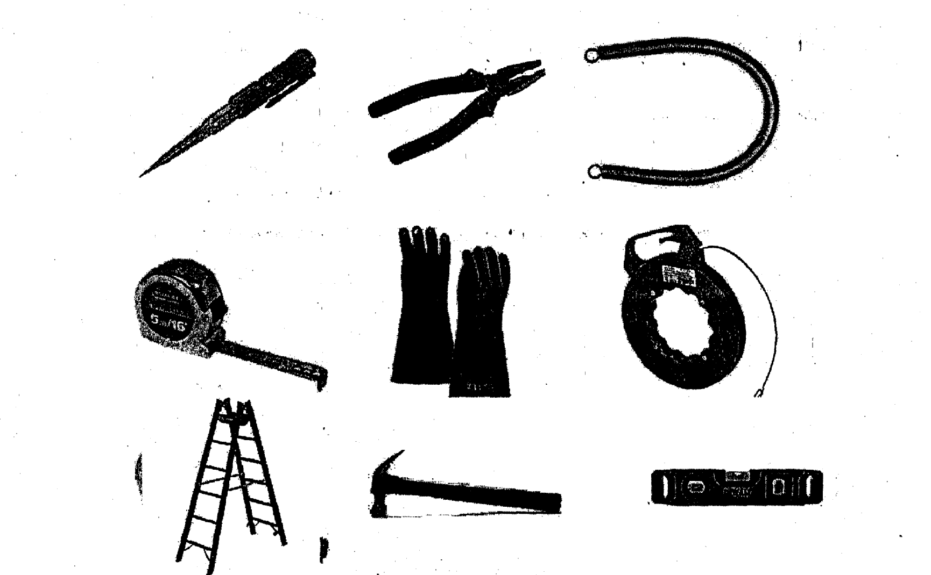

SOME COLOU CGDE$ IN ELECTRICAL WORK

COLOUR CODE
Yellow Earth
Green Earth
Black Neutral
Blue Neutral
Red Live
Brown Live
ELECTRICAL WIRING SYSTEM
Electrical wiring is a process of connecting cables and wires to the related devices such as fuse, switches, sockets, lights, fans etc. to the main distribution board in a specific structure to the utility pole for continue power supply. Electrical wiring system can be classified into the following:
- Surface wiring system
- Trunking wiring system
- Conduit wiring system
SURFACE WIRING SYSTEM
Surface wiring is a system in which the wires are simply run across the surface of a wall or ceiling but are concealed and protected by a decorative cover or channel This involves the use of PVC insulated which consists of 1,2, or 3 core cable laid up in flat formation with a close covering of through PVC as mechanical protection since there is no metal sheet, a bore conductor as in twin and earth cable will be enclosed in the PVC sheet to serve as the earth continuity conductor. It is referred to as the most commonly used cable in Nigeria for domestic wiring. It can also be done with little or no disruption to existing finishes.
- THE ACCESSORIES USED IN SURFACE WIRING
- Clip
• Wooden screw
• Twin cable
> SIZE OF CABLE USED
- 3029 or 1mm two core
• 1.5mm three core
• 2.5mm three core
- 4mm single
• 6mm single
• 10mm single
• 16mm single
• 6mm service wire
• 10mm service wire
• 16mm service wire
TRUNKING WIRING SYSTEM
Electrical trunking system2 are used to carry a compound current where various electrical cables come together using trunking pipes. There are three types of trunkirig wiring system, these are:
• Multiple cable trunking
• Bus bar trunking
• Tap on trunking
> MULTIPLE CABLE TRUNKING
It is used in a condition where a considerable numbers of cable are required to be run together in an installation and a conduit pipe may besmall to contain the cable. This type of trunldng is normally manufactured from plastic or steel sheet in the form of long box construction with removable or hinged cover.
> BUS BAR TRUNKING
This system consists of trunking boxes, and the conductors (copper aluminum sections) are supplied, fitted inside. The trunking are insulated from each other and trunked by porcelain support.
> TAP ON TRUNKING
This type of trunking can also be called overhead bus bar system. It is commonly used in industrial installations, where a considerable degree of flexibility is required. Tap on trunking is somewhat similar in construction to bus bar trunking but the conductors are constructed so that tap on boxes may be plugged in at regular intervals through plugging into the bus bar for protecting outgoing circuit.
CONDUIT WIRING SYSTEM
An electrical conduit is a tube used to protect and route electrical wiring in a building or structure. Electrical conduit may be made of metal, plastic, fiber, or fired clay. Most conduits are rigid, but flexible. This can also be referred to as the running of wires through conduit pipes.
- Classification of conduit
Conduit wiring system are classified into two major parts, these includes:
• Insulated or plastic conduit
• Metal conduit
- Insulated or plastic conduit
This is often made of plastic elastic materials such as hard PVC or polythene, and can be obtained in various grade of the size as steel conduits.
- Metal conduits
This type of conduit are the, light gauge steel unscrewed conduit, the heavy gauge steel screwed conduit and the non-ferrous metal (copper, aluminum, and zinc bus alloy)
2.4 MATERIALS NEEDED
1. 20mm PVC pipe
2. 25mm PVC pipe
3. 3/3 switch box
4. 3/6 switch box
5. Distribution board
6. U box
7. Y box
8. T box
9. Four way box
10. 20mm coupler
11. 25mmcoupler
12. 20mm main box
13. 25mm main box

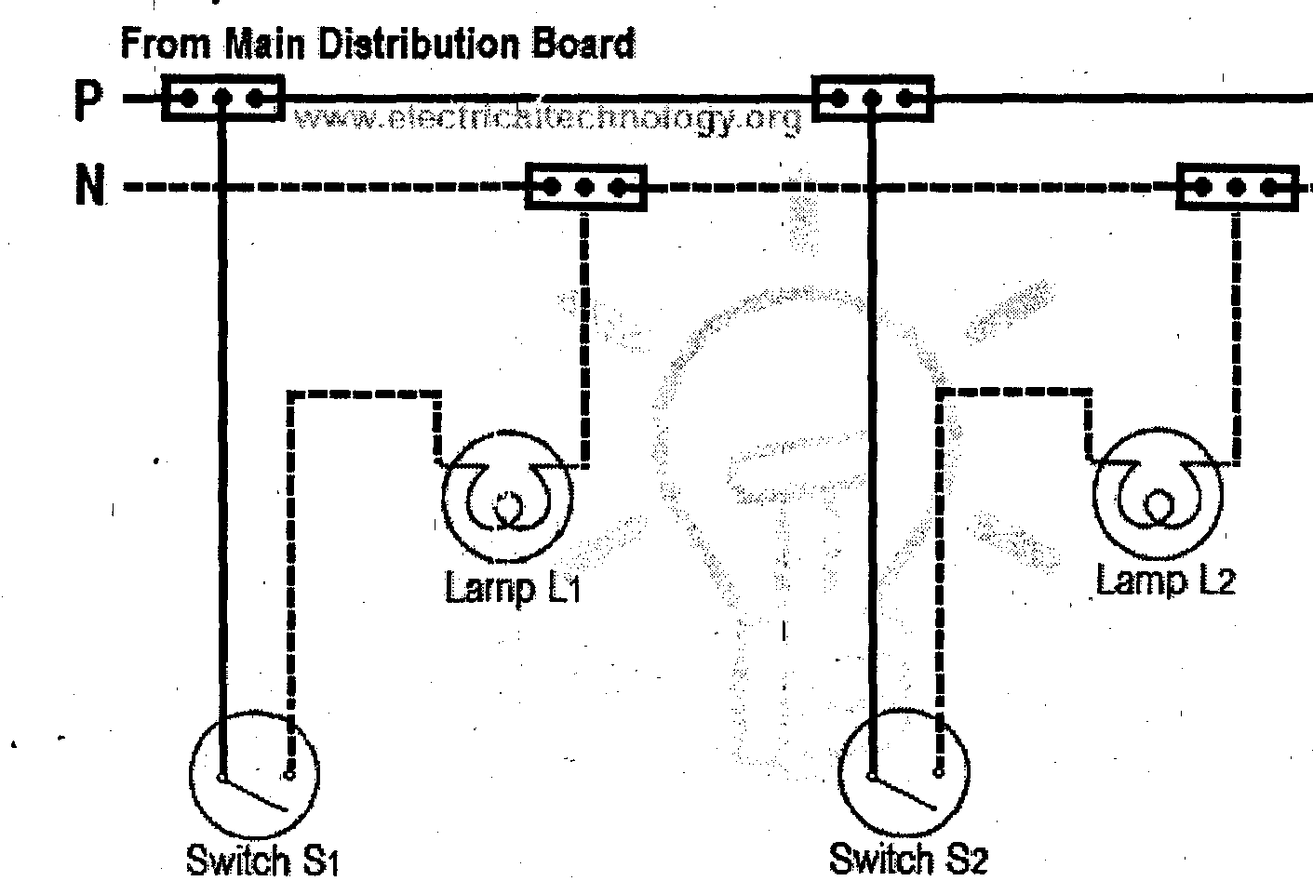

ELECTRICAL ACCESSORIES
There are different kinds of electrical accessories, these are:
i. Cutout fuse
ii. Lampholder
iii. Junction box
iv. Switch box
v. Socket
vi. Change over
vii. Gear switch
viii. Distribution board
ix. Lighting fittings
x. Switch
xi. Circuit breaker
xii. ceiling rose

- Cut out fuse
This type of device is a device which opens a circuit by means of a conductor designed to melt when an excessive current flow. A fuse consists of two main parts, which are base and bridge
There are different size of fuse such as 6Oarnps, 100amps, 200amps etc. There are two type of cut out
1. Plastic type
2. Granite type
> Lampholder
These are designed for quick removal and replacement of the lamp, and yet they mostly hold the lamp in firm metallic contact to prevent overheating. There are three main size of lampholder, these are: the bayonet cap (BC), the medium edition screw (ES) and the goliath edition screw (GES).
There are different types of lampholder;
1. Angle lampholder
2. Straight lampholder
3. Dropping lampholder
They are classified into two;
1. Screw lampholder
2. Pin lampholder
> JUNCTION BOX
An electrical junction box is an enclosure housing electrical connections. Junction boxes protect the electrical connections from the weather, as well as prevent people from accidental electric shocks.
- SWITCH BOX
These are types of device where switch socket and antenna socket are assembled.
Switch boxes are made in two ways;
I. Iron box
II. Par tress or plastic box
* And they are in different sizes;
1. 3/3 boxes
2. 3/6 boxes
3. Cooker unit boxes
> SOCKET
These types of circuits are devices that have switch and supply electricity current into appliances, televisions etc. it assemble to the switch box. We have different size of electric socket;
I. 13 amp socket
II. 15 amp socket
* Types of electric socket
i. Extension socket
ii. Multipurpose socket
> CHANGE OVER
These are types of device that control electricity current from PHCN to supply and Generator to supply and some control from inverter to supply.
There are different sizes of change ovr
i. 20 amp change over
ii. 30 amp change over
iii. 60 mp change over
iv. 100 amp change over
v. 120 amp change over

CHAPTER FOUR
4.0 RELEVANCE OF THE EXPERIENCE GAINED AT STUDENTS FIELD OF STUDY
In summary, this program has exposed me to some practical aspect in relation to my course of study (Electrical engineering) and I benefitted greatly from the grogram. What I learnt at various site involves the following
- Wiring installation system.
- Type of wire suitable for installation
- Types of wiring system
- Tools suitable for electrical installation
- Electronics repairing

CHAPTER FIVE
5.0 CONCLUSION
All this valuable experience and knowledge that have gained where only acquired through the dire involvement in task but also through other aspect of the training such as work observation, interaction with colleagues, superior and other people related to the field.
It also exposed me to some certain thing about electrical works and from what I have undergone, I am very sure that industrial training program has achieved it primary objective. As a result of the programme, I am now more confident to build my future career which I have already started with Omoolope Works Engineering Technology.
5.2 RECOMMENDATION
The polytechnic should make ii: compulsory for all students, since the programme goes way in improving student’s practical and theoretical experience.
SIWES programme is such a program that exposes students to the practical aspects of what a person has been taught theoretically in the school. A body also should be setup to give penalties to any students who refuses to go for his/her SIWES programs.

