A TECHNICAL REPORT

ON

STUDENT INDUSTRIAL WORKING EXPERIENCE SCHEME (SIWES)

HELD AT

COCOA RESEARCH INSTITUTE
21b Aba Akinjide Rd, Agodi, Ibadan 110115, Oyo

BY
ADELAKUN FARUK ADIO
ND/23/AGT/PT/0190

THE DEPARTMENT OF AGRICULTURAL TECHNOLOGY
INSTITUTE OF APPLIED SCIENCE (IAS)
IN PARTIAL FULFILMENT OF THE REQUIREMENT FOR THE AWARD OF NATIONAL DIPLOMA IN AGRICULTURAL TECHNOLOGY

SEPTEMBER – DECEMBER 2024

CERTIFICATION
This is to certify that the bearer has successfully completed the Student Industrial Work Experience (SIWES).

Department Coordinator Date

SIWES Director Date

DEDICATION
This report is dedicated to the Almighty God, the giver and sustainer of life, for His unconditional love and mercy granted to me throughout the period of my Industrial Training.
ACKNOWLEDGEMENTS

I thank Almighty God for the glory, honor, adoration and mercy I received during the course of my study and when undergoing my Student Industrial Work Experience Scheme (SIWES)

My appreciation also goes to my supervisor, during my training who accessibility, untiring effort, patience and guidance and suggestions fabulously contributed to the completion of this report. Who do not just teach me but makes me understood all his teaching, may Almighty God continue to guide and protect him and his house hold.

My appreciation also goes to my parent for their support during my training. May Almighty God continue to guide and protect them.

CHAPTER ONE

INTRODUCTION
1.0 BACKGROUND
The student industrial work experience scheme (SIWES) is a planned and supervised training intervention based on stated and specific learning and career objectives and geared towards developing the occupational competencies of the participants. It is a skill training program required to be undertaken by all student of tertiary institutions in Nigeria pursuing courses in specialized engineering, technical business, applied science and applied arts in order to expose and prepare them for industrial work situation (ITF, 2004a).
Therefore, SIWES is generic, cutting across over 60 programs in the universities, over 40 programs in the polytechnics and about 10 programs in the college of education. Thus, SIWES is not specific to ay one course of study or discipline.
1.1 ADVENT OF SIWES
In recognition of the short comings and weaknesses in the formation of SET graduated, particularly with respect to acquisition of relevant production skills (RPSS), the industrial training fund established the students industrial work experience scheme (SIWES) in 1973. The scheme exposes students to industry based skills necessary for a smooth transmission from the class room to the word of work. It affords student of tertiary institutions the opportunity of being familiarized and exposed to the needed experience in handing machinery and equipment which are usually not available in the educational institutions and enable them develop occupational competencies so that they can readily contribute their quote to national economic and technologies development after graduation.

1.2 ORGANIZATION AND OPERATION OF SIWES
The organization of the students’ industrial work experience scheme (SIWES) involves many stake holders as follows:
Federal Government (Federal Ministry of Commerce and Industry)
- Industrial training fund (SIWES DIVISION)
- Supervising/Regulating Agencies (NUC, NBTE, NCCE)
- Industry/Employers (NECA, NACCIMA, MAN, Government Establishments)
- Tertiary Institution (Universities, Polytechnic colleges of education) and
- Student Trainees (Engineering, Science, Technology, NCE Technical).
SIWES is operated as joint ventures through the contributory activities of the stake holders identified above. The roles of the various stake holders are:
The Federal Government (F) funds the scheme through the Federal Ministry of commerce and industry (FMCS & I). It also laid down broad politics and guidelines that govern the scheme.
The industrial training fund (ITF) parasternal of the Federal Ministry commerce of industry is responsible for the overall management of the scheme in collaboration with other stakeholders
- The Regulating/Supervising Agencies (NUC, NBTE, and NCCE) who regulate the tertiary institutions on behalf of the Federal Government to ensure that the guidelines of the operations of SIWES are followed by the institutions.
- Employers, members of the organized private sector (OPS) and Government Establishments, are the ultimate beneficiaries of SIWES since they depend on the national pool of technical skills for the operation and maintenance of their resources. They are required to provide places of industrial attachment for SIWES participants.
- Tertiary institutions are the primary beneficiaries of SIWES since the scheme contributes to enhancing the quality of their products. They carry out the implementation of SIWES. The institutions relate directly with all other stake holders except Federal Government.
- The students are the direct beneficiaries of SIWES since they are the recipients of the training provided through the scheme. In fact, the activities of all other stakeholder with respect of SIWES are geared towards ensuring relevant production skills (RPSS) before graduation, consequently, eligible students are required to participate in SIWES.
- In addition, an organ known as the chief Executives forum and comprising the chief Executives of ITF, NUC, NBTE, NCC and the OPS, is responsible for formulation of policies for the effective management and implementation of SIWES at the national level.
While all the stakeholders are involved in the operation of the scheme, the key actors or major players directly involved in the implementation of the scheme are the students, the employers and the institutions.
Other stakeholders have largely a lesser role or involvement with the actual training process (mate 2009)
The students, employers and the institution are the three actors in SIWES implementation.
Consequently, SIWES is a planned and structured program based on stated and specific career objectives which are geared toward developing the occupational competencies of participating students.
1.3 OBJECTIVES OF SIWES
The industrial training fund’s policy document No. 1 of 1973 (ITF, 1973) which established SIWES outlined the objectives of the scheme.
The objectives are to:
- Provide an avenue for students in institutions of higher learning to acquire industrial skills are experience during; prepare students for industrial work situations that they are likely to meet after, graduation.
- Expose students to work methods and techniques in handling equipment and machinery that may not be available in their institutions.
- Make the transition from school to the world of work easier and enhance students’ contacts for later job placements.
- Provide students with the opportunities to apply their educational knowledge in real work situations, thereby bridging the gap between theory and practice.
Enlist and strengthen employers’ involvement in the entire educational process through SIWES.
The Student Industrial Work Experience Scheme (SIWES) is a crucial part of the Agricultural Technology program, as it offers students the opportunity to apply the theoretical knowledge gained in the classroom to practical work experiences in the industry. For my SIWES placement, I was fortunate to be assigned to Cocoa Research Institute of Nigeria (CRIN), Ibadan, one of the foremost institutions dedicated to cocoa research in Nigeria.
Cocoa Research Institute of Nigeria (CRIN), established in 1964, is tasked with conducting research to improve the cultivation and processing of cocoa and other crops in Nigeria. CRIN is a key player in agricultural development and contributes significantly to the country's agricultural research efforts.

CHAPTER TWO
DESCRIPTION OF THE ESTABLISHMENT OF ATTACHMENT

2.1 HISTORICAL BACKGROUND OF COCOA RESEARCH INSTITUTE OF NIGERIA (CRIN), IBADAN
The Cocoa Research Institute of Nigeria (CRIN), located in Ibadan, Oyo State, is one of Nigeria's most prominent agricultural research institutions, with a focus on improving the cultivation, processing, and marketing of cocoa. The institute was established to conduct comprehensive research in various aspects of cocoa production, with the goal of enhancing the quality, yield, and overall sustainability of cocoa farming in Nigeria.

2.1.1 Founding and Early Development:
CRIN was founded in 1964 by the Federal Government of Nigeria in response to the growing importance of cocoa as a cash crop in Nigeria's agricultural economy. Cocoa had been one of Nigeria's most vital exports, but the production process faced numerous challenges, including pests and diseases, soil fertility issues, and low yields.
The institute was initially set up to address these challenges through scientific research and to support the Nigerian cocoa industry by improving the agricultural practices of local farmers. This was particularly important as the cocoa sector was essential to the national economy, providing jobs and livelihood to millions of Nigerians, especially in southwestern Nigeria.

2.1.2 Research Focus and Expansion:
Since its establishment, CRIN has been primarily focused on research in areas related to cocoa cultivation, pest control, genetics, and post-harvest handling. Some of the key research areas include:
- Cocoa Agronomy: Understanding the best farming practices for optimal cocoa yield, including soil management, planting techniques, irrigation, and intercropping systems.
- Pest and Disease Management: Identifying and combating pests and diseases that threaten cocoa production, including cocoa pod borer, black pod disease, and various fungal infections.
- Cocoa Genetics and Breeding: CRIN has worked to develop high-yielding and disease-resistant cocoa varieties, which are better suited to the local environment.
- Post-Harvest Technology: Researching techniques to improve the quality of cocoa after harvest, such as fermentation, drying, and storage methods to maintain and enhance flavor, and improve the market value of the cocoa beans.
- Environmental Sustainability: Developing farming practices that are environmentally sustainable and beneficial to both the ecosystem and cocoa farmers, including the reduction of the use of chemical fertilizers and pesticides.
CRIN has also diversified its research to cover other crops like coffee, kola nut, and cashew, which are economically significant in the region.

2.1.3 Significance in Nigeria's Agricultural Development:
Over the years, CRIN has played a significant role in the transformation of the cocoa industry in Nigeria. It has contributed to:
- The development of improved cocoa varieties that have higher yields and resistance to diseases.
- The dissemination of better farming practices to farmers, helping them increase their productivity.
- The formulation of policies that aim to improve the efficiency of the cocoa supply chain in Nigeria.
- A significant increase in the sustainability and profitability of cocoa farming in Nigeria.

2.1.4 Global Influence and Recognition:
The work carried out at CRIN has not only benefited Nigeria but has also contributed to global cocoa research. The institute has collaborated with international research bodies and cocoa industry stakeholders to share knowledge and expertise, helping improve cocoa production worldwide. Through its collaborations, CRIN has helped improve global cocoa quality standards and research methodologies.

2.1.5 Current Role and Contributions:
Today, CRIN continues to be a leading research institution in West Africa, contributing not only to the growth of the cocoa industry but also to the national economy by improving agricultural practices and promoting sustainable farming methods. Its outreach programs help educate and support cocoa farmers, improving their livelihood and boosting the local economy. Furthermore, CRIN’s research findings have enhanced the quality and competitiveness of Nigerian cocoa on the global market.
The Institute remains committed to its mission of advancing scientific research to enhance the production, processing, and marketing of cocoa, ensuring that Nigeria remains one of the top producers of cocoa globally.
In summary, the Cocoa Research Institute of Nigeria (CRIN) has played a pivotal role in the development of cocoa farming in Nigeria, from its establishment in 1964 to the present day. Its contributions to research in cocoa agronomy, pest control, post-harvest technology, and sustainable farming practices continue to have a profound impact on both the Nigerian economy and the global cocoa industry.
2.2 Core Mandate:
- To carry out research into cocoa production, processing, and marketing.
- To develop strategies for improving cocoa yield, pest control, and post-harvest handling.
- To provide training and support for cocoa farmers and stakeholders in the industry.
2.3 Mission: To enhance the production and quality of cocoa in Nigeria through innovative research and the dissemination of knowledge to farmers and industry stakeholders.
2.4 Vision: To be a global leader in cocoa research and innovation, improving livelihoods and contributing to sustainable agriculture.
2.5 ORGANOGRAM OF COCOA RESEARCH INSTITUTE OF NIGERIA (CRIN)

CHAPTER FOUR

TRAINING AND ACTIVITIES
During my SIWES placement at CRIN, I was involved in a variety of training activities that spanned different aspects of cocoa research and farming practices.
Introduction to Cocoa Research and Orientation
My first week at CRIN began with an orientation program where I was introduced to the mission, objectives, and research projects of the institute. I toured the research farms, the laboratory, and other key facilities. During this time, I was briefed on the importance of cocoa research, the institute's key areas of focus, and the basic operations in cocoa farming.
Cocoa Nursery Management
During my second week at the Cocoa Research Institute of Nigeria (CRIN), I had the opportunity to participate in cocoa nursery management, which is a critical stage in cocoa production. Cocoa nurseries are essential for growing healthy cocoa seedlings that will later be transplanted into the field. Proper management of the nursery ensures that the young cocoa plants are strong, disease-free, and ready for successful transplantation into the farm.

Cocoa Nursery Management

Planting Cocoa Seedlings: The first step I was involved in was the preparation of the nursery beds. This process included clearing the land, tilling the soil, and ensuring proper drainage to avoid waterlogging, which could adversely affect seedling growth. The selection of seeds was a crucial part of nursery management. I learned that only high-quality cocoa seeds from reliable sources are chosen for planting to ensure that the seedlings will have good genetic potential for high yields and disease resistance.
After preparing the nursery beds, I participated in planting cocoa seeds in small nursery pots, where they would be nurtured until they are strong enough for transplanting. The spacing of the seeds was important to allow sufficient room for root development and prevent overcrowding, which could lead to competition for nutrients and light.

Planting Cocoa Seedlings
Irrigation and Watering: Proper irrigation is crucial for the growth of cocoa seedlings. During my training, I learned how to maintain appropriate watering schedules, ensuring that the seedlings received the right amount of water. Over-watering or under-watering can stunt growth, so we ensured that the soil was kept consistently moist but not waterlogged. We used both manual watering methods and automated drip irrigation systems, depending on the scale of the nursery. I learned the importance of avoiding water stress, as it can lead to poor seedling development.

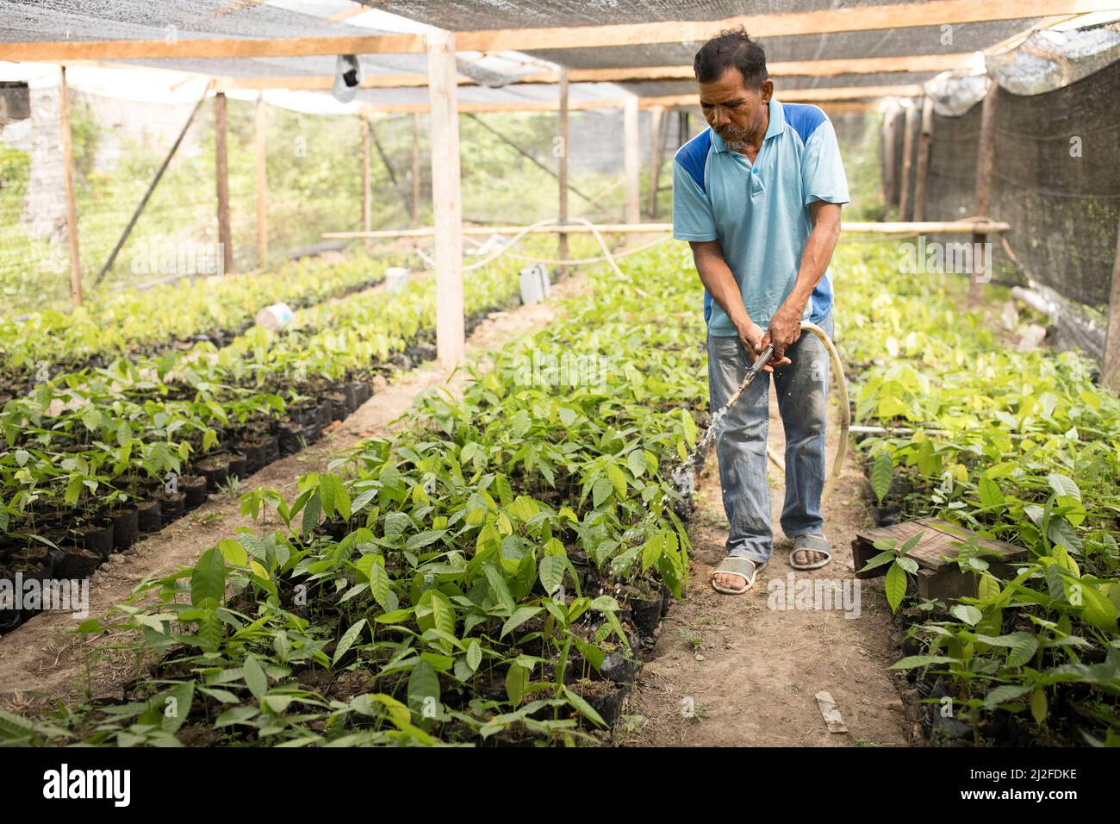

Irrigation and Watering
Soil Types and Fertility: The type of soil in the nursery plays a significant role in the development of cocoa seedlings. I was introduced to the concept of soil fertility management and learned about the different soil types suitable for cocoa cultivation, such as loamy soils, which are rich in organic matter and well-drained. I observed the practice of testing soil pH levels and other nutrients to ensure that the nursery soil was adequately prepared for the cocoa seedlings.
In some cases, fertilizers and organic matter were added to improve the nutrient content of the soil, particularly for areas where the soil fertility was low. I was also educated about the use of mulching techniques to conserve soil moisture, control weeds, and maintain soil temperature.
Managing Cocoa Plant Health: Maintaining the health of cocoa seedlings in the nursery was a critical part of my training. I learned about various common pests and diseases that affect cocoa seedlings, such as fungal infections, aphids, and cocoa mirids. Preventing these problems early on is essential for producing strong, healthy plants.
I participated in the application of preventive treatments and pesticides, although I was informed that CRIN prioritizes integrated pest management (IPM) techniques, which involve the use of biological control agents, cultural practices, and minimal use of chemical pesticides. I also learned how to monitor the nursery daily for any signs of disease or pest infestation and how to take quick action to contain the problem before it spreads.
Additionally, I was introduced to the importance of pruning the seedlings in the nursery to remove dead or damaged leaves, allowing better air circulation and light penetration. This helped prevent the buildup of diseases and promoted healthy growth.
Transplanting Seedlings: After spending several weeks in the nursery, the seedlings eventually reached the appropriate size and strength to be transplanted into the field. I had the opportunity to assist in preparing the seedlings for transplantation, ensuring that the roots were well-protected during the process to prevent transplant shock. This involved carefully digging up the seedlings, keeping the root systems intact, and transplanting them into prepared farm plots where they would continue their growth into mature cocoa trees.
In conclusion, my experience with cocoa nursery management at CRIN gave me a deeper understanding of the critical importance of the early stages of cocoa production. By learning the essential skills involved in preparing, nurturing, and maintaining healthy cocoa seedlings, I gained valuable insight into how research institutions like CRIN help farmers achieve higher yields and better-quality cocoa crops. The lessons on irrigation, soil management, pest control, and plant health will be valuable for my future career in agricultural technology.

Transplanting Seedlings

Field Management of Cocoa Farms
In my third week, I was actively involved in fieldwork, including the preparation of cocoa farms for planting and the maintenance of existing cocoa plants. I learned about the spacing of cocoa plants, the importance of soil fertility, and the use of fertilizers to ensure optimal growth. We also worked on weeding and mulching the cocoa fields to improve the health of the plants.
Pest and Disease Management
Cocoa crops are highly susceptible to various pests and diseases, which can significantly reduce yield and quality if not effectively controlled. During my time at the Cocoa Research Institute of Nigeria (CRIN), I was given a comprehensive introduction to the strategies employed to manage these threats. I had the opportunity to work closely with the research team, where I gained hands-on experience in pest and disease identification and learned about effective management strategies, including the widely adopted Integrated Pest Management (IPM) approach.

Key Pests and Diseases of Cocoa
One of the first aspects of pest and disease management that I was introduced to was understanding the common pests and diseases that affect cocoa plants. Some of the key pests and diseases that I learned about include:

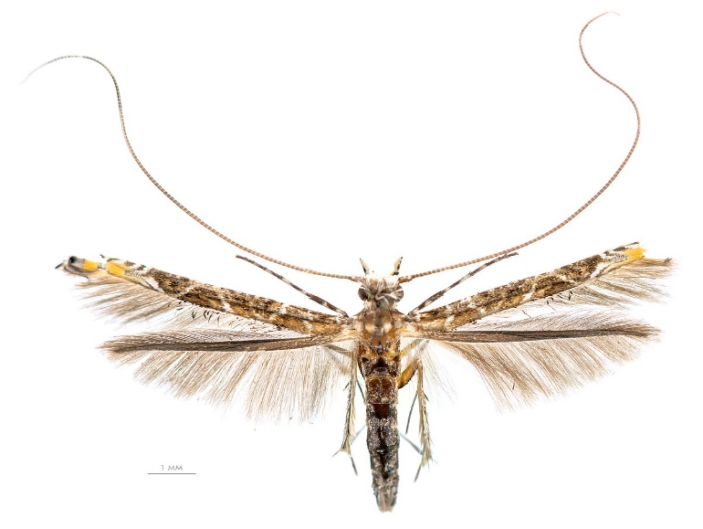
Cocoa Pod Borer (Conopomorpha cramerella)

Black Pod Disease (Phytophthora palmivora)

Cocoa Mirid (Sahlbergella singularis)

Cocoa Pod Sucking Moth (Crioprosopus curvifascia)

Integrated Pest Management (IPM)
The concept of Integrated Pest Management (IPM) was one of the most valuable techniques I learned during my training at CRIN. IPM is a comprehensive and sustainable approach to pest and disease management that combines various methods to reduce the use of chemical pesticides, which can harm the environment and non-target organisms. The strategies involved in IPM include biological, cultural, and chemical control methods.

Biological Control
One of the first methods I learned about was biological control, which involves using natural predators or parasites to control pest populations. For example, researchers at CRIN have explored the use of predatory insects, such as ant species that feed on the cocoa pod borer larvae, as a natural form of pest control. I also learned about beneficial fungi that can be used to target and kill pests like the cocoa pod borer without harming the cocoa plants or the environment.

Cultural Control
Cultural control methods focus on altering farming practices to reduce the suitability of the environment for pests. At CRIN, I was trained on how pruning cocoa trees to improve air circulation can reduce humidity around the plant, which helps prevent the spread of diseases like black pod. I also learned about the importance of sanitation in cocoa farms, such as removing infected pods and debris from the farm to prevent disease build-up. Additionally, we discussed the benefits of crop rotation and intercropping with other crops like banana or plantain that can act as natural barriers against pests.

Chemical Control
While CRIN emphasizes sustainable and environmentally friendly pest control methods, I also learned about the role of chemical control in certain situations. Pesticides are sometimes necessary when pest populations reach damaging levels. I was introduced to the safe and responsible use of chemical pesticides to control pests like the cocoa pod borer and mirids. The key takeaway from the training was that chemical pesticides should be used judiciously, ensuring that they do not harm the environment or beneficial organisms.
The team at CRIN also educated me about pesticide resistance, which can occur when pests become immune to the chemicals used to control them. To mitigate this, they advocated for the rotational use of pesticides, ensuring that different classes of pesticides are used over time to prevent resistance from developing.

Monitoring and Early Detection
A critical component of pest and disease management that I learned at CRIN was regular monitoring and early detection. Monitoring involves inspecting cocoa farms regularly for signs of pest or disease infestations. We participated in the systematic observation of cocoa trees, particularly during the flowering and fruiting seasons when pests like the cocoa pod borer are most active. Early detection allows for targeted interventions before the problem escalates and causes significant damage.
CRIN has established protocols for farmers to follow in order to monitor their cocoa crops effectively. This includes setting up trap systems for pests, using pest population count methods, and recording environmental conditions that might contribute to the spread of diseases. This proactive approach helps farmers minimize losses.

Research and Innovation at CRIN

The research at CRIN is focused on finding more sustainable and efficient ways to manage cocoa pests and diseases. I had the opportunity to assist in some of the research activities, including laboratory experiments to test the effectiveness of various pest control methods. We also participated in field trials to assess the performance of different cocoa varieties that are resistant to pests and diseases, and to evaluate new techniques for improving the health and resilience of cocoa plants.
One significant aspect of my training was learning how research findings at CRIN are communicated to farmers through extension services. The institute works closely with farmers, providing them with training and resources to implement pest and disease management strategies on their own farms. This knowledge transfer ensures that farmers can improve their crop yields and reduce losses due to pests and diseases.

Conclusion
My experience with pest and disease management at the Cocoa Research Institute of Nigeria (CRIN) was an invaluable part of my SIWES training. I gained an in-depth understanding of the challenges cocoa farmers face in protecting their crops from pests and diseases, and the various strategies employed to manage these threats. Through the use of Integrated Pest Management (IPM) techniques, I learned how to combine biological, cultural, and chemical methods in a balanced approach that prioritizes sustainability and environmental health. This knowledge will be useful in my future career in agricultural technology, as it emphasized the importance of sustainable farming practices and innovative research in addressing challenges in crop production.
Cocoa Harvesting Techniques
Cocoa harvesting is a delicate process that requires precision and knowledge of the correct timing. During this week, I learned how to identify mature cocoa pods and participated in the harvesting process. We also practiced the proper method of pod splitting, which is essential for the fermentation process that follows.

Cocoa Harvesting
Fermentation and Drying of Cocoa Beans
One of the key processes I was involved in was the post-harvest handling of cocoa. I learned about the importance of fermentation and how it influences the flavor and quality of cocoa beans. After fermentation, we were involved in the drying process, where I learned the importance of proper drying techniques to prevent the growth of molds and ensure that the beans maintain their quality for processing.

Fermentation and Drying of Cocoa Beans
Research Techniques and Data Collection
Throughout my time at CRIN, I assisted in collecting data from ongoing research projects. This involved measuring various parameters such as cocoa yield, the quality of harvested beans, and the effectiveness of different pest management strategies. I learned how to record and analyze research data accurately and how it is used to make informed decisions about cocoa farming practices.
Reporting and Documentation
In the final week of my training, I was involved in compiling research findings and documenting the results of ongoing projects. I learned the importance of effective data management and reporting in agricultural research, which is essential for drawing conclusions and making recommendations to farmers.

CHAPTER FOUR

SKILLS AND KNOWLEDGE ACQUIRED
During my SIWES training at Cocoa Research Institute of Nigeria (CRIN), I acquired the following skills and knowledge:
- Cocoa Cultivation Techniques:
  - Knowledge of the entire cocoa production process, including planting, maintenance, and harvesting.
- Pest and Disease Management:
  - Practical understanding of pest and disease management strategies for cocoa farms.
- Post-Harvest Handling:
  - Learned methods of fermenting and drying cocoa beans to improve quality.
- Research Skills:
  - Gained practical experience in conducting agricultural research, analyzing data, and preparing reports.
- Agricultural Extension Skills:
  - Improved my communication skills by learning how to convey research findings to farmers.
- Laboratory Skills:
  - Hands-on experience with laboratory techniques for analyzing cocoa beans and other agricultural products.
CHALLENGES ENCOUNTERED
- Fieldwork Challenges:
  - Working in the fields under varying weather conditions presented challenges, especially with weeding and pest control.
- Technical Difficulties:
  - Occasionally, some laboratory equipment was not functioning optimally, which delayed certain analyses.
- Adapting to Research Work:
  - The nature of research work required a high level of attention to detail and patience, which took time to adjust to.

CHAPTER FIVE

5.1 CONCLUSION
My SIWES training at Cocoa Research Institute of Nigeria (CRIN) was an incredibly valuable experience that enhanced my understanding of cocoa production and agricultural research. The knowledge and skills I gained have deepened my appreciation for the work done by agricultural researchers to improve food production systems. I am confident that the experience will contribute significantly to my academic journey and future career in agricultural technology.

5.2 RECOMMENDATIONS
- Enhanced Field Training:
  - More hands-on experience in the field to develop practical farming skills.
- Training on Advanced Research Techniques:
  - Exposure to advanced research methods and data analysis tools would enhance students' understanding of agricultural research.
- Community Outreach Programs:
  - Increasing community outreach and farmer engagement programs to ensure the dissemination of research findings.

