TECHNICAL REPORT WRITING
ON
STUDENTS’ INDUSTRIAL WORK EXPERIENCE SCHEME (SIWES)
HELD AT
ZAH DESIGN AND PROJECT LIMITED
OFFICE ADDRESS:- KM 5 OLD JEBBA ROAD, AGRIC ESTATE ILORIN, KWARA STATE.
PRESENTED BY
ADEKOLA ISMAILA TUNDE
ND/23/BLD/PT/0006
SUBMITTED TO THE DEPARTMENT OF BUILDING TECHNOLOGY, INSTITUTE OF ENVIRONMENTAL STUDIES,
KWARA STATE POLYTECNIC, ILORIN.
IN PARTIAL FULFILMENT OF THE REQUIREMENTS FOR THE AWARD OF NATIONAL DIPLOMA (ND) IN BUILDING TECHNOLOGY.
MARCH 2025.
DECLARATION
I ADEKOLA ISMAILA TUNDE with Matric Number ND/23/BLD/PT/0006,
Hereby declared that this project is authentic and a documentation of my research work during my (SIWES) at Zah Design and Project Limited.

Date ……………………..... Signature ………………….

DEDICATION
I declare this project firstly to Almighty God, the maker of heaven and earth, who has enabled me to be alive to study in this Institution and to write this project.
I also dedicate this project to my lovely parent who has been always helpful and caring for me since my childhood till this present moment. I pray that Almighty God continue to bless them.

ACKNOWLEDGEMENT
First and first most, I thank God Almighty for making this report a reality. I also thank my H.O.D of Building Technology Department.
My appreciation also goes to all my lecturers and non teaching staff in my department, who took me throughout my stay in school I say thanks to you all God bless you
One again, I will like to appreciate my parent in person Mr. & Mr. Adekola and all staff at Zah Design and Project Limited, I said thanks you all.

TABLE OF CONTENT
Declaration
Acknowledgement
CHAPTER ONE
1.0 Introduction to SIWES
1.1 Definition
1.2 Aims and Objectives of SIWES
1.3 The scope and importance of SIWES
CHAPTER TWO
2.0 Section/units of the organization and specific (ZAH DESIGN AND PROJECT
2.1 Historical background of the organization ZAH DESIGN AND PROJECT
2.2 Organization Chart of Zah Design and Project Limited
CHAPTER THREE
3.0 Students special involvement at various sections Architectural/Engineering instruments and their functions
CHAPTER FOUR
4.0 Setting out
4.1 Setting out equipment
4.2 Method of setting out a building
4.3 Process of setting out
CHAPTER ONE
INTRODUCTION
The Students’ Industrial Work Experience Scheme (SIWES) is a skill acquisition and training program designed to prepare students of tertiary institutions for the real-world challenges of the workplace. The scheme was established by the Industrial Training Fund (ITF) in 1973 to enhance the practical skills and competencies of undergraduates in engineering, technology, sciences, agriculture, and other applied disciplines. The primary goal is to bridge the gap between theoretical knowledge and practical application, ensuring that graduates are better equipped for employment in industries.
Before the introduction of SIWES, many graduates from technical and science-based courses lacked the necessary hands-on experience required by industries. Employers often found it necessary to retrain graduates before they could effectively contribute to the workforce. The scheme was initiated to solve this problem by exposing students to industrial processes, modern technology, and workplace ethics while still in school. Today, SIWES remains an integral part of higher education in Nigeria, playing a critical role in workforce development and industrial growth.
DEFINITION OF SIWES
The Students' Industrial Work Experience Scheme (SIWES) is a practical training program designed for undergraduates in Nigerian universities, polytechnics, and colleges of education. It is a structured industrial training program that provides students with an opportunity to gain relevant work experience in industries that align with their field of study.
SIWES is a compulsory training program for students in technical and science-based disciplines, ensuring that they acquire industry-related skills, familiarize themselves with real-world work environments, and become more employable upon graduation. The program is funded and supervised by the Industrial Training Fund (ITF), in collaboration with the National Universities Commission (NUC), National Board for Technical Education (NBTE), and National Commission for Colleges of Education (NCCE).
AIM AND OBJECTIVES OF SIWES
The primary aim of SIWES is to provide students with industrial exposure, helping them develop practical skills that complement their academic knowledge.
Objectives of SIWES:
1. bridging the Gap between Theory and Practice – SIWES ensures that students can apply the theoretical knowledge they gain in classrooms to real-world scenarios in industries.
2. Enhancing Employability – The scheme equips students with hands-on experience, making them more marketable and reducing the need for extensive post-graduation training by employers.
3. Skill Development – Students acquire technical and soft skills such as communication, teamwork, problem-solving, and time management.
4. Familiarization with Workplace Ethics – SIWES introduces students to organizational structures, work ethics, and professional conduct expected in the industry.
5. Exposure to Modern Equipment and Technology – Many industries use advanced technologies that may not be available in educational institutions. SIWES exposes students to these modern techniques.
6. Encouraging Entrepreneurship – By working in real business environments, students may identify opportunities and gain insights that can help them start their own businesses in the future.
7. Improving Academic Performance – Practical experience helps students understand their coursework better, reinforcing what they have learned in school.
8. Facilitating Industrial-Academic Collaboration – SIWES strengthens the relationship between educational institutions and industries, fostering innovation and knowledge transfer.
SCOPE OF SIWES
The scope of SIWES covers a wide range of industrial sectors and disciplines, allowing students to gain hands-on experience in areas related to their course of study.
Industries Covered by SIWES:
Engineering and Technology – Electrical, Mechanical, Civil, and Computer Engineering
Information Technology (IT) – Software Development, Networking, Cyber security
Agriculture and Environmental Science – Farming, Fisheries, Forestry, Soil Science
Medical and Pharmaceutical Sciences – Laboratory Science, Pharmacology, Biomedical Engineering
Oil and Gas Industry – Petroleum Engineering, Refining, Pipeline Management
Construction and Building Technology – Architecture, Building Technology, Urban and Regional Planning, Estate Management Quantity Surveying and Structural Engineering
Banking and Finance – Accounting, Economics, Investment Analysis
Media and Communication – Journalism, Mass Communication, Public Relations
The training is typically conducted in government agencies, private organizations, research institutions, and multinational companies that have relevant industrial facilities.
IMPORTANCE OF SIWES
SIWES is an essential component of education in Nigeria, benefiting students, industries, and the economy at large.
1. Importance to Students:
- Provides practical experience that complements classroom learning.
- Enhances employability by equipping students with real-world skills.
- Builds confidence and improves technical competencies.
- Exposes students to modern tools, equipment, and software used in industries.
- Improves teamwork, leadership, and problem-solving abilities.
2. Importance to Industries:
- Provides industries with an opportunity to train and recruit future employees.
- Reduces the cost of on-the-job training for fresh graduates.
- Helps industries identify and nurture talented students for future employment.
- Strengthens collaboration between academia and industries.
3. Importance to Educational Institutions:
- Improves the quality of graduates by integrating practical training with academic programs.
- Enhances research and innovation through industry-academic partnerships.
- Keeps institutions updated on industrial trends and technological advancements.

4. Importance to the Economy:
- Contributes to workforce development, boosting national productivity.
- Reduces unemployment by making graduates more job-ready.
- Encourages entrepreneurship and self-employment.
CONCLUSION
The Students’ Industrial Work Experience Scheme (SIWES) is a vital program that plays a crucial role in shaping the careers of undergraduates in Nigeria. It bridges the gap between theoretical education and practical industry demands, ensuring that students graduate with the necessary skills to succeed in their respective fields. SIWES not only benefits students but also strengthens industries and contributes to national economic growth.

CHAPTER TWO
2.0 SECTION/ UNITS OF THE ORGANIZATION AND SPECIFICATION AT
(ZAH DESIGN AND PROJECT LIMITED)
ZAH DESIGN AND PROJECT LIMITED is a private Architectural firm that Deal with Design, Building Services and oversees Construction. It’s an environmental designer that Deals with Construction Works and General Supplying Services, with diversified experience and sound background in the field of environmental planning and design, construction and related engineering services.
Presently Zah Design and Project Limited has the following department unit or sections headed by respective directors and these are;
1. Administrative department
2. Architectural and building department
3. Estate management department

HISTORICAL BACKGROUND OF ZAH DESIGN AND PROJECT LIMITED
was established for the design, costing and supervision of all building projects, maintenance and general consultancy services are also performed in the organization.
It is private firm located at no Km 5 Old Jebba Road, Agric Estate ilorin, Kwara State.
The company main responsibilities include; Architectural design, building construction and supervision, building valuation and land surveying. Many construction projects have been executed by the company Lagos State and other state of the country, their management efficiency attract lots of clients to the company. The company is committed to maintaining its personality and reputation by rendering quality services with absolute integrity and trustworthiness.
2.1 ORGANIZATION CHART
- Reception,
- Administrative and Finance Section ,
- Construction Management and Procurement Unit
- Design unit
- Principal Architect Office
- Chief Architect Office
- Directorate Office.

CHAPTER THREE

3.0 STUDENTS SPECIAL INVOIVEMENT AT VARIOUS SECTION ARCHITECTURAL INSTRUMENTS AND THIRD FUNCTIONS
Explaining the various architectural instruments to me and my colleagues and their various functions e.g. T-square for horizontal lines.
Adjustable Set Square for vertical lines and for angles, circles template for arc and circle, furniture arrangement, stencil for writing Alphabets and numbers and scale rule for measuring e.t.c.
Architectural Lettering, Accuracy, Linear Measurement and Units Conversion
This is the act of written an alphabet and number in architecture.
Lettering is important on architecture because is the act that will teach how to write in an architecture.
Conversion
This is the process of changing measurement from one unit to another e.g. changing of feet to meter, Millimeter to feet e.t.c

Table1.0
Minimize for (mm) | Metre (m) | Inches (") | Feet(')
25 | 0.025 | 1 | 0
50 | 0.050 | 2 | 0
300 | 0.3 | 12 | 1

Example
1. 300mm=0.4m12"=1ft
2.1200mm=1.2m=48"=14ft
3. 4200mm=4.2m 168"=14ft
Accuracy
This is an attempt to establish the difference between the measured value and the true value. Although absolute accuracy is not possible.
(a) Dimensioning; This Is the act of measuring the drawing so as to know the size of the drawing i.e. to know the length and breadth of a project and also per Square Meter covered.

(b) DRAWING
Various types of drawing involved to make up vis plan of a building are:
1. Architecture drawing
2. Structural drawing
3. Electrical and mechanical drawing
1. ARCHITECTURAL DRAWING
There are two classes of drawing in Architecture namely;
- Working drawing
- Presentation drawing
Working drawing
This is the type of drawing that is used for the construction of a project and is also the drawing that others draw i.e. structural, electrical and mechanical drawing will follow for the production of their own drawing, an architect must sure that drawing is well discussed .
Presentation Drawing
This is the type that is presented to the client so as to know that his/her project will look like.
FLOOR PLAN
This is plan that shows the arrangement of different rooms (spaces) and passage. Each floor must be provided with a floor plan.
A floor plan is usually a sectional plan at about the edge level of the observer and must give those details of the following.
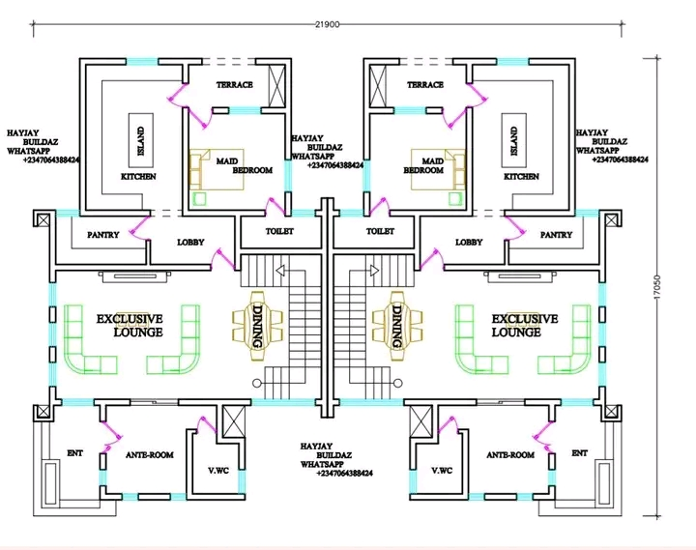
- Direction of North
- The size and spacing of all supporting members and the thickness of all walls.- the exact location of doors, windows, wardrobes, water closet, sinks, baths or any other features that can be changed seen.(There objects must be indicated by the appropriate standard symbols.)The overall dimensions and sizes of individual's part

ROOF PLAN
This is the plan that shows the roof of a building when it's viewed i.e. the view is above the plan. Roof plan must at least be 600mm projected away from the normal building this is because it will prevent the building from direct rays of the sun and rain. The projection is called roof overhang.

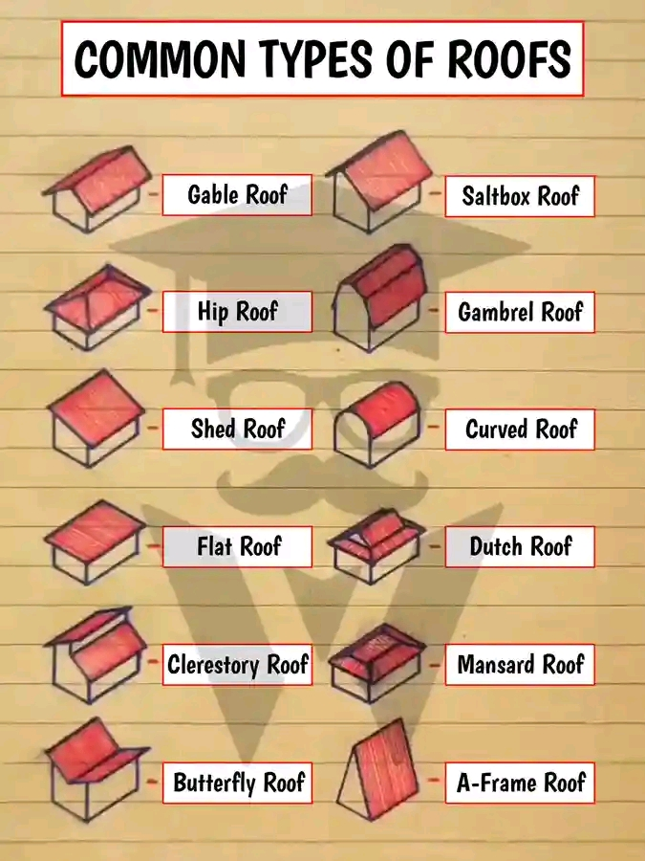
SECTION
This is the plan that show the skeleton of the building so as to detail some feature that can be seen in the elevations.
We have to two types of section namely:
1. Cross section
2 longitudinal section
(5a) CROSS SECTION
There are vertical sectional elevation through the building.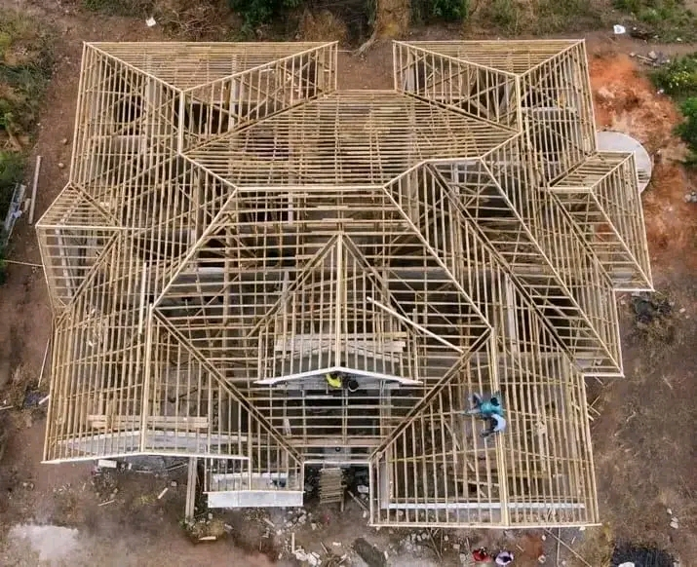
(5b). LONGITUDINAL SECTION
Longitudinal section Al elevation cut through the building section must be chosen so that they cut (and show) as many detail as possible. The following details must be given.
- Detail of construction materials ( which may beshown symbolically), together with the thickness of each.
- The height of doors, windows, wardrobes, and ceilings.
- The depth and width of foundations, beams walls and floors.
- The arrangement for and the slope of the roofs.
- The street and ground elevation
- Details of stair cases
ELEVATION
This is the plan that shows the external face of a building which will have four type of elevation.
1. front elevation
2 Right. elevation
3. Left elevation
4.Back elevation
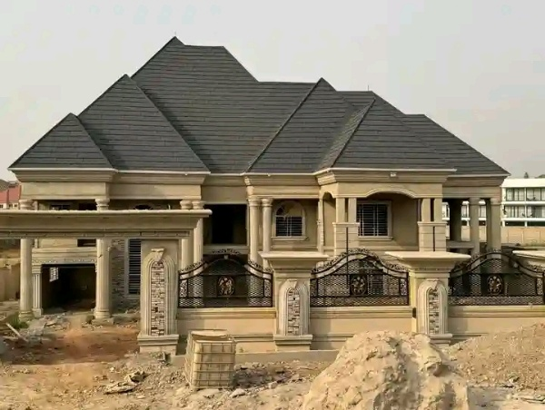
During the period of my attachment, my experiences constituted of the following
1. Office activities.
2. Site and technical meetings.
3. Construction and site activities.
Which are on detail below?
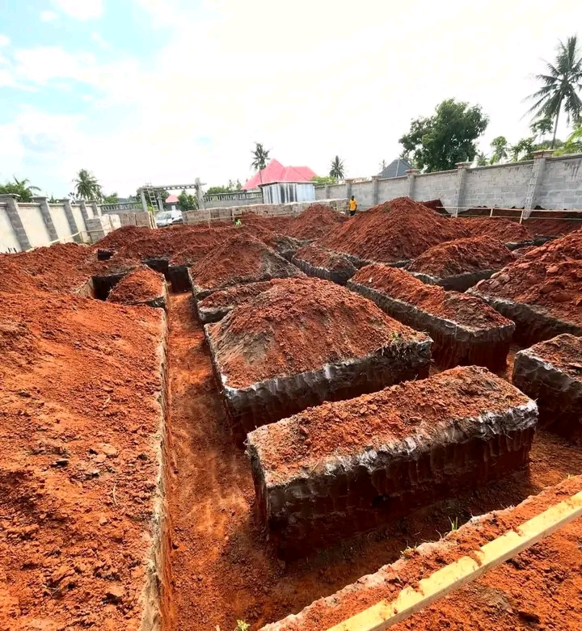

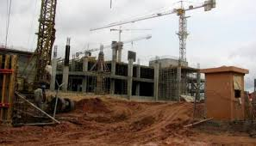
Site activities
3.1 OFFICE ACTIVITIES
I was exposed to some office and Secretariat works and computer works during the course of my attachment. Die to the development and scientific advancements in our t which has also affected Architecture in a large way.
One of such area is in the creation of Architectural design software such as autocad
I was privileged to draw with Autocad such as floor plan, roof plan, sections and elevations.

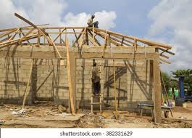
Construction and site activities 1

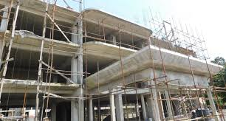
Construction and site activities 2

Office activities on software program

CHAPTER FOUR
SETTING OUT
is the process of transferring architectural and engineering designs from drawings to the ground. It involves marking the exact positions of structural elements such as walls, columns, foundations, and utilities to ensure construction is done accurately according to the plan. This process is crucial in avoiding errors that could lead to structural instability, misalignment, or costly rework.
A Setting Out Could Also Be Define as transferring of information on the building drawing to the ground with high degree of accuracy. The first tasked in setting out a building is to establish a base line from which the whole of the building can be set out. After the base line has been established, marked and checked the main lines of the building to be set out.
4.1 Setting out equipment
1 measuring tape 2 Profile 3 pegs 4 hammer 5 white chalk/marker or pencil 6 builder square 7 Leveling Instrument
Methods of Setting out in Construction
Several methods are used to set out buildings, depending on the size and complexity of the project. These methods include:
3-4-5 or Pythagoras Theorem Method
This method is used to ensure right angles are correctly set.
A triangle with sides in the ratio of 3:4:5 (or multiples of these numbers) is created using a tape measure.
The correct positioning of corners is verified using this geometric principle.
Theodolite and Total Station Method
A theodolite or total station is used to measure angles and distances with high accuracy.
Engineers/Architects set up reference points and use these instruments to mark out grid lines, foundation trenches, and structural positions.
This method ensures precise alignment and level control.
Peg and String Line Method
Wooden or metal pegs are driven into the ground at key points.
String lines are stretched between the pegs to mark straight lines for walls and boundaries.
This is a simple and cost-effective method, often used for small-scale projects.

Batter Boards and Sight Rails Method
Timber batter boards are installed around the site.
Horizontal and vertical reference lines are marked to control excavation and foundation levels.
This method helps keep level control throughout the construction process.
GPS and Digital Setting Out
Advanced GPS (Global Positioning System) technology is used for large-scale projects.
Digital data is fed into the system, which guides the construction team in marking out positions with high precision.
This is commonly used in modern civil engineering projects, including road and bridge construction.
Laser Leveling Method
A laser level is used to project a straight beam over a distance.
This method ensures horizontal and vertical accuracy for slab construction, formwork, and other structural components.
It is particularly useful in large sites where precise level control is essential.
Conclusion
Setting out is a critical step in construction that determines the accuracy and quality of the final structure. The choice of method depends on the project's complexity, available equipment, and required accuracy. Proper setting out minimizes errors, reduces material wastage, and ensures structural stability.
