

A TECHNICAL REPORT ON STUDENT INDUSTRIAL WORKING EXPERIENCE SCHEME (SIWES)

HELD AT
RAY POWER 95.1 FM
COCOA HOUSE DUGBE, IBADAN OYO STATE

BY

POPOOLA MUFULIAT AYOMIDE
ND/23/MAC/PT/0949

SUBMITTED TO
THE DEPARTMENT OF MASS COMMUNICATION
KWARA STATE POLYTECHNIC ILORIN, KWARA STATE.
IN PARTIAL FULFILMENT OF THE REQUIREMENT FOR THE
AWARD OF NATIONAL DIPLOMA IN MASS COMMUNICATION

AUGUST – NOVEMBER, 2024.
DEDICATION
This report is dedicated to ALLAH for the successful completion of this SIWES.

ACKNOWLEDGEMENT
My first appreciation goes to Almighty ALLAH for His faithfulness and loving kindness over me throughout my training period.
I also want to express my heart of immense gratitude to my beloved parents Mr and Mrs POPOOLA for their Maternal and Paternal love and support for me. To all staffs of RAY POWER 95.1 FM Radio/Audio Studio Cocoa House Dugbe, Ibadan, Oyo State, I’m grateful for accommodating us and for putting us through the major techniques used in broadcast media. You are all wonderful.
My appreciation also goes to everyone who had contributed to the success of this training in one way or the other. God Bless You All.

PREFACE
The Student Industrial Work Experience Scheme (SIWES) is a National Diploma Curriculum of the Department of Mass Communication, Kwara State Polytechnic Ilorin. The programme was established by the Industrial Training Fund (ITF) in 1973 to 1974.
It is designed to acquire the student with life situation in industries as well as supplies in a more practical manner and their knowledge in practical activities and other practical field during their course of study.

TABLE OF CONTENTS
Title Page i
Dedication ii
Acknowledgement iii
Preface iv
Table of Contents v

CHAPTER ONE
INTRODUCTION
1.0 Brief History of SIWES
1.1 Aims and Objectives of SIWES

CHAPTER TWO
THE ORGANIZATION
2.0 History of the Organization
2.1 Organogram of Raypower 95.1 fm Ibadan
2.2 Functions of the Major Department at Raypower 95.1 fm Ibadan

CHAPTER THREE
STUDIO EQUIPMENT
3.0 Studio Tools

CHAPTER FOUR
TRAINING EXPERIENCE
4.0 Technical Training Experience
4.1 Challenges

CHAPTER FIVE
CONCLUSION AND RECOMMENDATION
5.0 Suggestion for Improvement of the Scheme
5.1 Conclusion

CHAPTER ONE
INTRODUCTION
- BRIEF HISTORY OF SIWES
The Student Industrial Work Experience Scheme (SIWES) was established in 1973 by the Industrial Training Fund (ITF). Prior to the establishment of the scheme, there was a growing concern among our industrialist that graduates of our institutions of higher learning lacked adequate practical background studies preparatory for employment in industries. It is against this rationale for initiating and designing the scheme hinged.
Consequently the scheme affords students the opportunity of familiarizing and exposing themselves to the needed experience in handling equipment and machinery that are usually not available in their institutions so as to smoothen their entry into industrial practices on completion of their studies and also reduces period spent in training fresh graduates as new employees.
1.1 AIMS AND OBJECTIVES OF SIWES
Student Industrial Work Experience Scheme (SIWES) is strategized for skills acquisition, therefore, the key aim is to bridge the gap between theory and practice by exposing students to the industrial environment and enable them to develop occupational competences so that they can readily contribute their quota to national economic development and technological advancement after graduation.
The specific objectives of the scheme are as follows:
- To provide placements in industries for students of higher institution of learning and to acquire experience and skills relevant to their course of study.
- To prepare students for the real work situations they will meet after graduation.
- To expose students to work methods and techniques in handing of equipment and machinery that may not be available in school.
- To makes transition from school to the labour world smooth and enhance student contact for later job placement.
- To makes students with the opportunity to apply their knowledge in real life work situation thereby bridging the gap between theory and practice.
- To prepare students for employment in industry.
- To promote the desired technological know-how requirement of the nation.

CHAPTER TWO
THE ORGANIZATION
- BRIEF HISTORY OF RAYPOWER 95.1 FM IBADAN, OYO STATE
Raypower 95.1, Ibadan was established by DAAR communications limited. Raypower 95.1 FM is a radio station in Nigeria that is part of DAAR Communications Plc, a private broadcasting company. Raypower is a group of independent private Nigerian radio stations broadcasting in multiple cities nationwide owned by media company, the Daar Communications .
Raypower became an instant success pioneering live radio twenty four hours a day, seven days a week interactive programming format that promoted immediate feedback on sensitive socio-political, economic and cultural issues. It was a radical departure from what the radio audience in Nigeria had been used to. Raypower is in twelve locations across Nigeria and remains the station of choice by radio listeners. Its "infotainment" theme is guided by its development philosophy which is help to promote national unity and stability as well as foster global understanding.
HISTORY OF RAYPOWER 95.1 FM
In the wake of deregulation of broadcasting on 24 August 1992, DAAR Communications Plc, founded by Raymond Dokpesi, applied for and was granted approval to operate an independent radio station. The station which started test transmission on 15 December 1993 made history on 1 September 1994 when it commenced commercial broadcasting with the launch of Raypower 100.5 in Lagos, as the first 24-hour broadcast service station in Nigeria, as well as the first private independent broadcasting station in the country. The Abuja station launched on 1 January 2005.
In June 2019, the National Broadcasting Commission shut down Raypower and its sister television channel, Africa Independent Television. Dokpesi, an opposition figure, claimed his stations were being targeted and alleged licensing fees were too high. The commission said it forced their indefinite closure due to violations of broadcast codes and failure to meet other obligations to the regulator. It withdrew the suspension notice at the end of the month.
2.1 ORGANOGRAM OF RAYPOWER 95.1 FM
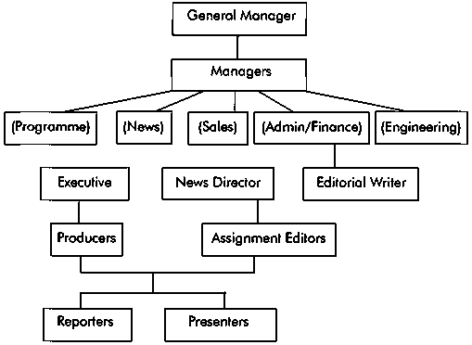

2.2 FUNCTIONS OF THE MAJOR DEPARTMENTS IN RAYPOWER 95.1 FM
- News and Current Affairs Department: The editor in chief assigns beat present news, edit news, source for news and coordinate program.
- Marketing Department: The head of marketing department make sure that the department generates enough funds for the firm through his hard work and outreach to the people, create cooperate image for the organization.
- Programmes Department: The head of department create plans, produce programmes, drama, jingle, preparing roaster of the presenter, anchors and monitor them while on air.
- Finance and Accounting Department: They are in charge of keeping good and accurate record of the organization income and expenditure.
- Technical Department: They make sure that there is smooth operation of the engine medium and tackle technical problem in the organization.
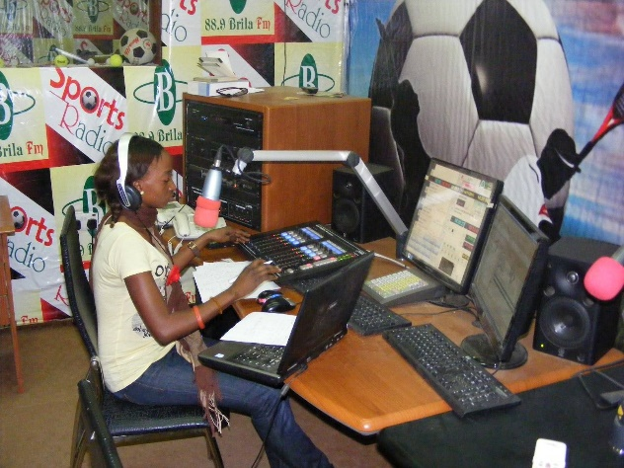
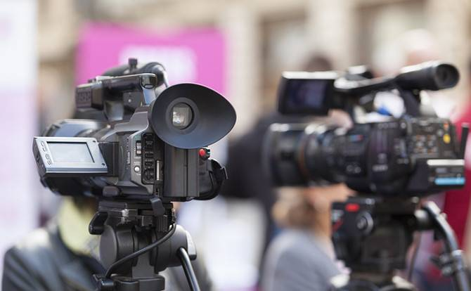
CHAPTER THREE
3.1 STUDIO EQUIPMENT
The Microphone
The seed, the origin, where everything is born: this is The Microphone. Technically, the Microphone captures the sound and converts it into electrical impulses, its primary responsibility is to carry the voice through to the listeners. On the microphone depend: timbre, depth, clarity, body and softness of voice.
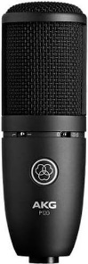

Headphones
Headphones allow you to listen carefully to the audio you broadcast. It is connected to the same audio channel that feeds the speakers: when you plug in the headphones, the speakers will mute automatically.
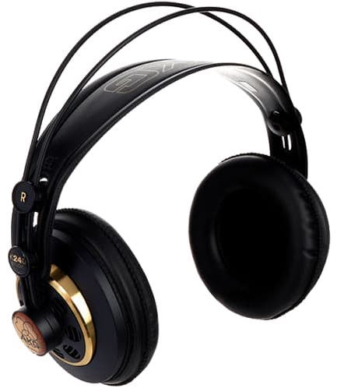
If you want to have complete control over your audio, you need to be able to monitor it using headphones, otherwise be able to monitor what the audio is like as well as ensure that your setup is working properly.

Active Monitor Speakers
Studio Monitor Speakers show you how the music sounds without headphones. It must be of high quality, so that all the abnormal sounds can be detected. It is also advisable to have another speaker, small and of low quality, to cross-check how the sound is even in this kind of speakers. Ultimately, the sound must be good but also understandable for every type of audience.
It is recommended to use speakers specifically designed for music, as they can provide the most accurate representation of the signal.
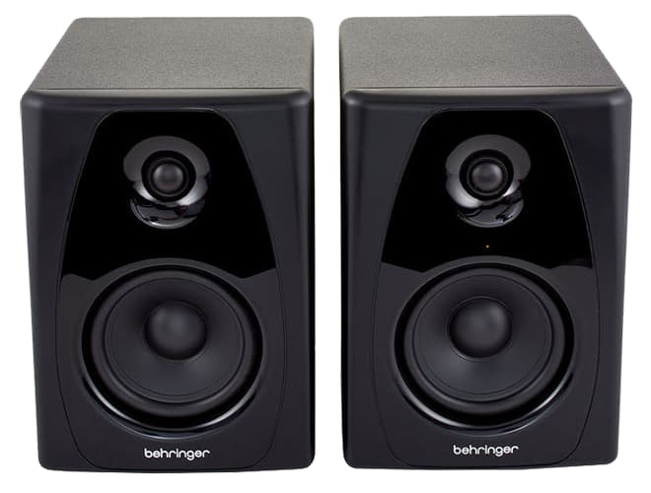

Microphone Processor
To stabilize the voice of the speaker on a constant level, a Microphone Processor is necessary. This is an audio compressor than can decrease the volume of the voice when it is too loud, or amplify it when it is too low. Doing so produces a sound that captures all the details of the voice but levels out volume changes. Too high a volume level could distort the signal; or, if too low, it could make speech incomprehensible.
A microphone processor helps smooth the audio, minimizes background noise and cleans the signal. It helps with the mixer control, since it is not necessary to continuously adjust the level of the microphone. It also helps to get "Radio Sound", so that it always sounds at the right level and the speaker can concentrate on performance – rather than worry about being too close or too far from the microphone, or even speaking in too loud or too soft a voice.
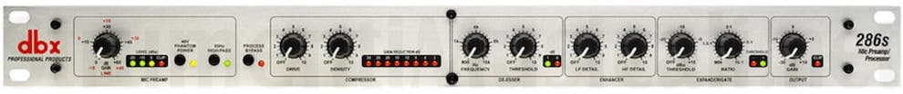

Headphone Distributor
In the studio there is often more than one person participating in the program. For this reason, a Headphone Distributor is necessary to connect several users to the same source.
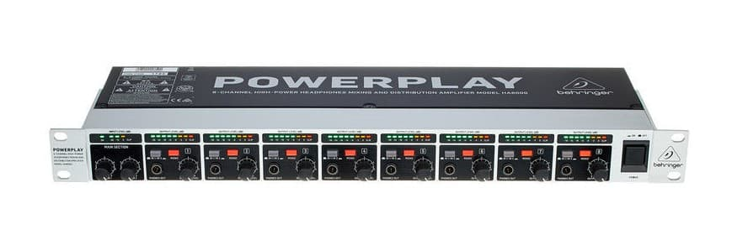
Headphone distributors have four, eight or more outputs; each one with an independent volume adjuster so as to allow each user to set a self-comfortable level.

Audio Mixer Console
At the heart of any studio is the Audio Mixer Console. This is the interface used to control what’s heard on air, and to choose which sounds should be broadcasted.
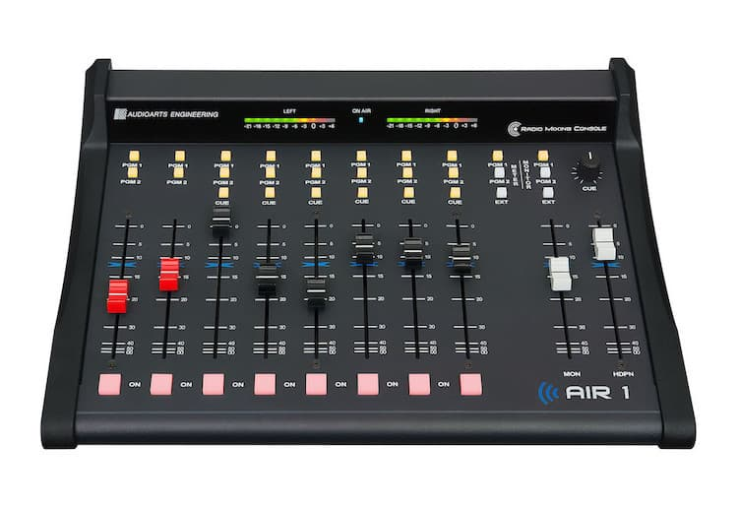
Each channel represents an “input”. The fader (slider) attenuates or amplifies the incoming signal; it can change the volume and the dynamics of the sources, and combine the various audio signals. The Audio Mixer Console is the device that allows us to monitor and control the audio.

Broadcast Audio Processor
The Audio Processor is a very important piece of equipment, as it is usually the last one you use before your audio is transmitted. It improves and optimizes the sound quality of your Radio, thus giving it a unique sound with its own character.
You may choose between several mood sounds such as jazz, pop, rock, classical, etc. or even create your own sound.
Mainly designed for medium/small radios (local radio stations, community radios, web radios), the Audio Processor combines ease of use, flexibility and robustness.
It is indeed a combination of a multiband compressor/limiter and a parametric equalizer together with other effects.
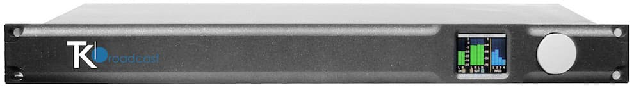

Telephone Hybrid
You also need a Telephone Hybrid Interface, to join the console with audios coming from phone calls. This is important if you want to take phone calls while you are on-air.
In simple terms, a Hybrid is an interface that connects two-wire phone lines into input and output XLRs. These XLR connectors are plugged into an audio console or I/O node. Many Hybrids also contain echo cancellation and an automatic equaliser.
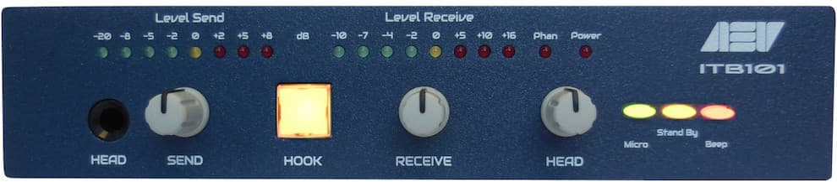

Computer
You also need a Computer with an Automation Software. This computer system makes it possible to play background music and commercials. The software is called Automation Software or “Playout”, and it is designed to continually play music in the background.
The heart of these programs is the Playlist – which is a list with all the audio files that need to be played. Most automation systems also contain a Music Database, Hot Keys (to play ad-hoc audio), an Audio Editor, a Segue Editor (to change the mix between the different elements), Interfaces for Website and RDS data, and a lot more.
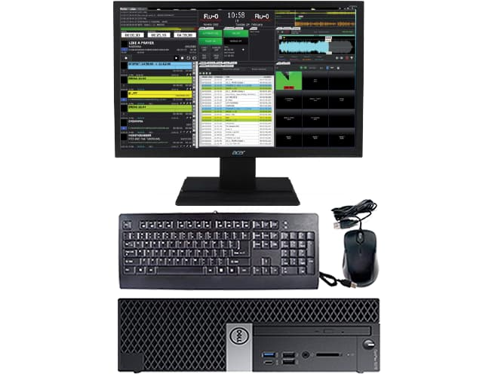

Tuner FM Receiver (good quality)
To monitor the real sound you are broadcasting a good quality Tuner is necessary.
This will also help you compare your on-air sound with that of your competitors.
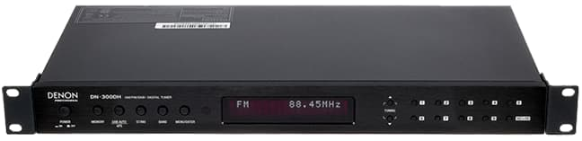

CHAPTER FOUR
- TECHNICAL TRAINING EXPERIENCE
My attachment in the organization was officially at the News and Current Affairs Department and I was opportuned to gain diverse experiences in the department.
First, I learnt the Organization house style of writing News Stories following my knowledge of the differences in writing news reports for print and broadcast.
After learning the art of writing broadcast news stories, my next experience was on news casting. I was detailed to words proper pronunciation via constant practice and familiarizing myself with vocabularies in the scripts as well as consulting the dictionary for proper pronunciation.
Furthermore, I learnt how to make news templates and how to align news of different sections such as the world news and National News. I also learnt how to compile news in such a comprehensive and concise manner.
Also, I had the opportunity to be at the recording studio for voice audition on several occasions with the help of my supervisor who never relented in encouraging me to do more and be the best I could be.
Following the aforementioned experiences, I was trained on how to record programmes, jingles and other voice recordings as well as how to edit them for presentation
4.1 CHALLENGES
The only challenge I had during my SIWES training was financial constraints. There wasn’t much financial capability for transportation from where I live to the organization.

CHAPTER FIVE
RECOMMENDATION AND CONCLUSION
- SUGGESTION FOR IMPROVEMENT OF THE SCHEME
One suggestion I should love to give for improvement of the scheme is provision for allowance for SIWES students by the organization. This allowance will be for interns’ upkeep and maintenance.
5.1 CONCLUSION
All that is included in this report are my practical experiences during my two month Students’ Industrial Work Experience Scheme (SIWES) and they are all beneficial in all ways as they complement the theoretical knowledge gained from the classroom.
My training had been filled with unforgettable and beneficial experience which I believe will continually be a reference point for me throughout my time of study in Mass Communication Department.

