

TECHNICAL REPORT ON STUDENT INDUSTRIAL WORK EXPERIENCE SCHEME [SIWES]

HELD AT
T-TAB FILLING STATION
KM 114, PRO FEMI AGBALIAJOBI WAY, ITAMARUN EPE, LAGOS STATE.

WRITTEN BY
AGBABIAKA OPEYEMI FRIDAY
MATRIC NO: ND/23/PT/MPE/0006

SUBMITTED TO
DEPARTMENT OF MINERALS AND PETROLEUM RESOURCES ENGINEERING.
IN PARTIAL FULFILMENTS FOR THE REQUIREMENT OF THE AWARD OF NATIONAL DIPLOMA [ND] IN MINERALS AND PETROLEUM RESOURCES ENGINEERING TECHNOLOGY KWARA STATE POLYTECHNIC, ILORIN.

AUGUST – DECEMBER, 2024.
DEDICATION
This is dedicated to Almighty God the maker of the universe who gives me the opportunity to start and complete my Student Industrial Work Experience Scheme. I also dedicate it to my family and also the Managing Director of T-tab Filling Station for their support financially.
Support towards my academics. My sincere appreciation goes to Mr Dotun for accepting me as a trainee in their firm. Special thanks to family, friends and colleagues throughout my SIWES programme.

ACKNOWLEDGEMENT
All praise and adoration to Almighty God for the inspiration, guidance and strength throughout my SIWES training.
I owe my profound gratitude to my HOD and all my lecturers in my department for their immense support towards my academics.
My since appreciation goes to Mr. Dotun for allowing me as a trainee in your firm Special thanks go to family and friends.

PREFACE
The Student Industrial Work Experience Scheme (SIWES) is a National Diploma Curriculum of the Department of Minerals and Petroleum Engineering, Kwara State Polytechnic Ilorin.
The programme was established by the Industrial Training Fund (ITF) in 1973 to 1974. It is designed to acquire the student with life situation in industries as well as supplies in a more practical manner and their knowledge in practical activities and other practical field during their course of study.

TABLE OF CONTENTS
TITLE PAGE. 1
ACKNOWLEDGEMENT II
DEDICATION III
TABLE OF CONTENTS IV
CHAPTER ONE

1.0 INTRODUCTION TO SIWES
1.1 Mission

1.2 Vision

1.3 Aims and Objectives
CHAPTER TWO

2.0 INTRODUCTION TO CRUDE OIL
2.1 Source of Crude Oil
2.2 Products of crude oil

2.4 Extraction of Crude Oil

2.5 Separation of Crude Oil

2.6 Equipment Used In Extraction
CHAPTER THREE
3.0 VARIOUS ACTIVITIES DONE AT THE ORGANISATION
CHAPTER FOUR
4.0 PETROL STATION
4.1 Industrial Use
CHAPTER FIVE
5.0 CONCLUSION
5.1 Personal Impression about The Organiztion
5.3 Recommendations to the Polytechnic Concerning the SIWES programme

CHAPTER ONE

1.0 INTRODUCTION TO SIWES
The Student Industrial Work Experience Scheme [SIWES] was established by the Industrial Training Fund [ITF] IN 1973 to enable student of tertiary institution to have technical knowledge of industrial work base on their course of study before the completion of their program in their respective institutions. The major background behind the embankment of students in SIWES was to expose them to the industrial environment and enable them to develop occupational competences so that they can live readily contribute their quota to national economic and technological development after graduation.
Student Industrial Work Experience Scheme [SIWES] has been necessarily required for the award of diploma and degree certificate in specific discipline in Nigeria institutions of higher learning in accordance with the educational policy.
1.1 MISSION
SIWES is charged with the responsibility of promoting and encouraging the acquisition of skills, commerce and industry with the view of generating pool of trained indigenous manpower sufficient to meet the need of the economy. It is aimed at developing the human resources of the nation. It builds the nation’s work force to promote the economy of the nation.

1.2 VISION
The vision of STWES is to prepare students to contribute to their nation and strengthen the student in practical aspect.

1.3 AIMS AND OBJECTIVES
The aim of study was to evaluate the impact of SIWES on technical skills development in the Nigeria economy. This is to enable institutions of higher learning and other stakeholders access the performance of their roles in the schemes.

Objectives
The Industrial Training Fund policy document No. 1 of 1973. Which established SIWES outline the objectives of the schemes. The objectives are to ;
- Provide an avenue for the student in institution of higher learning to acquire industrial skills and experience during their course of study.
- Prepare student for industrial work situation that they are likely to meet after graduation
- Expose student to work methods and techniques in handling equipment and machinery that may not be available in their institution
- Make the transition from school to the world of work carrier and enhances students contacts for later job placements.
- To provide students with industrial skills and needed experience during their course of study.

CHAPTER TWO

2.0 INTRODUCTION TO CRUDE OIL
Crude oil is a naturally occurring liquid found in geological formations beneath the Earth’s surface. It is a fossil fuel formed from the remains of ancient marine organisms, such as plants and animals that were buried under layers of sediment and subjected to heat and pressure over millions of years.
Crude oil is primarily composed of hydrocarbons, which are molecules made up of hydrogen and carbon atoms. The specific composition of crude oil can vary significantly depending on its source, leading to different grades and qualities. These variations can affect its density, viscosity, and the types of products that can be refined from it.
The extraction of crude oil typically involves drilling wells into the ground to bring the oil to the surface. Once extracted, crude oil is transported to refineries, where it undergoes a refining process to produce various petroleum products, including gasoline, diesel, jet fuel, and other chemicals used in manufacturing.
Crude oil is a major source of energy globally and plays a crucial role in the economy. However, its extraction and consumption also raise environmental concerns, including pollution and the contribution to climate change. As a result, there is ongoing research and development into alternative energy sources.
2.1 SOURCE OF CRUDE OIL
Crude oil is primarily sourced from deposits found in sedimentary rock formations beneath the Earth’s surface. These deposits are formed from the remains of ancient marine organisms that have been subjected to heat and pressure over millions of years. The main sources of crude oil include:
Offshore Drilling: Many of the world’s largest oil reserves are located beneath the ocean floor. Offshore drilling involves extracting oil from these underwater deposits.
Onshore Drilling: This involves drilling wells on land to access oil reserves. Onshore oil fields can be found in various regions around the world.

Oil Sands: These are a mixture of sand, water, clay, and bitumen, a thick and heavy form of crude oil. Oil sands are mined and processed to extract the crude oil.
Shale Oil: This is oil that is trapped within shale formations. Hydraulic fracturing, or fracking, is often used to extract shale oil.
Natural Seeps: In some areas, crude oil can seep naturally to the surface, where it can be collected without drilling.
2.2 PRODUCTS OF CRUDE OIL
The products of crude oil are numerous and varied, primarily obtained through the refining process. Here are some of the main products derived from crude oil:
Gasoline: This is one of the most well-known products, used primarily as fuel for vehicles.
Diesel Fuel: Another important fuel used in trucks, buses, and trains.
Jet Fuel: Specifically refined for use in aircraft engines.
Heating Oil: and Used for heating residential commercial buildings.
Liquefied Petroleum Gas (LPG): A mixture of propane and butane, used for heating, cooking, and as fuel for vehicles.
Asphalt: Used for paving roads and roofing materials.
Kerosene: Used as a fuel for jet engines and in lamps.
Petrochemicals: These are chemical products derived from petroleum, used to make plastics, fertilizers, and other industrial chemicals.

2.4 EXTRACTION OF CRUDE OIL
The extraction of crude oil involves several steps and techniques to access oil reserves located underground or underwater. Here’s an overview of the extraction process:
- Exploration: This initial phase involves geological surveys and seismic studies to locate potential oil reserves. Geologists analyze rock formations and use technology to identify areas that may contain oil.
- Drilling: Once a potential site is identified, drilling begins. There are two main types of drilling:
- Onshore Drilling: This occurs on land and involves drilling wells into the ground to reach oil deposits.
- Offshore Drilling: This takes place in oceans or seas, using specialized platforms to drill down to underwater oil reserves.

3. Production: After drilling, the oil is pumped to the surface. This can be done using various methods:
- Natural Lift: If the pressure in the reservoir is high enough, oil can flow to the surface without assistance.
- Artificial Lift: If natural flow is insufficient, pumps are used to bring the oil to the surface.
4. Separation: Once extracted, crude oil often contains water, gas, and other impurities. Separation processes are used to remove these substances, leaving behind crude oil.
- Transportation: The crude oil is then transported to refineries using pipelines, tankers, or trucks.
- Refining: Finally, the crude oil is refined to produce various petroleum products like gasoline, diesel, and jet fuel.

2.5 SEPARATION OF CRUDE OIL
The separation of products from crude oil is primarily achieved through a process called fractional distillation. Here’s how it works:
- Heating: Crude oil is heated in a distillation column. As the temperature rises, different components of the crude oil begin to vaporize at different temperatures.
- Fractional Distillation: The vaporized crude oil enters a distillation column, which is a tall tower with trays or packing. As the vapor rises, it cools and condenses back into liquid at various levels of the column, depending on the boiling points of the components.
- Collection: Each fraction (or component) that condenses at a certain height in the column is collected separately. The lighter fractions, such as gases and gasoline, condense at the top, while heavier fractions, like diesel and asphalt, condense lower down.
- Further Processing: Some fractions may undergo further refining processes, such as cracking, reforming, or treating, to improve their quality or to convert them into more valuable products.

2.6 EQUIPMENT USED IN EXTRACTION
The extraction of crude oil involves various types of equipment, each designed for specific tasks in the process. Here are some key pieces of equipment used:
- Drilling Rigs: These are large structures equipped with machinery for drilling wells into the earth. They can be onshore or offshore and are essential for reaching oil deposits.
- Blowout Preventers (BOPs): Safety devices installed on drilling rigs to control the pressure and prevent blowouts during drilling. They help manage unexpected surges of oil and gas.
- Pumps: Various types of pumps are used to bring oil to the surface. This includes centrifugal pumps for moving liquids and positive displacement pumps for higher pressure applications.
- Separators: Equipment that separates crude oil from water, gas, and other impurities once it is brought to the surface. These can be two-phase or three phase separators, depending on the components being separated.
- Storage Tanks: Large tanks that store crude oil after extraction and separation. They are designed to hold significant volumes and are crucial for managing the supply until transportation.
- Pipelines: Used for transporting crude oil from the extraction site to refineries. They are essential for moving large quantities of oil efficiently.
- Offshore Platforms: Specialized structures that support drilling operations in ocean waters. They can be fixed or floating, depending on the depth of the water.

CHAPTER THREE
VARIOUS ACTIVITIES DONE AT THE ORGANISATION

1. Fuel Dispensing and Customer Interaction
- Operated fuel pumps efficiently to serve customers promptly.
- Ensured no spillage during fuel dispensing by following standard procedures.
- Managed cash payments and provided accurate change to customers.
- Handled queries regarding fuel prices and advised customers on the type of fuel suitable for their vehicles.
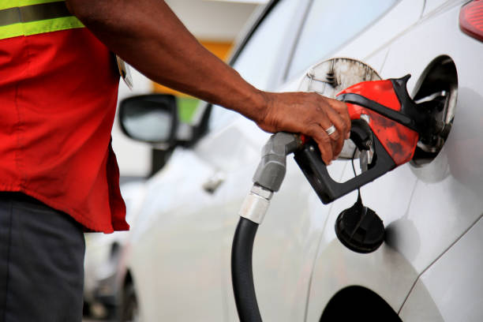

- A service attendant dispensing fuel at a pump, with the vehicle and fuel dispenser clearly visible. The attendant is wearing appropriate safety gear (uniform, gloves, etc.).

2. Safety Protocols and Procedures
- Implemented strict safety measures such as ensuring no open flames or smoking near the station.
- Conducted daily inspections of fire extinguishers and other safety equipment.
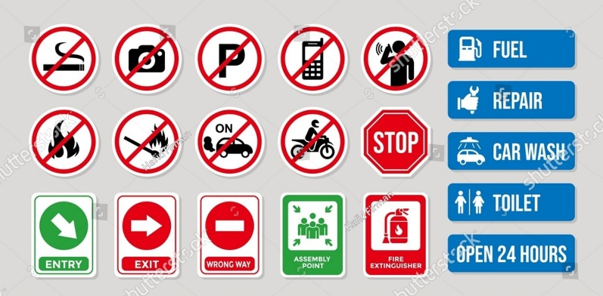
- Placed visible safety signage in critical areas, such as "Switch Off Engine" and "No Smoking."

- A fire extinguisher mounted on a wall near the pumps, with an attendant conducting a routine check. Safety signage is also visible.

3. Stock and Inventory Management
- Assisted in monitoring underground storage tank levels using manual dipsticks and automated systems.
- Helped reconcile daily sales with fuel inventory to ensure accuracy.
- Learned how to prepare and interpret inventory management reports.
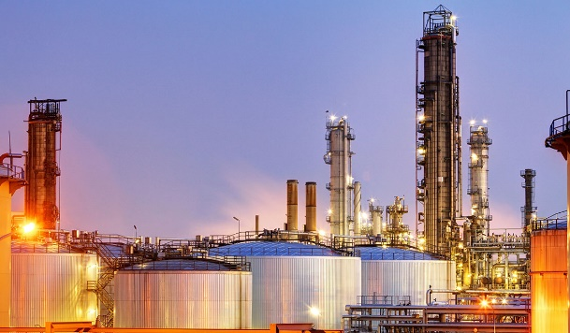

- A technician dipping a measuring rod into an underground storage tank, with a clipboard for recording data.

4. Equipment Maintenance and Inspection
- Supported regular maintenance tasks like cleaning and lubricating pump nozzles.
- Observed pump calibration to ensure accurate fuel dispensing.
- Learned how to identify and report equipment malfunctions promptly.
- A mechanic working on a fuel pump with tools, while the intern observes or assists.

5. Exposure to Petroleum Products and Specifications
- Gained insights into the properties and uses of petroleum products like petrol, diesel, and kerosene.
- Learned the importance of maintaining product quality by avoiding contamination.
- Observed how additives are mixed to enhance fuel quality.
- Samples of different fuel types (petrol, diesel, kerosene) in transparent containers, showcasing their distinct colors and properties.

6. Tank Monitoring
- Helped monitor fuel levels in underground tanks to prevent stockouts.
- Understood the process of tank calibration and how discrepancies in fuel levels are addressed.
- Participated in inspecting tanks for leaks and ensuring they comply with safety regulations.

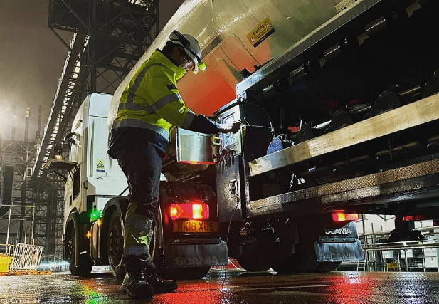

- An underground storage tank being inspected, with tools and safety equipment visible.

7. Cash Management and Report Documentation
- Assisted in tallying daily cash sales and comparing them with fuel dispensed.
- Learned how to prepare daily and weekly sales reports.
- Identified discrepancies in cash and fuel records and reported them for resolution.
- A cashier at the station counter tallying sales records, with a computer or ledger book in use.

8. Waste Management
- Helped in the safe disposal of waste oil and other byproducts to minimize environmental impact.
- Ensured compliance with local environmental regulations.
- Educated customers on the importance of proper waste disposal practices.
- A waste oil container being handled carefully, with proper disposal signage visible.

9. Training on Emergency Response
- Attended training sessions on handling fuel spills and fire emergencies.
- Learned how to use fire extinguishers and perform evacuation drills.
- Observed real-time application of emergency protocols during drills.
- A staged fire drill showing staff using a fire extinguisher, with emergency signage and assembly points visible.

10. Observation of Managerial and Administrative Activities
- Observed how schedules were created for fuel attendants.
- Learned about financial management, including cost control and customer retention strategies.
- Assisted in organizing staff meetings and implementing operational improvements.
- A manager briefing staff in a meeting room or an office setting, with charts or whiteboards showing operational metrics.
CHAPTER FOUR
4.0 PETROL STATION
Petrol Station commonly called Filling station in Nigeria, is an outlet usually by the road side where refined petroleum products such as PMS (Premium Motor Spirit) Petrol,
AGO (Automatic Gas Oil) Diesel, LPG (Liquefified Petroleum Gas) Gas, and DPK (Dual
Purpose Kerosene) Kerosene are sold to customers by pump.
Petrol filling station in Nigeria is very lucrative because of the high demand of
these petroleum products in the country. Nigeria is one of the highest consumers of
petroleum products in Africa and this is due to several reasons. One of the reason is
because of the population of Nigeria. Nigeria is the most populated country in Africa
and has the largest economy the whole of Africa.
Another reason why this business is mouthwatering business is because of
inadequate power supply in Nigeria. Companies, homes, hotels, hospitals, vehicles,
small scale businesses are always in need this petroleum products to function in their
day to day activities and this has created the demand for petroleum products in Nigeria.
4.1 INDUSTRIAL USE
Legalize your company and get your Petrol station licence in Nigeria. It will be required
of you to register your country with the corporate affairs commission of Nigeria to have
a legal name for your business because it is a requirement for obtaining your certificate
of incorporation which you will need to obtain your license of operating a filling station.
You will also need to obtain your tax clearance.
You will also on your way to make your business a legal entity need to obtaining
licenses, approval and permit to run your filling station. To start setting up and get
supplies of petroleum, the licence from these bodies:
DPR – Department of Petroleum Resources
PPPRA – Petroleum Products Price Regulatory Agency
PPMC – Pipelines and Products Marketing Company
NNPC – Nigerian National Petroleum Corporation
After the licences and permits are in place, you will also need to join these petroleum
association. They tend to help protect your interest concerning petroleum sale issues
IPMAN – Independent Petroleum Marketers Association of Nigeria
NUPENG – National Union of Petroleum and Gas Workers

Registration, Licencing, permits and association registration may cost up to #1.3m.
You definitely need to insure your business not only because it is a requirement but
because this business is a very risky business; all product are highly inflammable so
you will need to insure against fire insurance; the truck is also prone to hijack and
because this business also involve the movement of large cash, its prone to theft so
you will also insure against theft; and as many other insurance you deem fit and you
can afford.
Facilities building: you will need the services of a petrol station engineering company.
After you must have considered and selected a size of petrol station, you will need the
services of these engineers to bring it into physical being.
Building: this is dependent on your station size and what you’ll like to be in the station;
Restaurant, Supermarket, and Car Wash etc. it’s a require men to have bay in your
building or on your filling station premises.
Pumps Shelter: The shade constructed over petrol station pumps, it protect the pumps
and the petrol attendants from the weather conditions.
Storage tanks: After acquiring your property, before you fill the land if necessary, you
will sink your underground storage tank. Storage tanks measurements vary depending
on the size (between 35,000 liters and 65,000 liters) and the space you have. You will
definitely need at least three underground storage tanks, one for each product. Usually,
petrol storage tank is bigger because it sells faster and you will to stock large amount
of it.
Fence: by regulations, it is require to make fence all around the sides of the petro
station, as far as there is no access route there. This helps to increase security in and
around the petrol station. It is also required to provide access gates on sides that has a
route to link and provide easy access in and out of the filling station.
Flooring: The petrol station needs a fairly flat ground so you might need to cut or fill as
the topography may warrant. You’ll need a very firm concrete floor to accommodate the
huge pressure that the diverse number of vehicle coming in and out of the filling station
will exert on it and also to accommodate those vehicles as you dispense fuel.
Standby Generator (25kva to 60kva): we all know that the power supply in Nigeria is
erratic, so need for a steady power supply to power your pumps. Besides, standby
generator is one of the requirements for approval.
Pumps: there are two types of pumps, the analogue and the electronic. The analogue
pumps are outdated. They use the analogue counter to dispense fuel. Electronic pumps
gives you the freedom of advance technology as some pumps have Point of Sales
(PoS) slot, most come with a ‘dispense pre-set module’ and other accessories. The
pump that dispenses the fuel, you will need at least 4(two for petrol, one diesel and one
for kerosene)
Staffing your petrol station: the petrol state needs four categories of personnel to run
the business fully at the inception. The staff number depends on establishment level
and hours of work. Usually most of the staff will work on a shifting.
Manager: the manager is the highest in rank in the filling station. He handles the
managerial functions in filling station. He is the superior with the responsibility of the
whole operation of the petrol filling station and must be vast in running the oil
business. All other employee reports to him while he report directly to you. You don’t
necessarily need to interact directly with all your staff because they can go through him
to get to you.
Supervisor: he is the next in line to the manager, he is charged with the smooth
operation of the filling station. He ensures everyone and everything including the
facilities are in order. He sees to it that everyone is up to his task and report back to the
manager. He performs other basic supervisory duties.
Cashier/Accountant: a personnel that handles the financial computations of the
business. This person sees into the movement of the cash submitted by the
attendants, keeps the records of the cash transactions and process cash for the use in
the filling station by approved authority. Depend on how you want it, he will report to the
manager and submit periodic financial statement and reports.
Attendants: to reduce fatigue, you might need to employ two or more petrol attendants
for each pump. They would work in shifts, one person at a time.
Security: also very needed is security guards to secure your assets, your money and
maintain order on the premises of your filling station. As a way to increase security, I
will advise you to move your cash in bits and you ensure you do not leave plenty of
cash within your petrol station.
On the average, depending on location, it cost roughly around #80m to #150m, though
that’s not the maximum but for a small size in a middle class neighborhood, it should
establish a pump station. The return on capital is so high that profit ranges from a
million naira a month to five million naira a month. It is to be noted that from previous
observation and current trends, even if the price of petroleum is tripled over night, it will
still make its sale.

CHAPTER FIVE
5.0 CONCLUSION
I was extremely impressed about how they practiced their daily activities. They are time conscious and greatly discipline about their work as well as generous.
5.1 PERSONAL IMPRESSION ABOUT THE ORGANIZTION
The organization is industrious their workers are obviously well skilled. They are highly accommodative and their environment also conducive. The organization is also perfectly lively to stay.
5.2.1 RECOMMENDATIONS TO THE POLYTECHNIC CONCERNING THE SIWES PROGRAMME.
I would recommend that the polytechnic should try to get a placement for the student by containing all engineering organization to admit any student for their SIWES programme.
I would recommend that the polytechnic should try to give adequate supervision to the student in their places of attachment for student assessment before the completion of the programme.
I would recommend that the polytechnic should encourage their student to spend their training period well and try their possible best to acquire the practical knowledge on the field.

