

A
TECHNICAL REPORT ON
STUDENT INDUSTRIAL WORK EXPERENCE SCHEME (S.I.W.E.S)
HELD
AT
ABRASH FISH FARM
NO. 10, OLADUTUN ABISOYE STREET, AKEJA, OTTA, OGUN STATE.
BY

YUSUF FAWAZ OLALEKAN
ND/23/AGT/PT/0219

SUBMITTED

TO

DEPARTMENT OF AGRICULTURAL TECHNOLOGY
INSTITUTE OF APPLIED SCIENCE
KWARA STATE POLYTECHNIC, ILORIN

IN PARTIAL FULFILLMENT OF THE REQUIREMENT FOR THE AWARD OF NATIONAL DIPLOMA (ND) IN AGRICULTURAL TECHNOLOGY
KWARA STATE POLYTECHNICS

AUGUST 2024 TO JANUARY, 2025

1.0 INTRODUCTION TO THE TRAINING PROGRAM
A. Purpose of Training
The students industrial work experience scheme (SIWES) was initiated in 1973 by the industrial training fund (ITF).
This was to update practical knowledge of students in the universities, polytechnics and colleges of technology. it was aimed at bridging the gap between the theoretical knowledge acquired in classes and technical knowledge in the industrial by providing students with opportunities to apply their education knowledge in real work situations.
Over the years, SIWES has contributed immensely to building the common pool of technical and allied skills available to the Nigeria economy which are needed for the nation industrial development.
Furthermore, the place and relevance of Siwes is underscored by the fact that the scheme contributes to improving the quality of technical skills generally available in the pool from which employers’ source technical manpower.
It also gives students the opportunity to blend theoretical knowledge acquired in the classroom with practical hands on application of knowledge required to perform work in the industry, also it prepares students for employment and makes the transition from school to the world of work easier after graduation.
Aims and Objectives of Student Industrial Work Experience Scheme (S.I.W.E.S)
Siwes provides avenue for student to acquire industrial skills and experience in their course of study, this is few objectives of Siwes,
- Provision of avenue for students in the Nigerian universities to gain industrial skills and experience in their course of study.
- To expose students to work methods and techniques in handling equipment and machinery that may not be available in the universities.
- To prepare students for work situation they are likely to meet after graduation.
- To provide students with an opportunity to apply their theoretical knowledge in real work situation, thereby bridging the gap between university work and actual practice.
- To enlist and strengthen employers involvement in entire educational process of preparing university graduates for employment.
2.0 Company Profile (ABRASH FISH FARM), No. 10, Oladutun Anbisoye Street, Akeja, Otta, Ogun State.
Abrash Fish Farming Nigeria limited, is one of the fast growing, productive and focused integrated farm in kwara state and also Nigeria, and the tempo of the said development has been kept and maintained in that dynamic momentum. The fishery was established in May 2000 and was incorporated in 2008. The fishery farm is strategically located in the Agricultural Farming Settlement Apalara Area Ilorin, Kwara State.In achieving these monumental growth and development in the industry we are mindful and considered the listed factors:
These outlay will be possible because the management is focus and articulate, they always take customers complains very serious and timely decisions are taken on important issues concerning the operational and revenue generation of the company.
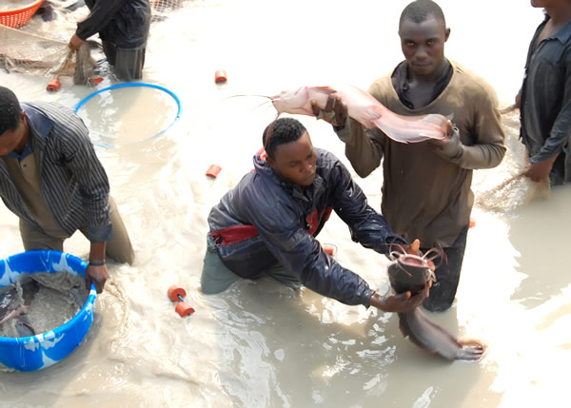
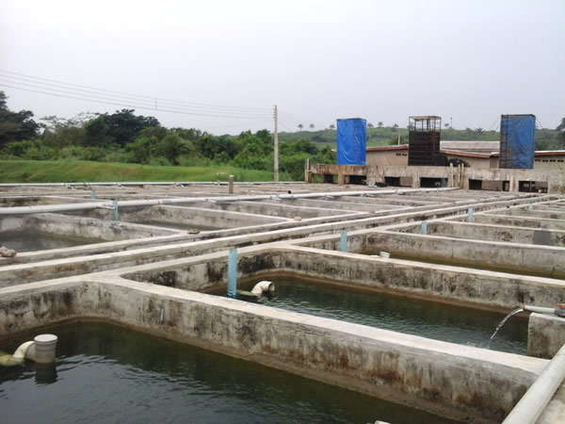
Presently we are concerned with the production and sales/marketing of fish production and products as well as imbibing our knowledge and expertise into our services for the mutual benefit of our establishment and our esteem clienteles. We produce the most giant and highest cat fish and tilapia volume in Ilorin ,. Fish fingerlings / juvenile and feeds for our customers to excel.
1OPE

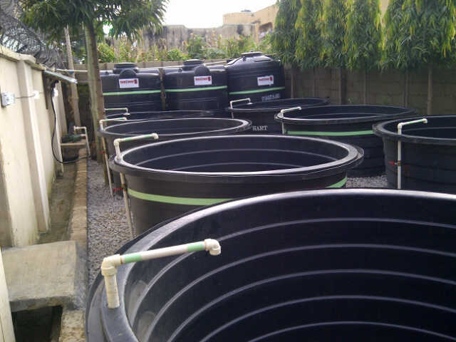
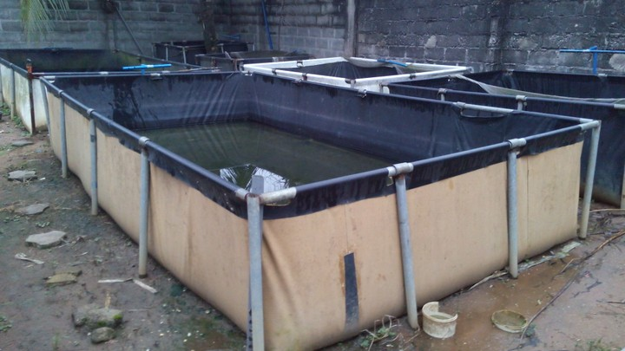

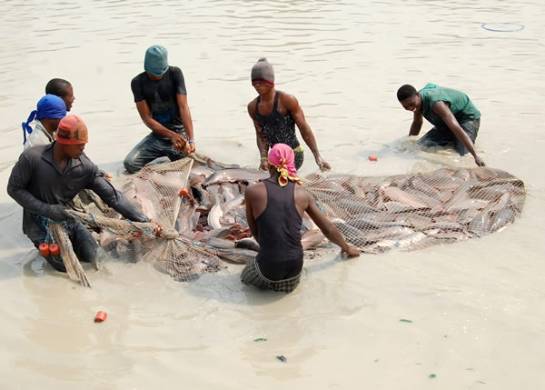
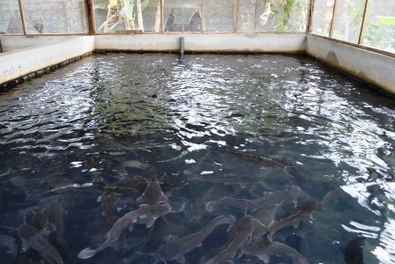

At Abrash fishery, customer relationship in very vital and critical to us because "No buyers, No seller" and there will be nothing to produce, all we produce and sell are at a very competitive price and a commensurate discount for our customers to grow. We also transport products to our customer as prompt as possible in good condition at a reasonable cost. We are also comfortable in moving our products round the country and beyond. We just don’t serve our customers but we always appreciate feed back from the customer and prompt follow-up is always provided so that continuity and a better result is achieved. We also have retailing outlets to get our products to every corners of the country and become a household name in kwara state. Selective credit facility within a reasonable time frame is offered to some selective customers.
We also render services like
- Consultancy
- Training programmes (IT & SIWES Training for student)
- Expert advice of cost and production of cat fish
- Livestock buying and vaccination
- Feeds for fisheries
B) Introduction to Cat Fish Farming
The story of aquaculture in Nigeria is essentially the story of catfish culture and the hope of fish supply in Nigeria hang on its development and culture. Recent trends all over the world, point to a decline in landing from capture fisheries, an indicator that fish stocks have approached or even exceeded the point of maximum sustainable yield. Aquaculture therefore remains the only viable alternative for increasing fish production in order to meet the protein need of the people
Fishery: An industry or occupation that are capable of processing or selling of fish
Fisheries: The science of producing fish and other aquatic resources for the purpose of providing human food, fish product such as fish oil
Aquaculture: Is the practice of cultivating aquatic animals and plants is managed aquatic environment
Polyculture or Composite Fish Culture: Is a type of fish culture in which different types of fishes of different feeding habit are cultured to exploits the different kinds of food that is present in the different parts of the ponds. This type of farming is also called mixed farming.
Liming: Lime is used to improve the pond bottom and kill parasite in the pond. It also prevent water from becoming too acidic. Liming increases the alkalinity of the water there by increasing the availability of carbon dioxide
Fertilization: To make H2O more productivity, fertilizers are added. They contain important nutrient which help in production of natural fish food organism (plan k ton)
Stages of Fish Growth
Larvae Fry Fingerlings Post fingerlings Juvenile Post juvenile Table Size
Importance of Healthy Fish Stock
Assurance of a profit oriented fish farming enterprise. Fish death due to poor health will rob a farmer not only of intended financial profit, but also of the total investment on the farm.
- To ensure good growth of fish
- To prevent disease transmission to man
African Catfish
Types of catfish (common)

Clarais garipinus Heterobrancus

Pattern non pattern bidorsalsi longflees aceto

B) Level of management input
1.Extensive Culture System: When food base in a pond is exclusively naturally occurring, without supplementation either feeds or fertilizer.
2.Semi intensive culture system: In this system these is occasional supplementary feeds addition and natural productivity is augmented with manure.
3.Intensive Culture System: This demands the highest level of management input feeds and fertilizers are intensively applied following appropriate recommended rates. Fish grow very fast when intensive managed and grow least in extensive management.
C) Fish Culture Practices: Pond can be classified as being monoculture or polyculture. Type
1.Monoculture: This is the practice of culturing only one species of fish in a pond unit. Under monoculture, a farmer may grow only tilapia in the pond on only clarias in the pond
2.Polyculture: This is the practice of culturing more than one species of fish in the same pond e.g clarias and tilapia fish yield under polyculture can be higher and foods in the pond properly utilized.

D) Scales of production
1. Homestead/Backyard ponds: This is a fish pond that is managed to augment family protein intake. The size of such a pond could vary according to land space available.
2. Commercial fish ponds/farm: This usually have an area of land not less than half hectare under culture. Such a farm will demand more attention from the fish famer.
Commonly Culture fish species in freshwater pond in Nigeria
Common Name scientific Name
Tilapia Oreochromis nioticus
Mud cat-fish Clarias gariepinus
Common Carp Cyprinus carpio
Spotted Cat-fish Heterobranchus bidorcalis
Niger Perch Lates niloticus
African bony tongue Heterotis niloticus
Grey cat fish Ghyscicliltry nitrodigitatus
Trunk- fish Cymnarchus niloticus
Cat fish Bagrus bayad
African carp Labeo coubie
Moon fish Citharinus citherus
Commonly cultured fish species in backish water ponds
Common Name scientific Name
Flat head grey mullet Mugil cephaius
Tilapia Tilapia guinnesis
Atlantic Tarpon Megalops atlanticus
West African Lady fish Elops lacerta
Grey cat-fish Chrysichthys nigrodigitatu
African red snapper Lutjamus agennes
Commonly Culture Fish Species
Fast grower e.g Hetterobranchus and Clarias
Ii. Accept and utilized supplementary feeds properly e.g Tilapia, Clarias, Heterobranchus
Iii Must be hardly and resistance to disease e.g clarias
Iv Must be tolerant to poor water quality e.g Clarias
V The fish must be easy to breed in captivity e.g Clarias and Tilapia
Vi It must attract low production cost e.g Tilapia & clarias
Vii Aceptable and marketable to comsumer e.g carp,Heterobranchus, Tilapia and Clarias.
Problems Encounter in Hatching of Fish
- Temperature
- Inadequate of facilities
- Inadequate supply of feeds
Catfish Production
- Materials / Basic Requirement in Catfish Production
  - Mature brood stock
  - Weighing scale
  - Thermometer
  - Acetone
  - Mortal & Pestle
  - Calibrated jug
  - Pair of pincers or hack saw
  - Dissecting kit
  - Syringe and needle
  - Table salt
  - Knife
  - Hand basin
  - Clean water
  - Normal saline
  - Blade

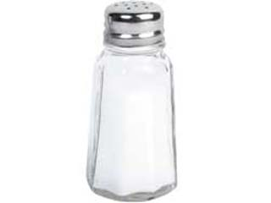
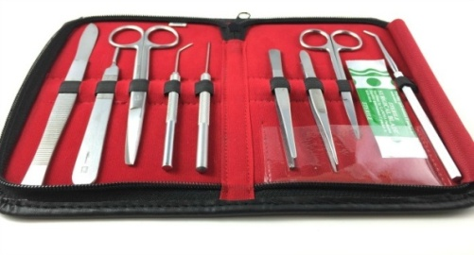
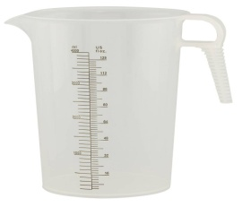
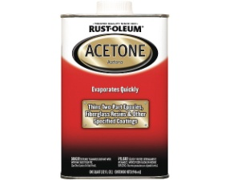
IMAGES OF EQUIPMENT FOR CATFISH
Acetone

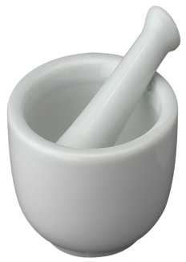
Table salt

Dissecting kit


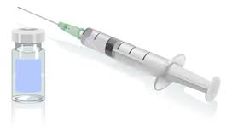

Weighing scale

Mortal & Pestle

Syringe and needle


Blade

Hand basin

Calibrated jug

IMAGES OF CAT FISH BROODING

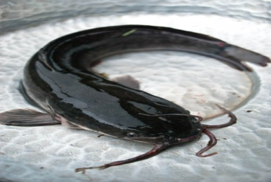
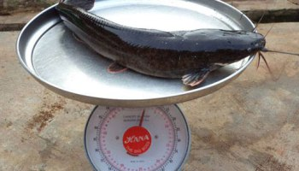
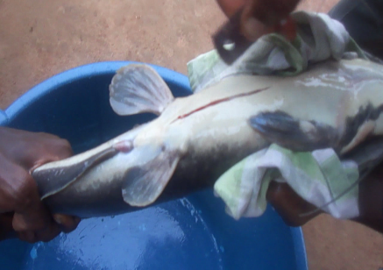

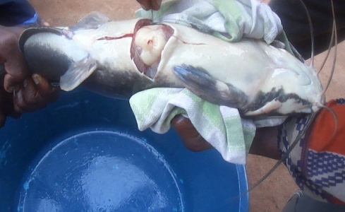
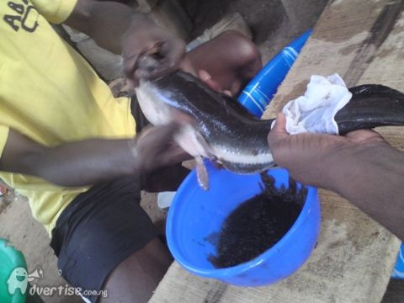
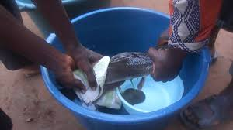
Steps in Catfish Production
Step 1: Sampling of brood stock
Step 2: Size of measurement
Step 3: Measuring of hormonal pituitary
Step 4: Injection
Step 5: Isolation / Separation
Step 6: Preparation of the caccabam incubator
Step 7: waiting for 8 – 12 hours
Step 8: Collection of the eggs
Step 9: Collection of the niilt
Step 10: Fertilisation of the egg
Step 11: Closing fertilization
Step 12: Spawning of the egg
Step 13: Waiting for 12 hours to know the % of fish that will fertilize
Step 14: Waiting for another 12 hours for the eggs to begin to hatch
The first thing I did was to drag out brood stock with the use of dragging net, after then I measured the size of the brood stock, the size of the brood stock will determine the amount of the ml of pitituary gland I used.
After measurement I put the fishes in a pond for them to regain their lost energy when they are been stressed, after some hours I injected the female fish and the male fish was not injected. Separation of the male fish from female fish not to cause damage to them, it takes female fish 24 hours before the eggs was ready for fertilization within time I prepared my caccabam incubator where I layed my eggs when it is ready.
I bisect the male fish and extracted the milt, mix the milt and normal saline then stripped the female fish by pressing the abdomen gently so that the eggs will easily come out, mix thoroughly the milt, the eggs and the normal saline.
Fertilization of eggs takes place; I closed my fertilization by adding water to removed the unfertilized eggs.
Spawning of the eggs take place.
I waited for 12 hours to know the percentage of fish that fertilized, I waited for another 12 hours for the eggs to begin to hatch.
After three days the eggs is now a larvae.
Factors Promoting Ill Health and Diseases In Cultured Fish
Poor Water Quality
Water is the medium for fish rearing. A farmer should therefore be careful on the source of water for the pond. Although water quality management in fish ponds is a wide area, a farmer should ensure that pond water is fertile.
Overstocking
Ignorance on the part of a fish farmer on the stocking densities / stocking rates of cultured fish in a pond environment could result in either under stocking or overstocking fish ponds. Dangers attached to this and numerous, overcrowding, insufficient dissolved oxygen pond water resulting in struggling for survival, cannibalism due to starving and more importantly possible epidemic, resulting in mass fish death.
Erratic (Irregular) Feeding
Like humans, fish need regular and consistent feeding in order to boost their immune system and make them less susceptible to disease. Under extensive fish culture system, fish are often left to the mercy of natural foods. In pond water with little or no feed supplementation. Excessive feeds in pond encourages water pollution
Nutrients Deficient Feeds
Balanced diet is important to fish in order to ensure the performance of their metabolic activities. Nutrients rich foods are security against susceptibility to ill health and diseases, fish food must be rich in protein content and energy requirements
Over Fertilization
In as much as it is necessary to ensure water quality improvement practices to boost pond activities in natural foods, a farmer should be careful enough not to cause algal boom (an indication of overfertlized pond water)
Incidence of Predators and Wild Fish
Predators are natural enemies of fish. Apart from causing fish death directly by preying on them, they also act as intermediate hosts for parasites that introduce disease to ponds, fish ponds should be kept free from predators and wild fish. This can be achieve by periodic draining of the ponds and treating them with quick line or rote none.
Bushy and Unhygienic Pond Environment
Bushy pond environment are hide outs for predators, which in turn are intermediate host to parasites. Unhygienic pond environment often reflect in environmental pollution. When pollution occurs in a fish pond environment, the entire fish stock can be made susceptible to diseases or instant death.
Rough Handling of Fish
Management practices involving handling or transportation of live fish (especially for stock) requires great care to prevent injuries in fish skins. Wounds on skin facilitate diseased condition. Even when fish are been test sampled, great care must be taken to minimize body injuries to the fish since one of the most common route to infection is through the skin, particularly when damaged .
PROCESSING OF FISH
Handling
Scaling fish
Cutting
Salting and sun drying
Smoking
Filleting fish
Preservation and Storage Of Fish
ICING: This is one of the best methods of reducing spoilage of fish especially during catching before reaching the landing site and during transportation. The quality if ice required to fish is one part ice to three part fish.
FREEZING: This is a process of reducing the temperature of fish using the deep freezer. It is done to such level that the activities of the spoilage agents are reduced to facilitate extended shelf life of fish
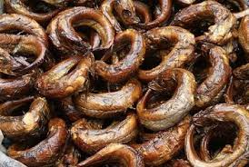
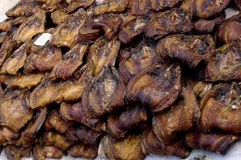
STORING SMOKED FISH OR DRY FISH: The store area is a suitable place for insect infestation and mites attack on dried fish. To avoid thus, the store area should be kept very clean. Use suitable disinfectants to destroy hidden insects in the area before putting the fish, fish should be stored inside wooden boxes that are very well sealed.

Cardboard boxes, jute bags, baskets, sacks and carton may be used for storage and transportation, even though they are not adequate. If old containers are to be used, they should be disinfected before use as they may carry high loads of micro organisms.

PONDS CULTURE SYSTEMS
Fish pond can be classified mainly using the following criteria:

Construction design
Earthen ponds : These are constructed by digging soil in a carefully selected site that is good enough to retain water for fish culture. Where the soil structure is weak to retain adequate water, dug out earthen ponds can be reinforced with concrete to make it suitable for fish to culture.
Concrete/Embankment ponds: This pond constructed on the ground, that is above the ground surface with concrete wall.
Barrage ponds: This types of pond is constructed by building a wall across a stream in a low valley. The wall ensures enough water reteation for fish growth.
Diversion ponds: Pond supplied by water diverted form a river/stream through a channel.
Rosary ponds: When ponds are built in a string and each drains into the other and are all managed as a single unit due to their water connection.
Parallel Ponds: These are ponds located in an area with each having its own hilet and outlet.

POND CONTRUCTION AND MAINTENANCE PRACTICE
Pond Impoundment: Impoundment refers to a process of entrapping water (from a good source) into a constructed structure with the aim of retaining/replenishing the required water level for a viable and profitable fish culture.
General Consideration on Impoundment
- Ensure that regular water sources is available to fill pond to require level.
- Impounded water need improvement to be enriched with nutrient for fish to eat.
- Ensure that water source is free from pollutants substances that are poisonous to the fish.
- Impounded water need improvement to be enriched with nutrients for fish to eat.
Stocking: Stocking is the introduction of fish (fingerlings or adult fish) into the new pond environment. Two source of stocking fish are available. Fish can be collected from wild (rivers, streams, lakes e.t.c) or from hatcheries/existing fish ponds. Stock from hatcheries are already adapted to culture condition and are preferable. The closer the source of getting the fish to the pond, the better. Test stocking (pre stocking should be practiced by introducing few fish into the new environment. Test stocking period ranges from two three hours. If the fish survive well, then the pond can be fully stocked.
Recommended stocking rate of fish (ratio of one species to another or male to female) and stocking density (Number of fish per M3 of pond water to avoid over-crowding, should be practiced. This will ease management problems and enhance the success of fish culture.
Importance of Water Quality Management in Fish Ponds
- The quality of water in terms of its suitability for fish growth, and its fertility, to a large extent determines the rate of growth of the fish.
- Pond water that is poor in quality will endanger the health of the fish and a fish farmer will have to spend extra time and money to remedy the situation.
- Where a farmer practices farming integration, for example, rearing livestock like sheep, goat or pig in the same fish pond environment, a polluted pond water can endanger the livestock as well, especially if they drink from such pond.
- When adequate water quality improvement practices are ensured natural production of fish food organisms will be in abundance for the fish to eat.
- Eating fish harvested from polluted pond could endanger the health of a fish farmer and his family.
- Poor quality water in a fish pond is the medium for development and spreading of fish disease.
How to Detect Pond Water of Poor Quality
- When water is clear, it indicates very low or absence of biological production. Such water is not fertile enough and fish will not grow well in it.
- When water is muddy (that is a lot of clay particle are present) fish can have their gills blocked by the soil particles and this can result in death. Muddy water are not good for fish culture.

- When water is deep green in colour, it indicates over-production of phytoplanktons and Zooplanktons.
- When a fish gives an offensive odour, it indicates pollution of pond water.
- In an already stocked fish pond, if a farmer notice the fish always struggling at the pond water surface to get oxygen then there is low dissolved oxygen (Do) content in the water

MANAGING POND WATER CHEMICAL PARAMETERS.
In fish pond chemical properties of water include the hydrogen ion concentration (PH), the dissolved oxygen content (Do) the conductivity of water, the carbon dioxide content (Co2) and the amount of mineral elements like nitrogen and phosphorous and compounds like nitrite and nitrate.
Hydrogenion concentration (PH): The various source of water used in fish culture are not chemically pure and contains, in solution, different substances which give it an acidic, neutral or alkaline reaction. The intensity of these characteristics is measured by determining the exacts quantity of the hydrogen ion (H+) PH readings ranges from 1 highly acidic) to 14 (Highly alkaline), PH reading of 7 indicate neutral.
Range for fish culture
PH RANGE | INTERPRETATION | REMARKS
1.0 -4.9 | Extremely acidic | Toxic To Fish
2.0 - 6.6 | Moderately Acidic | Low Productivity
6.7 – 9.9 | suitable H + ion | Desirable for fish(high productivity
9.1 – 11.0 | Moderately Alkaline | Low Productivity
11.1 – 14.0 | Extremely alkaline | Toxic To Fish

Two methods are mostly used to determine the ph of pond water. The more accurate and faster is the use of ph meter (electrometric method. The second method is the use of a ph paper (universal indicator).
Correcting ph in pond water
The ph of pond water may vary according to a number of chemical and biological factors in water with low alkalinity liming will raise the Ph to desires level.
Dissolved oxygen (DO) content in ponds
The distribution of Fish and other animals in water is strictly tied to the concentration of DO. The DO content of pond water depend to a large extend on water temperature, quantity of organic matter present and the population of submerged plants lead to dissolved oxygen depletion and this can be dangerous to fish
Water quality improvement practice
- Liming practices: In natural ponds (earthen) application of lines is important in correcting low ph, improve productivity and important ponds of parasites and diseases
- Fertilization: A fish farmer can increase pond productivity by applying organic manure with chemical fertilizers.

Feeding of pond fish
A) natural fish foods: living organisms are natural fish foods and they are produced in the water where the fish live. Phytoplankton, zooplankton, and larger aquatic organisms like insects, crustacean, moluscs and aquatic plants are all examples of natural foods.
B) supplementary feeds are not available in sufficient quantities to provide adequate nutrition for fish growth. Supplementary feeds should include finely divided artificial food like egg, yoke, blood meal, fish meal, shrimps, flour, beam flour, oil cakes, bone meals, cereal brans etc
Control of diseases and predators
Common fish diseases
Fish diseases are caused mostly by fish parasites
Maintaining hygienic pond environment is the best preventive method of checking diseases outbreak
Diseases can occur in fish pond due to
- Overcrowding i.e high density stocking
- Poor water quality resulting in fish kills
- Erratic feeding practices, starved fish are highly susceptible to diseases attack
- Intrusion of predators into the fond such as snakes, frogs, aquatic birds, dragon files etc.
- Over fertilization of pond water leading to high density algal bloom reduce the amount of dissolved oxygen (DO)
Cropping (harvesting) pond fish
In fish pond culture system, three types of cropping are practiced in routine management
- Test cropping
- Partial Harvest
- Total pond harvest
Test cropping: fish pond should be test cropped routinely to monitor dish growth and health. After examination, test cropped should be returned to the pond
Partial harvesting: when different age groups of the same fish species or different species combination are reared together in pond, the fish are bond to mature to able sizes at different times. Partial harvest should be done with appropriate mesh size
Total harvest: ponds that have been used to rear fish for over 5 years can be totally drained and whole fish harvested total pond harvest from management point of view can be carried
Common Diseases of Cultured Fish
Diseases Caused By Microbes
Microbes are germs that cannot be seen with the naked eye, but attack fish when condition that promote their occurrences exist.
Diseases caused by microbes are bacterial, viral & fungal diseases.
Bacterial; Bacterial are found practically everywhere in water and air, on plants and in the bodies of men and animals.
Factors Promoting Bacterial Infection
- Overstocking
- Wounds on fish flesh
- Presence of dead organic matter in pond
- Low dissolved oxygen content in water
TREATMENT OF SOME BACTERIAL DISEASES OF FISH
S/N | DISEASES | SYMPTOMS | TREATMENTS
 | Cotton wool or mouth fungus causative agent: myxobacteria | Occurrence of fungus like cotton wool growth on the mouth of fish  Swollen lips with macerations  Fish loss appetite and moves sluggishly | Apply 5 – 10mg/l of chloramophenicol  Dip fish in copper sulphate solution
 | Tail and fin rot. Causative agent bacterioses | Putrefaction of the tails or gills | Apply chloramphenicol 50mg/l for up to 24 hours  Chloramphenical to fish feed
Viral Disease
Viruses are infectious agents of varying small dimensions that multiply only within the living cell of a host and which are moretiny than bacterial and as such are not visible to the naked eyes
TREATMENT OF SOME VIRAL DISEASES
S/N | DISEASES | SYMPTOMS | TREATMENTS
 | Dropsy causative agents aeromonas punctata | Excessive abdominal swelling  Inflamed blood vessel showing reddish colour | Apply chloramphenicol 13mg/l for monger period or 50mg/l for 24 hours only
 | Swimbladed inflammation causative agent aeromonas spp | Loss of appetite  Poor response to flight stimuli  Disturbed balance in swimming  Swollen and cloudy swim bladder | Apply chloramphenicol 15 – 20mg/l for 24 hours
Fungal Diseases
Fungi are low from of plant life capable of producing diseases. Fungal infections are generally secondary and indicative of other problems. They are hardly found on healthy fish.
CONDITIONS THAT PROMOTE FUNGAL DISEASE ARE:
- Stress condition of fish population in pond due to overcrowding
- Poor handling of fish at stocking
- Starvation in pond causing fish to feed on rotten mouldy feed
- Malnutrition.

TREATMENT OF SOME FUNGAL DISEASES OF FISH
S/N | DISEASES | SYMPTOMS | TREATMENTS
 | Saprolegniasis causative agent: saprolegnia parastica | Cotton wool like infection on skin and gills  Circular lesions on skins | Drain and time the pond  Dip fish in malachite green solution for 30 seconds.
 | Gill rot or branchiomycosis  Causative agent: branchiomyces spp | Gill necrosis  Fusion of gill lamellae  General weakness of fish within sluggish movement | Strict pond hygiene  Immediate removal of dead fish  Avoid overfeeding

DISEASE CAUSED BY PARASITES
Most fish populations in the wild are infected with parasites but in the great minority of cases, no significant harm appears to be caused to the host fish. Parasites in wild fish are only frequently noticed when they are so obvious so as to lead to rejection of the fish by fisherman or customers. Parasites are organism which live in or on other animals known as host. Internal parasite (endo-parasites) they inhabit the digestive tract or other organs in the body while external parasites (ecto parasites) attached themselves to the gills, skill and fins of the fish.
FACTORS THAT PROMOTE PARASIIC INFECTIONS.
- Access of most fish predators to pond environments.
- Decomped fish carcasses in water
- Bushy pond environment that harbours predators
- Favourable environmental conditions enabling mass reproduction of the parasites
TREATMENT OF SOME PARASITE DISEASES OF CULTURED FISH
S/N | DISEASE | CAUSATIVE AGENT | SYMPTOMS | TREATMENT
 | Eye fluke | Liguala intestinals | Swollen stomach  Fish becomes restless, loss weight | Apply 2.7kg of butyl oxide per tone of feed  Drain pond and disinfect with carcium oxide
 | Fish lice | Argulus sp | Fish is restless  Red spot at point of infection on skin | Drain and disinfect with time 1 – 2 weeks  Apply formalin
 | Milk scale disease | Myxobalus notamigoni | White cyasts with milky appearance on raises scale that can easily rapture | Dip infected fish in salt solution of 7000mg/l for at least 5 days.

MANAGEMENT RELATED DISEASES
These are disease whose occurrence are promoted by an act of mismanagement on the part of the fish farmers. Such acts result in nutritional problems, poor water quality and low dissolved oxygen availability
The table below shows nutritional and environmental problems diseases condition in cultured fish and their treatment

S/N | PROBLEM | CAUSE | SYMPTOMS | TREATMENT
 | Starvation (absolute nutritional deficiency) | Management neglect | Large head with thin body.  Pale gills and weary parasite burden. | Feed fish regularly at recommended rates.  Ensure ration of balance diet with high proportion of protein & vitamins
 | Alkaline water | High PH (above 9) | Mortality of fish | Apply lime in sufficient quantity according to PH levels
 | Acidic water | Low PH (below 5) | Fish skin covered with whitish fins gills turn brownish | Apply 500kg caco 3 per hectance of pond
 | Lower dissolved oxygen | Over fertilization causing algal bloom | Fish regularly come out to gasp for atmospheric air.  Mass mortality of fish | Drain pond and change water  Aerate the pond
 | Water above irritants | Presence of cement particles, dust or silt and ammonia in pond water | Conspicuous gill damage.  Restleness and rubbing of fleshing against pond walls | Eliminate pondweeds.  Prevent pollutants from getting to pond water

Out at the end of a production cycle or in cases of emergency like diseases outbreak

Conclusion
The training scheme gave me much acquaintance with the organization and it also give me understanding with exposure to the practical aspect of the work that has been taught in school
I appreciate the effort of those that organize this great program, the organization where I did the program, the government as well as the institution of making the program successful.

Recommendations
My recommendation to this department is that they should make it compulsory that all students in this department attend this program because it is very important to the practical work of our field of study
Finally, the department should help the students to find appropriate place for both SIWES student and IT student

