

A TECHNICAL REPORT ON
STUDENT INDUSTRIAL WORK EXPERIENCE
SCHEME [S.I.W.E.S]
HELD AT
ILORIN SOUTH LOCAL GOVERNMENT HEADQUATER FUFU
BY
AFOLABI MUBARAQ ADEWALE
ND/23/OTM/PT/ 0045
DEPARTMENT OF OFFICE TECHNOLGY MANAGEMENT
INSTITUTE OF INFORMATION AND COMMUNICATION TECHNOLOGY
KWARA STATE POLYTECHNIC, ILORIN
FROM
AUGUST TO OCTOBER
IN PARTIAL FULFILMENT OF THE REQUIREMENT FOR THE AWARD OF ORDINARY NATIONAL DIPLOMA (OND) IN OFFICE TECHNOLOGY MANAGEMENT , KWARA STATE POLYTECHNIC

DEDICATION
This SIWES report is dedicated to GOD Almighty, Mr. & Mrs. ABULRZAQ Ahmed for their spiritual and financial support during my SIWES program.

ACKNOWLEDGEMENT
With overwhelming joy in my heart, I wish to thank the almighty God the fountain of all knowledge, my strength and my source, the great provider for his unconditional love and favor towards my life and throughout this academic pilgrimage. My immeasurable appreciation goes to my parents Mr. and Mrs. Imam Ahmed for their parental care and the support they have given me since the day I have been given birth to and for the effort they have put in ensuring that I become someone great in life.
My sincere appreciation goes to my SIWES supervisor, Mrs. Jimoh Aminat Yemisi for her support throughout my SIWES program. I say a very big thank you.
My acknowledgement is incomplete without acknowledging my H.O.D; for her firmness and tireless effort in making Office Technology Management Department the best. To all my lecturers, thank you for the grooming and shaping. God bless you all.
Finally, only God is above all sort of mistakes. All errors in this work are strictly and exclusively mine.

TABLE OF CONTENT
Title Pages
Title page…………………………………………………………………….…………..…i
Dedication…………………………………………………………………………………..ii
Acknowledgement…….…………………………………………………………………….iii
Table of content…………………………………………………………………………….iv
CHAPTER ONE: INTRODUCTION
1.0 Background.……………………………………………………….…………………….1
1.1 Objectives of SIWES……………………………………………...……………………..2
CHAPTER TWO: DESCRIPTION OF THE ESTABLISHMENT OF ATTACHMENT
2.1 Location and Brief History of Establishment...………………………………………...9
2.2 Objectives of the Establishment …………….…………………....…………………...9
2.3 Organizational Structure ………………………………………………………………10
2.4 The Departments in the Establishment and their Functions…………………………...10
CHAPTER THREE: INDUSTRIAL EXPERIENCE
3.1 Experience gained on Microsoft Word..………………...…………………………..12

CHAPTER FOUR
4.0 Challenges and problem Encountered………………………….…………………..17
CHAPTER FIVE: SUMMARY, CONCLUSION AND RECOMMENDATION
5.1 Summary……………………………………………………………………………..18
5.0 Conclusion…………………………………………………………………………….18
5.1 Recommendation……………………………………………….……………………..18

CHAPTER ONE
INTRODUCTION
1.1 BACKGROUND
SIWES was established by ITF in 1973 to solve the problem of lack of adequate practical skills preparatory for employment in industries by Nigerian graduates of tertiary institutions.
The Scheme exposes students to industry based skills necessary for a smooth transition from the classroom to the world of work. It affords students of tertiary institutions the opportunity of being familiarized and exposed to the needed experience in handling machinery and equipment which are usually not available in the educational institutions.
Participation in Industrial Training is a well-known educational strategy. Classroom studies are integrated with learning through hands-on work experiences in a field related to the student’s academic major and career goals. Successful internships foster an experiential learning process that not only promotes career preparation but provides opportunities for learners to develop skills necessary to become leaders in their chosen professions.
One of the primary goals of the SIWES is to help students integrate leadership development into the experiential learning process. Students are expected to learn and develop basic non-profit leadership skills through a mentoring relationship with innovative non-profit leaders.
By integrating leadership development activities into the Industrial Training experience, we hope to encourage students to actively engage in non-profit management as a professional career objective. However, the effectiveness of the SIWES experience will have varying outcomes based upon the individual student, the work assignment, and the supervisor/mentor requirements. It is vital that each internship position description includes specific, written learning objectives to ensure leadership skill development is incorporated.
Participation in SIWES has become a necessary pre-condition for the award of Diploma and Degree certificates in specific disciplines in most institutions of higher learning in the country, in accordance with the education policy of government.
Operators - The ITF, the coordinating agencies (NUC, NCCE, NBTE), employers of labour and the institutions.
Funding - The Federal Government of Nigeria
Beneficiaries - Undergraduate students of the following: Agriculture, Engineering, Technology, Environmental, Science, Education, Medical Science and Pure and Applied Sciences.
Duration - Four months for Polytechnics and Colleges of Education, and Six months for the Universities.
1.2 OBJECTIVES
The following are some of the objectives of SIWES:
i. SIWES will provide students the opportunity to test their interest in a particular career before permanent commitments are made.
ii. SIWES students will develop skills in the application of theory to practical work situations.
iii. SIWES will provide students the opportunity to test their aptitude for a particular career before permanent commitments are made.
iv. SIWES students will develop skills and techniques directly applicable to their careers.
v. SIWES will aid students in adjusting from college to full-time employment.
vi. SIWES will provide students the opportunity to develop attitudes conducive to effective interpersonal relationships.
vii. SIWES will increase a student's sense of responsibility.
viii. SIWES students will be prepared to enter into full-time employment in their area of specialization upon graduation.
ix. SIWES students will acquire good work habits.
x. SIWES students will develop employment records/references that will enhance employment opportunities.
xi. SIWES will provide students the opportunity to understand informal organizational interrelationships.
xii. SIWES will reduce student dropouts.
Foster commitment and collaboration with both internal and external constituents.
The 3 months Students Industrial Work Experience Scheme (SIWES) which is a requirement for the completion of my course of study, Computer Science, was undertaken at the Network Operations Centre of the University Of Ilorin. The Organizations function is to provide training services for computer programmers and enable them to learn on the field practitioner.

CHAPTER TWO
DESCRIPTION OF THE ESTABLISHMENT OF ATTACHMENT
2.1 LOCATION AND BRIEF HISTORY OF ESTABLISHMENT
Austineannedex Information No 78, Oniwa’s Complex, Old Shao Garage, Sobi Road, Ilorin, Kwara State Austineannedex Information was established on the 1st of October 2018, its main aim and objective was to serve as a co-working space for Computer Programmers and IT Enthusiasts. The hub was established as a subsidiary of Hacom Technologies to provide training services for would-be computer programmers and enable them to learn from on the field practitioners.
Austineannedex Information is headed by its Director, Mr Austine along with other top members of staff, including the CTO (Chief Technical Officer). The Administration of the hub is often responsible for recruiting trainers and overseeing the daily activities of the hub.
2.2 OBJECTIVES OF THE ESTABLISHMENT
i. To provide world class training services for computer students and IT enthusiast
ii. To provide a co-working space for experts to work and network
iii. To provide a community of like-minded technological experts
v. To create a platform where students of tertiary institutions can put classroom knowledge into real life practice

2.3 ORGANIZATIONAL STRUCTURE
DIRECTOR
C.T.O
HEAD OF HUMAN RESOURCES
HUB MANAGER
TRAINERS
SIWES STUDENTS

PROGRAMMERS

2.4 THE DEPARTMENTS IN THE ESTABLISHMENT AND THEIR FUNCTIONS
There are three major departments in Probity Hub
- Administrative Department
- Human Resources Department
- IT Department
- Administrative department: the main role of the administrator is to ensure the efficient performance of all departments in the organization. They provide motivation to the work force and make them realize the goals of the organization.
- Human resources department: this department is responsible for handling different functions within the organization. The department is responsible for hiring and firing employees, training workers, maintaining interoffice relationships and interpreting employments laws. The department works diligently behind the scenes to ensure that the organization runs efficiently.
- Information Technology Department: this is the department responsible for the architecture, hardware, software and networking of the computers in the company. Some of the activities of this department are programming, web development, technical support and administration.
CHAPTER THREE
INDUSTRIAL EXPERIENCE
3.2 EXPERIENCE GAINED ON MICROSOFT WORD
Microsoft Word (or simply Word) is a word processor developed by Microsoft. It was first released on October 25, 1983 under the name Multi-Tool Word for Xenix systems. Subsequent versions were later written for several other platforms including IBM PCs running DOS (1983), Apple Macintosh running the Classic Mac OS (1985), AT&T Unix PC (1985), Atari ST (1988), OS/2 (1989), Microsoft Windows (1989), SCO Unix (1994), and macOS (formerly OS X; 2001).
Commercial versions of Word are licensed as a standalone product or as a component of Microsoft Office, Windows RT or the discontinued Microsoft Works suite. Microsoft Word Viewer and Office Online are freeware editions of Word with limited features.

Word for Windows
Word for Windows is available stand-alone or as part of the Microsoft Office suite. Word contains rudimentary desktop publishing capabilities and is the most widely used word processing program on the market. Word files are commonly used as the format for sending text documents via e-mail because almost every user with a computer can read a Word document by using the Word application, a Word viewer or a word processor that imports the Word format (see Microsoft Word Viewer).
Word 6 for Windows NT was the first 32-bit version of the product, released with Microsoft Office for Windows NT around the same time as Windows 95. It was a straightforward port of Word 6.0. Starting with Word 95, releases of Word were named after the year of its release, instead of its version number.
Word 2010 allows more customization of the Ribbon, adds a Backstage view for file management, has improved document navigation, allows creation and embedding of screenshots, and integrates with Word Web App
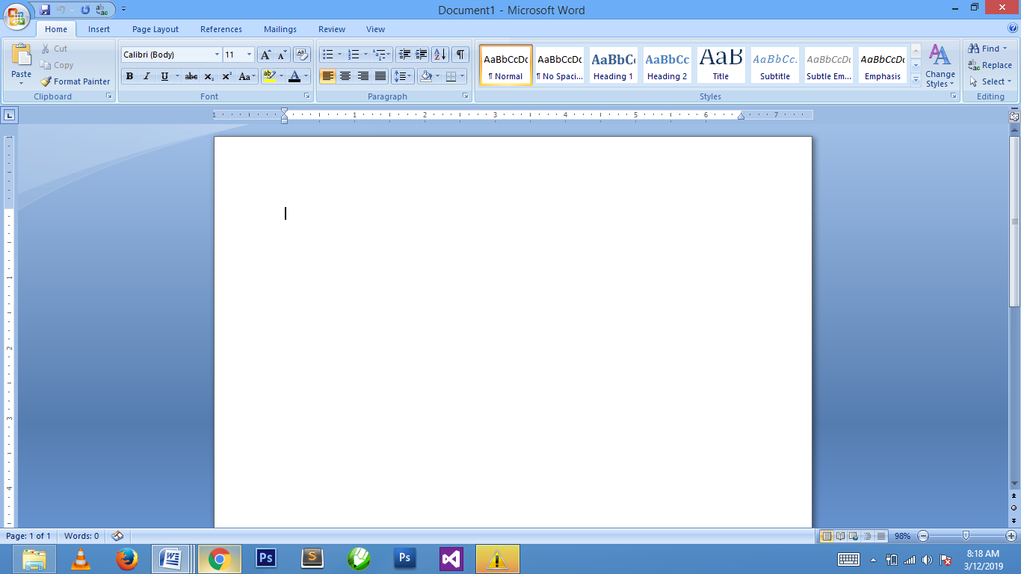

File extensions
Microsoft Word's native file formats are denoted either by a .doc or .docx filename extension.
Although the .doc extension has been used in many different versions of Word, it actually encompasses four distinct file formats:
- Word for DOS
- Word for Windows 1 and 2; Word 3 and 4 for Mac OS
- Word 6 and Word 95 for Windows; Word 6 for Mac OS
- Word 97 and later for Windows; Word 98 and later for Mac OS
The newer .docx extension signifies the Office Open XML international standard for Office documents and is used by Word 2007 and later for Windows, Word 2008 and later for macOS, as well as by a growing number of applications from other vendors, including OpenOffice.org Writer, an open source word processing program.

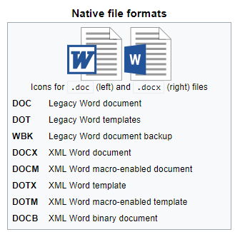

Features and Flaws
Among its features, Word includes a built-in spell checker, a thesaurus, a dictionary, and utilities for manipulating and editing text. The following are some aspects of its feature set.

Templates
Several later versions of Word include the ability for users to create their own formatting templates, allowing them to define a file in which the title, heading, paragraph, and other element designs that are unique from the standard Word templates. Users can find how to do this under the Help section located near the top right corner (Word 2013 on Windows 8).
For example, Normal.dot is the master template from which all Word documents are created. It determines the margin defaults as well as the layout of the text and font defaults. Although normal.dot is already set with certain defaults, the user can change normal.dot to new defaults. This will change other documents which were created using the template, usually in unexpected ways.

Image formats
Word can import and display images in common bitmap formats such as JPG and GIF. It can also be used to create and display simple line-art. Microsoft Word added support for the common SVG vector image format in 2017 for Office 365 ProPlus subscribers and this functionality was also included in the Office 2019 release.

WordArt
WordArt enables drawing text in a Microsoft Word document such as a title, watermark, or other text, with graphical effects such as skewing, shadowing, rotating, stretching in a variety of shapes and colors and even including three-dimensional effects. Users can apply formatting effects such as shadow, bevel, glow, and reflection to their document text as easily as applying bold or underline. Users can also spell-check text that uses visual effects, and add text effects to paragraph styles.
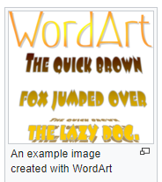

Macros
A Macro is a rule of pattern that specifies how a certain input sequence (often a sequence of characters) should be mapped to an output sequence according to defined process. Frequently used or repetitive sequences of keystrokes and mouse movements can be automated. Like other Microsoft Office documents, Word files can include advanced macros and even embedded programs. The language was originally WordBasic, but changed to Visual Basic for Applications as of Word 97.
This extensive functionality can also be used to run and propagate viruses in documents. The tendency for people to exchange Word documents via email, USB flash drives, and floppy disks made this an especially attractive vector in 1999. A prominent example was the Melissa virus, but countless others have existed.
These macro viruses were the only known cross-platform threats between Windows and Macintosh computers and they were the only infection vectors to affect any macOS system up until the advent of video codec trojans in 2007. Microsoft released patches for Word X and Word 2004 that effectively eliminated the macro problem on the Mac by 2006.
Word's macro security setting, which regulates when macros may execute, can be adjusted by the user, but in the most recent versions of Word, is set to HIGH by default, generally reducing the risk from macro-based viruses, which have become uncommon.

Layout issues
Before Word 2010 (Word 14) for Windows, the program was unable to correctly handle ligatures defined in TrueType fonts. Those ligature glyphs with Unicode codepoints may be inserted manually, but are not recognized by Word for what they are, breaking spell checking, while custom ligatures present in the font are not accessible at all. Since Word 2010, the program now has advanced typesetting features which can be enabled: OpenType ligatures, kerning, and hyphenation. Other layout deficiencies of Word include the inability to set crop marks or thin spaces. Various third-party workaround utilities have been developed.
In Word 2004 for Mac OS X, support of complex scripts was inferior even to Word 97, and Word 2004 does not support Apple Advanced Typography features like ligatures or glyph variants.

Bullets and numbering
Microsoft Word supports bullet lists and numbered lists. It also features a numbering system that helps add correct numbers to pages, chapters, headers, footnotes, and entries of tables of content; these numbers automatically change to correct ones as new items are added or existing items are deleted. Bullets and numbering can be applied directly to paragraphs and convert them to lists. Word 97 through 2003, however, had problems adding correct numbers to numbered lists. In particular, a second irrelevant numbered list might have not started with number one, but instead resumed numbering after the last numbered list. Although Word 97 supported a hidden marker that said the list numbering must restart afterwards, the command to insert this marker (Restart Numbering command) was only added in Word 2003.

CHAPTER FOUR
CHALLENGES AND PROBLEM ENCOUNTERED
4.0 It is not uncommon to hear students on their Student Industrial Work Experience Scheme (SIWES) or internship lament over their unpleasant experiences, especially the challenges encountered in the process of finding a firm to accommodate and support them.
While it is expected of students to go out and acquire practical knowledge of their chosen fields, it seems also right for firms to make provisions to support their efforts.
Though internship is peculiar to polytechnics, but most universities have followed suit depending on the course of study of the students. The major objective of internship is to help students apply theoretical knowledge and school-based skills to practice before they enter the world of work.
The program came into existence following decree No. 47 of October 08, 1971 as amended in 1990. This decree gave birth to the founding of the Industrial Training Fund (ITF) in 1973/1974, which in turn established the Students Industrial Work Experience Scheme (SIWES) to bridge the gap between school-based knowledge and work-place skills. Though industrial training provides students with work experience that prepares them for the work place, but the major advantage is that it helps students discover their areas of career interests which they are most likely to acquire.
But despite this advantage, internship isn’t without its hiccups, as students face the challenges of getting firms that would not just absorb them in their core areas of competence, but pay them monthly allowances. Vanguard Learning investigation reveals that organizations such as banks request for IT students because of cheap labour, others do not wish to accommodate students who beg for placements, while some organizations will ask the students to pay for the knowledge that will be acquired.
Though at Probity Software Company, the workers really work harder and they are very good at their work. Some of the challenges faced are listed below:
- Trekking each day to Probity Software Company.
- Lack of free access to internet for SIWES students at training place.
- Some of the projects I executed took me few days to debug at early stage of working.

CHAPTER FIVE
SUMMARY, CONCLUSION AND RECOMMENDATION
5.0 SUMMARY
There were many things that I have experience and learned during the four months of my SIWES programme at AUSTINEANNEDEX INFORMATION The whole training period was very interesting, instructive and challenging. Through this training I was able to gain new insights and more comprehensive understanding about the real industry working condition and practice. The four months placement also has provided me the opportunities to develop and improve my soft and functional skills. All of this valuable experience and knowledge that I have gained were not only acquired through the direct involvement in task given but also through other aspect of the training such as work observation, interaction with colleagues, superior, and other people related to the field. From what I have undergone, I am very sure that the industrial training program has achieved its entire primary objectives. It’s also the best way to prepare students to face the real working life. As a result of the program now I am more confident to build my future career.
CONCLUSION
This industrial training has afforded me the basic practical and theoretical knowledge that I may not have gotten from the lecture room. It also gave me the opportunity to have a feel of what it would be like after my under-graduate programme when I start working.
RECOMMENDATION
For subsequent trainees being taken up by the company, I strongly recommend a more stringent supervision of their training program, especially by the Human Resources Department. This will go a long way in ensuring that trainees do not lose focus and will constantly remind them that their services to the company remain valuable.
Also I suggest ITF should liaise with some companies where they will take up students for industrial training. This will help students who find it difficult to find attachments or who end up in companies where they do nothing.

