TECHNICAL REPORT

ON

STUDENTS INDUSTRIAL WORK EXPERIENCE SCHEME
(S.I.W.E.S)

WITH
PRIMARY HEALTH CARE 2, NEAR EMIR’S PALACE KAIMA, Kwara state
BY
FATAI RUKAYAT JOY
ND/23/NAD/FT/0048

Submitted to
DEPARTMENT OF NUTRITION AND DIATIES
INSTITUTE OF APPLIED SCIENCE
KWARA STATE POLYTECHNIC, ILOR

TABLE OF CONTENT
CHAPTER ONE
1.0 Introduction
1.1 Brief historical background of SIWES
1.2 Aims and objectives of the SIWES
1.3 Knowledge, experience and other benefit derived during SIWES
1.4 Historical background of the hospital
1.5 Approach of the hospital
CHAPTER TWO
2.0 Microbiology and parasitological unit
2.1 Pregnancy test
2.2 Urinalysis
2.3 Widal test
2.4 Malaria test
2.5 Stool microscopy
CHAPTER THREE
3.0 Antenatal care unit
3.1 Hb genotype
3.2VVRN test
3.3 Sick ling test
CHAPTER FOUR
4.0 Hematology and blood transfusion unit
4.1 packed cell volume [PCV]
4.2 Full blood count
4.3 Erythrocytes sedimentation rate [ESR]
4.4 Blood transfusion
4.5 blood donation

CHAPTER FIVE
5.0 Conclusion
5.1 Recommendation
5.2 Summary
5.3 Reference

CHAPTER ONE

INTRODUCTION

The course BIO 4315 titled stands Students Industrial Working and Experience Scheme. As the name implies, it is a course carried out to health laboratories, agricultural sectors explorations outside the school environment which is opposite to laboratory and/or classroom courses. It is main aims at measuring how students can relate their theoretical experience with their research findings to draw up good investigation, conclusions and recommendation.

It tends to broaden the students horizon of knowledge and make them to critical thinking in order to analyses their class taught and possibly future experience in a given area of study, another one of the most important view point of introducing this course to students is to enable them toward the understanding of the relationship and compared the relevance to the student field of study.

1.1 BRIEF HISTORICAL BACKGROUND OF S.I.W.E.S
S.I.W.E.S refers to the process of introducing student to the world of practical experience, which not is available in all institutions so as to improve them in their field of study and teach them on how to operate the system interface efficiently and effectively
The industrial training fund (ITF) was established by the federal government of Nigeria in the year 1973 by decree no 47 of 8th October 1973(now an act of the national assembly) to oversee the training of student of all tertiary institutions in a practical aspect of their field of study the SIWES programmer was established by the ITF to tackle the problem of lack of practical skills preparatory for employment in industries by Nigerian graduate of tertiary institutions. The scheme exposes student to industry based skills necessary for a smooth transition from the classrooms to the world of work .it afford the student of tertiary institutions the opportunity of been familiarized and exposed to the needed experience in handling machinery equipment which are not available at the educational institutions. Participation in sides has become a necessary pre condition for the award of degree in diploma certificate in specific disciplines in accordance with the educational policy of the government.

1.2 AIMS AND OBJECTIVES OF THE S.I.W.E.S
- Facilitates better understanding of different perceptions of concepts and terminologies.
- To learn the techniques of clinical laboratories
- To enable student to have a knowledge of some diseases, symptoms and how they look under a microscope.
- To identify and interpret adaptive features of the bacterial, viral, fungal and some protozoan’s infectious diseases species of animals.
- Provide an avenue to expose the student in Nigerian universities to acquire industrial skills and experience in the course of study
- To make industries and organization have confidence in abilities and capabilities of graduates
- To make transitions from the university to the world of work easier and enhance student contact for later job placements
- To develop student practical knowledge in their respective field of study
- Development for professional work habit and skills
- To prepare student for future challenges after study
- To expose student in handling work method and techniques in handling equipment and machineries that might not be available in the institutions

1.3IMPORTANCE OF S.I.W.E.S
- S.I.W.E.S stimulates student’s curiosity by enabling them to formulate and seek answers to questions.
- It helps to expand the level of understanding and stimulation of students.
- S.I.W.E.S provides students with different ways of viewing the world communicating with it and successfully introducing new questions and finding answers to them.
- The course orients students and facilitates closer link between the courses taught in the Classroom and the practical aspect of the courses present in the laboratories.
- It enable student to study the practical aspect of their profession
- It gives student the privilege to mix with professional graduate during their industrial training
- It gives student an idea of the relevant ministries or private organization that can suit their profession
- It creates an opportunity for students to be acquainted with important persons.

1.4KNOWLEDGE, EXPERIENCES AND OTHER BENEFIT DERIVED DURING S.I.W.E.S
- Helped to learn presenting findings that achieved in S.I.W.E.S
- Able to use the techniques in future career learnt during S.I.W.E.S and also doing some subject comes alive.
- Lots of fun and impressions when getting knowledge
- S.I.W.E.S are invaluable to gain an insight into the kind of things that actual go on in future profession.
- It is essential to have S.I.W.E.S to learn practical skills and to gain understanding of what it will be like to work in the field after.

1.5 Historical background of the hospital

The Primary health care centre 2 kaima Kwara state was founded around 1944, under the services of a white men since before the administration of sir, Abubakar Tarawa Balewa, during this regime, the PHC was just established for the purpose of health management and diseases control, required one block which is constructed by a rock used only for collecting medicines of some common diseases, working with 11 staff including the director of health, but letter re-established and bring about 8 department.

STRUCTURE
[1] Director PHC, [2] Drug and equipment, [3] Disease surveillance office, [4] Diseases control unit
[5] Expanded program of immunization [EPI], [6] Health educational unit, [7] Maternal and child health care unit [MHC], 8.Laboratory unit.
The financial activities are carried out by the Katsina state native authority [NA] under Funtua senatorial zone.

1.6 APPROACH OF THE HOSPITAL
Primary health care centre 2 kaiama provide social services to the around the local area, such as;

Family practices, Dental Care, Pediatric woman Care, Family Planning, Pharmacy etc

CHAPTER TWO

2.0 MICROBIOLOGY/ PARASITOLOGY UNIT

INTRODUCTION:
Microbiology & Parasitological unit involves the diagnosis and management of diseases cause by micro organisms such as bacteria, Fungi, virus Protozoan’s and parasite
The microbiology scientific staff are specialized in testing clinical specimens such as urine, blood, tissues and swabs for detecting microorganisms and other infection.
Tests carry out in this unit includes:
Pregnancy test, urinalysis, widal test and Malaria test

Microscopy: Is an observation, investigation or experiment that involves the use of microscope. There are two types which are:
Direct microscopy or wet preparation
- Non-direct microscopy; which staining takes place before microscopy
- Direct Microscopy: mostly urine, stool and semen undergo this process by viewing the specimen directly.
Microscopy which is not direct: This required staining of specimens before viewing under microscope, mostly are sputum for AFB, gram staining, e.t.c.
A microscope is an instrument used to see objects that are too small for the naked eye.
- The science of investigating small objects using such an instrument is called microscopy.
Microscopic means invisible to the eye unless aided by a microscope.

Instrument:
- Microscope Handlens
- Light microscope
- Compound microscope
- Binocular microscope
- Electron microscope

Classis of microscope
There two kinds of microscopes that you can identify in any laboratory. They are the simple and compound microscopes
Magnify an object directly, and on the other hand, compound microscopes magnify an object, and show the objects in their
Reverse position. You can observe that what is left in the image is right in the object when moving the slide in a certain direction.
History of microscope
- Invention of Glass Lenses (About 1590)
- Robert Hooke cell discovery
- Beyond the Light Microscope (1600’s)
- Electron Microscope (1930’s)

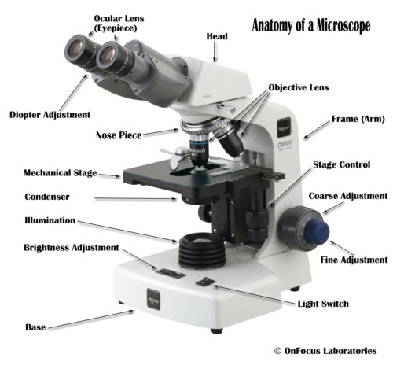

Anatomy of microscope
- Eyepiece: The lens the viewer looks through to see the specimen. The eyepiece usually contains a 10X or 15X power lens.
- Diopter Adjustment: Useful as a means to change focus on one eyepiece so as to correct for any difference in vision between your two eyes.
- Body tube (Head): The body tube connects the eyepiece to the objective lenses.
- Arm: The arm connects the body tube to the base of the microscope.
- Coarse adjustment: Brings the specimen into general focus.
- Fine adjustment: Fine tunes the focus and increases the detail of the specimen.
- Nosepiece: A rotating turret that houses the objective lenses. The viewer spins the nosepiece to select different objective lenses.
- Objective lenses: One of the most important parts of a compound microscope, as they are the lenses closest to the specimen.
- A standard microscope has three, four, or five objective lenses that range in power from 4X to 100X. When focusing the microscope, be careful that the objective lens doesn’t touch the slide, as it could break the slide and destroy the specimen.
- Specimen or slide: The specimen is the object being examined. Most specimens are mounted on slides, flat rectangles of thin glass.
- Stage: The flat platform where the slide is placed.
- Stage clips: Metal clips that hold the slide in place.
- Stage height adjustment (Stage Control): These knobs move the stage left and right or up and down.
- Aperture: The hole in the middle of the stage that allows light from the illuminator to reach the specimen.
- On/off switch: This switch on the base of the microscope turns the illuminator off and on.
- Illumination: The light source for a microscope. Older microscopes used mirrors to reflect light from an external source up through the bottom of the stage; however, most microscopes now use a low-voltage bulb.
- Iris diaphragm: Adjusts the amount of light that reaches the specimen.
- Condenser: Gathers and focuses light from the illuminator onto the specimen being viewed.
- Base: The base supports the microscope and it’s where illuminator is located.
Complex Compound Microscope: Light or optical types of complex compound microscopes combines objective, eyepiece
Lenses, and light condemner lens and magnify the image of small objects
Principal of operation: The light microscope is the basic tool that is used to observe objects too small to be seen with the unaided eye.
Objects or specimens are magnified up to about one hundred times and as such could be observed using light microscope.

2.2 PREGNANCY TEST
Pregnancy test is a process of testing and determining the pregnancy and also the fetus day/week/month in the pregnant womb, technically by using urine of the pregnant.
Ten number of test tubes are used during the process. The procedure is as follows;
i. TUBE 1: 2ml of urine and normal saline are mixed, put PT Strip inside the tube for result reading
ii. TUBE 2: Put 1.5ml of TUBE 1 MIXTURE and 1.5ml of normal saline, put PT Strip inside the tube for result reading.
iii. TUBE 3: put 1.5ml of TUBE 2 MIXTURE and 1.5ml of normal saline, put PT Strip inside the tube for result reading.
iv. TUBE 4: put 1.5ml of TUBE 3 MIXTURE and 1.5ml of normal saline, put PT Strip inside the tube for result reading.
v. TUBE 5: put 1.5ml of TUBE 4 MIXTURE and 1.5ml of normal saline, put PT Strip inside the tube for result reading.
vi. TUBE 6: put 1.5ml of TUBE 5 MIXTURE and 1.5ml of normal saline, put PT Strip inside the tube for result reading.
vii. TUBE 7: put 1.5ml of TUBE 6 MIXTURE and 1.5ml of normal saline, put PT Strip inside the tube for result reading.
viii. TUBE 8: put 1.5ml of TUBE 7 MIXTURE and 1.5ml of normal saline, put PT Strip inside the tube for result reading.
ix. TUBE 9: put 1.5ml of TUBE 8 MIXTURE and 1.5ml of normal saline, put PT Strip inside the tube for result reading.
x. TUBE 10: put 1.5ml of TUBE 9 MIXTURE and 1.5ml of normal saline, put PT Strip inside the tube for result reading.
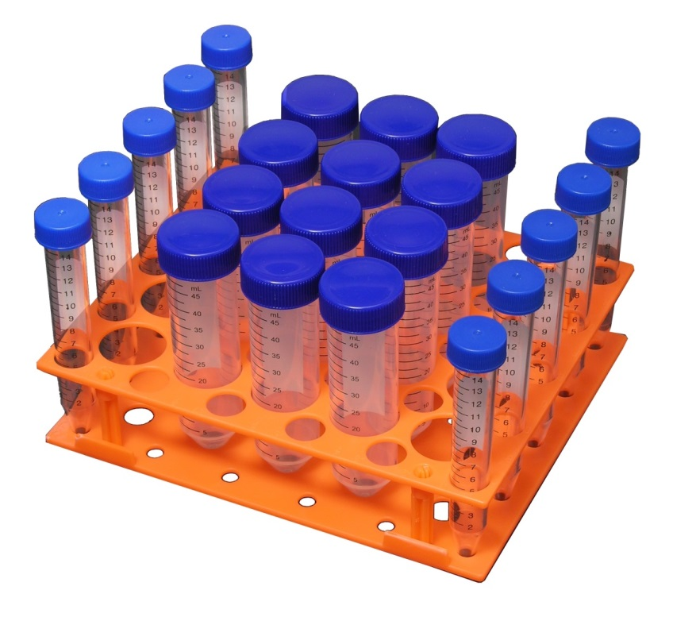
The procedure is progressively continuous provided all the result found are positive. Before reached to TUBE 10, negative result might be found as such you are to stop at that particular tube.
More over a simple home kit of pregnancy test were introduced, which pregnancy test can be carry out at home, when apply the sample the sample in the kit, in less than 5 minute you obtain your result by observing the either two appear line as a positive result or one as a negative result.

2.3 URINALYSIS
TESTS AND PROCEDURES
Urinalysis is a test that evaluates a sample of your urine. Urinalysis is used to detect and assess a wide range of disorders, such as urinary tract infection, kidney disease and diabetes. Urinalysis involves examining the appearance, concentration and content of urine. Abnormal urinalysis results may point to a disease or illness. For example, a urinary tract infection can make urine look cloudy instead of clear. Increased levels of protein in urine can be a sign of kidney disease. Abnormal results of a urinalysis often require more testing and evaluation to uncover the source of the problem.
Laboratory examination of urine sample, to obtain clinical information Most of the substances normally excreted in the urine are metabolic products dissolved or suspended in water. A deviation from normal in the concentration of urinary constituents or the abnormal presence of specific substances may thus be indicative of bodily disorders. Changes in urine color, specific gravity, and volume may also provide evidence of a specific disease or body injury.
Of the large number of organic and inorganic substances present in the urine, some tend to be more significant clinically than others and include sugars, such as glucose, fructose, and pentose; acetone bodies, which, together with glucose, may be excessively high in the urine of individuals with diabetescretin and creatinine, nitrogenous compounds; hemoglobin and myoglobin, the pigments involved in oxygen transport and storage; amino acids and metabolites, such as homogentisic acid, cysteine, cysteine, and phenylpyruvic acid, any one of which may be excreted in large amounts by individuals in whom the organic catalyst or enzyme metabolizing it is defective; uric acid, a purine derivative, in cases of gout; urea, the principal end product of protein metabolism in humans; urobilinogen and coproporphyrins, bile pigments; minerals, such as calcium, phosphorus, magnesium, copper, and lead; fats, which may be detected in the urine in cases of severe diabetes mellitus and kidney disease.
Among the hormones that find their way into urine, the most important clinically include the catecholamines, chorionic gonadotrophin, pituitary gonadotrophins, and 17 ketosteroids and 17 hydroxysteroids. Among the urinary proteins, which are normally barely detectable, those most frequently found in high concentrations are the serum albumins and globulins, the presence of which in the urine is usually associated with some disturbance in kidney function . A great variety of drugs can also be measured in the urine, an important factor in assessing over dosage and toxic states.
Combi9 or 10 ( strip ) are used during the tests. Each strip contain 9 or 10 parameters, it depends whether it is combi9 or 10 . Combi9 10 strip has a specific gravity while combi9 doesn’t have, this is the only difference between combi9 and 10 strip.
Change at any parameter when compare with the strip container indicates, that a change from normal to abnormal content and concentration of the urine in which the result are recorded by observing the different colors on the strip container…………for instance it be (result) +1,+2,+3 e.t.c in which the result are presented by tally mathematic sign.
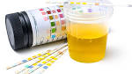
Those parameters include; blood, Urobilinogen, Bilirubin, Protein, Nitrates, Ketones, Ascorbic acid, Glucose and P^{H}. Each are represented by a specific colour , specific gravity are also f Put down the strip deep into the urine container until all the color box touch the urine, remove the strip immediately and read the result within the 30 seconds.
Appearance of the urine are of various kind such as; clear, pale yellow, amber, deep amber, bloody and turbid are the most appearance of the urine.
Precaution:
1. Ensure that, the result must be read within 30seconds
2. Shake the strip immediately after removing it from the urine

2.4 WIDAL TEST

A widal test slide showing agglutinations in reactions of corresponding O and H antigens. The Widal test is a presumptive serological test for enteric fever or undulant fever whereby bacteria causing typhoid fever are mixed with serum containing specific antibodies obtained from an infected individual. In case of Salmonella infections, it is a demonstration of the presence of O-soma false-positive result. Test results need to be interpreted carefully in the light of past history of enteric fever, typhoid vaccination, and the general level of antibodies in the populations in endemic areas of the world. Typhoid is the other test used to ascertain the diagnosis of typhoid fever . As with all serological tests, the rise in antibody levels needed to perform the diagnosis takes 7–14 days, which limits it applicability in early diagnosis. Other means of diagnosing Salmonellatyphi and Salmonellaparatyphi include cultures of blood, urine and faeces, these organisms produce H 2S from thiosulfate and can be easily identified on differential media such as Bismuth sulfite agar.
Often 2-mercaptoethanol is added to the Widal test This agent more easily denatures the IgM class of antibodies , so if a decrease in the titer is seen after using this agent, it means that the contribution of IgMhas been removed leaving the IgG component. This differentiation of antibody classes is important; as it allows for the distinction of a recent (IgM) from an old infection (IgG).
The Widal test is positive if TO antigen titer is more than 1:160 in an active infection, or if TH antigen titer is more than 1:160 in past infection or in immunized persons. A single Widal test is of little clinical relevance due to the number of cross reacting infections, including malaria. If no other tests (either bacteriologic cultureor more specific serology) are available, a fourfold increase in the titer (e.g., from 1:40 to 1:160) in thecourse of the infection, or a conversion from an IgM reaction to an IgG reaction of at least the same titer, would be consistent with a typhoid infection.
A new serological test is called the Tubes test is not superior than the Widal test and even the Widal test gives better performance results, so the Tubes test is not recommended for diagnosis of typhoid fever.
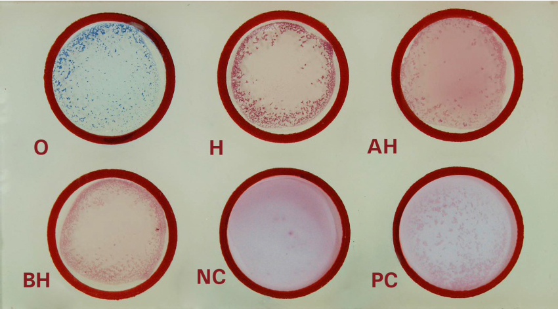
Positive test appear with agglutination within a minute while negative test have no agglutination.

2.5 MALARIA TEST

The mainstay of malaria diagnosis has been the microscopic examination of blood, utilizing blood films. Although blood is the sample most frequently used to make a diagnosis, both saliva and urine have been investigated as alternative, less invasive specimens.
More recently, modern techniques utilizing antigen tests or polymerase chain reaction have been discovered, though these are not widely implemented in malaria endemic regions. Areas that cannot afford laboratory diagnostic tests often use only a history of subjective fever as the indication to treat for malaria.
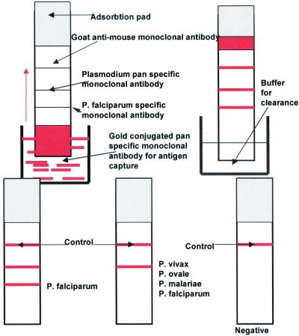

The most economic, preferred, and reliable diagnosis of malaria is microscopic examination of blood films because each of the four major parasite species has distinguishing characteristics Two sorts of blood filmier traditionally used. Thin films are similar to usual blood films and allow species identification because the parasite's appearance is best preserved in this preparation. Thick films allow the microscopes to screen a larger volume of blood and are about eleven times more sensitive than the thin film, so picking up low levels of infection is easier on the thick film, but the appearance of the parasite is much more distorted and therefore distinguishing between the different species can be much more difficult. With the pros and cons of both thick and thin smears taken into consideration, it is imperative to utilize both smears while attempting to make a definitive diagnosis. From the thick film, an experienced microscopic can detect parasite levels (or parasitemia ) as few as 5 parasites/ µL blood.
Diagnosis of species can be difficult because the early trophozoites ("ring form") of all four species look identical and it is never possible to diagnose species on the basis of a single ring form; species identification is always based on several trophozoites.
The main causative organisms are plasmodium malariae, plasmodium vivox, plasmodium ovale, and plasmodium falciparum. These are main pathogens that couse malaria fever to majority of the African countries.
Antigen tests
Malaria antigen detection tests For areas where microscopy is not available, or where laboratory staff are not experienced at malaria diagnosis, there are commercial antigen detection tests that require only a drop of blood.
RDTs (also called Malaria Rapid Diagnostic Tests, Antigen-Capture Assay or " Dipsticks ") have been developed, distributed and field tested. These tests use finger-stick or venous blood, the completed test takes a total of 15–20 minutes, and the results are read visually as the presence or absence of colored stripes on the dipstick, so they are suitable for use in the field.
The threshold of detection by these rapid diagnostic tests is in the range of 100 parasites/µl of blood (commercial kits can range from about 0.002% to 0.1% parasitemia) compared to 5 by thick film microscopy. One disadvantage is that dipstick tests are qualitative but not quantitative – they can determine if parasites are present in the blood, but not how many.
The first rapid diagnostic test was mainly used in identifying only plasmodium falciparum using a malaria kit or malaria cassette.
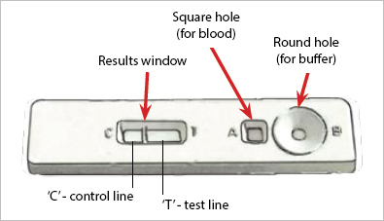

CHAPTER THREE

3.0 ANTI-NATAL CARE UNIT

Serology deals with the science that studies the reaction between antigens and antibodies in serum. I.e. a serology test is a blood test to detect the presence of antibodies.
Antenatal care unit falls under serology unit. It is a unit among laboratories which deals with the test of investigation of ANC patienpatient
ANC simply means Antenatal care in which every pregnant woman passes through it when she comes for her booking program or analysis.ANC investigation consists of series of test carried out by any pregnant woman who comes to the hospital for antenatal care they are.
- PCV
- HIV
- Urinalysis
- Blood grouping
- HB genotype
- VDRL.

3.1 HB genotype
HB genotype is carried out in other to know the inherited characteristics of offspring from parent, there are two techniques of detecting HB genotype:
1. High performance guild chromatography HPLC: this is a technique used as screening test for
A) Detection identification and quantification of hemoglobin’s variant.
B) Quantification of HBA2 and HBF.
It is well suited for neonatal screening since it can detect small amount of hemoglobin and needs small amount of blood.
2. Electrophoresis set: This is the useful method for further characteristics of hemoglobin variant electrophoresis at alkaline PH.
Materials needed
- Trace buffer solution
- Cellulose acetate paper
- Electrophoresis machine
- Electrophoresis tank
- Comb
- Plate
- Blood sample from patients.

Content of material
Electrophoresis machine has a voltage of o-300 and arms of 0-100. It has two electrolyte position and negative for movement of electrons. Buffer has a combination of ethylene of acetic acid, Acetic acid and a filter paper.
Procedure
- Sample of blood is collected from patient in EDTA container
- Collect the blood in another container flush with water.
- Use the comb to pick the sample from the plate and placed on the cellulose acetate paper.
- The cellulose acetate paper is then placed on the electrophoresis in the tank.
- Apply electricity set the timer 15mins to 20mins and then read the result.
Result interpretation
When the standard stays on A bond the result is AA, and when the standard stays on S bond the result is SS, when the standard separate into two on A bond and S bond then the result is AS, When the standard separate into two one on A bond and one before the S bond then the result is AC and lastly when the standard separate into two one on S bond and the other after S bond then the result is termed as SC. i.e. the result should show that each patient should contain one of the following types of genotype, AA, AS, AC, SS, and SC.
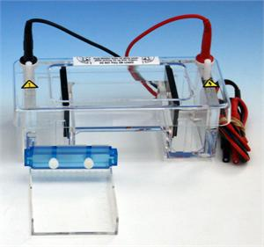
AN ELECTROPHORESIS MACHINE

3.2 VDRL
Veneral disease research laboratory and HIV-human immune deficiency virus this are carried out using test strips. The strip contains two lines control line and test lines which are close to observant pad.
When carrying out the test if one line appears on control line it indicate negative.
If no line fails to appear or one line on test line the result is invalid.
If two lines appear one on test line and the other on control line the test indicate positive.
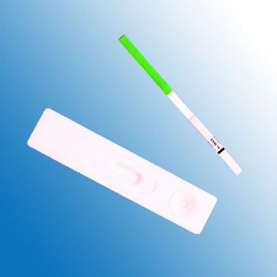

3.3 SICKLING TEST
the appear in crescent shape.
And can take or detect the gene type of the individual after observations on Sickle cell disease is a life threatening autosomal recessive genetic disorder resulting from inheritance of abnormal genes from both parent, in the sickling test we creat the condition at which oxygen tension will reduce or decline to induce the sickling process of HbS in RBCs
MATERIALS
- Clean free glass slide
- Cover slip
- Sample
- Microscope
- Vaseline

REAGENT
* 2% Metabosulphite
* 0.2g 0f sodium metabosulphite mixed with
* 10ml of distilled water until dissolved
Prepare fresh each time
PROCEDURE
- 0.5ml of whole blood was added in to 0.5ml of 2% sodium metabosulphite in a test tube and mixed thoroughly, a drop was placed on a glass slide and covered with the cover slip
- Glass slide with the sample was sealed with Vaseline and leave at room temperature for about 1-4 hours
- The red cell morphology was observed under the microscope.

RESULT
In sickle cell, the red blood cell lose their morphological characteristics to reduce the oxygen tension in the presence of sodium metabosulphite and they block the arteries
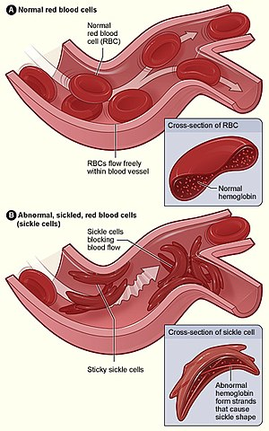

CHAPTER FOUR
4.0 HAEMATOLOGY AND BLOOD TRANSFUSION UNIT
The term Haematocrit comes from Ancient Greek word haima [blood] and krites [judge].Together haematocrit means ”to separate ”it was coined by Magnus blip at Uppsala in 1891 as haematokrit modeled after lactokrit which was used in dairy farming.
4.1 PACKED CELL VOLUME [P.C.V]
Packed cell volume [pcv] or erythrocyte volume fraction[EVF] is the volume percentage (%) of the red blood cells of blood it is normally 45% for men and 40% for women it is considered an integral part of a person complete blood count result along with Hemoglobin concentration white blood cells count and platelet count Because the purpose of red blood cell is to transfer oxygen from the lung to body tissue a blood sample’s haematocrit the red blood cell volume percentage can become a point of reference of its capability of delivering oxygen Additionally the measure of a subject’s blood samples haematocrit levels may expose possible disease in the subject, Anaemia refers to an abnormally low haematocrit, as oppose to polycythemia which refers to abnormally high haematocrict for a condition such as Anaemia that goes unnoticed one way it can be diagonosed by measuring the haemotacrict level in the blood. Both are potentially life threatening disorders.
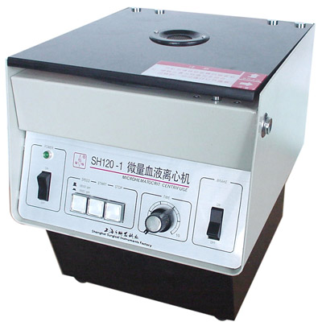

Haematocrit Centrifuging Machine

METHOD AND PROCEDURE
The packed cell volume (PCV) can be determined by centrifuging heparinized blood in a capillary tube (also known as a microhematocrit tube) at 10,000 RPM for five minutes. This separates the blood into layers. The volume of packed red blood cells divided by the total volume of the blood sample gives the PCV. Since a tube is used, this can be calculated by measuring the lengths of the layers. With modern lab equipment, the hematocrit is calculated by an automated analyzer and not directly measured. It is determined by multiplying the red cell count by the mean cell volume. The hematocrit is slightly more accurate as the PCV includes small amounts of blood plasma trapped between the red cells. An estimated hematocrit as a percentage may be derived by tripling the hemoglobin concentration in g/dL and dropping the units. There have been cases in which the blood for testing was inadvertently drawn proximal to an intravenous line that was infusing packed red cells or fluids. In these situations, the hemoglobin level in the blood sample will not be the true level for the patient because the sample will contain a large amount of the infused material rather than what is diluted into the circulating whole blood. That is, if packed red cells are being supplied, the sample will contain a large amount of those cells and the hematocrit will be artificially very high. On the converse, if saline or other fluids are being supplied, the blood sample would be diluted and the hematocrit will be artificially low. There are some risks and side effects that accompany the tests of hematocrit because blood is being extracted from subjects. Subjects may experience a more than normal amount of hemorrhaging, hematoma , fainting, and possibly infection. While known hematocrit levels are used in detecting conditions, it may fail at times due to hematocrit being the measure of concentration of red blood cells through volume in a blood sample. It does not account for the mass of the red blood cells, and thus the changes in mass can alter a hematocrit level or go undetected while affecting a subject's condition.

4.3 FULL BLOOD COUNT
A complete blood count ( CBC ), also known as a complete blood cell count , full blood count ( FBC ), or full blood exam ( FBE ), is a blood panel requested by a doctor or other medical professional that gives information about the cells in a patient's blood. A scientist or lab technician performs the requested testing and provides the requesting medical professional with the results of the CBC.
Blood counts of various types have been used for clinical purposes since the 19th century. Automated equipment to carry out complete blood counts was developed in the 1950s and 1960s. The cells that circulate in the bloodstream are generally divided into three types: white blood cells (leukocytes), red blood cells ( erythrocytes), and platelets (thrombocytes). Abnormally high or low counts may indicate the presence of many forms of disease, and hence blood counts are amongst the most commonly performed blood tests in medicine, as they can provide an overview of a patient's general health status. A CBC is routinely performed during annual physical examinations in some jurisdictions.

PROCEDURE FOR THE TEST
A phlebotomist collects the sample through venipuncture, drawing the blood into a test tube containing an anticoagulant (EDTA, sometimes citrate) to stop it from clotting . The sample is then transported to a laboratory. Sometimes the sample is drawn off a finger prick using a Pasteur pipette for immediate processing by an automated counter.
Currently, counting the cells in a patient's blood was performed manually, by viewing a slide prepared with a sample of the patient's blood (a blood film, or peripheral smear) under a microscope this process is still maintained in most developing countries include Nigeria. Presently, this process is generally automated by use of an automated analyzer , mostly in the developed countries with only approximately 10–20% of samples now being examined manually in those countries.
Manual blood count
Manual blood counts use a light microscope , usually with a specialized microscope slide , which is called hemocytometer . This shows the view through the microscope of the specialized hemocytometer slide. The built-in grid simplifies counting cells by helping the technician keep track of which cells have already been counted. Hemocytometers (counting chambers that hold a specified volume of diluted blood and divide it with grid lines) are used to calculate the number of red and white cells per litre of blood. (The dilution and grid lines are needed because there are far too many cells without those aids.)
To identify the numbers of different white cells, a blood film is made, and a large number of white blood cells (at least 100) are counted. This gives the percentage of cells that are of each type. By multiplying the percentage with the total number of white blood cells , the absolute number of each type of white cell can be obtained.
Manual counting is useful in cases where automated analyzers cannot reliably count abnormal cells, such as those cells that are not present in normal patients and are only seen in peripheral blood with certain haematological conditions. Manual counting is subject to sampling error because so few cells are counted compared with automated analysis.

Medical technologists examine blood film via a microscope for some CBCs, not only to find abnormal white cells, but also because variation in the shape of red cells is an important diagnostic tool. Although automated analysers give fast, reliable results regarding the number, average size, and variation in size of red blood cells, they do not detect cells' shapes. Also, some normal patients' platelets will clump in EDTA anticoagulated blood, which causes automatic analyses to give a falsely low platelet count. The person viewing the slide in these cases will see clumps of platelets and can estimate if there are low, normal, or high numbers of platelets.
Automated blood count
All blood counts include a CBC count and leukocyte differential count (LDC), but modern analyzers provide much more in addition. The blood is well mixed (though not shaken) and placed on a rack in the analyzer. This instrument has flow cells, photometers and apertures that analyze different elements in the blood.
A complete blood count will normally include:
White cells
Total white blood cells — all the white cell types are given as a percentage and as an absolute number per liter.
Red cells
Total red blood cells — the number of red cells is given as an absolute number per litre. Iron deficiency Anemia shows up as a Low RBC count. LOINC codes for Whole Blood RBC Counting
Hemoglobin
Hemoglobin – The amount of hemoglobin in the blood, expressed in grams per decilitre. A low level of Hemoglobin is a sign of anemia. LOINC codes for this test (Note: not all the codes in the search result are suitable for this test.)
Hematocrit
Hematocrit or packed cell volume (PCV) – This is the fraction of whole blood volume that consists of red blood cells.
An example report format for a complete blood count.
Note that test names, measurement units and reference ranges may vary between laboratories. Patient results should always be interpreted using the units and reference ranges from the laboratory that produced the results.
Interpretation
Certain disease states are defined by an absolute increase or decrease in the number of a particular type of cell in the bloodstream. For example:

TYPE OF CELL INCREASE DECREASE
Red Blood Cells (RBC) erythrocytosis or anemia or
Polycythemia erythroblastopenia
White BloodCells (WBC): leukocytosis leukopenia
lymphocytes – lymphocytosis – lymphocytopenia
granulocytes: – granulocytosisgranulocytopenia
Oragranulocytosis
Neutrophilsneutrophilianeutropenia
eosinophils eosinophilia eosinopenia
Basophilsbasophiliabasopenia
Platelets thrombocytosis thrombocytopenia
Leukocytosis can be a sign of infection
Thrombocytopenia can result from drug toxicity Pancytopenia is generally referred to as the result of decreased production from the bone marrow , and is a common complication of cancer chemotherapy.

4.5 ERYTHROCYTES SEDIMENTATION RATE (E.S.R)
The ESR is a simple non-specific screening test that indirectly measures the presence of inflammation in the body. It reflects the tendency of red blood cells to settle more rapidly in the face of some disease states, usually because of increases in plasma fibrinogen, immune globulins, and other acute-phase reaction proteins. Changes in red cell shape or numbers may also affect the ESR.
When anti coagulated whole blood is allowed to stand in a narrow vertical tube for a period of time, the RBCs – under the influence of gravity - settle out from the plasma. The rate at which they settle is measured as the number of millimeters of clear plasma present at the top of the column after one hour (mm/hr).
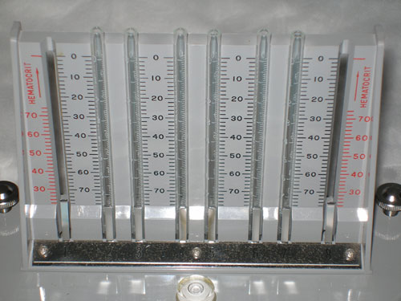
The Wintrobe sedimentation rack
There are two main methods used to measure the ESR: the Westergren method and the Wintrobe Method. Each method produces slightly different results. Most laboratories use the Westergren method.
Westergren method:
The Westergren method requires collecting 2 ml of venous blood into a tube containing 0 .5 ml of sodium citrate. It should be stored no longer than 2 hours at room temperature or 6 hours at 4 °C. The blood is drawn into a Westergren- Katz tube to the 200 mm mark. The tube is placed in a rack in a strictly vertical position for 1 hour at room temperature, at which time the distance from the lowest point of the surface meniscus to the upper limit of the red cell sediment is measured. The distance of fall of erythrocytes, expressed as millimeters in 1 hour, is the ESR.

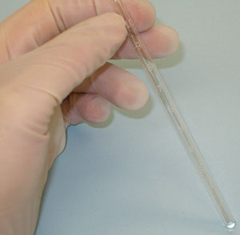
Wintrobe method:
The Wintrobe method is performed similarly except that the Wintrobe tube is smaller in diameter than the Westergren tube and only 100 mm long. EDTA anti coagulated blood without extra diluents is drawn into the tube, and the rate of fall of red blood cells is measured in millimeters after 1 hour. The shorter column makes this method less sensitive than the Westergren method because the maximal possible abnormal value is lower. However, this method is more practical for demonstration purposes.
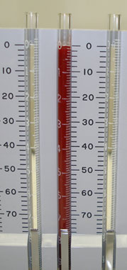

This picture shows a rack holding Wintrobe tubes, in which anti coagulated whole blood has just been added. (Time: 0)
Red blood cells have settled, leaving plasma at the top of the tube. Reading: 18 mm/hour (Time: one hour) Average values in healthy men are: <15mm/hr; in healthy females, they are somewhat higher: <20mm. The values are slightly higher in old age, in both genders.
Theoretical considerations
The RBCs sediment because their density is greater than that of plasma; this is particularly so, when there is an alteration in the distribution of charges on the surface of the RBC (which normally keeps them separate form each other) resulting in their coming together to form large aggregates known as rouleaux.
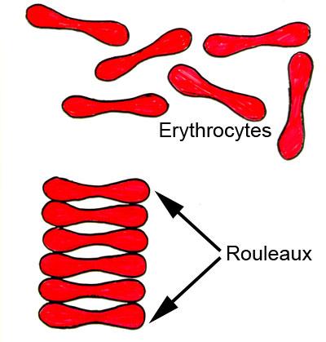

Rouleaux formation is determined largely by increased levels of plasma fibrinogen and globulins, and so the ESR reflects mainly changes in the plasma proteins that accompany acute and chronic infections, some tumors and degenerative diseases. In such situations, the ESR values are much greater than 20mm/hr. Note that the ESR denotes merely the presence of tissue damage or disease, but not its severity; it may be used to follow the progress of the diseased state, or monitor the effectiveness of treatment.
Some interferences which increase ESR: increased level of fibrinogen, gamma globulins.
Technical factors: tilted ESR tube, high room temperature.
Some interferences which decrease ESR: abnormally shaped RBC (sickle cells, spherocytosis).
Technical factors: short ESR tubes, low room temperature, delay in test performance (>2 hours), clotted blood sample, excess anticoagulant, bubbles in tube.

4.6 BLOOD TRANSFUSION
Beginning with William Harvey's experiments on the circulation of blood, research into blood transfusion began in the 17th century, with successful experiments in transfusion between animals. However, successive attempts by physicians to transfuse animal blood into humans gave variable, often fatal, results. Pope Innocent VIII is sometimes said to have been given the world's first blood transfusion by his Jewish physician Giacomo di San Genesio, who had him drink (by mouth) the blood of three 10-year old boys. The boys subsequently died. The evidence for this story, however, is unreliable and may have been motivated by anti- semitism.
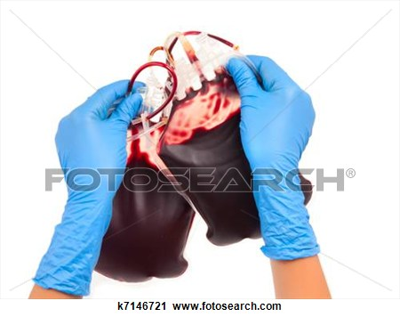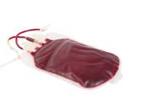
Richard Lower pioneered the first blood transfusion from animal to human in 1665 at the Royal Society. Working at the Royal Society in the 1660s, the physician Richard ssLower began examining the effects of changes in blood volume on circulatory function and developed methods for cross-circulatory study in animals, obviating clotting by closed arterial venous connections. The new instruments he was able to devise enabled him to perform the first reliably documented successful transfusion of blood in front of his distinguished colleagues from the Royal Society The first blood transfusion from animal to human was administered by Dr. Jean-Baptiste Denys , eminent physician to King Louis XIV of France, on June 15, 1667. He transfused the blood of a sheep into a 15-year- old boy, who survived the transfusion. Denys performed another transfusion into a laborer, who also survived. Both instances were likely due to the small amount of blood that was actually transfused into these people. This allowed them to withstand the allergic reaction.
Denys' third patient to undergo a blood transfusion was Swedish Baron GustafBonde. He received two transfusions. After the second transfusion Boned died.
In the winter of 1667, Denys performed several transfusions on Antoine Mauroy with calf's blood, which on the third account died.
Six months later in London, Lower performed the first human transfusion of animal blood in Britain, where he "superintended the introduction in a patient's arm at various times of some ounces of sheep's blood at a meeting of the Royal Society, and without any inconvenience to him." The recipient was Arthur Coga, "the subject of a harmless form of insanity." Sheep's blood was used because of speculation about the value of blood exchange between species; it had been suggested that blood from a gentle lamb might quiet the tempestuous spirit of an agitated person and that the shy Blood transfusion is generally the process of receiving blood products into one’s circulation intra venous Transfusion are used for various medical conditions to replace lost components of the blood. Early transfusions used whole blood, but modern medical practice commonly uses only components of the blood, such as red blood cells, white blood cells, plasma, clotting factors and platelets.
Unit of packed red blood cells are typically only recommended when either a patient’s hemoglobin level falls below 10g/dL or hematocrit falls below 30%. Because each unit of blood given carries risks, a trigger level lower than that at 7-8g/dL is increasingly being used and has shown to have better patient outcomes. The administration of a single unit of blood is the standard for hospitalized people who are not bleeding, with this treatment then followed with re-assessment and consideration of symptoms and hemoglobin concentration. Patient with poor oxygen saturation may need more blood. Caution in avoiding the transfusion of too much blood is in part due to the increasing evidence that there are cases where patients have worse outcomes when transfused. One may consider transfusion for people with symptoms of cardiovascular diseases such as chest pain or shortness of breath. In cases where patients have low levels of hemoglobin but are cardio vascular stable, parenteral iron is increasingly a preferred option based on both efficacy and safety. Other blood products are given where appropriate, such as clotting deficiencies.

4.7 Blood Donation
Blood transfusions typically use sources of blood; one’s own (autologous transfusion), or someone else’s (allogeneic or homologous transfusion). The latter is much more common than the former. Blood is commonly donated ad whole blood intravenously and collecting it with anticoagulant.
All donated blood is tested for infections. The current protocol tests donated blood for HIV-1, HIV-2 , HTLV-2 , Hepatitis B , Syphilis , Changes disease and west Nile virus. All donated blood is tested for ABO Rh group along with the presence of any red blood cell antibodies. Before a recipient receive a transfusion , compatibility testing between donor and recipient blood must be done. Type and screen recipient’s blood. Typing the recipient’s blood determines the ABO and Rh status. The sample is then screened for any all antibodies that may react with donor blood.
An antibody panel consists of commercially prepared group O red cell suspensions from donors that have been phenotype for antigens that correspond to commonly encountered and clinically significant all antibodies .Donor cells may have homozygous (e.g. K+k-),heterozygous (K+k+) expression or no expression of various antigens (K-k-). The phenotypes of all the donor cells being tested are shown in a chart. The patient's serum is tested against the various donor cells. Based on the reactions of the patient's serum against the donor cells, a pattern will emerge to confirm the presence of one or more antibodies. Not all antibodies are clinically significant (i.e. cause transfusion reactions, HDN, etc.). Once the patient has developed a clinically significant antibody it is vital that the patient receive antigen-negative red blood cells to prevent future transfusion reactions. A direct anti globulin test (Coombs test) is also performed as part of the antibody investigation. If there is no antibody present, an immediate spin cross match or computer assisted cross match is performed where the recipient serum and donor red blood cell are incubated. In the immediate spin method, two drops of patient serum are tested against a drop of 3-5% suspension of donor cells in a test tube and spun in a serofuge. Agglutination or hemolytic (i.e., positive Coombs test)in the test tube is a positive reaction and the unit should not be transfused. If an antibody is suspected, potential donor units must first be screened for the corresponding antigen by phenotype them. Antigen negative units are then tested against the patient plasma using an anti globulin/indirect cross match technique at 37 degrees Celsius to enhance reactivity and make the test easier to read. In urgent cases where cross matching cannot be completed, and the risk of dropping hemoglobin outweighs the risk transfusing uncross matched blood, O-negative blood is used, followed by cross match as soon as possible. O-negative is also used for children and women of childbearing age. It is preferable for the laboratory to obtain a pre-transfusion sample in these cases so a type and screen can be performed to determine the actual blood group of the patient and to check for all antibodies.
A positive screen warrants an antibody panel/ investigation to determine if it is clinically significant.
Citrate Phosphate Dextrose Adenine (CPDA) is an anticoagulant agent. 63ml of CPDA is contained in each blood bag which prevent the blood from clotting.
might be made outgoing by blood from more sociable creatures.
INSTRUCTION FOR BLOOD COLLECTION
1. Put bag on scale and adjust the gravitation to zero
2. Suspend the bag below the donor’s arm, a minimum of 60cm between bag and donor’s arm
3. Apply blood pressure and disinfect the puncture site
4. Make a loose knot in donor tube approximately 10cm from the needle
5. Grasp needle hub firmly, twist needle protector to remove it and perform venipuncture
6. Release pressure cuff and start to collect blood
7. As soon as blood flow starts, repeatedly mix blood
8. Collect up to 450mL blood
9. Knot firmly after collection and withdraw donor needle. Sever donor tube above knot and collect pilot sample
10. Immediately after collection gently invert the bag up and down at least x10 to thoroughly mix blood and anticoagulant
11. Squeeze the blood from donor tubing into the bag, mix and allow citrated blood to flow back into tubing
12. Seal donor tubing between numbers with aluminium rings or heat sealer
When a donor and recipient blood are not well screened, cross matched and tested before transfusion take place, some certain reactions in the recipient’s body might occur those reactions include;Acute hemolytic reactions occur with transfusion of red blood cells, and occurs in about 0.016 percent of transfusions, with about 0.003 percent being fatal. This is due to destruction of donor red blood cells by preformed recipient antibodies. Most often this occurs due to clerical errors or improper ABO blood typing and cross matching resulting in a mismatch in ABO blood type between the donor and the recipient. Symptoms include fever, chills, chest pain, back pain, hemorrhage, increased heart rate, shortness of breath, and rapid drop in blood pressure. When suspected, transfusion should be stopped immediately, and blood sent for tests to evaluate for presence of hemolytic. Treatment is supportive. Kidney injury may occur due to the effects of the hemolytic reaction (pigment nephropathy). Delayed hemolytic reactions occur more frequently (about 0.025 percent of transfusions) and are due to the same mechanism as in acute hemolytic reactions. However, the consequences are generally mild and a great proportion of patients may not have symptoms. However, evidence of hemolysis and falling hemoglobin levels may still occur. Treatment is generally not needed, but due to the presence of recipient antibodies, future compatibility may be affected.
Febrile non hemolytic reactions are the most common type of blood transfusion reaction and occur due to the release of inflammatory chemical signals released by white blood cells in stored donor blood. This type of reaction occurs in about 7% of transfusions. Fever is generally short lived and is treated with antipyretics, and transfusions may be finished as long as an acute hemolytic reaction is excluded. This is a reason for the now-widespread use of leuko reduction - the filtration of donor white cells from red cell product units. Allergic reactions may occur when the recipient has preformed antibodies to certain chemicals in the donor blood, and does not require prior exposure to transfusions. Symptoms include hives, itching , low blood pressure , and respiratory distress which may lead to anaphylactic shock. Treatment is the same as for any other type 1 hypersensitivity reactions and includes administering intramuscular epinephrine , glucocorticoids , antihistamines, medications to keep the blood pressure from dropping , and mechanical ventilation if needed.
INSTRUCTION FOR TRANSFUSION
1. Cross match before use
2. Do not add medication to the blood bag
3. Mix blood thoroughly immediately before use
4. Remove outlet protection and insert transfusion set
5. Transfusion set must have a filter
CAUTION
1. Use the blood bag in ten days from opened aluminium foil pack
2. Do not use bag if damaged or contained solution found to be turbid
STORAGE
Unused pack may be kept at room temperature and pack with blood should be kept +2⁰C to +6⁰C

CHAPTER FIVE

5.1 CONCLUSION

All praise and thanks to almighty Allah that made this S.I.W.E.S possible and successfully and achieved the main objectives of the course.
The aims and objectives of the S.I.W.E.S course was not defeated, but successfully achieved because we learnt a lot of things in all the laboratory sections attached. Most of the things I learnt were things I knew superficially, but thanks be to Allah that made this S.I.W.E.S course possible, and enjoyable.
Understanding the activities discussed in this report that there are a lot of important biological aspect that are relevant to my field of study so the objectives not defeated, various diagnostic tests are included with their description, their value as well as their economic importance.

5.2 RECOMMENDATIONS

Fistly,my recommendation goes to ITF that they should give monthly allowance during the training to enhance and serve as motivational factors for student.I would also like to call the attention of my colleagues to be participating fully during the excises because it advantages are incalculable high.

5.3 SUMMARY
Chapter one discussed only on introduction, aim and objectives of the S.I.W.E.S, history of the industry (Hospital).Chapter two will discussed only on two units; Haematology and Blood transfusion unit. All the tests carryout, how and why the tests are carryout, machines and equipment used during test, obstacles experienced during the tests and also the result interpretations where necessary are to discussed on that particular chapter.Chapter three will discussed on Microbiology Unit and Parasitology. The tests that are carryout at those units include; preparation of culture media, microscopy and sensitivity with the aid of sensitivity disc, urinalysis, PT indilution, Pregnancy test, malaria and widal test respectively.Chapter four will also discussed on Anti natal care (A.N.C) unit and Reception unit. At ANC unit the tests that are carried include; Genotype, widal and malaria test, HIV test and urinalysis WHILE at Reception unit it include how to register a patient name, sex, age, request test and how to collect blood sample from the patience and also to put the sample in an appropriate anticoagulated container. Chapter five are to discussed only on summary recommendations, conclusion and references.

5.4 REFERENCES
- Mayo Clinic (14 February 2014). "Complete blood count (CBC) Why it's done - Tests and Procedures" .mayoclinic.org . Retrieved 29 July 2014.
- A B C American Association of Blood Banks (24 April 2014), "Five Things Physicians and Patients Should Question" , Choosing Wisely : an initiative of the ABIM Foundation (American Association of Blood Banks), retrieved 25 July 2014.
- Analytical, Fluka. "55420 CLED Agar (Cystine- Lactose-Electrolyte Deficient Agar; Bromothymol-blue Lactose Cystine Agar)" .Fluka Analytical. Retrieved 18 October 2014.
- A B Madigan M, Martinko J (editors). (2005). Brock Biology of Microorganisms (11th ed. ed.). Prentice Hall. ISBN 0-13-144329-1 .
- Medical Microbiology (4th ed. ed.). McGraw Hill. ISBN 0-8385-8529-9 .
- A B Fisher, Bruce; Harvey, Richard P.; Champe, Pamela C. Lippincott's Illustrated Reviews: Microbiology (Lippincott's Illustrated Reviews Series) .Hagerstwon, MD: Lippincott Williams & Wilkins. ISBN 0-7817-8215-5 .
- Ralf Reski and Wolfgang O. Abel (1985): Induction of budding on chloronemata and caulonemata of the moss, Physcomitrella patens, using isopentenyladenine .Planta 165, 354–358.
- Hedin SG. "The Haematokrit: a New Apparatus for the Investigation of Blood". SkandinavischesArchivfürPhysiologie 2: 134–140,1891.

