

TECHNICAL REPORT AND PRESENTATION
STUDENT INDUSTRIAL WORK EXPERIENCE SCHEMES
(SIWES)

HELD@
HMF CONSTRUCTION LIMITED

PRESENTED BY:
ABDULSALAM UTHMAN
ND/23/ARC/FT/0024

SUBMITTED TO:
DEPARTMENT OF ARCHITECTURAL TECHNOLOGY
INSTITUTE OF ENVIROMENTAL STUDIES (IES)
KWARA STATE POLYTECHNIC, ILORIN

FROM
AUGUST-NOVEMBER

TABLE OF CONTENT
DEDICATION
ACKNOWLEDGEMENT
ABSTRACT

CHAPTER ONE…………………………………………………………………….........................1 1.1
INTRODUCTION TO SIWES
1.2 AIMS AND OBJECTIVE OF SIWES

CHAPTER TWO...................................................................................................................................2 2.1
LOCATION AND BRIEF HISTORY OF ESTABLISHMENT
2.2 OBJECTIVE OF ESTABLISHMENT
2.3 ORGANIZATION STRUCTURE (INCLUDING ORGANOGRAM)
2.4 THE VARIOUS DEPARTMENT/UNIT IN THE ESTABLISHMENT AND THEIR FUNCTIONS

CHAPTER THREE/FOUR...................................................................................................................3&4
WORK ACTUALLY CARRIED OUT WITH CLEAN STATEMENT ON EXPERIENCE GAINED CHAPPTER

FOUR.......................................................................................................................................................
4 5.1 SUMMARY OF ATTACHMENT ACTIVITIES
5.2 PROBLEM ECOUNTERED DURING THE PROGRAM 5.3 SUGGESTION FOR THE IMPROVEMENT OF THE SCHEME

DEDICATION
My first dedication goes to Almighty Allah, the merciful. who has lead and guide me through my industrial Training (SIWES).
secondly, to my parent and my brother’s who has been there for me, through their support and financial assistant.
through the beginning of my education and also some people who contribute to my uplift and where i am today.

ACKNOWLEDGEMENT
I thank GOD Almighty, who has preserved my life to attain this greater height of education. Providing me a suitable and correlated placement to my course of study and for granting me through, with knowledge, wisdom and understanding through my period of my (SIWES).
I thank HMF CONSTURCTION COMPANY. for supporting me and made it possible for me to understand and learn .
I would also appreciate my parents, MR AND MRS ABDULSALAM for there support throughout the whole period and my brother Sulaiman who support me financially for making my industrial training period successful. Am so grateful for all what you have done for me so far. I also thanks all the SIWES coordinator, The head Of Department, ARC TOMORI and the architect who have made the gradually building student into future architect.
MAY ALMIGHTY ALLAH STREGTHEN YOU ALL.

ABSTRACT
This technical is a detailed writeup comprising my four months student industrial work and experience scheme, undertake at HMF CONSTRUCTION LIMITED situated at no5 GRA Grazeland avenue
Ibadan Avenue Ibadan. Experience gained during the industrial training period were essential for the exposure of practical skills in construction industry.
A lot of site work where showed and done, we even follow some civil engineering for a inspection and construction of roads, and it makes my exposure to Architectural bright.
A personal assessment of knowledge prior to the commencement of my industrial work and after the four months showed a vivid differences from what have known before as a result of aspect in field in architectural profession.

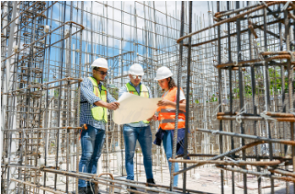
SIWES REPORT

ABDULSALAM UTHMAN
ND/23/ARC/FT/0024

CHAPTER ONE
1.1. INTRODUCTION TO SWIES
SWIES: stands for Students Industrial Work Experience Scheme. It is the accepted skills training program, which forms part of the approved minimum Academic standards in the various degree program for all Nigerian tertiary Universities (N.U.C 1996). SIWES goes a long way inputting to test the level of knowledge a student has acquired during the industrial training program. It is an effort to bridge the gap existing between theory and other practice of architecture, engineering and technology, sciences, agriculture and other professional educational programs in the Nigerian tertiary institutions. It is aimed at exposing students to machines and equipment and professional work methods in industries and other organizations.
The scheme is a program, involving the students, the universities and the industries (employers of labor). It affords students the opportunity to familiarize and expose themselves to the knowledge and experience needed in handling equipment that is not readily available in their various institutions. Before the establishment of this scheme, employers believed that the theoretical education in tertiary institutions were not adequate enough to meet most of the needs of employers of labor.
Students Industrial Work Experience Scheme (SIWES) was established in 1971 by decree 47 with the aim of promoting and encouraging the acquisition of skills in the private and public industries. Its relevance in education system cannot be over emphasized as it develops the student to become skilled and experience professionalism in their various disciplines. It enables students to appreciate the basic concept involved in their field of study. It is also an effort to bridge the gap existing between theory and practical, in the sense that it exposes students to real industrial work experience. SIWES, which involves the University authorities and the industrial sector, runs for 24 weeks for students in the fourth academic year in universities. The scheme was organized by the Federal Government and jointly coordinated by the Industrial Training Fund (ITF) and the Nigeria Universities.
Commission (NUC). The importance of the training scheme is justified as it is a research field, which enables students to be totally in-depth in finding the working culture, practice and tools in their various areas of specialization.

1.2 OBJECTIVES
1. Acquire practical skills: To enable students acquire practical skills and experience in their chosen profession.
2. Bridge the gap: To bridge the gap between theoretical knowledge and practical application in the industry.
3. Develop problem-solving skills: To develop problem-solving skills and critical thinking in students.
4. Exposure to industry practices: To expose students to industry practices, procedures, and standards. 5. Development of professional competence: To develop professional competence and confidence in students.
6. Enhance employability: To enhance the employability of students by providing them with relevant work experience.
7. Foster industry-academia collaboration: To foster collaboration between industry and academia for mutual benefit.
8. Improve skills in communication and teamwork: To improve students' skills in communication, teamwork, and leadership.
9. Apply theoretical knowledge in practical situations: To enable students to apply theoretical knowledge in practical situations.
10. Develop adaptability and flexibility: To develop adaptability and flexibility in students to respond to changing industry needs.

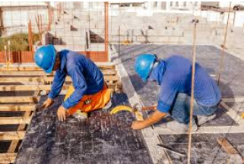



CHAPTER TWO
2.1: LOCATION AND BRIEF HISTORY OF ESTABLISHMENT
LOCATION: It was located at Ibadan Oyo State
HISTORY:
HMF: Is a construction company which was established in the year 2008 by (ENG’R IDRIS ADEOYE) which is the managing director of the company. HMF company mostly deal with road construction but they do have some Engineering branches under them like Architectural and Survey Engineering. But I will be talking about my own discipline which is Architectural, This Architectural firm has a integrated, much disciplinary design that dedicated to create places and spaces that elevate the human spirit and inspire human endeavors. The design building structure and construct it to the state of the client. Embracing every opportunity for innovation by uniting bright minds and diverse perspectives we have successfully designed projects at every scale, from community centers to state of the art labs Alternative delivery models have created long term valve for our clients and for the users of the building and spaces we design. Clients appreciate our data drive methodology during early design and planning stages of complex projects an approach that reduces the traditional and lengthy iterative design cycles of trial and error Architectural Design Through a highly participatory and respectful design process, we create Architecture that enriches our day -to - day experiences, that is both proud and creates a sense of place that is meaningful to the society it serves. In our design studio across the global a commitment to ever greater design excellence sustainable our culture and traditional

ARCHITECTURAL DESIGN
Through a highly participatory and respectful design process, we create Architecture that enriches our day -to - day experiences, that is both proud and creates a sense of place that is meaningful to the society it serves. In our design studio across the global a commitment to ever greater design excellence sustainable of our culture and traditional.

2.2: OBJECTIVES OF ESTABLISHMENT
- To develop a design ideal into Aesthetic proposal.
- To assist a building contractor to construct base on intent, as a record of the design and plan development.
- To communicate ideal and concept.
- To convince clients of a merit of a design
- Design Excellence: To produce innovative and functional design solutions that exceed client expectations.
- Project Timeliness: To ensure timely completion of architectural designs and documentation.
- Budget Compliance: To manage architectural project budgets effectively, ensuring cost-effectiveness without compromising quality
- Client Satisfaction: To deliver architectural designs that meet and exceed client requirements and expectations.
- Sustainability: To incorporate sustainable design principles and energy-efficient solutions in all architectural projects.
- Code Compliance: To ensure that all architectural designs comply with relevant building codes, regulations, and standards.
- Collaboration: To foster effective collaboration between architects, engineers, and other stakeholders to ensure seamless project delivery.
- Innovative Technology: To leverage innovative technologies, such as BIM and CAD, to enhance architectural design and documentation.
- Quality Assurance: To maintain high-quality architectural designs and documentation through rigorous quality assurance processes.
- Professional Development: To provide ongoing professional development opportunities for architects to enhance their skills and stay up-to-date with industry trends and best practices.

2.3: ORGANIZATION STRUCTURE (INCLUDING ORGANOGRAM)
1. Managing director: Engr Idris Adeoye
2. project manager: Engr Olayiwola Rasak
3. site Eng’r: Engr David Abiodun
4. Quality Control: Engn’r Onigbinde Emmanuel
5. Surveyor: Tajudeen Samad
6. Architectural: Architect Abdulfatai Sulaiman And Others

2.4: THE VARIOUS DEPARTMENT/UNIT IN THE ESTABLISHMENT AND THEIR FUNCTION
Associate of Engr
Quality control department
Surveyor department
Earthmoving department
Equipment and plants procurement
Architectural department

1. Associate of Engr (Top-level management)
- Oversees overall operations and strategic planning
- Ensures compliance with industry standards and regulations

2. Quality Control Department (Reports to Associate of Engr)
- Functions: - Conducts inspections and tests to ensure quality standards are met
- Identifies and addresses quality issues
- Develops and implements quality control procedures
- Collaborates with other departments to ensure quality standards are maintained
- Responsible for ensuring quality standards are met in all aspects of operations
3. Surveyor Department (Reports to Associate of Engr)

- FUNCTIONS:
• Conducts site surveys to gather data for earthworks and construction o Creates topographic maps and site plans o Provides data for project planning and execution o Ensures accurate measurement and calculation of quantities
• Responsible for providing accurate survey data to support project operations
4.Earthmoving Department (Reports to Associate of Engr)
• Functions: o Performs earthworks, excavation, and grading o Operates heavy equipment such as bulldozers, excavators, and graders o Ensures site preparation and excavation are completed to specifications o Collaborates with surveyors to ensure accurate grading and excavation
• Responsible for executing earthworks and excavation tasks to support project operations
5. Equipment and Plants Procurement (Reports to Associate of Engr)

- FUNCTIONS:
- Purchases and procures equipment and plants for project operations
- Ensures equipment is maintained and serviced regularly
- Sources spare parts and supplies for equipment maintenance
- Collaborates with other departments to ensure equipment needs are met

• Responsible for ensuring equipment and plants are available and operational to support project operations
6. Architectural Department (Reports to Associate of Engr)
- Functions:
- Designs buildings and structures
- Develops and prepares architectural drawings and models
- Collaborates with clients to understand their needs and preferences
- Ensures compliance with building codes and regulations
- Conducts site visits to monitor construction progress
• Responsible for creating architectural designs that meet client needs and industry standards
CHAPTER THREE/ FOUR
WORK CARRIED OUT AND EXPERINCE GAINED DURING SIWES
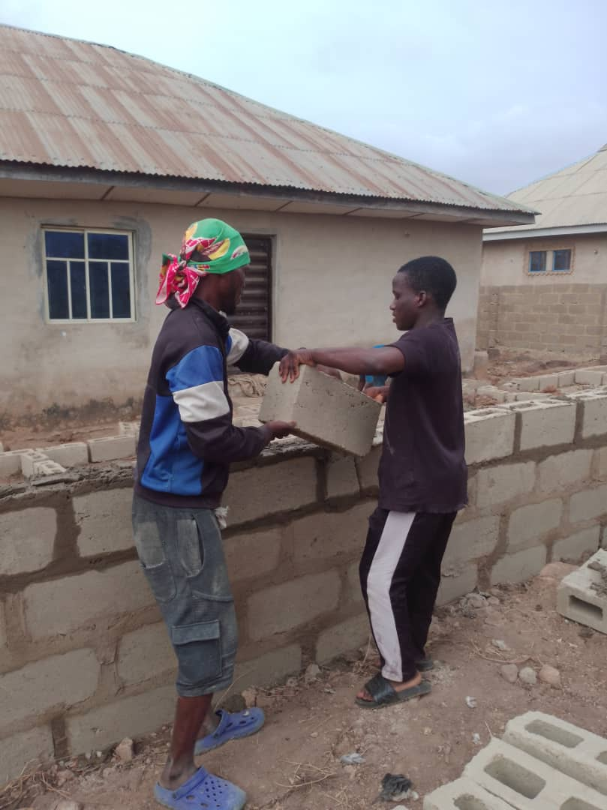
During my four-month SIWES program at HMF Construction Limited, I was exposed to various aspects of architectural practice and construction management. My experience was both challenging and rewarding, providing me with valuable skills and knowledge that will benefit my future career.

My primary responsibilities included:
- Assisting architects and engineers in preparing architectural drawings and documents
- Conducting site visits to monitor construction progress and identify potential issues and also i was taught on how to mix concrete and how to do a wall plastering
- Collaborating with the quality control team to ensure compliance with building codes and regulations
- And also i was opportune to visit Quarry where they turn a big stone to a granite And when i follow the civil engineering to site i was able to identify the machine they use e.g payloader, Bulldozer, Roller, Excavator
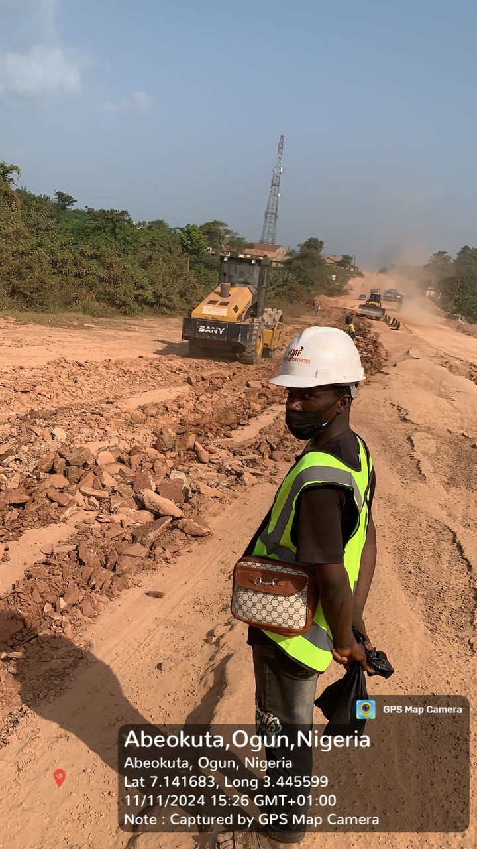

Through these experiences, I gained a deeper understanding of the construction industry and the role of architects in ensuring that buildings are designed and constructed to meet the needs of us.
One of the most significant experiences I gained during my SIWES program was the opportunity to work. I was assigned to assist the architectural team in preparing drawings and for a residential building project. This experience taught me the importance of attention to detail, effective communication, and teamwork in ensuring that projects are completed successfully.
In addition to the technical skills I gained, I also developed important soft skills such as time management, problem-solving, and adaptability. These skills will be invaluable in my future career as an architect.
Overall, my SIWES experience at HMF Construction Limited was invaluable, providing me with practical skills, knowledge, and industry insights that will benefit my future career. I am grateful for the opportunity to have worked with such a reputable company and talented professionals.

RECOMMENDATIONS
Based on my experience, I recommend that future SIWES students:
- Be proactive and willing to learn - Develop strong communication and teamwork skills
- Pay attention to detail and ensure accuracy in their work
- Be adaptable and willing to take on new challenges
By following these recommendations, future SIWES students can maximize their experience and gain valuable skills and knowledge that will benefit their future carrier

CHAPTER FIVE
5.1 SUMMARY OF ATTACHMENT ACTIVITIES
During my four-month SIWES program at HMF Construction Limited, I was attached to the Architectural Department where I gained hands-on experience in various aspects of architectural practice and construction management.
Key Activities: 1. Architectural Design: Assisted architects in preparing architectural drawings and documents for residential and commercial building projects.
2. Site Visits: Conducted site visits to monitor construction progress, identify potential issues, and ensure compliance with building codes and regulations.
3. Quality Control: Collaborated with the quality control team to ensure that construction works met the required standards.
4.Documentation: Assisted in preparing and updating project documents, including architectural drawings, specifications, and reports.

SKILLS ACQUIRED:
• Architectural design and drafting
• Construction management and supervision
• Quality control and assurance
• Project coordination and management
• Communication and teamwork

• This attachment has provided me with valuable practical experience and skills that will benefit my future career as an architect
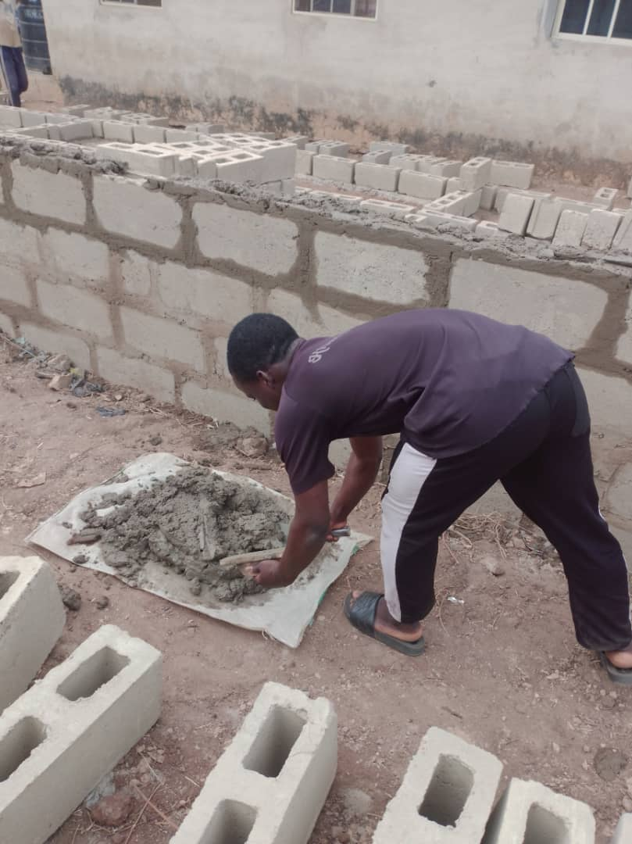

5.2 PROBLEM ENCOUNTER DURING PROGRAM
The problem or challenges encountered during my 4 month experience such as: 1 Rejection of students : there where some firm we went due to ND swies we were not allowed in the firm.
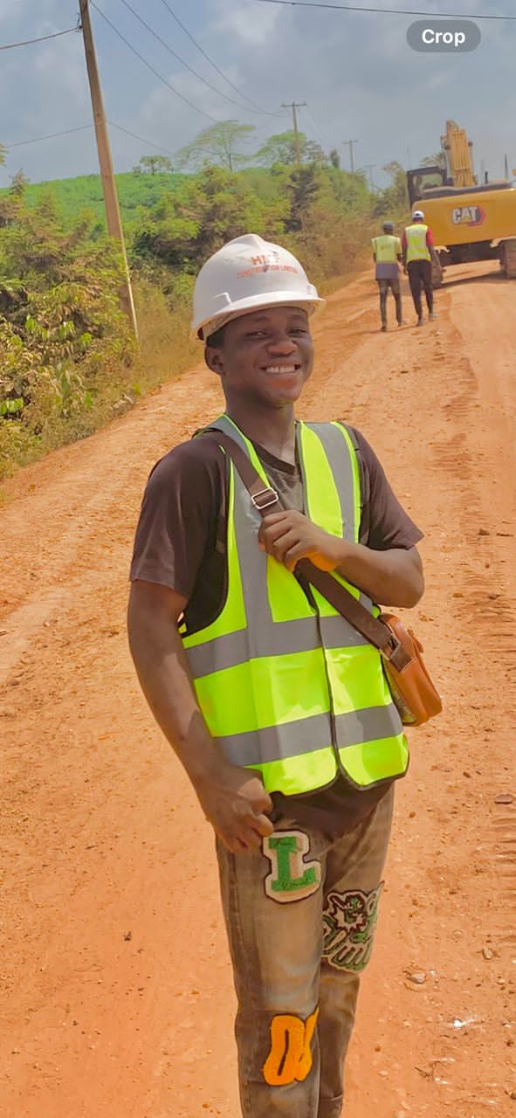
2 financial problem: we where not giving any money in the firm but i thank GOD i have a brother working in the company

4.2 RECOMMENDATIONS AND CONCLUSION
This Siwes program has being of immense benefit to me while undergoing the training. Thus, to ameliorate the situation sprouting from the identified problems and makes SIWES more beneficial, the following recommendations are following
1 The Federal Government should make it compulsory for all ministries, public parastatals and companies to offer placement to interested students as stated in the NUC job specification for SIWES.
2 The payment of prompt ITF allowance in order to encourage them for efficient carriage of duties.

CONCLUSION: In the past 4 months of my learning, I learnt a crucial aspect of Architecture and enlightening me to various design in building construction. The SIWES program has contributed immensely to the acquisition of practical experience and knowledge which are of paramount importance to my field of study. Its relevance therefore can never be overestimated. This training section has broadened my level of knowledge and as well paved way for diverse future opportunities

5.3 SUGGESTION FOR THE IMPROVEMENT OF SCHEME
Based on my experience during the four-month SIWES program at HMF Construction Limited, I suggest the following improvements to enhance the effectiveness of the scheme:
1. Clearer Objectives and Expectations: Provide clearer objectives and expectations for students, employers, and supervisors to ensure everyone is on the same page.
2. Better Matching of Students with Employers: Improve the matching process to ensure students are placed with employers that align with their career goals and interests.
3.Regular Monitoring and Evaluation: Conduct regular monitoring and evaluation to ensure students are meeting the scheme's objectives and to identify areas for improvement.
4.Increased Industry Engagement: Encourage more industry professionals to participate in the scheme as supervisors, mentors, or guest lecturers to provide students with valuable insights and networking opportunities.
5.Improved Logistics and Administration: Streamline the logistics and administration of the scheme o reduce bureaucracy and ensure a smoother experience for students and employers.
6. Enhanced Feedback Mechanism: Establish a robust feedback mechanism to allow students, employers, and supervisors to provide feedback and suggestions for improvement.
7. Incorporation of Emerging Technologies: Incorporate emerging technologies, such as Building Information Modelling (BIM), into the scheme to ensure students are equipped with the latest skills and knowledge.
8.Recognition and Reward: Consider recognizing and rewarding outstanding students, employers, and supervisors to motivate and encourage participation.
By implementing these suggestions, the SIWES scheme can be improved to provide students with a more effective and beneficial learning experience.

